PROJECT REPORT

ON
GITLAB RAG CHATBOT: FINAL PART (PART 3) - UI & INTEGRATION

A project submitted in partial fulfillment of the requirements for the degree of
Bachelor of Technology
In

Computer Science and Engineering

your_college_logo.png

Submitted by:

Your Name
Enrollment No: Your Enrollment Number

Under the supervision of:

Faculty Supervisor’s Name
Designation

Your College Name City, State Academic Year: 2024–2025

Certificate

This is to certify that the project report entitled “GitLab RAG Chatbot: LLM Integration and Conversational Backend” is a bona fide record of the work carried out by Your Name, Enrollment No. Your Enrollment Number, in partial fulfillment of the requirements for the award of the degree of Bachelor of Technology in Computer Science and Engineering at Your College Name during the academic year 2024– 2025.

Signature of Faculty Supervisor
(Faculty Supervisor’s Name)

Signature of H.O.D.
(Head of Department’s Name)

Signature of Principal/Director
(Principal/Director’s Name)

Student Declaration

I, Your Name, hereby declare that the work presented in this project report entitled “GitLab RAG Chat- bot: LLM Integration and Conversational Backend” is an authentic record of my own work carried out under the supervision of Faculty Supervisor’s Name at Your College Name. This work has not been submitted for the award of any degree, diploma, or fellowship to any other university or institution.

Signature of Student
(Your Name) Enrollment No: Your Enrollment Number

Place: Date:

Acknowledgement

I extend my sincere gratitude to my supervisor, Faculty Supervisor’s Name, for their consistent guidance, constructive feedback, and encouragement throughout the development of this project. I am grateful to the Head of Department and the entire faculty of the Computer Science and Engineering department for providing an enabling academic environment and the necessary resources to complete this work. I also thank my family and friends for their support and motivation.

Your Name

Abstract

This final part of the GitLab RAG Chatbot project serves as a comprehensive documentation of the system's user-facing integration and its readiness for practical deployment. Building upon the foundational work laid out in Part 1, which established the robust data pipeline and the intricate knowledge base, and Part 2, which delved into the seamless integration of the Large Language Model (LLM) and the sophisticated conversational backend, Part 3 now brings forth the interactive elements. It introduces the intuitive Streamlit-based user interface, meticulously presents the final code artefacts, and provides crucial insights into practical deployment considerations.

The overarching objective of this deliverable is to present a complete, easily inspectable, and user-friendly prototype. This prototype is designed to demonstrate a powerful combination of efficient information retrieval from a FAISS index, ensuring rapid access to relevant data, and the capabilities of a grounded generative model, which produces accurate and contextually appropriate responses. Furthermore, a key aim is to provide clear, step-by-step instructions and comprehensive code listings, thereby guaranteeing the reproducibility of the entire system. This ensures that other developers and users can easily replicate the environment and functionality, fostering further development and widespread adoption.

Contents

1 | Preface and Scope | 1
2 | Introduction and Objectives | 2
3 | System Architecture and Integration | 3
4 | Streamlit Implementation (User Interface) | 4
5 | Code Explanation and Design Rationale | 5
A | Streamlit Application Code | 6
B | Conclusion and Deployment Notes | 7

Preface and Scope

This report (Part 3) concludes the GitLab RAG Chatbot project by focusing on front-end development and deployment. While Part 1 addressed data acquisition and knowledge base creation, and Part 2 centered on LLM integration with a conversational backend, this final stage synthesizes those efforts into a complete, user-facing application.
A Streamlit interface has been developed to provide users with an interactive chat environment that connects the FAISS-based retriever with the conversational chain. The interface not only enables seamless interaction but also enhances trust by exposing source references alongside responses. Integration tasks ensure smooth communication between the knowledge base, retriever, and conversation memory, thereby supporting context-aware dialogue.
In addition to interface design, this part highlights deployment strategies, ensuring that the chatbot can be accessed, tested, and scaled for real-world use. The outcome of Part 3 is a fully functional, production-ready RAG chatbot that combines the strengths of data engineering, retrieval-augmented reasoning, and front-end usability into a cohesive system.

Introduction and Objectives
The goal of Part 3 is to transform the foundations built in the earlier phases into a production-ready, user-centric front-end that makes the chatbot both accessible and reliable for practical use. In alignment with the overall project vision, this stage emphasizes not only functional completeness but also transparency, reproducibility, and usability. The specific objectives are as follows:
- Provide a Web-Based Chat Interface
Develop an interactive front-end using Streamlit that allows end-users to engage with the Retrieval-Augmented Generation (RAG) pipeline. This interface should seamlessly connect to the FAISS index for document retrieval and integrate with the conversational chain, thereby enabling context-aware question answering.
- Surface Source Evidence and Context
Ensure that every response generated by the chatbot is accompanied by the underlying source documents and contextual evidence retrieved from the knowledge base. This feature is critical to building user trust, enabling verification of outputs, and reinforcing the academic and practical reliability of the system.
- Preserve Conversational Context
Implement mechanisms to maintain dialogue continuity across multiple turns within a session. By leveraging conversation memory, the chatbot should support context retention, follow-up questions, and coherent responses. Extending this capability across sessions further enhances user experience by ensuring long-term usability.
Through these objectives, Part 3 consolidates backend intelligence with an intuitive interface and a scalable deployment strategy, thereby finalizing the GitLab RAG Chatbot as a complete, production-ready system.

System Architecture and Integration
Part 3 functions as the integration layer, stitching together the components developed in Part 1 (data acquisition and knowledge base creation) and Part 2 (LLM integration with a conversational backend). At the forefront of this stage is the user interface, implemented with Streamlit, which acts as the orchestration layer between end-users and the retrieval-augmented conversational pipeline.
The workflow proceeds as follows:
- User Interaction
A user submits a query through the chat input widget provided in the Streamlit interface. This forms the entry point of the system and initiates the conversational loop.
- Invocation of the Conversational Retrieval Chain
The submitted query is passed to the previously built conversational retrieval chain, which combines three essential components:
  - Retriever (FAISS Index): Retrieves the most relevant context passages from the knowledge base.
  - LLM (Generative Model): Generates a coherent and context-aware response.
  - Memory Module: Maintains conversation history to support multi-turn dialogue.
- Response Rendering
The generated response is displayed in the chat interface, mimicking a natural dialogue experience for the user.
- Source Transparency
For verification and trust, the retrieved supporting documents are optionally shown in an expandable panel, ensuring that each response remains grounded and traceable to its evidence.
- State Management
Each conversational turn is preserved in Streamlit’s session state, enabling the dialogue to persist across page refreshes or reruns without losing context.

Streamlit Implementation (User Interface)
The interactive user interface of the GitLab RAG Chatbot is implemented in the streamlit.py module. This Streamlit application serves as the final integration point, bridging the backend conversational chain with the end-user. Its design emphasizes usability, transparency, and robustness, while ensuring that all system functionalities are accessible in a reproducible manner.
Upon execution, the application performs the following steps:
- Page Configuration
The app initializes with Streamlit’s page configuration, including title, icon, and layout settings, in order to provide a professional and consistent user interface.
- Credential Validation
The application validates the availability of the Google API key, which is securely stored in Streamlit’s secrets manager. This ensures that sensitive credentials are never hard-coded or exposed in the codebase. In the event of missing credentials, the app gracefully informs the user instead of failing silently.
- Loading the QA Chain
The Question-Answering (QA) chain, developed and refined in Part 2, is loaded into the application. This chain integrates the FAISS retriever, LLM, and memory module, enabling the system to process queries with context-aware responses.
- Chat Interface Rendering
A conversational interface is rendered where users can input queries. Responses are displayed sequentially in a chat-like format, and previous messages are preserved to maintain conversational history across turns.
- Source Transparency
To strengthen reliability and reproducibility, each generated response is accompanied by an expandable panel containing the supporting source documents. This allows users to directly inspect the passages retrieved from the knowledge base.
- Error Handling and Diagnostics
Robust error-handling mechanisms are incorporated. Missing credentials, retrieval issues, or LLM generation errors are surfaced with clear diagnostic messages, allowing users and developers to trace and resolve problems efficiently.

Code Explanation and Design Rationale

The project includes a supplementary file that explains the key sections of the Streamlit app and the backend chain. This file provides a line-by-line breakdown of the Streamlit UI setup, the API key handling strategy, session state management, and the rendering of source documents for provenance. The explanations in that document were used to create the narrative in this report and to validate UI behaviors during testing.
Key points extracted from the explanation file
- Streamlit’s page configuration must occur before other Streamlit calls to avoid runtime errors.
- API keys are loaded from Streamlit secrets to avoid embedding them in code; the app halts with a clear error if credentials are missing.
- Session state is used to persist conversation history; this provides a robust user experience across reruns.
- Source passages are displayed in an expandable panel, including metadata and an excerpt of the content for quick verification.
- Error handling and spinners are included to keep the user informed and to avoid app crashes

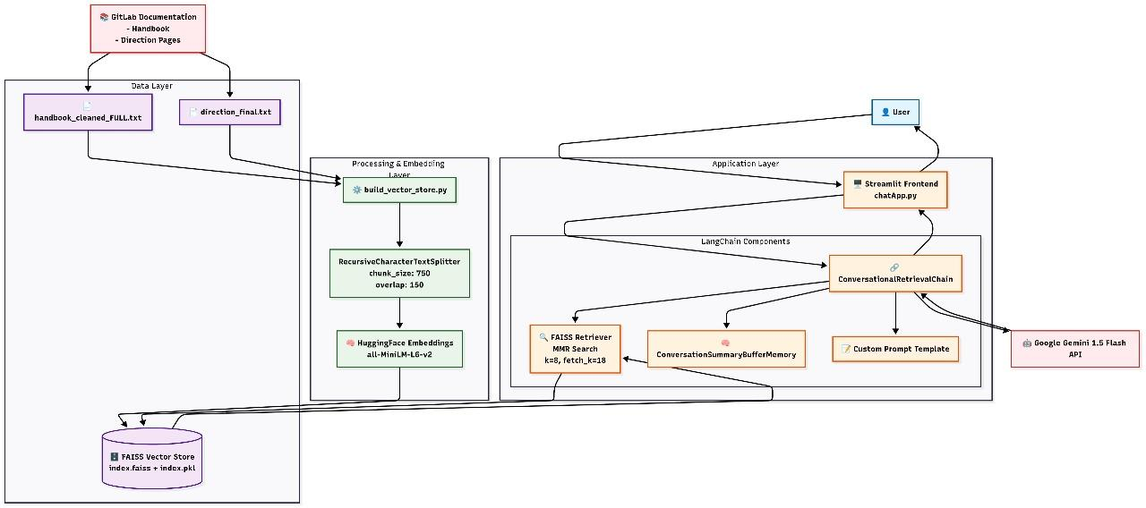
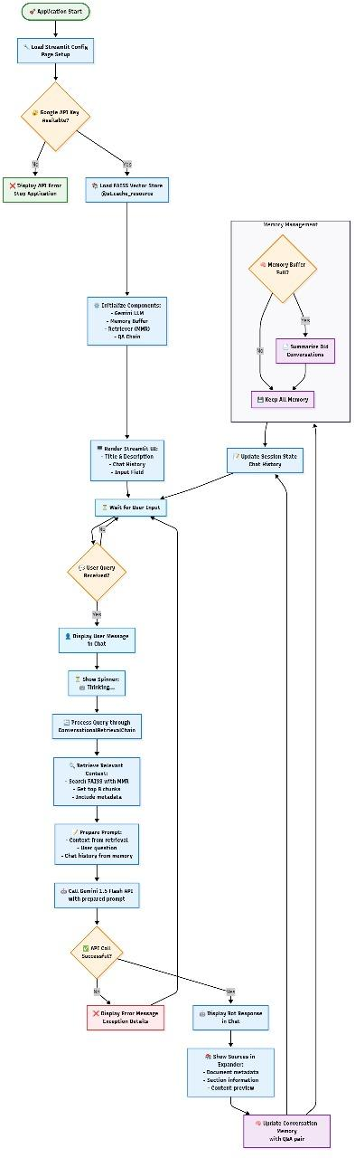
Appendix A

Streamlit Application :

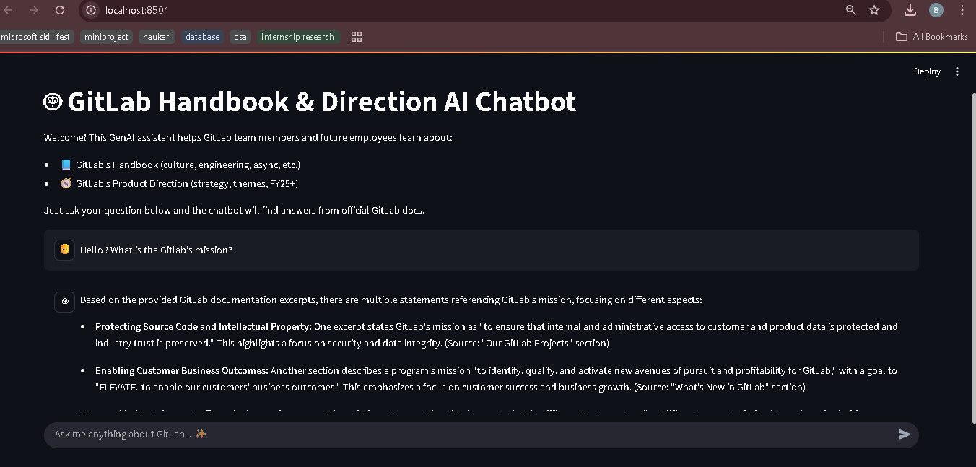

Conclusion and Deployment Notes :

Conclusion :
This final part demonstrates a complete, user-facing prototype that integrates the knowledge base and conver- sational backend into an interactive Streamlit application. The design balances transparency, reproducibility, and user experience to produce an effective RAG-based assistant for GitLab documentation.

Deployment Notes :
- The project is version-controlled using GitHub, ensuring organized structure and defined dependencies. Streamlit Cloud is utilized for deployment, with secure secret management and automated updates from the main branch. Caching techniques are applied to enhance performance, and a dedicated development branch is maintained for pre-production testing.

