PATHOSCOPE AI
Automated Viral Functional Genomics & Host Response Transcriptomics Pipeline
Project Submission Report
Degree of Bachelor of Science in Bioinformatics
Submitted to: SIR GHULAM ABBAS
Project Team:
1. M. EKRAMAH (Presenter 1: Core runner, FASTQ & AI Engines)
2. TAHA (Presenter 2: FASTA Annotation Pipeline)
3. MISHAL (Presenter 3: Transcriptomics DEG Engine)
4. ASAD IMAM (Presenter 4: Frontend UI, SSE & Exporters)

1. Introduction
Functional genomics is a core field of molecular biology that integrates genome-wide datasets to interpret gene and protein functions and cellular interactions. While structural genomics maps sequence layout, functional genomics monitors dynamic transcript abundance and protein activity under environmental or viral infection challenges. PathoScope AI was developed to simplify these pipelines by bridging pathogen identification with host transcriptomic profiling.

1.1 Project Objectives
The primary goal of PathoScope AI is to establish an integrated workflow engine with the following targets:
• Automated File Type Recognition: Inspects FASTA, FASTQ, and DEG table files to execute matching routines.
• Checkpoint Gating: Verifies stdout/stderr and file sizes at each step to prevent silent analysis failures.
• Asynchronous Scheduling: Runs heavy calculations on background thread workers while streaming logs via SSE.
• Grounded AI Explanations: Formulates pathobiology insights supported strictly by SwissProt hits and PubMed PMIDs.

1.2 GitHub Repository
All project source code, database migrations, and configurations are maintained in the following repository:
GitHub Link:
https://github.com/itsEkramah/FUNCTIONAL-GENOMICS-PROJECT

1.3 Problem Statement
Current biological pipelines suffer from several severe limitations:
1. Fragmented Tools: Chaining packages (FastQC, fastp, SPAdes, DIAMOND, HMMER) requires custom shell script writing and formatting.
2. System Setup Barriers: Installing CLI binaries across Linux systems often causes environment and library conflicts.
3. Separation of Annotations and Expression: Pipelines isolate the annotation of new viral sequences from the Host DEG transcriptomics, dividing pathogen identification from host immunobiology response studies.
4. NCBI Rate Throttling: Direct, un-cached queries to Entrez utilities trigger rate-limit blocks (3 requests/second) and timeouts.
5. Generative AI Hallucinations: Standard LLMs frequently hallucinate gene annotations, biological pathways, and PMIDs when summarizing scientific data.

2. System Architecture
PathoScope AI is built on a decoupled full-stack architecture, isolating client visualizations, REST endpoints, and pipeline execution workers.
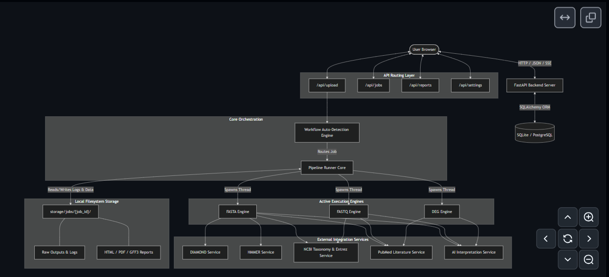
Figure 1: High-Level Architecture showing Frontend client, FastAPI web routers, SQLite databases, and pipeline worker wrappers.

2.1 Deployment & Ports (Local Host)
During development and local testing, the application runs on isolated ports under the local host loopback interface:
• Next.js Frontend Client: Runs on port 3000 (http://localhost:3000)
• FastAPI Backend API: Runs on port 8000 (http://localhost:8000)
• Swagger API Documentation: Accessible at http://localhost:8000/docs

2.2 Environment Configurations & API Keys (.env)
Sensitive settings, parameters, database configurations, and external API keys are managed inside the backend environment file located at backend/.env:
OPENAI_API_KEY=
GEMINI_API_KEY=
DATABASE_URL=sqlite:///./pathoscope.db
REDIS_URL=redis://localhost:6379/0
LOG_LEVEL=INFO
API keys are read dynamically by backend/config/settings.py using Pydantic Settings. These keys connect to Gemini and OpenAI APIs, which are then used in the AI interpretation service.

2.3 API Endpoints Table
HTTP Method & Route | Purpose | Associated Code Module
POST /api/upload | Uploads sequence/DEG files and auto-detects type | backend/api/upload.py
POST /api/jobs/{id}/start | Launches the selected workflow in background task | backend/api/jobs.py
GET /api/jobs/{id}/status | Retrieves job state and steps list | backend/api/jobs.py
GET /api/jobs/{id}/stream | Streams stdout pipeline logs in real-time (SSE) | backend/api/jobs.py
GET /api/jobs/{id}/results | Retrieves database output data | backend/api/jobs.py
POST /api/settings | Saves API keys to backend/.env configuration | backend/api/settings.py
GET /api/reports/{id}/download/{fmt} | Downloads PDF, HTML, GFF3, JSON, CSV files | backend/api/reports.py

3. Team Division & Presentation Order
To ensure high engineering quality, the team structured responsibilities and presentation roles sequentially:

3.1 Presenter 1: M. EKRAMAH (Core Orchestration, FASTQ & AI Engines)
• Orchestration Core: Designed the state-machine workflow coordinator (pipeline_runner.py).
• Preprocessing FASTQ Workflow: Integrated format check, FastQC reporting, fastp quality trimming, and SPAdes assembly.
• PubMed Integration Service: Programmed NCBI Entrez API query builder and database cache.
• Grounded AI Engine: Programmed structured prompt schemas and verification checks against SwissProt/Pfam hits.

3.2 Presenter 2: TAHA (Workflow A: Viral FASTA Annotation)
• FASTA Annotation Pipeline: Developed FASTA header scientific name parsing.
• ORF Detection: Programmed 6-frame scanning and coordinates overlap filters.
• SwissProt Alignment: Integrated DIAMOND homologous alignments.
• Domain Architectures: Integrated HMMER hmmscan domain searching and reverse-strand coordinate mappings.

3.3 Presenter 3: MISHAL (Workflow C: Transcriptomics DEG Engine)
• DEG Statistics Core: Programmed CPM matrix normalization and log-transformations.
• Hypothesis Testing: Developed Welch's t-test and Welch-Satterthwaite degrees of freedom.
• Multiple-hypothesis Correction: Programmed Benjamini-Hochberg FDR correction.
• Enrichment ORA: Developed GO and KEGG pathway enrichment utilizing GSEApy and local Fisher's Exact Test fallbacks.

3.4 Presenter 4: ASAD IMAM (Frontend UI, Visualizations & Reporting)
• Dashboard Interface: Designed Next.js scientific layouts and drops workspace.
• SSE Terminal Streamer: Programmed real-time terminal logging component.
• Recharts Visualizations: Built dynamic Volcano plots, bar charts, and domain tables.
• Report Exporters: Developed GFF3 coordinate exporters, PDF builders (ReportLab), and CSV/HTML template writers.

4. Workflow A: Viral FASTA Annotation (11 Steps)
Workflow A is designed to parse an assembled genome sequence, identify protein-coding coordinates, run annotation databases, mapping taxonomy, and write visual reports. The active codebase is located at backend/pipeline/workflow_fasta.py.
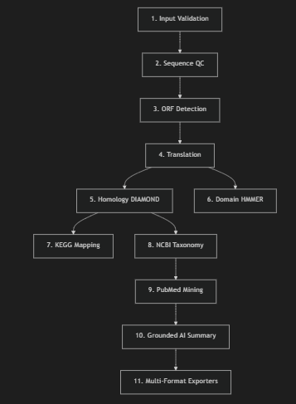

Step 1: Input Validation
Code Reference: backend/pipeline/workflow_fasta.py#L84
Verifies headers start with >. Compares sequence character elements against IUPAC nucleotide codes: set(sequence) - set('ATGCNRYKMSWBDHV'). If any non-IUPAC bases are found, it raises a ValueError.

Step 2: Sequence QC
Code Reference: backend/core/qc_engine.py#L4
Computes total genome length, GC-content percentage, and ambiguous base count. A warning is logged to the terminal if ambiguous bases ('N') exceed 10% of the total length.

Step 3: ORF Detection
Code Reference: backend/core/orf_finder.py#L82
Scans DNA in 6 reading frames for start (ATG) and stop (TAA, TAG, TGA) codons. Removes overlapping coordinates on the same strand, keeping the longer ORF. Bio-Constraint: Filters out ORFs shorter than 100 bp.

Step 4: Translation
Code Reference: backend/core/translator.py#L4
Translates DNA to protein. Bio-Constraint: Safely handles partial codons by truncating trailing base pairs that do not form a complete triplet. Runs Biopython translate(to_stop=True) to halt at the first stop codon, preventing translation errors.

Step 5: DIAMOND Annotation
Code Reference: backend/services/diamond_service.py#L22
Launches a subprocess running DIAMOND blastp against the SwissProt database. Bio-Constraints: Alignments are filtered based on threshold limits: E-value <= 10^-5, sequence identity >= 30%, and coverage >= 50%.

Step 6: Pfam Domain Search
Code Reference: backend/services/hmmer_service.py#L22
Launches a subprocess running HMMER hmmscan against Pfam-A profiles. Bio-Constraint: Identifies structural domain locations and E-values (threshold <= 10^-3). For reverse strand features, domain coordinates are mapped back to absolute genomic coordinates.

Step 7: KEGG Mapping
Code Reference: backend/services/kegg_service.py#L112
Maps SwissProt hits to KEGG Orthology pathways using a localized pathway database to identify metabolic networks and signaling cascades.

Step 8: NCBI Taxonomy Lookup
Code Reference: backend/services/ncbi_service.py#L8
Parses the scientific name from the FASTA header and queries the NCBI Entrez database to retrieve TaxID and evolutionary lineages (Kingdom, Phylum, Class, Order, Family, Genus, Species). Caches results in SQLite to respect NCBI rate limits.

Step 9: PubMed Retrieval
Code Reference: backend/services/pubmed_service.py#L161
Builds dynamic query queries (e.g. 'Organism AND GeneName') and queries the NCBI PubMed database to retrieve abstract records. Features offline stubs in case network connections are unavailable.

Step 10: AI Interpretation
Code Reference: backend/services/ai_service.py#L50
Passes annotated database hits, Pfam domains, and PubMed abstracts to Gemini/GPT. Prompts enforce structured JSON outputs, requiring verified PubMed PMIDs and homologous database IDs for all claims to prevent hallucinations.

Step 11: Report Generation
Code Reference: backend/reports/
Compiles analysis statistics and coordinates into download-ready PDF, HTML, GFF3, CSV, and JSON reports.

5. Workflow B: FASTQ Analysis (17 Steps)
Workflow B processes raw NGS sequencer reads. The first 6 steps handle quality control, trimming, and de novo assembly, generating an assembled FASTA file that is then fed to the downstream steps of Workflow A. The active codebase is located at backend/pipeline/workflow_fastq.py.
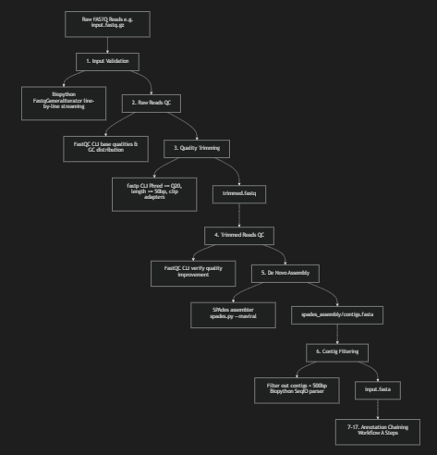

Step 1: FASTQ Input Validation
Code Reference: backend/pipeline/workflow_fastq.py#L47
Uses Biopython's FastqGeneralIterator to parse raw reads. Checks if the file is empty and verifies FASTQ syntax (each record must contain a header, sequence, separator, and quality scores). Uses streaming to avoid loading large files into RAM.

Step 2: Raw Reads QC (FastQC)
Code Reference: backend/pipeline/workflow_fastq.py#L99
Runs FastQC on raw reads to generate pre-trimming base quality profiles and GC bias statistics. If FastQC is missing or fails, it falls back to a python-based QC calculator.

Step 3: fastp Quality Trimming
Code Reference: backend/pipeline/workflow_fastq.py#L132
Launches fastp CLI to process raw reads. Bio-Constraints: Filters reads to retain only those with Phred quality scores >= Q20 (99% base-calling accuracy) and length >= 50 bp, and clips adapter sequences.

Step 4: Trimmed Reads QC (FastQC)
Code Reference: backend/pipeline/workflow_fastq.py#L167
Runs FastQC on processed reads to evaluate quality improvements and verify adapter removal.

Step 5: SPAdes De Novo Assembly
Code Reference: backend/pipeline/workflow_fastq.py#L194
Launches assembly in --rnaviral mode to reconstruct genome contigs from processed reads.

Step 6: Contig Length Filtering
Code Reference: backend/pipeline/workflow_fastq.py#L214
Parses spades_assembly/contigs.fasta using Biopython. Bio-Constraint: Filters out contigs shorter than 500 bp to reduce annotation noise, saving the filtered genome as input.fasta in the job directory.

Steps 7-17: Downstream Annotation Chaining
Code Reference: backend/pipeline/workflow_fastq.py#L324
Triggers the 11 steps of the FASTA pipeline on the assembled input.fasta file, performing ORF prediction, SwissProt homologous alignments, Pfam domain searches, KEGG pathway mapping, taxonomy classification, PubMed literature mining, and AI interpretation.

6. Workflow C: Transcriptomics DEG Engine (9 Steps)
Workflow C profiles host transcriptional responses to viral infection, identifying differentially expressed genes (DEGs) and mapping enriched biological pathways. The active codebase is located at backend/pipeline/workflow_deg.py.
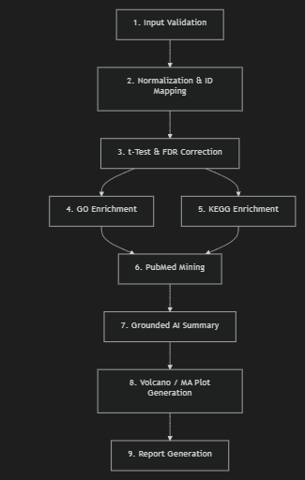

Step 1: Input Validation
Code Reference: backend/pipeline/workflow_deg.py#L42
Supports precomputed tables (Mode A) and raw count matrices (Mode B). Checks for nulls, infinite values, index duplicates, and invalid p-value bounds.

Step 2: Normalization & ID Mapping
Code Reference: backend/pipeline/workflow_deg.py#L188
Standardizes Ensembl/Entrez IDs to HGNC symbols. For Mode B raw counts, calculates Counts Per Million (CPM) to account for differences in library sizes between samples: CPM_i = (C_i / Sum(C)) * 10^6, followed by log-transformation: log2(CPM_i + 1). Bypasses the normalization step if the data is already log-transformed (E_max < 30) to prevent double-normalization.

Step 3: Statistical Classification
Code Reference: backend/pipeline/workflow_deg.py#L267
1. Group Auto-Detection: Uses substring pattern matchers to categorize columns into Control (e.g., control, ctrl, mock) and Treatment (e.g., infected, treat, disease) cohorts.
2. Welch's T-Test: Compares group expression levels without assuming equal variances. Degrees of freedom are calculated using the Welch-Satterthwaite equation.
3. FDR Correction: Applies Benjamini-Hochberg FDR correction to adjust p-values and control for false discoveries.
4. Regulation Classification: Classifies genes as UP (log2FC >= 1.0, padj < 0.05), DOWN (log2FC <= -1.0, padj < 0.05), or Not Significant.

Step 4: GO Enrichment
Code Reference: backend/pipeline/workflow_deg.py#L435
Runs Over-Representation Analysis (ORA) via GSEApy web interfaces. Calculates enrichment significance using Fisher's Exact Test. Features a local Fisher's Exact Test database fallback in case of timeouts.

Step 5: KEGG Enrichment
Code Reference: backend/pipeline/workflow_deg.py#L541
Runs pathway enrichment using GSEApy or falls back to a local ORA database. Maps enriched pathways to KEGG entries (e.g. hsa04110).

Step 6: PubMed Integration
Code Reference: backend/pipeline/workflow_deg.py#L705
Queries PubMed for literature connecting significantly perturbed genes to enriched pathways.

Step 7: AI Interpretation
Code Reference: backend/pipeline/workflow_deg.py#L732
Passes DEG lists, pathway enrichments, and PubMed abstracts to Gemini/GPT to write pathobiology summaries.

Step 8: Visualizations Generation
Code Reference: backend/pipeline/workflow_deg.py#L783
Generates Volcano Plots (comparing -log10(FDR) against log2FC), MA Plots, and GO/KEGG Dotplots using Matplotlib and Seaborn in non-interactive mode.

Step 9: Report Generation
Code Reference: backend/pipeline/workflow_deg.py#L983
Exports raw JSON results and structured audit reports.

7. Biological Constraints & Thresholds Summary
To ensure reproducible and reliable analysis, the application enforces specific biological constraints at key steps. These settings are managed in backend/config/thresholds.yaml:
Workflow | Constraint Parameter | Enforced Value | Scientific Rationale
FASTA | Minimum ORF Length | >= 100 bp (33 residues) | Filters out short, random codon selections to identify actual genes.
FASTA | DIAMOND E-value Max | <= 1e-5 | Filters out random matches to identify true homology.
FASTA | DIAMOND Identity Min | >= 30.0% | Filters out low-homology alignments.
FASTA | DIAMOND Coverage Min | >= 50.0% | Ensures the alignment spans at least half the query sequence.
FASTQ | fastp Quality Phred | >= Q20 | Enforces 99% base-calling accuracy during trimming.
FASTQ | fastp Min Length | >= 50 bp | Discards short reads post-trimming to prevent alignment errors.
FASTQ | SPAdes Contig Min Length | >= 500 bp | Focuses downstream annotation on assembled contigs rather than fragments.
DEG | FDR Maximum Cutoff | < 0.05 | Significance threshold for corrected p-values.
DEG | Log2 Fold Change UP | >= 1.0 | Identifies upregulated genes (2-fold expression increase).
DEG | Log2 Fold Change DOWN | <= -1.0 | Identifies downregulated genes (2-fold expression decrease).
DEG | Enrichment Size Limits | 15 to 500 genes | Focuses enrichment on pathway sets that are neither too generic nor too narrow.

Step 4: GO Enrichment
Code Reference: backend/pipeline/workflow_deg.py#L435
Runs Gene Ontology (GO) Over-Representation Analysis (ORA) covering Biological Process, Molecular Function, and Cellular Component ontologies. It leverages GSEApy web APIs to perform calculations. Bio-Constraints: Filters results based on threshold limits: adjusted p-value (FDR) < 0.05 and gene set size between 15 and 500. It implements a local Fisher's Exact Test fallback in case web services time out or are offline.

Step 5: KEGG Enrichment
Code Reference: backend/pipeline/workflow_deg.py#L541
Runs KEGG pathway over-representation checks against the human database. Extracts enriched pathways (e.g., hsa04110: Cell Cycle) using Fisher's exact test statistics, falling back to local dictionaries on network timeout. Saves results to csv and registers pathway IDs, genes count, and FDR values in database tables.

Step 6: PubMed Integration
Code Reference: backend/pipeline/workflow_deg.py#L705
Queries NCBI PubMed using dynamically formulated queries linking top perturbed host genes and pathways. Fetches abstracts and caches them inside SQLite to comply with Entrez rate limits, preventing workflow blocks.

Step 7: AI Interpretation
Code Reference: backend/pipeline/workflow_deg.py#L732
Passes the differential expression results, enriched GO/KEGG terms, and PubMed abstracts to Gemini/GPT. Utilizes a structured prompt to construct a grounded pathobiology report, ensuring all claims are cited with valid PMIDs.

Step 8: Visualizations Generation
Code Reference: backend/pipeline/workflow_deg.py#L783
Generates Volcano Plots (comparing -log10(FDR) against log2FC), MA Plots, expression heatmaps of top DEGs, and GO/KEGG dotplots. Uses Matplotlib and Seaborn in non-interactive backend mode to save plots to disk.

Step 9: Report Generation
Code Reference: backend/pipeline/workflow_deg.py#L983
Compiles all intermediate calculations, statistical tables, and plot paths into a unified JSON report. Builds a self-contained, interactive HTML dashboard page in the job directory and registers report paths in the database.

7. Biological Constraints & Thresholds Summary
To ensure reproducibility and reliability, the application enforces specific biological constraints at key steps. These settings are managed in backend/config/thresholds.yaml:
Workflow | Constraint Parameter | Enforced Value | Scientific Rationale
FASTA | Minimum ORF Length | >= 100 bp (33 residues) | Filters out short, random codon selections to identify actual genes.
FASTA | DIAMOND E-value Max | <= 1e-5 | Filters out random matches to identify true homology.
FASTA | DIAMOND Identity Min | >= 30.0% | Filters out low-homology alignments.
FASTA | DIAMOND Coverage Min | >= 50.0% | Ensures the alignment spans at least half the query sequence.
FASTQ | fastp Quality Phred | >= Q20 | Enforces 99% base-calling accuracy during trimming.
FASTQ | fastp Min Length | >= 50 bp | Discards short reads post-trimming to prevent alignment errors.
FASTQ | SPAdes Contig Min Length | >= 500 bp | Focuses downstream annotation on assembled contigs rather than fragments.
DEG | FDR Maximum Cutoff | < 0.05 | Significance threshold for corrected p-values.
DEG | Log2 Fold Change UP | >= 1.0 | Identifies upregulated genes (2-fold expression increase).
DEG | Log2 Fold Change DOWN | <= -1.0 | Identifies downregulated genes (2-fold expression decrease).
DEG | Enrichment Size Limits | 15 to 500 genes | Focuses enrichment on pathway sets that are neither too generic nor too narrow.

8. Biological Importance of All Results

8.1 FASTQ Preprocessing & Assembly Workflow
Raw sequencing datasets contain adapters, low-quality fragments, and sequencing errors. Preprocessing (QC and trimming) filters reads to a Phred score of Q20, ensuring base-calling accuracy exceeds 99%. Subsequent assembly and filtering reconstruct consensus genomes (e.g. Zika or Influenza) from these reads, allowing researchers to study pathogen genomes without needing pre-existing reference assemblies.

8.2 FASTA Pathogen Annotation Workflow
Open reading frame (ORF) predictions and sequence translation identify coding regions. Homology matching against SwissProt and domain searches against Pfam identify target proteins (e.g. viral envelope genes or polymerases). KEGG mapping links these to signaling pathways, and grounded AI models connect computational findings with scientific literature, providing molecular targets for drug and vaccine design.

8.3 DEG Transcriptomics Analysis Workflow
Differential gene expression (DEG) analysis compares mRNA abundance between control and infected cohorts. Using Welch's t-test and Benjamini-Hochberg FDR corrections, the engine identifies significant host expression changes. Pathway enrichment maps these genes to biological networks (e.g., Toll-like receptor signaling or Apoptosis), revealing how the host immune system responds to infection and highlighting target biomarkers to reduce inflammation.

9. Frontend Interface Screenshots & Image Placeholders
This section contains placeholders for screenshots of the Next.js visual dashboard, showing the user interface stages of PathoScope AI:

[INSERT SCREENSHOT: WORKSPACE DROPZONE]
Workspace Dropzone: Shows the file upload dropzone and format auto-detection.
┌────────────────────────────────────────────────────────┐
│ │
│ PASTE INTERFACE SCREENSHOT HERE │
│ │
└────────────────────────────────────────────────────────┘

[INSERT SCREENSHOT: SSE TERMINAL LOGS]
Server-Sent Events Log Terminal: Streams execution logs in real-time.
┌────────────────────────────────────────────────────────┐
│ │
│ PASTE INTERFACE SCREENSHOT HERE │
│ │
└────────────────────────────────────────────────────────┘

[INSERT SCREENSHOT: ANNOTATION RESULTS PANEL]
Pathogen Results View: Displays predicted ORFs, SwissProt hits, and Pfam domains.
┌────────────────────────────────────────────────────────┐
│ │
│ PASTE INTERFACE SCREENSHOT HERE │
│ │
└────────────────────────────────────────────────────────┘

[INSERT SCREENSHOT: DEG VOLCANO AND MA PLOTS]
DEG Visualizations: Interactive Volcano plots and MA plots representing gene regulation.
┌────────────────────────────────────────────────────────┐
│ │
│ PASTE INTERFACE SCREENSHOT HERE │
│ │
└────────────────────────────────────────────────────────┘

[INSERT SCREENSHOT: AI PATHOBIOLOGY AND PUBMED SUMMARY]
AI Interpretation: Grounded pathobiology summaries and supporting PubMed PMIDs.
┌────────────────────────────────────────────────────────┐
│ │
│ PASTE INTERFACE SCREENSHOT HERE │
│ │
└────────────────────────────────────────────────────────┘

10. Conclusion
PathoScope AI successfully integrates sequence preprocessing, viral de novo assembly, open reading frame detection, homology searches, taxonomic classifications, pathway mapping, and literature mining into a unified web application. By enforcing validation checks at every step and utilizing relational database caching for NCBI queries, the application ensures reproducible and stable analysis. Furthermore, the platform implements a grounded AI prompt schema that constrains generative summaries to verified SwissProt accessions and PubMed PMIDs, addressing the challenge of AI hallucinations in biological reporting. PathoScope AI provides an accessible, reliable, and comprehensive solution for genomics and host response transcriptomics research.

11. Future Work & Enhancements
To further extend the capabilities and performance of PathoScope AI, several future goals have been identified:
1. Metagenomic Profiling: Integrate taxonomical classification tools (such as Kraken2 and Bracken) to identify and classify multiple pathogens in mixed clinical samples.
2. Workflow Containerization: Package the application backend, frontend, and command-line binaries (fastp, SPAdes, DIAMOND, HMMER) into a single Docker or Singularity container to simplify deployment.
3. Scalability with Nextflow: Migrate the pipeline runner to Nextflow to support high-performance cloud computing environments.
4. Structure Prediction: Integrate protein structural modeling (ColabFold/AlphaFold) to predict the 3D structures of newly annotated viral proteins.
5. Multi-Agent AI Workflows: Implement multi-agent workflows where AI agents can design follow-up analyses based on pipeline results.

