|  |  |
| --- | --- |
| **Practicum Case** |  |
| ISYS6197  Business Application Development |
| **Computer Science** | **O221-ISYS6197-DU01-02** |
| ***Valid on*** *Odd Semester Year 2021/2022* | **Revision 00** |

## Learning Outcomes

* Explain Object Oriented concept

## Topic

* Session 02 - Object Oriented Concept, Class, Object, and Package

## Subtopics

* OOP Concept
* Access Modifier
* Class to Object
* Constructor
* Static Variables and Method
* Final Variables
* Package
* Encapsulation
* Accessor and Mutator (Setter & Getter)

## Soal

*Case*

**Student DUmmy Data**

You are asked to build an application for a dummy data tester called **Student DUmmy Data** for online ticketing. You are assigned to make a program with the description below:

* Ask user to input **name**. Validate length of **name** must be between **3 – 15 characters**.



* Ask user to input **age**. Validate age must be **numeric and minimum 16.**



* Ask user to input **GPA**. Validate **GPA** must be between **0.0 – 4.0 (inclusive)**.

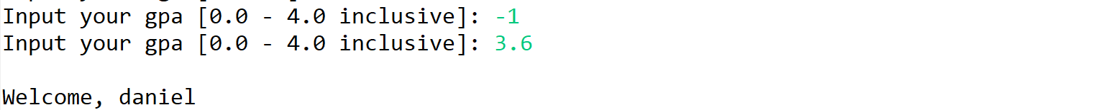

After that, show the user’s name and menu. The menu consists of:

* 1. **View Data**
  2. **Update Data**
  3. **Exit**

* Ask user to input menu choice between **1** and **3**.
* If the user chooses **menu 1:**
  + Show the current student data



* + Then return to main menu
* If the user chooses **menu 2:**
  + Show the current student data



* + Ask user to input **gpa**. Validate **gpa** must be between **0.0 – 4.0 (inclusive).**



* + Then show success update data and return to main menu.



* If user choose **Exit (Menu 3)**, the program ends.

**Please ask your teaching assistant if there is if there are any related questions.**