Mine Explorer

You are a young programmer with dreams to become a game developer. As every journey starts from a single step, you decide to create a simple game using Java Programming Language. the game detail is as follows:

1. There will be a 2 dimensional map with size N x N. we will call this map: **Board** from now on. **Board** has borders on the edges with an icon ‘=’. It also contains a **Player** with icon ‘P’, **Golds** with icon ‘G’.

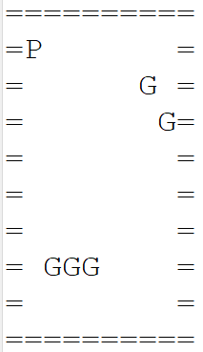

1. The game objective is for the **Player** to collect all **Gold** on the **Board**. to collect **Gold**, simply move the **Player** to where **Gold** is located. **Player** can move around the **Board** as long as needed using the W A S D key, it cannot pass through borders. **Player** always start at coordinates X = 1 and Y = 1.  
   W to move up.

A to move left.

S to move down.

D to move right.

1. Before the game starts, the game will generate a certain number of **Gold** depending on the map size (Use the formula N / 2). The location of the **Gold** is **generated randomly** but make sure the **Gold does not spawn along the borders** **or** **the Player location**. The game will show remaining gold to collect.
2. The game ends when the **Player** has collected all gold.

Note:

* Use OOP concepts you have learned such as Encapsulation, Inheritance, and Abstraction.
* There are many ways to make the game work! you may have thought of a sure algorithm but there is always another way (most of the time).