Dallos Loránd

XIKVIF

Webfejlesztés beadandó

1.Oldal

## Szövegek:

Felso textbox:

Félix Lengyel, better known as xQc or by his former screenname xQcOW (Félix Quebec OverWatch), is a Canadian Twitch streamer, internet personality, and former professional Overwatch player.

Lengyel began his esports career in 2016, while also regularly streaming. Most notably, he played for the Dallas Fuel in the Overwatch League's inaugural season, before being released midway through the season due to repeated controversy and suspensions, as well as for Team Canada in the Overwatch World Cup from 2017 to 2019.

After leaving competitive Overwatch, Lengyel focused on a full-time streaming career on Twitch, while being a content creator for organizations such as Sentinels and Luminosity Gaming. Although he has been temporarily banned multiple times on the platform, he was the most watched streamer on Twitch in both 2020 and 2021.

Rogton alatta:

xQc says "the juice" so often in his streams that it is now a recognized term in the Urban Dictionary. It defines "the juice" in the following manner.

"Something that is fulfilling, which has The juice. xQc defines "the juice" as, "The juice is whatever you make it. It can be anything. Nobody can define what it is for you, you know what the juice is right. For me, like sometimes, I think the juice is whenever I win I Pop Off right... maybe your juice is when you do a nice piece of art." xQc was quite motivational in his explanation of "the juice." He said the juice was pretty much anything that anyone could want it to be. For him, his 'juice' is his gaming. To someone else, it could be a piece of art they made. Therefore, it differs from person to person. Essentially, 'the juice' could be anything that is motivating an individual.

Az also 4 szoveg annyi, hogy hogy nezett ki a pali 2018 2019 2020 2021 ben.

## Képek:

Legfelso kep:

Utana egy video:

[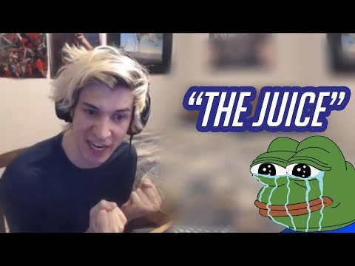](https://www.youtube.com/embed/FJVNbLWkMvc?feature=oembed)

Utana a 4 kep arrol, hogy hogyan fekjlodik a kinezete evente:

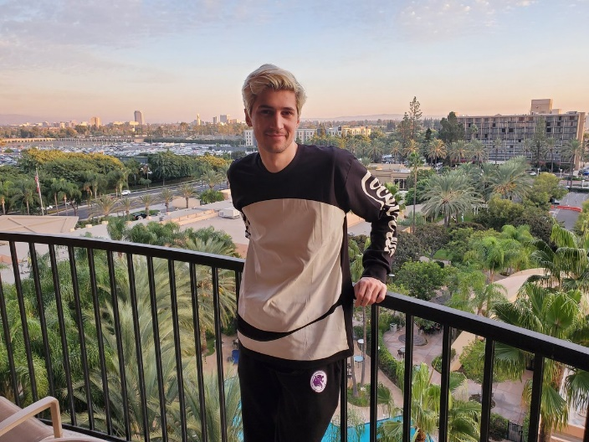

2.Oldal

## Szövegek:

Legfelso text box – bevezeto a tablazathoz:

If you're a fan of the popular Twitch streamer xQc, then you know that he's a prolific gamer who enjoys playing a wide variety of games. To help you keep track of what he's been playing recently, we've compiled a table of some of the games he's been streaming on his channel. From first-person shooters to battle royale games, and everything in between, xQc's gaming library is sure to have something that appeals to every type of gamer. So, without further ado, let's take a look at some of the games xQc has been playing lately!

Tabla tartalma:

|  |  |
| --- | --- |
| Game Name | Info About Game |
| League of Legends : | League of Legends is a popular multiplayer online battle arena game developed by Riot Games. It was first released in 2009 and has since become one of the most played and watched games in the world. In the game, players control a champion with unique abilities and battle against a team of other players, with the ultimate goal of destroying the enemy team's Nexus. With a massive player base and an ever-expanding roster of champions and updates, League of Legends has become a staple in the gaming community and continues to attract new players every day. |
| Overwatch: | Overwatch is a team-based multiplayer first-person shooter game developed and published by Blizzard Entertainment. It was first released in 2016 and quickly gained a massive following due to its unique characters, colorful visuals, and fast-paced gameplay. In Overwatch, players choose from a diverse cast of heroes, each with their own unique abilities and playstyles, and battle against other teams to complete objectives and achieve victory. With regular updates, new heroes, and a growing competitive scene, Overwatch continues to be a popular game for players of all skill levels and interests. |
| Minecraft: | Minecraft is a sandbox video game created by Mojang Studios. It was first released in 2011 and has since become one of the best-selling and most popular games of all time. In Minecraft, players are placed in a randomly generated world made up of blocks and are free to explore, mine resources, build structures, and interact with various creatures and other players. The game offers several different modes of play, including survival, creative, and adventure mode, which allows players to experience the game in a variety of different ways. Minecraft's open-ended nature and endless possibilities for creativity have made it a favorite among gamers of all ages and skill levels. The game also has a strong modding community, with players creating and sharing custom content to enhance the game even further. |
| Grand Theft Auto 5: | GTA V RP is a modded version of Grand Theft Auto V that allows players to create their own character and engage a virtual world with other players. It offers a unique and immersive experience, with players required to follow server-specific rules and speak in character. The freedom to engage in a variety of activities and create their own unique stories within the game has made it a popular choice among gamers, and with a dedicated and active community, it continues to grow in popularity as a new and exciting way to experience the open-world action game. |

## Képek:

Minden gomb egy rovid klipphez vezet, ami bemutatja xqc-t, ahogy az adott jatekkal jatszik es valami vicces tortenik. Minden clip folott egy rovid leiras szerepel ami megmagyarazza mi tortenik eppen

LoL:

[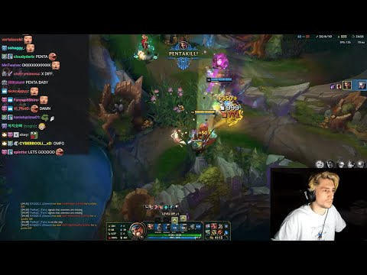](https://www.youtube.com/embed/BzNv1T6_NnY?feature=oembed)

OW:

[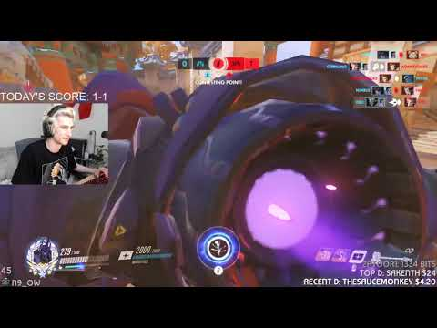](https://www.youtube.com/embed/s0EFgYOSKrs?feature=oembed)

MC:

[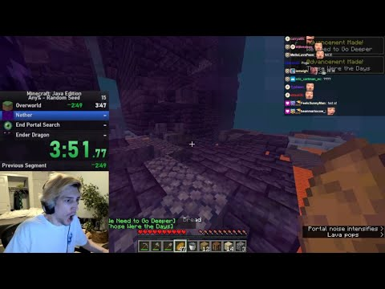](https://www.youtube.com/embed/auLjR51Q6R4?feature=oembed)

GTAV RP:

[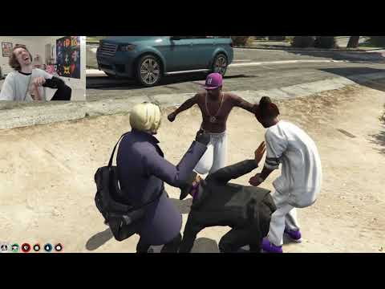](https://www.youtube.com/embed/sxb7QYfNTvI?feature=oembed)

3.Oldal

## Szövegek:

xQc nagyobb baklovesei bemutatva:

Félix Lengyel, who is better known by his online alias xQc, is a popular Twitch streamer and content creator who has been involved in several controversies throughout his career.

One of the earliest controversies xQc was involved in dates back to 2017 when he was part of the Overwatch League as a player for the Dallas Fuel team. During a live stream, he used a homophobic slur against an openly gay player from the opposing team. He was fined $2,000 and suspended for four matches as a consequence of his actions.

In 2018, xQc was again in hot water when he made a lewd gesture during a live stream, which resulted in him being banned from the Overwatch League and his contract with the Dallas Fuel team being terminated.

In 2019, xQc faced criticism for using racist language on his Twitch channel during a stream. He apologized for his behavior, and his channel was suspended for 72 hours.

In 2020, xQc faced backlash after he was caught cheating in a Twitch Rivals tournament for Fall Guys. He was disqualified from the tournament, and his Twitch account was suspended for a day.

In 2021, xQc received criticism for his comments on the streaming platform Twitch. He referred to a female streamer as a "4head," which is a derogatory term used to describe someone who is considered unattractive. He later apologized for his comments, but the incident caused a lot of controversy and backlash.

Another controversy that xQc was involved in occurred in 2021 when he was banned from the NoPixel GTA RP server. He was banned for breaking server rules and causing disruption during the role-playing sessions. This ban caused a lot of uproar among his fans, but xQc later apologized for his behavior and the situation was resolved.

Overall, xQc's controversies have had various consequences ranging from fines and suspensions to termination of contracts and bans from streaming platforms. However, despite these controversies, xQc remains a popular streamer and content creator with a large following on Twitch and other social media platforms.

## Képek:

Oldalso kep:

Alatta sorban a kepek

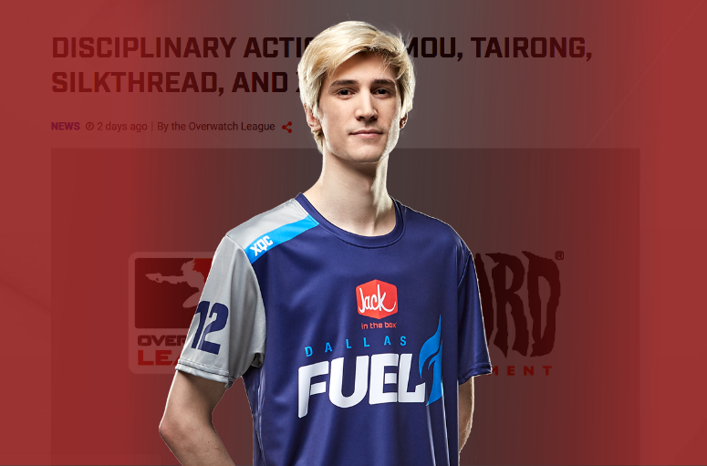

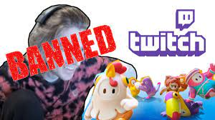

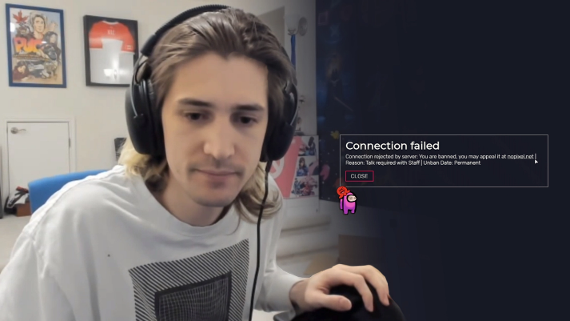

4.Oldal

## Szövegek:

Csak egy urlap, magatol ertetodo

Full name: <text>

email: <text >

Do you know xqc?: <text >

What type of stream is your favourite? <textarea>

Rate the website. <radio button> (5 választókapcsoló)

Subscribe to newsletter: <checkbox>

Send: <submit>

## Képek:

Egy mokas zaro kep:

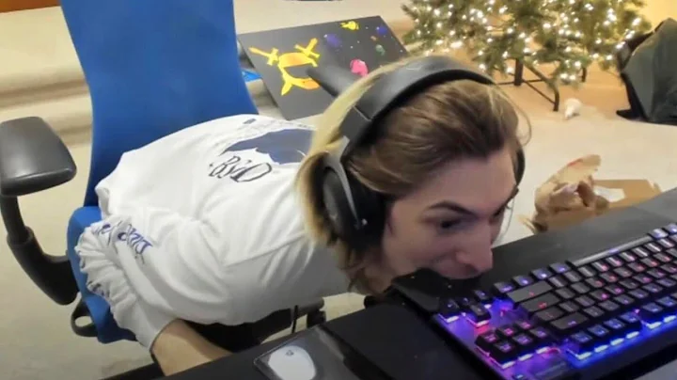

Minden heading helyen az adott oldal cime fog szerepelni.