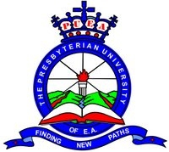

**PRESBYTERIAN UNIVERSITY OF EAST AFRICA**

NAME: PETER NDUATI NJOGU

REGISTRATION NO. G10/1007/11

UNIT: MANAGEMENT INFORMATION SYSTEM (MIS)

UNIT CODE: COP 010

MAIN CAMPUS : KIKUYU

LECTURER NAME: MR.MWAI

DATE DUE: 2/03/2012