RTL2GDSII WORKSHOP


23BEC159, Namya Shah

Electronics and Communication
School Of Technology
Pandit Deendayal Energy University

Project Report
Problem Statement: -

- Design 8x1 MUX for 8-bit inputs using the Verilog HDL.

- Generate GDS-II layout of the design using Synopsys-flow scripts.

  - Report Design Area
  - Clock frequency, where slack value is positive but less than 1.
  - Report power consumption.

Contents
Verilog Design and Testbench Code

VCS Results: -
- Waveform in Verdi
- Verdi Schematic

Design Compiled: -
- Time Constraints
- Library Used

IC Compiled II: -
- Scenario Used
- Every Stage (Floorplan, Power plan, Placement, clock and route)
- Report (qor (cell area and cell count), timing and power)

Prime Time Compiled: -
- pt shell Script (p1 and p2)
- Report timing (Final Slack time)
- Schematic Diagram

Results

Learnings and Outcomes

Mux_8X1_8bit rtl code: - (mux_rtl.v)
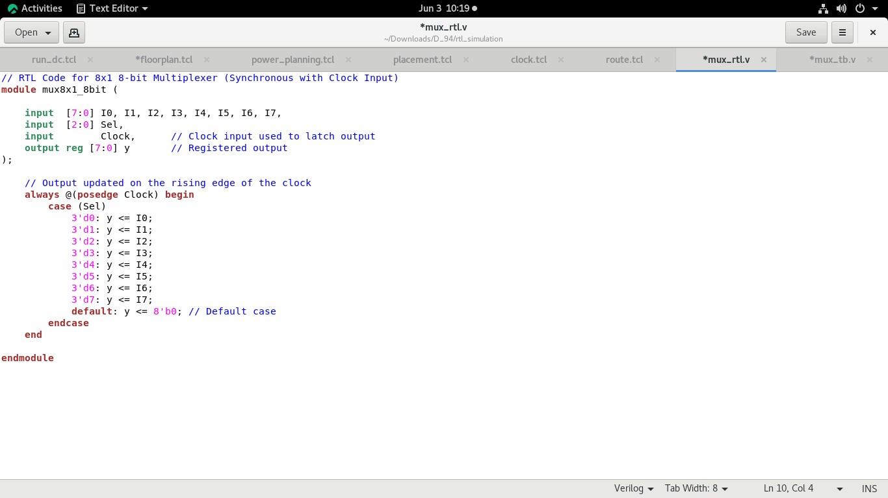

Mux_8X1_8bit tb (testbench) code: - (mux_tb.v)
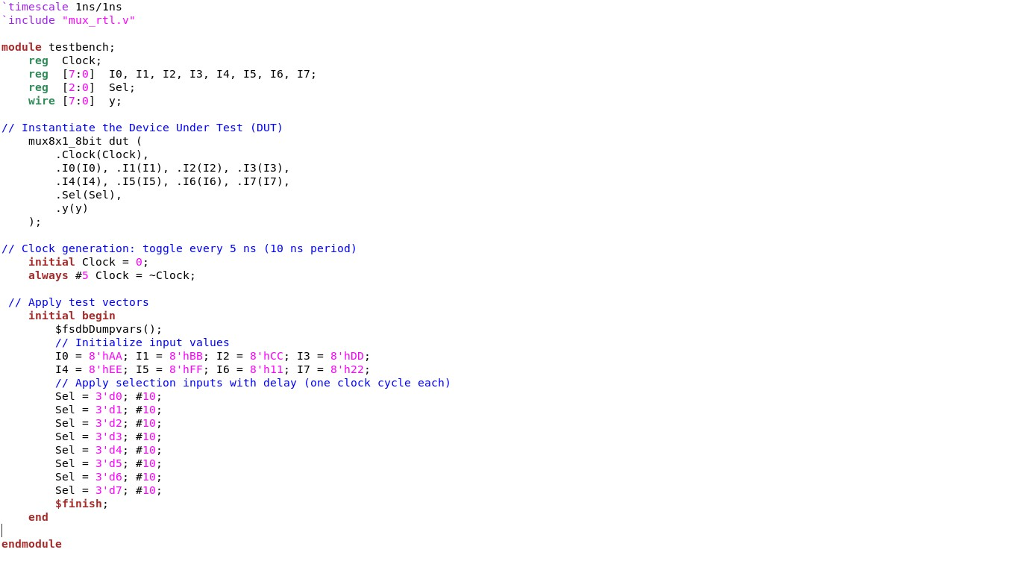

RTL serving as the functional description and testbench as the tool for verifying its correctness. The testbench provides stimuli for simulation, ensuring the design meets specifications before synthesis and physical implementation.

Compile and Simulate Using VCS
These steps will compile the RTL and testbench, run the simulation, and open the waveform viewer.
Compile RTL Design File. (Compiles the full adder module ( mux_rtl.v). vcs -full64 mux_rtl.v -debug_access+all -lca -kdb
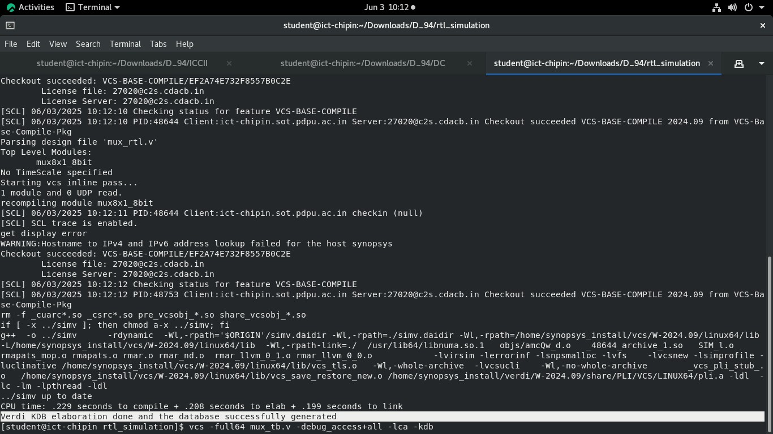
Compile Testbench File. (Compiles the testbench ( mux_tb.v ) that stimulates the design) vcs -full64 mux_tb.v -debug_access+all -lca -kdb
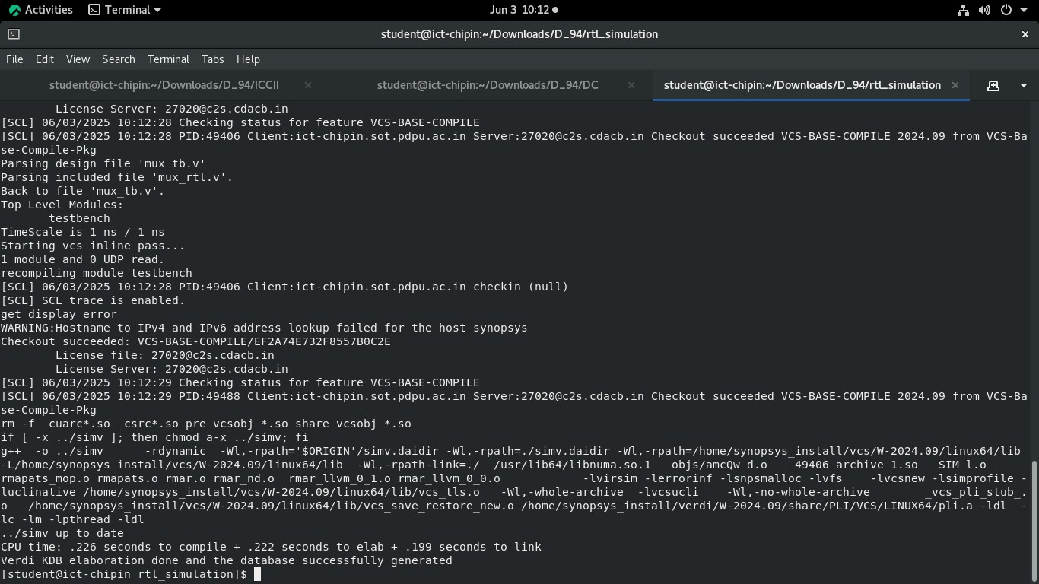
For Run simulation. (Executes the compiled simulation binary)

./simv Verdi For view waveform in Verdi. (Launches Verdi to visualize simulation waveforms) verdi -ssf novas.fsdb -nologo
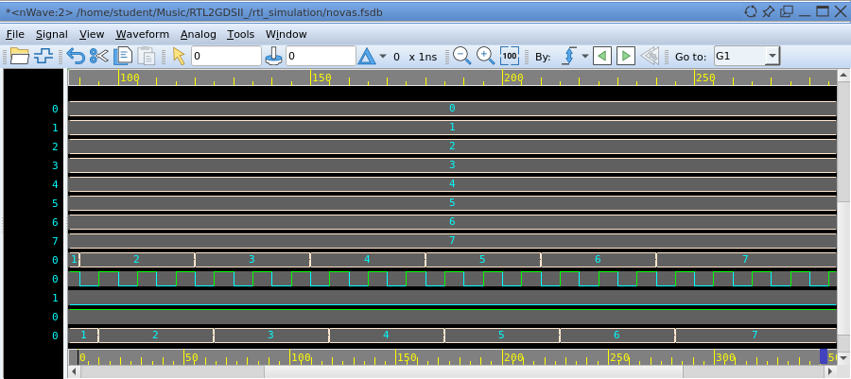

Schematic view: -
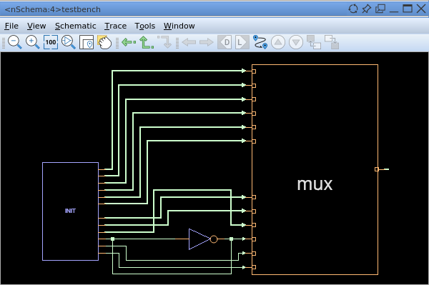

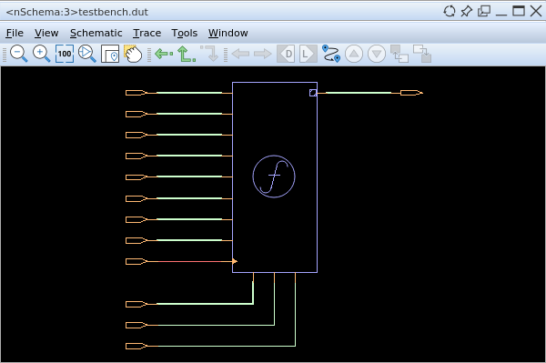

Code Implemented in green block is case (sel) in rtl code: -
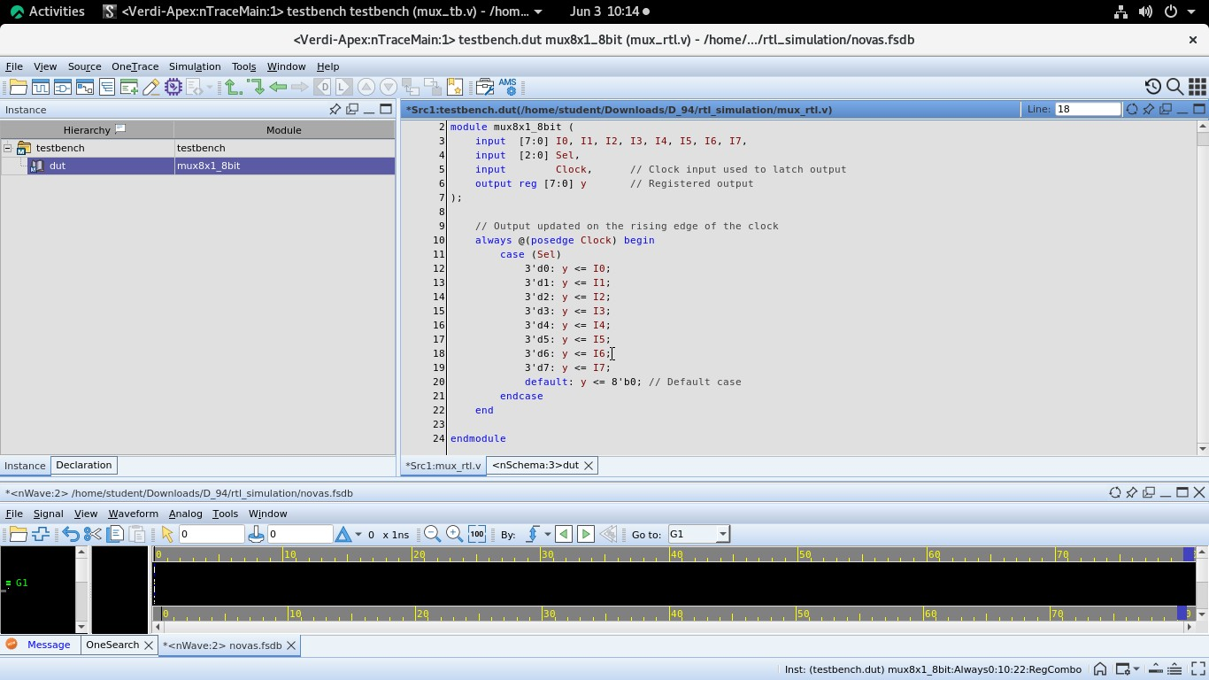

Common Setup File: - /common_setup.tcl
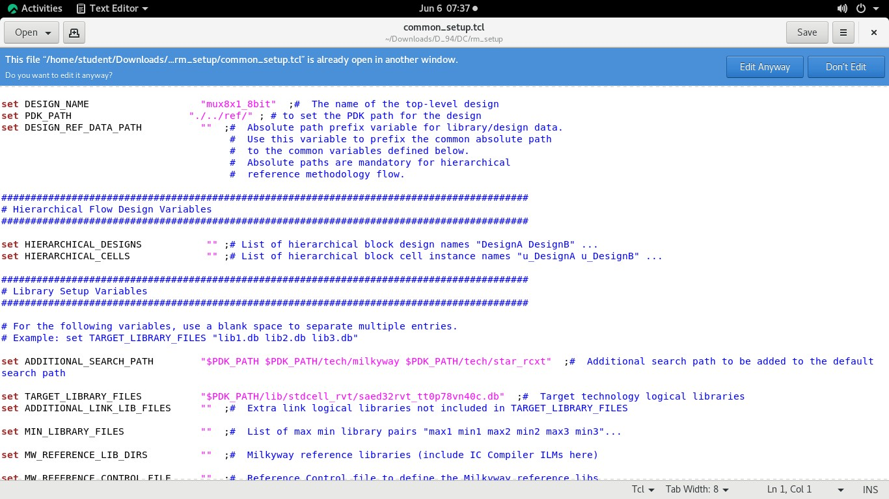
Library used: - “saed32rvt_tt0p78vn40c.db”
Design Mane: - “mux8x1_8bit”
Pdk_Path: - ./../ref/
Changes made in run_dc.tcl
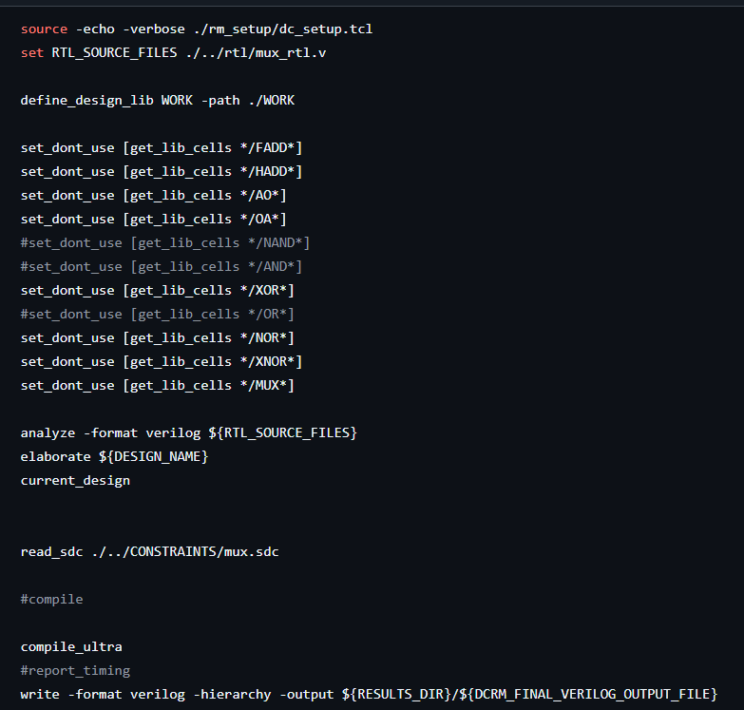
This is the main TCL script for synthesis.
Changes made in CONSTRAINT file for obtaining positive slack MET, don’t want negative slack as VILOATION.
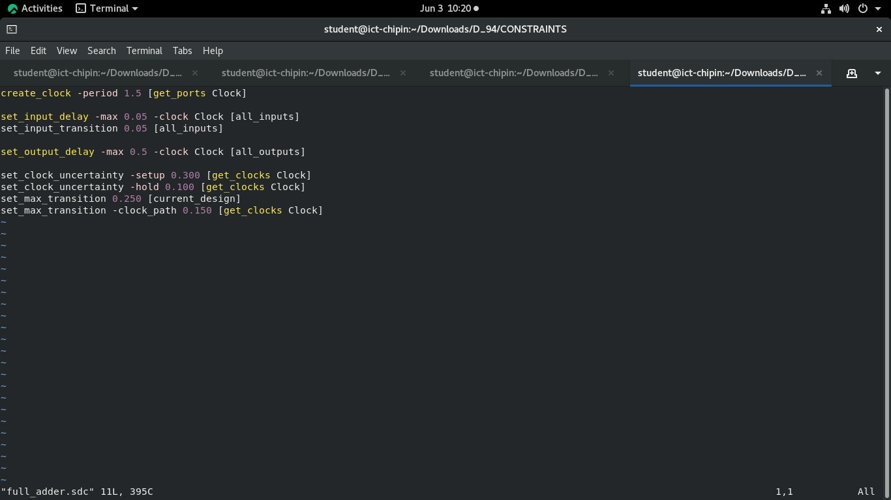
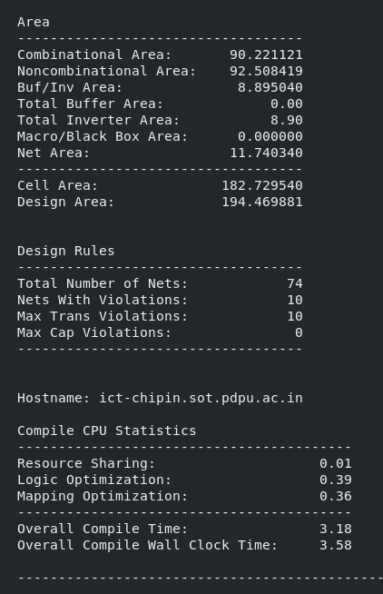
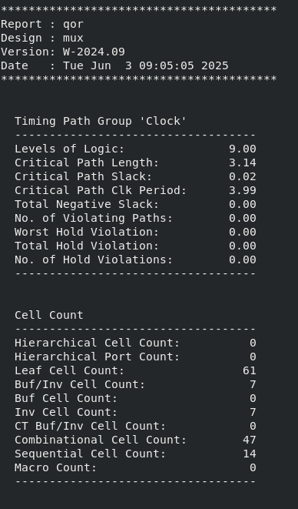
Timing report using command report_timing for slack time: -
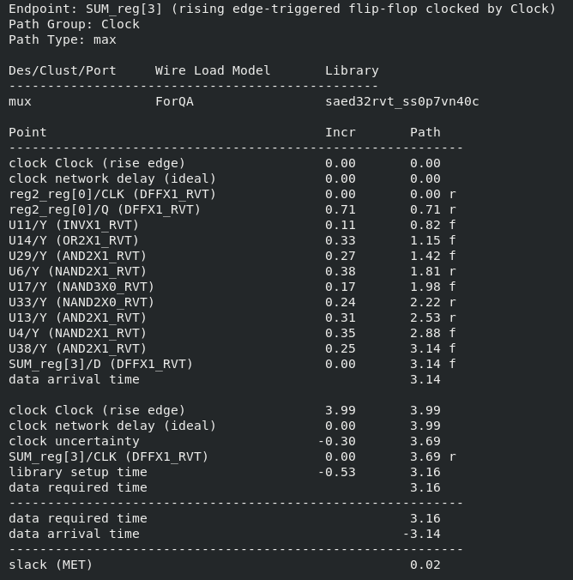

Going inside ICCII and using command as pt_shell to go inside <icc2_shell>
(ICCII = IC Compiler II)
Then applying command for physical design. Stages included: -
- Floorplan
- Power plan
- Placement
- Clock
- Route

1st Stage Floorplan:

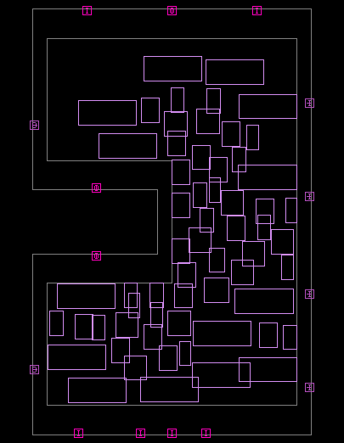

76 Ports seginfies its Flattened Bit-wise Ports: -
Flattening means breaking down each multi-bit port into its individual bits, where each bit becomes its own port.

input [7:0] D0; // Flattened becomes: input D0[0]; ...
input D0[7];
  - D0–D7 → 8 × 8 = *64 ports • sel (3 bits) → *3 ports
  - Y (8-bit output) → *8 ports
  - clk → 1 which makes total ports as 76.

- Other type of ports is Logical (Bus-wise) ports: -
A logical port represents a multi-bit signal as one unified entity, also called a bus.
- input [7:0] D0, D1, ..., D7; → 8 ports (each 8-bit wide)
- input [2:0] sel; → 1 port (3-bit wide)
- output [7:0] Y; → 1 port
- input clk; → 1 port

which makes total ports as 11.

Applying command “report_qor” to obtain Cell Count and Cell Area: - Cell Count: -

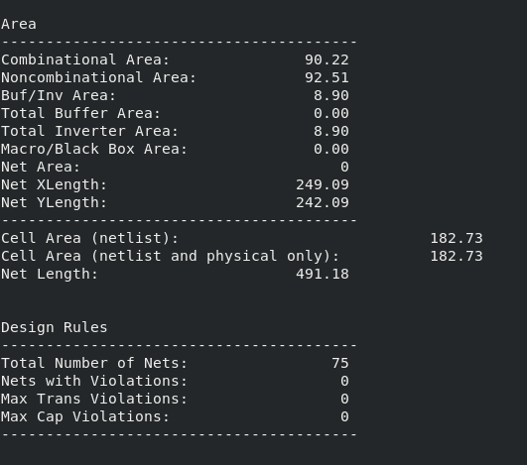
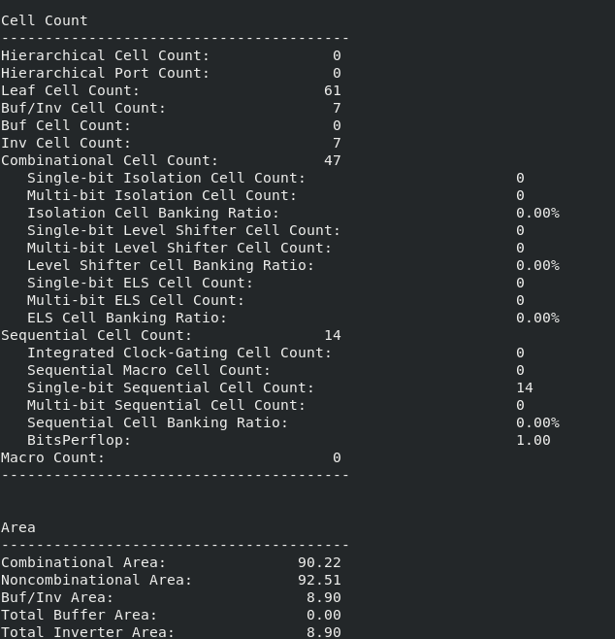

Applying command as “report_power” to obtain power: -
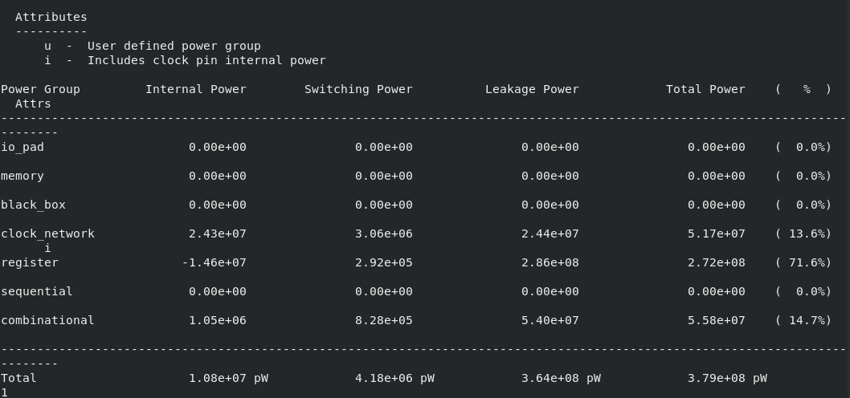

2nd Stage Power plan: -

POWER PLANNING CODE: -
######################################################################
### Step 1: to_create power/ground nets and to_connect power/ground nets: -
######################################################################

#to create power nets create_net -power {VDD} create_net -ground {VSS} ## to connect power/ground_nets connect_pg_net -all_blocks -automatic

###################################################################### step 2: to create power and ground ring patterns
###################################################################### #scenario1:
create_pg_ring_pattern core_ring_pattern -horizontal_layer M7 -horizontal_width .4 horizontal_spacing .3 -vertical_layer M8 -vertical_width .4 -vertical_spacing .3 set_pg_strategy core_power_ring -core -pattern {{name : core_ring_pattern}{nets : {VDD VSS}}{offset : {.5 .5}}} compile_pg -strategies core_power_ring

######################################################################
### step 3: to create pg mesh pattern
######################################################################

create_pg_mesh_pattern mesh -layers { {{vertical_layer: M6}{width: .34} {spacing: interleaving}{pitch: 5} {offset: .5}} {{horizontal_layer: M7}{width: .38} {spacing: interleaving} {pitch: 5} {offset: .5}} {{vertical_layer: M8}{width: .38} {spacing: interleaving}{pitch: 5} {offset: .5}}} set_pg_strategy core_mesh -pattern { {pattern:mesh} {nets: VDD VSS}} -core -extension {stop: innermost_ring}
#set_pg_strategy core_mesh -pattern { {pattern:mesh} {nets: VDD VSS}} -core -extension
{{{side: 1 2} {direction: L T} {stop: innermost_ring}}} compile_pg -strategies core_mesh

###################################################
step 4 : to create std cell power rail pattern
#######################################################

create_pg_std_cell_conn_pattern std_cell_rail -layers {M1} -rail_width 0.06 set_pg_strategy rail_strat -core -pattern {{name: std_cell_rail} {nets: VDD VSS} } compile_pg -strategies rail_strat
#compile_pg

########################################################## step 5 : To save block and Save lib
#############################################################

## "save_block" will save block as the deign name (full_adder.design) by default save_block
## "save_block -as <preferred name>" to save the block in user preferred name ##
## "save_lib" will save library as created already save_lib

Output of Power plan.
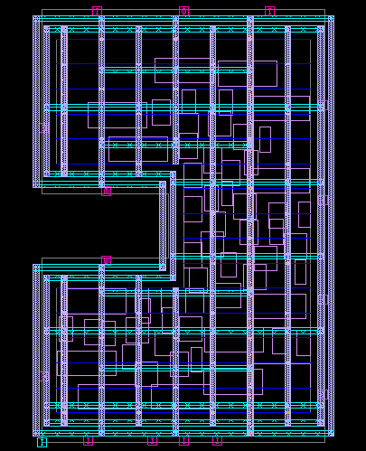

Power planning involves designing a robust power distribution network (PDN) to deliver:
• VDD (power) and VSS (ground)
Power Planning Flow in Physical design (PD).
- Analyse Floorplan:
  - Understand where macros, memories, and standard cells are placed.
- Create Power Rings:
  - Around the die core and/or around macros.
- Insert Power Straps:
  - Horizontally and vertically across the chip using multiple metal layers.
- Via Arrays & Connectivity:
  - Ensure all metal layers are well-connected for vertical power flow.
- Add Tap Cells & Decap Cells:
  - Inserted for substrate connection and power noise mitigation.
- IR Drop & EM Analysis (Post):
  - Tools simulate voltage drops and current density to ensure no part of the chip is underpowered or prone to reliability issues.

Output of report_qor for Cell Count and Cell Area: - Cell Count: -

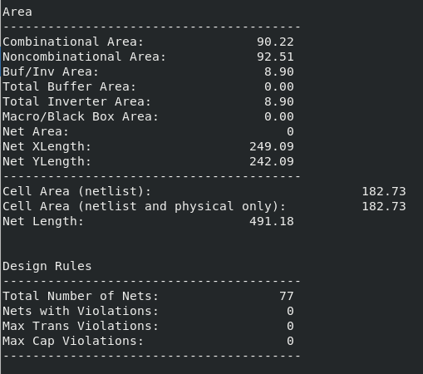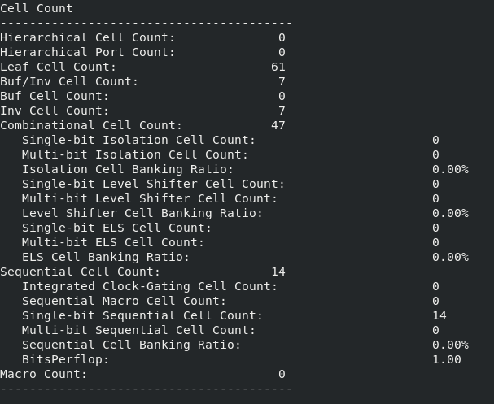

Code used for Placement: -
set mode1 "func" set corner1 "nom" set scenario1 "${mode1}::${corner1}" remove_modes -all; remove_corners -all; remove_scenarios -all

create_mode $mode1 create_corner $corner1 create_scenario -name func::nom -mode func -corner nom current_mode func current_scenario func::nom

source ./../CONSTRAINTS/full_adder.sdc

set_dont_use [get_lib_cells /FADD] set_dont_use [get_lib_cells /HADD] set_dont_use [get_lib_cells /AO] set_dont_use [get_lib_cells /OA] set_dont_use [get_lib_cells /NAND] set_dont_use [get_lib_cells /XOR] set_dont_use [get_lib_cells /NOR] set_dont_use [get_lib_cells /XNOR] set_dont_use [get_lib_cells /MUX]

current_corner nom
current_scenario func::nom

set parasitic1 "p1" set tluplus_file$parasitic1 "$PDK_PATH/tech/star_rcxt/saed32nm_1p9m_Cmax.tluplus" set layer_map_file$parasitic1
"$PDK_PATH/tech/star_rcxt/saed32nm_tf_itf_tluplus.map"

set parasitic2 "p2" set tluplus_file$parasitic2 "$PDK_PATH/tech/star_rcxt/saed32nm_1p9m_Cmin.tluplus" set layer_map_file$parasitic2
"$PDK_PATH/tech/star_rcxt/saed32nm_tf_itf_tluplus.map"

read_parasitic_tech -tlup $tluplus_filep1 -layermap $layer_map_filep1 -name p1 read_parasitic_tech -tlup $tluplus_filep2 -layermap $layer_map_filep2 -name p2

set_parasitic_parameters -late_spec $parasitic1 -early_spec $parasitic2 set_app_options -name place.coarse.continue_on_missing_scandef -value true

place_pins -self place_opt legalize_placement

save_block -as full_adder_placement save_lib

Output of Placement: -



Placement is the third major step in the physical design flow, after floorplanning and power planning. It determines the exact physical locations of all standard cells (logic gates, flip-flops, etc.) in the core area of the chip.

- Place all cells legally (no overlaps, within boundaries).
- Minimize total wirelength to reduce delay and routing congestion.
- Improve timing, power, and area.
- Ensure that cells can be routed successfully later.

4th Stage Clock: -

Code used for Clock: -

####################################################
#pre-clock sanity checks
#################################################### check_design -checks pre_clock_tree_stage

###################################################
CTS using CCD commands
####################################################
##stage 1:
synthesize_clock_tree ##stage 2:
set_app_options -name cts.optimize.enable_local_skew -value true set_app_options -name cts.compile.enable_local_skew -value true set_app_options -name cts.compile.enable_global_route -value false set_app_options -name clock_opt.flow.enable_ccd -value true clock_opt -to build_clock #stage 3: clock_opt -from route_clock -to route_clock clock_opt

########################################################### to report qor the respective CTS
############################################################ #report_clock_qor
#report_clock_qor -largest 2 -show_verbose_paths
#report_clock_qor -largest 2 -show_verbose_paths > cts_ccd.rpt

########################################################## to save the block
######################################################## save_block -as full_adder_cts_CCD save_lib

Output of Clock: -

In digital VLSI circuits, the clock is the heart of synchronization. It coordinates when data is launched and captured across sequential elements like flip-flops. In physical design, clock planning and distribution is a crucial part called: CTS

Clock Tree Synthesis (CTS)
CTS is the process of building a tree-like network to distribute the clock signal from the clock source (like a PLL or external pin) to all sequential elements.

5th stage is Route: - Code used for Route: -

#################################################### set app options
####################################################

#global route set_app_options -name route.global.timing_driven -value true set_app_options -name route.global.crosstalk_driven -value false

#track assignment set_app_options -name route.track.timing_driven -value true set_app_options -name route.track.crosstalk_driven -value true

#detail route set_app_options -name route.detail.timing_driven -value true set_app_options -name route.detail.save_after_iterations -value false set_app_options -name route.detail.force_max_number_iterations -value false set_app_options -name route.detail.antenna -value true set_app_options -name route.detail.antenna_fixing_preference -value use_diodes
set_app_options -name route.detail.diode_libcell_names -value */ANTENNA_RVT

####################################
#Atomic commands for route_auto
###################################

route_global
#save_block route_global_database

route_track
#save_block route_track_database

route_detail
#save_block route_detail_database

#route_auto route_opt

###################################### OUTPUTS
write_verilog ./results/mux.routed.v write_sdc -output ./results/mux.routed.sdc write_parasitics -format spef -output ./results/mux_${scenario1}.spef

<pt_shell> File1 = p1, named rum_pt_p1.tcl
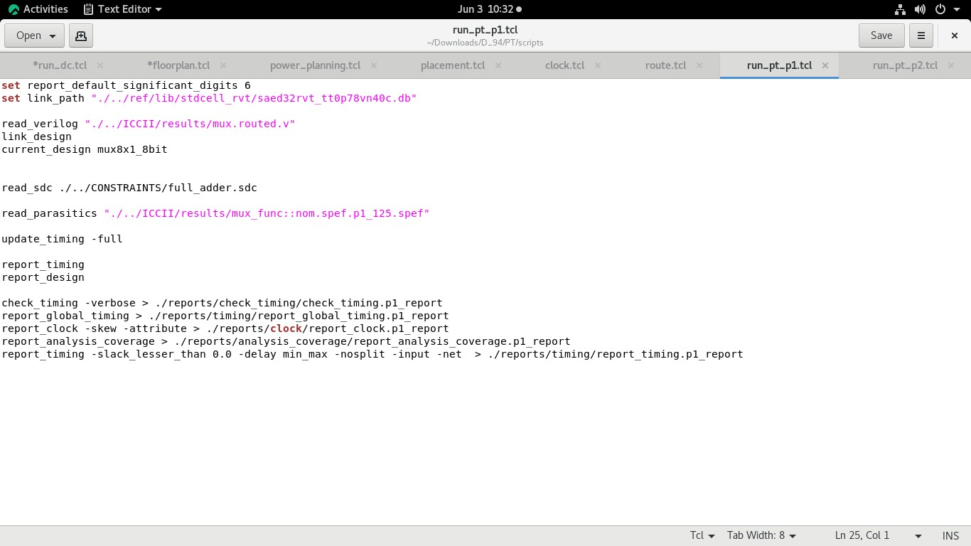

File2 = p2, named run_pt_p2.tcl
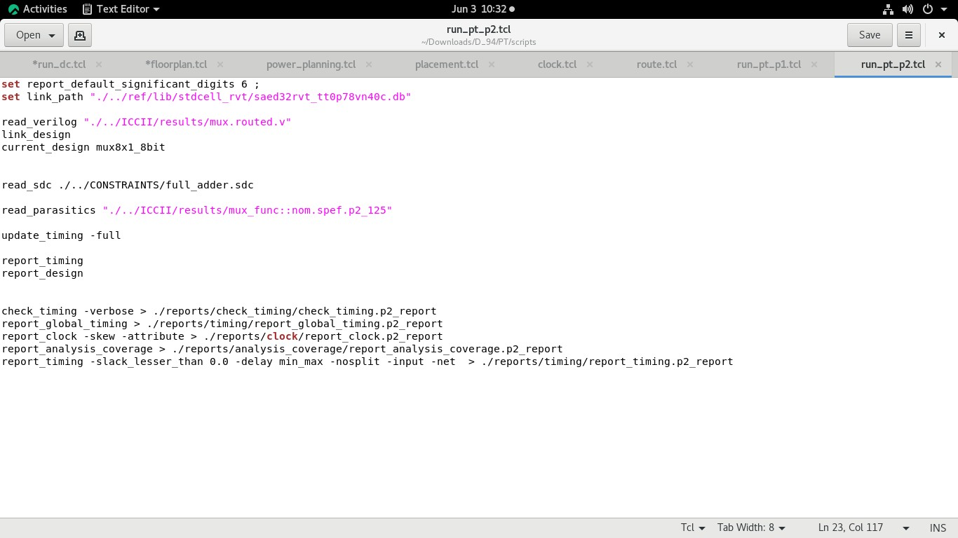
Includes path of which library is used and where mux.routed file situated insed ICCII.

Output after using command source run_pt_p1.tcl
Other Outputs of source run_pt_p1

Output after using command source run_pt_p2.tcl

Other outputs of source run_pt_p2: -
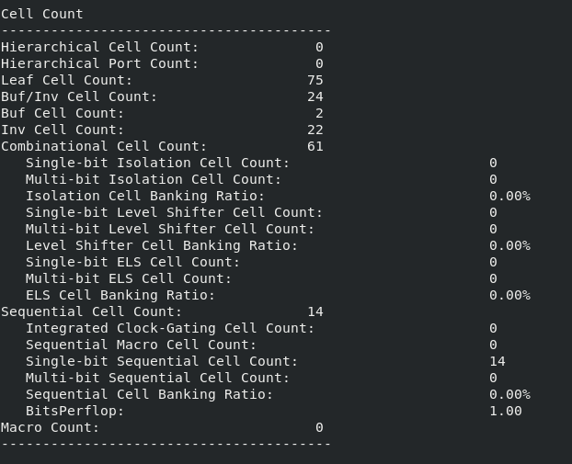
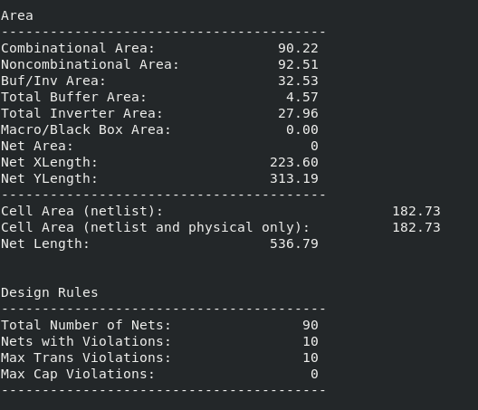
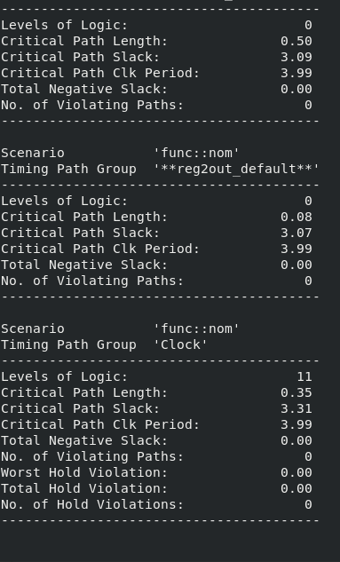

Internal schematic: -
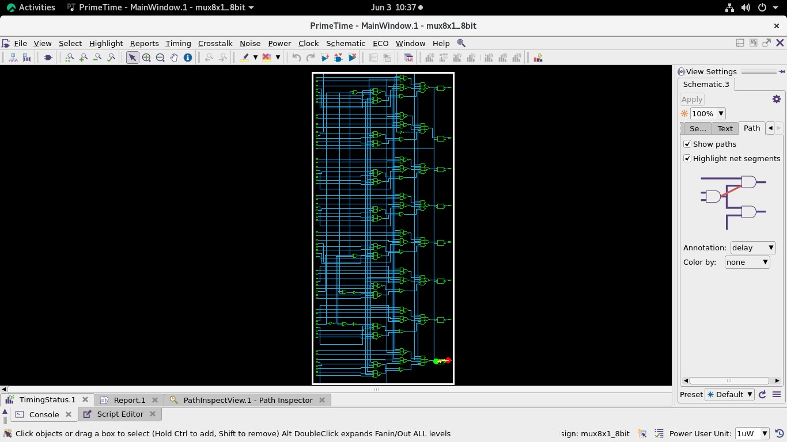
Using command “set paths [get_timing_paths -max_paths 1] gui_show_timing_path -paths $paths”

Slack: -

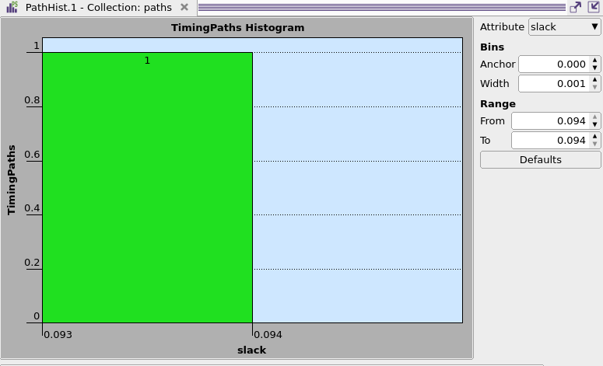

Learnings and Outcomes

Through this project, I gained practical exposure to the complete digital design flow—from RTL design to layout generation. Below are the key learnings and outcomes:

- Understanding of RTL Design:
  - Implemented an 8x1 Multiplexer using Verilog HDL.
  - Learned to describe hardware behavior at the register-transfer level.
- Hands-on Experience with Industry Tools:
  - Used Synopsys tools to synthesize, optimize, and implement the design.
  - Became familiar with the RTL-to-GDSII flow used in real-world VLSI projects.
- Exposure to Backend Design Stages:
  - Performed floorplanning, power planning, placement, clock tree synthesis, and routing. o Observed how logical design constraints affect physical implementation.
- Design Metrics Analysis:
  - Reported area, timing (positive slack), and power consumption from tool outputs. o Understood the importance of timing closure and power efficiency in chip design.
- Critical Thinking & Debugging:
  - Learned to interpret timing reports and resolve violations.
  - Applied optimization techniques to achieve a balance between performance, area, and power.
- GDS-II Generation:
  - Successfully generated the final GDS-II file, marking the completion of the physical design process. o Understood how the physical layout corresponds to the HDL description.

Conclusion:

This project not only strengthened my foundation in digital design and VLSI concepts but also gave me confidence in using professional EDA tools. It was a valuable step towards building the skills required for a future career in ASIC/VLSI design

