krishna
securify DAST testing
May 28, 2026

Table of Contents

Table of Contents 2
Scope 3
Application Details 3
User Roles 3
Tools 3
Assessment Limitation 4
Vulnerabilities 5
Summary 5
Detailed Vulnerabilities 6
True Positive 6
False Positive: Open Redirection on Logout Endpoint 6
Time-Based Blind SQL Injection in Query Parameter 8
Exposed Google API Key for Geocoding API 11
False Positive 13
Open Redirection 13

Scope
The assessment was conducted between May 28, 2026, and May 30, 2026. Testing was performed remotely.
The scope of the assessment was limited to the environments and targets below:

Application Details
Name | URL
abwkjfhahflk | fkjakfnaklf

User Roles
Role | Username
fjakjfkjaf | fkjanjkfnal

Tools
Tool Name | Description
Burp Professional Pro | An advanced proxy for testing web security.
OpenSSL | An open-source package to assess security in transit.
Nmap | A tool used to discover hosts and services on a network.
SQLMap | Python-based CLI tool that identifies SQL injection issues.
Acunetix Pro | An automated scanner to perform authenticated scans on web app / APIs.
cURL Utility | Command line utility to perform HTTP/s requests.

The following components and tests were out of scope for this review:
- Any applications and infrastructure were external to the krishna Web Application.
- In cases where the krishna Web Application had inbound and/or outbound interfaces with another application, the interfaces and communications were considered in scope. All other external elements were excluded.
- Supporting policies, procedures, and processes.
- Social engineering.
- Software development life cycle.

Assessment Limitation
The ever-changing technology landscape and the increasing sophistication of attacks against networked systems are reasons why no entity can truthfully claim to identify all security issues or guarantee the lifetime security of an organization’s network and applications. Note that this point-in-time assessment was based on a best-effort basis. It was also performed only in the environment provided by krishna. Thus, changes to the environment may impact the applicability of the results provided herein.
Securify cannot guarantee 100% coverage for any security assessment.

Vulnerabilities

Summary
Below is a summary of the vulnerabilities discovered during the assessment, ranked in order of risk as determined:
Vulnerability | Status | Risk
Time-Based Blind SQL Injection in Query Parameter | True-Positive | High
Exposed Google API Key for Geocoding API | True-Positive | Medium
False Positive: Open Redirection on Logout Endpoint | True-Positive | Informational
Open Redirection | False-Positive

Detailed Vulnerabilities

True Positive

False Positive: Open Redirection on Logout Endpoint
Risk: Informational
Description:
The automated scanner identified a potential Open Redirection vulnerability on the logout endpoint, specifically noting that the 'next' parameter could potentially be used to redirect users to an external domain after logout. Manual validation was performed to assess this finding. During testing, it was confirmed that the logout functionality does not redirect the user to the external URL supplied via the 'next' parameter. Therefore, despite the scanner's detection of a potentially risky parameter, the observed behavior does not constitute a valid Open Redirection vulnerability. This finding is classified as a False Positive.
Affected URL:
• https://app-staging.silentpush.com/api/auth/logout/
Impact & Likelihood:
Steps to Reproduce:
Payload :
http://app-staging.krishna.com/api/v2/filters/tag/name/?format=json&query=-1'%20OR%203*2*1=6%20AND%20000709=000709%20--%20

Step 1: Send a request to the affected endpoint and observe the baseline response time:
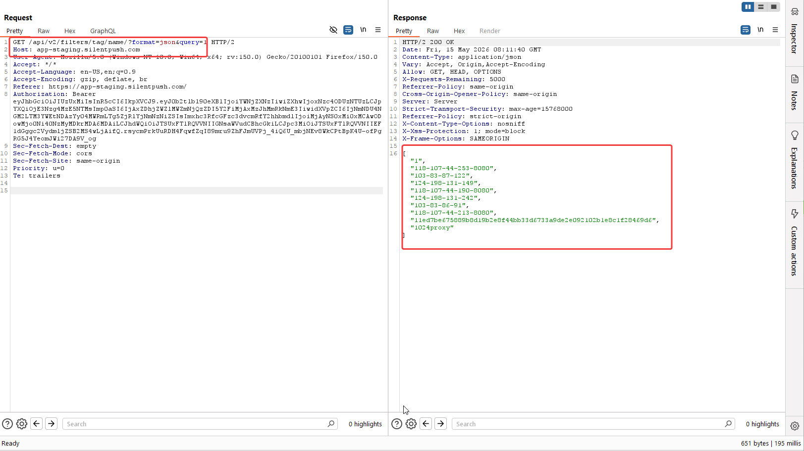
Fig: Sending the original request without any SQLi payload returns the response with the same matching tag name.
Step 2: Send the following SQL injection payload -1'%20OR%203*2*1=6%20AND%20000709=000709%20--%20 in the query parameter and observe that the server response has no error and list down all the tag names.
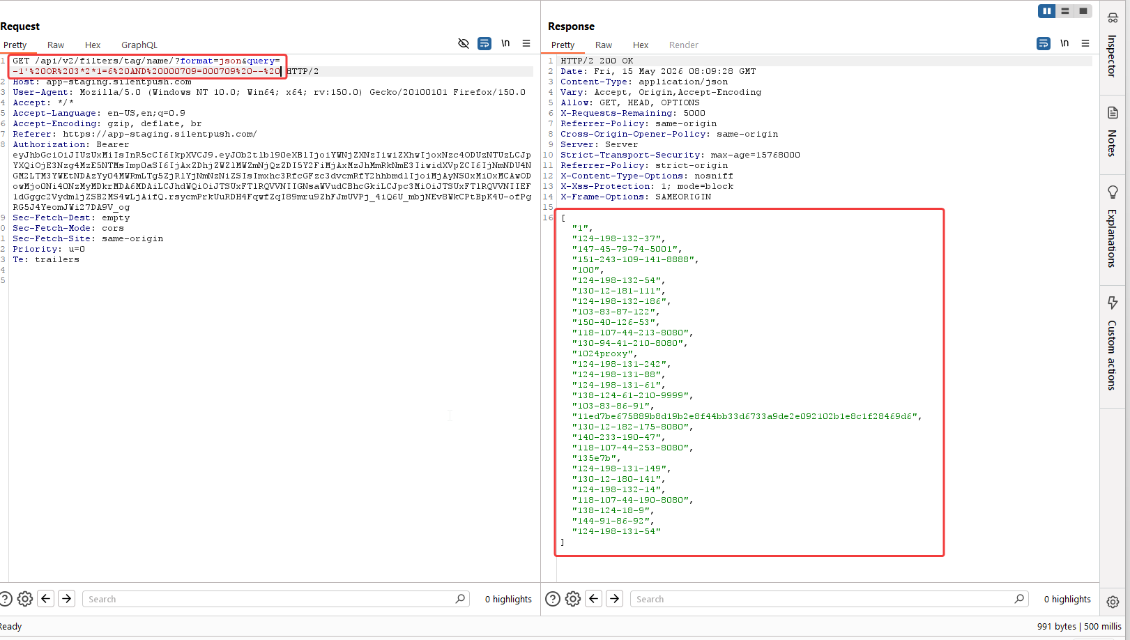
Fig: With the payload, the SQL query has been broken and balanced out, resulting in showing all the tag names.

Step 3: Running SQLmap against that request.
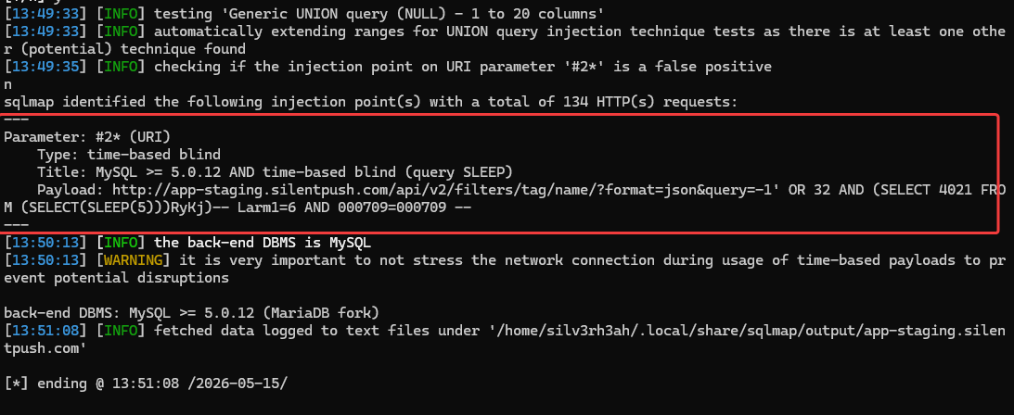
Fig: SQLMap is successfully able to identify the query parameter as vulnerable and can confirm the database type
Recommendations:
- Use parameterized queries / prepared statements for all database interactions.
- Avoid dynamically concatenating user input into SQL queries.
- Apply strict server-side input validation for the query parameter.
- Use allowlisting where possible, especially if the parameter is expected to contain only specific tag names or search strings.
- Escape user input using database-safe escaping functions only as a secondary defense, not as the primary control.
- Ensure the database user used by the application has least-privilege permissions.
- Disable verbose database error messages in API responses.
- Add monitoring and rate-limiting for repeated abnormal query patterns.
- Perform a full review of similar API endpoints that accept search, filter, tag, name, or query parameters.
References:
Back to Summary

Time-Based Blind SQL Injection in Query Parameter
Risk: High
Description:
A time-based blind SQL injection vulnerability was identified in the 'query' parameter of the API endpoint http://app-staging.silentpush.com/api/v2/filters/tag/name/. The application appears to directly incorporate user-supplied input from this parameter into a backend SQL query without adequate sanitization, validation, or the use of parameterized queries. This allows an attacker to inject arbitrary SQL commands, which are then executed by the database. The vulnerability was confirmed by injecting a MySQL time-delay payload (e.g., SLEEP(5)), which caused a noticeable delay in the application's response, indicating successful execution of the injected SQL.
Affected URL:
• http://app-staging.silentpush.com/api/v2/filters/tag/name/?format=json&query=
Impact & Likelihood:
• Impact:High – The impact of a successful time-based blind SQL injection is high. Although direct error messages or query results are not returned, an attacker can systematically extract sensitive information from the database, including user credentials, proprietary data, and other confidential records, by inferring data based on response times. Furthermore, depending on the database configuration and privileges, an attacker might be able to modify or delete data, escalate privileges, or even achieve remote code execution on the underlying server, leading to a complete compromise of the application and potentially the entire system.
• Likelihood:High – The likelihood of exploitation is high because the vulnerability is directly accessible via a user-controlled HTTP GET parameter. An attacker can easily craft malicious requests to inject SQL payloads, as demonstrated by the successful time-based injection. No complex authentication or authorization bypasses are required to trigger the vulnerability, making it straightforward to exploit.
Steps to Reproduce:
Step 1: Access the vulnerable API endpoint: http://app-staging.silentpush.com/api/v2/filters/tag/name/?format=json&query=
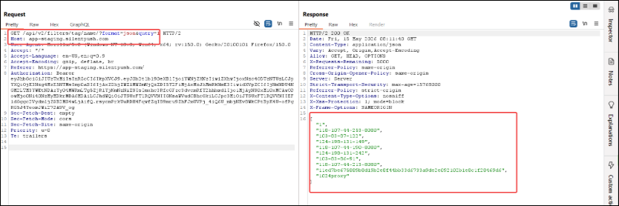
Fig: Sending the original request without any SQLi payload returns the response with the same matching tag name.
Step 2: Append a time-based SQL injection payload to the 'query' parameter. For example, use the following URL to inject a MySQL SLEEP function: http://app-staging.silentpush.com/api/v2/filters/tag/name/?format=json&query=%27%20AND%20SLEEP(5)--%20
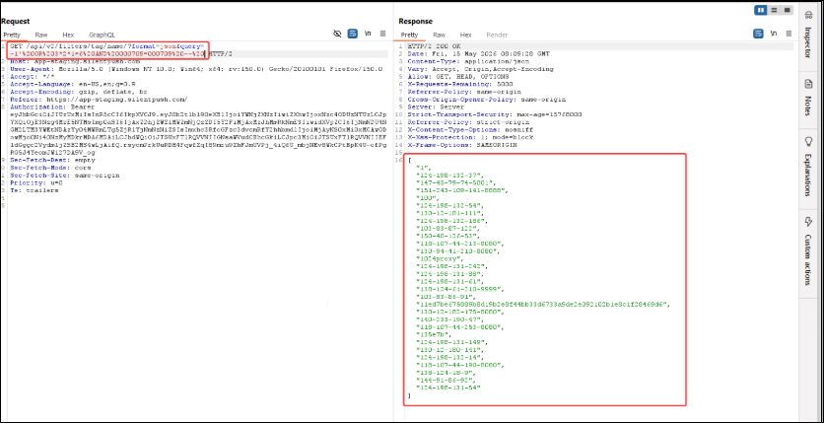
Fig: With the payload, the SQL query has been broken and balanced out, resulting in showing all the tag names.
Step 3: Observe the HTTP response time. A noticeable delay (e.g., approximately 5 seconds) in the server's response confirms the successful execution of the injected SQL payload, indicating a time-based blind SQL injection vulnerability.
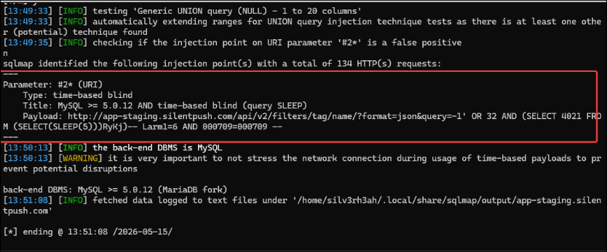
Fig: SQLMap is successfully able to identify the query parameter as vulnerable and can confirm the database type
Recommendations:
- Input Validation and Sanitization: Implement strict input validation on all user-supplied data, especially for parameters used in database queries. Sanitize input to remove or neutralize potentially malicious characters.
- Parameterized Queries/Prepared Statements: Utilize parameterized queries or prepared statements for all database interactions. This ensures that user input is treated as data and not as executable code, effectively preventing SQL injection attacks.
- Least Privilege: Configure database users with the principle of least privilege. Database accounts used by the application should only have the minimum necessary permissions to perform their required functions, limiting the potential damage from a successful SQL injection.
- Web Application Firewall (WAF): Deploy and properly configure a Web Application Firewall (WAF) to detect and block common SQL injection attack patterns. While not a primary defense, a WAF can provide an additional layer of security.
- Error Handling: Implement generic error messages and avoid returning verbose database errors to the client, as these can provide valuable information to an attacker.
References:
• https://owasp.org/www-project-top-ten/2021/A03_2021-Injection
• https://cwe.mitre.org/data/definitions/89.html
• https://portswigger.net/web-security/sql-injection/blind
Back to Summary

Exposed Google API Key for Geocoding API
Risk: Medium
Description:
An exposed Google API key was identified and validated as active for the Google Maps Geocoding API. While some restrictions were noted for other Google APIs (e.g., YouTube Data API, Google Custom Search API), the key remains publicly accessible and functional for Geocoding requests. This exposure allows unauthorized parties to utilize the key.
Affected URL:
• https://app-staging.silentpush.com/login
Impact & Likelihood:
• Impact:Medium – Unauthorized use of the exposed API key for the Geocoding API could lead to several negative consequences. These include the consumption of the project's API quota, resulting in increased billing costs for the organization. Furthermore, malicious or excessive requests could exhaust the allocated quota, potentially causing service disruption for legitimate users relying on the Geocoding functionality.
• Likelihood:High – The Google API key is publicly exposed and was successfully validated against the Google Maps Geocoding API. An attacker can easily discover and reuse this key to make unauthorized requests, making the likelihood of exploitation high.
Steps to Reproduce:
Step 1: Identify the exposed Google API key within the application's client-side code or configuration.
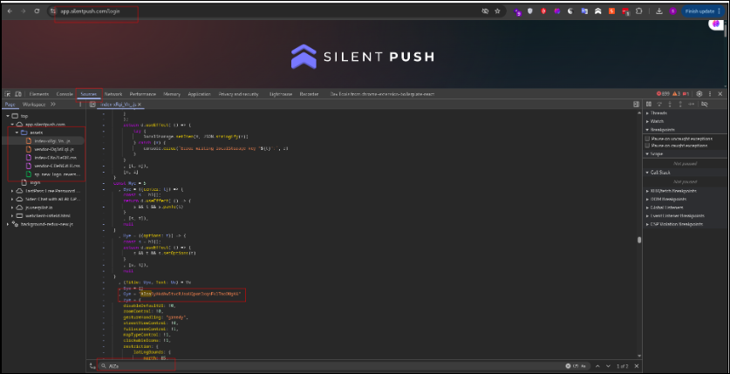
Fig: Google API key exposed in JavaScript file
Step 2: Use the identified API key to send a request to the Google Maps Geocoding API (e.g., 'https://maps.googleapis.com/maps/api/geocode/json?address=1600+Amphitheatre+Parkway,+Mountain+View,+CA&key=YOUR_EXPOSED_API_KEY').
Step 3: Observe a successful response, confirming the key's validity and functionality for the Geocoding API.
Recommendations:
- API Key Management: Immediately revoke the exposed API key and generate a new one. Ensure all API keys are stored securely and are not exposed in client-side code, public repositories, or insecure configurations.
- API Key Restrictions: Implement strict API key restrictions, including HTTP referer restrictions (if applicable), IP address restrictions, and explicit API service restrictions, to limit the key's functionality only to the necessary services and origins.
- Quota Monitoring: Implement robust monitoring and alerting for API key usage and billing to detect and respond to unusual activity promptly.
- Service Account Usage: Consider using service accounts with appropriate IAM roles instead of API keys for server-to-server interactions where possible, as service accounts offer more granular control and are less prone to accidental exposure.
References:
• https://cloud.google.com/docs/authentication/api-keys
• https://owasp.org/www-project-top-ten/2021/A05_2021-Security_Misconfiguration
Back to Summary

False Positive

Open Redirection
Description:
The automated scanner identified a potential Open Redirection vulnerability on the `https://app-staging.silentpush.com/api/auth/logout/` endpoint. The scanner reported that user-controlled input supplied through the `next` parameter could potentially lead to redirection to arbitrary external domains. Manual validation was performed to assess this finding. During validation, it was confirmed that the application either sanitizes the `next` parameter input, enforces a whitelist of allowed redirection targets, or restricts redirections to internal application paths only. As a result, the application does not permit redirection to arbitrary external URLs, preventing the exploitation of an Open Redirection vulnerability. This finding is therefore classified as a False Positive.
Affected URL:
• https://app-staging.silentpush.com/api/auth/logout/
Evidence:
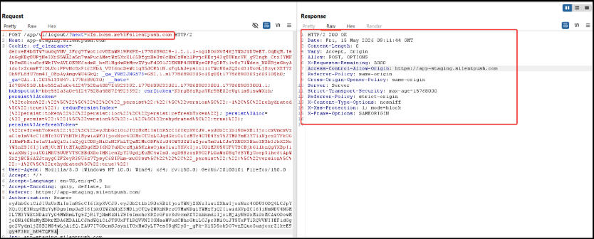
Fig: Logout functionality, with the next parameter is not redirecting to the unintended URL
Back to Summary

