SilentPush
Dynamic Analysis Security Test Report
May 22, 2026

Table of Contents

Table of Contents 2
Scope 3
Application Details 3
User Roles 3
Tools 3
Assessment Limitation 4
Vulnerabilities 5
Summary 5
Detailed Vulnerabilities 6
SQL Injection – Time-Based Blind 6
Exposed Google API Key with Active Geocoding API Access 9
Outdated JavaScript Library – Bootstrap 3.4.1 12
Misconfigured Content Security Policy 14
False Positive 18
Open Redirection 18
Cookie Not Marked as HttpOnly 19

Scope
The assessment was conducted between May 14, 2026, and May 15, 2026. Testing was performed remotely.
The scope of the assessment was limited to the environments and targets below:

Application Details
Name | URL
Staging Application | https://app-staging.silentpush.com/
Production Application | https://app.silentpush.com/login

User Roles
Role | Username
Admin user | bshah@silentpush.com

Tools
Tool Name | Description
Burp Professional | Burp Suite Professional is an advanced proxy for testing web security.
Jsmon | Advanced Javascript Security and Monitoring tool
Nuceli | A CLI based automated vulnerability scanner
Gau | A CLI based tool to collect all archived URLs
Katana | A golang based tool to crawl into application and collect all URLs
Nessus Professional | Nessus is a vulnerability scanner that identifies weaknesses in IT infrastructure by scanning networks, servers, and applications for known vulnerabilities and misconfigurations.
Retire.js | Retire.js is a security tool that scans for and identifies outdated and vulnerable JavaScript libraries in web applications.

The following components and tests were out of scope for this review:
- Any applications and infrastructure were external to the Silentpush Web Application.
- In cases where the Silentpush Web Application had inbound and/or outbound interfaces with another application, the interfaces and communications were considered in scope. All other external elements were excluded.
- Supporting policies, procedures, and processes.
- Social engineering.
- Software development life cycle.

Assessment Limitation
The ever-changing technology landscape and the increasing sophistication of attacks against networked systems are reasons why no entity can truthfully claim to identify all security issues or guarantee the lifetime security of an organization’s network and applications. Note that this point-in-time assessment was based on a best-effort basis. It was also performed only in the environment provided by Silentpush. Thus, changes to the environment may impact the applicability of the results provided herein.
Securify cannot guarantee 100% coverage for any security assessment.

Vulnerabilities

Summary
Below is a summary of the vulnerabilities discovered during the assessment, ranked in order of risk as determined:
Vulnerability | Status | Risk
SQL Injection – Time-Based Blind | True-Positive | Critical
Exposed Google API Key with Active Geocoding API Access | True-Positive | Low
Outdated JavaScript Library – Bootstrap 3.4.1 | True-Positive | Low
Misconfigured Content Security Policy | True-Positive | Low
Open Redirection | False - Positive
Cookie Not Marked as HttpOnly | False - Positive

Detailed Vulnerabilities

True Positive

SQL Injection – Time-Based Blind
Risk: Critical
Description:
A time-based blind SQL injection vulnerability was identified in the query parameter of the following API endpoint:
http://app-staging.silentpush.com/api/v2/filters/tag/name/?format=json&query=
The application appears to pass user-supplied input from the query parameter directly into a backend SQL query without proper sanitization, validation, or parameterization. The vulnerability was confirmed using a MySQL time-delay payload that caused the database to execute the SLEEP(5) function, resulting in a delayed application response.
This confirms that an attacker can inject SQL logic into the backend query even when the application does not directly return database errors or query results.
Affected URL:
- http://app-staging.silentpush.com/api/v2/filters/tag/name/?format=json&query=
Impact & Likelihood:
- Impact: High – Successful exploitation may allow an attacker to:
- Extract sensitive database information using blind SQL injection techniques.
- Enumerate database names, table names, column names, and application data.
- Bypass application-level filtering logic.
- Access sensitive user, customer, API, or business-related records.
- Potentially escalate to further database compromise depending on database privileges.
- Likelihood: High – The issue is exploitable remotely through an exposed API endpoint. Since the vulnerability is blind and time-based, exploitation may require automated tooling and multiple requests, but it remains practical for an attacker with network access to the staging application.
Steps to Reproduce:
Payload :
http://app-staging.silentpush.com/api/v2/filters/tag/name/?format=json&query=-1'%20OR%203*2*1=6%20AND%20000709=000709%20--%20

Step 1: Send a request to the affected endpoint and observe the baseline response time:
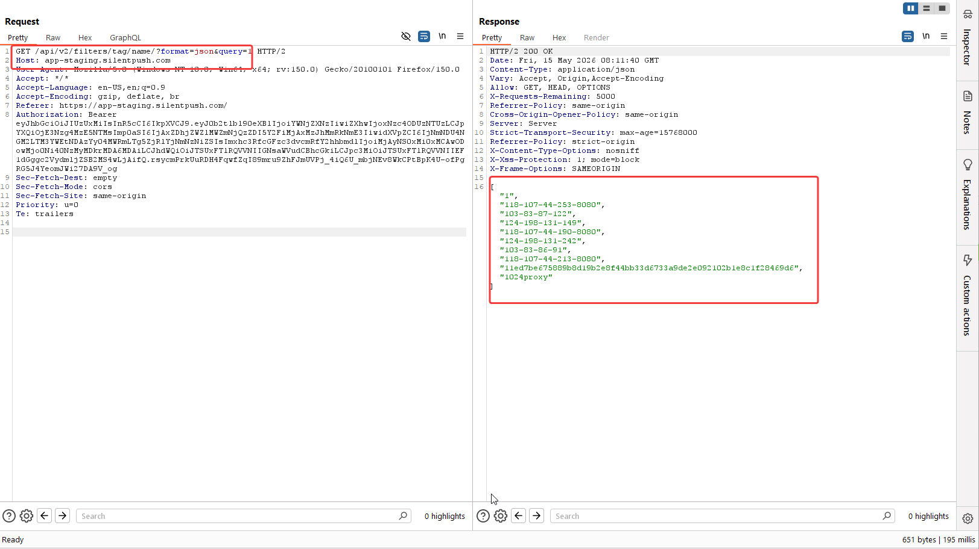
Fig: Sending the original request without any SQLi payload returns the response with the same matching tag name.
Step 2: Send the following SQL injection payload -1'%20OR%203*2*1=6%20AND%20000709=000709%20--%20 in the query parameter and observe that the server response has no error and list down all the tag names.
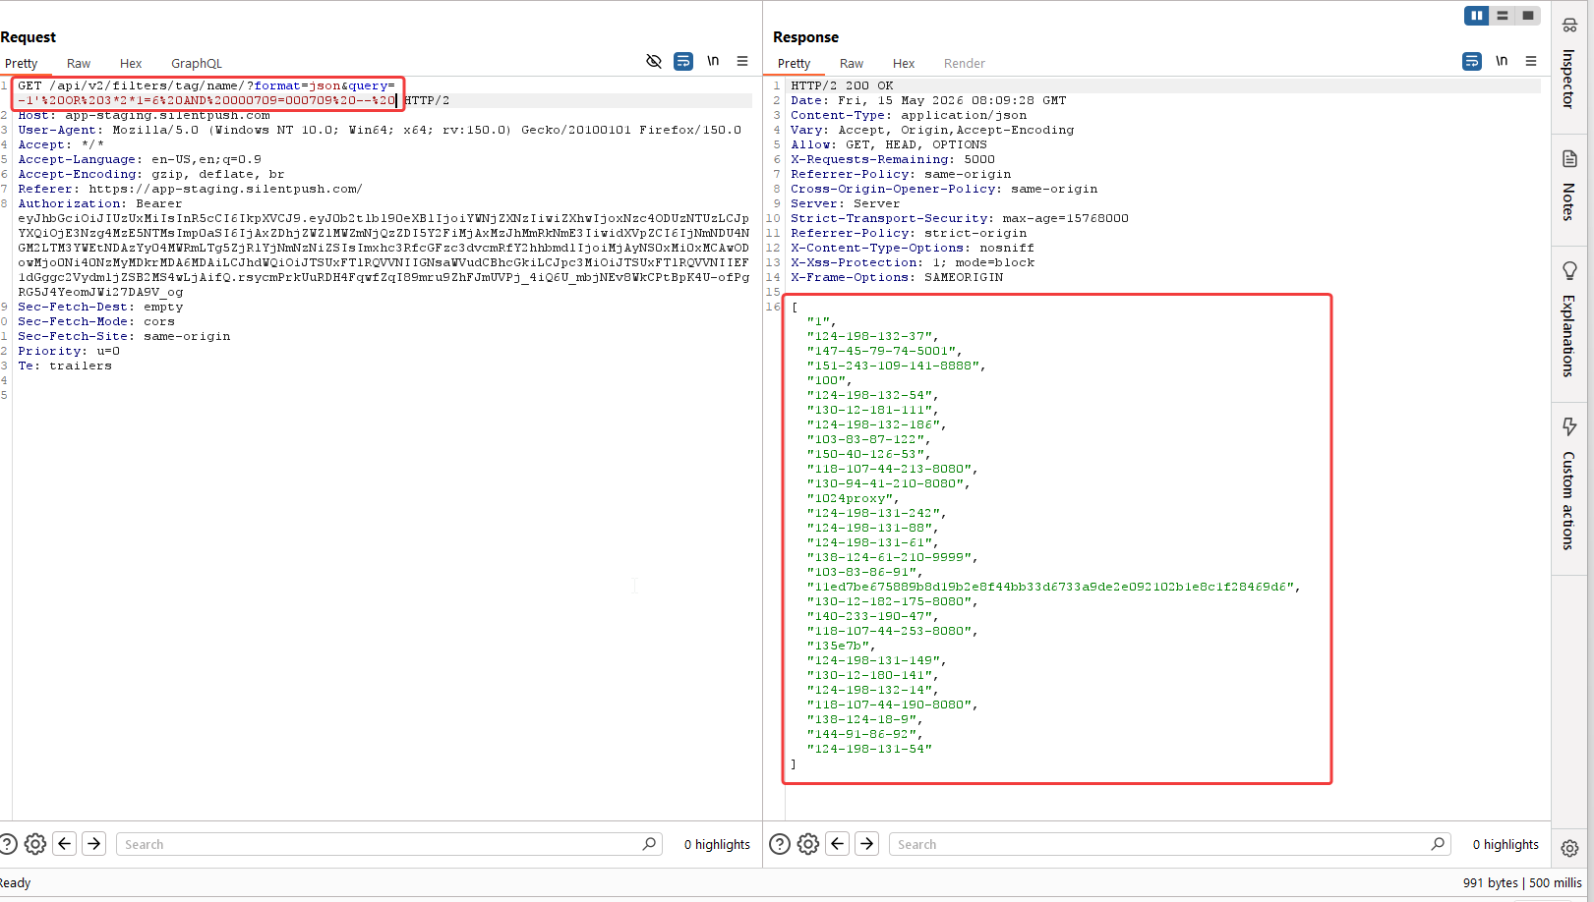
Fig: With the payload, the SQL query has been broken and balanced out, resulting in showing all the tag names.

Step 3: Running SQLmap against that request.
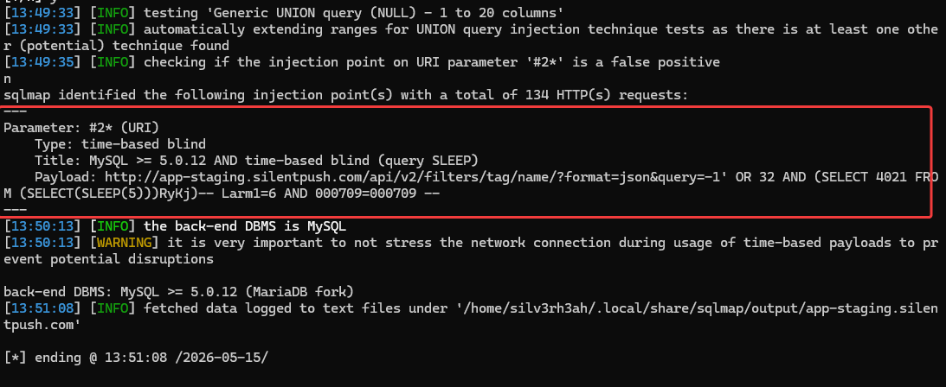
Fig: SQLMap is successfully able to identify the query parameter as vulnerable and can confirm the database type
Recommendations:
- Use parameterized queries / prepared statements for all database interactions.
- Avoid dynamically concatenating user input into SQL queries.
- Apply strict server-side input validation for the query parameter.
- Use allowlisting where possible, especially if the parameter is expected to contain only specific tag names or search strings.
- Escape user input using database-safe escaping functions only as a secondary defense, not as the primary control.
- Ensure the database user used by the application has least-privilege permissions.
- Disable verbose database error messages in API responses.
- Add monitoring and rate-limiting for repeated abnormal query patterns.
- Perform a full review of similar API endpoints that accept search, filter, tag, name, or query parameters.
References:
- https://owasp.org/www-community/attacks/SQL_Injection
- https://owasp.org/www-project-web-security-testing-guide/
- https://portswigger.net/web-security/sql-injection#how-to-prevent-sql-injection
- https://cwe.mitre.org/data/definitions/89.html

Back to Summary

Exposed Google API Key with Active Geocoding API Access
Risk: Low
Description:
An exposed Google API key was identified and validated against multiple Google APIs. The key was found to be active and successfully allowed requests to the Google Maps Geocoding API.
Testing also showed that access to other APIs, such as the YouTube Data API and Google Custom Search API, was blocked. This indicates that some API restrictions are configured; however, the key remains usable for the Geocoding API.
Since the API key is exposed, an attacker could reuse it to make unauthorized Geocoding API requests, potentially consuming project quota, increasing billing costs, or causing service disruption through quota exhaustion.
Affected URL:
- https://app-staging.silentpush.com/login
- https://app.silentpush.com/login
Impact and Likelihood:
- Impact: Low – An attacker could abuse the exposed API key to perform unauthorized requests to the enabled Google Maps Geocoding API. This may result in unexpected billing charges, quota exhaustion, rate-limit issues, or disruption of legitimate application functionality that depends on the same key.
- Likelihood: Low – The likelihood is low because the exposed Google API key has partial API restrictions configured. However, unauthorized users can still abuse the Geocoding API, potentially leading to quota exhaustion and increased billing costs.
Steps to Reproduce:
Step 1: Navigate to the application login page and open the browser Developer Tools using the inspection option.
Step 2 : Go to the “Sources” tab, expand the “Assets” section, and identify the loaded JavaScript (`.js`) files..
Step 3 : Open the JavaScript files and search for the keyword starting with `"AIza"` to identify potential Google API keys.
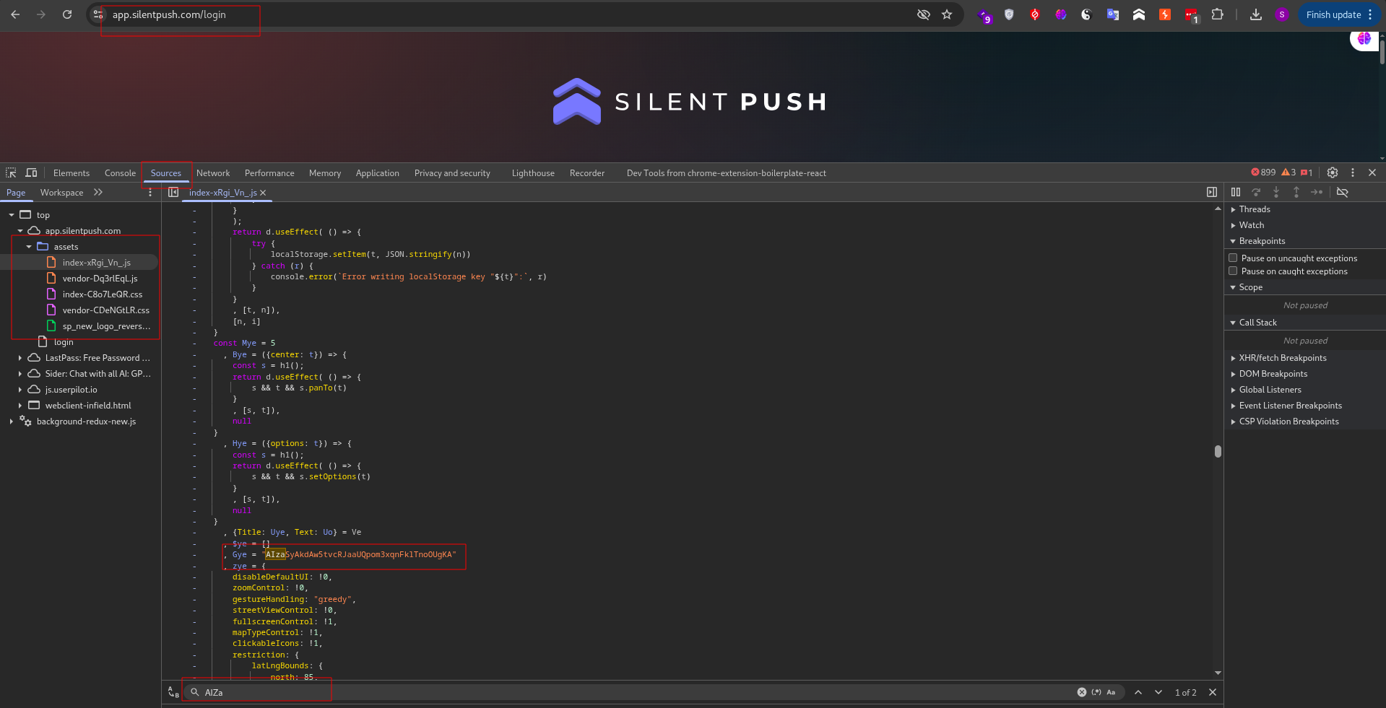
Fig: Google API key exposed in JavaScript file
Step 4 : Observe that a valid Google API key is disclosed within the JavaScript files. Upon validation, the identified keys were confirmed to be active Google API keys.
Step 5 : Using a custom Python script, test the permissions associated with the exposed API key against Google Maps services and observe that the key has overly permissive access to Google Maps APIs.
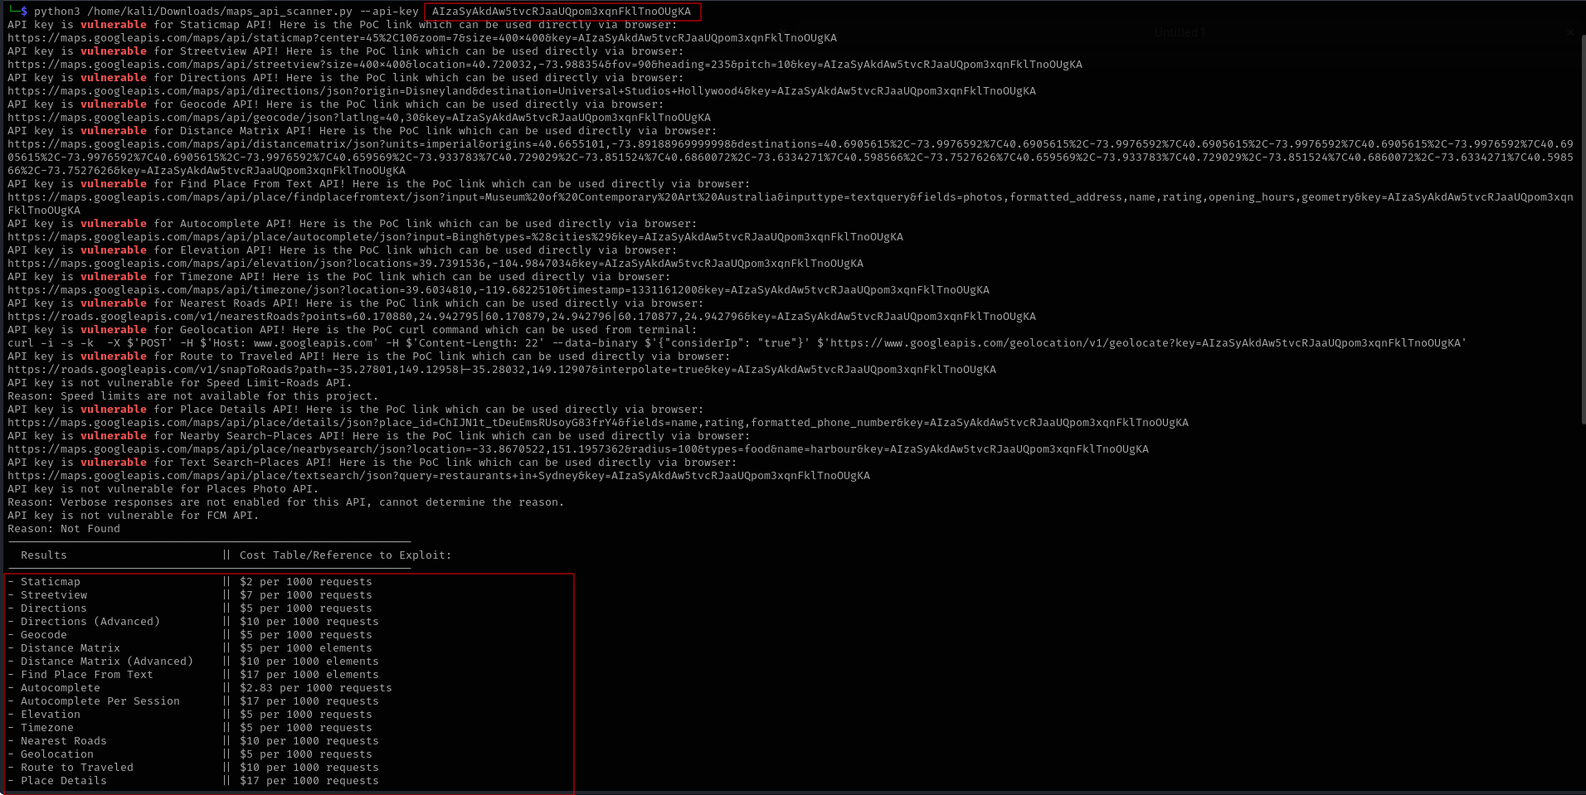
Fig: The response confirms that the API key is active and allowed to access the Google Maps APIs
Additional APIs, such as Gemini API and Google Fonts API, were also tested using the exposed API key; however, the requests returned a 403 Forbidden response. This confirms that certain API restrictions are configured, but the key remains valid and usable for Google Maps API services.
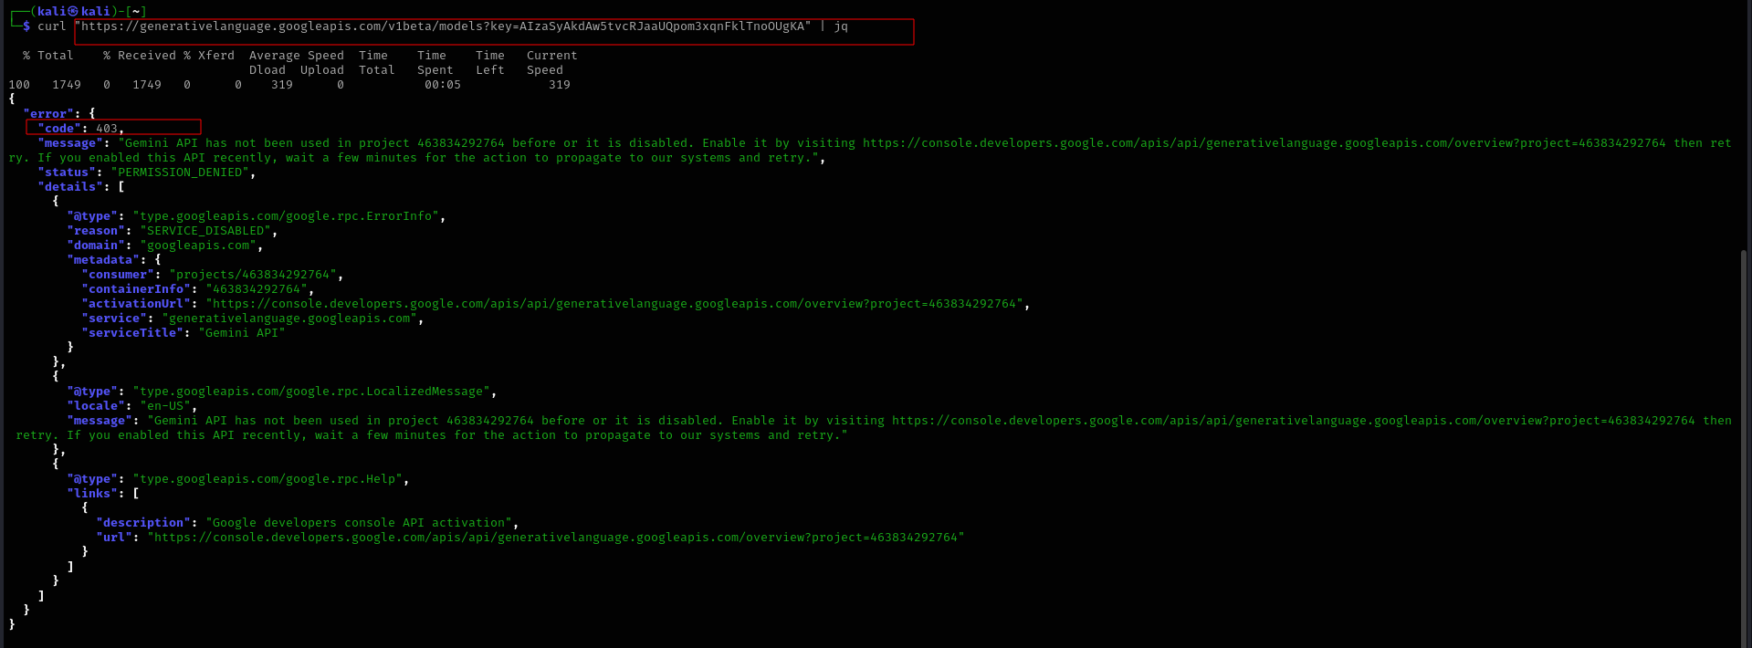
Fig: The response confirms that the exposed API key is active, while access to certain other tested APIs is restricted with 403 Forbidden responses
Recommendations:
- Restrict the key to only the required APIs, such as Geocoding API.
- Apply application restrictions based on usage:
- IP address restrictions for backend/server-side usage.
- HTTP referrer restrictions for web applications.
- Delete or disable the exposed key after replacement.
- Review Google Cloud billing and API usage logs for any abnormal usage.
- Avoid storing API keys in public repositories, frontend source code, logs, or client-accessible files unless properly restricted.
- Implement monitoring and alerting for unusual API usage or quota spikes.
References:
- https://cloud.google.com/docs/authentication/api-keys
- https://cloud.google.com/docs/authentication/api-keys-best-practices
- https://developers.google.com/maps/documentation/geocoding/overview

Back to Summary

Outdated JavaScript Library – Bootstrap 3.4.1
Risk: Low
Description:
An outdated JavaScript library was identified on the staging application. The application is using Bootstrap v3.4.1, which was detected from the contents of the JavaScript file served by the application.
Bootstrap 3.4.1 is an older version and may no longer align with current frontend security and maintenance best practices. Although no direct exploitable vulnerability was confirmed during testing for this specific instance, outdated JavaScript libraries can increase the application’s exposure to known or future client-side vulnerabilities.
Known CVEs Reported for Bootstrap 3.4.1
Bootstrap 3.4.1 is now flagged by multiple vulnerability databases/scanners for XSS-related issues. The following CVEs are relevant to this version:
- CVE-2025-1647
- CVE-2024-6485
- CVE-2019-8331
Affected URL:
- https://app-staging.silentpush.com/django-static/rest_framework/js/bootstrap.min.js
Impact and Likelihood:
- Impact: Low – The use of an outdated JavaScript library may expose the application to client-side security weaknesses if vulnerable components are used or if future vulnerabilities are identified in the library. It may also increase maintenance risk due to reliance on an older dependency version.
- Likelihood: Low – No direct exploitation was confirmed during testing. Exploitation would typically require a vulnerable Bootstrap component to be used in an unsafe way or combined with another issue such as Cross-Site Scripting.
Steps to Reproduce:
Step 1: Navigate to the affected JavaScript file:
https://app-staging.silentpush.com/django-static/rest_framework/js/bootstrap.min.js
Step 2: Confirm the detected Bootstrap version from the file banner:

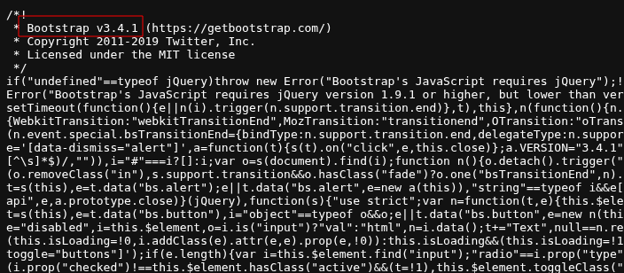
Fig: Application is using the vulnerable Bootstrap version V3.4.1
Recommendations:
- Upgrade Bootstrap to the latest stable supported version where feasible.
- Review whether Bootstrap 3.4.1 is still required by the application or Django REST Framework browsable API interface.
- Remove unused static JavaScript files from public access if they are not required.
- Maintain a dependency inventory for frontend libraries.
- Regularly perform JavaScript dependency audits.
- Ensure frontend dependencies are updated through a controlled patch management process.
References:
- https://cheatsheetseries.owasp.org/cheatsheets/Content_Security_Policy_Cheat_Sheet.html
- https://developer.mozilla.org/en-US/docs/Web/HTTP/Reference/Headers/Content-Security-Policy/script-src

Back to Summary

Misconfigured Content Security Policy
Risk: Low
Description:
The Content Security Policy (CSP) is a browser security mechanism designed to reduce the impact of attacks such as Cross-Site Scripting (XSS), clickjacking, and unauthorized content loading by restricting the sources from which scripts, styles, frames, images, and other resources can be loaded.
The application has implemented a CSP, and several directives are configured securely, including:
- object-src 'none'
- frame-ancestors
- upgrade-insecure-requests
- base-uri
- form-action
- worker-src
However, the CSP contains multiple weaknesses that reduce its effectiveness against script injection and DOM-based XSS attacks.
The script-src directive allows unsafe script execution through:
- 'unsafe-inline'
- 'unsafe-eval'
The use of 'unsafe-inline' permits inline scripts and inline event handlers to execute, while 'unsafe-eval' permits execution of dynamically generated code through functions such as eval() and similar DOM APIs. These configurations weaken the CSP’s ability to prevent or limit exploitation if an XSS injection point is discovered.
Additionally, the policy relies on host allowlists for JavaScript sources. Host allowlists can often be bypassed when trusted domains host JSONP endpoints, AngularJS libraries, or other script resources that can be abused to execute attacker-controlled code. The CSP evaluation identified multiple allowed script sources that are known to present potential bypass risks.
Affected URL:
- https://app.silentpush.com/
- https://app-staging.silentpush.com/
Impact and Likelihood:
- Impact: Low – The application has a CSP in place and includes several restrictive directives that reduce common browser-based attack risks. However, the presence of 'unsafe-inline', 'unsafe-eval', and potentially risky third-party script sources weakens the policy’s ability to mitigate XSS.
- Likelihood: Low – Successful exploitation would require an additional vulnerability, such as reflected, stored, or DOM-based XSS. The CSP does not appear to use fully permissive wildcard script sources such as *, and several important directives are already configured securely.
Steps to Reproduce:
Step 1: Navigate to the URL https://csp-evaluator.withgoogle.com/ and paste the web application URL https://app.silentpush.com// to analyze and evaluate its Content Security Policy (CSP).
Step 2: Inspect the response headers and observe the CSP configuration. The presence of 'unsafe-inline' and 'unsafe-eval' in the script-src directive weakens script execution controls.
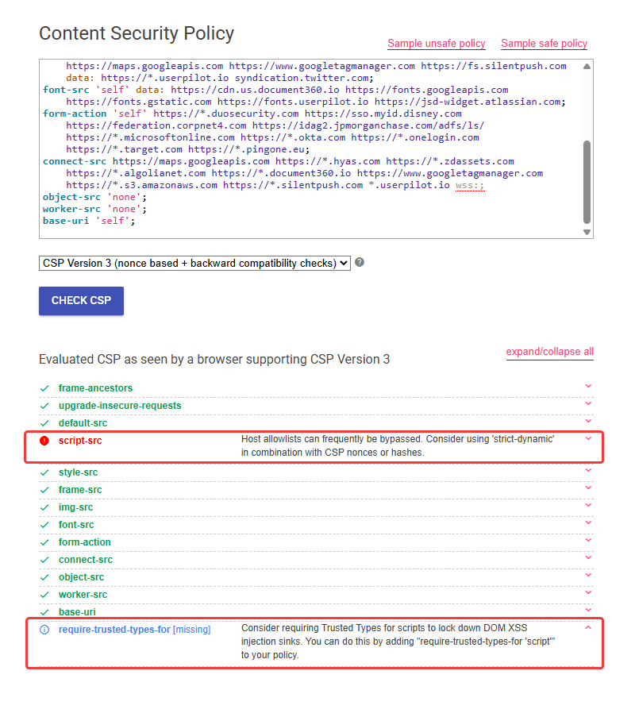
Fig: The application has a misconfigured Content Security Policy (CSP)
Recommendations:
- Remove 'unsafe-inline' and 'unsafe-eval' from script-src and adopt a nonce or hash-based approach for safer script execution.
- Enforce Trusted Types to mitigate DOM-based XSS attacks. Example Configuration:
Content-Security-Policy: require-trusted-types-for 'script';
- Enable CSP violation reporting to monitor and respond to attacks. Example Configuration:
Content-Security-Policy: report-uri https://example.com/csp-violation-report;
References:
- https://cheatsheetseries.owasp.org/cheatsheets/Content_Security_Policy_Cheat_Sheet.html
- https://developer.mozilla.org/en-US/docs/Web/HTTP/Reference/Headers/Content-Security-Policy/script-src

Back to Summary

False Positive

Open Redirection
Description:
The scanner reported a possible Open Redirection issue on the logout endpoint due to user-controlled input being supplied through the next parameter.
https://app-staging.silentpush.com/api/auth/logout/
The scanner identified that the next parameter could potentially be used to redirect users to an external domain after logout. However, manual validation confirmed that the logout functionality does not redirect the user to the supplied external URL.
This finding is considered a false positive. Although the scanner detected a potentially risky next parameter, manual testing confirmed that the logout endpoint does not use this parameter to redirect users to external URLs. Therefore, no Open Redirection vulnerability was identified on the tested endpoint.
Affected URL:
- http://app-staging.silentpush.com/api/v2/filters/tag/name/?format=json&query=
Evidence:
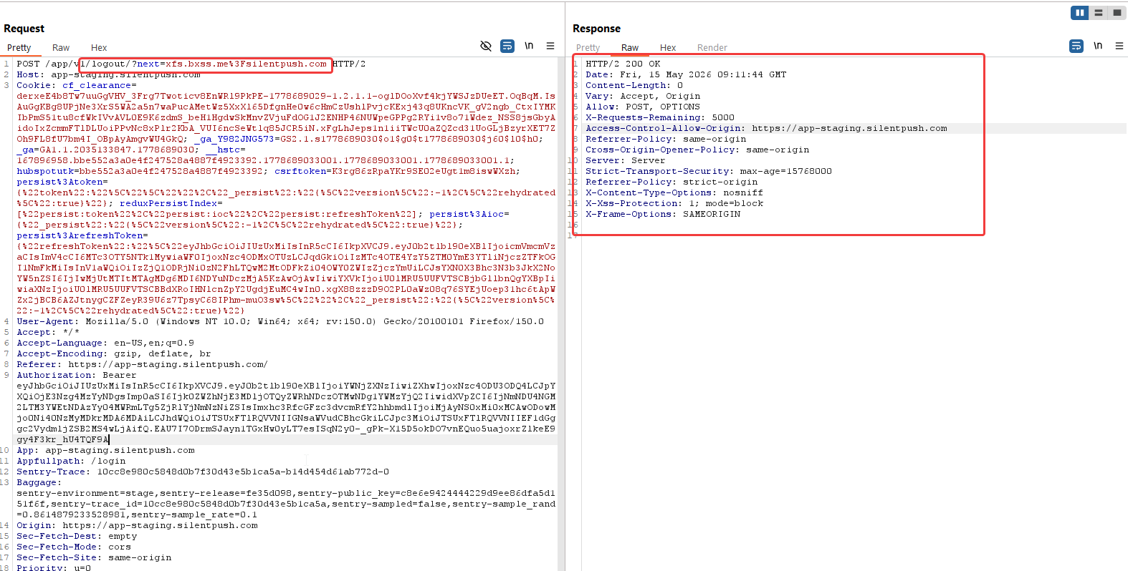
Fig: Logout functionality, with the next parameter is not redirecting to the unintended URL

Back to Summary

Cookie Not Marked as HttpOnly
Description:
The scanner identified that the csrftoken cookie does not have the HttpOnly attribute set. However, manual review confirmed that this cookie is a CSRF token cookie, not a session or authentication cookie.
The reported cookie is: csrftoken
This cookie is intentionally readable by client-side scripts in many web application frameworks so that the frontend can read the token and include it in CSRF-protected requests, usually through a request header such as:
X-CSRFToken: <token>
Since the cookie does not contain a session identifier, authentication token, password, or other sensitive secret, the absence of the HttpOnly flag does not introduce a direct security issue in this case.
Affected Cookie:
- csrftoken=UN7ggT94Pg9btkAFoipxZG0S9vXWuRlG; expires=Thu, 13 May 2027 08:58:17 GMT; Max-Age=31449600; Path=/; SameSite=Lax
Evidence:
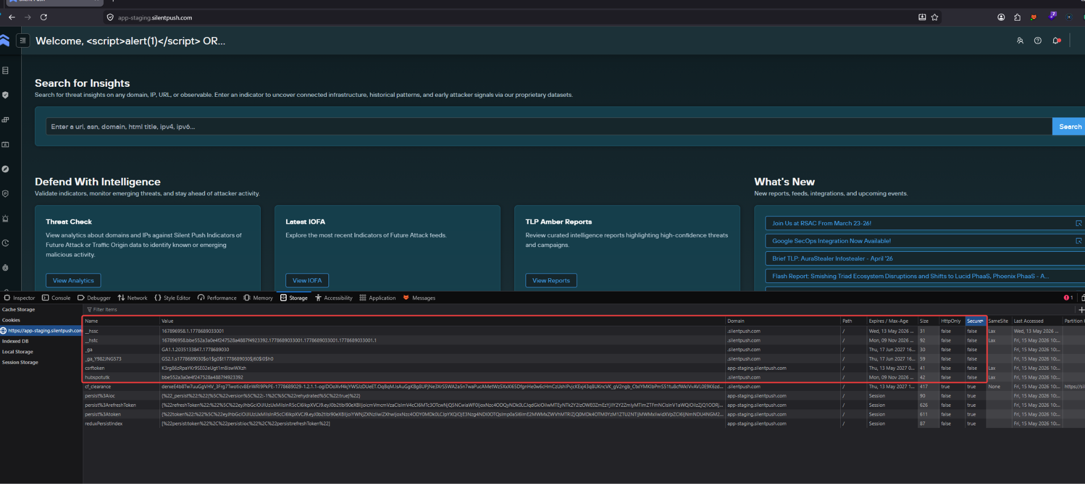
Fig: Cookies with No HTTPOnly Mark are non-critical in nature

Back to Summary

