blueally.com



Application Vulnerability Assessment and Penetration Test Report
Prepared for: PubNub
Original Test: June 14, 2025
Remediation Test: September 29, 2025

Copyright© 2025. All Rights Reserved.


Table of Contents

1 Executive Summary 1
2 Introduction 2
3 Approach 3
4 Scope 5
4.1 Tools Used 5
4.2 Assessment Limitation 6
5 Findings and Recommendations 7
5.1 Risk Classification 7
5.2 Measurement of Impact 7
5.3 Measurement of Likelihood 8
5.4 Overall Risk 9
5.5 Zero-Risk Issues 9
6 Vulnerabilities 10
6.1 Web Application Findings 10
7 Detailed Vulnerabilities 11
7.1. Public Exposure of User and Employee Credentials of PubNub Through Data Leak 11
7.2 Inkeep API Key Exposure Leading to Unauthorized Chat Operations 14
7.3 No Rate Limiting on Keyset Creation Functionality 17
7.4 Sensitive Credentials Leakage via Public JavaScript and JSON Configuration Files 24
7.5 Content Spoofing 27
7.6 Improper Input Validation 31
7.7 Concurrent Login 36
8. Appendix A: Penetration Test Scope 39

Executive Summary
BlueAlly conducted a penetration test of the PubNub web application and its APIs to identify security weaknesses. The goal of this assessment is aimed at minimizing risks to data, systems, and company reputation. The duration of the pen test ran from 6th June to 8th July 2025.
The BlueAlly team assessed the application's functionality, security controls, and potential vulnerabilities. Common weaknesses listed in the OWASP Top 10 and security best practices outlined in the OWASP ASVS were considered. While the pen test consisted of a mixture of automated tools, manual analysis formed the basis of the assessment.
Vulnerabilities identified were categorized as follows:
- Critical: 1
- High: 1
- Medium:1
- Low: 4

Introduction
Background
As part of an ongoing security program, PubNub identified the need to conduct an application security assessment and penetration test of its web application.

This report includes the following:
- BlueAlly’s approach to the assessment
- Assessment scope
- Key findings are listed with their qualitative risk assessment
- Detailed recommendations for each finding
- A remediation plan

Approach
BlueAlly performed a Runtime Web Application Vulnerability Assessment of the PubNub web application components that were defined in the scope.

Web Application Assessment & Penetration Test
- Identify the possible security vulnerabilities and test the possibility of exploitation in the Web application infrastructure
- Assess the security vulnerabilities present in the Web application infrastructure concerning industry standard methodologies like OSSTMM (Open-Source Security Testing Methodology Manual) and OWASP (Open-Web Application Security Project) Web application testing methodology
- Suggest best practices for remediation

Runtime Application Vulnerability Assessment
The Runtime Application Vulnerability Assessment involves detecting security vulnerabilities through detailed examination and testing of the application in a runtime environment. This assessment simulates an attack by a skilled adversary in a controlled setting, allowing the tester to identify the types of vulnerabilities that can be realistically exploited. A Runtime Application Vulnerability Assessment includes the following phases:
- Information Gathering — Gain a better understanding of the application by browsing the website as an anonymous visitor, a typical user, and then as a privileged user (where applicable)
- Attacking Authorization — Attempt to gain access to data belonging to other users of the system, resources, or functionalities belonging to privileged users
- Session Management — Attempt to exploit session management vulnerabilities and manipulate client state
- Input Validation Attacks — Attempt to inject invalid, malformed, or unexpected input to trigger unexpected behavior or exceptions in the application or related libraries. This is also done to traverse seldom-used business logic, find unaccounted-for use cases, or bypass application controls. In addition, input-validation attacks attempt to inject instructions like code, commands, and packets into user-controlled input to exploit logic or code that directly interprets or executes user-supplied input.

This assessment report contains:
- Technical details of the vulnerabilities discovered, with substantiation of the exploits
- The risk mitigation recommendations that need to be implemented to ensure that the systems are secure from the risks stemming from the discovered vulnerabilities

Scope
The assessment was conducted between June 06th and July 09th, 2025. Testing was performed remotely.
The objective of the re-test was to assess the effectiveness of Pubnub's efforts to remediate the issues identified during the original penetration test.
The following domains were considered within the scope of this assessment.

Domain
https://pubnub.com
https://admin.pubnub.com
https://ps.pndsn.com

The scope for this security assessment included, but was not limited to, the following tests:
- Identification of running services
- Vulnerability Assessment
- Penetration Testing of Web Application
- Identification of vulnerable or outdated components and software in use

Tools Used
The following open-source tools were used during this vulnerability assessment exercise:
- Nmap
- SSLScan
- Burp Professional Pro
- SQLMap
- Postman
- Caido

Assessment Limitation
The ever-changing technology landscape and the increasing sophistication of attacks against web applications are reasons no entity can truthfully claim to identify all security issues nor guarantee the lifetime security of an organization’s web applications. Note that this point-in-time assessment was based on a best-effort basis. It was also performed only in the environment provided by PubNub. Thus, environmental changes may impact the applicability of the results provided herein.

BlueAlly cannot guarantee 100% coverage for any security assessment.

Findings and Recommendations

Risk Classification
The remainder of this report describes the vulnerabilities that BlueAlly identified as part of the assessment, their impact, and recommendations for resolving the vulnerabilities. To help determine the risk posed by these vulnerabilities to the PubNub web applications, BlueAlly leveraged the ASVS L1 Security & NIST v3.0 Risk Rating Methodology. The observations were categorized based on technical impact and likelihood, explained below. These impact and likelihood scores may be further modified by PubNub based on the business criticality of the target.

Measurement of Impact
The impact is an estimation of the damage potential of a successful exploit of a vulnerability. We’ll use the following factors to help qualitatively determine the impact of a vulnerability.

Impact Factor | Description
Classification of Data Loss | If an adversary exploited this vulnerability, what type of data would he/she have stolen?  Non-sensitive, non-customer-specific data would reduce the impact of an exploit.
Data Integrity | If an adversary exploited this vulnerability, would he/she have the ability to edit/delete data that they shouldn't have access to? If so, what type of data would they be able to corrupt?  Not being able to edit/delete data or the corruption of non-sensitive data would reduce the impact of an exploit.
Blast Radius | How many potential victims would there be if the vulnerability was exploited? For instance, an obscure service with few users would have a smaller victim pool than a major service that is publicly accessible with millions of users.  The impact of a successful exploit is reduced with fewer potential victims.

There is no science to determine the impact of using the above factors. If most/all of the factors are pointing to a lower impact, we can evaluate it as Low. If the factors pointing to lower impact are about 50%, then the impact would be rated Medium. Lastly, if most/all of the factors are pointing to a higher impact, we can evaluate it as High.

Measurement of Likelihood
Likelihood is a qualitative estimation of the probability of an adversary exploiting the vulnerability in question. To determine the likelihood of an exploit, we can consider the following factors:

Likelihood Factor | Description
Required Skill Level of Adversary | How technically skilled would an adversary have to be to exploit this vulnerability?  - Higher levels of technical skills required would reduce the likelihood of a successful exploit.
Number of Potential Adversaries | How many potential adversaries exist? Technically, any person who can access the system and discover the vulnerability is a potential adversary.  - If a smaller number of users have access to the system, the likelihood of a successful exploit is reduced.
Cost of Exploit | How expensive are the systems and resources needed by an adversary to exploit this vulnerability?  - More expensive systems and resources required would reduce the likelihood of a successful exploit.
Ease of Exploit | Once the vulnerability has been discovered, how simple is it for an adversary to exploit it? Does it depend on other events? Does it require a specific delivery mechanism?  - Theoretical vulnerabilities with complex exploit scenarios would reduce the likelihood of the vulnerability.

There is no science to determine the likelihood using the above factors. If most/all of the factors are pointing to a lower likelihood, we can evaluate it as Low. If the factors pointing to lower likelihood are about 50%, then the likelihood would be rated Medium. Lastly, if most/all of the factors are pointing to a higher likelihood, we can evaluate it as High.

Overall Risk
The following graph illustrates how Impact x Likelihood scores translate to overall Low, Medium, and High-risk ratings:

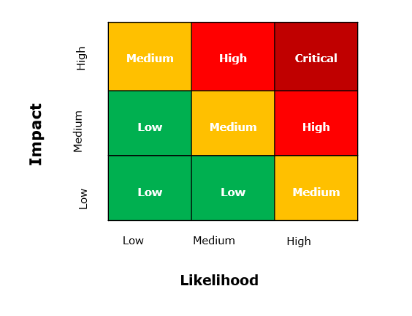

Zero-Risk Issues
There are cases where a particular issue doesn't have a direct security impact or likelihood of exploitation. These could be issues related to documentation or semantics that are suggested based on the security assessors' technical and industry experience. Such issues will be reported with an Informational risk rating.

Vulnerabilities
Below is a summary of the vulnerabilities discovered during the assessment, ranked in order of risk:

Web Application Findings
Vulnerability | Risk | Status
Public Exposure of User and Employee Credentials of PubNub Through Data Leak | Critical | Closed
Inkeep API Key Exposure Leading to Unauthorized Chat Operations | High | Closed
No Rate Limiting on Keyset Creation Functionality | Medium | Closed
Sensitive Credentials Leakage via Public JavaScript and JSON Configuration Files | Low | Closed
Content Spoofing | Low | Closed
Improper Input Validation | Informational | Open
Concurrent Login | Informational | Open

Detailed Vulnerabilities

7.1. Public Exposure of User and Employee Credentials of PubNub Through Data Leak
Risk: Critical

Description:
During a targeted domain inspection using WhiteIntele.io and Pentester.com, a critical data exposure involving PubNub was identified. The breach revealed a large volume of sensitive login credentials, including those belonging to over 500 external users and more than 100 PubNub employees.
A majority of the exposed information was traced back to the app distribution platform Apollo.io, indicating that the leak most likely originated there. This points to a potential upstream compromise or poor security hygiene in third-party integrations, significantly increasing the risk to both PubNub’s infrastructure and its users.

Affected URL: https://admin.pubnub.com

Steps to reproduce:
Step 1: Use WhiteIntel.io to search your domain for any associated data leaks
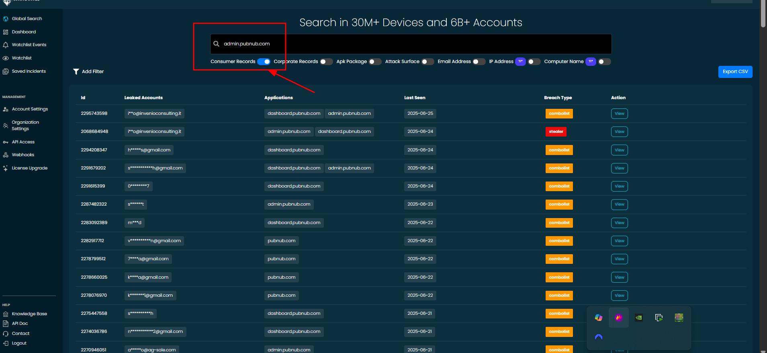
Fig: Showing that the user's details are leaking
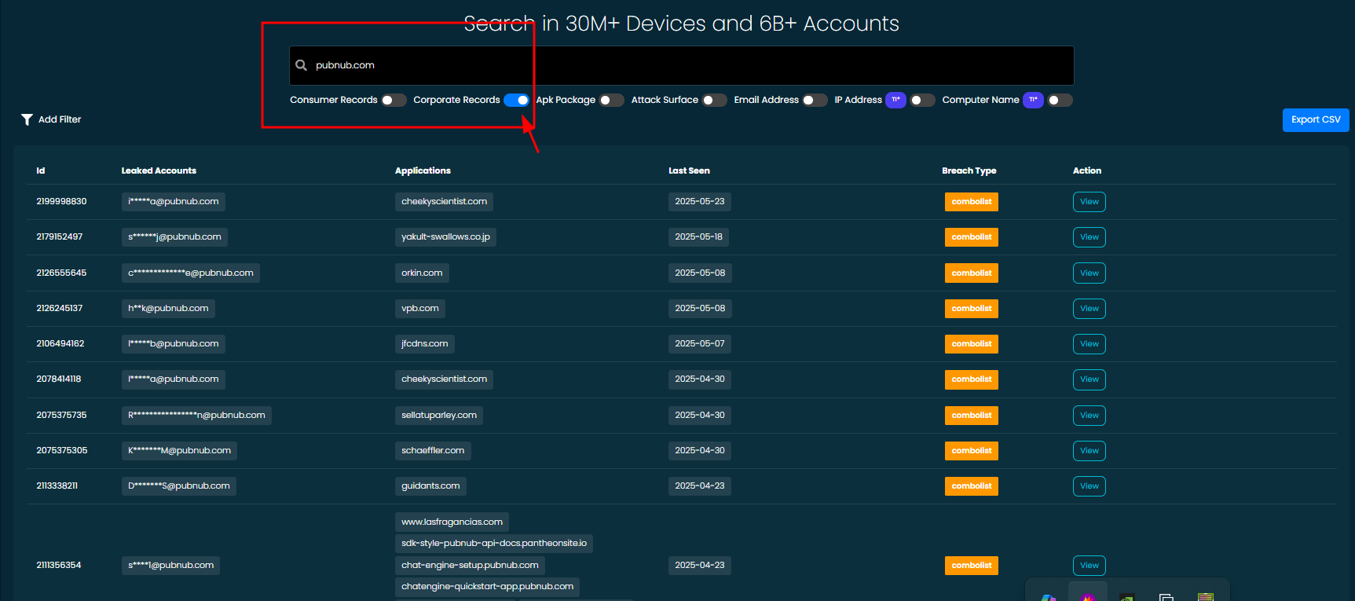
Fig: Showing that the employee's details are leaking
Impact and Likelihood:
- Exposure of user and employee credentials can lead to unauthorized access and account takeovers, compromise internal systems and sensitive information through abused employee credentials, and increase the risk of phishing, social engineering, and further cyberattacks targeting affected individuals.
- There is a high likelihood of exploitation due to the public availability of sensitive credentials, as attackers commonly automate credential stuffing and phishing campaigns using leaked data.

Recommendations:
- Identify the source of the data leak and contain it by securing or removing the exposed data.
- Notify all impacted individuals with guidance on changing passwords and spotting phishing attempts.
- Revoke any exposed credentials and require affected users and employees to reset their passwords.
- Notify all impacted individuals with guidance on changing passwords and spotting phishing attempts.
- Contact breach intelligence website administrators (e.g., WhiteIntel.io) to request the removal of your data listings.
- Strengthen security measures by implementing multi-factor authentication, secrets management, and regular audits.
Reference:
- https://owasp.org/www-community/attacks/Credential_stuffing
Back to Summary

7.2 Inkeep API Key Exposure Leading to Unauthorized Chat Operations
Risk: High

Description:
The application uses an Inkeep API key to enable chat functionality within the support system, powered by Inkeep’s real-time chat infrastructure (potentially integrated with PubNub). This API key is exposed in client-side code or publicly accessible locations.
Due to this exposure, an attacker with access to the API key can initiate or send messages within the Inkeep chat environment without proper authentication or authorization checks.

Affected URL: https://admin.pubnub.com/config.json

Steps to reproduce:
Step 1: Visit the vulnerable URL and extract the Inkeep API key for exploitation.
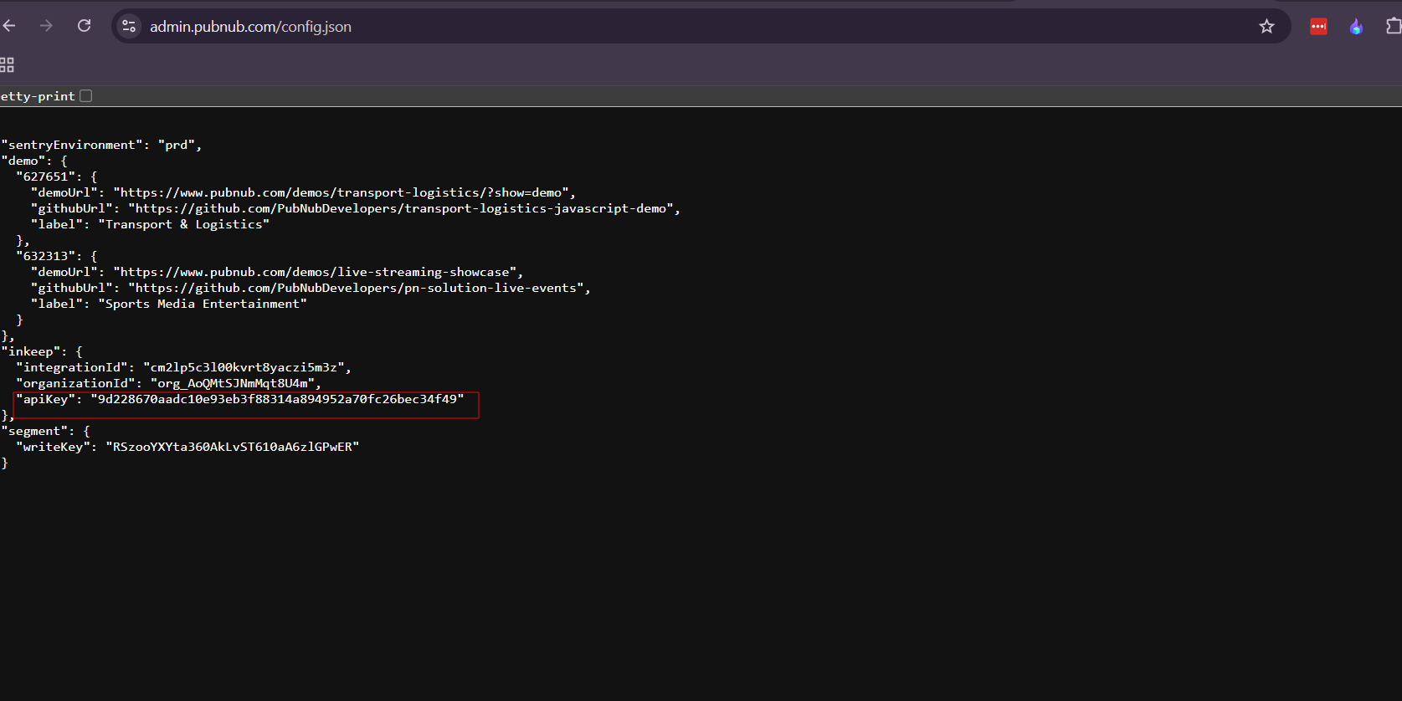
Step 2: Now, run the following cURL command and observe the response to verify that you can communicate with the Inkeep Chat.
CURL command :
curl https://api.inkeep.com/v1/chat/completions -H "Content-Type: application/json" -H "Authorization: Bearer <Your API key>" -d '{ "model": "inkeep-context-expert", "messages": [ { "role": "user", "content": "Your prompt?" } ] }'

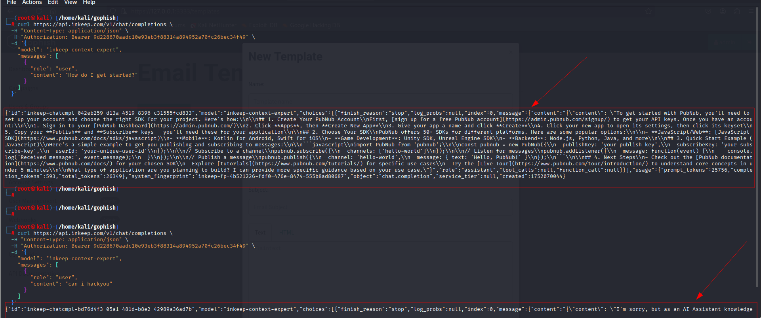
Fig: Showing use of exposed INKEEP API Key

Impact and Likelihood:
- Unauthorized access and misuse of chatbot and messaging services using exposed API keys.
- Data leakage, privacy violations, and breach of sensitive information.
- Disruption of service availability and chatbot abuse.
- Financial loss due to unauthorized usage of third-party messaging services, leading to increased operational costs.
- The likelihood is high because exposed keys in client-side code and public files are easily discoverable, enabling attackers with minimal effort to exploit them.
Recommendations:
- Protect the Inkeep API key by moving it to a secure backend environment; avoid exposing it in client code.
- Enforce strict authentication and authorization on all chatbot interaction APIs.
- Implement rate limiting and anomaly detection on chatbot messages to prevent abuse.
- Regularly rotate API keys and monitor chatbot usage for suspicious activity.

Reference:
- https://iaraoz.medium.com/abusing-api-keys-how-attackers-discover-and-exploit-them-f9764fd0da0a

Back to Summary

7.3 No Rate Limiting on Keyset Creation Functionality
Risk: Medium
Description:
The application provides functionality for authorized users to generate keysets (e.g., API keys) through a designated endpoint. However, it was observed that this endpoint lacks server-side rate limiting or anti-abuse mechanisms.
During assessment, we authenticated into an account with keyset creation privileges and initiated a series of rapid, automated requests to the keyset creation endpoint. These requests were processed without delay or rejection, confirming the absence of rate controls such as request throttling or burst detection.

Affected URL: https://admin.pubnub.com/
Endpoint: /api/keys/
Method: POST

Steps to reproduce:
Step 1: Log in using any valid user account with App Admin or Admin permissions, then navigate to the App & Secrets section and select any app.
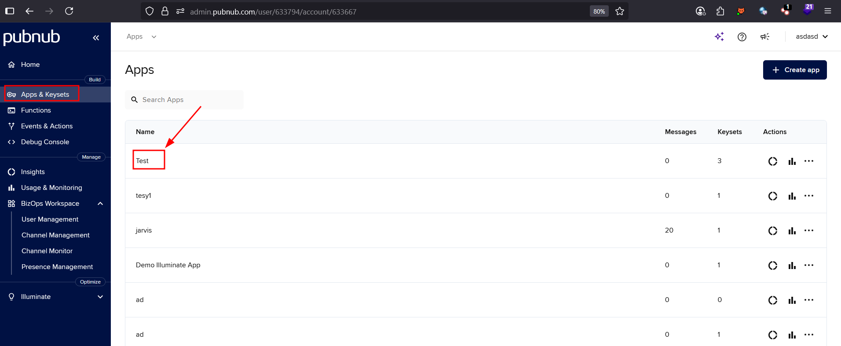
Step 2: Next, click on Create Keyset, then enter the keyset name and configure the settings accordingly.
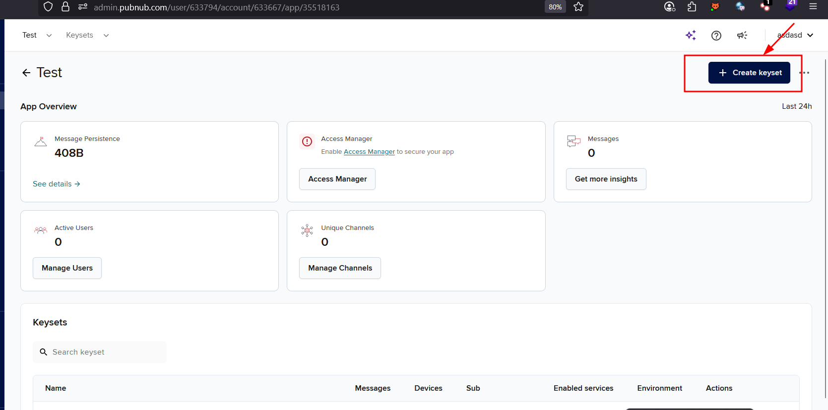
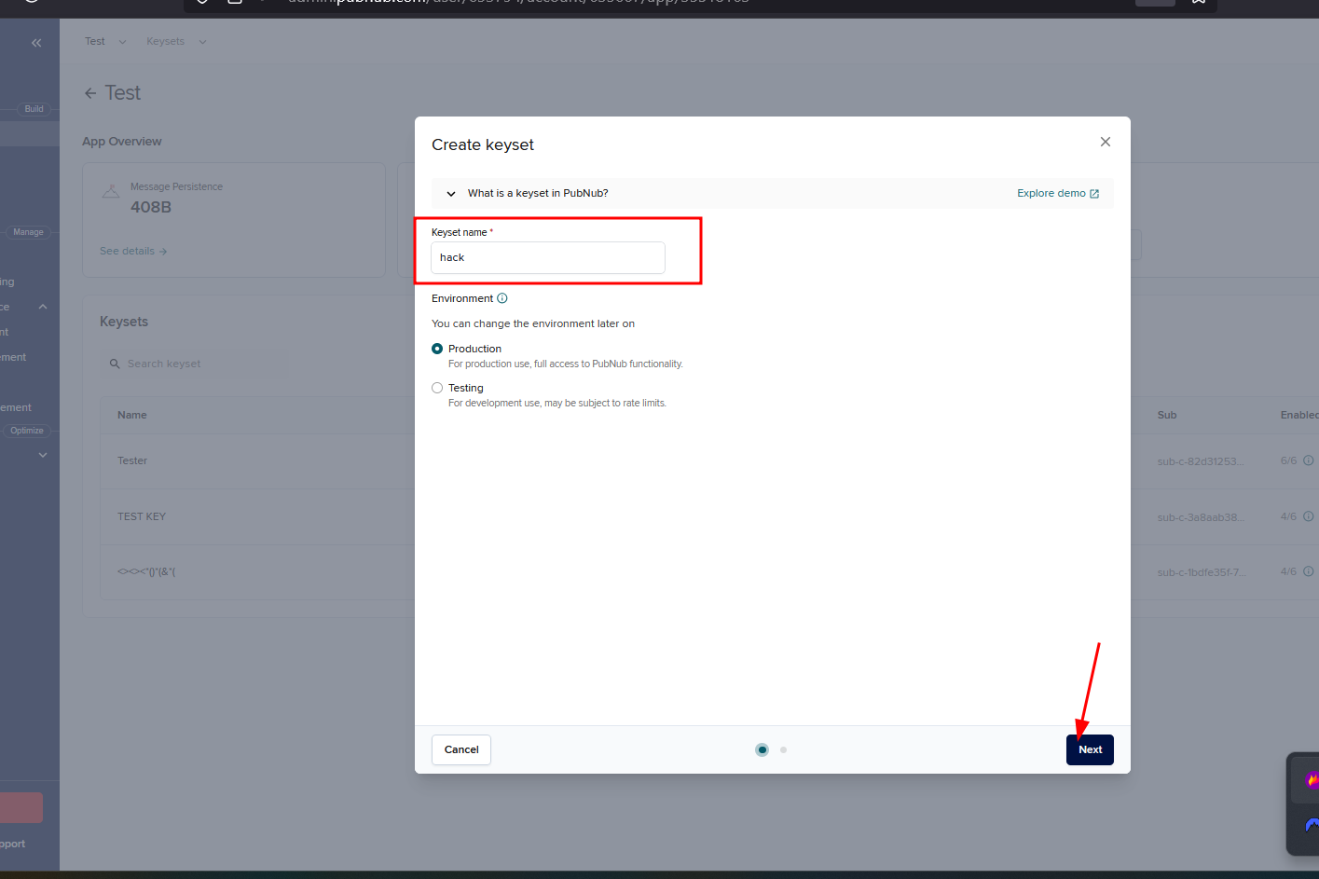

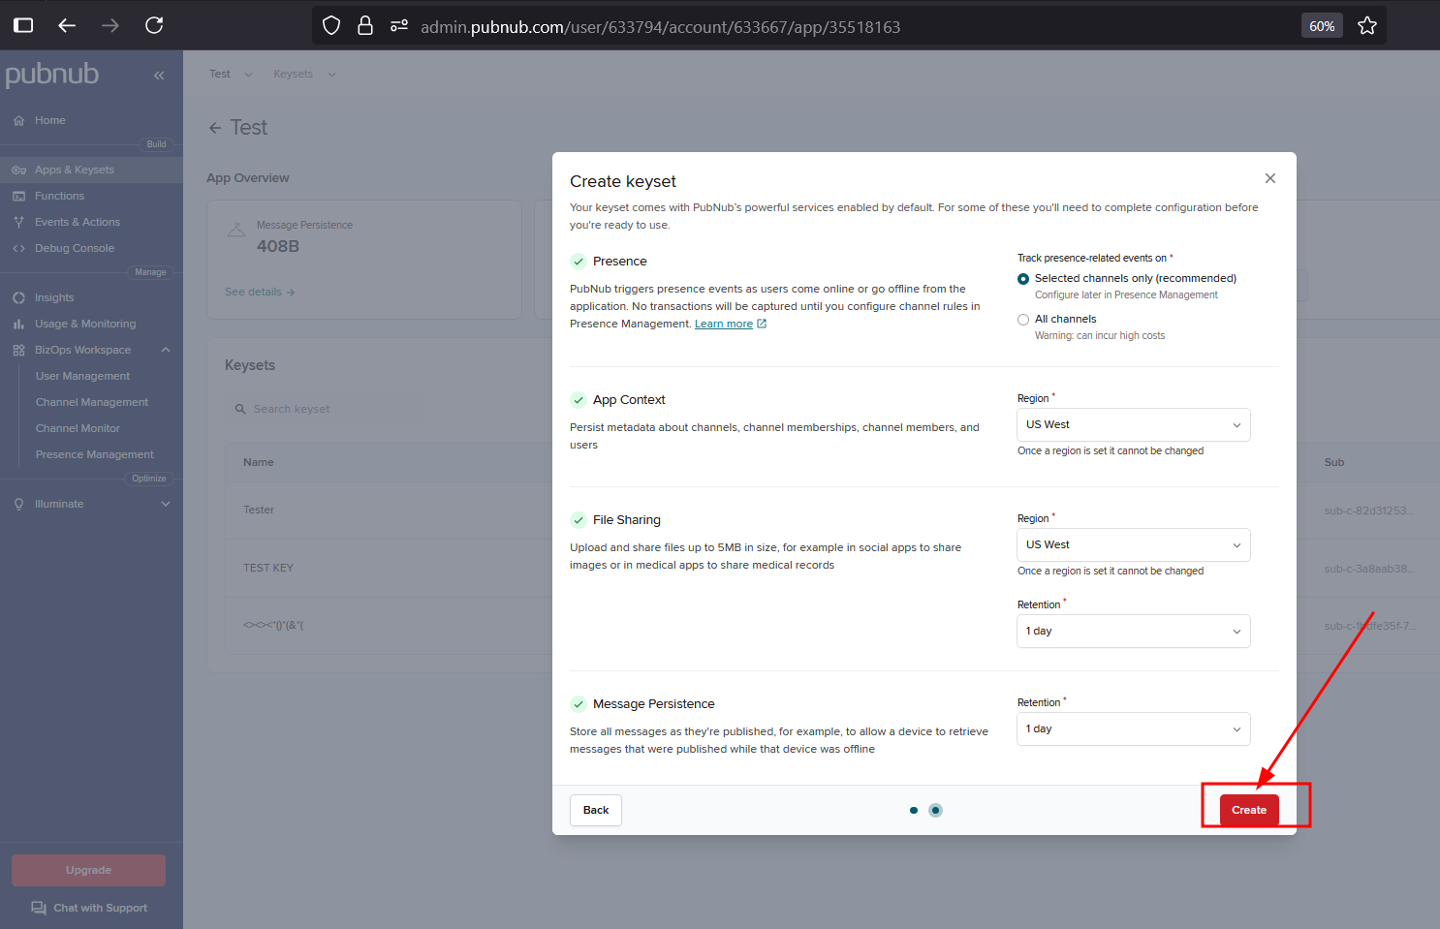
Step 3: Send the create request from your Burp proxy history to the Intruder tool.
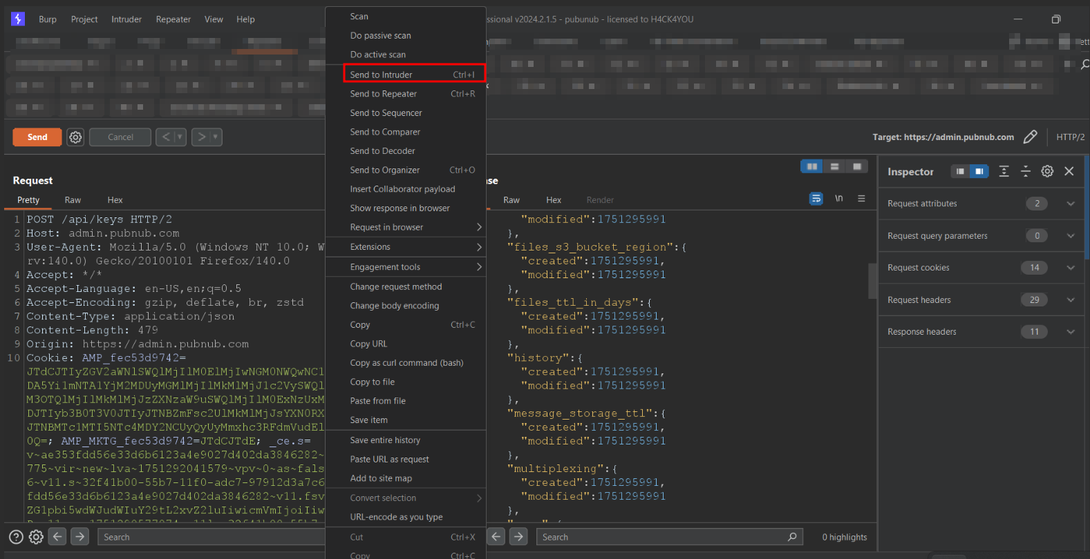
Step 4: Now, in the Intruder tab, configure the payloads with null values and specify the desired payload quantity, then launch the attack.
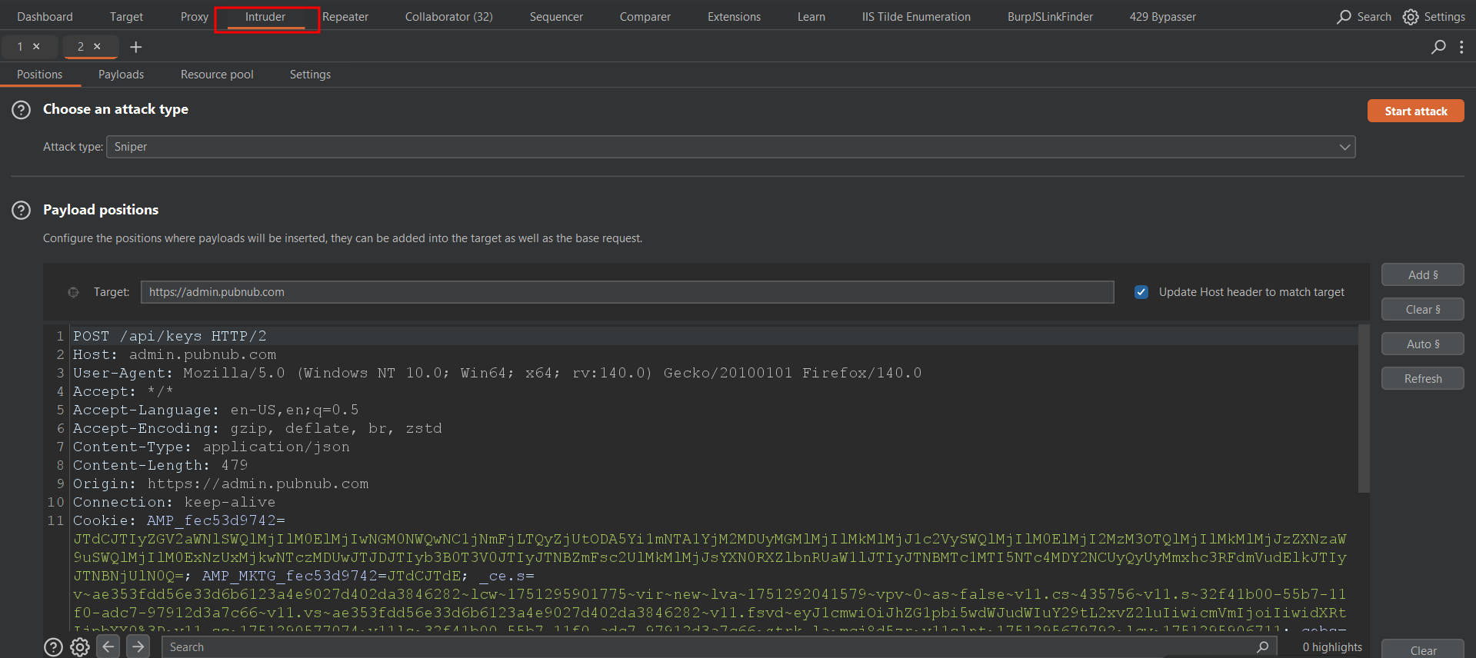
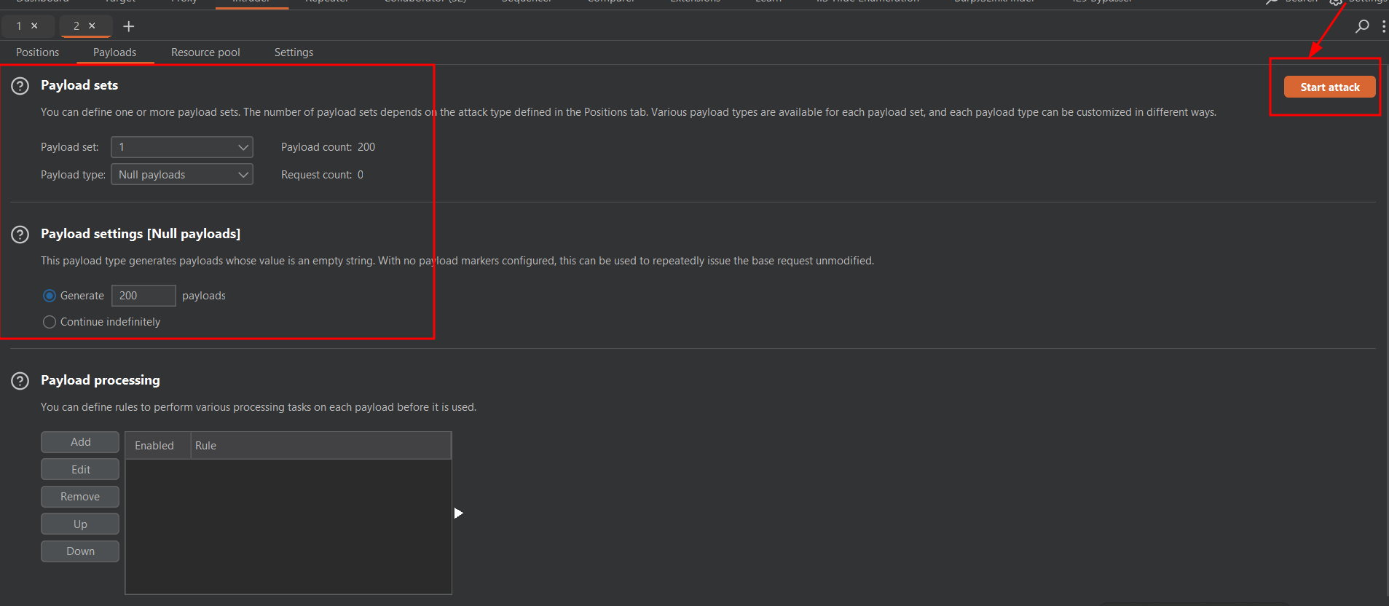
Step 5: Now, observe that the server accepted all 200 simultaneous requests within a minute and created multiple keysets without restriction.
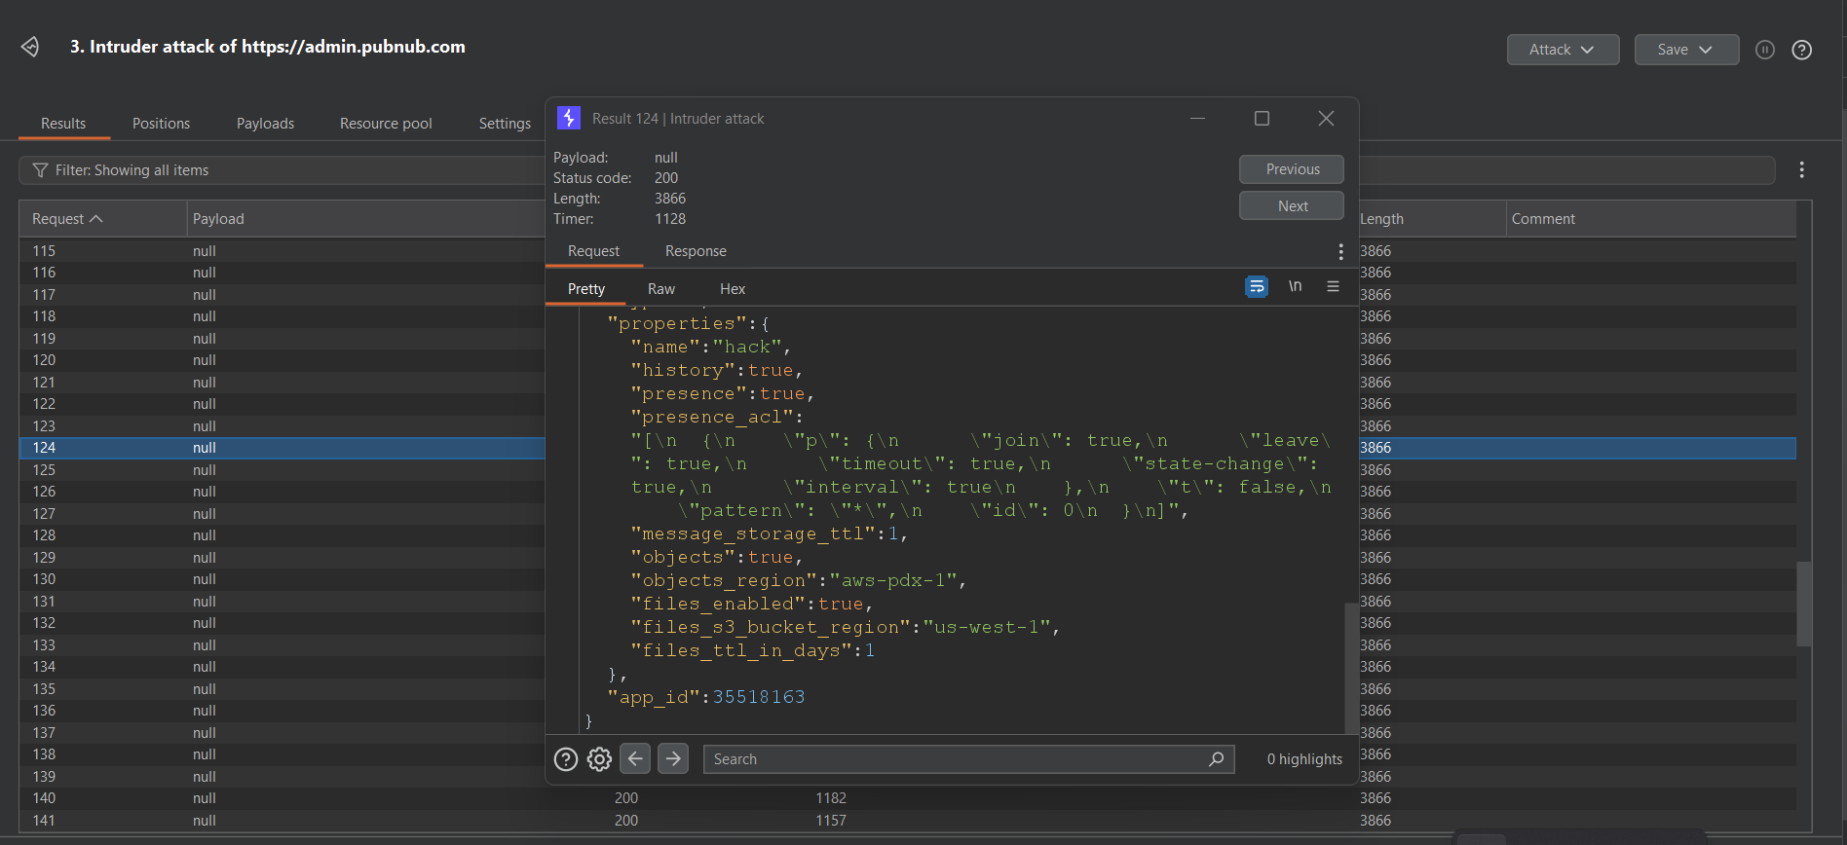
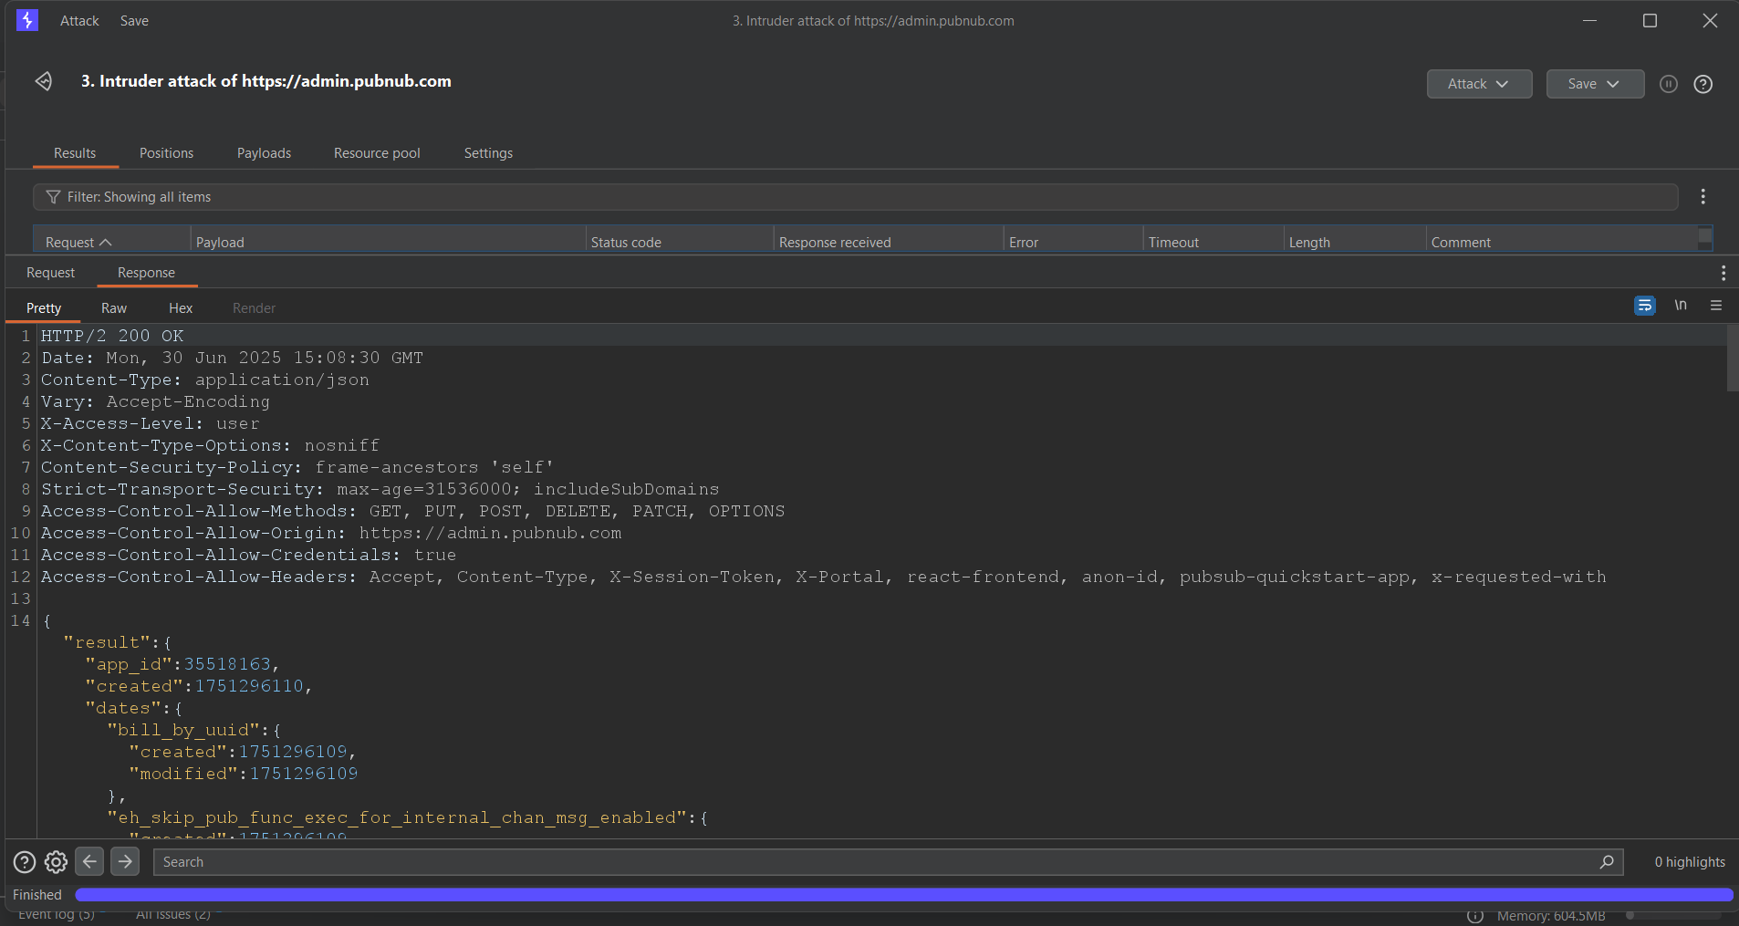

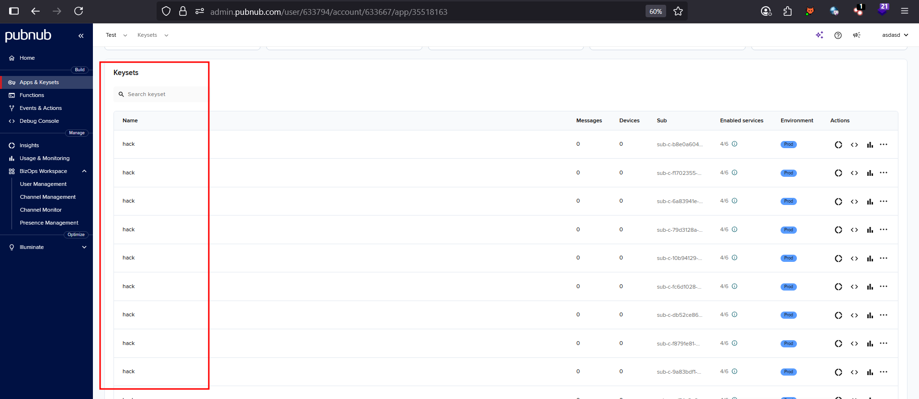

Impact and Likelihood:
- Attackers can generate unlimited keysets, leading to resource exhaustion on the backend.
- System performance may degrade or crash due to unbounded keyset creation (potential DoS).
- Key management becomes unmanageable, increasing operational and administrative overhead.
- Likelihood is moderate because exploitation requires an authenticated user with keyset creation permissions, limiting access to only privileged users despite the lack of rate-limiting controls

Recommendations:
- Implement rate limiting on the keyset creation endpoint to restrict the number of requests per user or IP within a defined time frame.
- Set a maximum quota for the number of keysets a user can create to prevent excessive generation.
- Monitor keyset creation activity for abnormal or suspicious patterns and trigger alerts accordingly.
- Ensure comprehensive logging and auditing of all keyset creation events for traceability and investigation.
Reference:
- https://owasp.org/API-Security/editions/2019/en/0xa4-lack-of-resources-and-rate-limiting/
- https://www.geeksforgeeks.org/computer-networks/no-rate-limiting-flaw-in-cyber-security/
Back to Summary

7.4 Sensitive Credentials Leakage via Public JavaScript and JSON Configuration Files
Risk: Low

Description:
During analysis of the web application, it was observed that sensitive credentials, including publish and subscribe keys used for real-time messaging, were hardcoded and exposed in publicly accessible frontend JavaScript files. These keys are embedded directly in JavaScript code that any user loading the application can access.

Furthermore, a publicly accessible .json configuration file was discovered that contains additional sensitive information such as the Inkeep API key and Segment Write API key. Exposure of these secrets allows malicious actors to misuse these keys to access or manipulate real-time messaging channels, write or track data via third-party services, and potentially gain unauthorized access to internal resources or user data.

Affected URL: https://www.pubnub.com/_next/static/chunks/677-1f9a63e5ef28acb9.js

Steps to reproduce:
Step 1: Open the vulnerable JavaScript file in your browser's Tools and Ctrl + F (or Cmd + F on Mac) to search for the exposed subscribeKey and publishKey
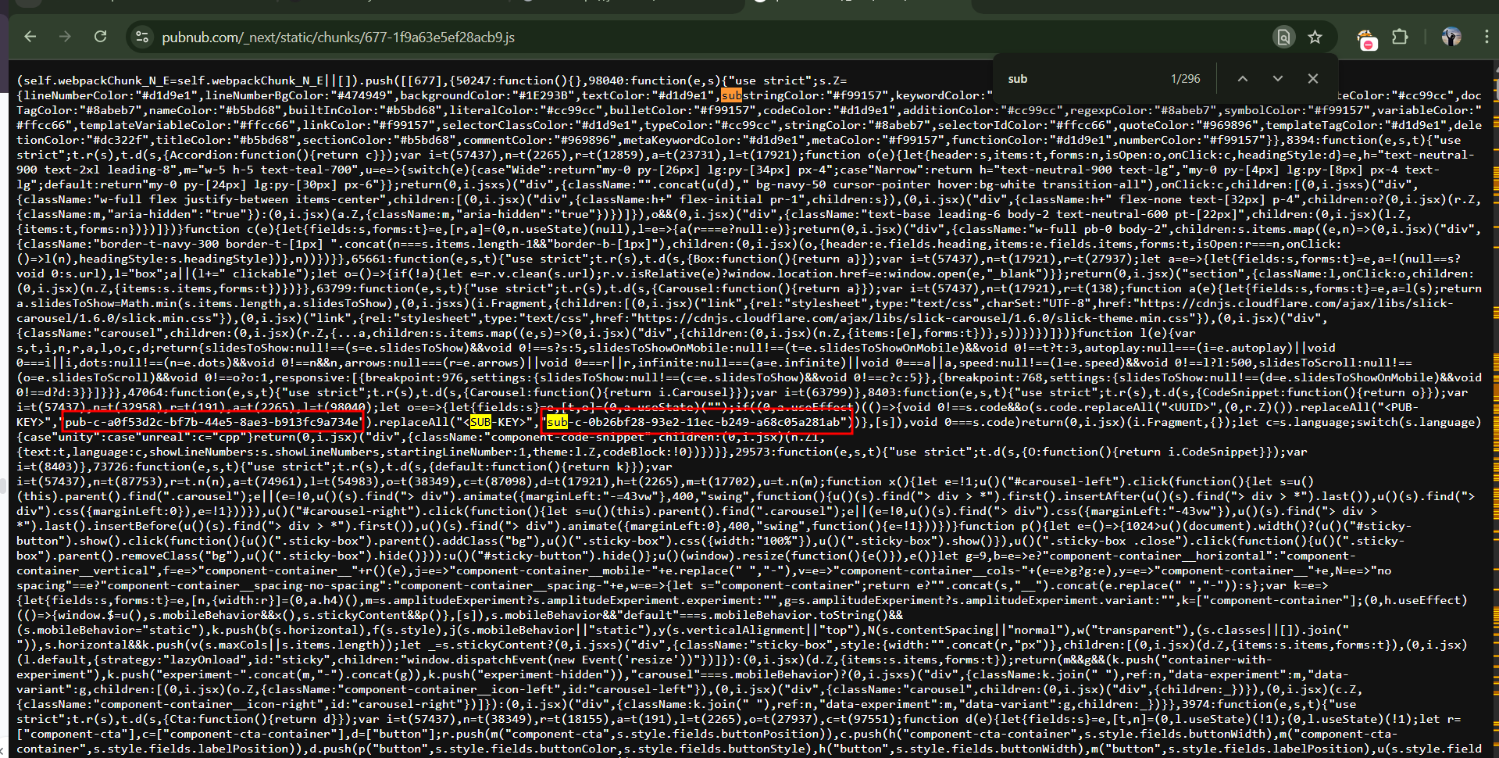
Fig: Showing exposed subscriber and publish key
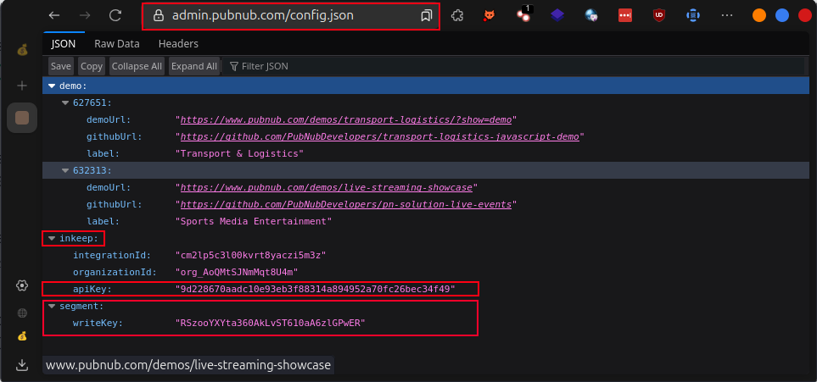
Impact and Likelihood:
- Unauthorized access to the application’s real-time messaging infrastructure enables attackers to eavesdrop, inject, or manipulate critical data in transit.
- Loss of platform integrity and user trust, as attackers may impersonate users or internal systems within communication channels.
- Potential for automated abuse, including data scraping, impersonation, or triggering unintended system behavior through forged messages.
- The likelihood is low because although the keys are exposed, we were not able to successfully exploit them in this environment, indicating additional protections or limited access tied to their usage.

Recommendations:
- Immediately revoke and regenerate all exposed publish and subscribe keys.
- Remove all sensitive credentials from the frontend JavaScript code.
- Implement a secure server-side proxy that handles messaging actions with authentication and access controls.
- Use short-lived tokens and role-based access permissions to enforce channel-level security.
- Monitor for abnormal usage of old credentials to detect abuse.
Reference:
- https://cwe.mitre.org/data/definitions/798.html
- Remediating Segment Workspace API Key leaks | GitGuardian
- https://medium.com/@m.habibgpi/exposed-segment-analytics-api-key-in-neons-web-console-a-critical-oversight-with-serious-c0849a01754c

Back to Summary

7.5 Content Spoofing
Risk: Low

Description:
The PubNub application is vulnerable to content spoofing on the sign-up process, where the email= parameter in the email confirmation URL (e.g., https://admin.pubnub.com/confirm-email?email=*...) can be manipulated to display arbitrary content. For instance, modifying the parameter to email=This%20site%20is%20under%20maintenance%20click%20visit%20evil.com allows attackers to present a misleading message, potentially tricking users into visiting malicious sites. This vulnerability arises from insufficient input validation or sanitization of the email parameter in the confirmation page.

Affected URL: https://admin.pubnub.com/config.json

Steps to reproduce:
Step 1: Navigate to the application's registration page and fill in the required details (e.g., name, email, password), then click on "Register."
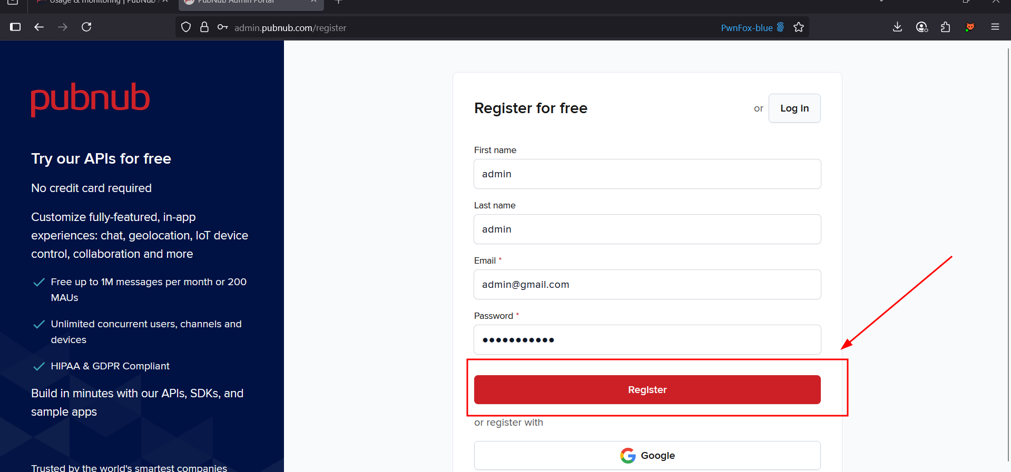
Fig: Fill in the required information and click on the register button

Step 2: After clicking "Register," you will be redirected to the verification page (e.g., https://admin.pubnub.com/confirm-email?email=).
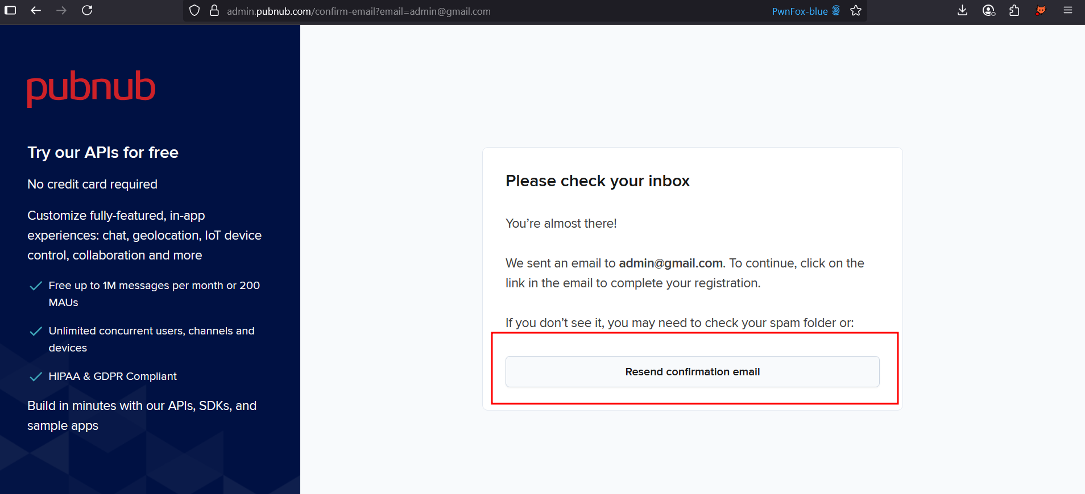
Fig: Page got redirected after clicking on the register button
Step 3: Modify the email parameter in the URL (e.g., ?email=This site is under maintenance) and press Enter. Observe that the page displays the spoofed content
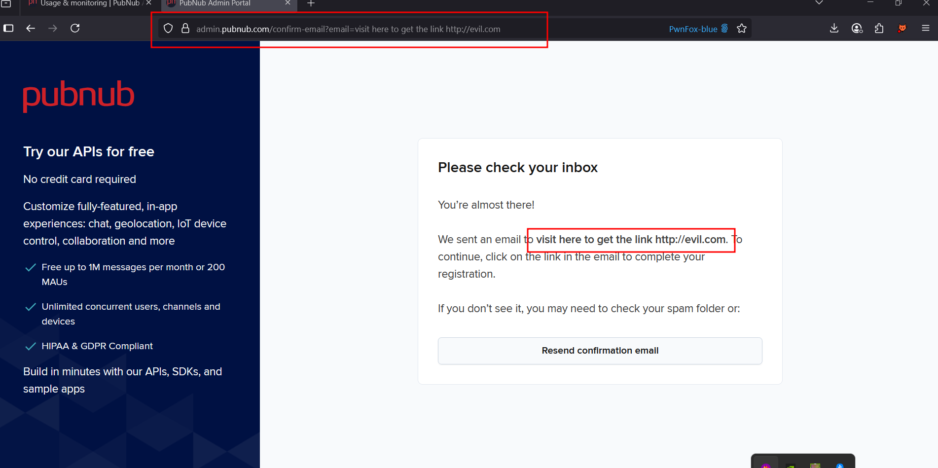
Fig.: Screenshot showing the spoofed email parameter in the URL with custom text.

Impact and Likelihood:
- Successful exploitation allows attackers to spoof visible content in the browser by crafting a malicious URL containing user-defined text. Although clickable links are not rendered due to HTML encoding, the displayed spoofed content may still be used in social engineering attempts to deceive users.
- The likelihood of exploitation is moderate, but the impact is low due to the lack of active scripting or executable payloads.

Recommendations:
- Validate and sanitize the email parameter to accept only valid email addresses, rejecting arbitrary text.
- Limit the email parameter to internal processing, avoiding its display or manipulation by users.
- Log and alert on unusual URL parameter changes to detect potential spoofing attempts.
Reference:
  - https://owasp.org/www-community/attacks/Content_Spoofing
  - https://hackerone.com/reports/1245051

Back to Summary

7.6 Improper Input Validation
Risk: Informational

Description:
The PubNub application lacks proper server-side input validation across multiple endpoints, including the app creation functionality. This allows users to submit special characters in input fields such as "App Name" without restriction or sanitization. Although front-end encoding may be implemented, it can be bypassed, allowing attackers to inject potentially harmful characters that could lead to data inconsistency, UI rendering issues, or potential XSS in downstream components if not properly handled.

Affected URL: https://admin.pubnub.com/api/keys
Note: This issue is not limited to a single endpoint and appears to be a systemic weakness throughout the application.

Steps to reproduce:
Step 1: Log in to the application with valid credentials.
Step 2: Navigate to the Apps & Keysets section and click on Create App.
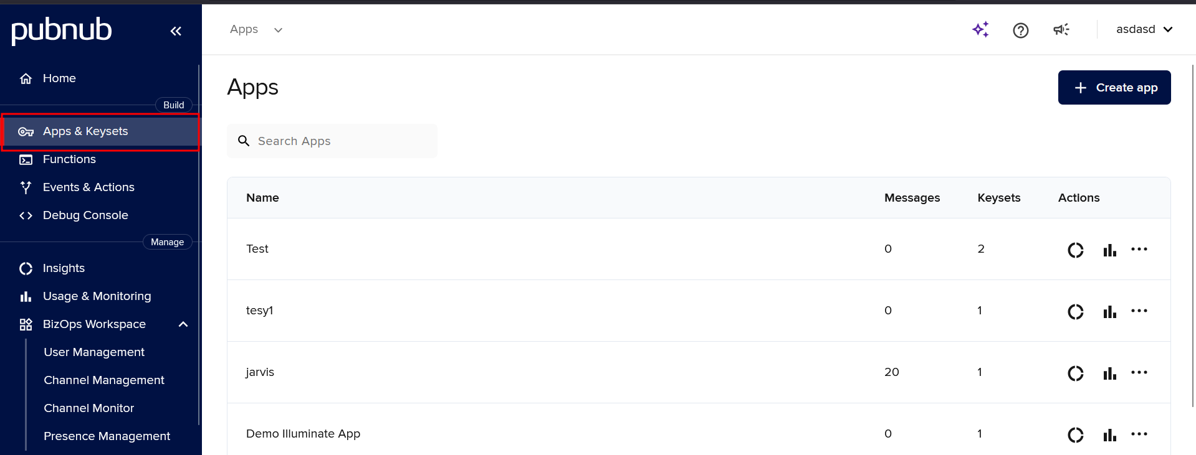
Fig: Navigating to the Apps & Keysets section
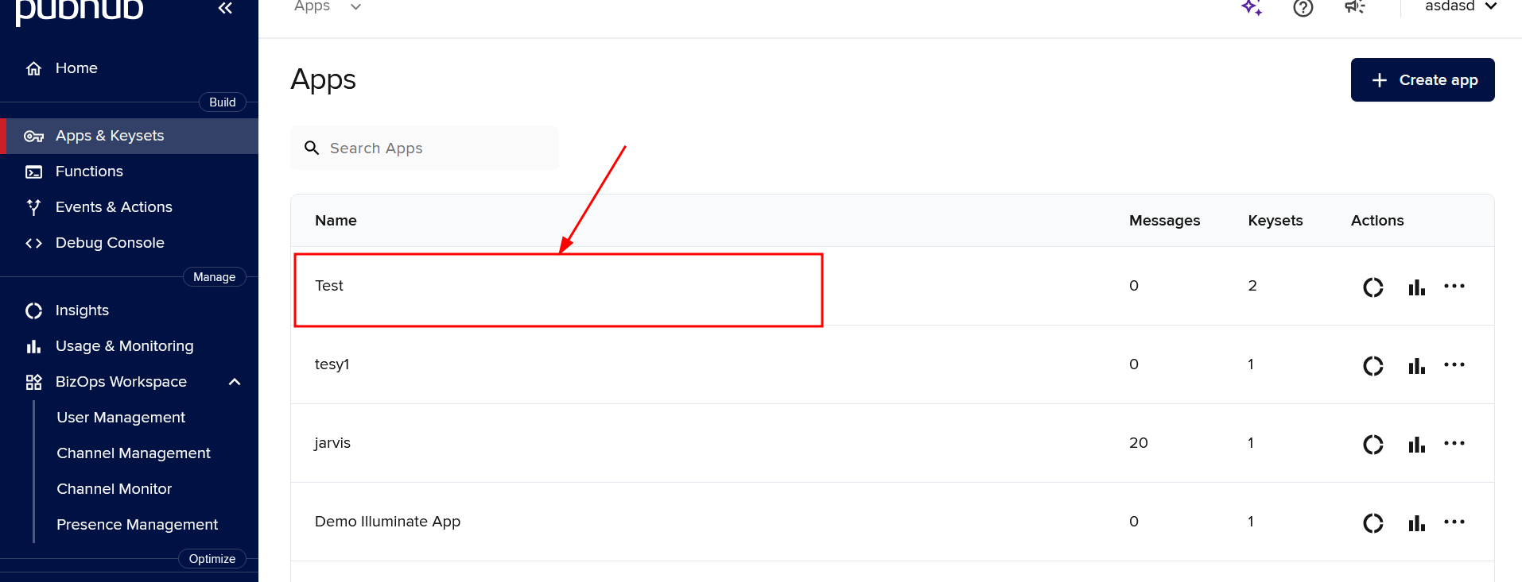
Fig: Opening any created app page

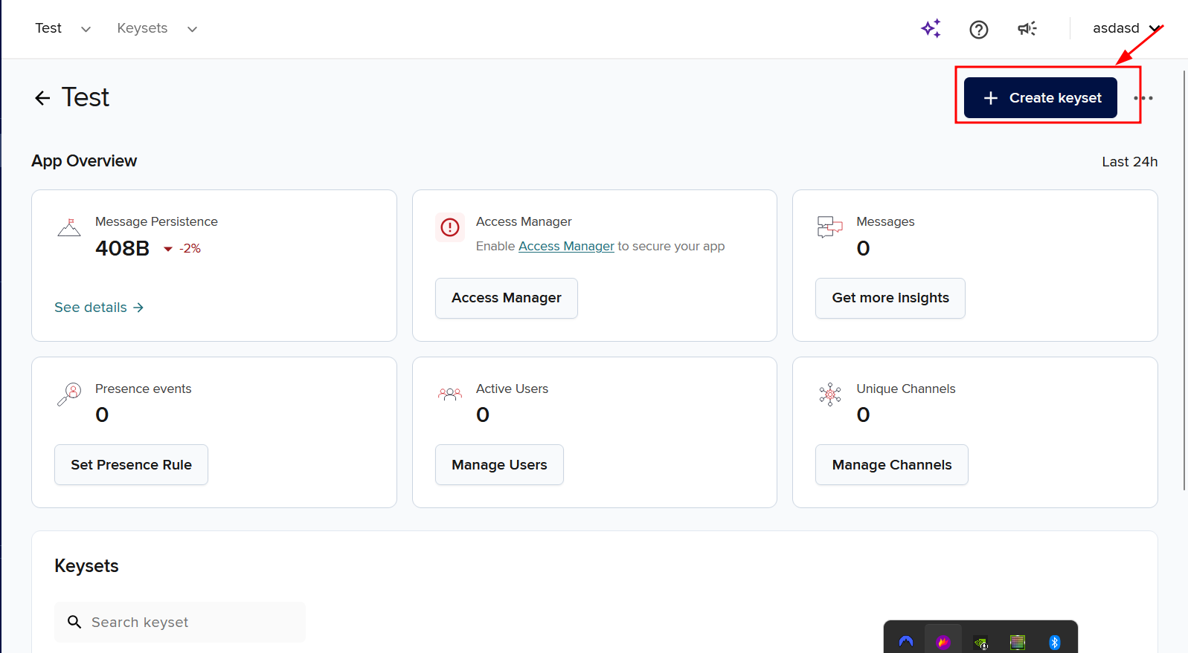
Fig: Clicking on the Create Keyset button.

Step 3: In the App Name field, enter a string containing special characters (e.g., <@#$%^&*()). and click on the next button and the create button.
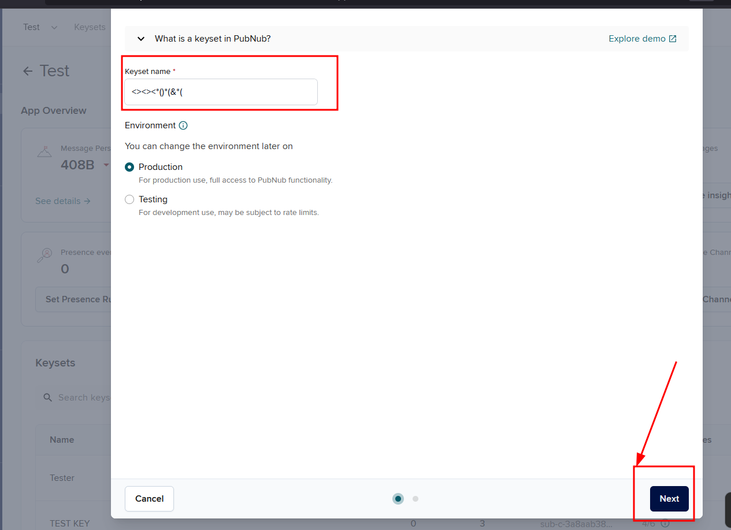
Fig: Entering a special character in the Keyset name and clicking Next.
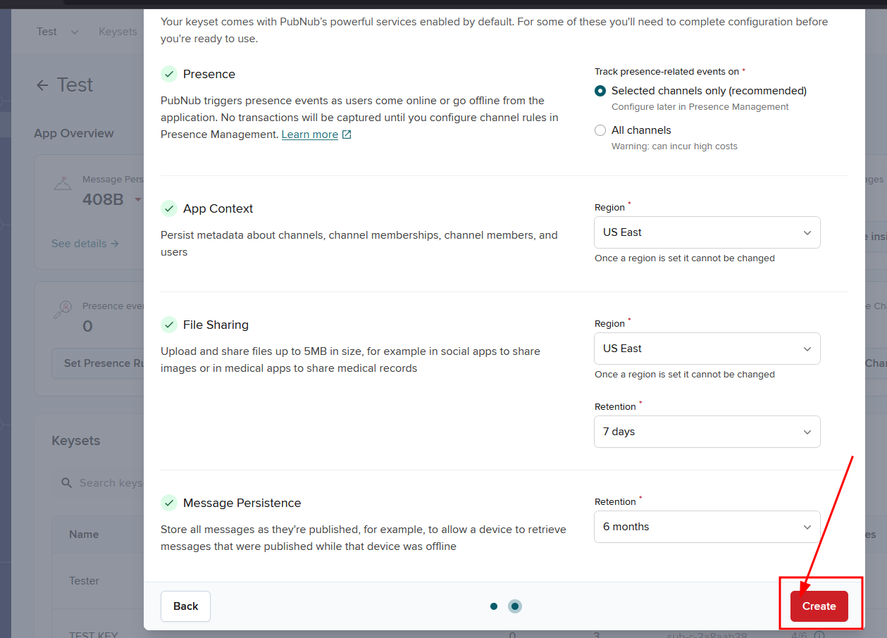
Fig: Submission of special characters upon clicking the Create button
Step 4: Observe that the application successfully creates the app with the provided special characters.
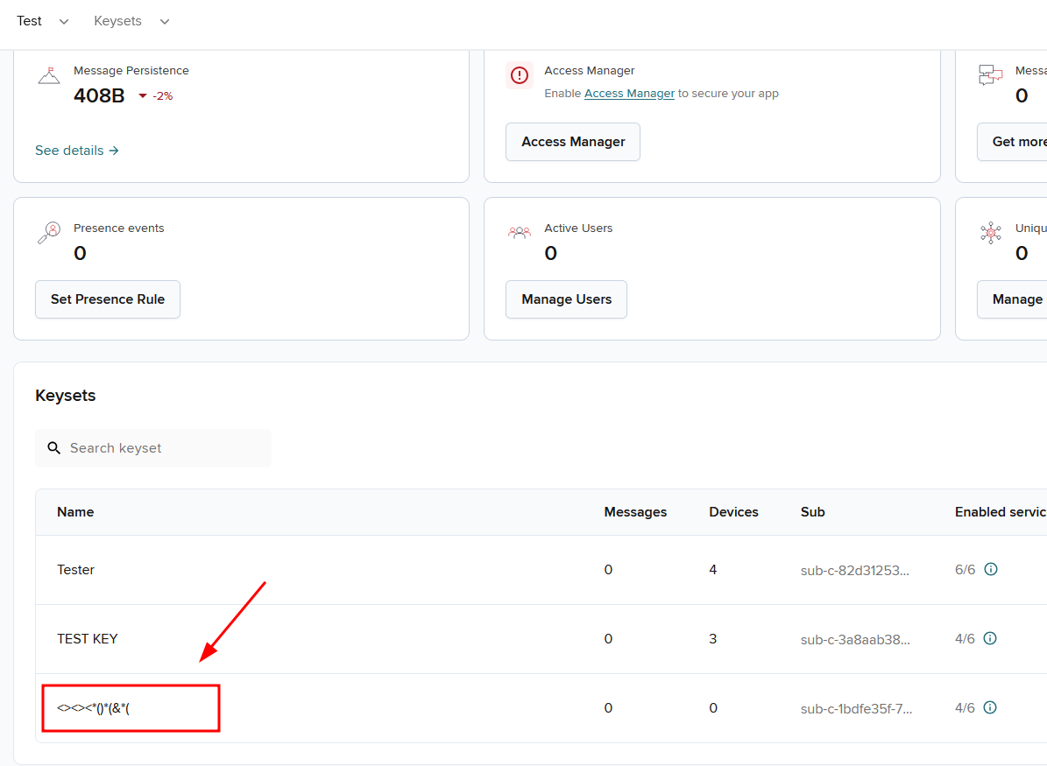
Fig: Special characters are getting accepted and displayed on the page as expected
Impact and Likelihood:
- The immediate impact of this vulnerability is low, primarily affecting data integrity and UI consistency. However, if user-supplied input is later rendered on web pages without proper escaping or sanitization, it could lead to cross-site scripting (XSS) attacks.
- The likelihood of exploitation is low. Effective exploitation requires combining this flaw with other vulnerabilities, and the encoding of frontend characters reduces the immediate risk, though server-side bypass remains a concern.

Recommendations:
- Enforce validation rules to reject or sanitize special characters at all server-side input points.
- Sanitize inputs to disallow or escape special characters where not explicitly required.
- Adopt a centralized validation framework or library to enforce consistent input handling
Reference:
- M4: Insufficient Input/Output Validation | OWASP Foundation
- What is improper input validation? | Tutorial & examples | Snyk Learn
- Input validation errors: The root of all evil in web application security | Invicti

Back to Summary

7.7 Concurrent Login
Risk: Informational

Description:
The PubNub application allows concurrent logins, permitting the same user account to be logged in from multiple devices or sessions simultaneously using the same credentials. This lack of session exclusivity can lead to unauthorized access if credentials are compromised or shared. For example, if an attacker gains access to a user’s credentials, they can log in without the legitimate user being aware, as the original session remains active. This is particularly concerning for sensitive accounts (e.g., admin accounts), where concurrent logins could enable undetected malicious activity.

Affected URL: https://admin.pubnub.com
Note: This issue is not limited to a single endpoint and appears to be a systemic weakness throughout the application.

Steps to reproduce:
Step 1: Log in to the application with a user account from one device (e.g., Device A, such as a laptop).
Step 2: Using the same credentials, log in to the application from a different device (e.g., Device B, such as a smartphone) or a different browser session (e.g., incognito mode).
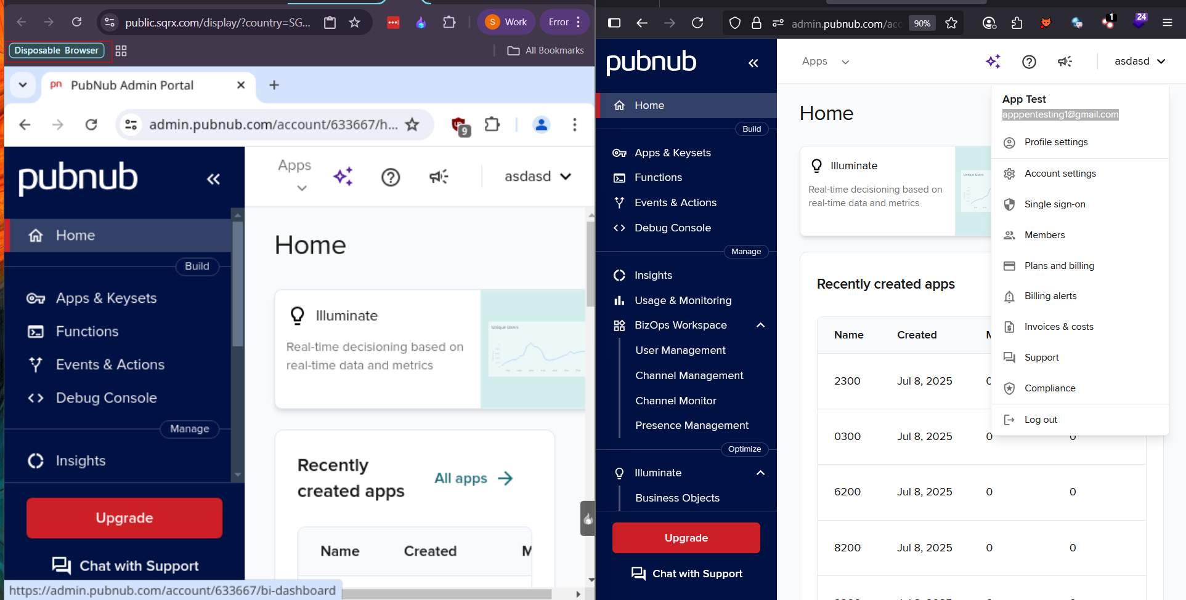
Fig: Concurrent user sessions maintained across devices without invalidation.
Impact and Likelihood:
- Concurrent logins increase the risk of unauthorized access, especially if credentials are stolen, shared, or improperly managed. An attacker could perform malicious actions (e.g., data theft, account modification) while the legitimate user remains unaware, as their session is not terminated. For admin accounts, this could lead to significant damage, such as data breaches or system compromise.
- The likelihood of exploitation is moderate. It requires an attacker to obtain valid credentials (e.g., through phishing, credential stuffing, or session hijacking), but the absence of session exclusivity makes it easier for attackers to operate undetected once credentials are compromised. Application-wide rate limiting does not mitigate this issue, as it does not prevent legitimate credential use across multiple sessions.

Recommendations:
- Implement a policy to allow only one active session per user account at a time. When a new login occurs, terminate the previous session by invalidating its session token.
- Implement a notification system to alert users via email or another secure channel when a new login occurs. Include details such as the device, location, and timestamp to help users identify unauthorized access.
- Allow users to view and manage their active sessions through the application interface. Enable users to terminate all other sessions except the current one, especially after a password change.
- Log all login events with details (e.g., IP address, device, timestamp) and monitor for suspicious activity, such as logins from multiple geographic locations in a short time frame. Use this data to trigger alerts or automatically terminate suspicious sessions.
Reference:
- Session Management - OWASP Cheat Sheet Series
- What Is Session Management & Tips to Do It Securely
- Best Practices for Application Session Management
- How Session Management Works and Why It’s Important | Ping Identity

Back to Summary

8. Appendix A: Penetration Test Scope

V2 | Authentication Verification Requirements
2.5.3 | Verify that password credential recovery does not reveal the current password in any way
2.5.4 | Verify shared or default accounts are not present (e.g., "root", "admin", or "sa").

V4 | Access Control Verification Requirements
4.2 | Operation Level Access Control
4.2.2 | Verify that the application or framework enforces a strong anti-CSRF mechanism to protect authenticated functionality, andthat effective anti-automation or anti-CSRF protection protects unauthenticated functionality
4.3 | Other Access Control Considerations
4.3.2 | Verify that directory browsing is disabled unless deliberately desired. Additionally, applications should not allow discovery or disclosure of file or directory metadata, such as Thumbs.db.DS_Store, .git, or .svn folders

V5 | Validation, Sanitization and Encoding Verification Requirements Control Objective
5.1 | Input Validation Requirements
5.1.1 | Verify that the application has defenses against HTTP parameter pollution attacks, particularly if the application framework makes no distinction about the source of request parameters (GET, POST, cookies, headers, or environment variables)
5.1.2 | Verify that frameworks protect against mass parameter assignment attacks, or that the application has countermeasures to protect against unsafe parameter assignment, such as marking fields private or similar
5.1.3 | Verify that all input (HTML form fields, REST requests, URL parameters, HTTP headers, cookies, batch files, RSS feeds, etc) is validated using positive validation (whitelisting)
5.1.4 | Verify that structured data is strongly typed and validated against a defined schema, including allowed characters, lengt,h and pattern (e.g,. credit card numbers or telephone, or validating that two related fields are reasonable, such as checking that suburb and zip/postcode match)
5.1.5 | Verify that URL redirects and forwards only allow whitelisted destinations, or show a warning when redirecting to potentially untrusted content
5.2.1 | Verify that all untrusted HTML input from WYSIWYG editors or similar is properly sanitized with an HTML sanitizer library or framework feature
5.2.2 | Verify that unstructured data is sanitized to enforce safety measures such as allowed characters and length
5.2.3 | Verify that the application sanitizes user input before passing to mail systems to protect against SMTP or IMAP injection
5.2.4 | Verify that the application avoids the use of eval() or other dynamic code execution features. Where there is no alternative, any user input being included must be sanitized or sandboxed before being executed
5.2.5 | Verify that the application protects against template injection attacks by ensuring that any user input being included is sanitized or sandboxed
5.2.6 | Verify that the application protects against SSRF attacks by validating or sanitizing untrusted data or HTTP file metadata, such as filenames and URL input fields, using whitelisting of protocols, domains, paths, and ports
5.2.7 | Verify that the application sanitizes, disables, or sandboxes user-supplied SVG scriptable content, especially as they relate to XSS resulting from inline scripts, and foreignObject
5.2.8 | Verify that the application sanitizes, disables, or sandboxes user-supplied scriptable or expression template language content, such as Markdown, CSS or XSL stylesheets, BBCode, or similar
5.3 | Output encoding and Injection Prevention Requirements
5.3.1 | Verify that the output encoding is relevant for the interpreter and context required. For example, use encoders specifically for HTML values, HTML attributes, JavaScript, URL Parameters, HTTP headers, SMTP, and others as the context requires, especially from untrusted inputs (e.g., names with Unicode or apostrophes, such as ねこ or O'Hara).
5.3.2 | Verify that output encoding preserves the user's chosen character set and locale, such that any Unicode character point is valid and safely handled
5.3.3 | Verify that context-aware, preferably automated - or at worst, manual - output escaping protects against reflected, stored, and DOM-based XSS
5.3.4 | Verify that data selection or database queries (e.g., SQL, HQL, ORM, NoSQL) use parameterized queries, ORMs, entity frameworks, or are otherwise protected from database injection attacks
5.3.5 | Verify that, where parameterized or safer mechanisms are not present, context-specific output encoding is used to protect against injection attacks, such as the use of SQL escaping to protect against SQL injection
5.3.6 | Verify that the application projects against JavaScript or JSON injection attacks, including for eval attacks, remote JavaScript includes, CSP bypasses, DOM XSS, and JavaScript expression evaluation.
5.3.7 | Verify that the application protects against LDAP Injection vulnerabilities, or that specific security controls to prevent LDAP Injection have been implemented
5.3.8 | Verify that the application protects against OS command injection and that operating system calls use parameterized OS queries or use contextual command line output encoding
5.3.9 | Verify that the application protects against Local File Inclusion (LFI) or Remote File Inclusion (RFI) attacks
5.3.10 | Verify that the application protects against XPath injection or XML injection attacks
5.5 | Deserialization Prevention Requirements
5.5.1 | Verify that serialized objects use integrity checks or are encrypted to prevent hostile object creation or data tampering
5.5.2 | Verify that the application correctly restricts XML parsers to only use the most restrictive configuration possible and to ensure that unsafe features, such as resolving external entities, are disabled to prevent XXE
5.5.3 | Verify that deserialization of untrusted data is avoided or is protected in both custom code and third-party libraries (such as JSON, XML and YAML parsers)
5.5.4 | Verify that when parsing JSON in browsers or JavaScript-based backends, JSON.parse is used to parse the JSON document. Do not use eval() to parse JSON

V7 | Error Handling and Logging Verification Requirements
7.4 | Error Handling
7.4.1 | Verify that a generic message is shown when an unexpected or security-sensitive error occurs, potentially with a unique ID that support personnel can use to investigate

V8 | Data Protection Verification Requirements
8.3 | Sensitive Private Data
8.3.1 | Verify that sensitive data is sent to the server in the HTTP message body or headers, and that query string parameters from any HTTP verb do not contain sensitive data

V9 | Communications Verification Requirements
9.1 | Communications Security Requirements
9.1.1 | Verify that secured TLS is used for all client connectivity, and does not fall back to insecure or unencrypted protocols.
9.1.2 | Verify using online or up-to-date TLS testing tools that only strong algorithms, ciphers, and protocols are enabled, with the strongest algorithms and ciphers set as preferred
9.1.3 | Verify that old versions of SSL and TLS protocols, algorithms, ciphers, and configurations are disabled, such as SSLv2, SSLv3, or TLS 1.0 and TLS 1.1. The latest version of TLS should be the preferred cipher suite

V11 | Business Logic Verification Requirements
11.1.1 | Verify that the application will only process business logic flows for the same user in sequential step order and without skipping steps
11.1.2 | Verify the application will only process business logic flows with all steps being processed in realistic human time, i.e., transactions are not submitted too quickly
11.1.3 | Verify the application has appropriate limits for specific business actions or transactions, which are correctly enforced on a per-user basis
11.1.4 | Verify the application has sufficient anti-automation controls to detect and protect against data exfiltration, excessive business logic requests, excessive file uploads or denial of service attacks
11.1.5 | Verify the application has business logic limits or validation to protect against likely business risks or threats, identified using threat modelling or similar methodologies

V12 | File and Resources Verification Requirements
12.1 | File Upload Requirements
12.1.1 | Verify that the application will not accept large files that could fill up storage or cause a denial of service attack
12.2 | File Integrity Requirements
12.2.1 | Verify that files obtained from untrusted sources are validated to be of the expected type based on the file's content
12.3 | File Execution Requirements
12.3.1 | Verify that user-submitted filename metadata is not used directly with system or framework file and URL API to protect against path traversal
12.3.2 | Verify that user-submitted filename metadata is validated or ignored to prevent the disclosure, creation, updating, or removal of local files (LFI)
12.3.3 | Verify that user-submitted filename metadata is validated or ignored to prevent the disclosure or execution of remote files (RFI), which may also lead to SSRF
12.3.4 | Verify that the application protects against reflective file download (RFD) by validating or ignoring user-submitted filenames in a JSON, JSONP, or URL parameter, the response Content-Type header should be set to text/plain, and the Content-Disposition header should have a fixed filename
12.3.5 | Verify that untrusted file metadata is not used directly with system API or libraries, to protect against OS command injection
12.3.6 | Verify that the application does not include and execute functionality from untrusted sources, such as unverified content distribution networks, JavaScript libraries, node npm libraries, or server-side DLLs
12.5 | File Download Requirements
12.5.1 | Verify that the web tier is configured to serve only files with specific file extensions to prevent unintentional information and source code leakage. For example, backup files (e.g., .bak), temporary working files (e.g., .swp), compressed files (.zip, .tar.gz, etc,) and other extensions commonly used by editors should be blocked unless required
12.5.2 | Verify that direct requests to uploaded files will never be executed as HTML/JavaScript content

V13 | API and Web Service Verification Requirements
13.1 | Generic Web Service Security Verification Requirements
13.1.1 | Verify that all application components use the same encodings and parsers to avoid parsing attacks that exploit different URI or file parsing behavior that could be used in SSRF and RFI attacks
13.1.2 | Verify that access to administration and management functions is limited to authorized administrators
13.1.3 | Verify API URLs do not expose sensitive information, such as the API key, session tokens, etc
13.1.4 | Verify that authorization decisions are made at both the URI, enforced by programmatic or declarative security at the controller or router, and at the resource level, enforced by model-based permissions
13.1.5 | Verify that requests containing unexpected or missing content types are rejected with appropriate headers (HTTP response status 406 Unacceptable or 415 Unsupported Media Type)
13.2 | RESTful Web Service Verification Requirements
13.2.1 | Verify that enabled RESTful HTTP methods are a valid choice for the user or action, such as preventing normal usersfrom using DELETE or PUT on protected API or resources
13.2.2 | Verify that JSON schema validation is in place and verified before accepting input
13.2.3 | Verify that RESTful web services that utilize cookies are protected from Cross-Site Request Forgery via the use of at least one or more of the following: triple or double submit cookie pattern (see references), CSRF nonces, or ORIGIN request header checks
13.2.4 | Verify that REST services have anti-automation controls to protect against excessive calls, especially if the API is unauthenticated
13.2.5 | Verify that REST services explicitly check the incoming Content-Type to be the expected one, such as application/XML or application/JSON
13.2.6 | Verify that the message headers and payload are trustworthy and not modified in transit. Requiring strong encryption for transport (TLS only) may be sufficient in many cases as it provides both confidentiality and integrity protection. Permessage digital signatures can provide additional assurance on top of the transport protections for high-security applications but bring with them additional complexity and risks to weigh against the benefits
13.3 | SOAP Web Service Verification Requirements
13.3.1 | Verify that XSD schema validation takes place to ensure a properly formed XML document, followed by validation of each input field before any processing of that data takes place
13.3.2 | Verify that the message payload is signed using WS-Security to ensure reliable transport between client and service
13.4 | GraphQL and other Web Service Data Layer Security Requirements
13.4.1 | Verify that query whitelisting or a combination of depth limiting and amount limiting should be used to prevent GraphQL or data layer expression denial of service (DoS) as a result of expensive, nested queries. For more advanced scenarios, query cost analysis should be used
13.4.2 | Verify that GraphQL or other data layer authorization logic should be implemented at the business logic layer instead of the GraphQL layer

V14 | Configuration Verification Requirements
14.2 | Dependency
14.2.1 | Verify that all components are up to date
14.2.2 | Verify that all unneeded features, documentation, samples, configurations are removed, such as sample applications, platform documentation, and default or example users
14.2.3 | Verify that if application assets, such as JavaScript libraries, CSS stylesheets or web fonts, are hosted externally on a content delivery network (CDN) or external provider, Subresource Integrity (SRI) is used to validate the integrity of the asset
14.3 | Unintended Security Disclosure Requirements
14.3.1 | Verify that web or application server and framework error messages are configured to deliver user actionable, customized responses to eliminate any unintended security disclosures
14.3.2 | Verify that web or application server and application framework debug modes are disabled in production to eliminate debug features, developer consoles, and unintended security disclosures
14.3.3 | Verify that the HTTP headers or any part of the HTTP response do not expose detailed version information of system components
14.4 | HTTP Security Headers Requirements
14.4.1 | Verify that every HTTP response contains a content type header specifying a safe character set (e.g., UTF-8, ISO 8859-1)
14.4.2 | Verify that all API responses contain Content-Disposition: attachment; filename="api.json" (or other appropriate filename for the content type).
14.4.3 | Verify that a content security policy (CSPv2) is in place that helps mitigate impact for XSS attacks like HTML, DOM, JSON, and JavaScript injection vulnerabilities
14.4.4 | Verify that all responses contain X-Content-Type-Options: nosniff
14.4.5 | Verify that HTTP Strict Transport Security headers are included on all responses and for all subdomains, such as Strict-Transport-Security: max-age=15724800; includeSubdomains
14.4.6 | Verify that a suitable "Referrer-Policy" header is included, such as "no-referrer" or "same-origin
14.4.7 | Verify that a suitable X-Frame-Options or Content-Security-Policy: frameancestors header is in use for sites where content should not be embedded in a third-party site
14.5 | Validate HTTP Request Header Requirements
14.5.1 | Verify that the application server only accepts the HTTP methods in use by the application or API, including pre-flight OPTIONS
14.5.2 | Verify that the supplied Origin header is not used for authentication or access control decisions, as the Origin header can easily be changed by an attacker
14.5.3 | Verify that the cross-domain resource sharing (CORS) Access-Control-AllowOrigin header uses a strict white-list of trusted domains to match against and does not support the "null" origin
14.5.4 | Verify that HTTP headers added by a trusted proxy or SSO devices, such as a bearer token, are authenticated by the application

