**ETL: Extract, Transform, Load**

ETL stands for Extract, Transform, and Load, which are the key processes in data handling and preparation. Below is a detailed explanation of each step:

### **1. Extract:**

* **Definition:** Pull data from various data sources.
* **Common Data Sources:**
  + Excel files
  + CSV files
  + Text files
  + Databases, etc.

### **2. Transform:**

* **Definition:** Process and clean the data to make it usable for analysis.
* **Key Actions:**
  + Data processing
  + Data cleaning (handling NULL, missing, or duplicate values)
  + Formatting data for consistency

### **3. Load:**

Load the data for analysis

### **Steps to Perform ETL in Power BI**

#### **STEP 1:** Open Power BI Desktop Application

#### **STEP 2:** Click on **Blank Report** to start a new project.

#### **STEP 3:** Click on **Get Data** and select the appropriate data source (e.g., **Text/CSV**) to load the dataset into Power BI.

#### **STEP 4: Transform Data**

* Click on **Transform Data** to open the Power Query Editor.
* If there is and empty column then select it and remove it as it will not contribute in any of our visualization, If by mistake if a column is removed then we can get it back from the Applied steps table in the right side of Power query editor

#### **STEP 5: Save Changes**

* After making all necessary transformations, save the changes in Power Query Editor.

#### **STEP 6: Power BI Features**

* Return to Power BI Desktop, where you can access several views on the left-hand pane:
  1. **Report View:** Used for creating visualizations and dashboards.
  2. **Table View:** Displays the dataset, including the transformed data.
  3. **Model View:** Allows you to create relationships among different tables and map them together.
  4. **DAX Query View:** Enables advanced querying and calculations using Data Analysis Expressions (DAX).

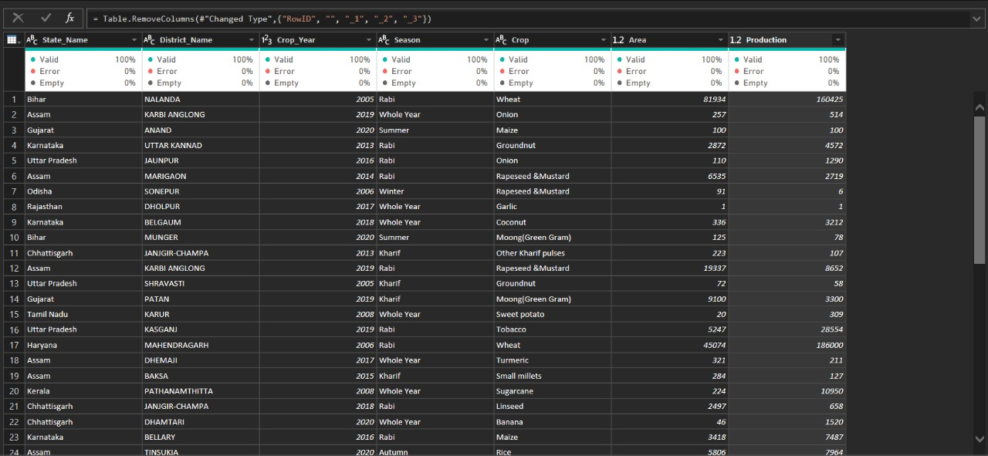

**Assignment Screenshot**