IMD vs ERA5 Rainfall over West Bengal
Methodology, Reading Guide, and Viva Defence
Companion to EDA/EDA_02_imd_vs_era5_correlation.ipynb (Track 1B). Prepared 2026-05-29. All figures and numbers come directly from the notebook run.

1. What this notebook answers, and why it matters
Our best rainfall model (exp_13, a GAT-GRU graph network) was trained on ERA5 reanalysis data, which is complete and tidy. The guide asked a fair question: does it work on REAL observed rainfall from IMD rain gauges? In exp_14 we trained the identical model on IMD gauges for the same 16 stations and the same period, and the error was much higher (RMSE about 17.6 mm) than on ERA5 (about 10.4 mm).
This notebook (Track 1B) explains WHY, by directly measuring how different the two datasets are, station by station, using only simple and easily-defended statistics. The short answer: IMD and ERA5 agree on the long-run average rainfall, but disagree substantially day to day. That disagreement is a known, published property of ERA5, and it is the reason the model looks better on ERA5 than on observations.

2. Background: what the two datasets are (the theory)
IMD (observation). Daily rainfall measured by physical rain gauges run by the India Meteorological Department. A gauge is ground truth at a single point, but the network is sparse and has large gaps (many stations have years of missing data).
ERA5 (reanalysis). ERA5 is not raw observation. It is the output of a numerical weather model (from ECMWF) that blends many observations together and produces a gap-free, physically-consistent grid covering the whole globe at about 0.25 degrees (roughly 31 km) resolution. Crucially, rainfall in ERA5 is a MODEL-GENERATED field (it is forecast by the model, not measured directly), so it inherits the model's tendencies.
Why we should EXPECT them to differ. Two structural reasons, both of which we will see in the figures: (1) a 31 km grid cell reports an area average, which smooths out the sharp local downpours a single gauge records, so ERA5 under-represents extremes; (2) weather models tend to produce light rain too often (the well-known reanalysis drizzle problem), so ERA5 reports many more rainy days than gauges do. These are theoretical expectations that the data then confirms.

3. The data and how it is prepared (inputs)
The notebook loads four inputs:
File | What it is | Used for
preprocessed_rain_data.parquet | IMD daily rainfall, long form (station, date, rainfall, lat, lon) | Observed (gauge) series
era5_pivot_data/rain_pivot.parquet | ERA5 daily rainfall, wide form (date x station) | Reanalysis series
wb_station_coords.csv | Station latitude / longitude | Plotting on the map
West_Bengal/...shp | District boundary shapefile | Map background
Alignment and an important choice: both datasets are put on the same daily calendar and restricted to their overlap, 1970-2021. IMD is pivoted to (date x station) and we keep OBSERVED days only - missing gauge values stay missing and are NEVER filled in. This matters: we only compare ERA5 against IMD on days a real gauge value exists, so the comparison is honest.
291 stations are common to both datasets. For the maps we keep the 199 stations that have at least one full year (>=365) of overlapping observed days, so each station's statistics are stable rather than computed from a handful of noisy days.

4. The four measurements (what they are, how computed, how to read)
Pearson correlation (r). Line the two daily series up day-by-day and ask: when one goes up, does the other go up too? r runs from -1 (opposite), through 0 (no relationship), to +1 (move in lockstep). Computed with numpy's corrcoef on the paired daily values. Reading: closer to 1 = better day-to-day agreement. We get a median of about 0.37 - moderate: the same broad wet/dry rhythm, but a lot of day-to-day disagreement.
Mean bias = average(ERA5 minus IMD). A single number per station: positive means ERA5 is too wet on average, negative too dry, near zero means the long-run averages match. We get a median near 0 mm/day - the good-news half: ERA5 gets the average right.
Mean absolute difference (MAD) = average(|ERA5 minus IMD|). Bias can be near zero while individual days are very wrong (a +10 day and a -10 day cancel). MAD ignores the sign and measures the typical SIZE of the daily mismatch. We get about 7.6 mm - large next to the ~6.4 mm average. So: averages agree, single days do not. Bias and MAD always read together.
Wet-day frequency = share of days with at least 1 mm. The simplest check of all: how often does each dataset say it rained? IMD about 30%, ERA5 about 51%. ERA5 calls far more days rainy - the drizzle bias, made concrete.
Measurement | What it captures | Our result (median) | How to read it
Pearson r | day-to-day agreement | 0.37 full / 0.29 monsoon / 0.24 rainy | 1=identical, 0=unrelated; ours = moderate, weaker on rainy days
Mean bias | systematic over/under | about 0 mm/day | near 0 = averages match
MAD | typical daily error size | 7.6 mm/day | large vs 6.4 mm mean = big daily mismatch
Wet-day % | how often it rains | IMD 30% vs ERA5 51% | ERA5 over-reports rain (drizzle)

5. Why three slices: full, monsoon, rainy
Daily rainfall is zero-inflated - most days are dry in BOTH datasets. Agreeing on 'it was 0 mm today' inflates correlation for free, making ERA5 look better than it is. So we recompute on monsoon-only (Jun-Sep), then on rainy days only (IMD at least 1 mm). As we strip away the easy zeros, the correlation falls: 0.37 -> 0.29 -> 0.24. That decline IS the finding - the agreement was partly propped up by dry days; on the days that actually matter (when it rains), ERA5 and the gauge agree only weakly. This is the honest way to show it, and it needs no advanced statistics to explain.

6. The figures: inputs and how to read them

Figure 1 - Correlation histograms (three slices)
Input: the per-station Pearson r values (one number per station), split into three histograms - full series, monsoon, rainy days. The red dashed line marks the median; the x-axis is the correlation value, the y-axis counts how many stations fall in each bar.
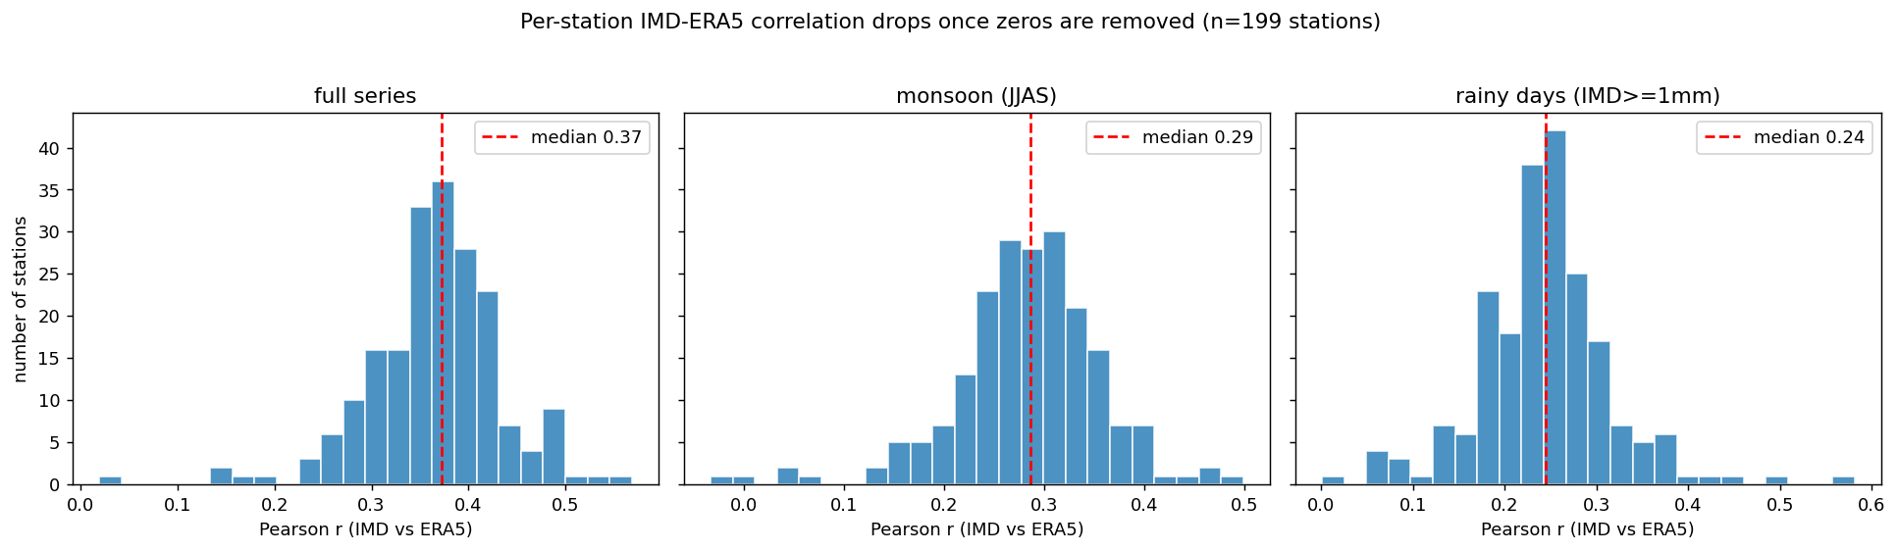
Figure 1. Distribution of per-station IMD-ERA5 correlation across the three slices.
How to read it: each bar = a group of stations with similar correlation. The whole distribution shifts LEFT (lower) as we go full -> monsoon -> rainy. Inference: stations broadly agree on the seasonal rhythm, but agreement weakens exactly when it rains - no single station reaches strong agreement (the maximum is about 0.57).

Figure 2 - Maps of correlation and bias across West Bengal
Input: the 199 well-sampled stations, plotted at their lat/lon on the district map. Left panel colours each station by its full-series correlation (brighter = higher). Right panel colours by mean bias on a red-blue scale (red = ERA5 wetter, blue = ERA5 drier, white = no bias).
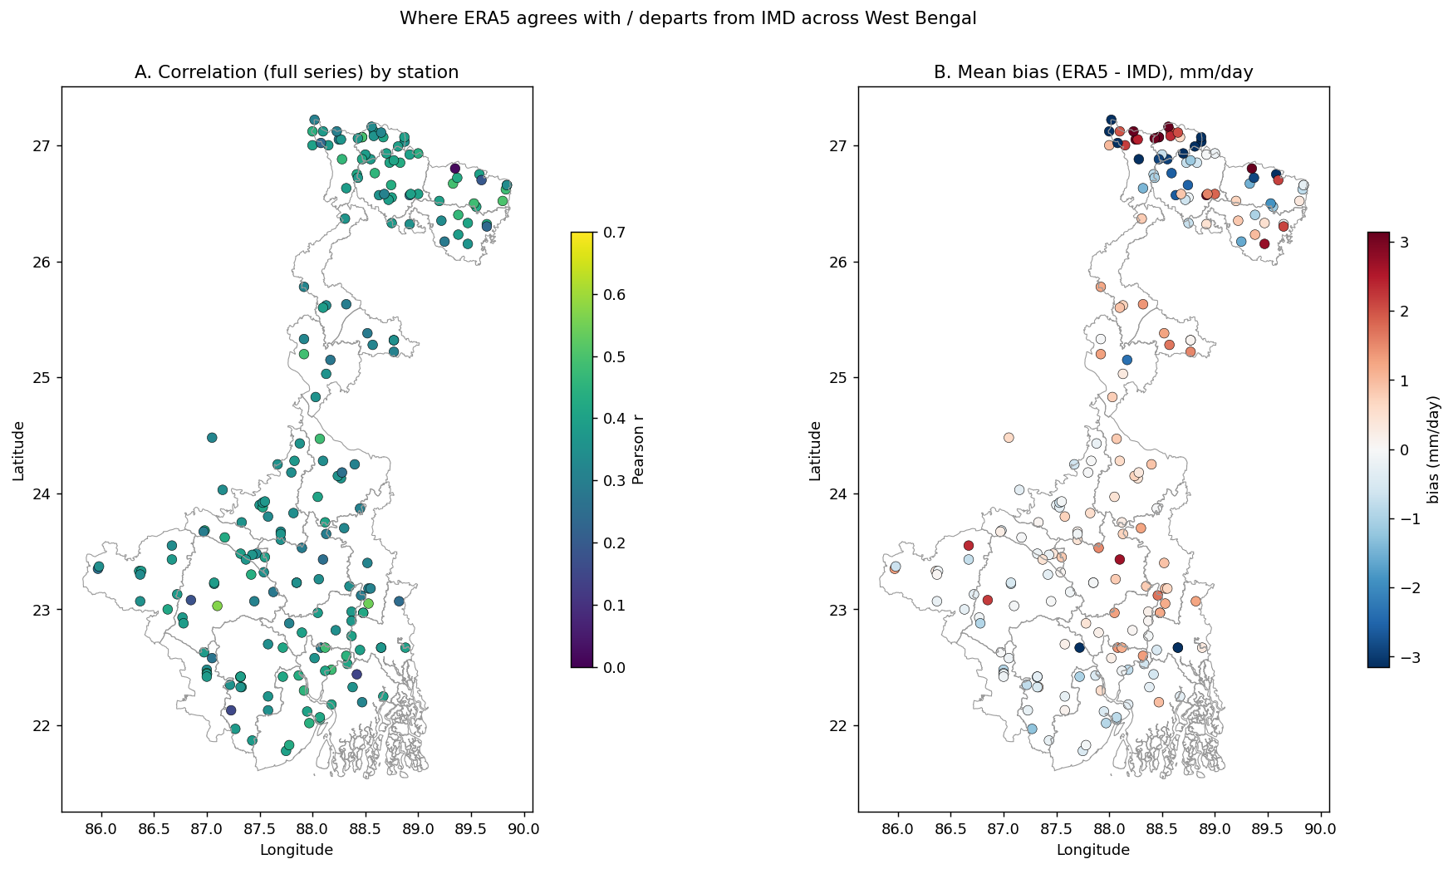
Figure 2. Spatial pattern of correlation (left) and bias (right). Note the noisier north.
How to read it: colour = the metric's value at that location. Inference: correlation is uniformly moderate across the plains and clearly LOWER in the hilly north (Darjeeling / foothills), and the bias is near zero almost everywhere except scattered strong departures in that same northern terrain. This matches the known fact that reanalyses struggle most over complex topography.

Figure 3 - Bias vs latitude, and the drizzle test
Inputs: left, each station's bias plotted against its latitude (purple dots) with a straight-line fit; right, each station's IMD wet-day % (x) against its ERA5 wet-day % (y), with the red line marking where they would be equal.
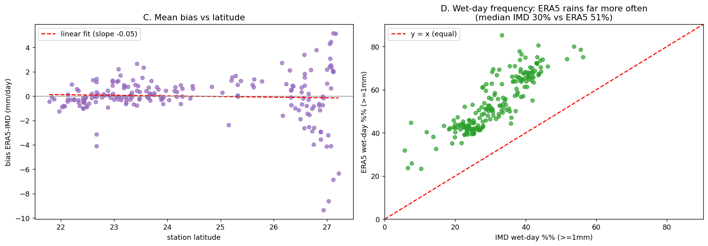
Figure 3. Bias has no latitude trend overall (left); ERA5 reports far more wet days than IMD (right).
How to read it: left - the flat fit means there is no overall north-south bias trend, but the SCATTER widens in the far north (foothills are hard for ERA5). Right - EVERY point sits well ABOVE the equal line, i.e. for every single station ERA5 records more rainy days than the gauge. This is the clearest, most intuitive evidence of the drizzle bias: median 51% vs 30%.

Figure 4 - One station, one monsoon
Input: the daily IMD (orange) and ERA5 (blue) series for a single median-correlation station, over one well-observed monsoon season - a concrete picture of everything the summary numbers describe.
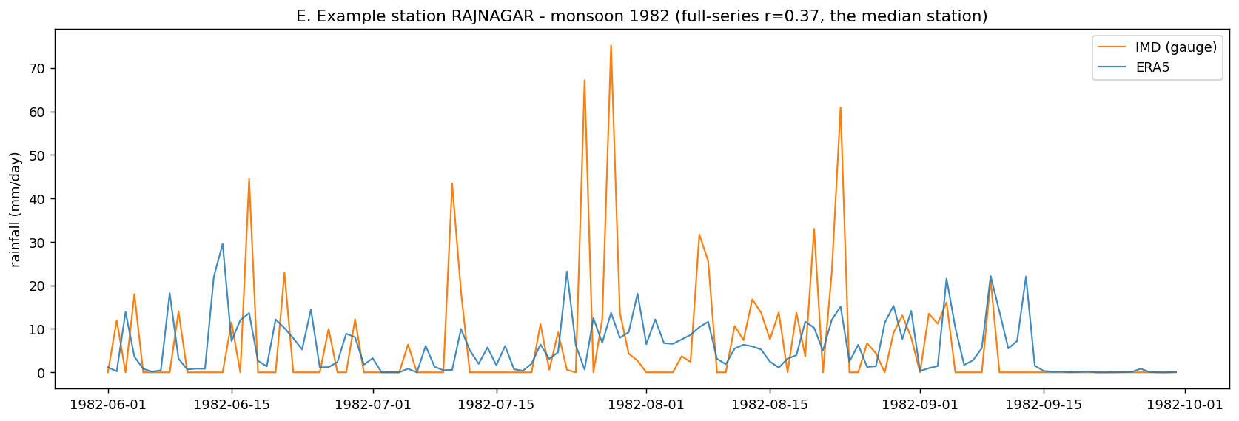
Figure 4. Example median-correlation station over one monsoon: ERA5 tracks the rhythm but shaves the gauge's sharp peaks.
How to read it: follow the two lines together. They rise and fall in roughly the same places (that is the ~0.37 correlation), but the orange gauge spikes higher and sharper while the blue ERA5 line is smoother and rains on more days. Inference: ERA5 is a smoothed, drizzly version of the real series - good for the rhythm, poor for the peaks.

7. Connecting every dot: the story
- ERA5 matches the AVERAGE / seasonal cycle (bias about 0). So it is a sound basis for the main GNN work, where gauges are too sparse to build a full graph.
- ERA5 is only a MODERATE match at the daily scale (r about 0.37, falling to 0.24 on rainy days), it over-reports light rain (51% vs 30% wet days) and smooths extremes, worst over the hilly north.
- This is exactly what the published literature reports for ERA5 over India and the monsoon (see references). So our result corroborates established science - it is not a fragile new claim or a pipeline bug.
- Therefore the exp_14 result makes sense. Because ERA5 is smoother and roughly twice as autocorrelated day-to-day (lag-1 autocorrelation about 0.56 for ERA5 vs 0.31 for IMD), 'predict tomorrow from recent days' is intrinsically easier on ERA5. The same architecture therefore scores better on ERA5 than on real gauges. The gap is a property of the DATA, not a failure of the MODEL.
In one line: Track 1B (this notebook) explains the gap that Track 1A (exp_14) measured.
The exp_14 numbers this explains (real-space test RMSE, mm/day):
Model / baseline | Data (16 stations, 2000-2020) | RMSE (mm)
Persistence (naive) | - | 22.5
Climatology (seasonal mean) | - | 18.5
GAT-GRU, rain only | IMD (observations) | 17.6
GAT-GRU, rain only | ERA5 (reanalysis) | 10.4
GAT-GRU, 12 features | ERA5 (reanalysis) | 10.0
Reading the table: the IMD model still beats the naive baselines (so it learned something real), but it cannot match the ERA5 model - and Figures 1-4 show why.

8. Defending it in the viva (likely questions)
Q: Isn't your IMD model simply bad? A: It has real, measured skill - it beats both persistence (22.5) and climatology (18.5). The higher error reflects that daily gauge rainfall is intrinsically hard to predict, which Track 1B quantifies. The contribution is measuring the observation-vs-reanalysis gap on identical stations, not chasing a low number.
Q: Why is correlation only ~0.4? A: We compare a single gauge POINT against a 31 km ERA5 area-average, on a zero-inflated daily variable. Moderate correlation is exactly what the literature reports for ERA5 vs gauges over monsoon India; ~0.4 is consistent, not anomalous.
Q: Did you cherry-pick stations? A: No. Track 1B uses all 291 shared stations (199 with >=1 year of data) across the whole state, and the pattern is uniform. The exp_14 16-station subset gives the same picture (r about 0.41/0.31/0.27), so the finding is network-wide.
Q: Why only simple statistics? A: Deliberately. Correlation, bias, absolute difference and wet-day frequency are transparent, hard to misread, and standard in precipitation-evaluation papers. They are enough to support every claim, and they agree with the published record.

9. Honest limitations
- Point vs area: a gauge measures one point; ERA5 a 31 km cell. Some disagreement is unavoidable and is a property of the comparison, not a defect in either dataset.
- Missing data: IMD has large gaps, so per-station statistics use only overlapping observed days; we require >=365 days for the maps to keep them stable.
- We deliberately stop at simple descriptive statistics (no Spearman, quantile regression, or categorical skill scores) - a conscious scope choice for clarity and defensibility, noted here for transparency.

10. References (ERA5 vs gauges)
- Lavers et al. (2022). An evaluation of ERA5 precipitation for climate monitoring. Q. J. R. Meteorol. Soc.
- Assessment of IMDAA, NGFS and ERA5 against rainfall observations for the Indian region. Atmospheric Research (2021).
- Characteristics of extreme rainfall in different gridded datasets over India 1983-2015. Atmospheric Research (2021).
- Spatial reproducibility of Indian summer monsoon rainfall regimes in gridded products. Scientific Reports (2024).

