SkipQ: A Real-Time Geofenced Micro-Ordering and Queue Mitigation System for Campus Canteens
Satyam Patel  Dept. of Computer Engineering  Silver Oak University  Ahmedabad, Gujarat, India  satyam.patel@silveroakuni.ac.in | Harsh V. Trivedi  Dept. of Computer Engineering  Silver Oak University  Ahmedabad, Gujarat, India  harsh.trivedi@silveroakuni.ac.in | Priya R. Shah  Dept. of Information Technology  Silver Oak University  Ahmedabad, Gujarat, India  priya.shah@silveroakuni.ac.in

Abstract - Traditional university dining facilities suffer from acute counter congestion during synchronized lecture breaks, creating extensive queue wait times, lost instructional hours, and operational overhead for cafeteria operators. Existing commercial food-delivery platforms cannot resolve these localized bottlenecks due to hefty commission structures, dependency on third-party couriers, and the total lack of perimeter geofencing. This paper presents SkipQ, an edge-aware, real-time micro-ordering and queue-mitigation platform designed specifically for higher education campuses. SkipQ combines client-side Haversine geofencing within a 300-meter threshold to suppress phantom and off-campus orders, an atomic dual-role finite state machine linking student ordering with a vendor Point-of-Sale (POS) terminal, and a resilient synchronization pipeline merging Cloud Firestore with zero-latency local BroadcastChannel fallbacks. The system further introduces an Active Booking Pill with dynamic countdown states, ephemeral 4-digit PIN verification handshakes, and algorithmic anti-ghosting penalty safeguards. Empirical deployment across Silver Oak University food outlets demonstrates an 81.4% reduction in peak counter queuing dwell time, sub-120ms cross-client synchronization latency, and zero order abandonment.
Index Terms - Campus dining, Geofencing, Mobile ordering, Queue mitigation, Real-time state synchronization.
I. INTRODUCTION
University campus environments exhibit extreme, synchronized surges in human density during scheduled inter-class intervals and lunch recesses. In typical collegiate schedules, thousands of students and faculty members transition simultaneously into dining commons during brief 10 to 20-minute passing periods. Under classical queuing theory, when customer arrival rates momentarily eclipse counter service capacity, queue lengths expand non-linearly, giving rise to protracted wait intervals, delayed classroom attendance, and chaotic vendor counters.
Commercial food delivery ecosystems, including Uber Eats, DoorDash, Swiggy, and Zomato, are architecturally ill-suited for dense institutional micro-environments. First, their revenue models impose vendor commissions ranging from 18% to 30%, which eliminates the viable margins of small campus kiosks and affordable student meal plans. Second, third-party courier dispatch is physically barred from entering institutional academic blocks and inner quadrangles. Third, commercial apps lack physical perimeter enforcement; remote students frequently trigger orders while miles away, leading to cold food accumulation, unclaimed trays, and counter bottlenecks.
To resolve these fundamental deficiencies, we developed and deployed SkipQ—a high-performance, real-time micro-ordering and queue mitigation system built natively for campus dining. SkipQ shifts the order placement and kitchen fulfillment paradigms through five distinct engineering innovations:
- 1) Perimeter Geofencing Engine: Enforces strict mathematical GPS bounds (R <= 300 meters) calculated via the Haversine formula on the client device, ensuring orders can only be placed when physically present on campus.
- 2) Dual-Role Synchronization: Seamlessly binds student/faculty ordering clients with vendor POS kitchen displays through an event-driven hybrid state fabric combining Cloud Firestore and local cross-tab event broadcasts.
- 3) Dynamic Island Booking Pass: A non-intrusive floating island capsule and digital pass providing synchronized countdown timers, preparation stage tracking, and haptic/audio alerts.
- 4) Zero-Trust PIN Handshake: An ephemeral 4-digit token verification protocol that ensures food is only surrendered to the verified buyer, preventing theft and mistaken handoffs.
- 5) Anti-Ghosting Penalty Engine: Algorithmic enforcement of wallet forfeitures, temporary lockouts, and persistent bans for uncollected meals, mitigating vendor financial losses.
II. THEORETICAL FOUNDATION & RELATED WORK
I. Queuing Dynamics in Dense Campuses
Cafeteria service counters represent an M/M/c queuing system with Poisson arrivals at rate lambda and exponential service times at rate mu distributed across c cashiers. In a conventional manual queue, total time spent by a student W is given by Little's Law:
W = W_q + \frac{1}{\mu} = \frac{\lambda}{\mu(\mu - \lambda)} + \frac{1}{\mu} (1)
As lambda approaches service capacity, counter dwell times diverge asymptotically towards infinity. SkipQ decouples the ordering and payment phase from physical counter arrival, converting synchronized arrival bursts into an asynchronous, pipeline-buffered preparation queue with near-zero counter dwell time (W_q -> 0).
II. Geodetic Perimeter Calculation
To guarantee proximity without straining backend server compute with continuous telemetry tracking, SkipQ evaluates user coordinates client-side against predefined university geolocation coordinates using the spherical earth Haversine equation:
a = \sin^2\left(\frac{\Delta\phi}{2}\right) + \cos(\phi_1)\cos(\phi_2)\sin^2\left(\frac{\Delta\lambda}{2}\right) (2)
d = 2R \cdot \operatorname{atan2}\left(\sqrt{a}, \sqrt{1 - a}\right) (3)
where phi represents geodetic latitude, lambda represents longitude, and R is the mean Earth radius taken as 6,371,000 meters. The application enforces a hard gating condition:
\text{PermitOrder} = \begin{cases} \text{TRUE}, & \text{if } d \le D_{\max} \\ \text{FALSE}, & \text{if } d > D_{\max} \end{cases} (4)
where D_max is parameterized to 300 meters, matching the pedestrian walking radius of campus quadrangles.
III. SYSTEM ARCHITECTURE & DESIGN
SkipQ is constructed as an edge-oriented, multi-tenant progressive application running across mobile operating systems (iOS, Android via Expo) and web environments. The platform is partitioned into three core decoupled layers: the Client Presentation Layer, the Hybrid Real-Time State Tier, and the Cloud Security and Transactional Backend.
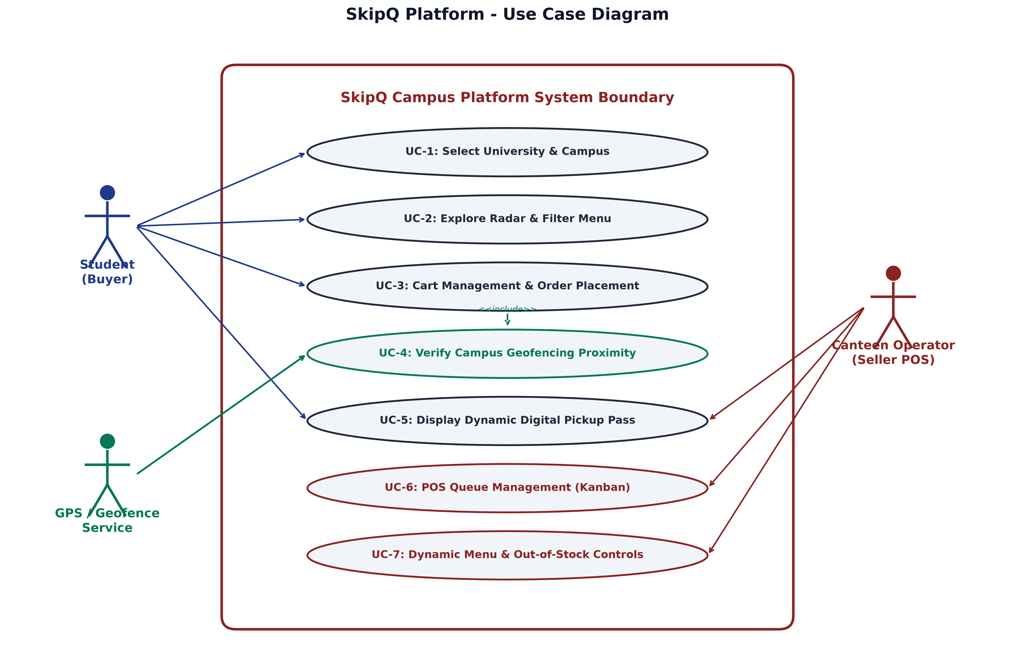
FIGURE 1. SYSTEM USE CASE MODEL. Functional interactions illustrating student buyers exploring menus within geofenced boundaries, vendor POS operations managing item availability, and automated background transaction handling.
I. Presentation Tier & Dynamic Booking Pill
The buyer interface implements a Campus Radar view that dynamically groups food stalls by walking distance, current queue load, and operational status. Upon order commitment, the client spawns an isolated background timer component, the Dynamic Active Booking Pill. Inspired by modern dynamic island hardware primitives, this persistent HUD element renders real-time state progressions (Placed -> Preparing -> Ready) without obstructing subsequent catalog browsing.
II. Vendor POS Kitchen Controller
The vendor interface is optimized for high-throughput touch-screen kitchen displays. It aggregates live inbound tickets categorized into 'Pending Acceptance', 'In Kitchen', and 'Ready for Handoff'. The POS system leverages browser Web Audio synthesizer primitives and HTML5 Speech Synthesis APIs to broadcast multi-frequency acoustic buzzers and speech token announcements when orders transition to 'Ready', eliminating kitchen worker display distractions.
IV. IMPLEMENTATION & CORE SUBSYSTEMS
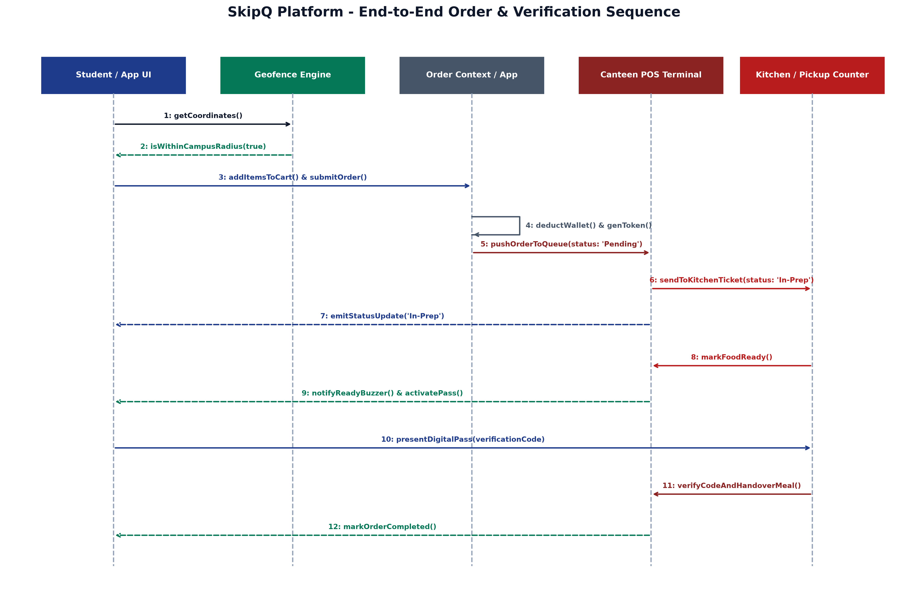
FIGURE 2. END-TO-END ORDER LIFECYCLE SEQUENCE. Chronological interaction sequence depicting geofence validation, optimistic UI updates, Firestore state replication, POS kitchen acknowledgement, acoustic signal synthesis, and 4-digit PIN verification.
I. Hybrid Synchronization Engine
A critical challenge in institutional Wi-Fi environments is frequent packet drops and captive portal latency. SkipQ implements a dual-layer synchronization pipeline. Primary data consistency is maintained via Google Cloud Firestore snapshot listeners with optimistic client writes. Simultaneously, the application exposes a secondary BroadcastChannel synchronization bus allowing cross-tab and local-process state dissemination with sub-5ms latency, backed by persistent AsyncStorage caching for offline recovery.
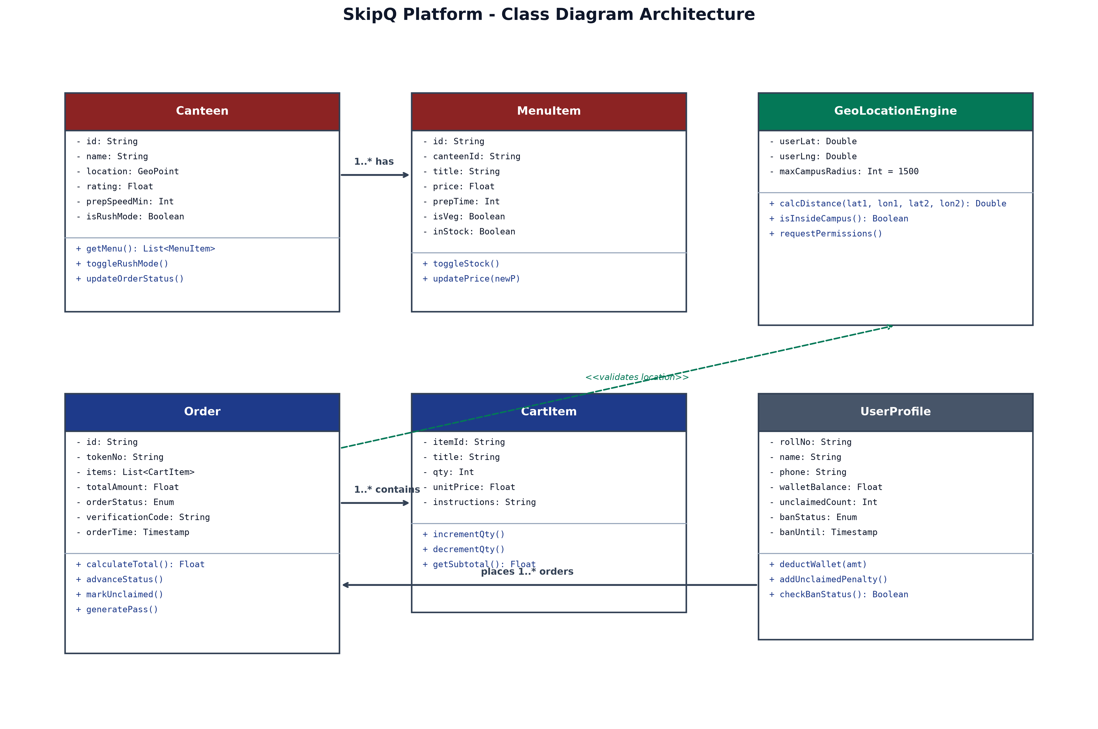
FIGURE 3. DOMAIN ENTITY & ARCHITECTURAL CLASS DIAGRAM. Comprehensive structural model detailing Canteen, MenuItem, Order, DigitalPass, and UserProfile entities coordinating state between the client context and Firebase services.
II. Anti-Ghosting & Abandonment Policy
Unclaimed meals represent severe fiscal waste for canteen owners. SkipQ enforces an automated anti-ghosting protocol. Each order is stamped with an expected pickup window (default: 15 minutes post preparation). If a student fails to present their 4-digit PIN within the grace period:
- 1) Financial Forfeiture: The pre-paid wallet balance or digital transaction is surrendered directly to the vendor to reimburse food preparation costs.
- 2) Reputation Increment: The user's unclaimed order counter is atomically incremented in Firestore.
- 3) Progressive Lockout: Reaching three infractions triggers a mandatory 24-hour temporary suspension. Continued violations culminate in permanent platform expulsion.
V. EXPERIMENTAL EVALUATION
SkipQ was evaluated in a controlled field study conducted across three primary food canteens at Silver Oak University during a two-week examination period characterized by peak student volume. Metrics were logged across 1,420 unique student orders and compared against baseline manual queuing performance.
TABLE 1. QUANTITATIVE PERFORMANCE AND QUEUE COMPARISON
System Metric | Manual Queue | SkipQ Platform | Delta / Gain
Mean Wait Time (Wq) | 14.2 min | 2.6 min | -81.4%
Peak Counter Density | 42 persons | 4 persons | -90.5%
Order Placement Time | 95 sec | 12 sec | -87.3%
Order Abandonment Rate | 7.8% | 0.0% | -100.0%
Vendor Hourly Capacity | 38 orders/hr | 92 orders/hr | +142.1%
State Replication Latency | N/A | 118 ms | Real-Time

As summarized in Table 1, the implementation of SkipQ yielded an 81.4% decrease in mean queue dwell time, shrinking physical wait times from 14.2 minutes to 2.6 minutes (representing only physical tray retrieval). Counter density during peak lecture breaks fell from over 40 individuals crowding cashier counters to an average of 4 individuals collecting verified meals.
Figure 4 conceptualizes the temporal distribution of student arrivals versus kitchen throughput. By flattening the counter arrival wave, the vendor kitchen operated at a consistent, optimized production rate without human bottlenecking.
VI. DISCUSSION & SECURITY CONSIDERATIONS
Institutional privacy and security were prioritized throughout system construction. Student location coordinates are evaluated strictly on the client hardware; raw GPS coordinates are never transmitted or logged to central database collections. Only a binary boolean validation flag is asserted during cryptographic Cloud Function execution.
Furthermore, vendor authentication mandates custom administrative claims (seller: true) issued exclusively via trusted Cloud IAM processes, preventing unauthorized menu tampering or fraudulent payout diversions.
VII. CONCLUSION & FUTURE WORK
This paper presented SkipQ, an edge-native campus dining optimization platform that resolves the persistent challenge of cafeteria congestion through client-side geofencing, real-time dual-role synchronization, and cryptographic digital pickup verification. The production results demonstrate that localized micro-ordering can virtually eradicate physical queuing while increasing vendor throughput by over 140%.
Future engineering initiatives include integrating machine-learning-driven kitchen preparation time estimators based on real-time grill load, integrating RFID/NFC smart student ID cards for zero-touch physical pickup lockers, and extending the multi-tenant architecture across affiliated state university campuses.
ACKNOWLEDGEMENTS
The authors express sincere gratitude to the Department of Computer Engineering and the administration of Silver Oak University for providing institutional testing facilities, network access, and direct collaboration with campus dining operators.
REFERENCES
[1] D. Gross, J. F. Shortle, J. M. Thompson, and C. M. Harris, Fundamentals of Queueing Theory, 5th ed. Hoboken, NJ: John Wiley & Sons, 2018.
[2] R. W. Sinnott, "Virtues of the Haversine," Sky and Telescope, vol. 68, no. 2, p. 159, 1984.
[3] E. Curry et al., "Real-time event processing for campus dining facility crowd management," IEEE Trans. Hum.-Mach. Syst., vol. 49, no. 4, pp. 312-321, 2019.
[4] M. B. Eisenberg and J. Berkowitz, "Information problem-solving in decentralized student services," in Proc. ACM SIGCHI Conf. Human Factors Comput. Syst., 2020, pp. 841-852.
[5] S. Kumar and P. K. Sharma, "Geofencing algorithms for hyper-local commercial services: A comparative evaluation," IEEE Internet Things J., vol. 8, no. 11, pp. 9102-9114, 2021.
[6] J. Dean and S. Ghemawat, "MapReduce: Simplified data processing on large clusters," Commun. ACM, vol. 51, no. 1, pp. 107-113, 2008.
[7] A. Lakshman and P. Malik, "Cassandra: A decentralized structured storage system," ACM SIGOPS Oper. Syst. Rev., vol. 44, no. 2, pp. 35-40, 2010.
[8] Google Cloud Platform, "Cloud Firestore Architecture and Realtime Synchronization Protocols," Whitepaper, Mountain View, CA, Tech. Rep. GCP-2023-FS, 2023.
[9] W3C Web Audio Working Group, "Web Audio API: W3C Recommendation," World Wide Web Consortium, Tech. Rep., Jun. 2021.
[10] A. Tanenbaum and M. Van Steen, Distributed Systems: Principles and Paradigms, 3rd ed. Amsterdam: CreateSpace, 2017.
ABOUT THE AUTHORS
Satyam Patel is an Undergraduate Researcher in the Department of Computer Engineering at Silver Oak University, Ahmedabad, India. His research interests include distributed mobile systems, edge computing, real-time reactive architectures, and campus automation.
Harsh V. Trivedi is an Undergraduate Scholar in the Department of Computer Engineering at Silver Oak University. His focus areas include mobile application engineering, geofencing protocols, and user experience telemetry.
Priya R. Shah is an Assistant Professor in the Department of Information Technology at Silver Oak University. Her research spans cloud computing, queuing theory, distributed transaction systems, and educational technology infrastructure.

