Oral Cancer Classification — Results Documentation
Multi-model comparison for dual-head oral-pathology classification (binary Benign vs Malignant + 7-class subtype: CaS, CoS, Gum, MC, OC, OLP, OT). Held-out test set: 1,646 images.
Metrics reported per model: Accuracy, Recall, Precision, F1, Confusion Matrix, Training Batch Time, Test Inference Time, Model Total Training Time, FLOPs, Epoch Time, Model Size (Trainable Parameters), Memory Usage, Latency Distribution.

1. Classification Metrics — Binary (Benign vs Malignant)
Model | Accuracy | Recall | Precision | F1
Custom EfficientNet V2 (tuned) | 0.9947 | 0.9947 | 0.9947 | 0.9947
EfficientNet-V2-B2 | 0.9936 | 0.9936 | 0.9936 | 0.9936
Inception-V3 | 0.9930 | 0.9930 | 0.9930 | 0.9930
ResNet-50 | 0.9912 | 0.9912 | 0.9912 | 0.9912
Custom EfficientNet V2 (baseline recipe) | 0.9906 | 0.9906 | 0.9906 | 0.9906
DenseNet-121 | 0.9889 | 0.9889 | 0.9889 | 0.9889
EfficientNet-V2-B3 | 0.9889 | 0.9889 | 0.9889 | 0.9889
EfficientNet-B0 | 0.9883 | 0.9883 | 0.9883 | 0.9883
EfficientNet-V2-S | 0.9866 | 0.9866 | 0.9866 | 0.9865
Swin-T | 0.9819 | 0.9819 | 0.9819 | 0.9819
ConvNeXt-Tiny | 0.9532 | 0.9532 | 0.9535 | 0.9533

2. Classification Metrics — Subtype (7-class)
Model | Accuracy | Recall | Precision | F1
Custom EfficientNet V2 (tuned) | 0.9970 | 0.9970 | 0.9970 | 0.9970
DenseNet-121 | 0.9933 | 0.9933 | 0.9934 | 0.9933
EfficientNet-V2-B2 | 0.9933 | 0.9933 | 0.9934 | 0.9933
Inception-V3 | 0.9921 | 0.9921 | 0.9922 | 0.9921
Custom EfficientNet V2 (baseline recipe) | 0.9921 | 0.9921 | 0.9921 | 0.9921
ResNet-50 | 0.9909 | 0.9909 | 0.9909 | 0.9909
EfficientNet-B0 | 0.9903 | 0.9903 | 0.9904 | 0.9903
EfficientNet-V2-B3 | 0.9842 | 0.9842 | 0.9842 | 0.9842
EfficientNet-V2-S | 0.9836 | 0.9836 | 0.9836 | 0.9836
Swin-T | 0.9769 | 0.9769 | 0.9773 | 0.9769
ConvNeXt-Tiny | 0.9046 | 0.9046 | 0.9069 | 0.9048

3. Model Size, FLOPs, and Memory Usage
Model | Trainable Parameters | Size on Disk | FLOPs | GPU Peak Memory | CPU RSS Memory
Custom EfficientNet V2 (tuned) | 4,898,430 | 18.988 MB | 1.127 GFLOPs | 52.32 MB | N/A
Custom EfficientNet V2 (baseline recipe) | 4,898,430 | 18.988 MB | 1.127 GFLOPs | 52.32 MB | N/A
EfficientNet-B0 | 5,323,909 | 20.599 MB | 0.772 GFLOPs | 76.91 MB | N/A
DenseNet-121 | 8,008,073 | 31.149 MB | 5.668 GFLOPs | 80.19 MB | N/A
EfficientNet-V2-B2 | 10,134,519 | 39.165 MB | 2.338 GFLOPs | 72.47 MB | N/A
EfficientNet-V2-B3 | 14,399,911 | 55.569 MB | 3.22 GFLOPs | 94.14 MB | N/A
EfficientNet-V2-S | 21,493,849 | 82.86 MB | 5.7 GFLOPs | 126.94 MB | N/A
Inception-V3 | 23,888,361 | 91.468 MB | 5.676 GFLOPs | 132.18 MB | N/A
ResNet-50 | 25,610,825 | 98.011 MB | 8.178 GFLOPs | 148.37 MB | N/A
Swin-T | 28,311,427 | 108.07 MB | 6.772 GFLOPs | 179.33 MB | N/A
ConvNeXt-Tiny | 28,612,201 | 109.22 MB | 8.911 GFLOPs | 171.98 MB | N/A

4. Timing Metrics
Training Batch Time = forward pass time averaged over 20 training batches. Test Inference Time = mean ± std of single-image forward pass (100 runs, GPU-synchronised). Epoch Time = mean wall-clock seconds per training epoch. Total Training Time = sum across all completed epochs.
Model | Training Batch Time | Test Inference Time | Epoch Time | Epochs | Total Training Time
ResNet-50 | 48.93 ms | 9.465 ± 3.402 ms | 61.26 s | 129/200 | 131.82 min (7909.39 s)
DenseNet-121 | 53.04 ms | 19.601 ± 4.345 ms | 65.26 s | 100/200 | 108.84 min (6530.27 s)
ConvNeXt-Tiny | 47.327 ms | 6.792 ± 1.087 ms | 78.71 s | 200/200 | 262.55 min (15753.07 s)
Swin-T | 63.558 ms | 11.522 ± 0.571 ms | 73.93 s | 118/200 | 145.52 min (8731.04 s)
EfficientNet-B0 | 23.819 ms | 8.887 ± 0.163 ms | 49.52 s | 126/200 | 104.05 min (6242.98 s)
EfficientNet-V2-B2 | 22.077 ms | 13.049 ± 0.132 ms | 50.72 s | 135/200 | 114.2 min (6852.09 s)
EfficientNet-V2-B3 | 28.439 ms | 15.327 ± 0.095 ms | 56.0 s | 99/200 | 92.47 min (5548.25 s)
EfficientNet-V2-S | 43.362 ms | 19.107 ± 0.2 ms | 68.8 s | 86/200 | 98.72 min (5923.46 s)
Inception-V3 | 29.035 ms | 13.449 ± 0.18 ms | 52.97 s | 153/200 | 135.22 min (8112.98 s)
Custom EfficientNet V2 (tuned) | 21.568 ms | 9.808 ± 0.163 ms | 43.1 s | 190/200 | 136.53 min (8191.85 s)
Custom EfficientNet V2 (baseline recipe) | 21.548 ms | 11.435 ± 3.78 ms | 45.92 s | 172/200 | 131.7 min (7902.16 s)

5. Latency Distribution (Single-Image Inference, ms)
Percentile statistics across up to 200 single-image forward passes on GPU. P95 and P99 show worst-case user-facing latency.
Model | Mean | Std | Min | P50 | P90 | P95 | P99 | Max
ConvNeXt-Tiny | 7.1 | 1.094 | 6.422 | 6.558 | 8.616 | 8.8 | 12.325 | 13.068
ResNet-50 | 7.381 | 0.929 | 6.756 | 6.875 | 9.088 | 9.178 | 9.622 | 10.13
EfficientNet-B0 | 8.951 | 0.325 | 8.72 | 8.878 | 9.051 | 9.512 | 10.406 | 10.429
Custom EfficientNet V2 (baseline recipe) | 10.673 | 1.621 | 9.841 | 10.162 | 11.656 | 13.414 | 20.105 | 20.508
Custom EfficientNet V2 (tuned) | 11.52 | 1.499 | 9.721 | 12.816 | 12.932 | 13.017 | 13.318 | 13.441
Swin-T | 11.695 | 0.621 | 11.465 | 11.541 | 11.723 | 12.184 | 15.38 | 15.412
EfficientNet-V2-B2 | 13.337 | 0.802 | 12.931 | 13.151 | 13.399 | 14.019 | 17.552 | 17.682
Inception-V3 | 15.79 | 2.09 | 13.298 | 17.572 | 17.684 | 17.763 | 18.054 | 19.151
EfficientNet-V2-B3 | 16.521 | 2.044 | 15.208 | 15.406 | 20.298 | 20.377 | 20.518 | 20.605
DenseNet-121 | 19.0 | 2.747 | 17.322 | 17.59 | 22.712 | 23.769 | 31.305 | 33.567
EfficientNet-V2-S | 20.422 | 2.553 | 18.892 | 19.117 | 25.451 | 25.595 | 25.782 | 25.801

6. Per-Model Visuals: Confusion Matrix + Latency Distribution

ResNet-50
Summary: Binary F1 = 0.9912, Subtype F1 = 0.9909 | 25,610,825 params | size 98.011 MB | GPU peak 148.37 MB | trained 129/200 epochs (131.82 min)
Confusion Matrix:
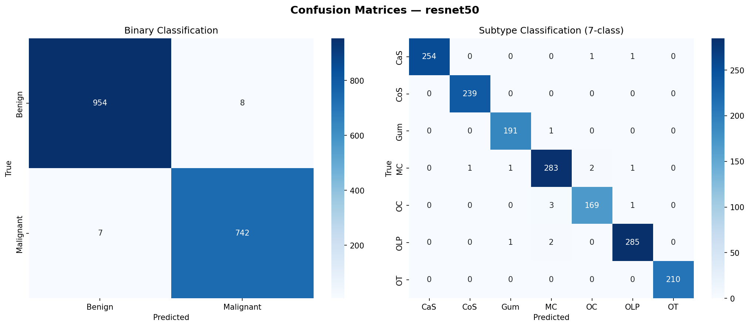
Latency Distribution:
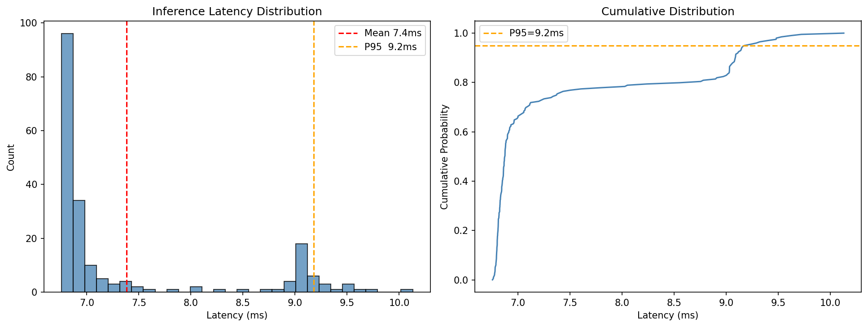
Per-Class Report (Subtype):
precision recall f1-score support
CaS 1.00 0.99 1.00 256
CoS 1.00 1.00 1.00 239
Gum 0.99 0.99 0.99 192
MC 0.98 0.98 0.98 288
OC 0.98 0.98 0.98 173
OLP 0.99 0.99 0.99 288
OT 1.00 1.00 1.00 210
accuracy 0.99 1646
macro avg 0.99 0.99 0.99 1646
weighted avg 0.99 0.99 0.99 1646

DenseNet-121
Summary: Binary F1 = 0.9889, Subtype F1 = 0.9933 | 8,008,073 params | size 31.149 MB | GPU peak 80.19 MB | trained 100/200 epochs (108.84 min)
Confusion Matrix:
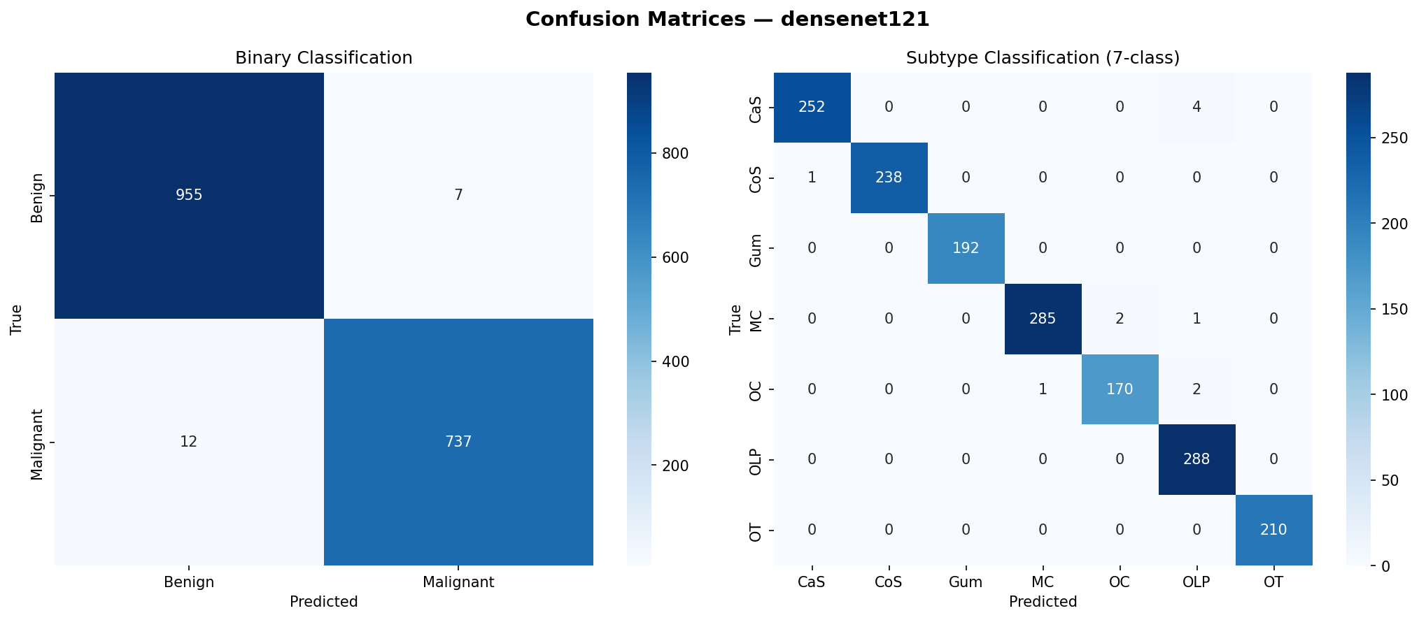
Latency Distribution:
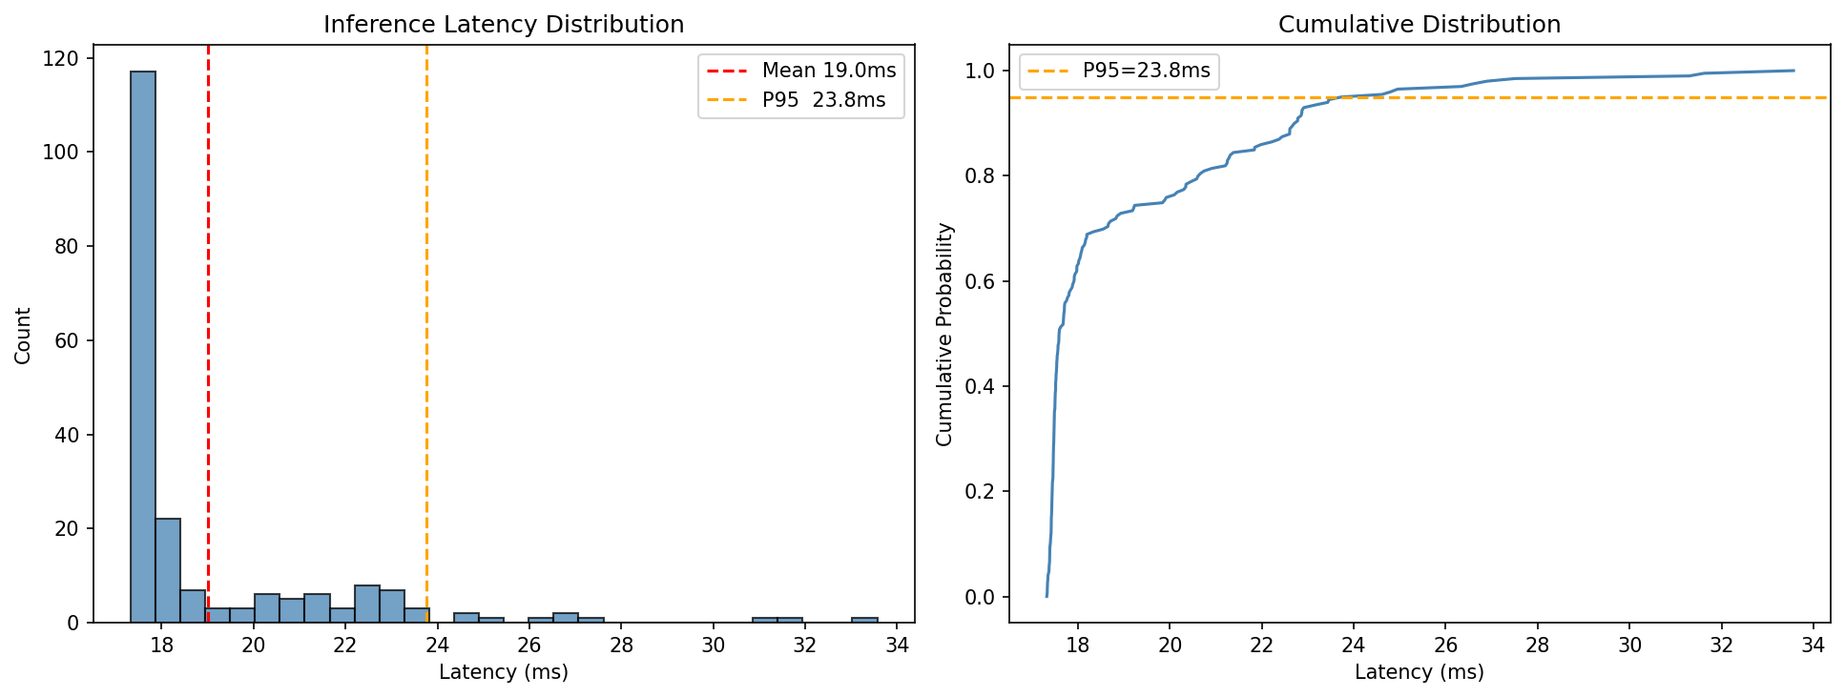
Per-Class Report (Subtype):
precision recall f1-score support
CaS 1.00 0.98 0.99 256
CoS 1.00 1.00 1.00 239
Gum 1.00 1.00 1.00 192
MC 1.00 0.99 0.99 288
OC 0.99 0.98 0.99 173
OLP 0.98 1.00 0.99 288
OT 1.00 1.00 1.00 210
accuracy 0.99 1646
macro avg 0.99 0.99 0.99 1646
weighted avg 0.99 0.99 0.99 1646

ConvNeXt-Tiny
Summary: Binary F1 = 0.9533, Subtype F1 = 0.9048 | 28,612,201 params | size 109.22 MB | GPU peak 171.98 MB | trained 200/200 epochs (262.55 min)
Confusion Matrix:
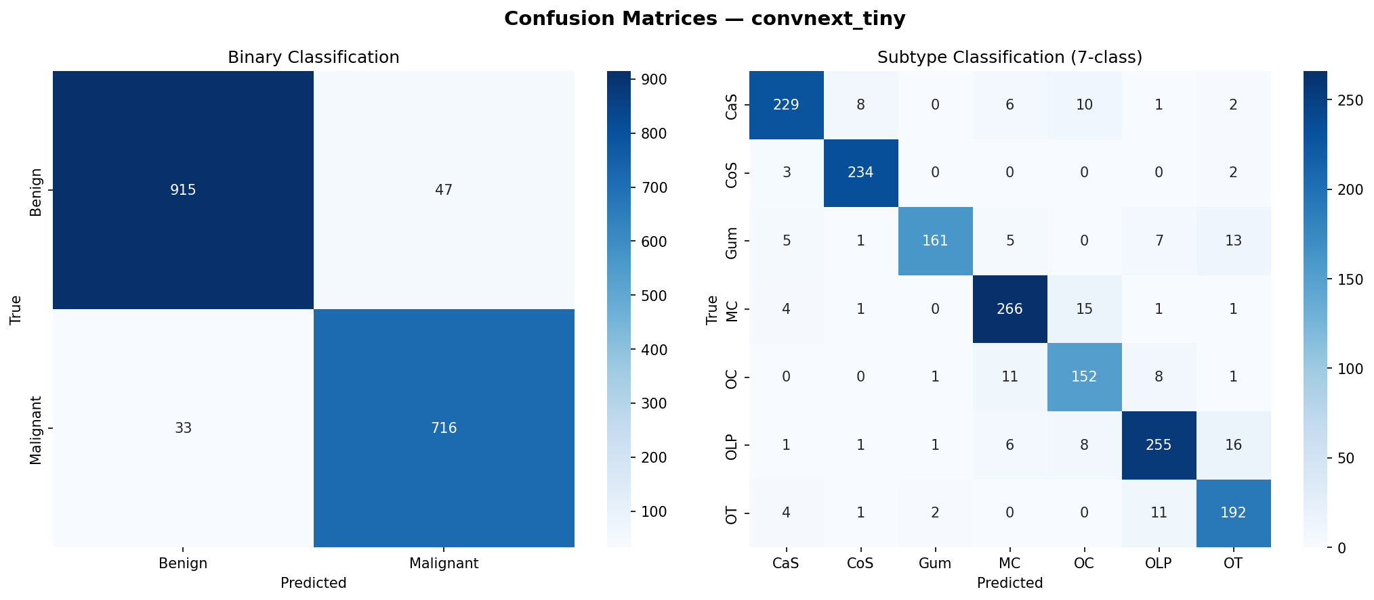
Latency Distribution:
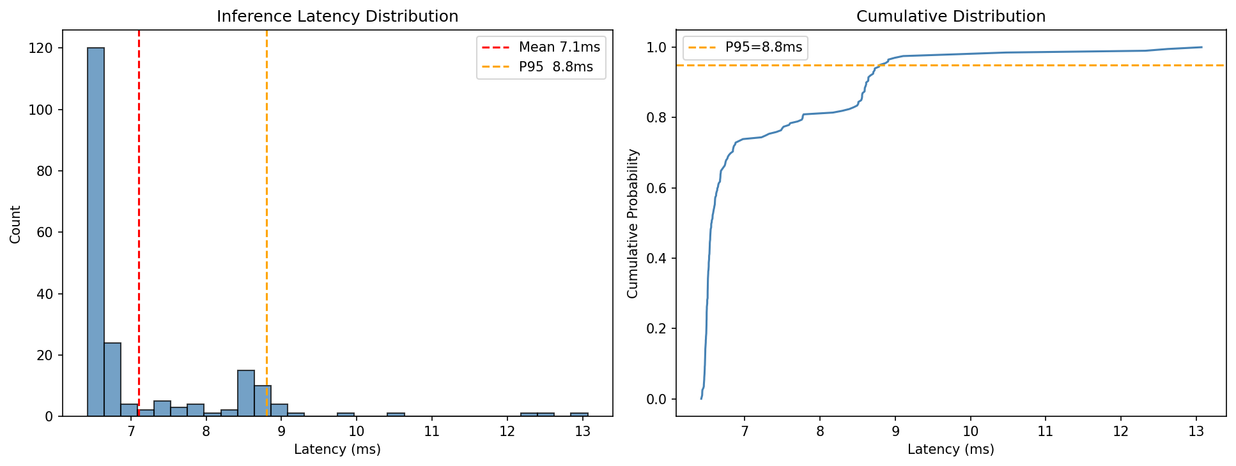
Per-Class Report (Subtype):
precision recall f1-score support
CaS 0.93 0.89 0.91 256
CoS 0.95 0.98 0.96 239
Gum 0.98 0.84 0.90 192
MC 0.90 0.92 0.91 288
OC 0.82 0.88 0.85 173
OLP 0.90 0.89 0.89 288
OT 0.85 0.91 0.88 210
accuracy 0.90 1646
macro avg 0.90 0.90 0.90 1646
weighted avg 0.91 0.90 0.90 1646

Swin-T
Summary: Binary F1 = 0.9819, Subtype F1 = 0.9769 | 28,311,427 params | size 108.07 MB | GPU peak 179.33 MB | trained 118/200 epochs (145.52 min)
Confusion Matrix:
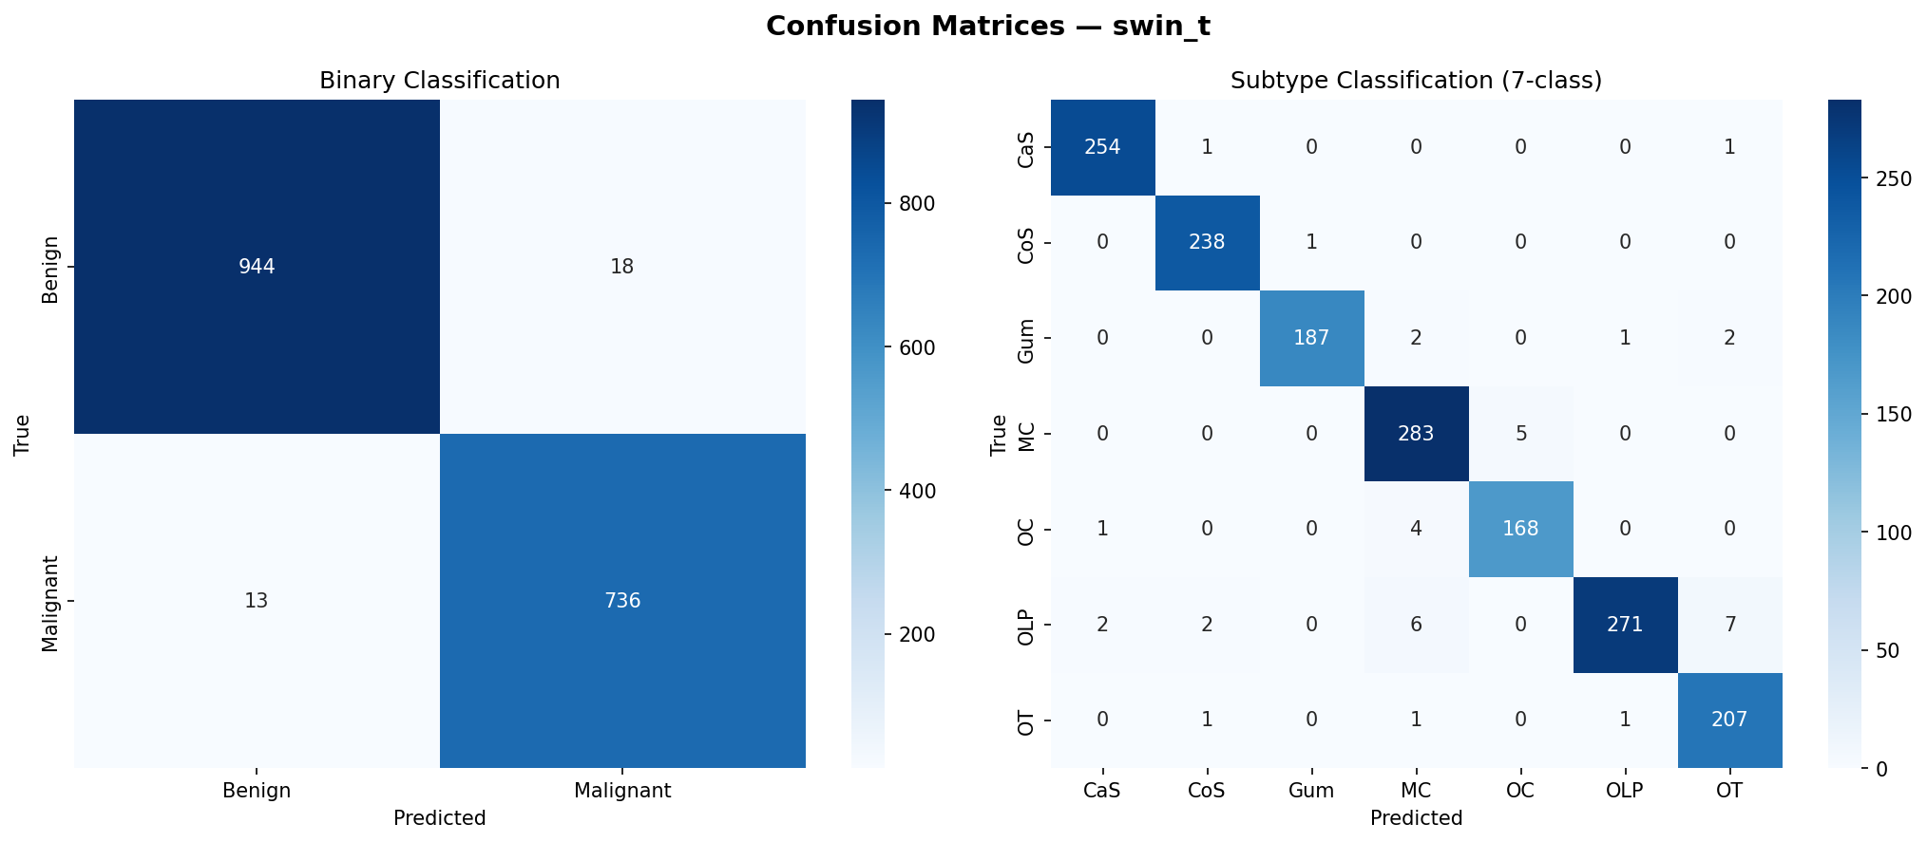
Latency Distribution:
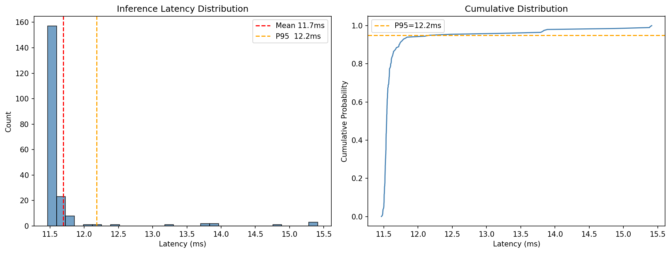
Per-Class Report (Subtype):
precision recall f1-score support
CaS 0.99 0.99 0.99 256
CoS 0.98 1.00 0.99 239
Gum 0.99 0.97 0.98 192
MC 0.96 0.98 0.97 288
OC 0.97 0.97 0.97 173
OLP 0.99 0.94 0.97 288
OT 0.95 0.99 0.97 210
accuracy 0.98 1646
macro avg 0.98 0.98 0.98 1646
weighted avg 0.98 0.98 0.98 1646

EfficientNet-B0
Summary: Binary F1 = 0.9883, Subtype F1 = 0.9903 | 5,323,909 params | size 20.599 MB | GPU peak 76.91 MB | trained 126/200 epochs (104.05 min)
Confusion Matrix:
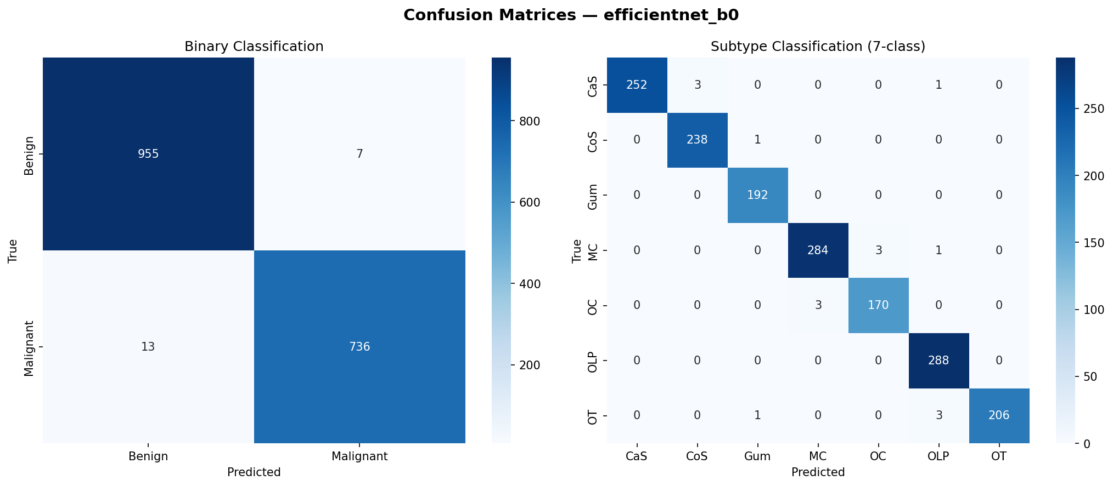
Latency Distribution:
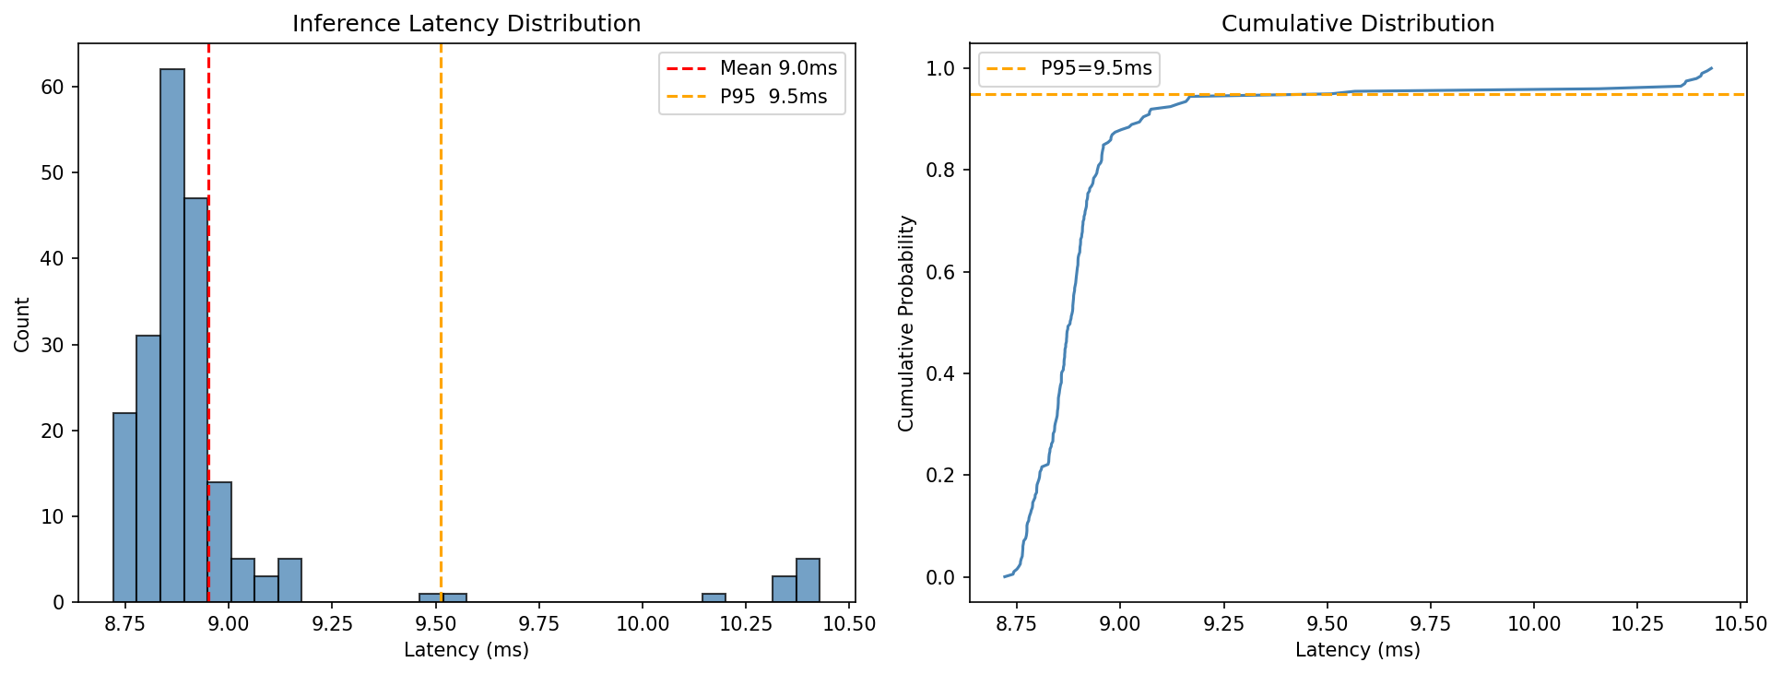
Per-Class Report (Subtype):
precision recall f1-score support
CaS 1.00 0.98 0.99 256
CoS 0.99 1.00 0.99 239
Gum 0.99 1.00 0.99 192
MC 0.99 0.99 0.99 288
OC 0.98 0.98 0.98 173
OLP 0.98 1.00 0.99 288
OT 1.00 0.98 0.99 210
accuracy 0.99 1646
macro avg 0.99 0.99 0.99 1646
weighted avg 0.99 0.99 0.99 1646

EfficientNet-V2-B2
Summary: Binary F1 = 0.9936, Subtype F1 = 0.9933 | 10,134,519 params | size 39.165 MB | GPU peak 72.47 MB | trained 135/200 epochs (114.2 min)
Confusion Matrix:
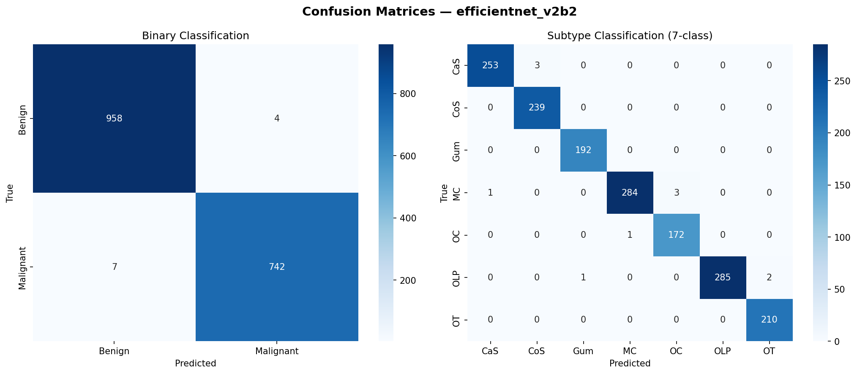
Latency Distribution:
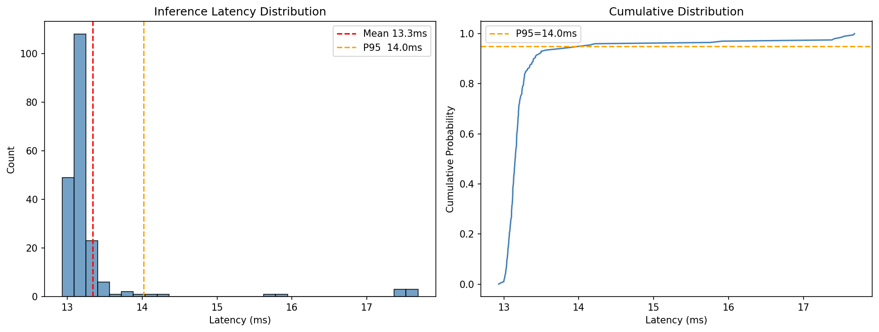
Per-Class Report (Subtype):
precision recall f1-score support
CaS 1.00 0.99 0.99 256
CoS 0.99 1.00 0.99 239
Gum 0.99 1.00 1.00 192
MC 1.00 0.99 0.99 288
OC 0.98 0.99 0.99 173
OLP 1.00 0.99 0.99 288
OT 0.99 1.00 1.00 210
accuracy 0.99 1646
macro avg 0.99 0.99 0.99 1646
weighted avg 0.99 0.99 0.99 1646

EfficientNet-V2-B3
Summary: Binary F1 = 0.9889, Subtype F1 = 0.9842 | 14,399,911 params | size 55.569 MB | GPU peak 94.14 MB | trained 99/200 epochs (92.47 min)
Confusion Matrix:
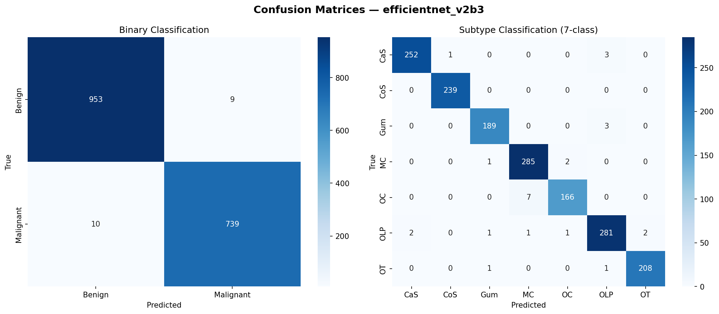
Latency Distribution:
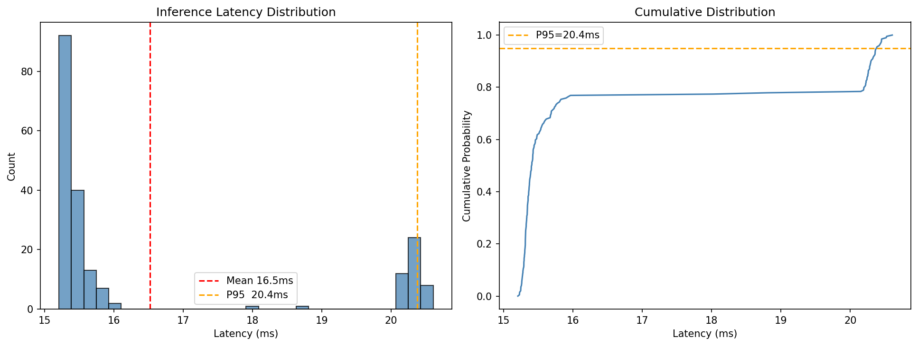
Per-Class Report (Subtype):
precision recall f1-score support
CaS 0.99 0.98 0.99 256
CoS 1.00 1.00 1.00 239
Gum 0.98 0.98 0.98 192
MC 0.97 0.99 0.98 288
OC 0.98 0.96 0.97 173
OLP 0.98 0.98 0.98 288
OT 0.99 0.99 0.99 210
accuracy 0.98 1646
macro avg 0.98 0.98 0.98 1646
weighted avg 0.98 0.98 0.98 1646

EfficientNet-V2-S
Summary: Binary F1 = 0.9865, Subtype F1 = 0.9836 | 21,493,849 params | size 82.86 MB | GPU peak 126.94 MB | trained 86/200 epochs (98.72 min)
Confusion Matrix:
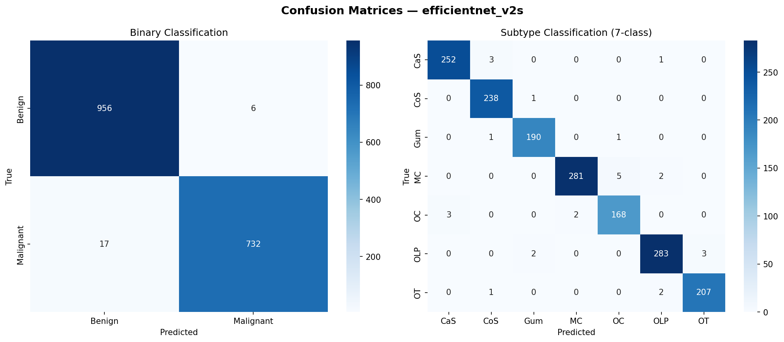
Latency Distribution:
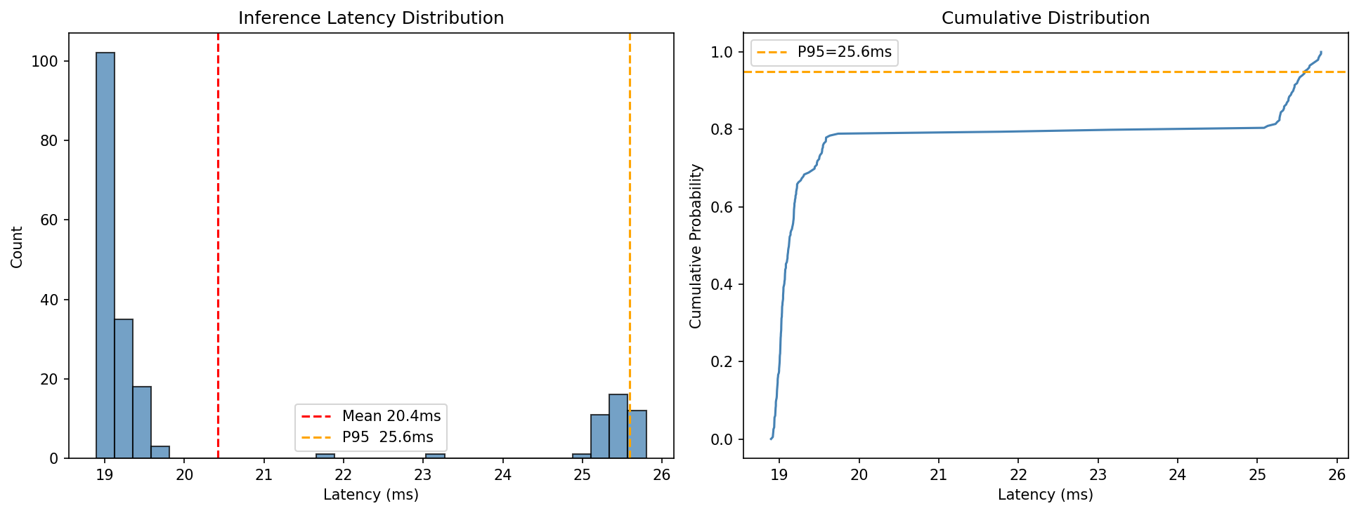
Per-Class Report (Subtype):
precision recall f1-score support
CaS 0.99 0.98 0.99 256
CoS 0.98 1.00 0.99 239
Gum 0.98 0.99 0.99 192
MC 0.99 0.98 0.98 288
OC 0.97 0.97 0.97 173
OLP 0.98 0.98 0.98 288
OT 0.99 0.99 0.99 210
accuracy 0.98 1646
macro avg 0.98 0.98 0.98 1646
weighted avg 0.98 0.98 0.98 1646

Inception-V3
Summary: Binary F1 = 0.9930, Subtype F1 = 0.9921 | 23,888,361 params | size 91.468 MB | GPU peak 132.18 MB | trained 153/200 epochs (135.22 min)
Confusion Matrix:
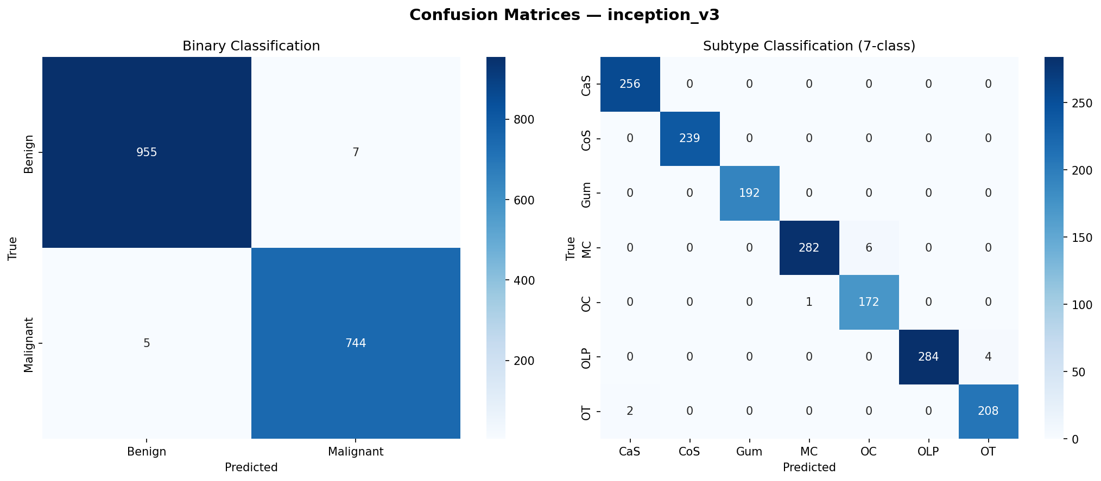
Latency Distribution:
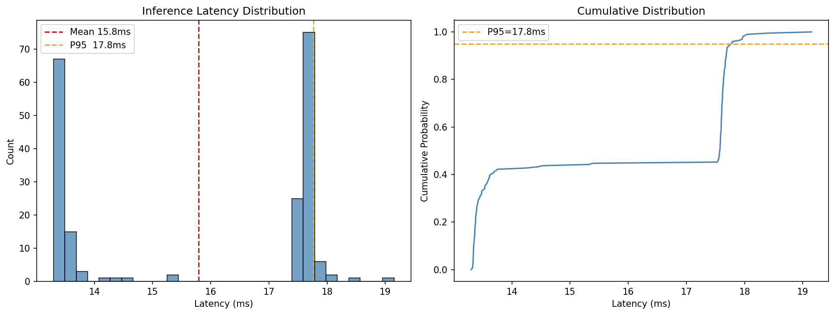
Per-Class Report (Subtype):
precision recall f1-score support
CaS 0.99 1.00 1.00 256
CoS 1.00 1.00 1.00 239
Gum 1.00 1.00 1.00 192
MC 1.00 0.98 0.99 288
OC 0.97 0.99 0.98 173
OLP 1.00 0.99 0.99 288
OT 0.98 0.99 0.99 210
accuracy 0.99 1646
macro avg 0.99 0.99 0.99 1646
weighted avg 0.99 0.99 0.99 1646

Custom EfficientNet V2 (tuned)
Summary: Binary F1 = 0.9947, Subtype F1 = 0.9970 | 4,898,430 params | size 18.988 MB | GPU peak 52.32 MB | trained 190/200 epochs (136.53 min)
Confusion Matrix:
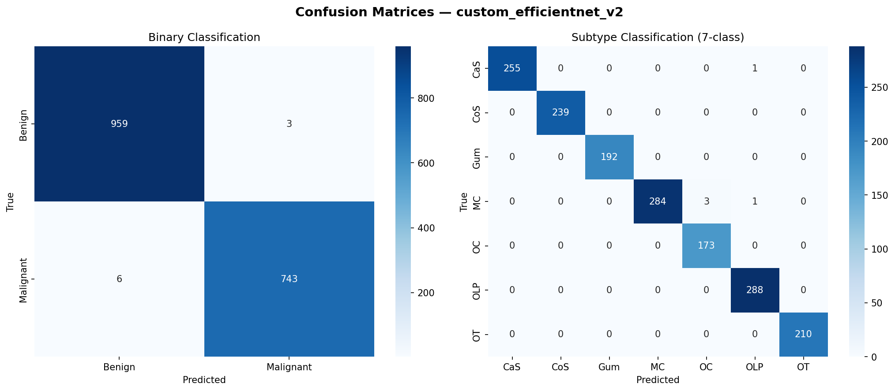
Latency Distribution:
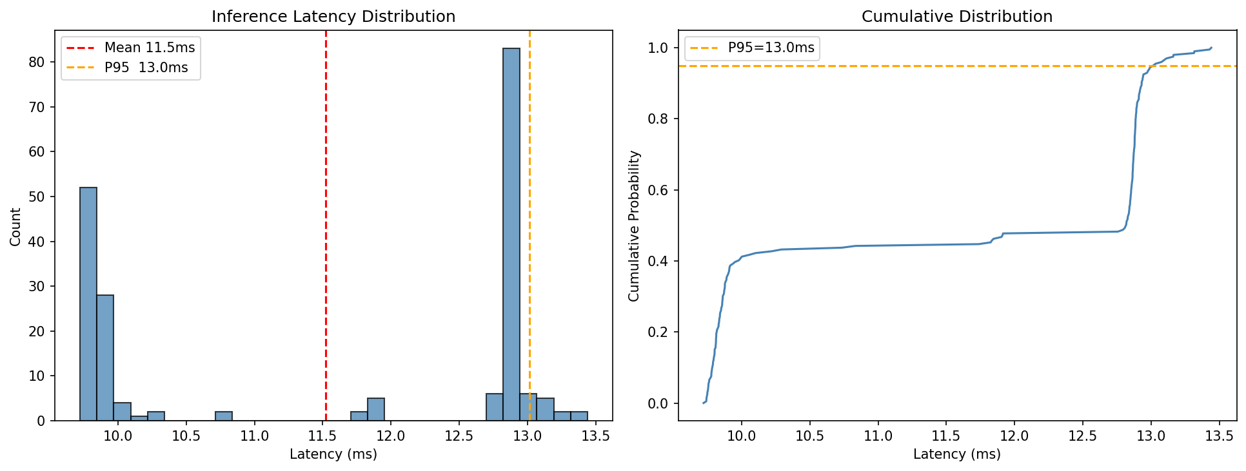
Per-Class Report (Subtype):
precision recall f1-score support
CaS 1.00 1.00 1.00 256
CoS 1.00 1.00 1.00 239
Gum 1.00 1.00 1.00 192
MC 1.00 0.99 0.99 288
OC 0.98 1.00 0.99 173
OLP 0.99 1.00 1.00 288
OT 1.00 1.00 1.00 210
accuracy 1.00 1646
macro avg 1.00 1.00 1.00 1646
weighted avg 1.00 1.00 1.00 1646

Custom EfficientNet V2 (baseline recipe)
Summary: Binary F1 = 0.9906, Subtype F1 = 0.9921 | 4,898,430 params | size 18.988 MB | GPU peak 52.32 MB | trained 172/200 epochs (131.7 min)
Confusion Matrix:
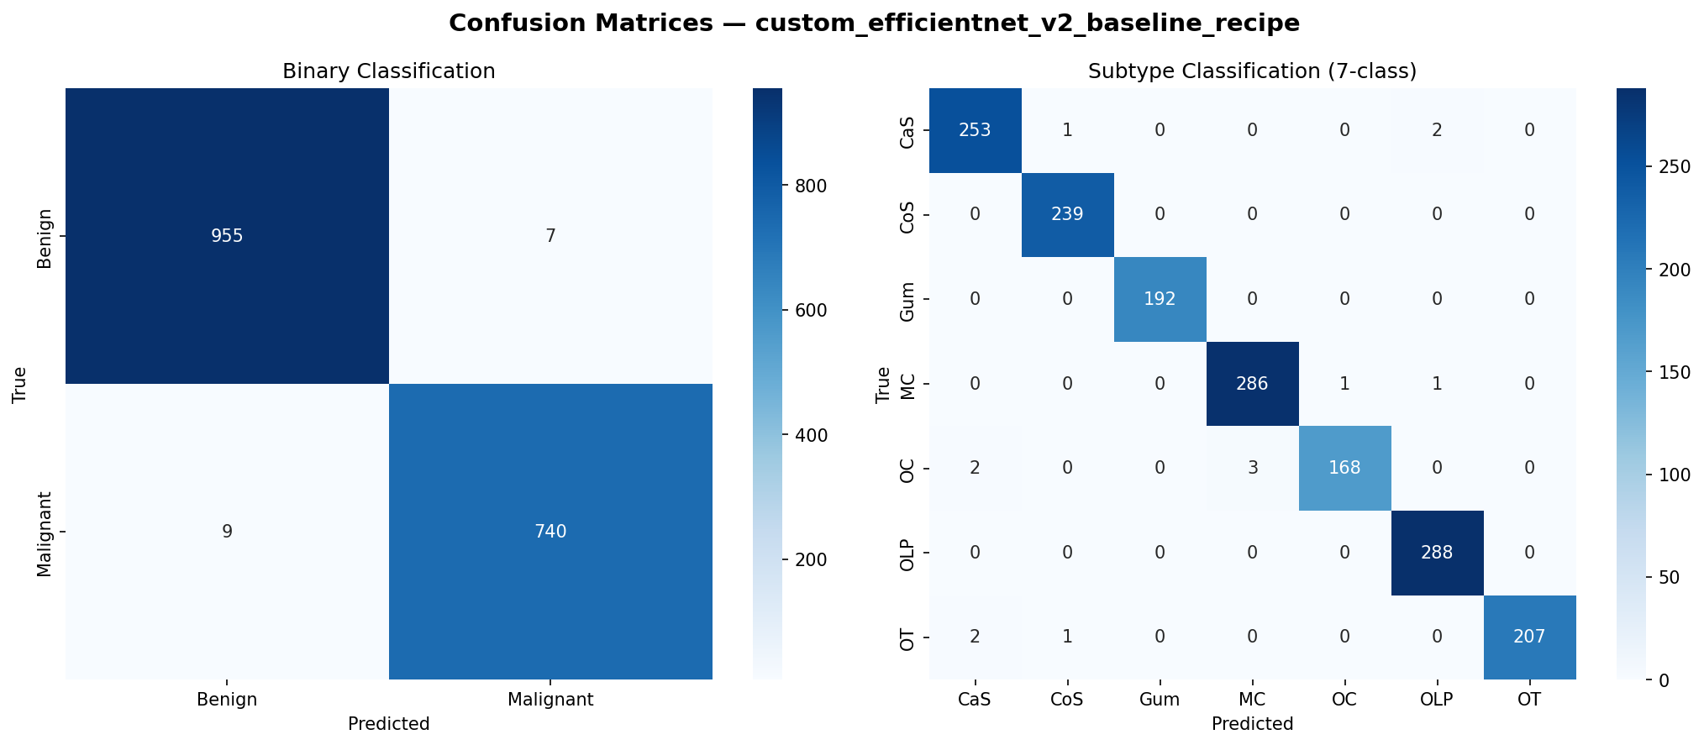
Latency Distribution:
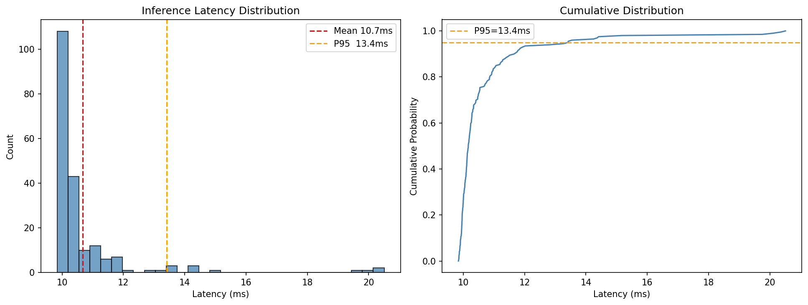
Per-Class Report (Subtype):
precision recall f1-score support
CaS 0.98 0.99 0.99 256
CoS 0.99 1.00 1.00 239
Gum 1.00 1.00 1.00 192
MC 0.99 0.99 0.99 288
OC 0.99 0.97 0.98 173
OLP 0.99 1.00 0.99 288
OT 1.00 0.99 0.99 210
accuracy 0.99 1646
macro avg 0.99 0.99 0.99 1646
weighted avg 0.99 0.99 0.99 1646

7. Notes
- Custom EfficientNet V2 (tuned) uses warmup, AMP, gradient clipping, Kaiming init, early-stopping patience=25, and Test-Time Augmentation (5 views). Custom EfficientNet V2 (baseline recipe) uses the same training recipe as the 8 pretrained baselines (lr=1e-4, no warmup/AMP/clip, ES=15, no TTA) — this is the fair-comparison ablation.
- VGG-19 folder is empty — no checkpoint was produced, so it is excluded from all tables.
- FLOPs are not reported because the 'thop' package is not installed. Install with 'pip install thop' to populate the FLOPs column on rerun.
- Energy and CO2 figures (when shown) are rough estimates from wall-clock time; install codecarbon for hardware-measured values.

