**VISVESVARAYA TECHNOLOGICAL UNIVERSITY**

"Jnana Sangama", Belgaum: 590 018

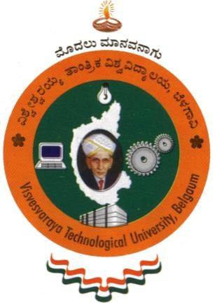

A Mini Project report on

**“Monkey Jump”**

Submitted in partial fulfillment of the requirement for the award of Degree of

**BACHELOR OF ENGINEERING IN**

**COMPUTER SCIENCE AND ENGINEERING**

By

**NIKHIL TALWAR DAKSHITA SHARMA**

**1AY15CS057 1AY15CS025**

Under the guidance of

**Prof. Vani K.S. Prof. Sunil G L**

**Assistant Professors**

Department of Computer Science & Engineering



**DEPARTMENT OF COMPUTER SCIENCE & ENGINEERING ACHARYA INSTITUTE OF TECHNOLOGY**

(Affiliated to Visvesvaraya Technological University, Belgaum)

**2017-2018**

**ACHARYA INSTITUTE OF TECHNOLOGY**

(Affiliated to Visvesvaraya Technological University, Belgaum)

Soladevanahalli, Bangalore – 560090

**DEPARTMENT OF COMPUTER SCIENCE & ENGINEERING**



**Certificate**

Certified that the Mini Project entitled **“Monkey Jump”** is a bonafide work carried out by **NIKHIL TALWAR (1AY15CS057)** and **DAKSHITA SHARMA (1AY15CS025)** in partial fulfillment for the award of degree of **Bachelor of Engineering in Computer Science & Engineering of the Visvesvaraya Technological University**, Belgaum during the year **2017-2018.** It is certified that all corrections/ suggestions indicated for internal assessments have been incorporated in the Report deposited in the departmental library. The Mini Project report has been approved as it satisfies the academic requirements in respect of Mini Project work prescribed for the **Bachelor of Engineering Degree**.

**Signature of Guides Signature of H.O.D**

**Dr. PRASHANTH C.M**

**Professor & HOD**

**Name of the examiners Signature with date**

1.

2.