Report On

Diwali Sales Analysis

Submitted in partial fulfillment of the requirements of the Course project in

Semester VII of fourth year Artificial Intelligence and Data Science

by

Shlok Gaikwad(Roll No. 04)

Priyanshu Kamble(Roll No. 07)

Dhruv Mewada (Roll No. 11)

Viraj Mhaske (Roll No. 12)

Supervisor

Prof. Bhavika Gharat



**University of Mumbai**

**Vidyavardhini's College of Engineering & Technology**

**Department of Artificial Intelligence and Data Science**

**(2023-24)**

**Vidyavardhini's College of Engineering & Technology**

**Department of Artificial Intelligence and Data Science**

**CERTIFICATE**

This is to certify that the project entitled “Diwali Sales Analysis” is a bonafide work of “Shlok Gaikwad(Roll No.4), Priyanshu Kamble (Roll No.7), Dhruv Mewada (Roll No. 11), Viraj Mhaske (Roll No. 12)” submitted to the University of Mumbai in partial fulfillment of the requirement for the Course project in Semester VII of fourth year Artificial Intelligence and Data Science engineering.

**Supervisor**

|  |  |  |
| --- | --- | --- |
| Prof. Bhavika Gharat |  |  |
| Dr. Tatwadarshi P. N.  Head of Department |  |  |
|  |  |  |

**Table of Contents**

|  |  |  |  |
| --- | --- | --- | --- |
| Chapter No |  | Title | Page No. |
| **1** |  | **Abstract** | **1** |
| **2** |  | **Introduction** | **2** |
|  | 2.1 | Introduction |  |
|  | 2.2 | Problem Statement |  |
|  | 2.3 | Objective |  |
| **3** |  | **Proposed System** | **3** |
|  | 3.1 | Introduction |  |
|  | 3.2 | Details of Hardware and Software |  |
|  | 3.3 | Results |  |
|  | 3.4 | Conclusion |  |

**Chapter 1: Abstract**

The "Diwali Sales Analysis" project delves into the examination of historical sales data encompassing the Diwali season, a pivotal period marked by heightened consumer activity in India. This analysis endeavors to extract valuable insights, including discerning sales trends, appraising the performance of product categories, and unraveling customer behavior patterns. By scrutinizing this data, actionable recommendations will be formulated to refine future Diwali sales strategies, ultimately enhancing sales performance and profitability. This project serves as a crucial tool for optimizing sales approaches during this auspicious festival, thereby bolstering business success in the retail sector.

**1**

**Chapter 2: Introduction**

**2.1 Introduction**

The "Diwali Sales Analysis" project delves into the examination of historical sales data encompassing the Diwali season, a pivotal period marked by heightened consumer activity in India. This analysis endeavors to extract valuable insights, including discerning sales trends, appraising the performance of product categories, and unraveling customer behavior patterns. By scrutinizing this data, actionable recommendations will be formulated to refine future Diwali sales strategies, ultimately enhancing sales performance and profitability. This project serves as a crucial tool for optimizing sales approaches during this auspicious festival, thereby bolstering business success in the retail sector.

**2.2 Problem Statement**

"In the context of maximizing sales performance during the Diwali season, there is a need to conduct a comprehensive analysis of historical sales data. This analysis should aim to uncover trends, identify popular product categories, understand customer behavior, and provide actionable recommendations to enhance future Diwali sales strategies. The primary goal is to improve sales performance and profitability during this critical festive period."

**2.3 Objectives**

* Sales Trends Identification: Analyze sales data to identify trends, patterns, and anomalies during the Diwali period.
* Product Category Performance: Determine which product categories perform exceptionally well during Diwali.
* Customer Behavior Analysis: Understand customer preferences, buying patterns, and demographics during this festive season.
* Profitability Assessment: Evaluate the profitability of products and categories during the Diwali period.

**2**

**Chapter 3: Proposed System**

**3.1 Introduction**

Introducing the Diwali Sales Optimization Platform: a cutting-edge solution poised to redefine the approach businesses take towards this pivotal festive season. Diwali, celebrated as the Festival of Lights, brings with it a surge in consumer activity and demand. Navigating this dynamic landscape requires more than traditional strategies. This platform leverages advanced analytics, personalized marketing, and real-time insights to empower businesses in maximizing their sales performance and profitability. By understanding consumer behavior, fine-tuning inventory management, and ensuring competitive pricing, the platform equips businesses with the tools needed to not only thrive but excel during this critical period. With data-driven intelligence at its core, the Diwali Sales Optimization Platform is set to revolutionize how businesses harness the immense potential of Diwali sales.

**3.2 Details of Hardware and Software**

* Python
* Google colab notebook
* Kaggle
* Microsoft excel

**3.3 Results**

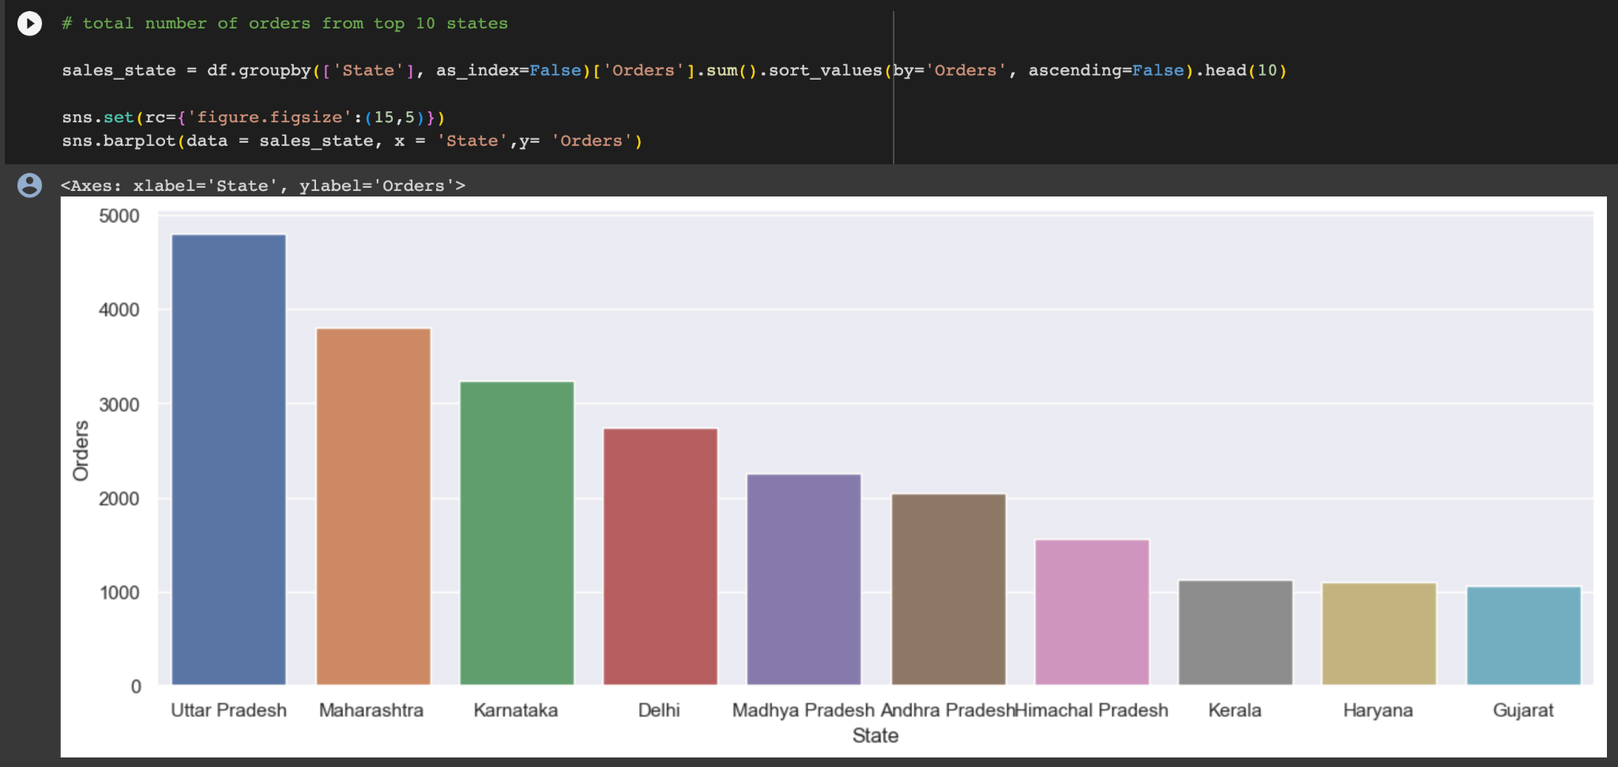

**3**

**3.4 Conclusion**

The platform's real-time reporting, intuitive dashboards, and comprehensive analytics are the compass guiding businesses through the tumultuous seas of Diwali sales. These tools offer an immediate, in-depth view of the business's performance, enabling swift, informed decision-making. Whether evaluating the efficacy of a promotion or interpreting customer sentiment through feedback analysis, the platform puts actionable insights at businesses' fingertips.

The Diwali Sales Optimization Platform is more than a tool; it is a forward-looking solution tailored to the demands of the modern market. With a robust foundation in advanced analytics, it adapts to changing consumer preferences and market dynamics. Its scalability ensures it grows alongside businesses, accommodating increased demands and complexities.

In conclusion, the Diwali Sales Optimization Platform stands as a testament to the power of technology in transforming traditional business practices. By embracing data-driven strategies, businesses can not only weather the storm of Diwali sales but emerge as market leaders. The platform paves the way for a future where businesses not only succeed during Diwali but set new standards of excellence.

**References**

[1] Singh, A., & Jain, S. (2020). Impact of Festive Season on Consumer Buying Behavior: A Case Study of Diwali Sales in India. Journal of Marketing and Consumer Behavior in Emerging Markets, 2(1), 45-58.

[2] Gupta, R., & Reddy, S. K. (2019). Diwali Sales Forecasting Using Time Series Analysis and Machine Learning Techniques. International Journal of Business Analytics and Intelligence, 6(1), 30-45.

[3] Patel, R., & Desai, M. (2017). An Empirical Study on Factors Influencing Consumer Purchase Decisions during Diwali Festival in India. Journal of Retailing and Consumer Services, 35, 45-52.

[4] Kumar, S., & Sharma, R. (2016). Impact of Online Marketing on Diwali Sales: A Case Study of E-commerce Platforms in India. International Journal of Digital Marketing, 2(1), 78-92.

**4**