**RS Assignment 1**

**21K-4896**

**Abdullah Islam**

**Question no: 1**

***Figure A: Content Based RS***

1. Consists of three primary components: item analyzer, user profile builder, and recommendation engine.
2. The user profile encompasses the user's information, which includes all related data such as history, ratings, and feedback.
3. The user profile builder formats the user profile data appropriately for processing.
4. The item analyzer contains details about the item, including its metadata and features.
5. Both item details and the user's profile are stored in a permanent storage database.
6. All information from the database is transferred to the recommendation engine.
7. The recommendation engine assesses the similarity between the user's profile and the item profile.
8. The recommendation engine produces suggestions based on the specific user's profile.
9. The user responds to the recommendations by providing feedback through ratings, ignoring, or clicking.
10. The user profile is updated based on the feedback received, and this process continues.

***Figure B: Architecture of Docear's research paper recommender system***

1. User creates mind maps including the references and all the information related to research.
2. Webservice searches for the paper whose url is added in the mind map, it retrieves recommendation, store statistics, request and deliver recommendations.
3. Mind map is parsed with the help of mind map parser.
4. When new mind maps are added recommendation engine is triggered to generate new recommendations.
5. Recommendation engine creates user model using mind map models and then recommend new paper by using CBF or stereotype recommendations randomly.
6. PDF spider search for research paper in the research paper PDFs in the web.
7. PDF analyzer format PDF into processable form.
8. Offline evaluator is used to evaluate recommendation accuracy by removing recent mind map updates and then analyzing recommendations which include that removed updates.
9. New recommendations and statistics is stored.
10. Finally, Webservice deliver recommendations to Docear desktop and user can get recommended papers.

***Figure C: Vector Based Approach***

1. More accurate recommendations because of improved representation.
2. User is allowed to express implicit or explicit interest into a particular item’s feature.
3. Alternatively using user- item data if user-feature is not available.
4. Items are being represented as a vector of features they have.
5. User and item features are represented into a form of a graph.
6. Vectorized user profile and items.
7. Using cosine similarity for finding similarity between user and items.
8. Similarity of user and items are calculated.
9. Recommended user items based on the similarities.
10. Recommendation sequence is from highest to lowest similarity.

***Figure D: Graph Based Approach***

1. More accurate recommendations because of improved representation.
2. User is allowed to express implicit or explicit interest into a particular item’s feature.
3. Alternatively using user- item data if user-feature is not available.
4. User and item features are represented into a form of a graph.
5. Despite of simplicity recommendations are accurate.
6. Correctly modeled data is very important to be effective.
7. High response time due to simplicity, no algorithms are needed.
8. Simple queries can give accurate recommendation once data is modeled into the form of graph.
9. Model can consider more features because of graph representation.
10. Increased features improve recommendations.

***Figure E: RS in Fashion Industry***

1. Personalization for improved recommendations.
2. Recommendations based on user’s style.
3. AI is used for accurate personalized recommendations.
4. Computer vision can be used for advancement.
5. Can cover all fashion categories with AI/ML solutions.
6. Body shape based recommendations.
7. Considering design point of view.
8. Voice processing for visually impaired people.
9. Both supervised and unsupervised models utilization.
10. Trends predictions.

**Question no: 2**

import numpy as np  
  
def Rank_according_to_k_similar_neighbours(k,u,item,R):  
  similarities=[]  
  for i in range(len(R)):  
    if i!=u:  
      A= np.array(R[i])  
      B= np.array(R[u])  
      dot=np.dot(A,B)  
      magA=np.linalg.norm(A)  
      magB=np.linalg.norm(B)  
      if magA or magB ==0:  
        similarities.append(0)  
      else:  
        similarities.append(dot/(magA*magB))  
  
    else:  
      similarities.append(1)  
  similarities=np.array(similarities)  
  k_neighbours = np.argsort(similarities)[-k-1:-1]  
  rating_sum=0  
  for i in k_neighbours:  
    rating_sum+=R[i][item]  
  return rating_sum/k  
  
def recommend_items(N,k,u,items,R):  
  for i in range(len(items)):  
    if R[u][i]==0:  
      R[u][i]= Rank_according_to_k_similar_neighbours(k,u,i,R)  
  
  user_ratings= np.array(R[u])  
  sorted_items=np.argsort(-user_ratings)[:N]  
  
  return np.take(items,sorted_items)  
  
  
N=3  
k=2  
u= 0 *# user 1*  
items=['item 1','item 2','item 3','item 4','item 5','item 6','item 7','item 8']  
R=[  
    [5,3,0,0,6,7,0,2], *# user 1*  
    [4,3,8,4,5,1,0,7], *# user 2*  
    [0,7,5,3,7,0,0,2], *# user 3*  
    [0,0,9,5,5,4,3,2]  *# user 4*  
]  
  
recommended_items=recommend_items(N,k,u,items,R)  
  
print(f"items to be Recommended: {recommended_items}")

**Question no: 3**

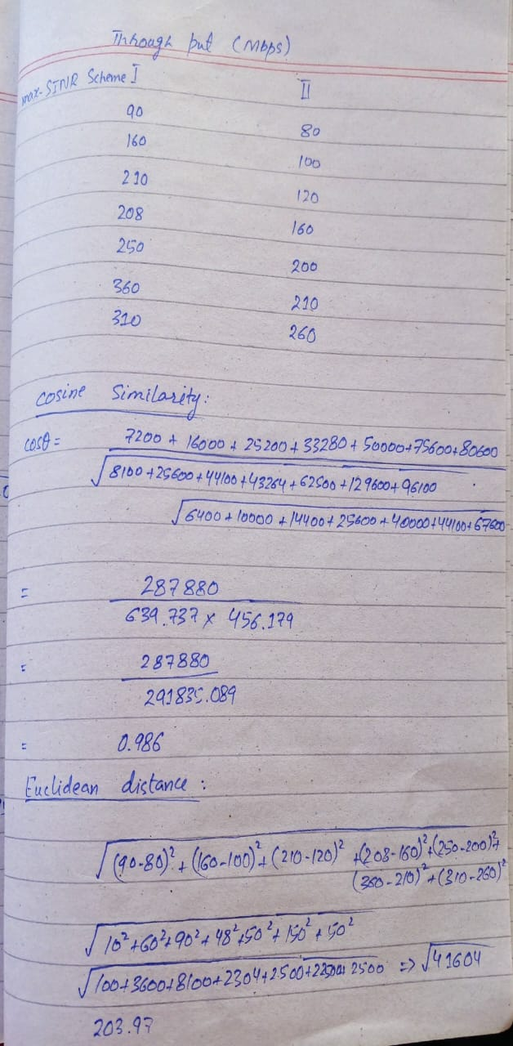

Cosine Similarity= 0.986

Euclidian distance= 203.97

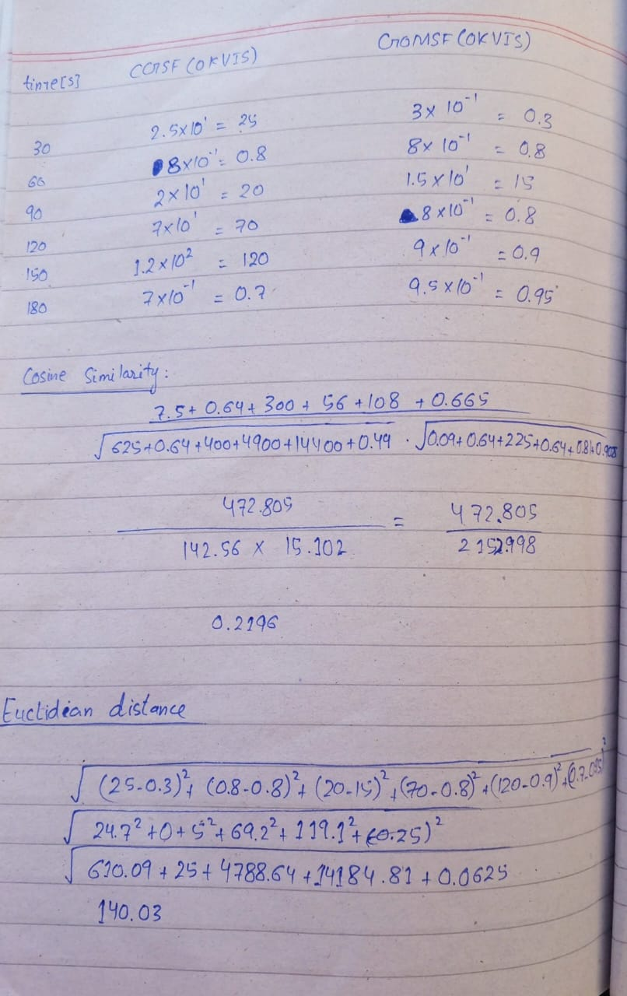

Cosine similarity= 0.2196

Euclidian distance= 140.03

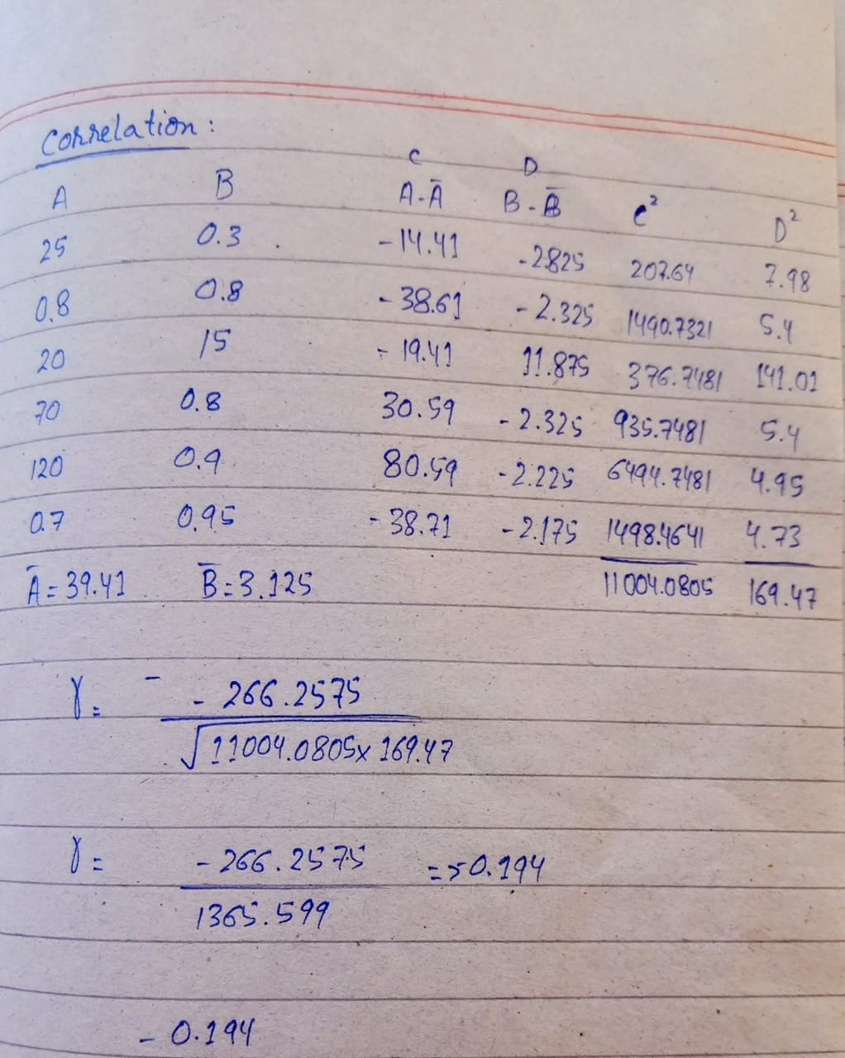

Correlation = - 0.194

**Question no: 4**

Wetlands are one of the most important ecosystems on our planet, playing a crucial role in storing carbon, purifying water, and regulating climate. However, climate change poses a serious threat to these ecosystems, potentially disrupting their ability to provide these essential services. This research paper takes a deep dive into how climate change—especially rising temperatures and changing water levels—impacts both natural wetlands (peatlands) and constructed wetlands. One of the key concerns highlighted in the study is that climate change could shift wetlands from being carbon sinks (absorbing and storing carbon) to carbon sources (releasing carbon into the atmosphere), which would further accelerate global warming.

The study reviews past research on wetland responses to climate change, particularly focusing on greenhouse gas emissions (CO₂, CH₄, N₂O) and nutrient release. The authors identify major gaps in previous studies, such as inconsistencies in experimental methods, short study durations, and a lack of comprehensive climate simulations. To address these gaps, they propose a mesocosm experiment framework—a controlled experimental setup that allows for more realistic and accurate simulations of climate change effects on wetlands. The framework considers key climate variables like temperature, water levels, and seasonal changes to provide better insights into how wetlands might respond in the future.

A particularly interesting takeaway from the paper is that wetlands may not react to climate change in a simple, uniform way. For instance, drought conditions can lead to higher decomposition rates, causing wetlands to release stored carbon. On the other hand, higher temperatures combined with increased precipitation could boost plant growth and photosynthesis, helping wetlands maintain their carbon-storing abilities. This means that finding a critical water level—where wetlands can still function effectively despite climate change—could be the key to managing these ecosystems sustainably.

Ultimately, the study emphasizes the urgent need for long-term experiments and better management strategies to ensure wetlands remain resilient in the face of climate change. By improving research methods and developing adaptive wetland conservation strategies, we can help protect these valuable ecosystems and their role in combating climate change.