1. Create an HTML page to validate Name and Email. (Use Bootstrap, JQuery wherever applicable)

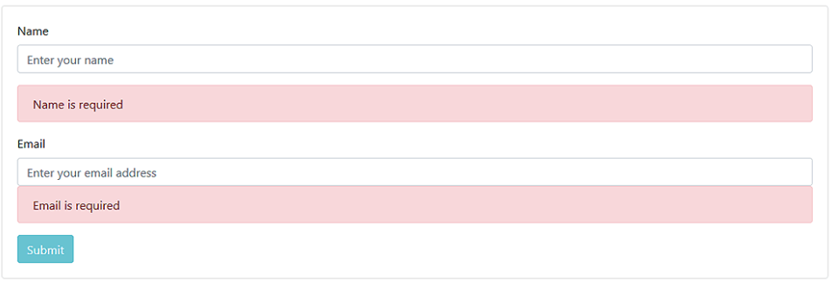

2. If the name and email entered are correct it should dynamically add the details to the below table. The table should look like below:

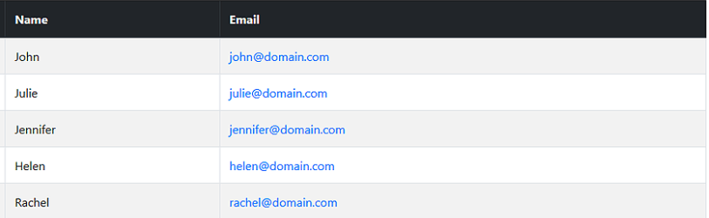

Ans-

|  |  |
| --- | --- |
|  | <html> |
|  |  |
|  | <head> |
|  | <link rel="stylesheet" href="[css/bootstrap.css](file:///C:\\Users\\akumar2078\\Documents\\bootstrap\\assesment_Abhijit_Kumar_1\\css\\bootstrap.css" \t "_blank)"> |
|  | <script type="text/javascript"> |
|  | function check(){ |
|  | var name=document.getElementById("name").value |
|  | var email=document.getElementById("mail").value |
|  | var alert1=document.getElementById("alert1") |
|  | var alert2=document.getElementById("alert2") |
|  | if(name.length<=0){ |
|  | alert1.classList.add("new1") |
|  | } |
|  | if(email.length==0){ |
|  | alert2.classList.add("new1") |
|  | } |
|  | else{ |
|  |  |
|  | var table = document.createElement('table'); |
|  | table.style.border="solid black 1px" |
|  |  |
|  | var tr = document.createElement('tr'); |
|  |  |
|  | var td1 = document.createElement('td'); |
|  | var td2 = document.createElement('td'); |
|  |  |
|  | var text1 = document.createTextNode(name); |
|  | var text2 = document.createTextNode(email); |
|  |  |
|  | td1.appendChild(text1); |
|  | td2.appendChild(text2); |
|  | tr.appendChild(td1); |
|  | tr.appendChild(td2); |
|  |  |
|  | table.appendChild(tr); |
|  | } |
|  | document.body.appendChild(table); |
|  | } |
|  |  |
|  |  |
|  |  |
|  | </script> |
|  | <style> |
|  | .new{ |
|  | display:none; |
|  | } |
|  | .new1{ |
|  | display:block; |
|  | } |
|  |  |
|  |  |
|  | </style> |
|  | </head> |
|  |  |
|  |  |
|  | <body> |
|  | <div class="container"> |
|  | <div class="row"> |
|  | <div class="col-xs-12"> |
|  | <form class="form-horizontal"> |
|  | <div class="form-group"> |
|  | <label class="col-xs-1 control-label">Name</label> |
|  | <div class="col-xs-12"> |
|  | <input type="text" id="name" class="form-control" placeholder="Enter your name"> |
|  |  |
|  | <div class="alert alert-danger new" role="alert" id="alert1"> |
|  | Enter your name |
|  | </div> |
|  |  |
|  | </div> |
|  |  |
|  | </div> |
|  |  |
|  | <div class="form-group"> |
|  | <label class="col-xs-1 control-label">Email</label> |
|  | <div class="col-xs-12"> |
|  | <input type="email" id="mail" class="form-control" placeholder="Enter your Email"> |
|  | <div class="alert alert-danger new" role="alert" id="alert2"> |
|  | Enter your email |
|  | </div> |
|  |  |
|  | </div> |
|  | </div> |
|  | <div> |
|  |  |
|  | <input type="button" class="btn btn-primary"value="submit" onclick="check()"> |
|  | </div> |
|  |  |
|  |  |
|  |  |
|  |  |
|  |  |
|  |  |
|  |  |
|  |  |
|  | </form> |
|  |  |
|  | </div> |
|  | </div> |
|  | </div> |
|  | </body> |
|  |  |
|  | </html> |
|  |  |
|  |  |

1. Create a user form like below and perform the validation as shown in the below images:

**Image - 1-4**

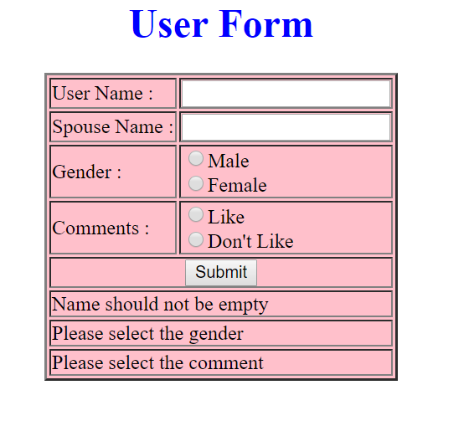

**Image - 2-4**

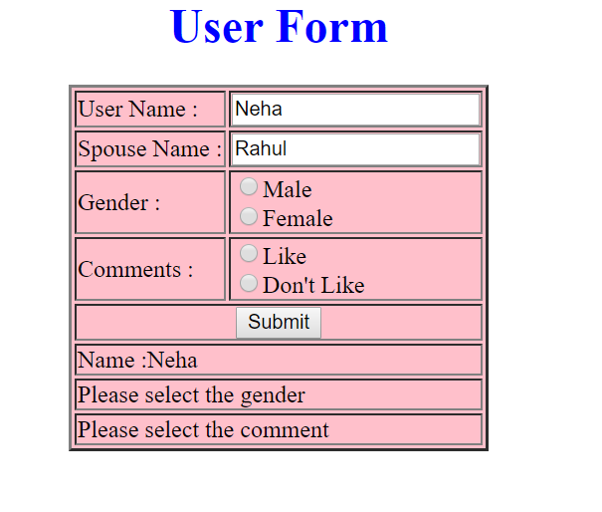

**Image - 3-4**

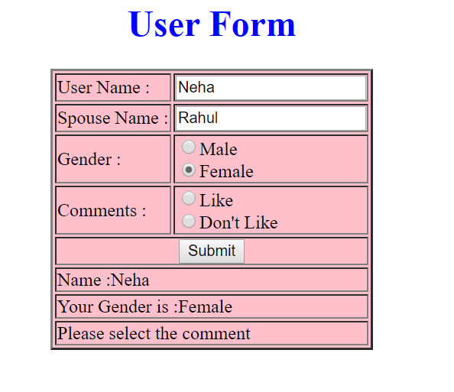

**Image - 4-4 (Success)**

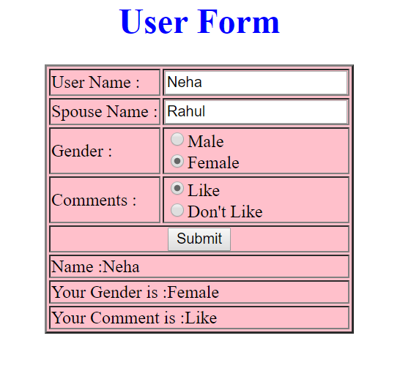

Ans -

|  |  |
| --- | --- |
|  | <html> |
|  | <head> |
|  | <script type="text/javascript"> |
|  | function check(){ |
|  | var uname=document.getElementById("uname").value; |
|  | var sname=document.getElementById("sname").value; |
|  | var s1=document.getElementById("s1") |
|  | var s2=document.getElementById("s2") |
|  | var s3=document.getElementById("s3") |
|  | var gender=document.getElementById("gender") |
|  | var comment=document.getElementById("comment") |
|  | if(uname.length==0){ |
|  | s1.innerHTML="Name should not be empty" |
|  | } |
|  | else{ |
|  | s1.innerHTML="Name:"+document.getElementById("uname").value |
|  | } |
|  | if(gender.checked==false){ |
|  | s2.innerHTML="gender should not be empty" |
|  | } |
|  | else{ |
|  | s2.innerHTML="your Gender is "+gender.value; |
|  | } |
|  | if(comment.checked==false){ |
|  | s3.innerHTML="please enter comments" |
|  | } |
|  | else{ |
|  | s3.innerHTML="Your comment is "+document.getElementById("comment").value |
|  | } |
|  |  |
|  |  |
|  | } |
|  |  |
|  |  |
|  |  |
|  |  |
|  |  |
|  | </script> |
|  | </head> |
|  | <body bgcolor="pink"> |
|  | <h1 align="center" ><font color="blue" >UserForm</font></h1> |
|  | <form> |
|  | <table border="10px" align="center"> |
|  | <tr> |
|  | <td>Username:</td> |
|  | <td><input type="text" id="uname" name="uname" ></td> |
|  | </tr> |
|  | <tr> |
|  | <td>Spousename:</td> |
|  | <td><input type="text" id="sname" name="sname" ></td> |
|  | </tr> |
|  | <tr> |
|  | <td>Gender:</td> |
|  | <td onblur="check()"><input type="radio" id="gender" name="gender" value="male" >Male<br> |
|  | <input type="radio" id="gender" name="gender" value="female" >female</td> |
|  | </tr> |
|  | <tr> |
|  | <td>Do you like it?:</td> |
|  | <td onselect="check()"><input type="radio" id="comment" name="comment" value="Yes" >Yes<br> |
|  | <input type="radio" id="comment" name="comment" value="No" >No</td> |
|  |  |
|  | </tr> |
|  | <tr> |
|  | <td colspan="2" align="center"><input type="button" id="submit" name="submit" value="Submit" onclick="check()"></td> |
|  | </tr> |
|  | <tr> |
|  | <td colspan="2" align="center"><span id="s1"> </span></td> |
|  | </tr> |
|  | <tr> |
|  | <td colspan="2" align="center"><span id="s2"> </span></td> |
|  | </tr> |
|  | <tr> |
|  | <td colspan="2" align="center"><span id="s3"> </span></td> |
|  | </tr> |
|  | </table> |
|  | </form> |
|  |  |
|  | </body> |
|  | </html> |
|  |  |

4.

CyberShoppe, Inc. sells toys and books in the United States. It has three branches in different parts of the country. Currently, the three branches maintain data on their local computer systems. The IT manager at CyberShoppe has identified that a centralized data repository on the products sold through its   
e-commerce site is required. The data from all branches must be collated and housed in a centralized location. This data must be made available to the Accounts and Sales sections at the individual branches, regardless of the hardware and software platforms being used at the branches.

1. In addition, the sales personnel require access to the data using palmtops and cellular phones. The product details of CyberShoppe consist of the product name, a brief description, the price, and the available quantity on hand. A product ID uniquely identifies each product. Create a responsive web page to capture these details.
2. The various products at CyberShoppe are purchased from their suppliers through their branch offices. The purchase order details are sent to the head office to generate reports. To ensure that the data can be accessed across all hardware and software used at the head office, the branch offices. On receiving this data, the head office needs to verify that all branches have specified the required information in a consistent format.

The purchase order details sent by the branch offices include the product ID, order ID, date of the purchase order, name and address of the supplier, quantity ordered, and price per unit.

1. The product Id must start with P following by 5 digits
2. The order Id must start with OD followed by 4 digits
3. The remaining fields are mandatory.
4. The look and feel should be consistent throughout the website.

Use jQuery, Bootstrap, JavaScript .

Ans-

|  |  |
| --- | --- |
|  | <html> |
|  |  |
|  | <head> |
|  | <title>Welcome to DXC- Registration Form</title> |
|  | <link rel="stylesheet" href="[css/bootstrap.css](file:///C:\\Users\\akumar2078\\Documents\\bootstrap\\assesment_Abhijit_Kumar_1\\css\\bootstrap.css" \t "_blank)"> |
|  | <style> |
|  | .customDiv{ |
|  | margin:2px; |
|  | min-height:150px; |
|  | background-color:silver; |
|  | text-align:center; |
|  | font-size:large; |
|  | } |
|  |  |
|  | </style> |
|  | <script type="text/javascript"> |
|  | function check() { |
|  | var productID = document.getElementById("pid").value |
|  | var span1 = document.getElementById("s1") |
|  | var orderID = document.getElementById("oid").value |
|  | var span1 = document.getElementById("s2") |
|  |  |
|  | if(productID.charAt(0)!="P"){ |
|  | span1.innerHTML = "id should start with p" |
|  | } |
|  | if(productID.length!="6"){ |
|  | span1.innerHTML ="id should contain 6 characters " |
|  | } |
|  | if(orderID.charAt(0)!="O"){ |
|  | span2.innerHTML = "id should start with O" |
|  | } |
|  | if(orderID.charAt(1)!="D"){ |
|  | span2.innerHTML = "id should have second letter as D" |
|  | } |
|  | if(orderID.length!=6){ |
|  | span2.innerHTML ="id should contain 6 characters" |
|  | } |
|  | } |
|  |  |
|  |  |
|  |  |
|  | </script> |
|  | </head> |
|  |  |
|  | <body bgcolor="pink" text="red"> |
|  | <div class="row"> |
|  | <div class ="col-md-3 "> |
|  | <div class="customDiv">Product Name</div> |
|  | </div> |
|  |  |
|  | <div class="col-md-3"> |
|  | <div class ="customDiv">Product Details</div> |
|  | </div> |
|  | </div> |
|  |  |
|  | </div> |
|  | <div class="row"> |
|  | <div class ="col-md-3"> |
|  | <div class ="customDiv">Product Price</div> |
|  | </div> |
|  | <div class ="col-md-3 "> |
|  | <div class ="customDiv">Available Quantity</div> |
|  | </div> |
|  |  |
|  |  |
|  |  |
|  | </div> |
|  | <h2> |
|  | <center>Product Details</center> |
|  | </h2> |
|  | <form action="success.html" onsubmit="return check()"> |
|  | <table cellspacing="10" cellpadding="10" align="center"> |
|  | <tr> |
|  | <td>product ID</td> |
|  | <td><input type="text" name="pid" id="pid" /></td> |
|  | <td><span id="s1"></span></td> |
|  | </tr> |
|  | <tr> |
|  | <td>order ID</td> |
|  | <td><input type="text" name="oid" id="oid" /></td> |
|  | <td><span id="s2"></span></td> |
|  | </tr> |
|  | <tr> |
|  | <td> DOP</td> |
|  | <td><input type="text" name="DOP" id="DOP" required /></td> |
|  | <td><span id="errConfirmPassword"></span></td> |
|  | </tr> |
|  | <tr> |
|  | <td> Name \*</td> |
|  | <td><input type="text" name="fullName" id="fullName" required /></td> |
|  | <td><span id="errFullName"></span></td> |
|  | </tr> |
|  | <tr> |
|  | <td>No Ordered</td> |
|  | <td><input type="text" name="quantity" id="no" required /></td> |
|  | <td><span id="no"></span></td> |
|  | </tr> |
|  | <tr> |
|  | <td>Price per unit</td> |
|  | <td><input type="text" name="quantity" id="no" required /></td> |
|  | <td><span id="no"></span></td> |
|  | </tr> |
|  |  |
|  |  |
|  |  |
|  |  |
|  | <tr> |
|  | <tr> |
|  | <td align="center"> |
|  | <input type="submit" value="submit" onclick="check()"></td> |
|  | <td align="center"> |
|  | <input type="reset" value="Clear"></td> |
|  | </tr> |
|  | </table> |
|  | </form> |
|  | </body> |
|  |  |
|  | </html> |