A Project Report

On

Face Recognition Using Machine Learning

Submitted in partial fulfilment of the requirements

For the Award of the degree of

Masters of Computer Application

in

Session: 2021-2022

By

Abhinav Guglani 20MCA1531
Rashi Sharma 20MCA1494
Aditya Bhadoriya 20MCA1544

Supervised By

Prof. Prabhsharan Kaur

Assistant Professor/Project Coordinator,

Chandigarh University



University Institute of Computing

CHANDIGARH UNIVERSITY, GHARUAN, MOHALI, PUNJAB, 140413

Project Coordinator Head-UIC

2021-2022

ACKNOWLEDGEMENT

I express my gratitude to all those who helped me to prepare and complete my seminar report entitled “Face Recognition Using Machine Learning”. First of all, I convey my deep gratitude and heart full thanks to Prof. Prabhsharan Kaur for his inspiration, cooperation and encouragement for pursuing my work. His valuable suggestion and guidance helped me a lot to complete my work in this institution with in a very short period.
I render my sincere respect and heart full gratitude to Dr. Manisha Malhotra, (HOD) University Institute of Computing, Chandigarh University. I am also thankful to all the faculty members, for their valuable suggestion towards completing the seminar report. I am also grateful to all my class mates, who helped me directly or indirectly in completing my seminar report successfully.
Last but not least, I am really ever grateful to my parents, who remained a constant source of encouragement and inspiration during the completion of this work successfully in Chandigarh University, Mohali.

Abhinav Guglani(20MCA1531)
Rashi Sharma(20MCA1494)
Aditya Bhadoriya(20MCA1544)
University Institute of Computing
Chandigarh University, Mohali

DECLARATION BY CANDIDATES

I hereby declare that the work, which is being presented in the Project Report, entitled “Face Recognition Using Machine Learning” in partial fulfilment for the award of Degree of “Masters of Computer Applications” in University Institute of Computing of Chandigarh University is a record of my own investigations carried under the Guidance of “Prof. Prabhsharan Kaur”.
I have not submitted the matter presented in this Seminar anywhere for the award of any other Degree.

Abhinav Guglani(20MCA1531)
Rashi Sharma(20MCA1494)
Aditya Bhadoriya(20MCA1544)
Chandigarh University, Mohali

Prof. Prabhsharan Kaur
Supervisor
Chandigarh University, Mohali

CERTIFICATE BY SUPERVISOR

This is to certify that the Project report entitled “Face Recognition Using Machine Learning” done by Abhinav Guglani (20mca1531), Rashi Sharma (20mca1494) and Aditya Bhadoriya (20mca1544) is an original work carried out by them in Department of Computer Applications, Chandigarh University, Mohali under my guidance. The matter embodied in this project work has not been submitted earlier for the award of any degree or diploma to the best of my knowledge and belief.

Date: 05/11/2021

Signature of the Supervisor Head of the Department
Prof. Prabhsharan Kaur Dr. Manisha Malhotra

ABSTRACT

Face recognition has recently gained a lot of interest in today's age of networked multimedia information access. Face recognition technology is beneficial in areas such as network security, content indexing and retrieval, and video compression because "humans" are the centre of attention in a lot of footage. Face recognition for network access control not only makes it nearly impossible for hackers to acquire one's "password," but it also improves the user-friendliness of human-computer interaction. Users such as news reporters, political scientists, and moviegoers will benefit from indexing and/or retrieving video material based on the appearances of specific people.

Face recognition can also help with videophone and teleconferencing applications by providing a more efficient coding system. We provide an overview of this innovative information processing method in this publication. The study demonstrates the fundamental structure for a face recognition system as well as the variants that the face recognizer typically encounters. Several well-known face recognition methods will also be discussed, including eigenfaces and neural networks.

Table of Contents
Title… 01
Acknowledgement… 02
Declaration by Student............................................................................................03
Certificate 04
Abstract… 05
Table of Contents 06-07
Table of Figures… 08-09
Table of Tables… 09
Chapter 1: Introduction… 10-13
1.1. Background .............................................................................................10-11
1.2. Features ........................................................................................................11
1.3. Objective......................................................................................................11
1.4. Purpose........................................................................................................12
1.5. Scope............................................................................................................12-13
Chapter 2: System Analysis 14-34
2.1. Identification of Need....................................................................................14
2.2. Preliminary Investigation..............................................................................14-15
2.3. Feasibility Study.......................................................................................15-16
2.4. Planning and Requirement Gathering...........................................................17-24
2.5. DFD, Proposed Approach, ER Diagram .................................................25-34
Chapter 3: System Design 35-42
3.1. Modularisation........................................................................................35-37
3.2. Data Integrity and Constraint ................................................................37-39
3.3. User Interface Design............................................................................39-40
3.4. Test Cases (Unit Test and System Test) ...................................................40-42
Chapter 4: Coding 42-48
4.1. Complete Project Coding......................................................................42-48
4.2. Implementation..........................................................................................48
Chapter 5: Testing 48-54
5.1. Testing Techniques.............................................................................48-49
5.2. Testing Plan Used......................................................................................49
5.3. Test Report of Unit Testing................................................................50-54
Chapter 6: Documentation 55-59
6.1. Cost Estimation of Project..........................................................................55-57
6.2. Pre-Requisites for Project Installation......................................................58
6.3. Comparative Analysis.........................................................................59
6.4. Negative Result..........................................................................................59
Chapter 7: Conclusion and Bibliography 60-61
7.1. Conclusion..................................................................................................60
7.2. Future Scope and Future Enhancement of the Project...............................60
7.3. Final Output........................................................................................60-61
7.4. Biblography.................................................................................................61

Table of Figures

Figure 1. Circle 25
Figure 2. Arrow 25
Figure 3. Square 26
Figure 4. Cylinder 26
Figure 5. 0-Level DFD 27
Figure 6. 1- Level DFD 30
Figure 7. 2- Level DFD 32
Figure 8. ER Diagram 34
Figure 9. Database Design 37-39
Figure 10. User Interface Design 39-40
Figure 11. Unit Testing 41
Figure 12. System Test 42
Figure 13. System Case Testing 39

Table of Tables
Table 1. Hardware Specification 24
Table 2. Software Specification 24
Table 3. Unit Testing 58-59
Table 4. Development Cost 56
Table 5. Operational Cost 57

CHAPTER 1: INTRODUCTION

INTRODUCTION

Face Recognition System is the security and practically user accessible application developed as a part of our MCA 2nd Year curriculum for Minor Project. The name of the App is derived from the creators Abhinav Guglani, Rashi Sharma, Aditya Bhadoriya. Facial Recognition is a new technology that may be used to identify and authenticate people.
The focus of this work is on authentication, which is the comparison of an individual against a stated identity rather than identification, which is the comparison of an individual against an unknown identity.

BACKGROUND

Software systems can use biometric technologies to identify or authenticate persons. They use identifiers that are more difficult to forge, such as a person's face, fingerprint, or iris scan, rather than traditional access cards and pin numbers. Biometric technologies are useful for access control systems due to the uniqueness of biometric data as well as its availability.

Developments Tools:

Back-end Design:

In this project, the components of the back-end design are the server-side script and the relational database. MySQL also the backup will be stores in CSV file in local storage. Since the OVO is a free and open-source web-application that requires a database management system with full features, MySQL suits such needs as it is appropriate for applications that require a rapid structuring and storage databases, as well as being able to manipulate stored data with ease. This is a major requirement for these applications to render their functions completely as it enables a form of interaction with the GUi and the database.

Front-end Tools:

- OpenCV 2.0
- Python 2.7

Data Set:
Dataset created by group of people manually.

Server-Side Tools:

OBJECTIVES OF THE PROJECT

Our goal is to create a system that will automatically detect and identify faces from digital images derived from input video using computer vision techniques. Face traits such as the area of the eyes, the form of the face, and others are used to identify and recognize people. The following are the project's primary goals:
- We're working on a fast and accurate face recognition system that can detect faces in congested environments quickly. We wish to limit the effects of undesirable objects in the real-time environment by using a learning-based technique, specifically the haar-cascade classifier.
- After we've completed the face detection part, we'll need to train our system with enough photographs. A feature vector is to be produced for each image using Local Binary Patterns (LBP), where histograms are retrieved for all sub areas in an image and concatenated.
- We want to use SVM classification to label the target photos using these feature vectors.
We want to examine different recognition techniques and show how they differ in terms of accuracy and speed.

PURPOSE

Our goal is to create a system that will automatically detect and identify faces from digital images derived from input video using computer vision techniques. Face traits such as the area of the eyes, the form of the face, and others are used to identify and recognize people.
Security is one of the most common applications of facial recognition nowadays. Facial recognition is a powerful tool that may aid law enforcement in identifying criminals, and software companies are using it to help people access their devices. This technique could be expanded further to be utilised in ATMs, accessing confidential information, and other sensitive materials. Other security mechanisms, such as passwords and keys, may become obsolete as a result.

SCOPE OF THE PROJECT

Facial recognition is a biometrics field where various technologies collide. A few other factors, such as the next generation of mobile networks, 5G, and edge technologies, will help it become even more pervasive than it is now.

There are features in this project like custom visualizations to go along with your tunes. Here are some of its features:

- Biometric authentication-based security: Biometric authentication and access control systems rely on this technology.

- Immigration Checkpoints: Face recognition is used at immigration checkpoints to impose better border control.
- Security: Face recognition is used by security and law enforcement agencies to identify a large number of persons and for less intrusive monitoring.
- Ride Sharing Firms: Face recognition can be used by ride-sharing firms to ensure that the proper passengers are picked up by the right drivers.
- Additional Functionality: Face recognition is used by smartphone manufacturers such as Apple for biometric identification.

ORGANIZATION OF REPORT

When it comes about the Project Report, the organization of report is must necessary to explain how to whole project is organized. Here I have made the query type organization report to make sure the report is easily understood able.

- Which database is used and how the data is getting managed?
- Python GUI – PyCharm is used to implement the coding based on Face Recognition.
- Each and every module is organized in S2S (sequence to sequence) way, so that the PyCharm implementation can be worked perfectly.
- Any pipeline used for organization of report?

Above are the point-based explanation, how the project is organized.

CHAPTER 2: SYSTEM ANALYSIS

IDENTIFICATION OF NEED

Many access control businesses rely on keycards, which can be misplaced or forgotten — and are frequently shared, which is unsettling in a pandemic. Face recognition is utilized by billions of people because of the great accuracy made possible by improvements in computer vision. Touchless door entry solutions are more crucial than ever in the Covid age. Organizations may now deploy frictionless, touchless access to buildings, events, schools, and a variety of other locations utilising face recognition access control solutions like Swiftlane. End users benefit from increased security and frictionless access thanks to this technology.

PRELIMINARY INVESTIGATION

Initial Knowledge about the topic was obtained by attending online webinars and lectures on that matter. After referring to various online sites and taking into consideration various similar application the Front End and Back End were agreed upon.
After finding the need for the system. The first step forward to software development to check that what the system is being built to do. It is called the preliminary investigation phase. This is the first of the software development life cycle (SDLC).

In this, we investigate the system. We do three primary tasks in this phase: -
- Defining the problem
- Checking alternative solutions
- Generating the report or document.

The following task is done in this phase
- Determine the time limit to complete the system.
- Decides the total cost to complete the system work. (Cost estimation)
- Define the problem and read all the existing input file.
- Decide the specific achievements of the proposed system on an existing system like Gui, better performance, cost reduction, etc.
- Decide the limitation of system.
- Generate software requirement specification.

FEASIBILITY STUDY

Deep learning will be used in two important steps to develop our OpenCV face recognition pipeline:

- To use face detection, which detects but does not identify the presence and location of a face in an image.

- To obtain the 128-dimensional feature vectors (also known as "embeddings") that quantify each face in a picture.

There we have mentioned the five area of feasibility analysis examines…
Technical feasibility: Analysis of technical resources available in the organizations concerning the project requirement comes under technical feasibility. Technical feasibility analysis helps Face recognition systems to find out the technical resources meet the capacity and evaluates the hardware, software and other technical requirements.
Legal Feasibility: Analysis of the laws and actions related to the project comes under Legal, feasible analysis. This analysis investigates whether any aspect of the proposed project conflicts with legal requirements like data protection acts, social media laws, etc.
Economic Feasibility: Analysis of costs, benefits of the project fall under Economic feasibility. Economic feasibility helps Face recognition systems to find out the viability, cost, and benefits related to a project before financial resources are allocated.
Operational Feasibility: Analysis of the operations that the Face recognition systems adopts to perform the completion of the project falls under operational feasibility. This assessment involves the study to analyse and determine whether and how the Face recognition systems needs can be met by completing the project.
Scheduling Feasibility: This is the important one for the project success because a project will fail if not completed on time. Under scheduling feasibility, the company decides the time duration that how much time the project will take to complete.

PROJECT PLANNING

Under comparison to other biometrics verification systems, a face detection and recognition system would surely speed up the process of confirming student attendance, and in the correct circumstances, it would be able to equal their accuracy. There is a large range of software available today, whether it's a Face API like Microsoft's or a library like OpenCV, that enables face detection and identification accessible, dependable, and always improving.

Each piece of software has its own set of limitations, such as the number of calls you may make to Microsoft's Face API. Using many software programmes, on the other hand, can help to overcome these limitations and produce superior outcomes.

To achieve the final production of project. Planning is given below:
- Data Collection
- Checking feasibility
- Feature Engineering
- Feature Selection
- Designing UI
- Development of Face recognisation feature
- Training
- Unit testing
- Template Building
- App Integration
- Final testing
How the project will be working:

Step 1: Data Collection part will be done through internet, as datasets are open source for research and quality improvement purpose.

Step 2: In this step, feasibility of project is check. Feature Engineering, Feature Selection, Modern Training and evaluation will be done.

Step 3: Design and develop the app features, in this step our model will be deployed as android application. Front End will be build using Python Pycharm GUI.

Step 4: This is the last step, we integrate all the system and test the performance and it’s ready to use.

After these 4 steps our project will be ready to use by public users in production site, the user will visit the application. He will have option to fill the required details and get the result.

PROJECT SCHEDULING

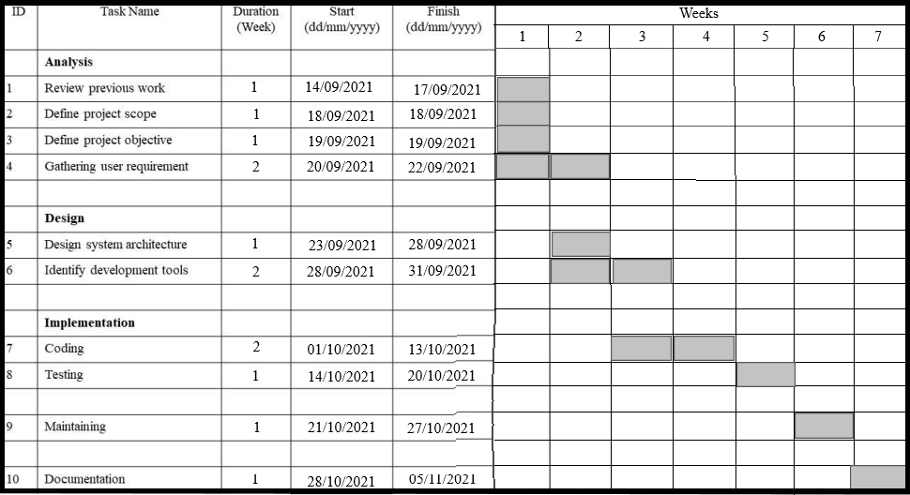
PERT (application assessment and evaluation technique) and CPM (important route method), are to be had to help the control of a large-scale mission that calls for coordinating sever activities. A myriad of details should be taken into consideration in making plans the way to coordinate most of these activities, in growing a sensible schedule, and then in tracking the development of the mission. These strategies make heavy use of networks to assist plan and show the coordination of all of the activities. A Gantt Chart is a timeline this is used as a mission control device to demonstrate how the mission will run. You can view man or woman tasks, their intervals and the sequencing of those tasks. View the general timeline of the mission and the predicted of entirety date.

The Gantt chart and the PERT chart are probable the 2 great recognised charts in mission control. Each of those may be used for scheduling, however due to the fact Gantt charts do not illustrate undertaking dependencies and PERT charts may be confusing, PMs frequently use both.

Software Requirement Specification
The creation of the prerequisites phase of the product improvement measure is Software Requirements Specifications (SRS) (likewise called a necessities record). This report establishes a framework for computer programming exercises and is building when whole necessities are evoked and dissected. SRS is a conventional report, which goes about as a portrayal of programming that empowers the clients to survey whether it (SRS) is as per their prerequisites. Likewise, it involves client necessities for a framework just as itemized particulars of the framework prerequisites.
The SRS is a determination for a particular programming item, program, or set of utilizations that perform specific capacities in a particular climate. It serves a few objectives relying upon who is composing it. To start with, the SRS could be composed by the customer of a framework. Second, the SRS could be composed by an engineer of the framework. The two techniques cause completely different circumstances and set up various purposes for the archive out and out. The principal case, SRS, is utilized to characterize the necessities and assumption for the clients. The subsequent case, SRS, is composed for different purposes and fills in as an agreement report among client and designer.
These following are the features of SRS document:

- Correctness: Client survey is utilized to give the precision of prerequisites expressed in the SRS. SRS is supposed to be great in the event that it covers every one of the necessities that are genuinely anticipated from the framework.

- Completeness: The SRS is complete if it includes the following elements:
- All the necessary requirements, whether external interfaces or relating to functionality, attributes, performance, design, constraints.
- Definition of their reactions of the software to all achievable classes of input information in all available categories of situations
- Full names and references to all figures, tables, and charts in the SRS and meanings, all things considered, and units of measure.

- Consistency: The SRS is steady if no subset of individual prerequisites depicted in its contention. There are three kinds of conceivable struggle in the SRS:

- The predefined attributes of true items may clash. For instance,
- The organization of a yield report might be depicted in one necessity as plain yet in one more as text based.
- One condition might express that all lights will be green while another states that all lights will be blue.

- There might be a sensible or transient clash between the two determined activities. For instance,
- One prerequisite might discover that the program will add two sources of info, and another may verify that the program will duplicate them.

- One condition might express that "A" absolute necessity consistently follow "B," while other requires that "An and B" cheapens.

- At least two necessities might characterize a similar true article yet utilize various terms for that item. For instance, a program's solicitation for client info might be known as a "brief" in one necessity and a "prompt" in another. The utilization of standard phrasing and portrayals advances consistency.

SOFTWARE REQUIREMENT PARADIGM APPLIED:

- Requirement Gathering: The feasibility report is positive towards the project and next phase start with gathering requirement from the user. Engineer communicates with the client and end-users to know their Idea and which features they want to software to include.

- Software design: It is a process to transform user requirements into a suitable form. It helps programmers in software coding. There is a need for more specific and detailed requirements in software. The output of the process can directly be used in implementation in a programming language. There are three design levels as follows.

- Architectural design: It is the highest abstract version of the system. In a software system, many components interact with each other.

- High-Level design: It focuses on how the system along with all its components and its can be implemented in form of modules.

- Detailed design: It defines the logical structure of each module and its interface to communicate with each module.

- Developing Product: In this phase of SDLC, you will see how the product will be developed. It is one of the crucial parts of SDLC, It is also called the Implementation phase.

- Product Testing and Integration: In this phase, we will integrate the modules and will test the overall product by using different testing techniques.

- Deployment and Maintenance: In this phase, the actual deployment of the product, or you can say the final product will be deployed, and also we will do maintenance of product for any future update and release of new features.

SOFTWARE REQUIREMENT SPECIFICATION

Microsoft Windows 7 / 8 / 10.

PC or laptop with x86-64 (64-bit) compatible processors.

2 GHz or better processor is recommended.

x86 (32-bit) processors can still be used, but the algorithm will not provide the specified performance.

At least 512 MB of free RAM should be available for the application.

A camera or webcam which is accessible using DirectShow interface.

Microsoft .NET framework 4.5 or newer (for .NET components usage).

One of following development environments for application development:

Microsoft Visual Studio 2012 or newer (for application development under C/C++, C#, Visual Basic .Net)

Internet connection required for managing the Face Verification transaction licenses.

TOOLS, HARDWARE AND SOFTWARE SPECIFICATION

H/W System Configuration: -
- Processor – Intel dual-core or above
- Processor speed – 1.0 GHz or above
- Ram – 1GB RAM or above
- Hard disk – 20GB of hard disk
- Web Camera

S/W System Configuration: -

Apart from the basic Python REPL (command-line interface), we may use one of these two professional editors to run our Python programme:

PyCharm - Get started with the renowned Python IDE for Professional Developers. It's similar to other well-known IDEs in that it's easy to get started with and use.

Programmers and professional trainers use Jupyter Notebooks, a web-based code editor.

DATAFLOW DIAGRAM

Data flows are data structures in motion, while data stores are data structures. Data flows are paths or ‘pipe lines’, along which data structures travel, whereas the data stores are place where data structures are kept until needed.
Data flows are data structures in motion, while data stores are data structures at rest. Hence it is possible that the data flow and the data store would be made up of the same data structure.
Data flow diagrams is a very handy tool for the system analyst because it gives the analyst the overall picture of the system, it is a diagrammatic approach.

Circle: The processes are represented by circle provide information about what the activity takes on the data-checking. An interaction accepts input information required for the process to be completed and creates data that it passes on to other part of the Dataflow diagram.

Figure 1. Circle

Arrow: Arrow represents direction of the data flow. It shows the direction source to processes and between a data store to another data store.

Figure 2. Arrow

Square: Square represents the source and destination of the system.

Figure 3. Square

Cylinder: Cylinder represents a database that is a repository of data. This data may be updated, stored either temporarily or permanently by administrator.

Figure 4. Cylinder

Level of DFD:-

The general procedure of Face Recognition System monitoring is depicted in this data flow diagram. This will also serve as a guide as you work your way through the Face Recognition System data flow diagrams' more complex procedures.

As you can see, as the levels of data flow diagrams are built, the linkages between transactions and data broaden and get more explicit.

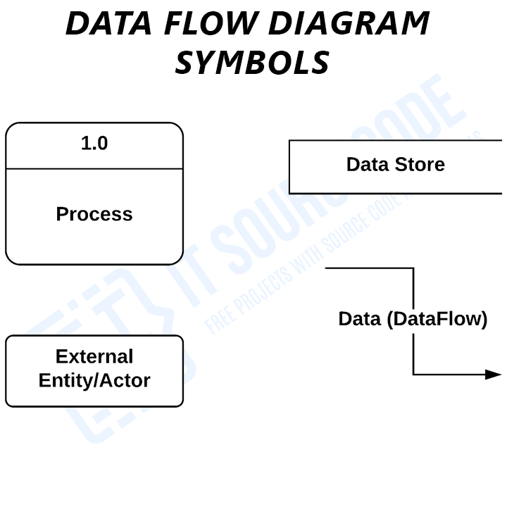
DFD Level 0 Face Recognition System
To begin, let us define DFD level 0 of the Face Recognition System.

Context diagram is another name for the Face Recognition System DFD level 0. The mechanism is designed to be depicted as a single process with external partners in an abstract view.

The overall structure of the Face Recognition System is depicted as a single bubble in this DFD. It includes incoming/outgoing indicators that display data input and output.

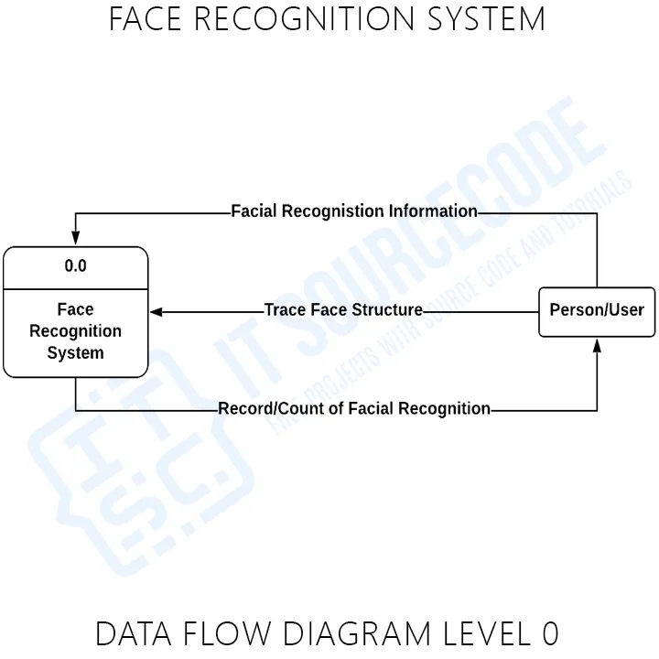

The general procedure of Face Recognition System monitoring is depicted in this data flow diagram. This will also serve as a guide as you work your way through the Face Recognition System data flow diagrams' more complex procedures.
As you can see, as the levels of data flow diagrams are built, the linkages between transactions and data broaden and get more explicit.
DFD Level 1 Face Recognition System
The level 1 data flow diagram is located next to the context diagram.
Face Recognition System DFD level 1 content is broken down into sub processes and must be a single process node from the context diagram.
The system must display or reveal additional processing information at this level.
The following information is required to be accommodated:
• Records of Face Recognition • Records of Visitors • Records of Employees/Staff

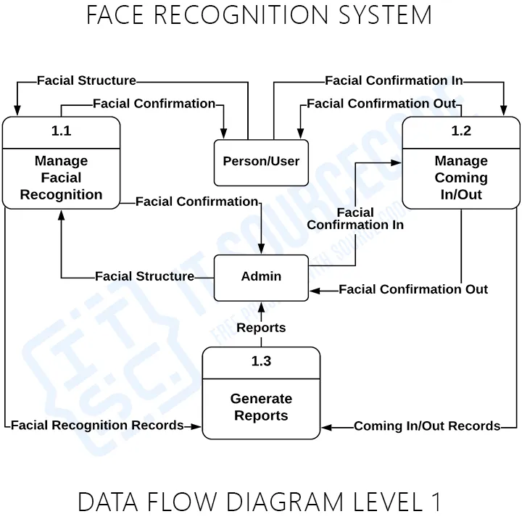

These procedures necessitate data such as a list of recognisable faces, unknown faces, and the total number of people who have entered the firm/ establishment, which served as the foundation for the Face Recognition System to be managed by the admin. A data store is used to represent this type of information.

Knowing the DFD level 1 of the Face Recognition System will allow you to understand its broader context terms.
Additionally, this may serve as a reference for how the system's inputs or data are fed. The system's outputs will then be communicated to you as well.

All of the processes depicted in the DFD were based on the Face Recognition System idea.
Level 2 Face Recognition System
The Face Recognition System DFD levels 0 and 1 are presented first, followed by level 2.

Here are some things to think about while drawing a data flow diagram level 2 for a Face Recognition System.
• The system's Level 2 DFD should show the basic modules as well as data flow between them.
• Because DFD level 2 is the highest abstraction level, the Face Recognition System procedures that are based on DFD level 1 must be comprehensive.

Finally, the user's request will be processed after they have figured out the system's processes.
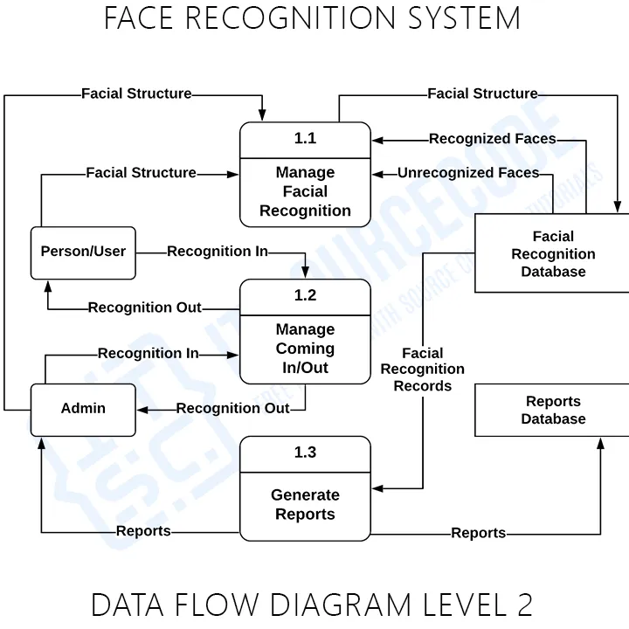
DFD level 2 gives you an understanding of where the data inputs go and where the data inputs come from within the Face Recognition System. When you consider the dataflow levels discussed above, you can see how important it is to split down processes in a more detailed way.

The displayed level not only displays you the system's detailed procedures, but also the precise destination of the data that travels through it.

This DFD will also serve as a guide for creating and designing your own project DFD levels 0, 1, and 2.

ER DIAGRAM

This ER (Entity Relationship) diagram represents the model of office management system entity. The ER-relationship diagram of office management system shows all the visual instruments of database tables and the relation between employees, tasks, offices, time entries etc. It used structured data and to define the relationship between structured data groups of office management system functionalities. The main entities of the office management system are offices, employees, resources, tasks, attendance and entries.
Office Entity: Attributes of Offices are office_id, office_company_id, office_employee_id, office_name, office_place, office_type, office_address
Employees Entity: Attributes of Employees are employee_id, employee_name, employee_mobile, employee_email, employee_username, employee_password, employee_addresS
Resources Entity: Attributes of Resources are resource_id, resource_employee_id, resource_name, resource_type, resource_description
Tasks Entity: Attributes of Tasks are task_id, task_employee_id, task_name, task_type, task_description
Attendance Entity: Attributes of Attendance are attendance_id, attendance_employee_id, attendance_type, attendance_description
Time Entries Entity: Attributes of Time Entries are time_entry_id, time_entry_employee_id, time_entry_type, time_entry_description
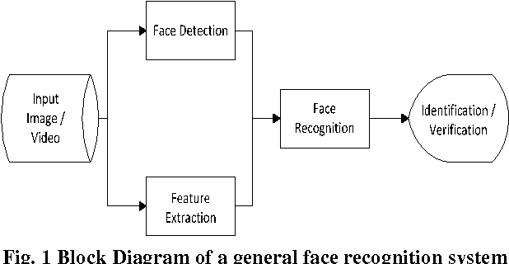

CHAPTER 3: SYSTEM DESIGN

MODULARIZATION DETAILS

Modularization is a process that breaks down complex systems into small and solvable parts. By dividing the product structure into modules, companies seek to optimize the way they function and operate in terms of transforming their products in a more flexible and accurate way. Modularization has gained momentum over the years as it helps projects achieve significant benefits by removing underperforming processes, products and parts. Since it is still a relatively new field outside the automotive and aircraft industry where it initially evolved, there is a growing interest in the development process of the modular patterns.
It uses Stack logic to traverse between Activities. The LIFO logic provides users with a continuous and smooth Experience.

Html i-frames
Another major aspect of the design of the protocol is HTML I-frames. A HTML I-frame, which can also be called “Internal Frame” is a HTML front end web design tag or tools that is used to allow a web browser window to be shared into several portions thereby allowing the possibility of viewing different web-sites or web content, either from the local site or externally, at the same time dependent on the availability of these sites at that point in time also. Since the development of this project gives liberty to use several facility the possibility of embedding other hosted objects or sites that provide some of the features required by the web application can be done in several ways, a few of which include using objects, applets, as well as Iframes. The word embed here still refers to the same intention of an I-frame which is to load internal or external content using a web page and making it look like it was a part of the web page. Such content that can be embedded into web pages include pictures, data macromedia flash documents, etc.

Let’s define the stages which are followed by software engineering paradigms:

- Planning: The first stage is the planning phase, for every project, we first make a plan. The same case applies for our project as well.

- Feasibility Study: It is most necessary to do the feasibility study. Feasibility study helps in reduce the cost and schedule the all gatherings.

- Requirement Gathering: At third, when the planning is complete, the next stage is to gather the all the requirements. After planning and feasibility study, we start working on project.

- Data Analysis: As this is data science project, the next phase is the data analysis which we got from requirement gatherings.

- Model Training: After data analysis and preprocessing, we make our dataset to be ready for the model training. There is another feasibility study inside model training. The feasibility study of selecting best suitable machine learning algorithm.

- Testing and Deployment: The final process is the deploying the model and doing some test cases
DATABASE DESIGN

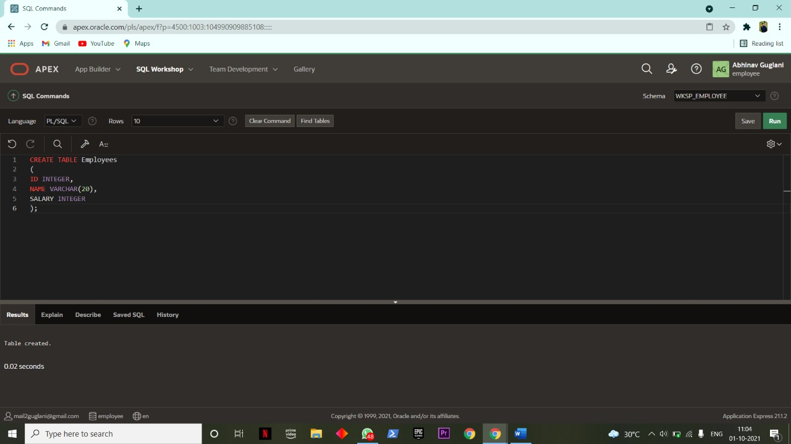

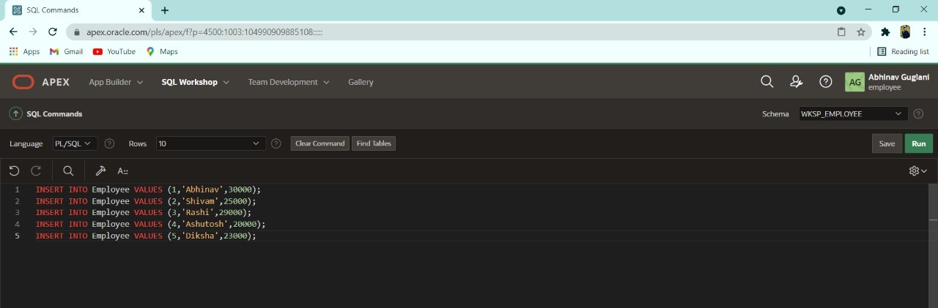

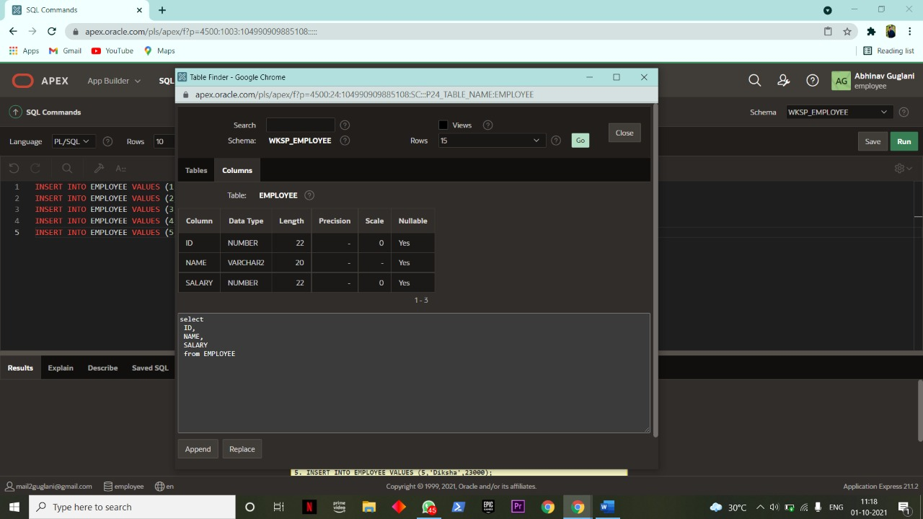

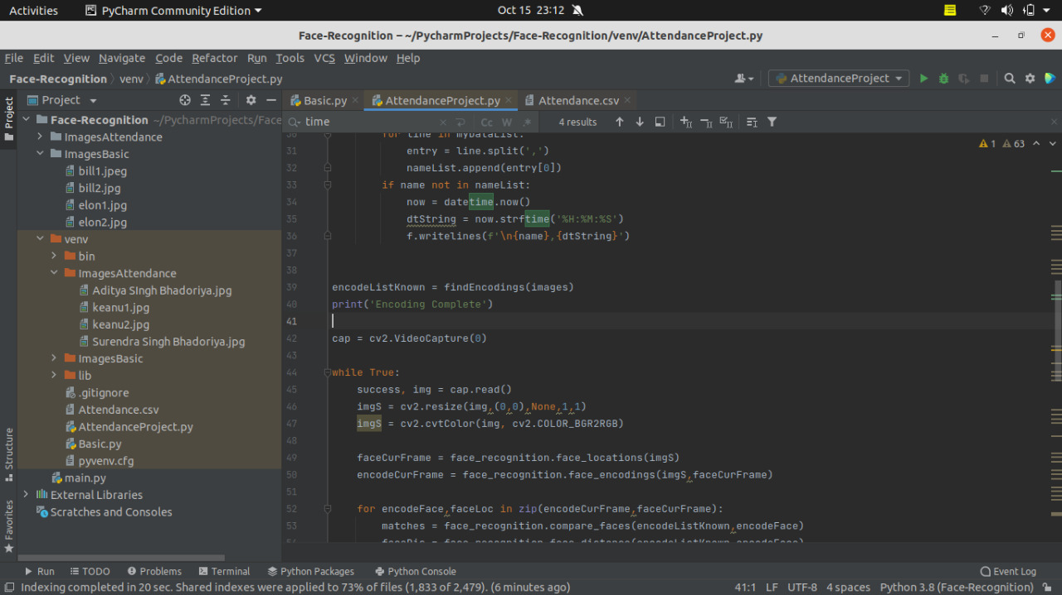

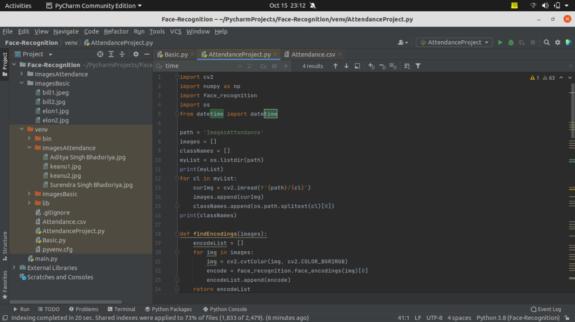

USER INTERFACE DESIGN

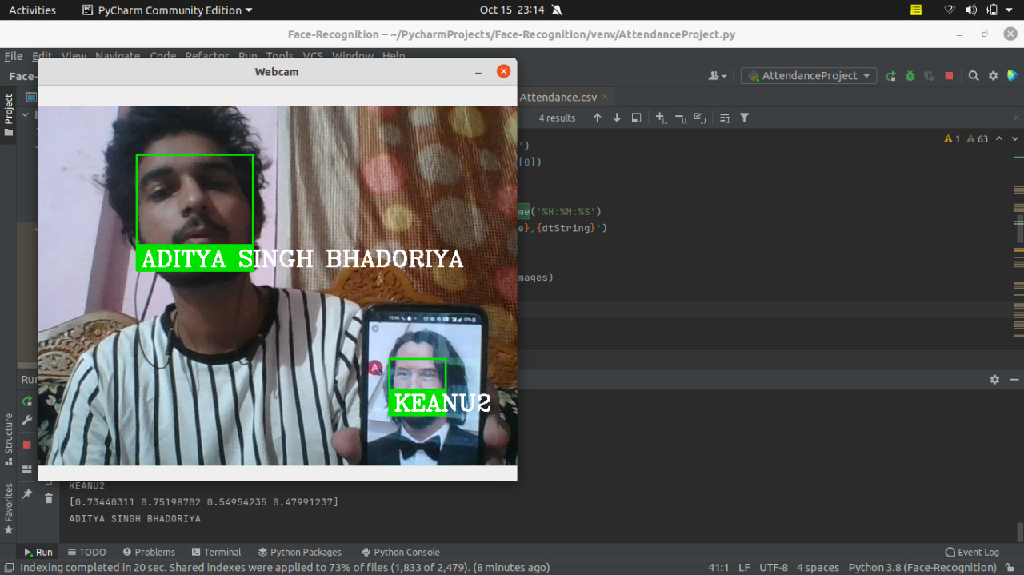

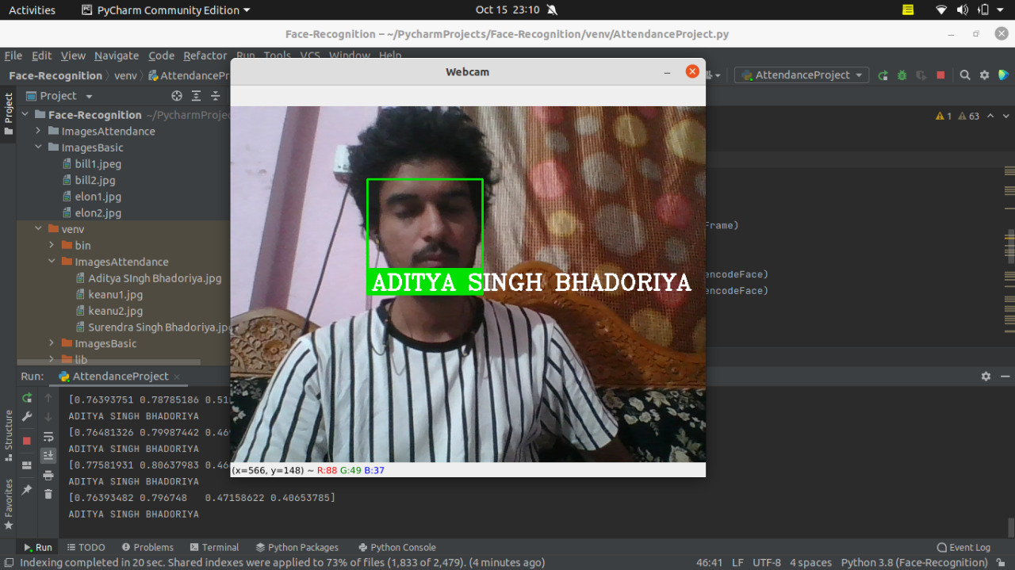

Test Cases (Unit Test Case and System Test Case)

Unit testing:
It is a strategy by which individual units of source code, sets of at least one program modules all things considered with related control information, utilization methods, and working techniques, are tried to decide if they are good for use. Naturally, you can see a unit as the shortest testable piece of an app. In procedural programming a unit can be a whole module yet is all the more ordinarily a singular capacity. In object-arranged programming a unit is a whole interface yet could be a singular technique. Unit test is made by software engineers or by white box analyzers during the advancement interaction.

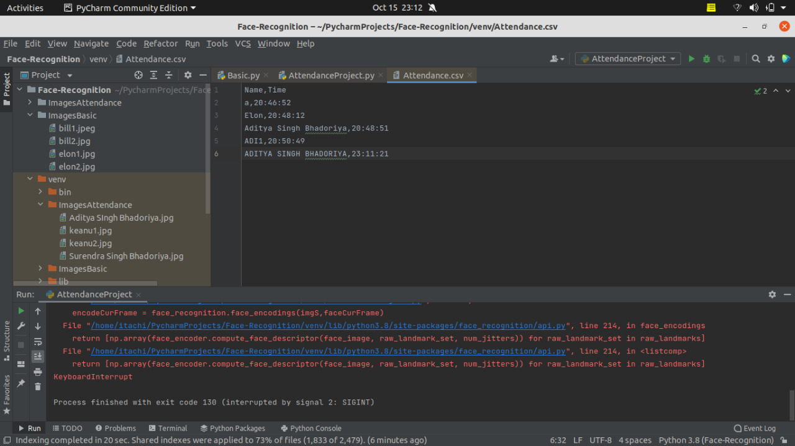

System Test:

When the program test for each of the projects of the framework is composed and mistakes are eliminated then framework test is finished. At this stage the test is done on genuine information. The total framework is placed into execution on the genuine information. At each phase of the execution, the yield of the framework is examined.

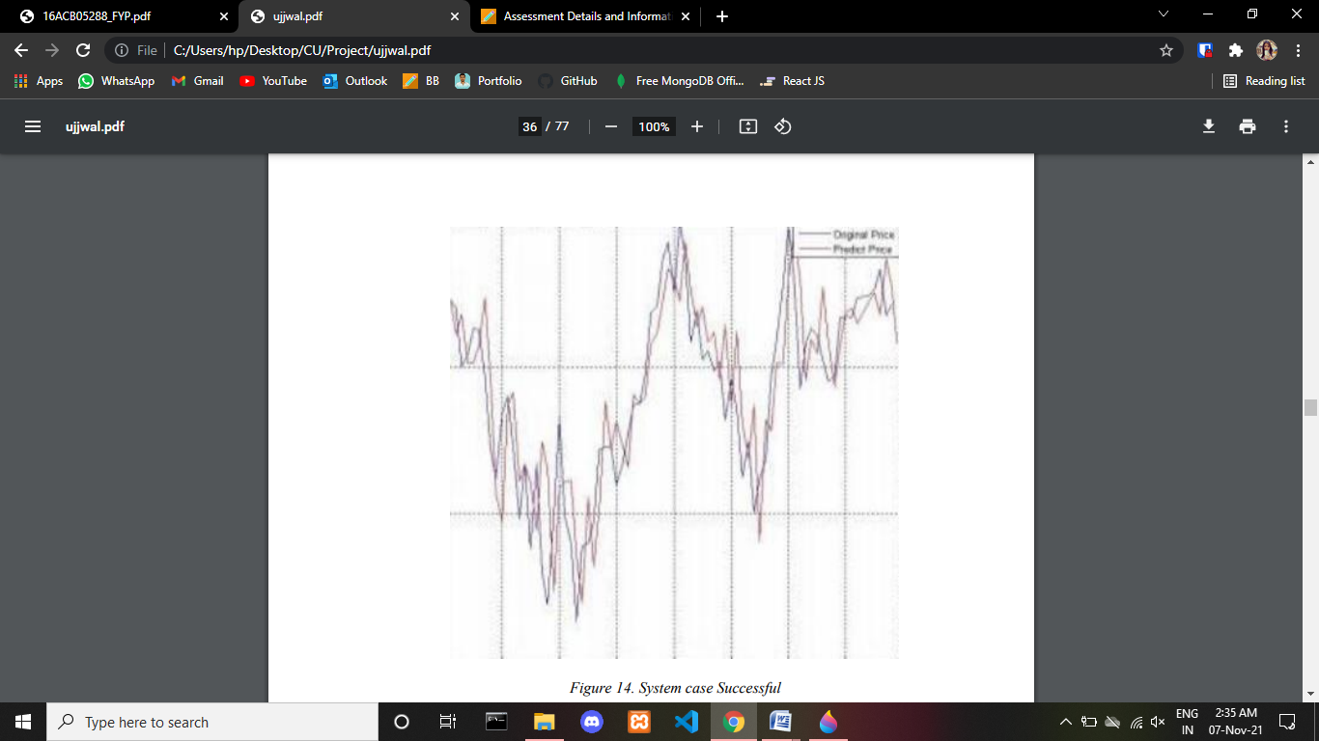

CHAPTER 4: CODING

The purpose of the coding phase of a particular project is to use the design in the best possible way. At this stage system building is translated into code in programming language. The coding phase affects the monitoring and evaluation phase of the life cycle process of system development. Testing and correction effort is minimized if the code is properly written. Since the cost of testing and maintaining software is more expensive than coding costs, the goal of coding should be to reduce the testing and repair effort. Therefore, during code writing the emphasis is on developing easy-to-write programs. Simplicity and clarity should be achieved, during the coding phase.

import cv2
import numpy as np
import face_recognition
import os
from datetime import datetime

path = 'ImagesAttendance'
images = []
classNames = []
myList = os.listdir(path)
print(myList)
for cl in myList:
curImg = cv2.imread(f'{path}/{cl}')
images.append(curImg)
classNames.append(os.path.splitext(cl)[0])
print(classNames)

def findEncodings(images):
encodeList = []
for img in images:
img = cv2.cvtColor(img, cv2.COLOR_BGR2RGB)
encode = face_recognition.face_encodings(img)[0]
encodeList.append(encode)
return encodeList

def markAttendance(name):
with open('Attendance.csv','r+') as f:
myDataList = f.readlines()
nameList = []
for line in myDataList:
entry = line.split(',')
nameList.append(entry[0])
if name not in nameList:
now = datetime.now()
dtString = now.strftime('%H:%M:%S')
f.writelines(f'\n{name},{dtString}')

encodeListKnown = findEncodings(images)
print('Encoding Complete')

cap = cv2.VideoCapture(0)

while True:
success, img = cap.read()
imgS = cv2.resize(img,(0,0),None,1,1)
imgS = cv2.cvtColor(img, cv2.COLOR_BGR2RGB)

faceCurFrame = face_recognition.face_locations(imgS)
encodeCurFrame = face_recognition.face_encodings(imgS,faceCurFrame)

for encodeFace,faceLoc in zip(encodeCurFrame,faceCurFrame):
matches = face_recognition.compare_faces(encodeListKnown,encodeFace)
faceDis = face_recognition.face_distance(encodeListKnown,encodeFace)
print(faceDis)
matchIndex = np.argmin(faceDis)

if matches[matchIndex]:
name = classNames[matchIndex].upper()
print(name)
y1,x2,y2,x1 = faceLoc
cv2.rectangle(img,(x1,y1),(x2,y2),(0,225,0),2)
cv2.rectangle(img,(x1,y2-35),(x2,y2),(0,225,0),cv2.FILLED)
cv2.putText(img,name,(x1+6,y2-6),cv2.FONT_HERSHEY_COMPLEX,1,(255,255,255),2)
markAttendance(name)

cv2.imshow('Webcam',img)
cv2.waitKey(1)

#faceLoc = face_recognition.face_locations(imgElon)[0]
#encodeElon = face_recognition.face_encodings(imgElon)[0]
#cv2.rectangle(imgElon, (faceLoc[3], faceLoc[0]), (faceLoc[1], faceLoc[2]), (225, 0, 225), 2)

#faceLocTest = face_recognition.face_locations(imgTest)[0]
#encodeTest = face_recognition.face_encodings(imgTest)[0]
#cv2.rectangle(imgTest, (faceLocTest[3], faceLocTest[0]), (faceLocTest[1], faceLocTest[2]), (225, 0, 225), 2)

#results = face_recognition.compare_faces([encodeElon], encodeTest)
#faceDis = face_recognition.face_distance([encodeElon], encodeTest)
#print(results, faceDis)
#cv2.putText(imgTest, f'{results} {round(faceDis[0], 2)}', (50, 50), cv2.FONT_HERSHEY_COMPLEX, 1, (0, 0, 225), 2)

Marking the Attendance

import cv2
import numpy as np
import face_recognition
import os
from datetime import datetime

path = 'ImagesAttendance'
images = []
classNames = []
myList = os.listdir(path)
print(myList)
for cl in myList:
curImg = cv2.imread(f'{path}/{cl}')
images.append(curImg)
classNames.append(os.path.splitext(cl)[0])
print(classNames)

def findEncodings(images):
encodeList = []
for img in images:
img = cv2.cvtColor(img, cv2.COLOR_BGR2RGB)
encode = face_recognition.face_encodings(img)[0]
encodeList.append(encode)
return encodeList

def markAttendance(name):
with open('Attendance.csv','r+') as f:
myDataList = f.readlines()
nameList = []
for line in myDataList:
entry = line.split(',')
nameList.append(entry[0])
if name not in nameList:
now = datetime.now()
dtString = now.strftime('%H:%M:%S')
f.writelines(f'\n{name},{dtString}')

encodeListKnown = findEncodings(images)
print('Encoding Complete')

cap = cv2.VideoCapture(0)

while True:
success, img = cap.read()
imgS = cv2.resize(img,(0,0),None,1,1)
imgS = cv2.cvtColor(img, cv2.COLOR_BGR2RGB)

faceCurFrame = face_recognition.face_locations(imgS)
encodeCurFrame = face_recognition.face_encodings(imgS,faceCurFrame)

for encodeFace,faceLoc in zip(encodeCurFrame,faceCurFrame):
matches = face_recognition.compare_faces(encodeListKnown,encodeFace)
faceDis = face_recognition.face_distance(encodeListKnown,encodeFace)
print(faceDis)
matchIndex = np.argmin(faceDis)

if matches[matchIndex]:
name = classNames[matchIndex].upper()
print(name)
y1,x2,y2,x1 = faceLoc
cv2.rectangle(img,(x1,y1),(x2,y2),(0,225,0),2)
cv2.rectangle(img,(x1,y2-35),(x2,y2),(0,225,0),cv2.FILLED)
cv2.putText(img,name,(x1+6,y2-6),cv2.FONT_HERSHEY_COMPLEX,1,(255,255,255),2)
markAttendance(name)

cv2.imshow('Webcam',img)
cv2.waitKey(1)

IMPLEMENTATION

If this system were to be implemented in a university, the following recommendations would be made:

- The facial recognition camera should be placed 3 feet away from the lecture theatre door, at a height of 65 inches. The face recognition system would be more accurate as a result of this.

- Because they are guaranteed to contain just one face, the photographs uploaded to face lists should preferably be the same as the pictures used for student IDs.

- To maintain consistency with the folders matching to each face list made and the photographs in each folder corresponding to the faces each face list contains, the application should be hosted on the university's servers.

CHAPTER 5: TESTING

TESTING PHASE

Testing is the process of executing then programs with the intention of finding out errors. During the process, the project is executed with set of test and the output of the application is evaluated to determine if the project is performing as expected. Testing makes a logical assumption that if all the parts of the module are correct then goal will be successfully achieved. Testing includes after the completion of the coding phase. The project was tested from the very beginning and also at each step by entering different type of data. In the testing phase some mistakes were found, which did not come to knowledge at the time of coding the project. Then changes were made in the project coding so that it may take all the relevant data and gives the required result. All the forms were tested one by one and made all the required changes.
Testing is vital to the success of the system. Testing makes a logical assumption that if all the parts of the system are correct, the goal will be successfully achieved. A small system error can conceivably explode into a much larger problem. Effective testing early in the process translates directly into long-term cost savings from a reduced number of errors. For the verification and validation of data various-nesting task are performed. Testing is itself capable of finding the syntactical mistakes in the system but user need to test the system for logical checking.

LEVELS OF TESTING

The aim of the testing process is to identify all the defects in the application. It is not practical to test the application with respect to each value that the input request data may assume. Testing provides a practical way of reducing defects in the application and increasing the user’s confidence in a developed system. Testing consists of subjecting the application to a set of test inputs and observing if the program behaves as expected. If the program fails to Testing behave as expected then conditions under which failure occurs are noted for later debugging and correction. The following things are associated with testing:
While developing the web application, tests were carried out. Some of the tests were carried out to verify how user friendly the system was, bandwidth intensiveness of some features of the web application, the response rate of some of the features portrayed by the web application, etc. A few of these tests were carried out in a classroom session to verify how viable the video conferencing feature of the web application is

System Effectiveness Test

Parameter | Strongly  Agree | Agree | Disagree | Strongly  Disagree
I Was Able To Complete My Task Successfully And  Correctly Using The Application | 5% | 45% | 27% | 23%
The System Did Not Show Error Message(s) While Using It | 10% | 60% | 10% | 20%
I Was Able To Recover From My Mistakes Easily | 5% | 50% | 23% | 22%
I Feel Comfortable Using The Application | 10% | 55% | 15% | 20%
The Voice Request/Response From The System Was Clear | 0% | 9% | 50% | 41%

User Satisfaction Test

Parameter | Strongly  Agree | Agree | Disagree | Strongly  Disagree
The System Was Easy To Learn | 14% | 71% | 4% | 11%
The System Was Easy To Use And Is User Friendly | 14% | 68% | 7% | 11%
I Am Satisfied Using The System | 4% | 50% | 31% | 15%
I Feel The System Met My Need | 4% | 44% | 36% | 20%
I Am Satisfied With The Performance Of The System In  Accomplishing My Tasks | 0% | 40% | 36% | 20%

System Efficiency Test

Parameter | Strongly  Agree | Agree | Disagree | Strongly  Disagree
Using The System Saves Me Time Of Learning | 7% | 32% | 36% | 28%
I Was Able To Complete My Task On Time | 7% | 54% | 21% | 21%
I Was Able to Navigate the VUI On Time When Using The  System | 7% | 33% | 40% | 20%
I Didn’t Have to Carry Out Too Many Difficult Steps  Before Completing My Tasks | 14% | 61% | 4% | 21%
I Am Satisfied with The Performance of The System In  Accomplishing My Tasks | 0% | 43% | 25% | 32%

FUCTIONAL TESTING

Here the system is a black box whose behavior is determined by studying its inputs and related outputs. The key problem is to select the inputs that have a huge probability of being members of a set in many cases; the selection of these test cases is based on the previous studies.

STRUCTURAL TESTING

A great deal can be learnt about the strength and the limitation of the application by examinee the manner in which the system breaks. This type of testing has two limitations.
It tests failure behavior of the system circumstances may arise through an unexpected combination of events where the node placed on the system exceeds the maximum anticipated load.
The structure of each module was checked at every step. Some structures were firstly wrong, which came to notice at the time of the connectivity.

UNIT TESTING

The test's results help to resoundingly refute the theory. The system was able to achieve low false acceptance error rates in some trials, but it was never able to achieve low rates for both false acceptance and false rejection for the same enrollment sets. The results also suggest that the assumptions about lighting and enrollment image quality that were made prior to the test were correct, despite the fact that the impacts of these variables were inconsistent. Decreased illumination reduced false rejection rates across the board and improved false acceptance rates for video enrollments, but marginally increased false acceptance rates for digital camera enrollments.

INTEGRITY TESTING

Integrity phases the entire module using the bottom-up approach and tested them. Integrity testing is a systematic technique for constructing the program structure while at the same time conducting tests to uncover errors associated with interfacing. The objective was to take unit tested modules and build a program structure that has been dictated by design.
The testing strategy has two different approaches namely the top-down approach in which the integration is carried out from the top-level module to the bottom and the bottom- up approach in which the integration is carried out from the low-level module to the top.
The modules were tested using the bottom-up approach by introducing stubs for the top-level functions. This test was used to identify the errors in the interfaces, the errors in passing the parameters between the functions and to correct them.

There are two types of testing available:

- Black Box Testing
- White Box Testing

- Black Box Testing
In black box testing the structure of the program is not considered. Test cases are decided solely on the basis of the requirements or specifications of the program or module, and the consideration for selection of test classes. In this section, we will present some techniques for
Generating test cases for black-box testing. In black-box testing, the testing only knows the inputs that can be given to the system and what output the system can give. In other words, the basis for deciding test case in functional testing is the requirement or specification of the system module. This form of testing is obvious functional or behavioral testing.
The most obvious functional testing procedure is exhaustive testing, which as we have stated, is empirical. One criterion for generating test causes is to strategy has little chance of resulting in a set of test causes that is close to optimal (i.e. that detects the maximum errors with minimum test cases). Hence, we need some other criterion or rule for selecting test cases. There are no formal rules for designing test cases for functional testing. In fact, there are no precise criteria for selecting test cases however, there have been found to be very successful in detecting errors. Here we mention some of these techniques.

- White Box Testing
In the previous section we discussed testing, which is concerned with the function that the tested program is proposed to program and does not deal with the internal structure of the program responsible for actually implementing that function. Those black-box testing is concerned with functionality rather than implementation of the program. On the other hand, white-box testing is concerned with testing implementation of the program. The intent of this testing is not to exercise all the different input or output conditions (although that may be buy products) but to exercise the different programming structures and data structures used in the program. White-box testing is also called structure testing and we will use the two terms interchangeably to test the structures of a program, structural testing aims to achieve test cases that force the desired coverage of different structures various criteria have been proposed for this. Unlike the criteria for functional testing which are frequently imprecise, the criteria for structural testing are generally quite precise as they are based on program structures, which are formal and precise.

CHAPTER 6: DOCUMENTATION

COST ESTIMATION OF THE PROJECT ALONG WITH COST ESTIMATION MODEL

This project consumed around 4 months of time, if there is a need to calculate the cost estimation of the project. Then I will choose CoCoMo Model.
Cost estimation means finding out the total cost to create computer-based software. Cost of the software is depending on many factors like humans, software, hardware, time availability, etc.
The main thing for calculating the cost for software is the “size” of software. Sizing means approx. lines of code and size of each part in software.
I basically estimated the cost bases on two factors: -

EFFORT ESTIMATION: -
Effort estimation refers to total man hours needed for designing and development for a project. It also included time of making documentation and user manual.

HARDWARE REQUIRED ESTIMATION: -

This include the cost of hardware which are require for development.

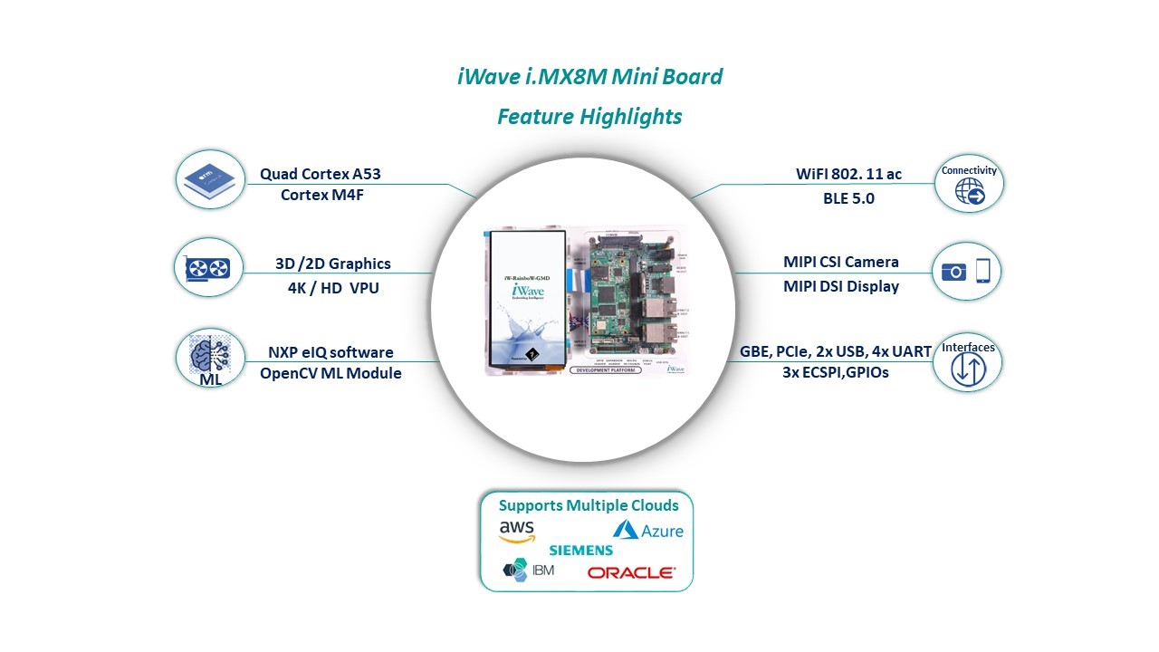

Table 5- Development Cost

Operational Cost

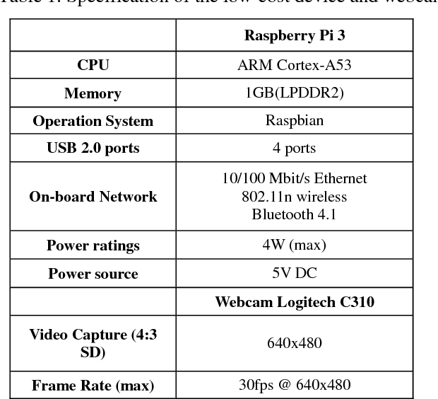

PRE-REQUISITE FOR PROJECT INSTALLATION

In this project, we use
1. Python GUI – PyCharm (to implement the coding based on Face Recognition)
2. OpenCV 2.0 (Open-source machine learning software library)
Hardware requirement:
- Processor – Intel dual-core or above
- Processor speed – 1.0 GHz or above
- Ram – 1GB RAM or above
- Hard disk – 20GB of hard disk
- Web Camera

Software requirement:

- OpenCV 2.0
- Python 2.7

Non-Functional Requirement:
- Relation with each activity within project.
- Normalization to reduce redundancy
- Safety Requirements: Getting proper inputs for prediction (Handling Exceptions)

COMPARATIVE ANALYSIS

Comparative assessments of the many approaches to facial recognition have been demonstrated. This study considers a variety of methods, including Gabor + ICA, Kernel associated Memory Model (KAMM), Kullback-Leibler divergence (KLD)-based local Gabor binary patterns, Hybrid Colour and Frequency Features, Gabor Image Representation, Kernal Fisher Analysis + Fractional Power Polynomial Models, Enhanced sidefaceImage, Virtual Frontal-View Face 3D Facial Aging Model And Simulation Method (3D Ageing Model), Gait Energy A comparison of the graph reveals that Gabor + ICA is the Kernel associated Memory Model.

Problem Encountered
Environmental issues such as lighting, enrollment image quality, and quality of hardware are essential factors that need to be addressed in an operational facial recognition system. Furthermore, this test has proven the value of scenario testing being conducted on biometric systems before they are integrated into operational systems. In environments where maintaining security is a paramount concern, it is inadvisable to install a system that has not been tested under similar conditions as the operational environment.

NEGATIVE RESULTS

This project’s aim is to feature a group video call but sometimes users find difficult to add people. By adding more features to it to make it modern and feature friendly, a user might find things tricky to do in an application at one time.

CHAPTER 7: CONCLUSION AND FUTURE SCOPE

CONCLUSION

Face recognition is a new technology that has a lot of potential. Face recognition may help businesses save money and time, as well as establish new revenue streams, if done correctly.

What does the future hold for this technology?

It's tough to know for sure. According to some experts, our looks will eventually replace IDs, passports, and credit card pin numbers. This prediction is not far-fetched, given how easy and cost-effective this technology is.

If this prediction comes true, any company that adopts the technology now will have a competitive advantage in the future.

FUTURE SCOPE AND FURTHER ENHANCEMENT OF THE PROJECT

Face recognition technology is being used all over the world, and it is having a positive impact. Why is India being left out? This technology has a lot of potential in India, and it can help the country progress in a variety of ways. The technology and its applications can be used in a variety of industries across the country.

- In India, preventing ATM fraud is a priority. It is possible to construct a database of all ATM cardholders in India, and facial recognition technologies can be deployed. As a result, everytime a user enters an ATM, his photograph will be collected in order to grant access once it is matched with a database photo.
- In India, duplicate voters are being reported.
- This technology can also be used to verify passports and visas.
- The same method can also be used to verify a driver's license.

BIBLIOGRAPHY

- YouTube

REFERENCES

The Extraction of Spatio-Temporal Energy in • Human and Machine Vision, Proceedings of Workshop on Motion: Representation and Analysis, Adelson, E. H., and Bergen, J. R. (1986).

• Research (pp. 151-155) May 7-9, Charleston, SC
• AAFPRS (American Association for the Prevention of Cruelt (1997). The American Academy of Facial Plastic and Reconstructive Surgery publishes a newsletter.

Third Quarter 1997, Vol. 11, No. 3, Page 3. Reconstructive Surgery. Third Quarter 1997, Vol. 11, No. 3, Page 3.

• R. J. Baron (1981). Human facial recognition mechanisms. The International Journal of Man is a publication dedicated to the study of human

15:137-178 in Machine Studies

• D. Beymer and T. Poggio, Face Recognition From One Example View, A.I. Memorandum, 1995

C.B.C.L. Paper No. 121, No. 1536, MIT

M. Bichsel, M. Bichsel, M. Bichsel, M (1991). Robust Object Recognition Strategies for Automatic Identification

PLAGIARISM AND GRAMMAR REPORT

