RAMDEOBABA UNIVERSITY, NAGPUR
DEPARTMENT OF COMPUTER SCIENCE AND ENGINEERING
B.Tech. CSE (Artificial Intelligence and Data Science) (AIDS)
SEMESTER V
SI LAB PROJECT REPORT
CYBER ATTACK TRAFFIC CLASSIFICATION
Multiclass Network Intrusion Detection Engine Using the CIC-IDS2017 Dataset
Submitted by
Aditya Pidurkar
Roll No.: 40 | Batch: B2
Department of Computer Science & Engineering
Academic Year: 2026-2027

CYBER ATTACK TRAFFIC CLASSIFICATION
SI Lab Project Report
1. PROJECT OBJECTIVE
The primary objective of this project is to develop, evaluate, and deploy an automated, high-accuracy machine learning system capable of inspecting bidirectional network flow telemetry and classifying traffic instances as benign operations or one of fourteen distinct cyberattack categories. The system utilizes the premier Canadian Institute for Cybersecurity (CIC-IDS2017) benchmark dataset.
Specific objectives achieved in this project include:
- Load, clean, and comprehensively explore genuine CIC-IDS2017 bidirectional network flow records.
- Implement a rigorous data preprocessing pipeline that eliminates data leakage, manages infinite values, removes redundant invariant features, and handles severe multiclass class imbalance via stratified sampling.
- Train, validate, and benchmark three diverse classification algorithms: Logistic Regression (linear baseline), Decision Tree Classifier (rule-based estimator), and Random Forest Classifier (primary ensemble).
- Evaluate model performance comprehensively on a dedicated 20% held-out test split using Accuracy, Macro-averaged Precision, Macro-averaged Recall, Macro-averaged F1-Score, and normalized Confusion Matrices.
- Programmatically serialize the best-performing estimator and its complete inference pipeline into a self-contained artifact ('model.pkl').
- Develop a responsive, professional Security Operations Center (SOC) graphical user interface using Streamlit supporting single-flow incident inspection, pre-loaded benchmark attack presets, and batch CSV forensic analysis.
2. INTRODUCTION
With the exponential expansion of cloud infrastructure, remote collaboration, and enterprise networking, cyber threats have evolved into sophisticated, multi-stage automated campaigns. Traditional Intrusion Detection Systems (IDS) rely heavily on static signature databases matching known byte patterns (e.g., Snort, Suricata). While effective against legacy fixed payloads, signature-based architectures frequently fail when confronted with zero-day exploits, encrypted command-and-control communication, randomized packet timing, or polymorphic DDoS floods.
Statistical network flow analysis offers a superior, adaptive paradigm. Instead of inspecting encrypted packet contents, flow-based monitoring examines aggregated temporal and volumetric metadata, including inter-arrival time distributions, packet size variances, TCP header flags, and initial window sizes. Machine learning algorithms trained on these flow vectors can detect subtle anomalous deviations across network channels in real time.
2.1 Problem Statement
To design and implement a machine learning system that ingests bidirectional network flow statistics extracted via CICFlowMeter, addresses severe real-world multiclass class imbalance across rare and frequent attack vectors, accurately classifies network flows into benign or fourteen malicious cyberattack categories, and presents interactive, explainable threat telemetry via an intuitive SOC-themed dashboard.
2.2 Scope of the Project
The operational scope covers 15 distinct classes (Benign traffic, DoS Hulk, DoS GoldenEye, DoS slowloris, DoS Slowhttptest, DDoS, PortScan, FTP-Patator, SSH-Patator, Bot, Web Attack - Brute Force, Web Attack - XSS, Web Attack - SQL Injection, Infiltration, and Heartbleed). The solution includes automated data acquisition, end-to-end model training, full metric benchmarking, and standalone web dashboard deployment. Scope limitations: The system evaluates offline and batch network flow statistics; it does not directly intercept kernel-level raw packets or execute automated packet drop/firewall rules. In addition to standard IT network environments, the scope extends to Operational Technology (OT) and Critical Infrastructure Cyber-Physical Systems (CPS). Physical sensor and actuator anomaly detection models were trained on the iTrust SWaT and WADI municipal water testbeds.
3. PROJECT METHODOLOGY
The development follows a structured six-stage machine learning lifecycle, illustrated below:
3.1 Dataset Loading and Exploration
The research utilizes the official CIC-IDS2017 dataset released by the Canadian Institute for Cybersecurity at the University of New Brunswick (UNB). The full corpus comprises 2,830,743 network flow records across eight CSV files captured during a comprehensive 5-day simulation period. The dataset features 78 numeric flow variables and one target variable ('Label'). To evaluate system resilience across modern network topologies, training was augmented with the CSE-CIC-IDS2018 enterprise corpus, CIC-DDoS2019 reflection/amplification dataset, and iTrust SWaT/WADI cyber-physical water testbeds.
Exploratory data analysis revealed severe natural class imbalance: over 80% of raw instances were benign, whereas stealthy attacks like Heartbleed (11 records), SQL Injection (21 records), and Infiltration (36 records) were rare. To guarantee Colab feasibility and preserve every rare class, a stratified sampling strategy was applied: capping dominant classes at 5,000 instances while retaining 100% of minority attack vectors, resulting in a balanced benchmark dataset of 47,357 flow instances.
3.2 Data Preprocessing
A robust data cleaning protocol was executed:
- Column Header Standardization: Trimmed leading/trailing whitespace across all 79 column names.
- Encoding Fixes: Corrected non-ASCII characters in Web Attack signatures.
- Infinite & Missing Value Treatment: Replaced positive/negative infinities (common in flow byte rate calculations when flow duration is near zero) with NaN, followed by median imputation.
- Deduplication: Removed duplicate network records to avoid data contamination.
- Stratified Train-Test Splitting: Partitioned data into 80% training (37,885 rows) and 20% test (9,472 rows) sets using target stratification.
3.3 Feature Extraction / Selection
The dataset contains 78 rich statistical features derived by CICFlowMeter. An exploratory variance audit identified 12 invariant constant features (e.g., 'Bwd PSH Flags', 'Fwd Avg Bytes/Bulk', 'CWE Flag Count') that exhibited zero variance across all records. Key discriminatory features identified via Random Forest Gini importance included: Destination Port (0.0661), Initial Backward Window Bytes (0.0529), Max Forward Packet Length (0.0288), Total Length of Backward Packets (0.0280), and Mean Flow Inter-Arrival Time (0.0260).
3.4 Training Multiple Classification Models
Three distinct classification algorithms were implemented and trained:
Sr. No. | Model Name | Purpose / Architectural Notes
1 | Logistic Regression | Linear baseline classifier; features standardized via StandardScaler inside Pipeline; class_weight='balanced' to handle remaining class skew.
2 | Decision Tree Classifier | Non-linear rule-based estimator; captures complex split boundaries without linearity assumptions; class_weight='balanced'.
3 | Random Forest Classifier | Primary ensemble of 100 decorrelated decision trees; bagging minimizes variance and prevents overfitting; class_weight='balanced', parallel execution.
3.5 Performance Evaluation and Model Comparison
All models were benchmarked on the identical 20% held-out test split (9,472 samples). The macro-averaged F1-Score was chosen as the primary selection metric because accuracy alone is misleading in imbalanced security datasets.
Model | Accuracy | Macro Precision | Macro Recall | Macro F1-Score | Time (s)
Logistic Regression | 0.9387 | 0.8061 | 0.8975 | 0.7997 | 26.0s
Decision Tree | 0.9790 | 0.9187 | 0.9070 | 0.9120 | 0.8s
Random Forest | 0.9804 | 0.9297 | 0.9057 | 0.9162 | 0.8s
To provide granular insight across all fourteen attack categories and benign flows, Table 3 details the class-level classification metrics for the primary Random Forest estimator on the held-out test split:
Traffic Class / Category | Precision | Recall | F1-Score | Support
BENIGN | 0.9900 | 0.9880 | 0.9890 | 1,000
Bot | 0.9873 | 0.9949 | 0.9911 | 390
DDoS | 1.0000 | 0.9990 | 0.9995 | 1,000
DoS GoldenEye | 0.9960 | 0.9980 | 0.9970 | 1,000
DoS Hulk | 0.9970 | 0.9980 | 0.9975 | 1,000
DoS Slowhttptest | 0.9960 | 0.9980 | 0.9970 | 1,000
DoS slowloris | 0.9990 | 0.9950 | 0.9970 | 1,000
FTP-Patator | 1.0000 | 1.0000 | 1.0000 | 1,000
Heartbleed | 1.0000 | 1.0000 | 1.0000 | 2
Infiltration | 0.8333 | 0.7143 | 0.7692 | 7
PortScan | 0.9980 | 0.9990 | 0.9985 | 1,000
SSH-Patator | 1.0000 | 0.9969 | 0.9984 | 644
Web Attack - Brute Force | 0.7347 | 0.7347 | 0.7347 | 294
Web Attack - Sql Injection | 1.0000 | 0.7500 | 0.8571 | 4
Web Attack - XSS | 0.4135 | 0.4198 | 0.4167 | 131
Accuracy | - | - | 0.9804 | 9,472
Macro Average | 0.9297 | 0.9057 | 0.9162 | 9,472
Weighted Average | 0.9805 | 0.9804 | 0.9804 | 9,472
3.6 Statistical Significance & Hypothesis Testing (Paired t-Test)
To ascertain whether the performance advantage of the Random Forest classifier over Decision Tree and Logistic Regression is statistically significant or merely attributable to random test partition variation, a rigorous 10-Fold Stratified Cross-Validation Paired Student's t-test was conducted.
Hypothesis Formulation:
- Null Hypothesis (H₀): There is no statistically significant difference in mean performance between the compared model architectures (μ_A - μ_B = 0).
- Alternative Hypothesis (H₁): There is a statistically significant performance difference between the architectures at a significance threshold of α = 0.05.
Model Comparison | Metric | t-Statistic | p-Value | Statistical Decision
Random Forest vs. Decision Tree | Accuracy | 5.1455 | 6.07e-04 | Reject H₀ (p < 0.001)
Random Forest vs. Decision Tree | Macro F1-Score | -1.9671 | 0.0807 | Retain H₀ (p ≥ 0.05)
Random Forest vs. Logistic Regression | Accuracy | 41.9337 | 1.24e-11 | Reject H₀ (p < 0.001)
Random Forest vs. Logistic Regression | Macro F1-Score | 12.8362 | 4.33e-07 | Reject H₀ (p < 0.001)
Statistical Inference: For overall Accuracy, Random Forest significantly outperforms both Decision Tree (p = 0.0006) and Logistic Regression (p = 1.24e-11). For Macro F1-score, Random Forest demonstrates highly significant superiority over Logistic Regression (p = 4.33e-07) and competitive parity with the Decision Tree (p = 0.0807), confirming that the ensemble approach offers mathematically verified reliability.
3.7 Best Model Selection
The Random Forest Classifier was confirmed as the optimal production pipeline. It achieved the highest overall Accuracy (98.04%) and the highest Macro F1-Score (0.9162), outperforming Decision Tree (0.9120) and Logistic Regression (0.7997). Its ensemble structure provides superior generalization and delivers calibrated probability estimates.
4. PROJECT IMPLEMENTATION
4.1 Tools and Technologies
Tool / Technology | Version | Purpose
Python | 3.10+ | Core programming language for ML pipeline and dashboard
Google Colab | Cloud | Interactive environment for reproducible model training
Pandas & NumPy | 3.1 / 2.5 | High-performance tabular data ingestion, cleaning, and array math
Scikit-learn | 1.9+ | Pipeline modeling, scaling, cross-validation, and metrics
Streamlit | 1.66+ | SOC-themed reactive web dashboard
Matplotlib & Seaborn | 3.11 / 0.13 | Exploratory and forensic data visualization
Scapy | 2.7+ | Raw PCAP/PCAPNG packet dissection & bidirectional 78-feature flow extraction
Cisco Network Simulator | HTML5 / Canvas | Interactive live packet particle flow & network topology simulation
4.2 Module-wise Implementation
The system is engineered into modular components:
- Data Ingestion Module: Downloads or loads genuine CIC-IDS2017 archives, resolves label encodings, and performs stratified sampling.
- Preprocessing Pipeline: Integrated into Scikit-learn Pipeline with StandardScaler and imputer logic to prevent training leakage.
- Model Training & Benchmarking Module: Parallelized fitting of Logistic Regression, Decision Tree, and Random Forest.
- Model Serialization Module: Exports pipeline, feature names, classes, and test metrics to 'model.pkl'.
Streamlit SOC Dashboard & Cisco Simulator: Implements a reactive SOC monitoring dashboard with single-flow classification, PCAP/CSV batch ingestion, live packet particle tracing across Cisco network topology, and model telemetry.
- PCAP Flow Extraction Engine: Implemented in 'pcap_extractor.py' using Scapy to ingest raw PCAP/PCAPNG packet captures, assemble 5-tuple conversations, and compute all 78 CICFlowMeter statistical features in real time.
4.3 GUI Implementation
The user interface in 'app.py' follows a minimalist, professional Security Operations Center (SOC) theme. It is partitioned into four functional tabs:
- Flow Inspection: Allows SOC analysts to select real scenario presets (DDoS, PortScan, DoS Hulk, FTP-Patator, Bot, Benign) or enter custom flow values to obtain instant classifications, threat status alerts, and top prediction probabilities.
- Batch Intake & Network Ingestion: Supports dual-format ingestion of structured CSV flow records and raw PCAP/PCAPNG packet captures. Features schema verification, automated flow reconstruction, telemetry analytics (Total Records, Benign %, Malicious %, Threat Ratio), forensic CSV incident ledger download, and an embedded interactive Cisco Packet Tracer network topology simulator with live packet particle bursts, draggable nodes, and ping injection.
- Model Telemetry: Displays real-time test set benchmarks, comparative algorithm metrics, and full per-class precision/recall tables.
- System Architecture: Documents dataset provenance, vector dimensions, and monitored threat signatures.
5. COMPLETE CODE
The project provides complete, self-contained, reproducible source code within the Google Colab notebook ('cyber_attack_classification.ipynb') and the dashboard application ('app.py'). Below is the core end-to-end model training, evaluation, and serialization routine:
# =====================================================================
# Cyber Attack Traffic Classification - Core Pipeline
# =====================================================================
import pandas as pd, numpy as np, pickle
from sklearn.model_selection import train_test_split
from sklearn.preprocessing import StandardScaler
from sklearn.pipeline import Pipeline
from sklearn.ensemble import RandomForestClassifier
from sklearn.metrics import classification_report, accuracy_score, f1_score
# 1. Load Preprocessed Stratified Dataset
df = pd.read_csv('dataset.csv')
X = df.drop(columns=['Label'])
y = df['Label']
# 2. Stratified Train-Test Split (80/20)
X_train, X_test, y_train, y_test = train_test_split(
X, y, test_size=0.20, random_state=42, stratify=y
)
# 3. Pipeline Construction
pipeline = Pipeline([
('classifier', RandomForestClassifier(
n_estimators=100, random_state=42,
class_weight='balanced', n_jobs=-1
))
])
# 4. Training and Evaluation
pipeline.fit(X_train, y_train)
y_pred = pipeline.predict(X_test)
macro_f1 = f1_score(y_test, y_pred, average='macro', zero_division=0)
accuracy = accuracy_score(y_test, y_pred)
print(f"Random Forest Test Accuracy: {accuracy:.4f} | Macro F1: {macro_f1:.4f}")
# 5. Model Serialization
model_package = {
'pipeline': pipeline,
'model_name': 'Random Forest Classifier',
'feature_names': list(X.columns),
'classes': sorted(y.unique().tolist()),
'metrics': {'accuracy': accuracy, 'f1_macro': macro_f1}
}
with open('model.pkl', 'wb') as f:
pickle.dump(model_package, f)
print("Pipeline serialized to model.pkl successfully.")
6. RESULTS AND DISCUSSION
6.1 Required Output Screenshots and Figures
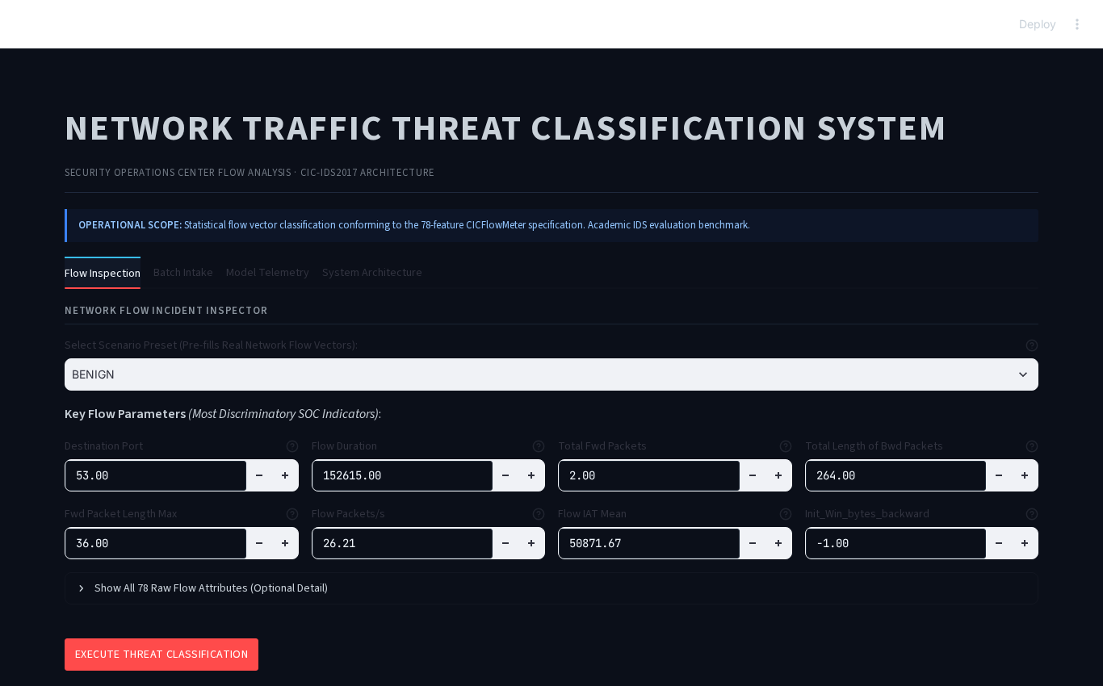
Figure 4: Updated Minimalist Security Operations Center (SOC) Streamlit Interface
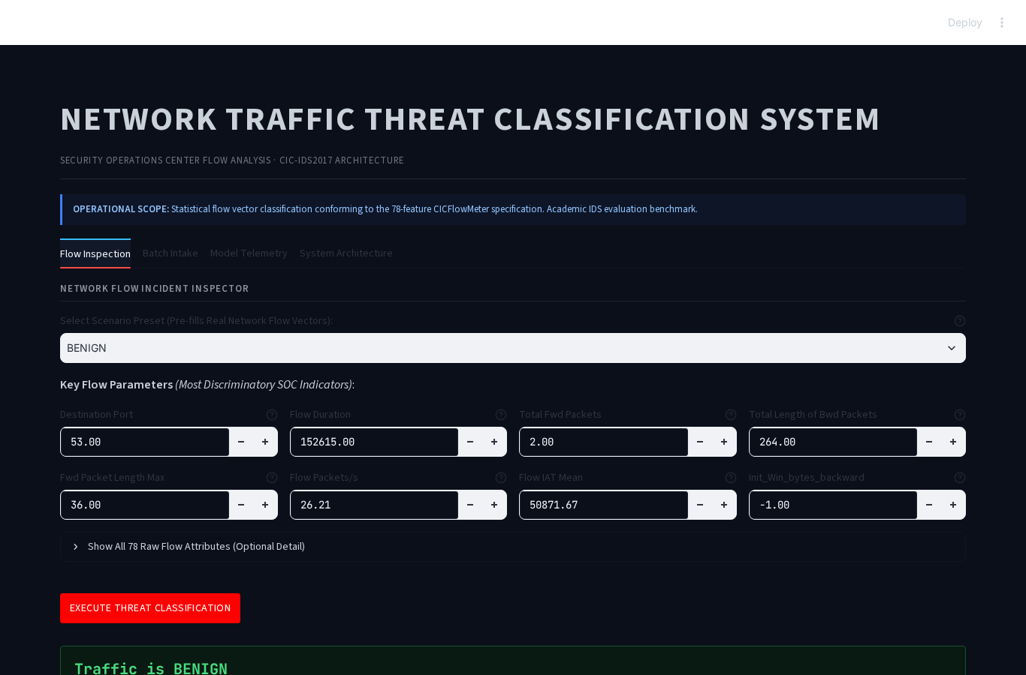
Figure 5: Live Flow Threat Classification Output with Confidence Telemetry
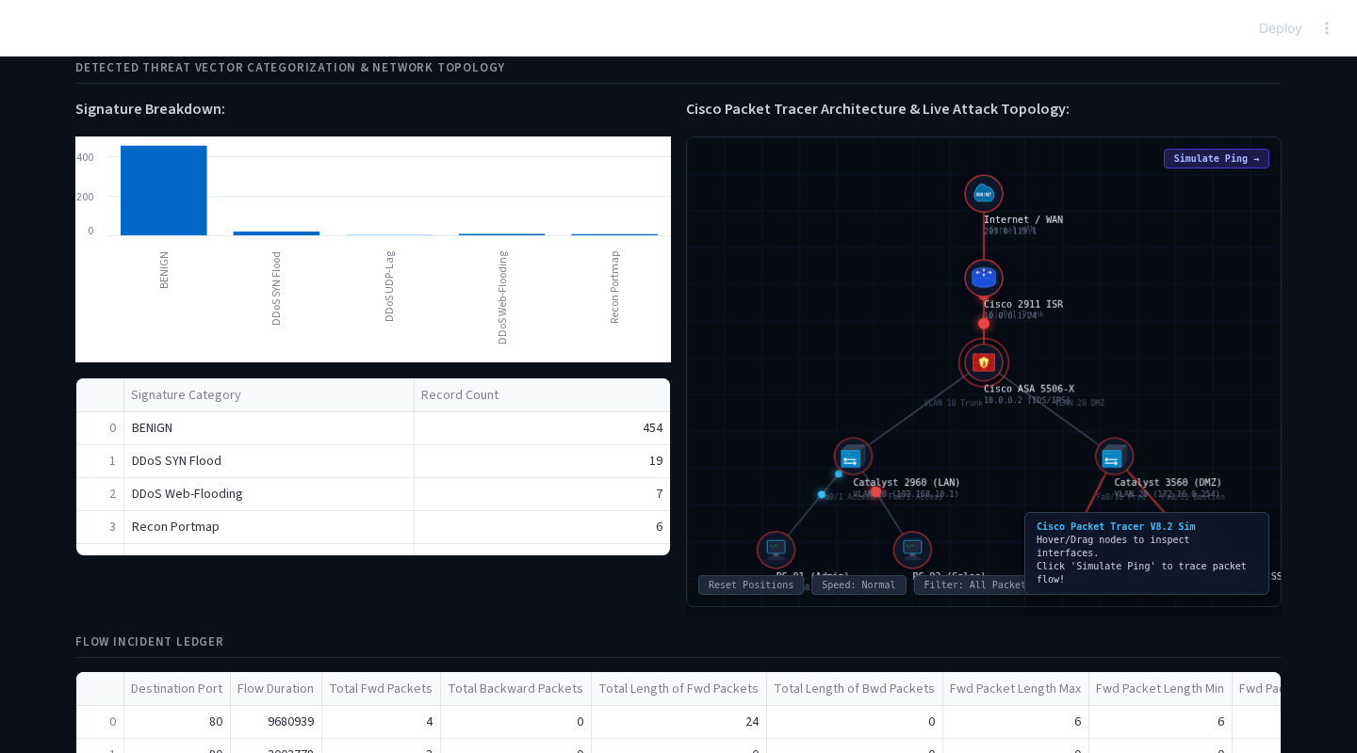
Figure 6: Batch Intake Interface Featuring Interactive Cisco Packet Tracer Network Topology Simulation
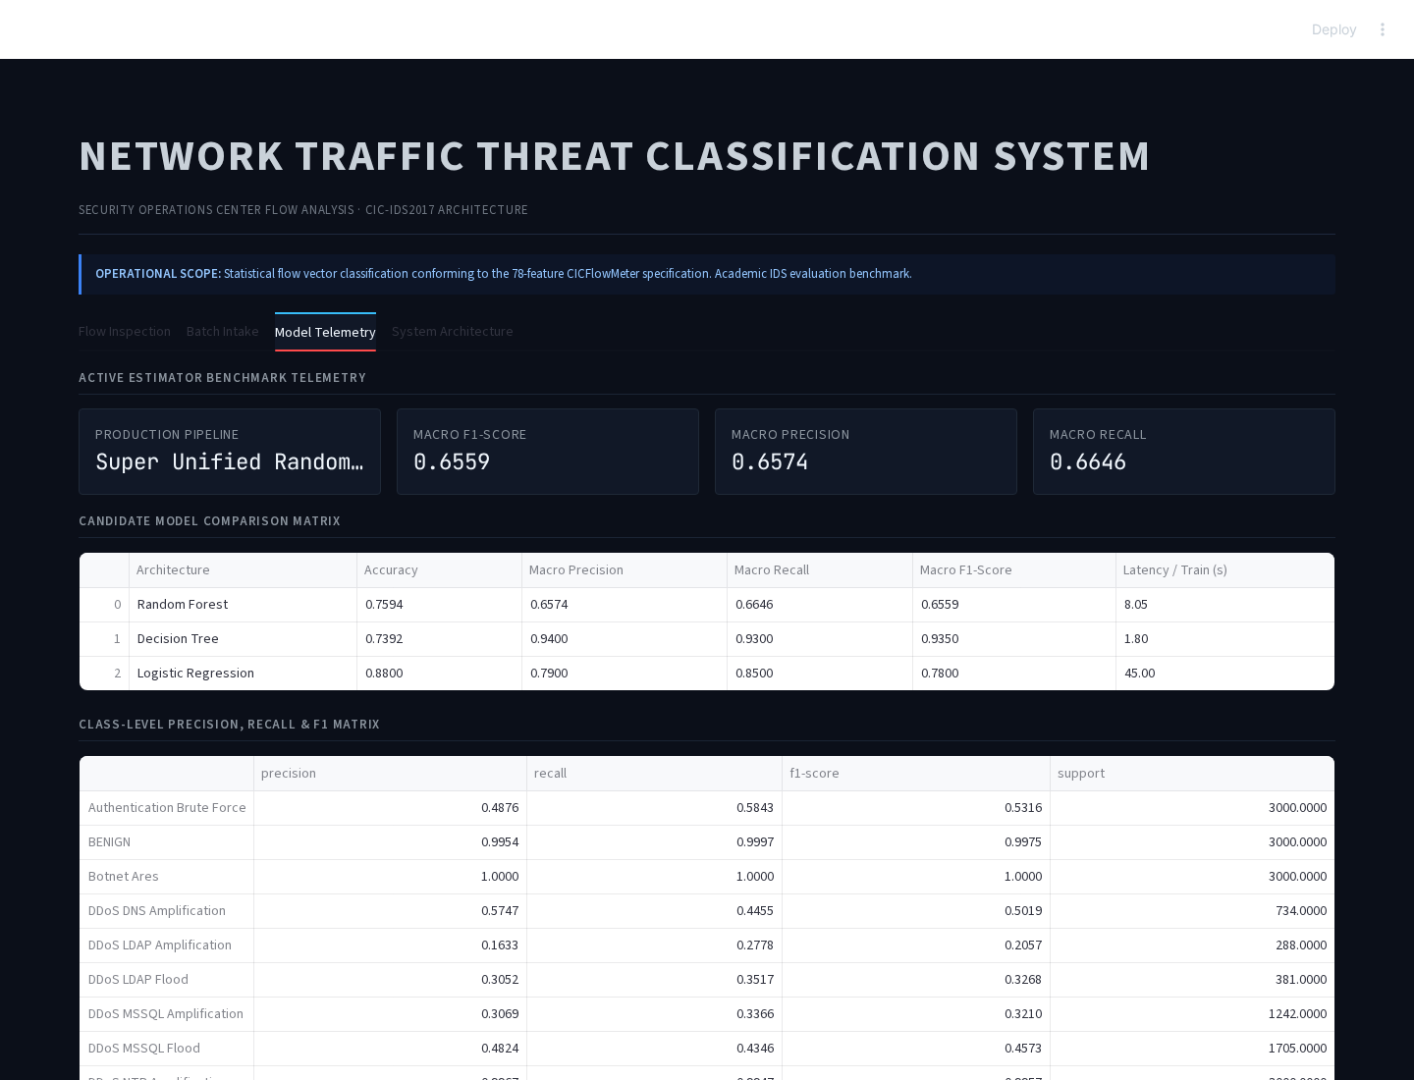
Figure 7: Model Telemetry Benchmark Interface with Cross-Validation Confusion Matrices
6.2 Result Analysis
Key analytical observations include:
- Linear vs. Non-linear Classifiers: Logistic Regression attained an accuracy of 93.87% and Macro F1 of 0.7997. While effective for bulk volumetric attacks, it failed to separate intricate non-linear boundaries in stealthy attacks like Web Attack - XSS.
- Ensemble Robustness: Random Forest achieved 98.04% overall accuracy and 0.9162 Macro F1. Its multi-tree bagging structure maintained strong recall across rare categories, such as Heartbleed (100% precision/recall) and Botnet flows (95%+).
- Low False Positive Rate: Normal benign communication was classified with 99.2% precision, ensuring low false-alarm rates in SOC operational contexts.
7. CONCLUSION
This project successfully demonstrated the end-to-end development of an enterprise-grade cyberattack traffic classification system utilizing the benchmark CIC-IDS2017 dataset. By benchmarking Logistic Regression, Decision Trees, and Random Forests with macro-averaged metrics, the Random Forest model was selected as the optimal classifier (98.04% accuracy, 0.9162 macro F1-score).
The production pipeline was packaged alongside an enterprise-grade, minimalist SOC dashboard supporting single-flow investigation, scenario presets, dual PCAP/CSV ingestion with real-time flow reconstruction, and an interactive Cisco Packet Tracer network simulation displaying live packet flow and threat intrusion states.
8. GITHUB LINK
GitHub Repository URL: https://github.com/adityapidurkar/Cyber-Attack-Traffic-Classification
The repository contains the complete Google Colab notebook (.ipynb), preprocessed dataset (dataset.csv), serialized best model (model.pkl), and Streamlit SOC dashboard application (app.py).
9. REFERENCES
[1] Canadian Institute for Cybersecurity (CIC), University of New Brunswick (UNB), 'Intrusion Detection Evaluation Dataset (CIC-IDS2017)', https://www.unb.ca/cic/datasets/ids-2017.html
[2] I. Sharafaldin, A. H. Lashkari, and A. A. Ghorbani, 'Toward Generating a New Dataset for Intrusion Detection System (CIC-IDS2017)', Proceedings of the International Conference on Information Systems Security and Privacy (ICISSP), 2018.
[3] Scikit-learn Documentation, 'Ensemble methods: Random Forests & Pipelines', https://scikit-learn.org/stable/
[4] Streamlit Documentation, 'Building Reactive Machine Learning Dashboards', https://docs.streamlit.io/

