**Dataset selection and download**

I have downloaded the dataset of Most Streamed Spotify Songs 2023 from Kaggle.

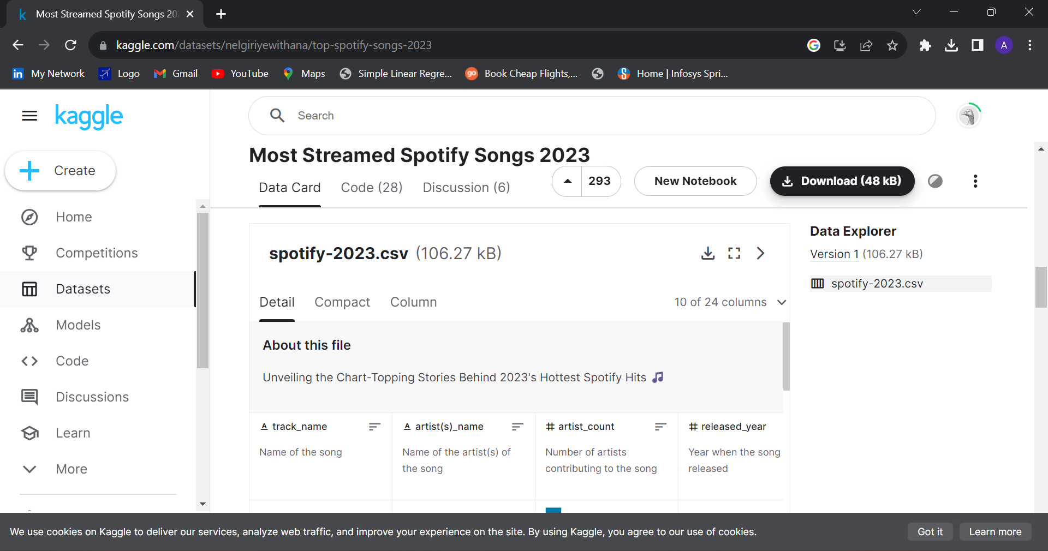

**Dataset Description**

This dataset contains a comprehensive list of the most famous songs of 2023 as listed on Spotify. The dataset offers a wealth of features beyond what is typically available in similar datasets. It provides insights into each song's attributes, popularity, and presence on various music platforms. The dataset includes information such as **track name, artist(s) name, release date, Spotify playlists and charts, streaming statistics, Apple Music presence, Deezer presence, Shazam charts, and various audio features**.

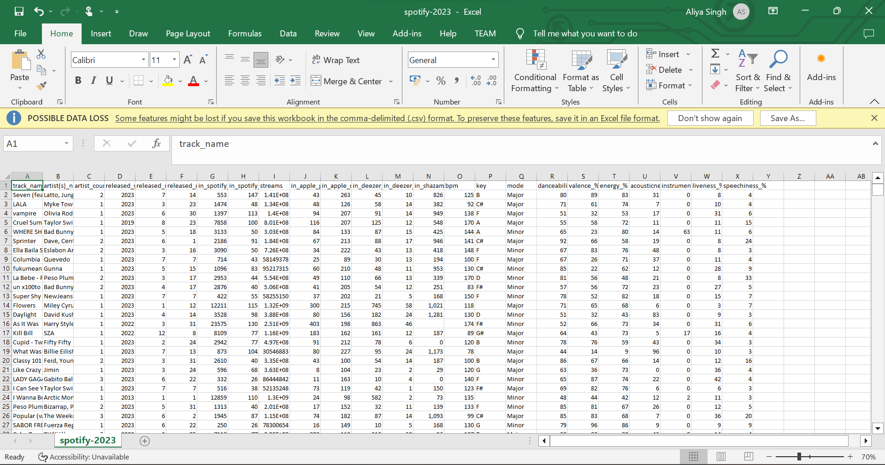

**Dataset import into PowerBI**

Loading dataset into PowerBI

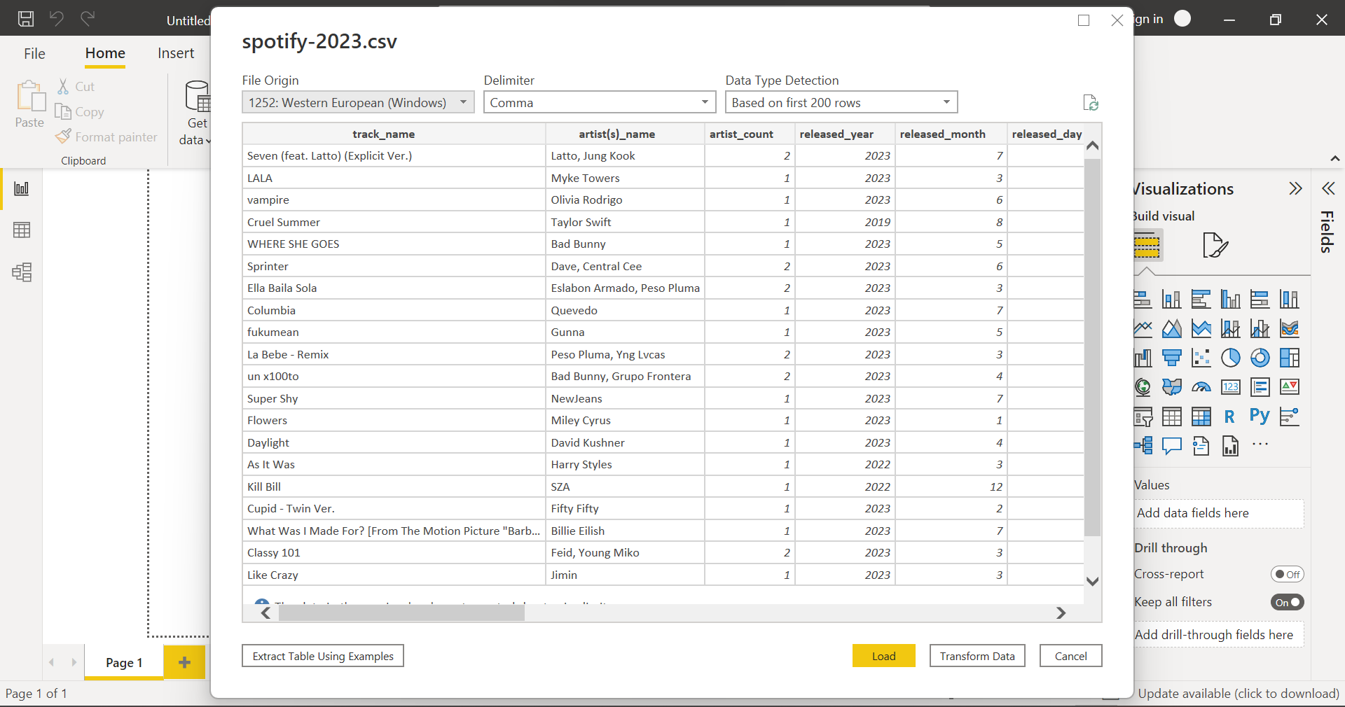

**Report and Graphs in powerBI**

**Stacked bar chart**

1. Stacked bar chart which shows the streams different artists got in 2023

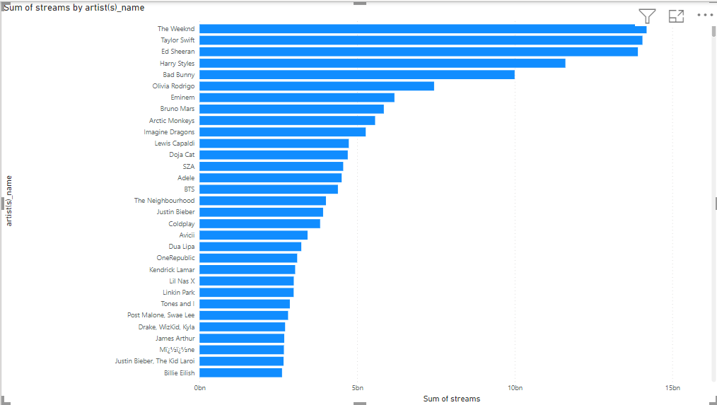

1. Stacked bar chart between the sum of energy_%, Sum of Speechiness_% with respect to artist.

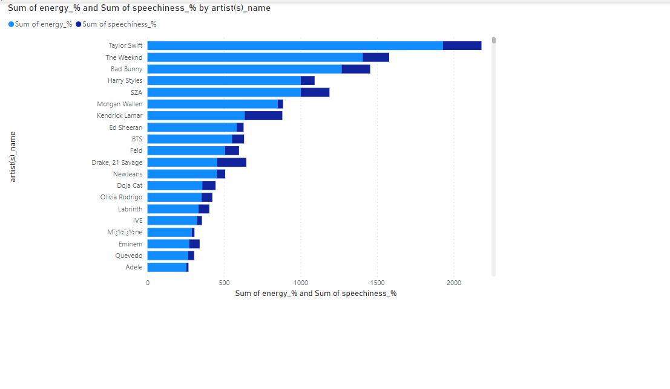

1. Apple charts and Spotify charts by artists name

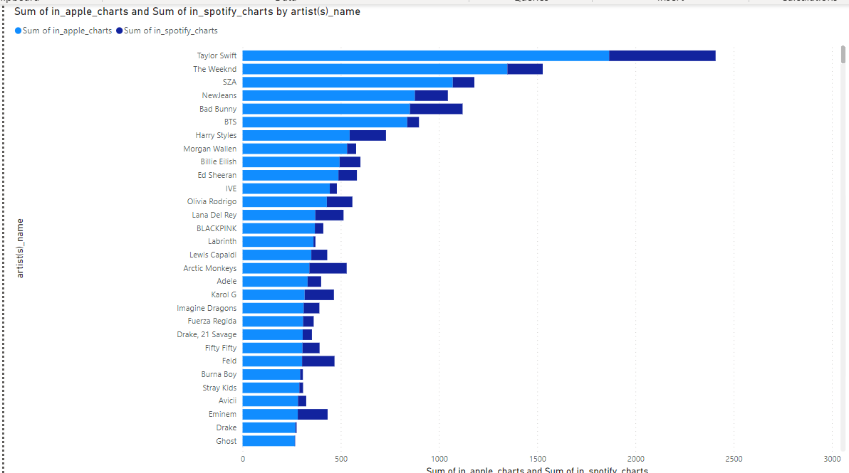

**Stacked column chart**

1. Stacken column chart bpm with respect to artist

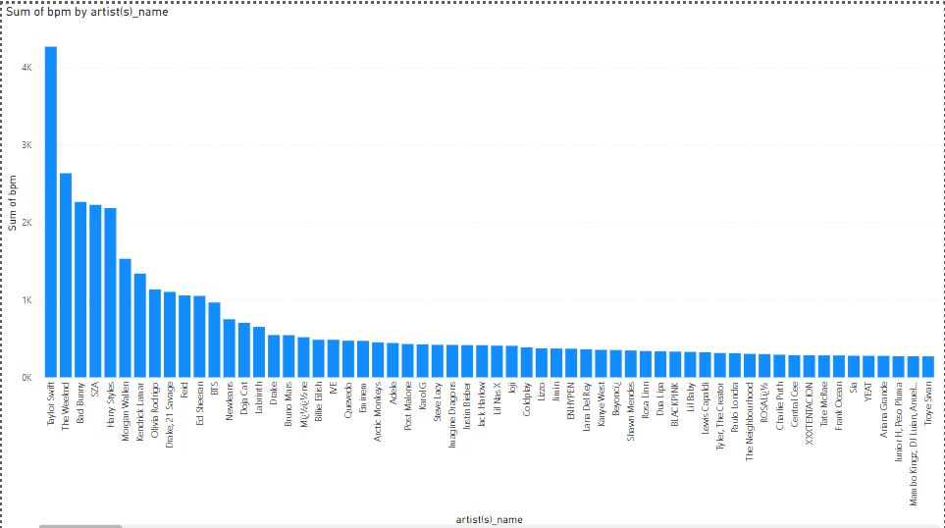

1. Stacked column chart in_apple_charts, in_spotify_charts with respect to artist name.

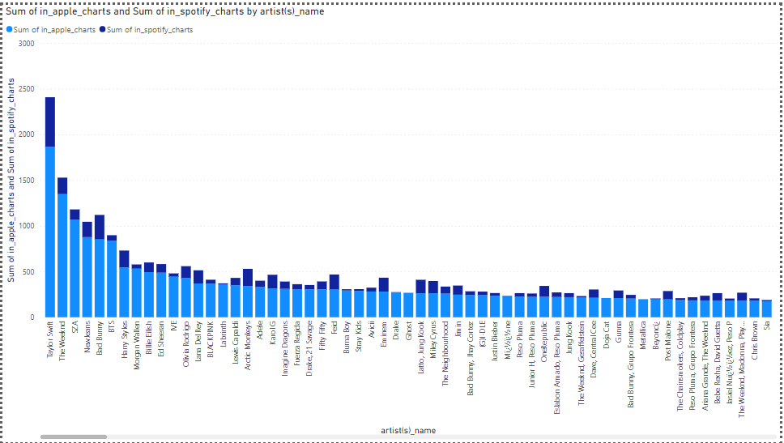

1. Stacked column chart liveness_%, sum of energy_% with respect to artist

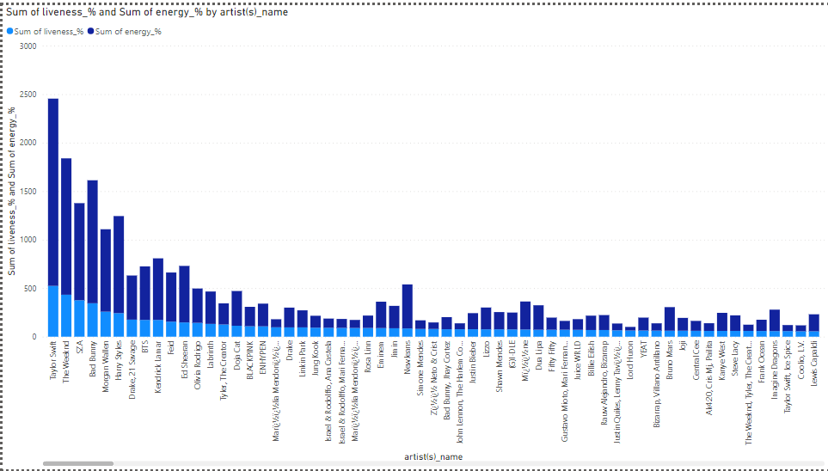

1. Stacked column chart energy_%, speechiness_% with respect to Artist Name

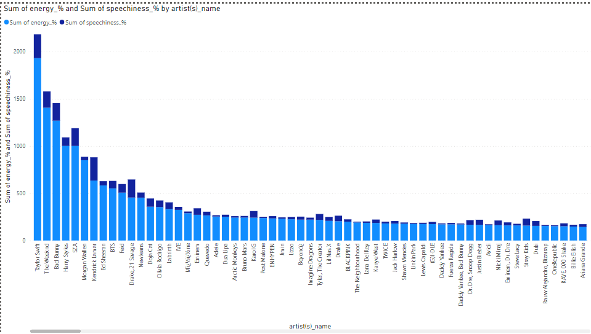

1. Artist name with respect to stream

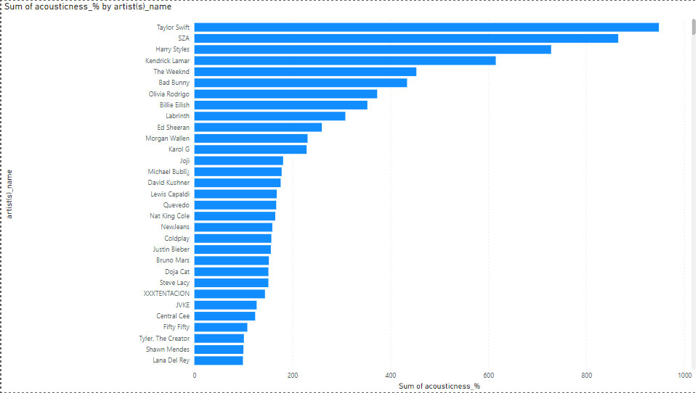

**Line Chart**

1. Line chart between Sum of speechiness_% and released_day

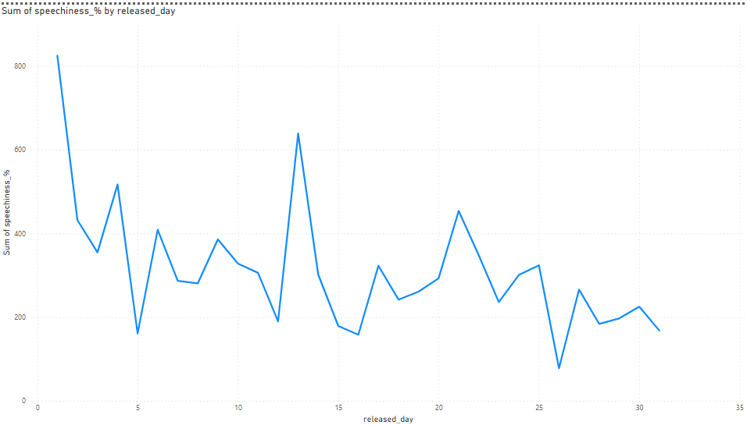

**Area Chart**

1. Area chart between in_apple_charts, in_apple_playlists, in_deexer_charts with respect to each artists

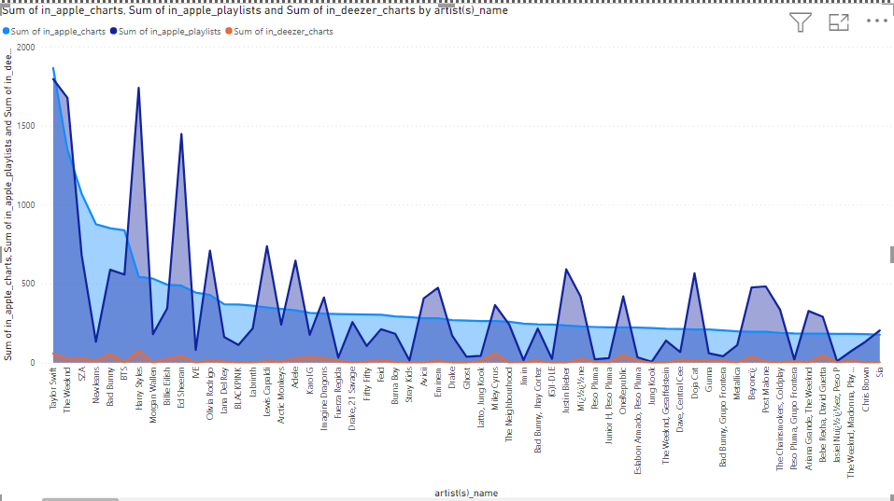

**Line and stacked column chart**

1. Line and stacked column with in_deezer_charts and sum of streams with respect to release date

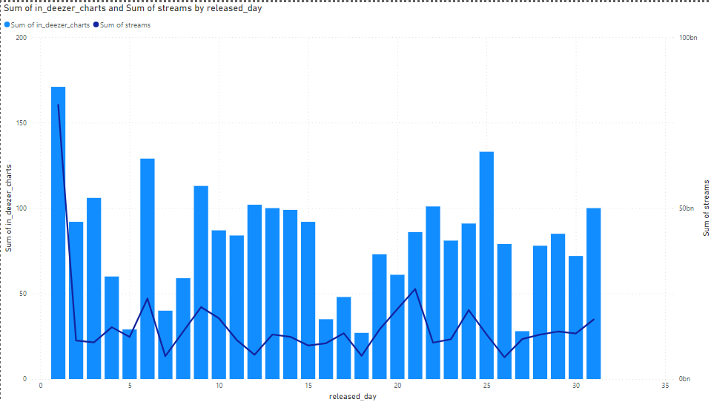

**Pie Chart**

Pie Chart between sum of streams and artists

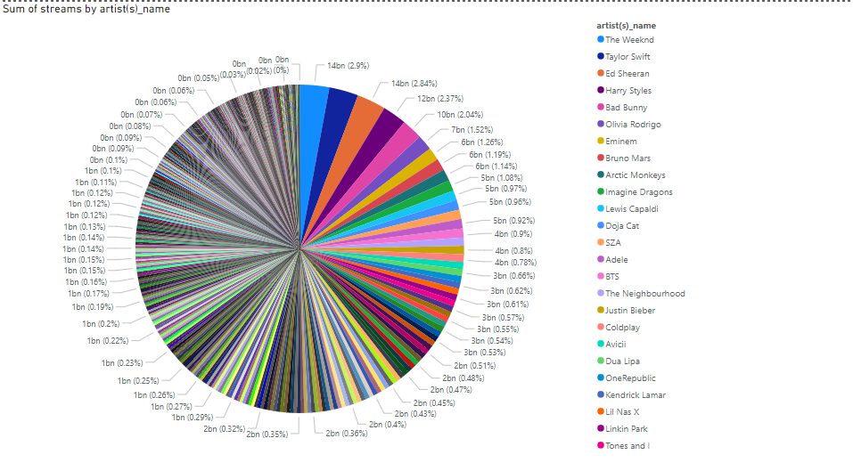

**Donut Chart**

Donut chart between sum of streams and artists

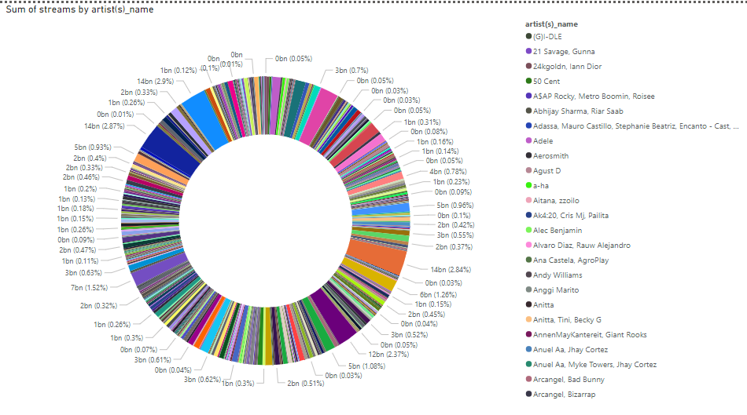

**Treemap**

Treemap between artist and sum of streams

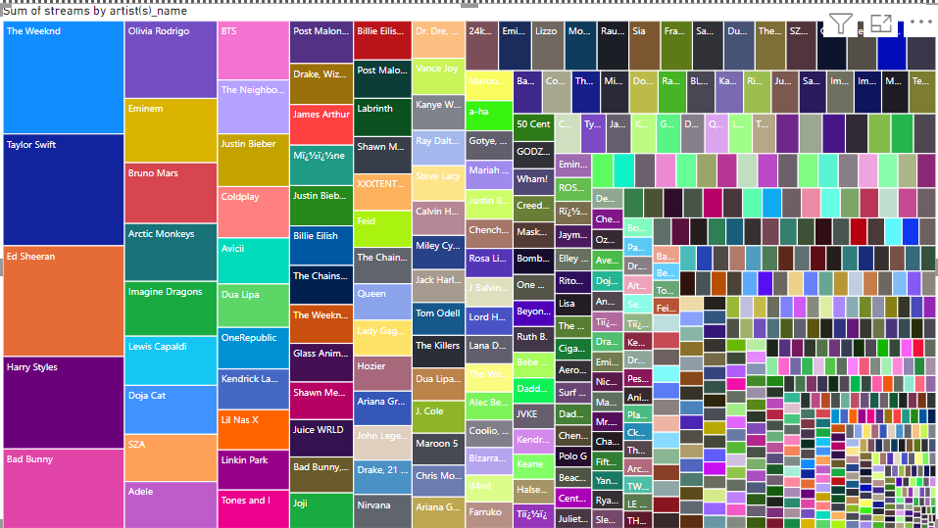

**Funnel**

1. Funnel between sum of streams and artist

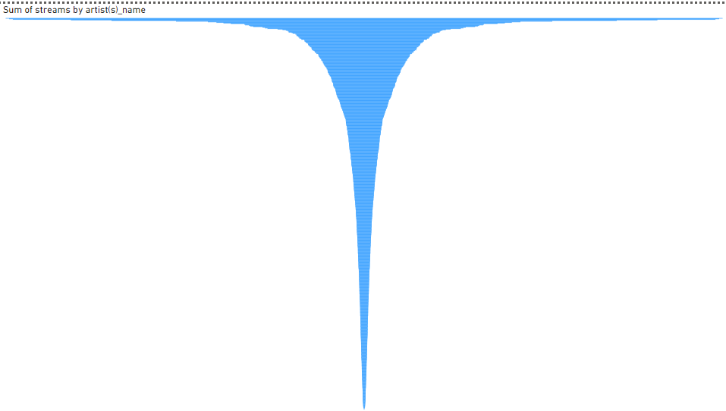

**Ribbon Chart**

1. Ribbon chart between bpm, danceability, energy, in_apple_charts with respect to artist.

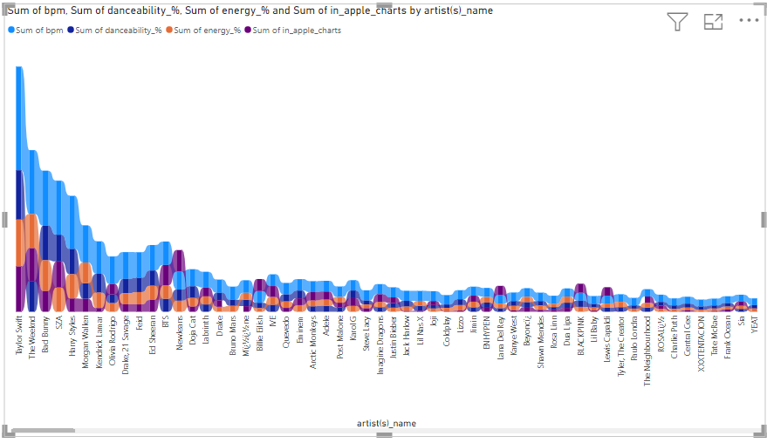

**100% stacked column chart**

Stacked column chart between in_apple_charts, in_spotify_charts, in_apple_playlist with respect to artist name

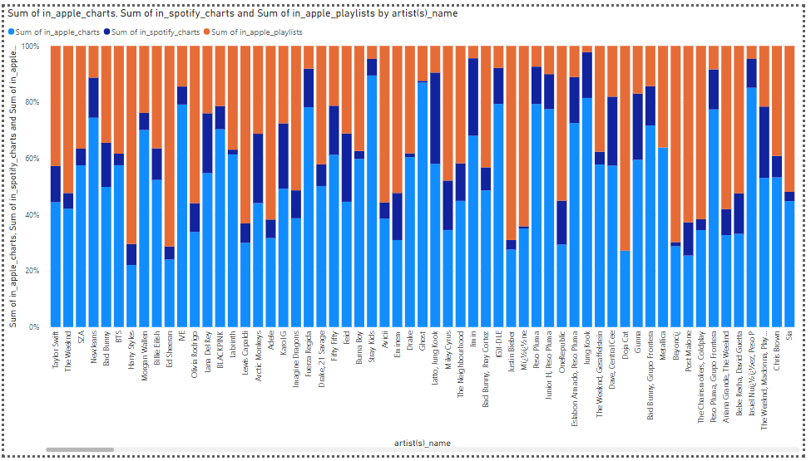

**100% stacked bar chart**

1. Stacked bar chart with respect to acousticness, in_deezer_playlists, danceability, energy with respect to artist name

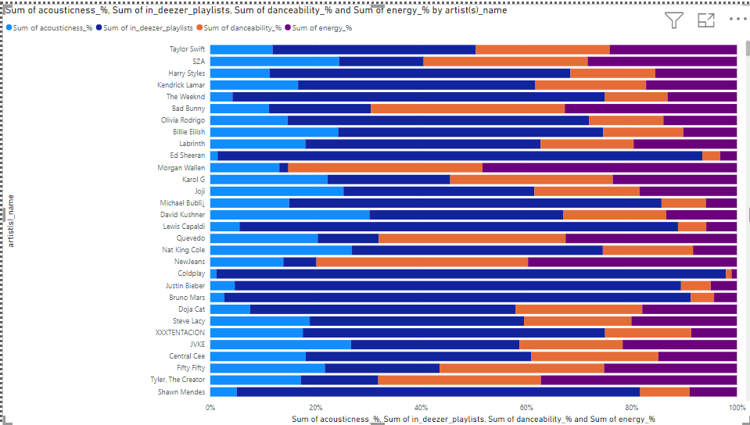

**Waterfall chart**

1. Waterfall chart between stream and artist

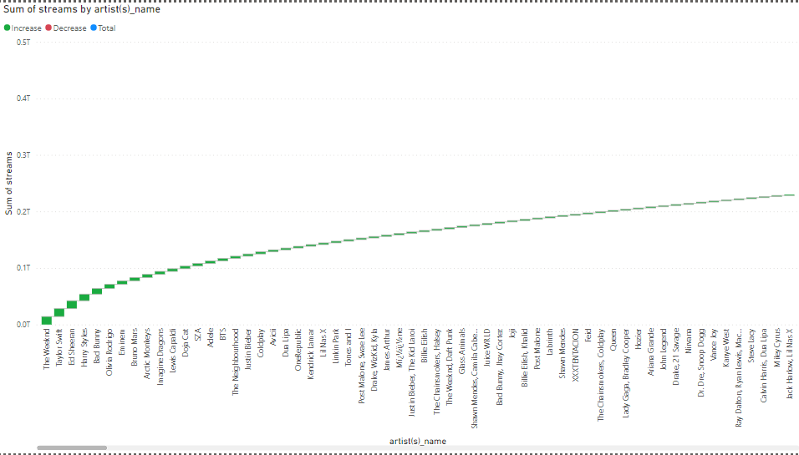

**Clustered column chart**

1. Clustered column chart between energy, in_apple_charts, in_apple_playlists, in_deezer_charts, in_spotify_charts with respect to artist

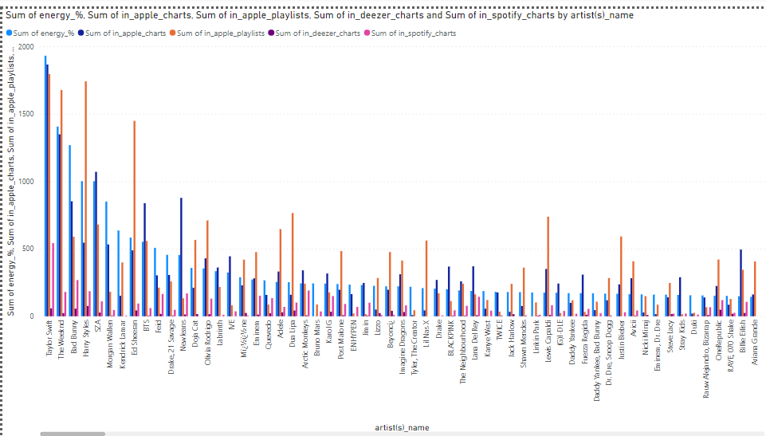

1. Clustured column chart between danceability, energy, in_apple_charts by artist name

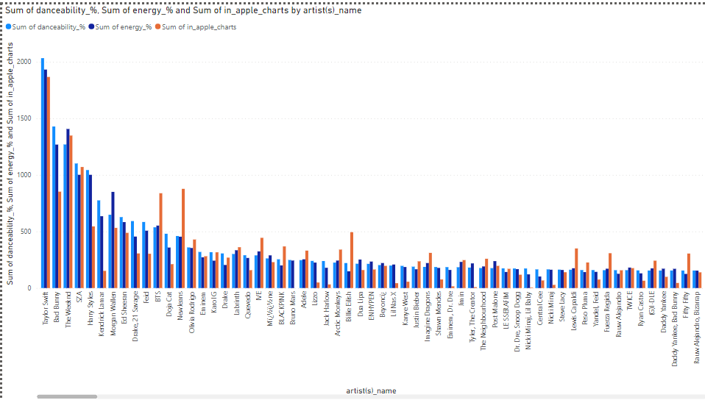

**Area Chart**

1. Area chart with respect to danceability, energy, in_apple_playlists, in_deezer_charts with respect to artist name

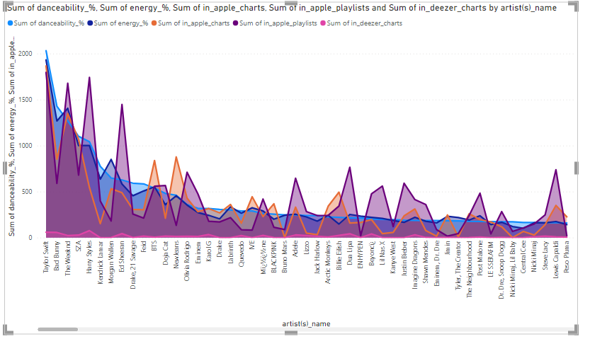

**Dashboard**

1. Dashboard of all the music artists

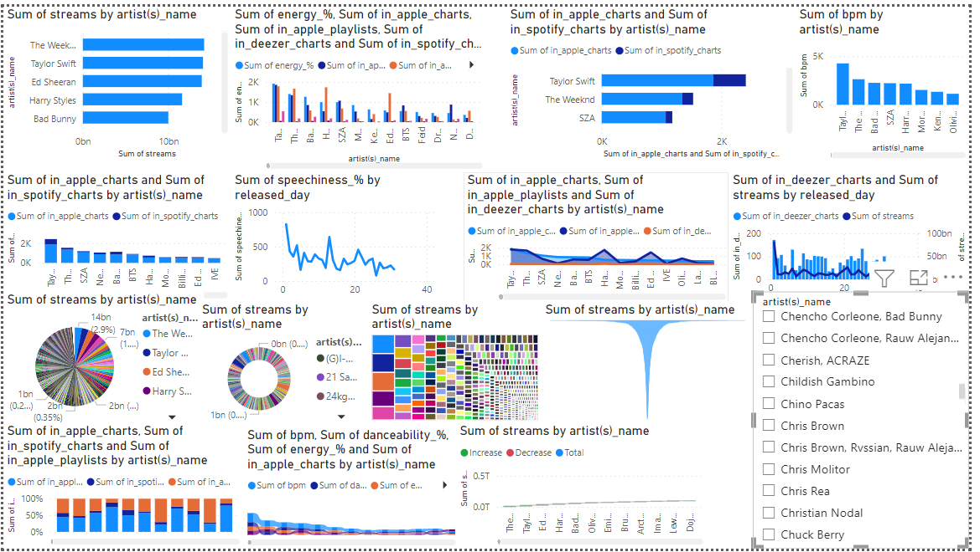

1. Dashboard of Charlie Puth

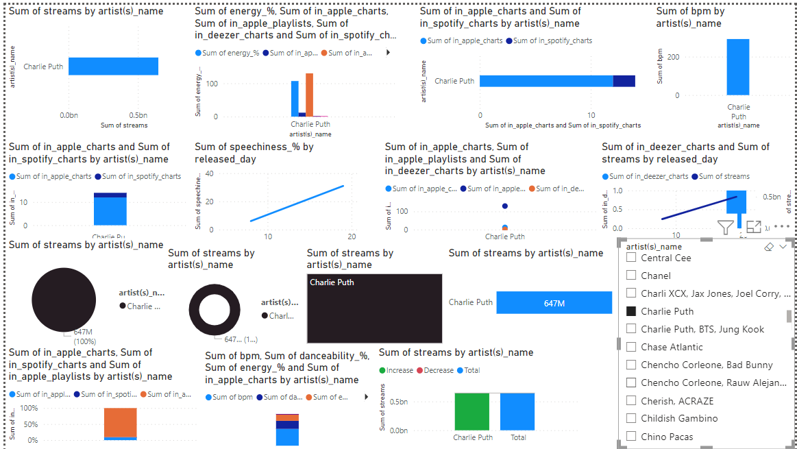

1. Dashboard of Taylor Swift

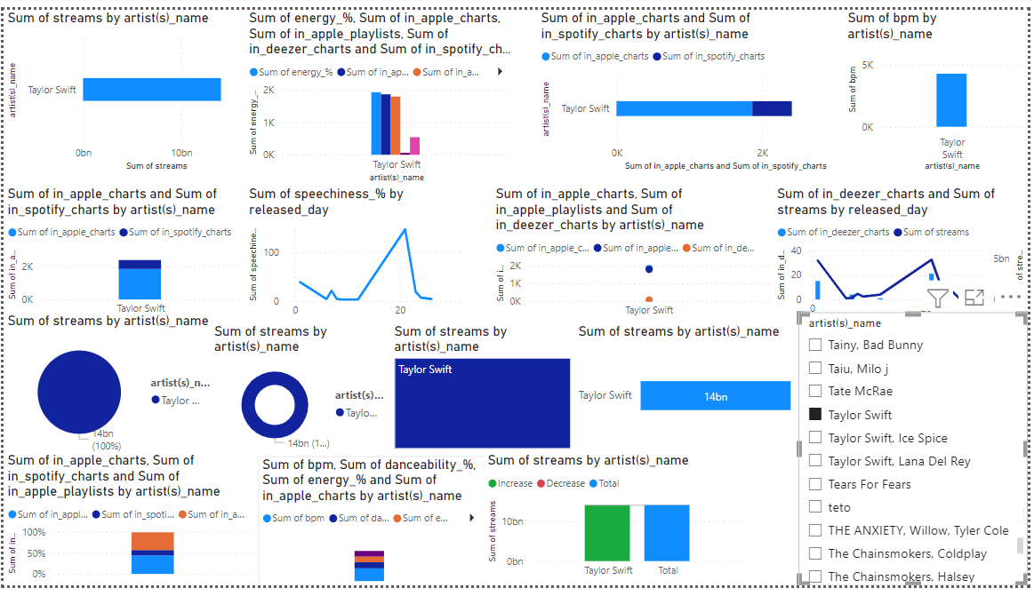

1. Dashboard of Ed Sheeran

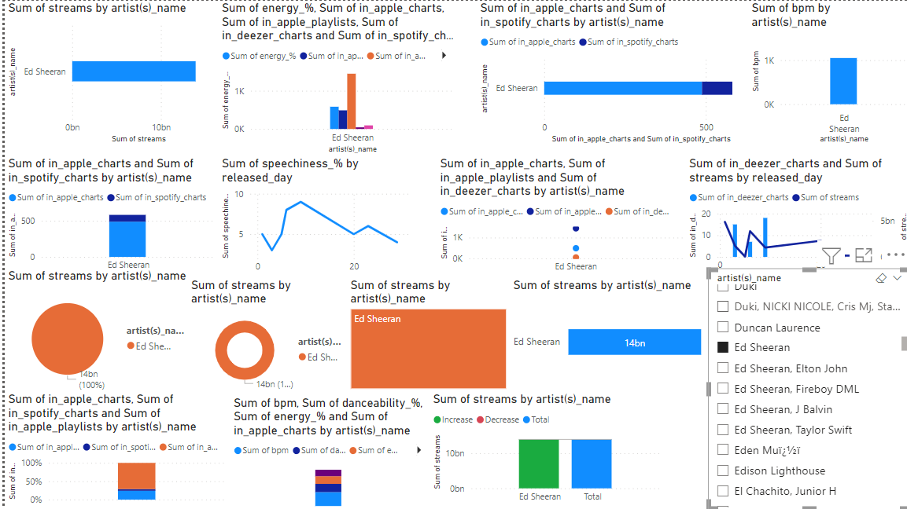

1. Dashboard of Eminem

