# csjm.pngChhatrapati Shahu Ji Maharaj University Project Report

On

**File Sharing Web Application**

Submitted in Partial Fulfillment of the Requirements for the Degree of

**Bachelors of Computer Application**

By:

**Alok Kumar Sharma**

**0102623**

Under the Supervision of

**Mrs. Poonam Singh**



**PSIT College of Higher Education**

**Kanpur-Agra-Delhi National Highway – 2, Bhauti, Kanpur**

**(2019-2020)**

**Declaration**

I hereby declare that the project entitled “InShare (File Sharing Web Application)” submitted for the Bachelor of Computer Application degree is my original work and the project has not formed the basis for the award of any other degree of the university or other institute of higher learning, except where due acknowledgment has been made in the text.

Signature of the student

(Alok Kumar Sharma)

(0102623)

BCA

PSIT College of Higher Education, Kanpur

### **CERTIFICATE**

### This is to certify that project entitled “InShare (File Sharing Web Application)” submitted for partial fulfillment of the degree of BCA. Under the Department of Bachelor of Computer Application to through PSIT College of Higher Education, Kanpur, done by Mr. Alok Kumar Sharma, Roll No. 0102623 is an authentic work carried out by him under my guidance. The matter embodied in this project work has not been submitted earlier for award of any degree or diploma to the best of my knowledge and belief.

### Internal Examiner/Guide External Examiner

### Head of Department

**ACKNOWLEDGEMENT**

Presentation inspiration and motivation have always played a key role in the success of any venture.

I express my sincere thanks to **Dr. Shivani Kapoor, Director, PSIT College of Higher Education, Kanpur.**

I pay my deep sense of gratitude **to Mr. Santosh Kumar Sharma (HOD)** of BCA Department, **PSIT College of Higher Education** to encourage me to the highest peak and to provide me the opportunity to prepare the project. I am immensely obliged to my friendsfor their elevating inspiration, encouraging guidance and kind supervision in the completion of my project.

I feel to acknowledge my indebtedness and deep sense of gratitude to my guide **Mrs. Poonam Singh** whose valuable guidance and kind supervision given to me throughout the course which shaped the present work as its show.

Last, but not the least, my parents are also an important inspiration for me. So with due regards, I express my gratitude to them.

**ABSTRACT**

File sharing is one of the oldest applications of the internet. One way of sharing files online is for a user to upload files to a common space on the web and others users can download the files from the common web space.

The objective of this project is to design an online file sharing website where users can upload files and other users can download them. To attain this objective a PHP enabled interactive user interface involving features are added. To make the website more user friendly, users are given file upload box and the other user is given a download box where one can see and download the file which is sent to him by the other user, and PHP based file sharing system that works like browsing files from the computer with file selector or uploader box, context menu functionalities etc.

This report discusses the implementation details of the website, and the advantages of having different visualizations of the file system. This report also addresses one frequently asked question regarding file storage; where to store the files, in database as files in the file system on web server? This report analyzes the time needed to upload, download the files stored in both places and discusses the advantages and disadvantages of both techniques in terms of performance, security, integrity, maintenance and code complexity.

**INDEX**

* Chapter-I: Introduction
* Project Overview
* Problem Definition
* Objective
* Details of Hardware & Software used
* Modules & Description
* Chapter-II: Feasibility Study & Technology Used in Project
* Feasibility Study
* About the technology used in project
* Chapter-III: System Analysis & Design
  + - Software Development Life Cycle
    - Data Flow Diagram
    - Data Base Schema Design,
    - System Planning (PERT Chart)
* Chapter-IV: Screen/Snap-Shots of the project
* Conclusion
* References

**CHAPTER-I**

**INTRODUCTION**

**Project Overview**

The project titled InShare is file sharing web application for sharing files. The project FILE SHARING WEB APPLICATION is developed in PHP, which mainly focuses on sharing files among different users across the internet. This project is fast and secure way to share your file. The size of the file to be sent can be up to 40 Mbs. File types that can sent are JPEG or JPG, PNG, GIF, SVG, DOC, DOCS, PDF, etc.

InShare has great features, but the best feature is probably that sending files is so easy that anyone can use it. Just add your files, specify the receiver’s email and you're good to go. No need to zip files yourself.

InShare is optionally using end-to-end encryption to secure your transferred files. Only recipients that know the password can open your transfer. The file transfer is encrypted on your computer, so no unencrypted data is being sent to us.

InShare uses state-of-the-art technology to make the file sharing as fast as possible. Transfers are already being compressed on your computer to reduce the amount of data to be sent. Our servers are located all around the world to provide you with the fastest upload and download speed.

**Problem Definition**

Online File Sharing is practice of sharing files among different users across the internet. Common forms of file sharing are FTP (File Transfer Protocol) model and P2P (Peer-to-Peer) file sharing network. Another common form of sharing files over the internet is for a user to upload files to a website and allow other users to download them from the website. There are a lot of issues to consider when developing such a website.

Users of an online file sharing website who use features like upload, download, share, search, etc would want a website that is very interactive and fast and not annoying with a lot of post backs and flashing screens. Another issue is the visualization of their file system where usually users have a limit to upload files. The normal web based file folder view would be good, but if there are other types of visualizations it would be great. Another important issue to consider is the location where the website stores the uploaded files. Two places where one can store the uploaded files are Database and Server.

The existing system is semi-automated system.  Here in this system needs to save the information in the form of excel sheets or Disk Drives. There is no sharing is possible if the data is in the form Disk drives. This system gives us very less security for saving data; some data may be lost due to mismanagement. It’s a limited system and fewer users friendly. Searching of particular information is very critical it takes lot of time. The users cannot able to restrict the file sharing options.  The users only know his information only not others. It is very critical to share public information to all users.

**Objective**

There are three main objectives in this project:

First objective is to build an PHP enabled online file sharing website which not only reduces the annoying post backs and loss of control focus, but also gives a faster and more interactive user interface. Moreover to make the website more feature rich.

Second objective is to give the users different visualizations of their file system. Usually in a file sharing website, users will be given only one option where they can view their files and folders in the traditional windows style folder view i.e. where they have the option to sort their files and folders based on size, type, and time uploaded etc. And navigate through their file system by clicking on the folders. In this website, users are given different visualizations of their file system i.e. one traditional windows style folder view with post backs as seen in other similar websites.

Third objective is PHP based windows style folder view with no post backs and additional functionalities like right click menus and two space-constrained hierarchical visualizations of their file system.

**Details of Hardware & Software used**

Latest technologies and tools were used in developing the website. With these tools and technologies, complex coding can be made very simple.

**Visual Studio Code**

Visual Studio Code is a free [source-code editor](https://en.wikipedia.org/wiki/Source-code_editor) made by [Microsoft](https://en.wikipedia.org/wiki/Microsoft) for [Windows](https://en.wikipedia.org/wiki/Windows), [Linux](https://en.wikipedia.org/wiki/Linux) and [macOS](https://en.wikipedia.org/wiki/MacOS). Features include support for [debugging](https://en.wikipedia.org/wiki/Debugging), [syntax highlighting](https://en.wikipedia.org/wiki/Syntax_highlighting), [intelligent code completion](https://en.wikipedia.org/wiki/Intelligent_code_completion), [snippets](https://en.wikipedia.org/wiki/Snippet_(programming)), [code refactoring](https://en.wikipedia.org/wiki/Code_refactoring), and embedded [Git](https://en.wikipedia.org/wiki/Git). Users can change the [theme](https://en.wikipedia.org/wiki/Theme_(computing)), [keyboard shortcuts](https://en.wikipedia.org/wiki/Keyboard_shortcut), preferences, and install [extensions](https://en.wikipedia.org/wiki/Plug-in_(computing)) that add additional functionality.

Microsoft has released Visual Studio Code's [source code](https://en.wikipedia.org/wiki/Source_code) on the **VSCode** repository of [GitHub](https://en.wikipedia.org/wiki/GitHub), under the permissive [MIT License](https://en.wikipedia.org/wiki/MIT_License), while the compiled releases are [freeware](https://en.wikipedia.org/wiki/Freeware).

In the [Stack Overflow](https://en.wikipedia.org/wiki/Stack_Overflow) 2019 Developer Survey, Visual Studio Code was ranked the most popular developer environment tool, with 50.7% of 87,317 respondents reporting that they use it.

Visual Studio Code can be extended via [extensions](https://en.wikipedia.org/wiki/Plug-in_(computing)), available through a central repository. This includes additions to the editor and language support. A notable feature is the ability to create extensions that add support for new [languages](https://en.wikipedia.org/wiki/Programming_language), [themes](https://en.wikipedia.org/wiki/Theme_(computing)), and [debuggers](https://en.wikipedia.org/wiki/Debugger), perform [static code analysis](https://en.wikipedia.org/wiki/Static_code_analysis), and add [code linters](https://en.wikipedia.org/wiki/Lint_(software)) using the [Language Server Protocol](https://en.wikipedia.org/wiki/Language_Server_Protocol).

**XAMPP**

XAMPP is a [free and open-source](https://en.wikipedia.org/wiki/Free_and_open-source) [cross-platform](https://en.wikipedia.org/wiki/Cross-platform) [web server](https://en.wikipedia.org/wiki/Web_server) [solution stack](https://en.wikipedia.org/wiki/Solution_stack) package developed by Apache Friends, consisting mainly of the [Apache HTTP Server](https://en.wikipedia.org/wiki/Apache_HTTP_Server), [MariaDB](https://en.wikipedia.org/wiki/MariaDB) [database](https://en.wikipedia.org/wiki/Database), and [interpreters](https://en.wikipedia.org/wiki/Interpreter_(computing)) for scripts written in the [PHP](https://en.wikipedia.org/wiki/PHP) and [Perl](https://en.wikipedia.org/wiki/Perl) [programming languages](https://en.wikipedia.org/wiki/Programming_language). Since most actual web server deployments use the same components as XAMPP, it makes transitioning from a local test server to a live server possible.

XAMPP's ease of deployment means a [WAMP](https://en.wikipedia.org/wiki/WAMP) or [LAMP](https://en.wikipedia.org/wiki/LAMP_(software_bundle)) stack can be installed quickly and simply on an operating system by a developer, with the advantage that common add-in applications such as [WordPress](https://en.wikipedia.org/wiki/WordPress) and [Joomla!](https://en.wikipedia.org/wiki/Joomla!) Can also be installed with similar ease using [Bitnami](https://en.wikipedia.org/wiki/Bitnami). Though it is a heavy app for most of the operating systems even when owing to its less size it takes a load on the processor speed.

XAMPP is regularly updated to the latest releases of [Apache](https://en.wikipedia.org/wiki/Apache_HTTP_Server), [Maria DB](https://en.wikipedia.org/wiki/MariaDB), [PHP](https://en.wikipedia.org/wiki/PHP) and [Perl](https://en.wikipedia.org/wiki/Perl). It also comes with a number of other modules including [OpenSSL](https://en.wikipedia.org/wiki/OpenSSL), [phpMyAdmin](https://en.wikipedia.org/wiki/PhpMyAdmin), [MediaWiki](https://en.wikipedia.org/wiki/MediaWiki), [Joomla](https://en.wikipedia.org/wiki/Joomla), [WordPress](https://en.wikipedia.org/wiki/WordPress) and more. Self-contained, multiple instances of XAMPP can exist on a single computer, and any given instance can be copied from one computer to another. XAMPP is offered in both a full and a standard version (Smaller version).

**PhpMyAdmin**

PhpMyAdmin is a [free and open source](https://en.wikipedia.org/wiki/Free_and_open_source) administration tool for [MySQL](https://en.wikipedia.org/wiki/MySQL) and [Maria DB](https://en.wikipedia.org/wiki/MariaDB). As a portable [web application](https://en.wikipedia.org/wiki/Web_application) written primarily in [PHP](https://en.wikipedia.org/wiki/PHP), it has become one of the most popular MySQL administration tools, especially for [web hosting services](https://en.wikipedia.org/wiki/Web_hosting_service).

**Modules & Description**

The system after careful analysis has been identified to be presented with the following modules:

The Modules involved are

1. Users
2. File Uploading and Downloading
3. File Sharing
4. Registration
5. Authentication

**Users**

User is nothing but a registered user.   A registered user directly uploads information into the system.  Before uploading he needs to specify his credentials for authentication.

The upload files have 3 types of priorities.

* Public priority
* Private priority
* Partial Public priority

The definition of Public priority means, the files which are uploaded in to the system, those are shared by all the users which are registered in the system.

Private priority means, the accessibility of the uploaded file only by the user itself.  Other users don’t have any permission for downloading.

Partial public priority means while uploading the file the user can choose some other users which are registered into the system, and give accessibility of the file to them.

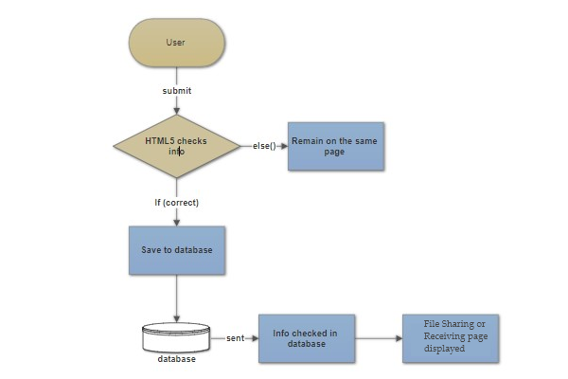

**File Uploading and Downloading**

All registered user having authority to upload any file into the system, admin can track all uploaded files.  Based on the priority users can down load file from the system.  For file uploading and downloading the system provides a good user interface for easy to use.  User can save the downloading file with his desired location.

**File Type:** Therefore user can upload files for that file types only. The file types normally

* Word File
* PDF file
* Text File
* Images

**File Sharing**

For every uploading file user can put priority.  Private means no accessibility for other users.  It’s simply personal.  Public means every user can access that file.  Partial public means user can choose a list of other users and give accessibility.

**Registration**

The system has a process of registration.  Every user need to submit his complete details in the form of registration.  Whenever a user registration completed automatically user can get a user id and password.  By using that user id and password user can log into the system.

**Authentication:**

Authentication is nothing but providing security to the system. Here every must enter into the system throw login page.  The login page will restrict the UN authorized users.  A user must provide his credential like user Id and password for log into the system. For that the system maintains data for all users.  Whenever a user enters his

User id and password, it checks in the database for user existence.  If the user is exists he can be treated as a valid user. Otherwise the request will throw back.

In this system authentication is made of using

* Virtual Key Boards
* Password Encryption Algorithms

**Virtual Key Boards:**User can must provide his credentials using this virtual key board only. There is no physical key board usage in login scenario. For giving user id and password user need to use the mouse only.

**Password Encryption Algorithms:** The registered user password can be stored in the database in the form of encrypted by using SHA1 Algorithm.

**System Requirement Specifications**

**Hardware Requirements:**

* PIV 2.8 GHz Processor and Above
* RAM 512MB and Above
* HDD 40 GB Hard Disk Space and Above

**Software Requirements:**

* WINDOWS OS (XP / 2000 / 200 Server / 2003 Server)
* Visual Studio .Net 2008 Enterprise Edition
* Internet Information Server 5.0 (IIS)
* Visual Studio .Net Framework (Minimal for Deployment)   version 3.5
* SQL Server 2005 Enterprise Edition

**CHAPTER-II**

**Feasibility Study & Technology Used in Project**

**Feasibility Study**

Preliminary investigation examine project feasibility, the likelihood the system will be useful to the organization. The main objective of the feasibility study is to test the Technical, Operational and Economical feasibility for adding new modules and debugging old running system. All system is feasible if they are unlimited resources and infinite time. There are aspects in the feasibility study portion of the preliminary investigation:

* Technical Feasibility
* Operational Feasibility
* Economic Feasibility

**TECHNICAL FEASIBILITY**

The technical issue usually raised during the feasibility stage of the investigation includes the following:

* ·Does the necessary technology exist to do what is suggested?
* ·Do the proposed equipment’s have the technical capacity to hold the data required to use the new system?
* ·Will the proposed system provide adequate response to inquiries, regardless of the number or location of users?
* ·Can the system be upgraded if developed?
* ·Are there technical guarantees of accuracy, reliability, ease of access and data security?

Earlier no system existed to cater to the needs of ‘Secure Infrastructure Implementation System’. The current system developed is technically feasible. It is a web based user

interface for audit workflow at NIC-CSD. Thus it provides an easy access to the users. The database’s purpose is to create, establish and maintain a workflow among various entities in order to facilitate all concerned users in their various capacities or roles. Permission to the users would be granted based on the roles specified.    Therefore, it provides the technical guarantee of accuracy, reliability and security. The software and hard requirements for the development of this project are not many and are already available in-house at NIC or are available as free as open source. The work for the project is done with the current equipment and existing software technology. Necessary bandwidth exists for providing a fast feedback to the users irrespective of the number of users using the system.

**OPERATIONAL FEASIBILITY**

Proposed projects are beneficial only if they can be turned out into information system. That will meet the organization’s operating requirements. Operational feasibility aspects of the project are to be taken as an important part of the project implementation. Some of the important issues raised are to test the operational feasibility of a project includes the following: -

* + Is there sufficient support for the management from the users?
  + Will the system be used and work properly if it is being developed and implemented?
  + Will there be any resistance from the user that will undermine the possible application benefits?

This system is targeted to be in accordance with the above-mentioned issues. Beforehand, the management issues and user requirements have been taken into consideration. So there is no question of resistance from the users that can undermine the possible application benefits.

The well-planned design would ensure the optimal utilization of the computer resources and would help in the improvement of performance status.

**ECONOMICAL FEASIBILITY**

A system can be developed technically and that will be used if installed must still be a good investment for the organization. In the economic feasibility, the development cost in creating the system is evaluated against the ultimate benefit derived from the new systems. Financial benefits must equal or exceed the costs.

**About the technology used in project**

**LANGUAGE USED:-**

* PHP

**DATABASE:-**

* My SQL

**USER INTERFACE DESIGN:-**

* HTML
* CSS
* JAVASCRIPT
* JQUERY
* BOOTSTRAP

**SOFTWARE:-**

* APACHE XAMPP SERVER

**WEB BROWSER:-**

* MOZILLA FIREFOX
* GOOGLE CHROME

**HTML/ HTML5**

**HTML** or **Hyper Text Markup Language** is the main markup language for creating web pages and other information that can be displayed in a web browser.HTML is written in the form of HTML elements consisting of *tags* enclosed in angle brackets (like <html>), within the web page content. HTML tags most commonly come in pairs like <h1> and </h1>, although some tags represent *empty elements* and so are unpaired,

**for example** **-** <img>. The first tag in a pair is the *start tag*, and the second tag is the *end tag* (they are also called *opening tags* and *closing tags*). In between these tags web designers can add text, further tags, comments and other types of text-based content.

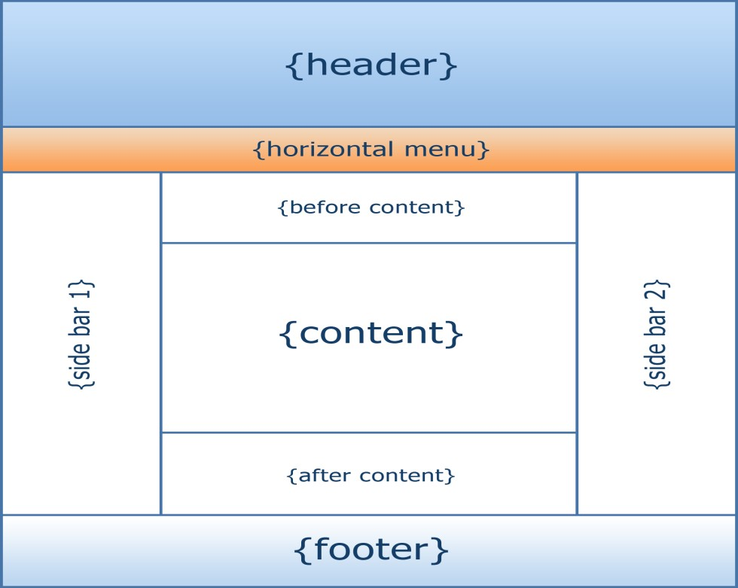

HTML5 is just an updated version of the HTML. It supports new features, new attributes, new HTML elements, full CSS3 support, video and audio, 2D/3D graphics that help users and also help web developers to create new features easily on the website. The structure of HTML5 is shown in figure

**CSS**- **Cascading Style Sheets** (**CSS**)

It is a style sheet language used for describing the look and formatting of a document written in a markup language. While most often used to style web pages and interfaces written in HTML and XHTML, the language can be applied to any kind of XML document, including plain XML, SVG and XUL. CSS is a cornerstone specification of the web and almost all web pages use CSS style sheets to describe their presentation.CSS is designed primarily to enable the separation of document content from document presentation, including elements such as the layout, colors, and fonts.

**Basic syntax:**

Selector {property: value}

HTML tag you want to modify

The property you want to change.

The value you want the property to take.

CSS is simply referred to as Cascading Style Sheets.CSS is used to define styles for web pages, including the design, layout, and variations in the display for different devices and screen sizes.

**PHP- Hypertext Preprocessor**

It is a server-side scripting language designed for web development but also used as a general-purpose programming language.

PHP is now installed on more than 244 million websites and 2.1 million web servers. Originally created by Rasmus Lerdorf in 1995, the reference implementation of PHP is now produced by The PHP Group. While PHP originally stood for *Personal Home Page*, it now stands for *PHP: Hypertext*

*Preprocessor*, a recursive backronym.PHP code is interpreted by a web server with a PHP processor module, which generates the resulting web page: PHP commands can be embedded directly into an HTML source document rather than calling an external file to process data. It has also evolved to include a command-line interface capability and can be used in standalone graphical applications. PHP is free software released under the PHP License. PHP can be deployed on most web servers and also as a standalone shell on almost every operating system and platform, free of charge.

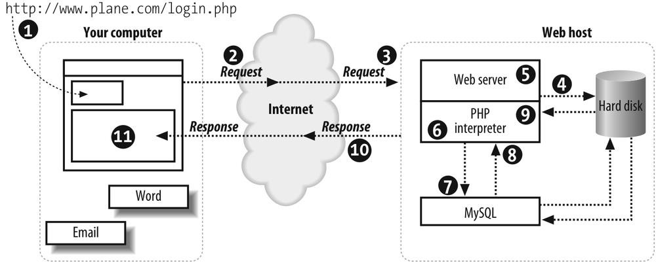

**Demonstrating how the web server operates using PHP**

**JavaScript**- JavaScript is a [programming language](https://techterms.com/definition/programming_language) commonly used in [web development](https://techterms.com/definition/web_development). It was originally developed by Netscape as a means to add dynamic and interactive elements to websites. While JavaScript is influenced by [Java](https://techterms.com/definition/java), the [syntax](https://techterms.com/definition/syntax) is more similar to [C](https://techterms.com/definition/cplusplus) and is based on ECMAScript, a scripting language developed by Sun Microsystems.

JavaScript is a client-side scripting language, which means the [source code](https://techterms.com/definition/sourcecode) is processed by the client's [web browser](https://techterms.com/definition/web_browser) rather than on the [web server](https://techterms.com/definition/web_server). This means JavaScript [functions](https://techterms.com/definition/function) can run after a webpage has loaded without communicating with the server. For example, a JavaScript function may check a web form before it is submitted to make sure all the required [fields](https://techterms.com/definition/field) have been filled out. The JavaScript code can produce an error message before any information is actually transmitted to the server.

Like server-side scripting languages, such as [PHP](https://techterms.com/definition/php) and [ASP](https://techterms.com/definition/asp), JavaScript code can be inserted anywhere within the [HTML](https://techterms.com/definition/html) of a [webpage](https://techterms.com/definition/webpage). However, only the [output](https://techterms.com/definition/output) of server-side code is displayed in the HTML, while JavaScript code remains fully visible in the source of the webpage. It can also be referenced in a separate [.JS](https://fileinfo.com/extension/js) file, which may also be viewed in a browser.

JavaScript functions can be called within <script> tags or when specific events take place. Examples include onClick, onMouseDown, onMouseUp, onKeyDown, onKeyUp, onFocus, onBlur, onSubmit, and many others. While standard JavaScript is still used for performing basic client-side functions, many web developers now prefer to use JavaScript libraries like [jQuery](https://techterms.com/definition/jquery) to add more advanced dynamic elements to websites.

**Basic JavaScript Format Code-**

*<script=” javascript” type=”text/javascript”>*

*JavaScript code*

*</script>*

**MySQL**-is an open-source relational database management system (RDBMS). Its name is a combination of "My", the name of co-founder Michael Widenius' daughter, and "SQL", the abbreviation for Structured Query Language. The MySQL development project has made its source code available under the terms of the GNU General Public License, as well as under a variety of proprietary agreements. MySQL was owned and sponsored by a single for-profit firm, the Swedish company MySQL AB, now owned by Oracle Corporation. For proprietary use, several paid editions are available, and offer additional functionality. MySQL is a central component of the LAMP open-source web application software stack (and other "AMP" stacks). LAMP is an acronym for "Linux, Apache, MySQL, and Perl/PHP/Python". Applications that use the MySQL database include: TYPO3, MODx, Joomla, WordPress, phpBB, MyBB, and Drupal. MySQL is also used in many high-profile, large-scale websites, including Google (though not for searches), Facebook, Twitter, Flickr, and YouTube.

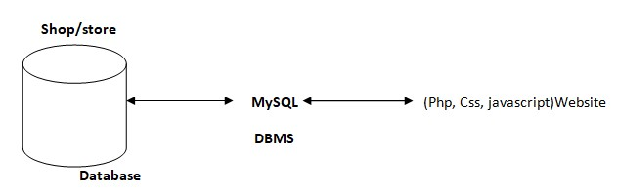

**A diagram showing the concept of MySQL**

**JQUERY-** is a [JavaScript](https://techterms.com/definition/javascript) library that allows web developers to add extra functionality to their websites. It is [open source](https://techterms.com/definition/opensource) and provided for free under the MIT license. In recent years, jQuery has become the most popular JavaScript library used in [web development](https://techterms.com/definition/web_development).

To implement jQuery, a web developer simply needs to reference the jQuery JavaScript file within the [HTML](https://techterms.com/definition/html) of a [webpage](https://techterms.com/definition/webpage). Some websites host their own local copy of jQuery, while others simply reference the library hosted by [Google](https://techterms.com/definition/google) or the jQuery server. For example, a webpage may load the jQuery library using the following line within the <head> section of the HTML.

Once the jQuery library is loaded, a webpage can call any jQuery [function](https://techterms.com/definition/function) supported by the library. Common examples include modifying text, processing form data, moving elements on a page, and performing animations. JQuery can also work with [Ajax](https://techterms.com/definition/ajax) code and scripting languages, such as [PHP](https://techterms.com/definition/php) and [ASP](https://techterms.com/definition/asp) to access data from a [database](https://techterms.com/definition/database). Since jQuery runs on the client side (rather than the web server), it can update information on a webpage in [real-time](https://techterms.com/definition/realtime), without reloading the page. A common example is "autocomplete," in which a search form automatically displays common searches as you type your [query](https://techterms.com/definition/query). In fact, this is how TechTerms.com provides search suggestions when you type in the search box.

Besides its free license, the other main reason jQuery has gained such popularity is its [cross-browser](https://techterms.com/definition/crossbrowser) compatibility. Since each browser renders HTML, [CSS](https://techterms.com/definition/css), and JavaScript

Differently, it can be difficult for a web developer to make a website appear the same across all [browsers](https://techterms.com/definition/web_browser). Instead of having to write custom functions for each browser, a web developer can use a single jQuery function that will work in Chrome, Safari, Firefox, and Internet Explorer. This multi-browser support has led many developers to switch from standard JavaScript to jQuery, since it greatly simplifies the coding process.

**BOOTSTRAP**- Bootstrap is a [free and open source](https://whatis.techtarget.com/definition/Free-and-open-source-software-FOSS-or-free-libre-open-source-software-FLOSS) [front end](https://whatis.techtarget.com/definition/front-end) development framework for the creation of websites and [web apps](https://searchsoftwarequality.techtarget.com/definition/Web-application-Web-app). The Bootstrap framework is built on [HTML](https://www.theserverside.com/definition/HTML-Hypertext-Markup-Language), [CSS](https://www.theserverside.com/definition/cascading-style-sheet-CSS), and JavaScript ([JS](https://www.theserverside.com/definition/JavaScript)) to facilitate the development of [responsive](https://whatis.techtarget.com/definition/responsive-design), [mobile-first](https://searchmobilecomputing.techtarget.com/definition/mobile-first) sites and apps.

Responsive design makes it possible for a web page or app to detect the visitor’s screen size and orientation and automatically adapt the display accordingly; the mobile first approach assumes that [smartphones](https://searchmobilecomputing.techtarget.com/definition/smartphone), [tablets](https://searchmobilecomputing.techtarget.com/definition/tablet-PC) and task-specific Mobile apps are employees' primary tools for getting work done and addresses the requirements of those technologies in design.

Bootstrap includes user interface components, layouts and JS tools along with the framework for implementation. The software is available precompiled or as [source code](https://searchapparchitecture.techtarget.com/definition/source-code).

Mark Otto and Jacob Thornton developed Bootstrap at Twitter as a means of improving the consistency of tools used on the site and reducing maintenance. The software was formerly known as Twitter Blueprint and is sometimes referred to as Twitter Bootstrap.

In computers, the word bootstrap means to [boot](https://searchwindowsserver.techtarget.com/definition/boot): to load a program into a computer using a much smaller initial program to load in the desired program (which is usually an operating system).

**CHAPTER-III**

**System Analysis & Design**

**Software Development Life Cycle**

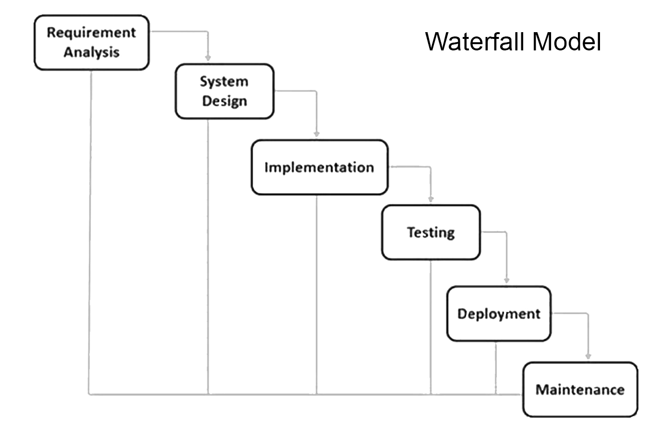

**Data Flow Diagram**

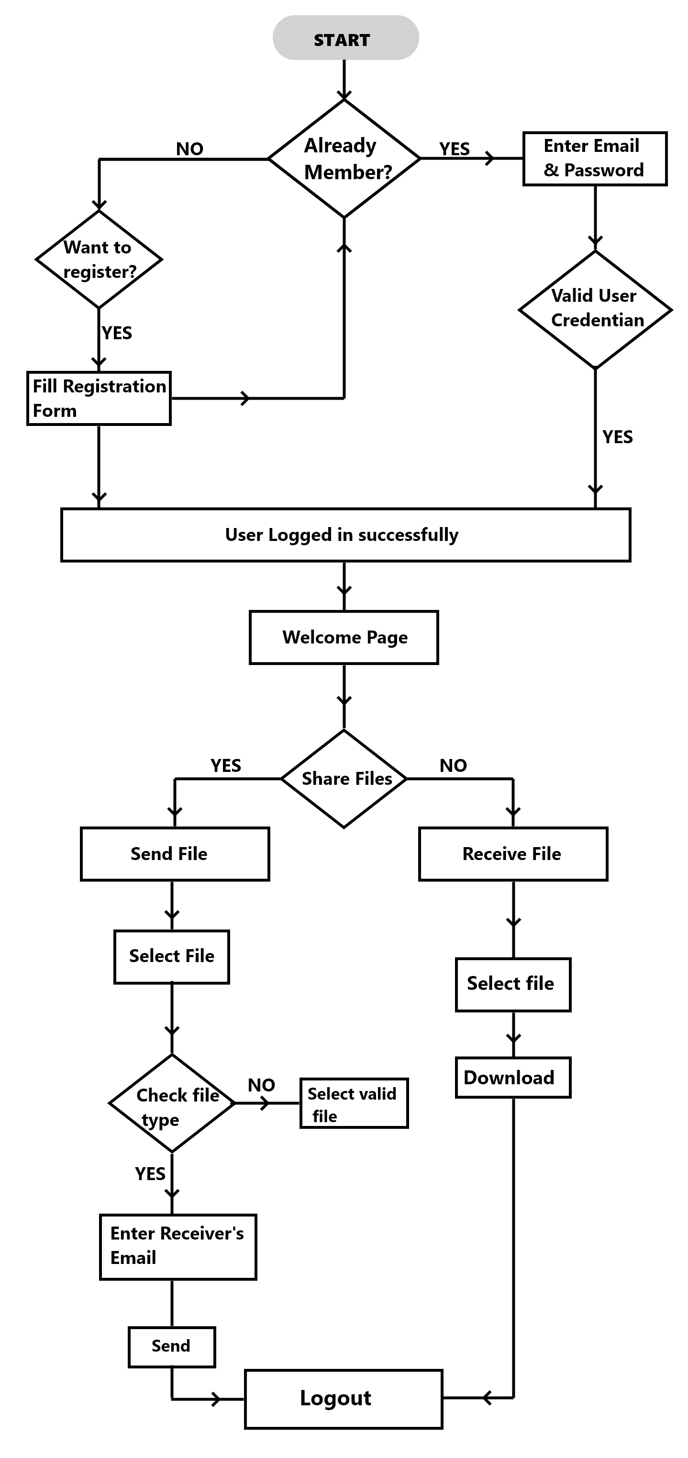

* First when the user will enter on the landing page he or she will have to register. If the user is registered the person will need to log in.
* Once he or she has logged in successfully the person will be on the welcome page. The welcome page will provide two options that is to send a file or to view a received file.
* If the person has to send a file he or she will select the file which is needs to be sent on the space provide. Once it is validated he or she can send it by entering the receivers address.
* If the person has to view you are received file he or she will go on the received file section and download the desired file and after that he or she can logout.

**Data Base Schema Design**

Database is an integrated collection of data and provides a centralizedaccess to the data and makes possible to treat data as a separate resource. Usually centralized data managing software is called a Relational Database Management System (RDBMS). The most significant different between RDBMS and other type of Data Management is the separation of data as seen by the program and data as store of on the direct access storage device. This is the difference between logical and physical data.

**Database Dictionary**

The efficiency of an application developed using RDBMS mainly depend upon the database tables, the fields in each table and the way the tables are opened using the contents in them to retrieve the necessary information. Hence a careful selection of tables and their fields are imperative.

The database tables used in this system are created keeping the above points in mind. The tables used are given below.

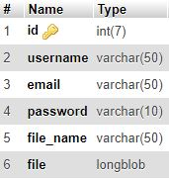

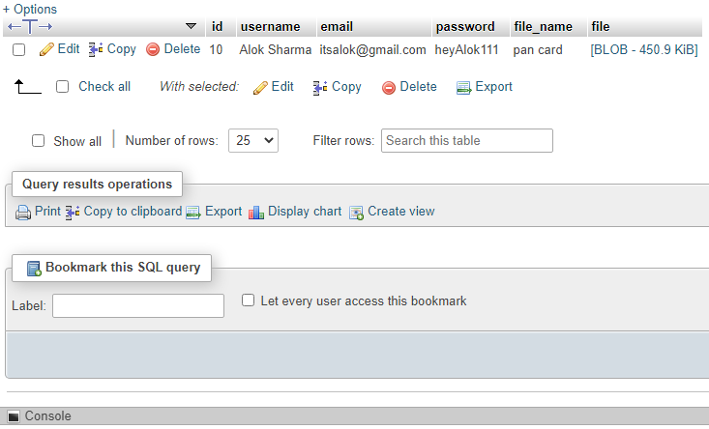

The user who have registered to the website have their data automatically stored in the database.

**System Planning (PERT Chart)**

A PERT chart is a project management tool used to schedule, organize, and coordinate tasks within a project. PERT stands for Program Evaluation Review Technique, a methodology developed by the U.S. Navy in the 1950s to manage the Polaris submarine missile program. A similar methodology, the Critical Path Method (CPM) was developed for project management in the private sector at about the same time.

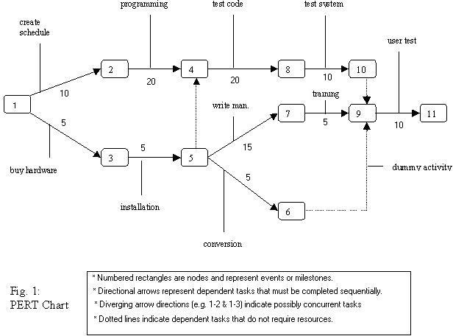

A PERT chart presents a graphic illustration of a project as a network diagram consisting of numbered nodes (either circles or rectangles) representing events, or milestones in the project linked by labelled vectors (directional lines) representing tasks in the project. The direction of the arrows on the lines indicates the sequence of tasks. In the diagram, for example, the tasks between nodes 1, 2, 4, 8, and 10 must be completed in sequence. These are called dependent or serial tasks. The tasks between nodes 1 and 2, and nodes 1 and 3 are not dependent on the completion of one to start the other and can be undertaken simultaneously. These tasks are called parallel or concurrent tasks. Tasks that must be completed in sequence but that don't require resources or completion time are considered to have event dependency. These are represented by dotted lines with arrows and are called dummy activities. For example, the dashed arrow linking nodes 6 and 9 indicates that the system files must be converted before the user test can take place, but that the resources and time required to prepare for the user test (writing the user manual and user training) are on another path. Numbers on the opposite sides of the vectors indicate the time allotted for the task.

The PERT chart is sometimes preferred over the Gantt chart, another popular project management charting method, because it clearly illustrates task dependencies. On the other hand, the PERT chart can be much more difficult to interpret, especially on complex projects. Frequently, project managers useboth techniques*.*

**CHAPTER-IV**

**Screen/Snap-Shots of the project**

**User Interface layout**

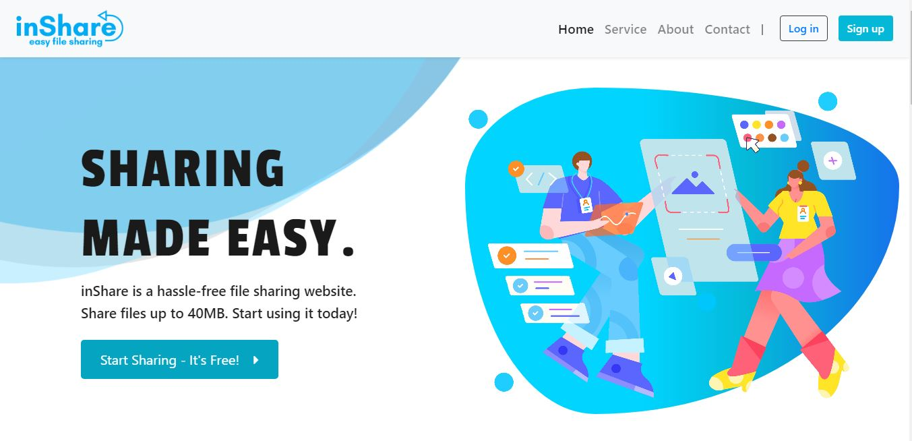

**Landing page**

It has a mild description about the website and is supported by navigation bar in which you can toggle to sign up or register and also toggle to other portion of the landing page.

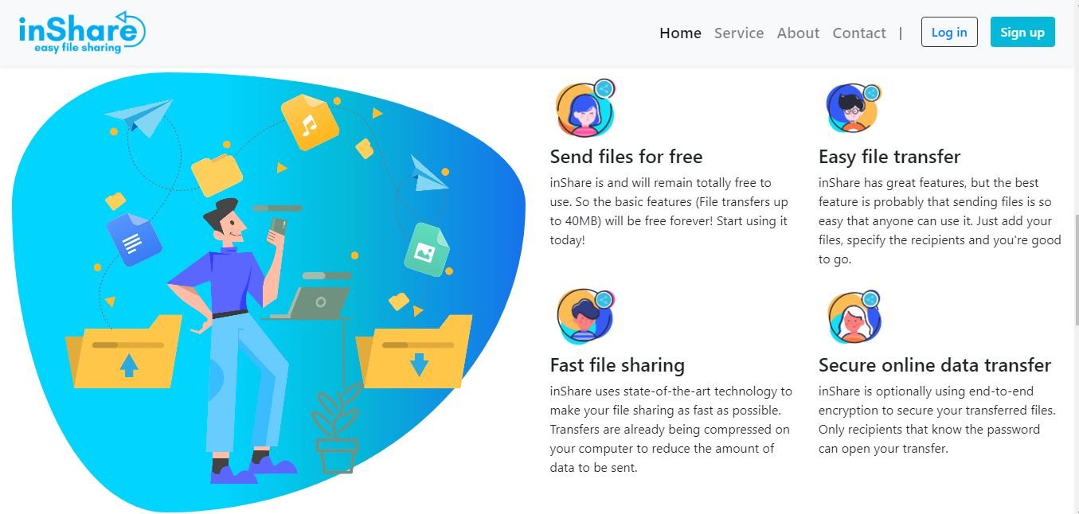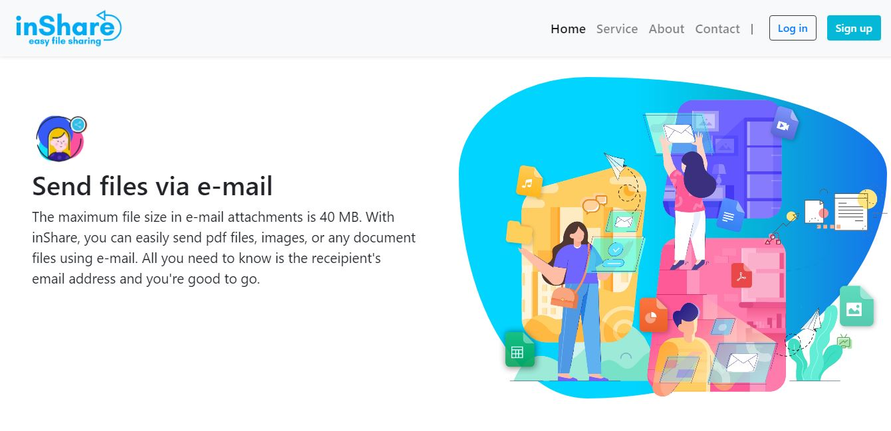

**About Page**

The about page has the description of the website and what it is all about.

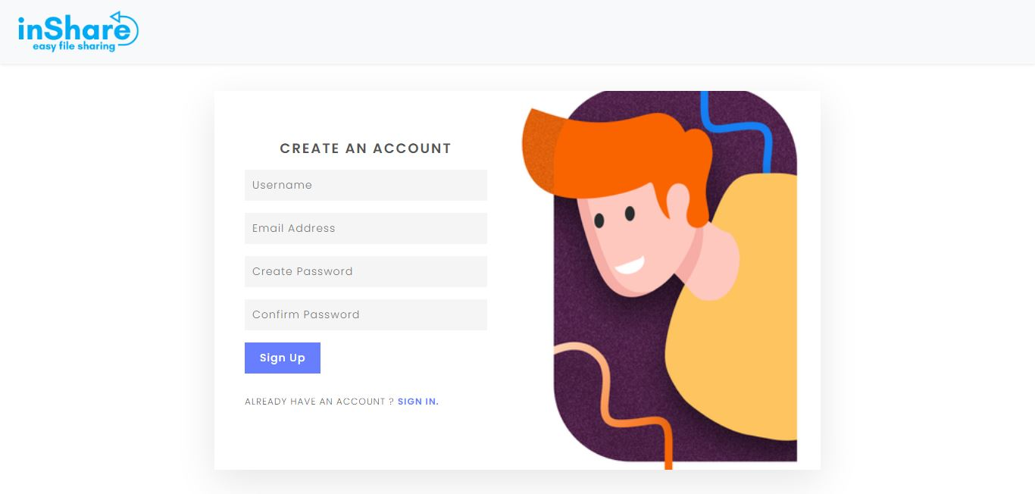

**Sign up page**

If there is a new user one will go to the signup page where one has to fill name email address and password and that person can sign up for the website.

The user has to meet the required filled standard for them to register successfully; otherwise, he/she will remain on the same page. This registration file "*signup.php*" is run with a code editor.

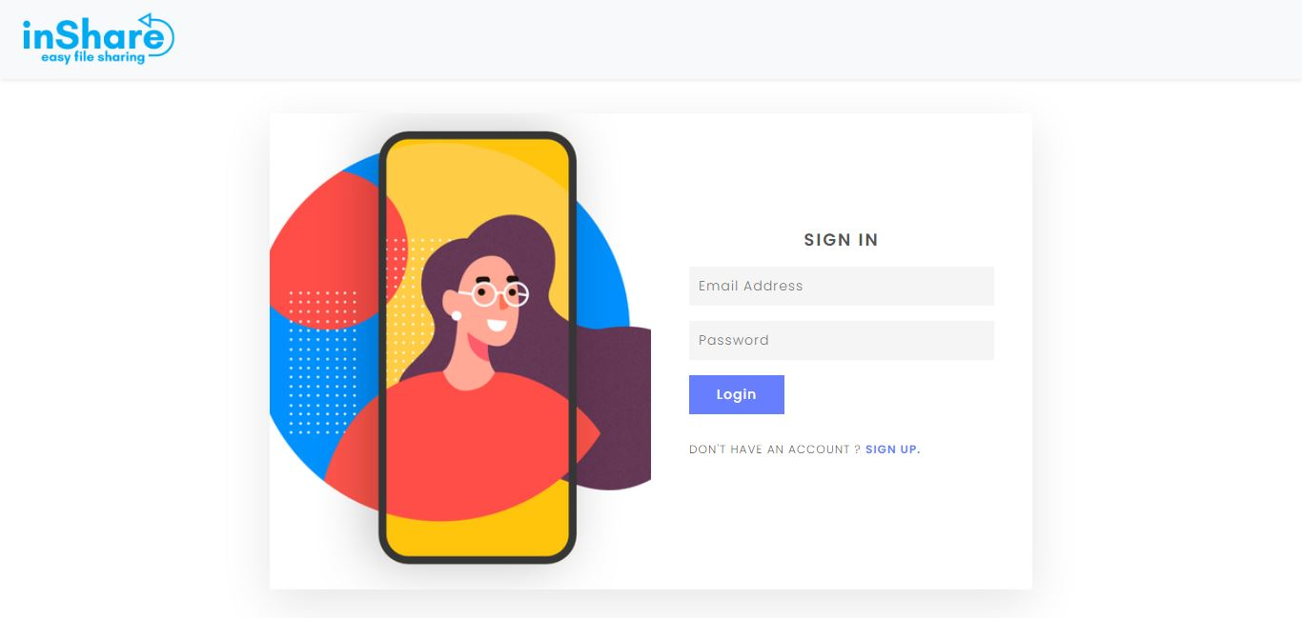

**Login page**

If the user is old one and has an ID one will login using email and password.

User will have the right to log in with their information such as e-mail and password. The information is sent to the database to check for a match. If no match is found the user remains on the same page, otherwise he is directed to the login page. This can be accessed by running "*signup.php*" file with an editor.

**Sending file interface**

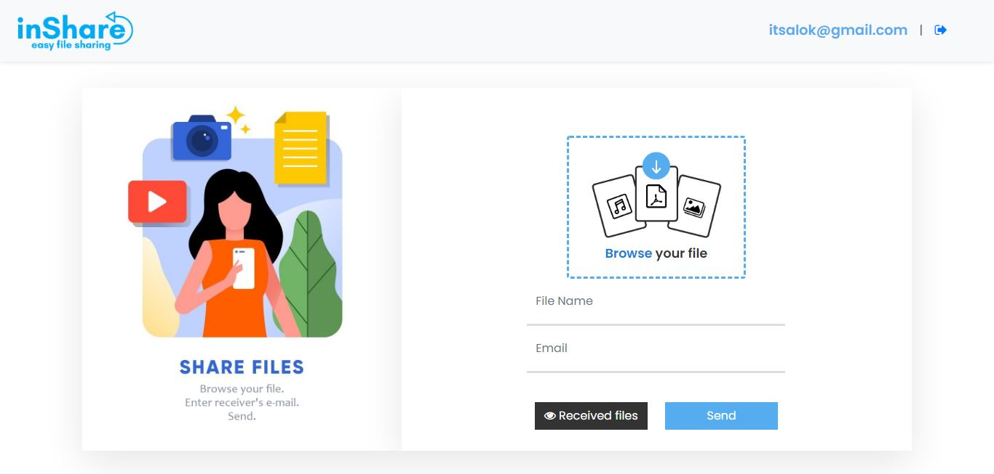

If a user has to send a file one will go on the sending page where one can see can add file option, enter the file name, enter the recipient's email address and send it.

**Receiving file interface**

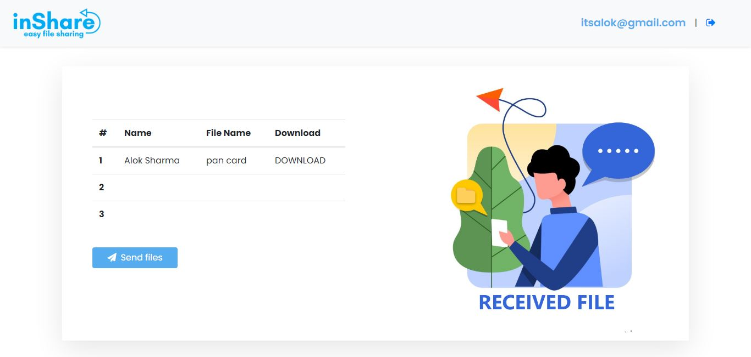

On the received file page one can see the receipt files and download the desired one.

**CONCLUSION**

It has been a great pleasure for me to work on this exciting and challenging project. This project proved good for me as it provided practical knowledge of not only programming in PHP web based application and no some extent Web Application and SQL Server, but also about all handling procedure related with **“inShare”.** It also provides knowledge about the latest technology used in developing web enabled application. This will provide better opportunities and guidance in future in developing projects independently.

**BENEFITS:**

The project is identified by the merits of the system offered to the user. The merits of this project are as follows: -

·       It’s a web-enabled project.

·      This project offers user to enter the data through simple and interactive forms. This is very helpful for the client to enter the desired information through so much simplicity.

·      The user is mainly more concerned about the validity of the data, whatever he is entering. There are checks on every stages of any new creation, data entry or updating so that the user cannot enter the invalid data, which can create problems at later date.

·      Sometimes the user finds in the later stages of using project that he needs to update some of the information that he entered earlier. There are options for him by which he can update the records. Moreover there is restriction for his that he cannot change the primary data field. This keeps the validity of the data to longer extent.

·       User is provided the option of monitoring the records he entered earlier. He can see the desired records with the variety of options provided by him.

·      From every part of the project the user is provided with the links through framing so that he can go from one option of the project to other as per the requirement. This is bound to be simple and very friendly as per the user is concerned. That is, we can say that the project is user friendly which is one of the primary concerns of any good project.

·      Data storage and retrieval will become faster and easier to maintain because data is stored in a systematic manner and in a single database.

·      Decision making process would be greatly enhanced because of faster processing of information since data collection from information available on computer takes much less time than manual system.

·      Allocating of sample results becomes much faster because at a time the user can see the records of last years.

·       Easier and faster data transfer through latest technology associated with the computer and communication.

·      Through these features it will increase the efficiency, accuracy and transparency,

**LIMITATIONS:**

·      The size of the database increases day-by-day, increasing the load on the database back up and data maintenance activity.

·      Training for simple computer operations is necessary for the users working on the system.

**REFERENCE**

1. www.w3school.com
2. CSS3 characteristic and attributes 3.05.2018
3. php features. 08.03.2018

http://www.biogem.org/downloads/notes/PHP%20-

%20Hypertext%20Preprocessor.pdf/4/JavaScript academic. Accessed 09.03.2018

1. http://www.w3schools.com/js/default.asp https://dev.mysql.com/doc/apis-php/en/apis-php-pdo-mysql.html
2. XAMPP 2.05.2018 https://www.apachefriends.org/index.html
3. PhpMyAdmin. 5.05.2018 https://www.phpmyadmin.internet/
4. The basic diagram of the HTML/HTML5 5/24/2018 http://www.modelrumahminimalis.co/html-menu-templates-freedownload/69033.html