SID: 200968838

**Coursework 2**

**Question 1**

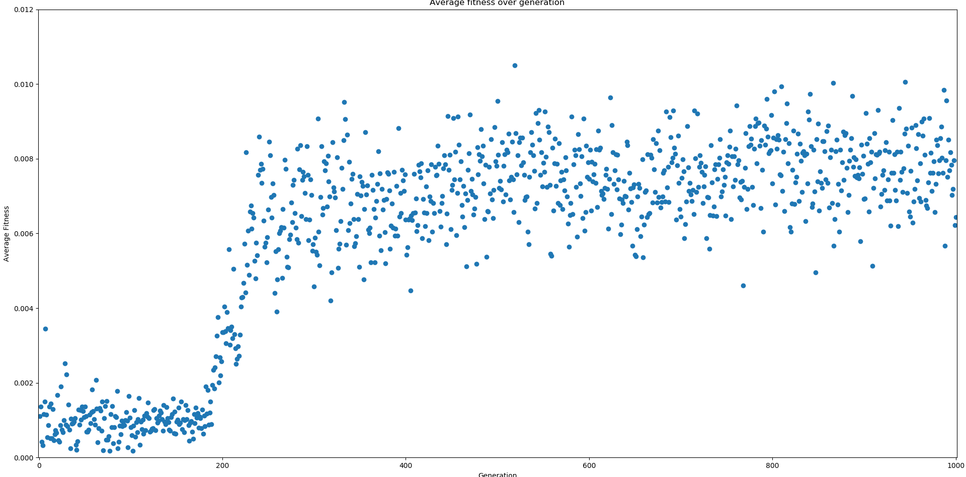

The above scatter plot shows the average fitness over 1000 generations. Markers have been used instead of a continuous line because the abrupt changes in fitness meat lots of almost vertical lines making the fitness at a certain generation indiscernible. Major improvements start happening around generation 200 and then settle around generation 300. The plot goes all the way to a thousand to show that even though there are some outliers the trend remains constant.

**Question 2**

At first the mice wonder around randomly stumbling into cheese “unintentionally”. As the generations progresses the start actively moving towards the cheese but not very accurately and with fairly wide turning radius that in many cases brings them to orbit around the cheese without ever reaching it. As we progress further and further the mice start moving towards the cheese faster and more accurately snapping to the direction of the next piece of cheese. In this situation we also start observing what looks like packs of mice snapping towards the cheese moving in compact unit. This last phenomenon is probably a sign of the underlying network being very similar for all the mice leaving use to conclude that the variation of fitness between generation should be mostly due to the random initialisation of the environment.

**Question 3**

The fitness function is calculated by dividing the distance travelled by the number of cheese collected. This means the better mice are the ones that move from one cheese to another the most efficiently.

If we get rid of the energy requirement by using just the number of chees collected as fitness functions we can observe a few things happening. First, the mice don’t move as erratically, they tend to aim for the same piece of cheese even if a closer one appears. They are also more prone to orbiting the cheese further along into the generation than the previously used simulation. Also the mice have stopped moving together in packs and collide with one another more frequently. The overall performance seems to be worse than the previous since the fitness criteria is less strict.