1.Framework Overview:

Its an automation framework where u can automate web applications and relies on webdriverIO and mocha to perfrom automation.It supports POM model and also provide the flexbilty to execute test cases in docker containers(Hub &Node).

2.Framework Steup:
As a part of prerequisite software required.

Node.js
VS Code
Java (jdk 8 and above).
Docker
webDriverIO library.

Setup Commands:

npm init -y

npm i @wdio/cli

npx wdio config

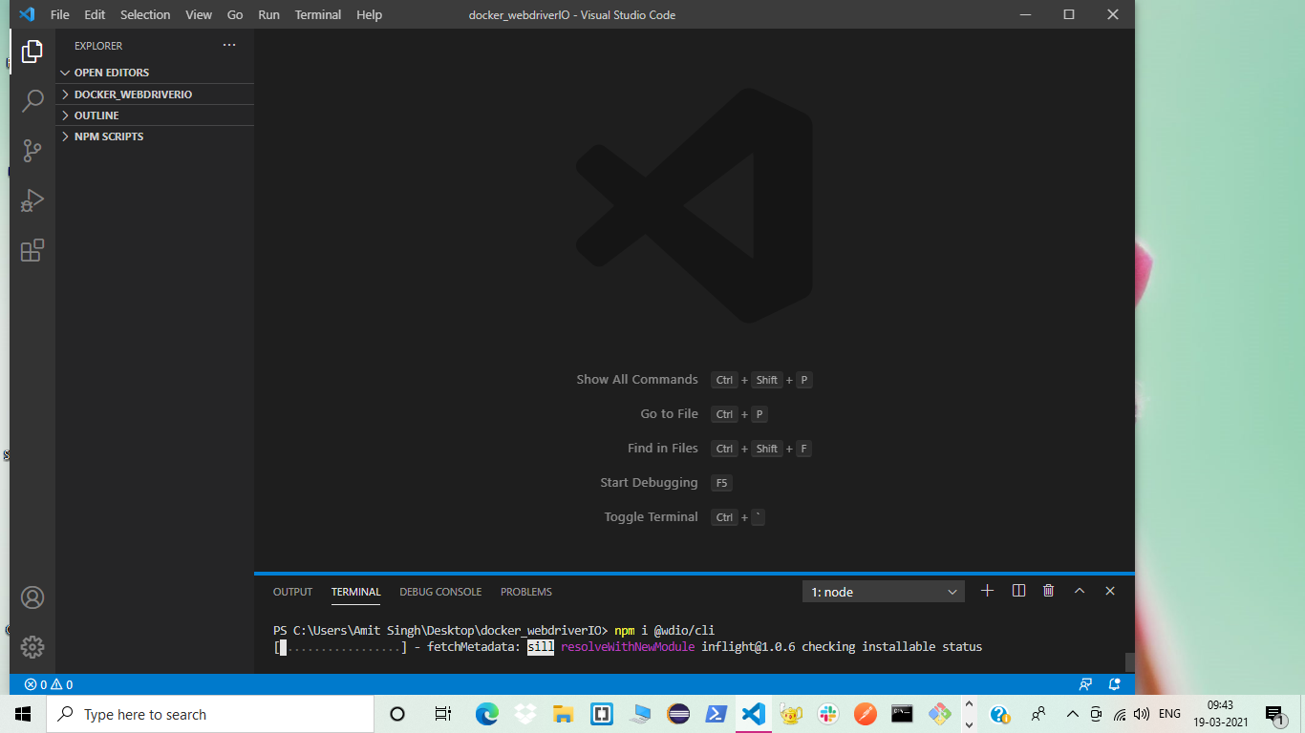

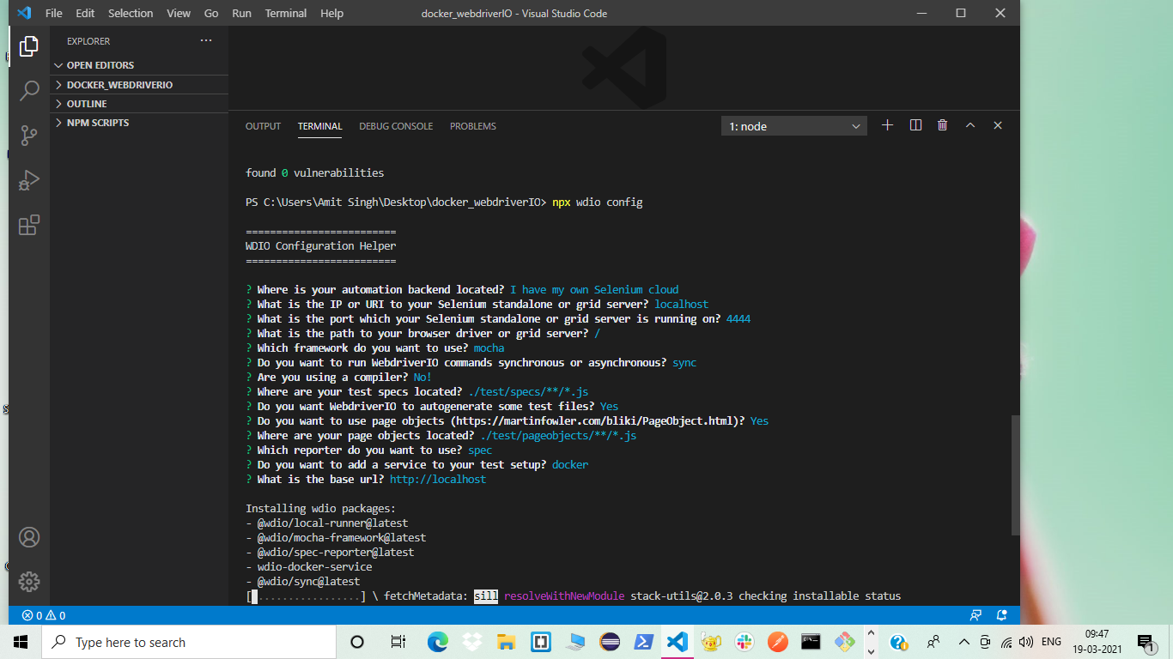

Create docker-compose.yml file.

Refer link :
https://raw.githubusercontent.com/SeleniumHQ/docker-selenium/trunk/docker-compose-v3.yml

Update the ports details for chrome and FireFox Images.
Update scale value to create Multiple nodes.

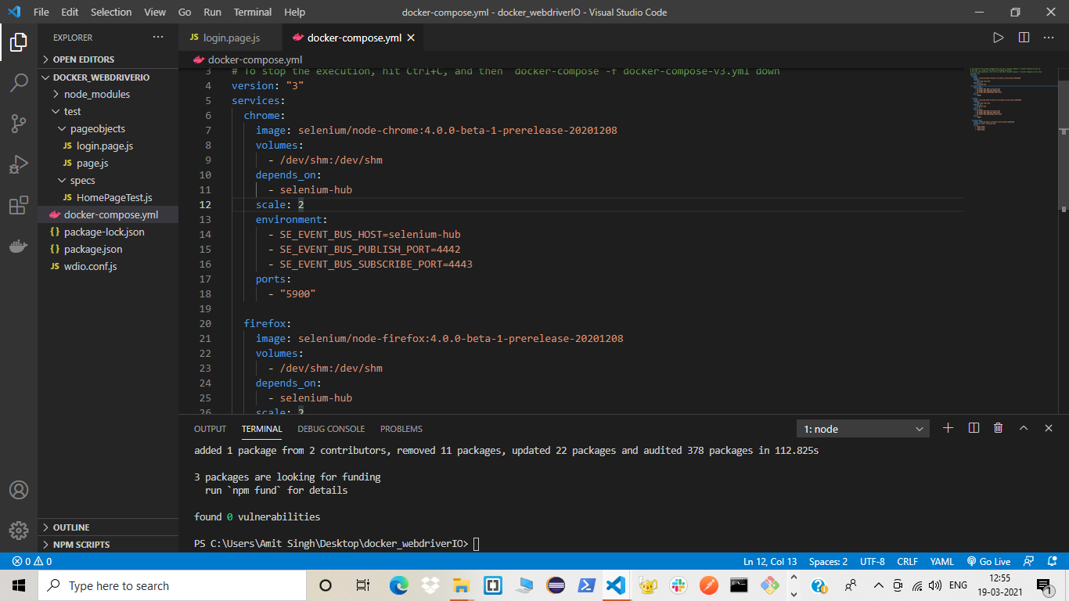

As per required instance of browser update maxInstance value for parallel run.

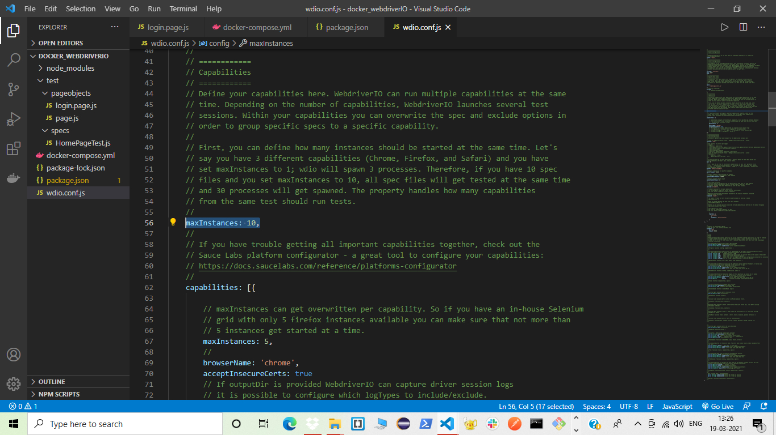
Excecution:

Update package.json
"scripts": {
"test": "npx wdio wdio.conf.js"
},

Start Hub(Selenium Server):
Command: docker-compose up
Command: npm test

Reporting:Configure AllureReport

Command:

npm install @wdio/allure-reporter –save-dev

npm install -g allure-commandline –save-dev

Update conf:
exports.config = {
// ...
reporters: [['allure', {
outputDir: 'allure-results',
}]],
// ...
}
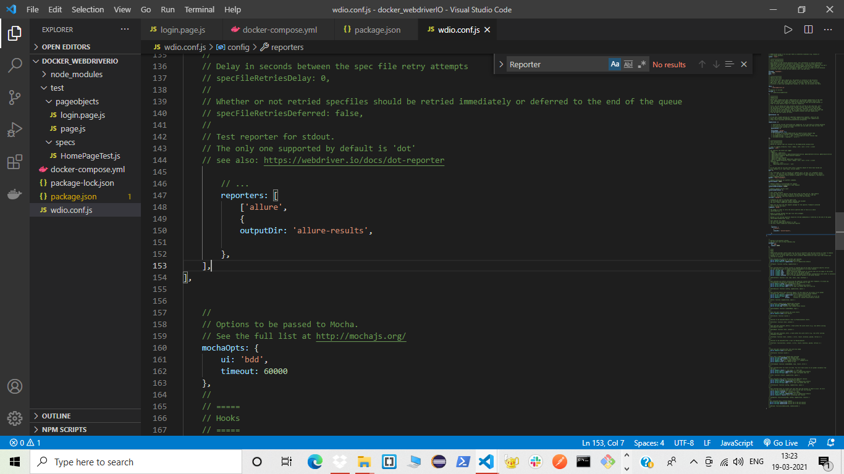

Generate Allure report:

generate allure-results && allure open

Create Page and SpecFiles:

