Wellspring: Asset Intelligence Copilot
FlytBase Hack Day 2026 · Design and results
Public repository (MIT licence): https://github.com/itsanjan/wellspring-asset-copilot

1. The problem and our answer
Operators ask plain-English questions about hundreds of oil wells: which wells are down and why, which spills break a rule, what a regulator's letter requires, which pumps are recalled. The answers sit across weekly inspections, repair reports, operator notes, manuals and SOPs. A wrong answer here is a missed spill report or an unsafe well, so the copilot must be correct, show its evidence, admit what the data cannot tell, remember what people tell it, and keep working on a dataset it has never seen.
Core idea. A language model decides what to ask; deterministic tools decide what is true. The model never computes a number, date or status. It picks tools, reads their results and writes the answer. Every visual is built from a tool result, never from numbers the model typed. Rules (production thresholds, spill classes, deadlines) are parsed from the manuals and SOPs with their section, so a new rule or SOP revision needs no code change.

2. Architecture
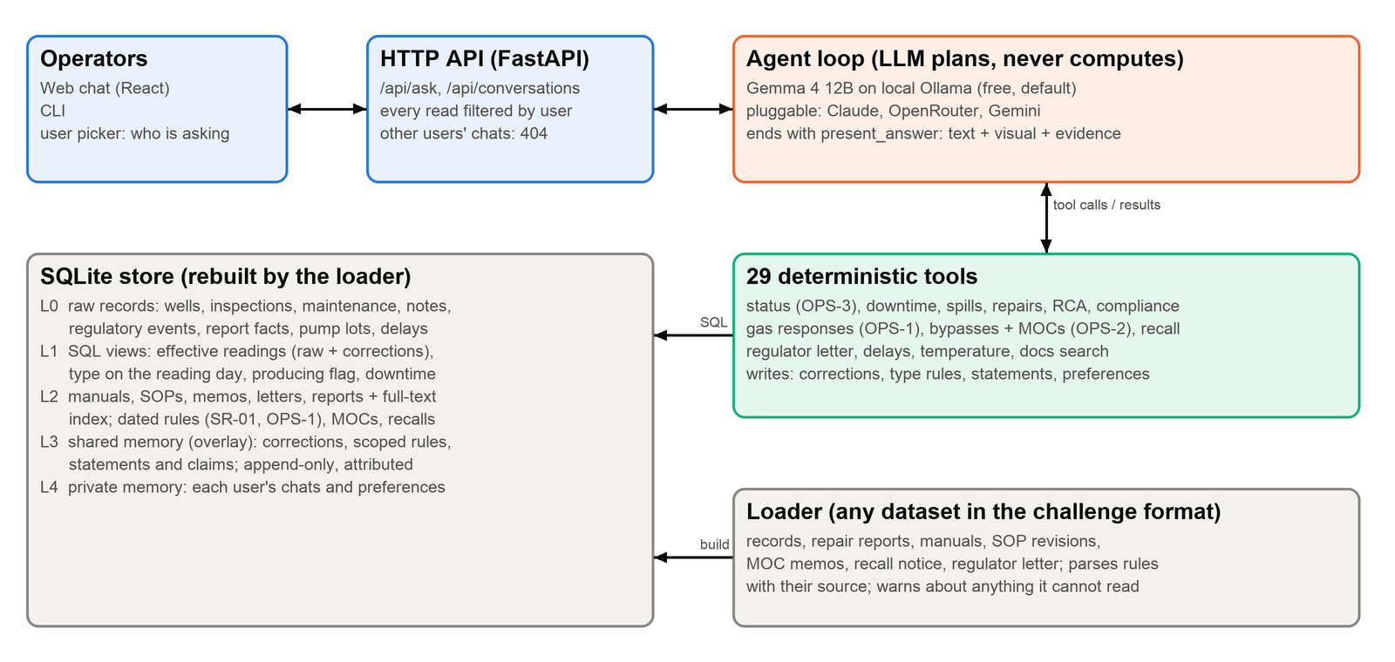
- Loader. Rebuilds a SQLite store from one or more dataset folders in the challenge format (about 10 s for 600 wells, 125,000 inspections). It parses repair reports (containment time, pump lot, follow-up, why the well waited, H2S readings, lab soil samples), classifies operator notes (gas, shut-in, restart, bypass, symptoms), and reads rules from documents, including dated ones such as SR-01 (24 h, 12 h from 1 Jan 2027).
- Effective truth. SQL views apply corrections over the raw data (a user correction wins, then a data-correction note, then the raw reading) and use the well's type on the day of each reading. Raw values are always kept and shown.
- Tools. 29 typed tools return one contract: rows, summary, evidence (record IDs and document sections), ready-made visuals (card, table, line, bar, stacked bar, map, heatmap) and flags (conflicts, stale records, corrections, unconfirmed claims, missing rules).
- Agent. A provider-neutral tool loop. Default model: Gemma 4 12B on local Ollama, so it runs free and offline; Claude, OpenRouter or Gemini by one environment variable. Small models get a compact view of results.
- Memory. Shared memory is an append-only overlay: corrections to one inspection, rules for one well type, statements about one well; each attributed to its author with a reason and applied only at its scope. Private memory (each user's conversations and display preferences) is only ever read for that user; the API returns 404 for anyone else's chat.

3. How it behaves (solution highlights)
- Honest about missing data. Asked to map reservoir pressure, it says the data has no pressure readings (only the 3,000 psi design limit in OM-T200 section 9.1). Asked for the best producer, it says no oil volumes exist and offers a clearly labelled uptime proxy.
- Honest about conflicts. When an operator note and an inspection disagree it applies the SOP's precedence (OPS-3), marks restarts as unconfirmed until inspected, and flags a 'back online' note while a repair is still open.
- Learns from feedback at the right scope. A corrected temperature changes that inspection for everyone and says what changed (the well is now producing); a rule for T350 wells changes only T350 wells; a corrected spill volume re-classifies the spill and shows the new reporting deadline.
- Knows who said what. A supervisor's report that a recalled pump was swapped is stored under their name as 'reported, no work order yet', never as fact. A second-hand claim ('Nathan told me WELL-0577 was swapped') is checked against what Nathan actually said; he never said it, so it stays unconfirmed and the pump stays on the recall list.
- Generalises. The test dataset added 400 wells, 3 areas, a team, ESP wells (T500, 25 °C rule), operator notes, an SOP revision, management-of-change memos, a supplier recall and a regulator letter. All are loaded and parsed from the documents; the load reports any rule it could not read.

4. Results
Sample dataset (200 wells), local Gemma 4 12B: Q1-Q10 scored 42 of 42 expected facts with the right visual on all 10; the memory and feedback scenarios Q11-Q18 scored 46 of 52 checks before the final fixes. The tool layer alone reproduces every expected fact for Q1-Q18, and the product agrees with an independent ground-truth implementation on all 600 test-dataset wells. 136 automated tests run in CI.
Final questions on the test dataset (600 wells, today = 15 Jan 2027). Tool results were recomputed independently from the raw files by a separate QA pass; model answers were run on local Gemma 4 12B:
Q | Answer from the tools (verified) | Model run
1 | No pressure data in the records; cannot map it. Only the 3,000 psi design limit exists. | Correct (2 min)
2 | No oil volumes recorded; uptime proxy only, T500 wells lead (producing at every 2026 inspection). | Correct (6.5 min)
3 | 26 gas reports since 1 Nov 2026: 17 met OPS-1, 9 missed (e.g. WELL-0332: only a drone flight, which does not count; WELL-0599 and WELL-0516 missed the new 12 h limit). | Correct, full table (19 min)
4 | In place now: WELL-0248 allowed (MOC-2026-031 extended by 044), WELL-0249 expired, WELL-0405 never approved. Past violations: WELL-0087, WELL-0158 (expired), WELL-0561 (not approved). | Correct (4.5 min)
5 | Letter covers 6 reportable spills in NE-07/NE-08 since 1 Jun 2026; WELL-0123, 0182, 0262 not compliant (field soil readings only, no lab samples). | Not run in time
6 | 11 wells where inspection and notes disagree; e.g. WELL-0010 not producing (type changed to T350, 20 °C rule); WELL-0026/0033/0046 restart notes while repairs are still open. | Not run in time
7 | 116 wells with symptom notes and no repair since; top: WELL-0263 (fluid pound + recalled pump), 0336, 0182, 0219, 0401 (T500 falling-temperature early warning). | Not run in time
8-9 | 9 recalled pumps still in the ground (4 in Northwest Block 12); Northwest Production led by Nathan Pierce, 150 wells; December cold-weather misses e.g. WELL-0310; no H2S reading exists for WELL-0332 on 3 Dec. | Not run in time
10 | Delays by area for 2026: Southeast Block 31 stands out on contractors (42.5 %, 14 days typical), Northeast Block 7 on parts (15 days). | Not run in time
11 | No area runs consistently hotter once well type is accounted for (all within 0.12 °C); SE-31's raw lead comes from its share of T500 wells. | Not run in time

Limits and next steps. What we would do next: run all final turns on a faster model (the local model takes 2-19 minutes per answer, mostly writing), add the remaining memory scenarios to CI, and let users confirm or reject unconfirmed claims from the UI.

5. Demo (video outline, under 5 minutes)
Time | What we show
0:00-0:30 | The problem and the core idea: the model asks, tools decide what is true.
0:30-1:30 | Michael Turner: 'Which wells in Northeast Block 8 are not producing, and why?' Table with reasons, evidence IDs, threshold source; switch the chart to its table view; dark mode.
1:30-2:30 | Feedback: correct a faulty thermal reading; the well becomes producing for every user, the raw value is kept, and the author and reason are shown. Then a type rule for T350 wells only.
2:30-3:30 | Laura Simmons: gas reports vs the OPS-1 deadline (Met / Missed table); Chris Dalton: bypasses vs MOC memos.
3:30-4:30 | Who told you that? Nathan reports a pump swap; Olivia relays a claim Nathan never made, and the copilot refuses to drop it. A private preference changes only Nathan's tables.
4:30-5:00 | Honesty: 'map the reservoir pressure' gets a clear 'the data has no pressure readings'. Architecture slide.

Try it. git clone https://github.com/itsanjan/wellspring-asset-copilot.git, then scripts/fetch_data.sh; python -m wellspring.loader --data <dataset> --db var/wellspring.db; uvicorn wellspring.server:app --port 8000 (web UI at http://localhost:8000). Full setup in the README: https://github.com/itsanjan/wellspring-asset-copilot#readme

