**CSCE 5430 Software Engineering Section 008**

**Group Project Part – 1**

**Requirements and Risk Management**

**Submitted by: Group 1**

**Aiswarya Marapatla**

**Email: aiswaryamarapatla@my.unt.edu**

**Akshat Khapra**

**Email: akshatkhapra@my.unt.edu**

**Arnav Sharma**

**Email: arnavsharma@my.unt.edu**

**Baji Sharif Patan**

**Email: bajisharifpatan@my.unt.edu**

**Mohammed Ibrahim Sohaib**

**Email: mohammedibrahimsohaib@my.unt.edu**

**Mohan Seshu Ganapaneni**

**Email: mohanseshuganapaneni@my.unt.edu**

**Sai Kiran Medarametla**

**Email: saikiranmedarametla@my.unt.edu**

**Sai Krishna Kotni**

**Email: saikrishna.kotni@my.unt.edu**

**Sai Srikanth Jasti**

**Email: saisrikanth.jasti@my.unt.edu**

**Shyam Sunder Mundrika**

**Email: shyamsundermundrika@my.unt.edu**

**TOOLS USED IN THE PROJECT TO BE DOWNLOADED**

* **NODE JS :**

<https://nodejs.org/en/download/>

Download the LTS version according to your platform and then install it with all the default instalation setup.

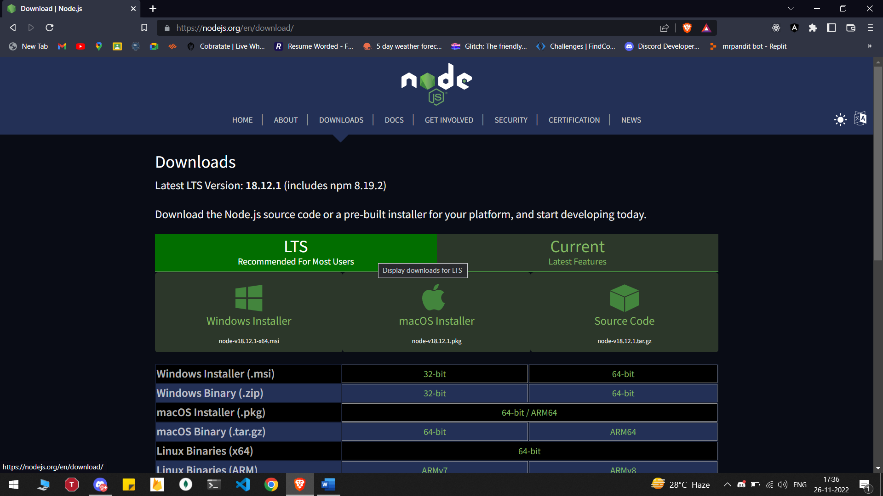

* **MONGO DB :**

[**https://www.mongodb.com/try/download/community**](https://www.mongodb.com/try/download/community)

Download the current version of mongo db community server and install it with the default setup options.

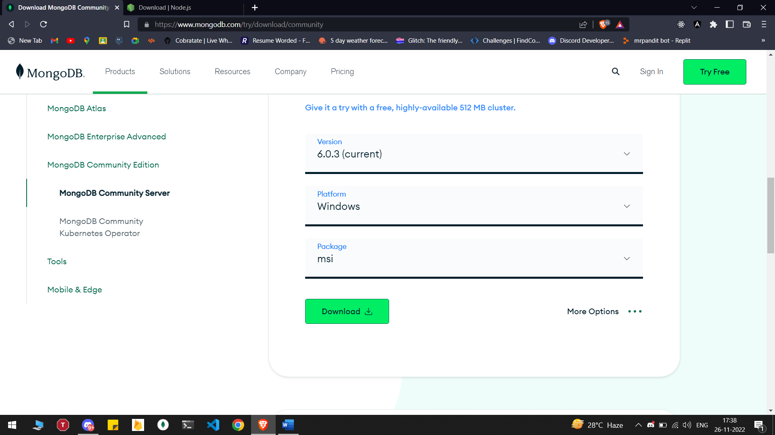

* **VISUAL STUDIO CODE :**

[**https://code.visualstudio.com/download**](https://code.visualstudio.com/download)

**Download as per your platform. Then install it with the default options.**

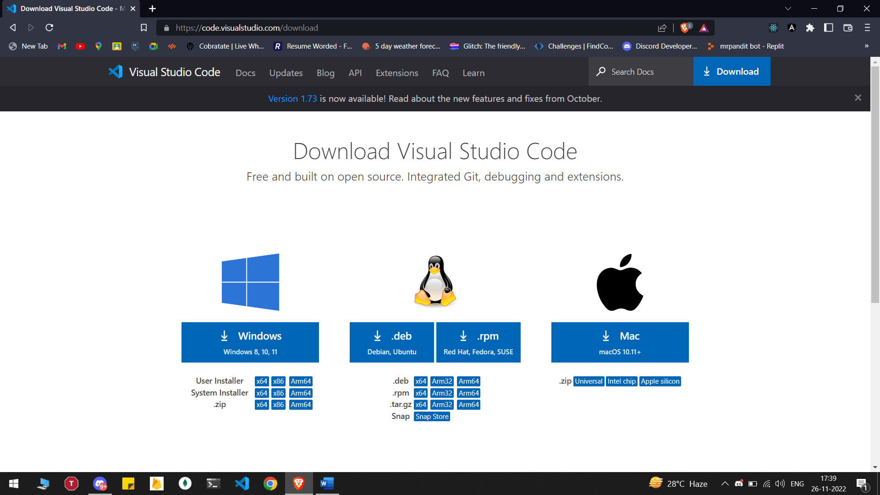

* **Setting up thunder client**

Open the both the folder of the project in VS Code and install the thunder client extension from vs code extensions

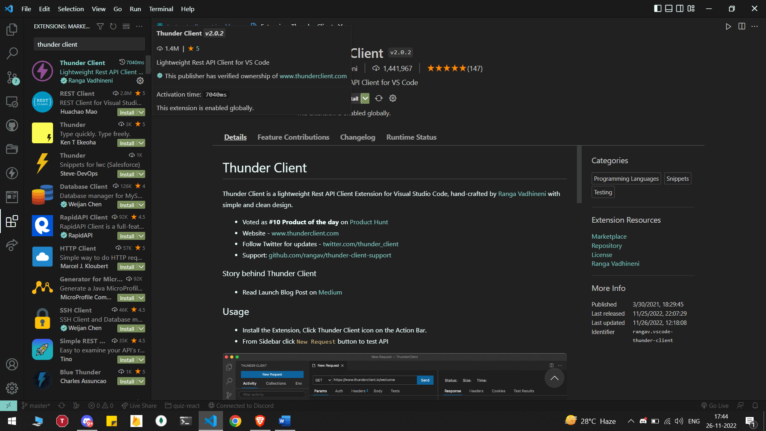

After downloading thunder client we will now setup the thunder client requests for creating a admin. Click on the three dots

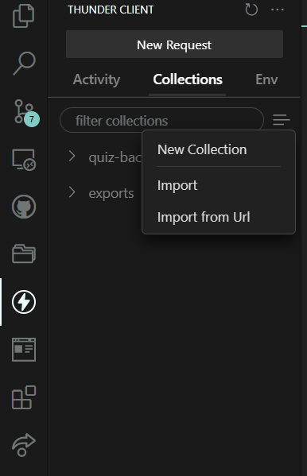

1. Select the file named (thunder-collection_exports.json) from the downloaded folder

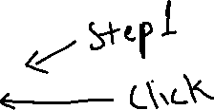

Now open windows PowerShell as admin and follow this linked site for setup.

<https://www.sharepointdiary.com/2014/03/fix-for-powershell-script-cannot-be-loaded-because-running-scripts-is-disabled-on-this-system.html>

After this you have to follow this step for running the servers

1. Open one terminal for the frontend folder and one terminal for backend folder.
2. Now run command “npm i” in both terminals to install all the scripts.
3. After that run command “ npm i -g nodemon ” in the backend terminal
4. After that run command “ npm run dev ” on the frontend and “ nodemon server.js ” on the backend terminal to start the servers.

We are complete with the server part now lets setup the database part

1. Open mongo db compass
2. Enable the edit connection string

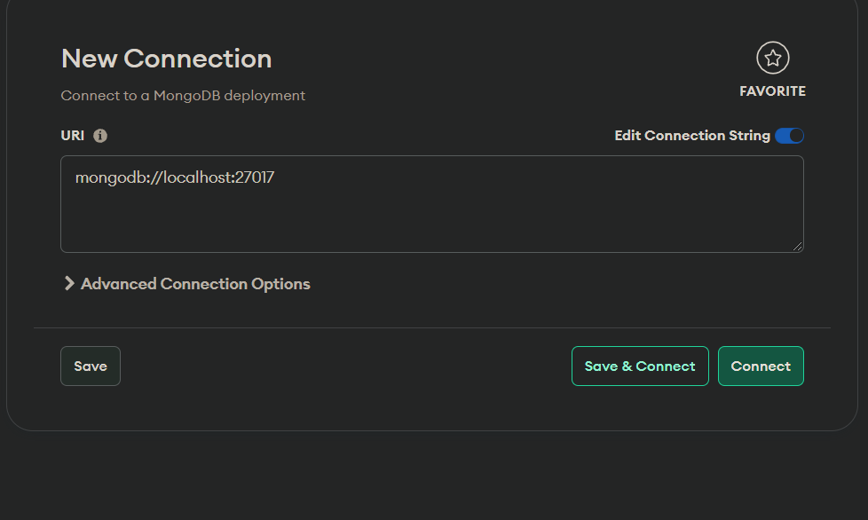



1. Now paste this link in the URI input “ mongodb://127.0.0.1:27017 ” and hit to save & connect.
2. Search for the file “ .env ” in the backend folder opened in VS code .
3. Replace the marked part with the “mongodb://127.0.0.1:27017/quiz-test?readPreference=primary&tls=false&directConnection=true ”

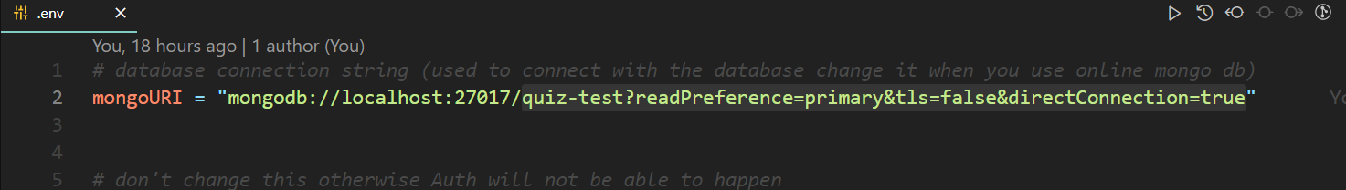



1. Save the file a message will restart the backend server from the terminal by typing “ rs ” and pressing enter if all done properly a message will be printed in the terminal

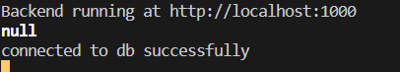

Now check the connection of front end with the backend open the file server.js in vs code of the backend folder on “line no. – 14 ” replace the link with your frontend website like obtained from the frontend terminal .

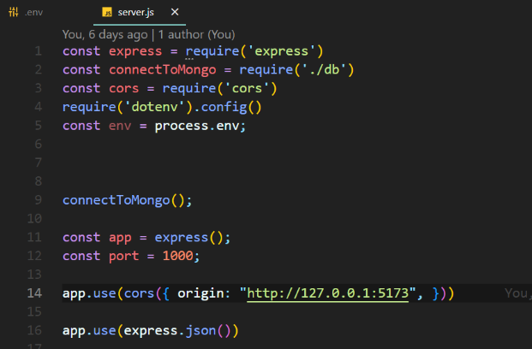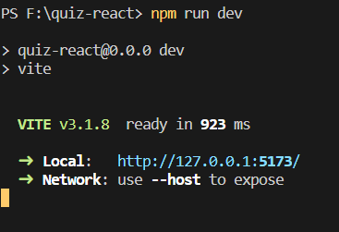



**Creating Admin**

Step 1: Open the imported thunder client collection

Step 2: Open the admin new request and then enter a valid email with password ( more than 8 characters length )

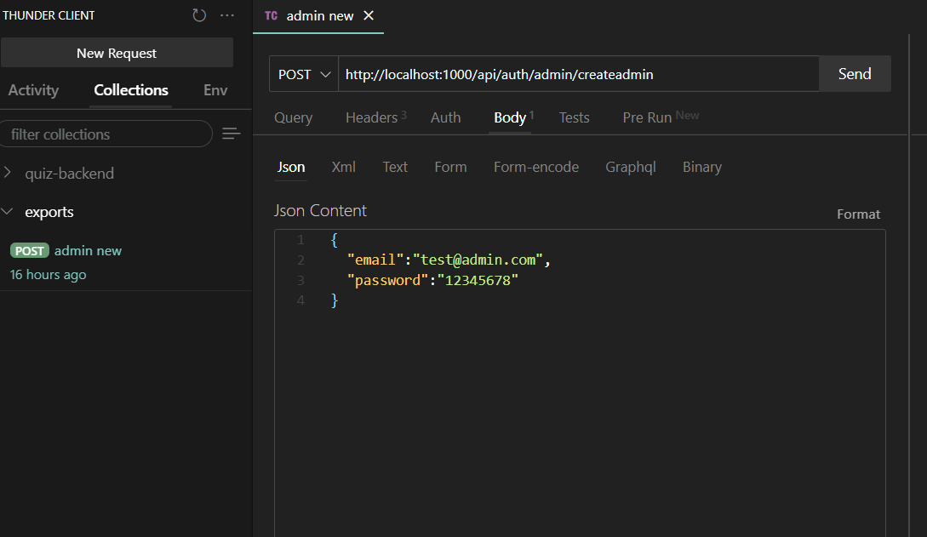



Step 3: Now click on send button to generate admin credentials those credentials will be your admin credentials.

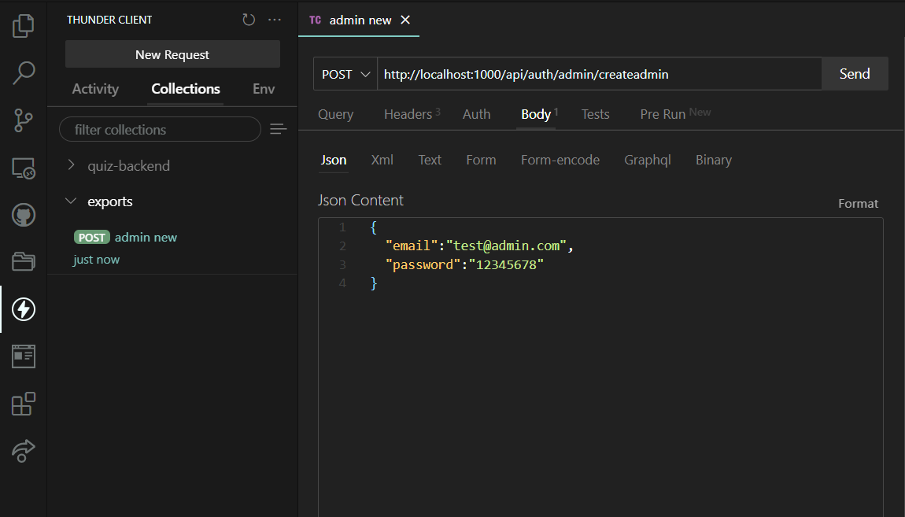



Now visit the copied link in your browser you will get your website all up and running. Routes for all end users : ( Replace host with the link copied from the frontend terminal to visit the website )

Admins: host/admin

Instructors: host/instructor

Users: host