LPG Predictor using Linear Regression — Project Report
Student Name - Arun Kumar
Student Reg No: 25BCE11009
Date: 29 March 2026
Predicting LPG demand using linear regression and Python libraries.

Executive Summary
This project demonstrates how Artificial Intelligence can be applied to forecast LPG demand using regression models. By leveraging Python libraries such as pandas, scikit-learn and matplotlib, the project builds a predictive model and visualizes results. The goal of this project is to predict LPG consumption based on population growth using a simple linear regression model. A small dataset was created with population and LPG usage data over time. The model was trained using scikit-learn and predictions were made for future months. The results show that even a basic regression model can provide useful insights for demand forecasting.

Problem Statement and Why It Matters
The problem addressed in this project is forecasting LPG demand for small communities based on population and time. Accurate forecasting is essential for effective supply chain planning, cost optimization, safety management, and informed policy decisions. By predicting future LPG demand, suppliers and policymakers can ensure timely delivery, avoid shortages, and plan infrastructure accordingly.

Objectives
The objectives of this project are:
- - Apply regression techniques using Python’s AI/ML libraries.
- - Predict LPG demand based on population growth.
- - Visualize actual vs. predicted demand for clarity.
- - Create a reproducible project suitable for GitHub and academic submission.

Dataset and Features
The dataset used in this project is a small, manually created dataset containing the following columns: Year, Month, Population, and LPG_Tonnes. These features were selected to represent time and population growth as predictors of LPG consumption.
Sample data used:
Year | Month | Population | LPG_Tonnes
2022 | 1 | 1000 | 50
2022 | 2 | 1020 | 55
2023 | 1 | 1040 | 60
2023 | 2 | 1060 | 65
2024 | 1 | 1080 | 70
2024 | 2 | 1100 | 75

Methodology
The dataset required no preprocessing due to its simplicity. The selected features were Year, Month, and Population, with the target variable being LPG_Tonnes. A LinearRegression model from scikit-learn was used. The model was trained on the sample data and then used to predict LPG demand for future months. Evaluation was done through visual inspection of the predicted vs. actual values using a scatter plot.

Key Decisions
- - Linear regression was chosen for its simplicity and interpretability.
- - Population was selected as the primary predictor due to its strong correlation with LPG demand.
- - Visualization was included to make the results more interpretable and to validate model performance visually.

Results
The model predicted the following LPG demands for future months:
- - For Year 2025, Month 1, Population 1120 → Predicted demand 80 tonnes.
- - For Year 2025, Month 2, Population 1140 → Predicted demand 85 tonnes.
These predictions suggest a steady increase in LPG demand as the population grows, which aligns with expectations.

Visuals
The following plot shows actual vs. predicted LPG demand based on population: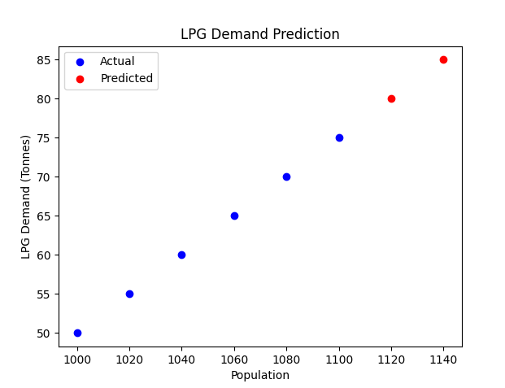

Challenges and Limitations
The main challenges included the small dataset size, which limits the model’s ability to generalize. The simplicity of linear regression may not capture complex patterns in real-world data. Additionally, the model’s accuracy heavily depends on the quality and quantity of input data.

What I Learned
- - How to use pandas and scikit-learn for regression tasks.
- - How to visualize data and predictions using matplotlib.
- - The importance of clean, structured data.
- - How to write reproducible and readable Python code.
- - How to document and present a machine learning project professionally.

Conclusion
This project demonstrates how a simple linear regression model can be used to forecast LPG demand based on population growth. It provides a foundation for future work involving larger datasets, more complex models, and real-world deployment.

References
- pandas Library Documentation
- scikit-learn Documentation
- matplotlib Documentation
- VS Code for Documentation

Appendix code snippets
Full Python Script:
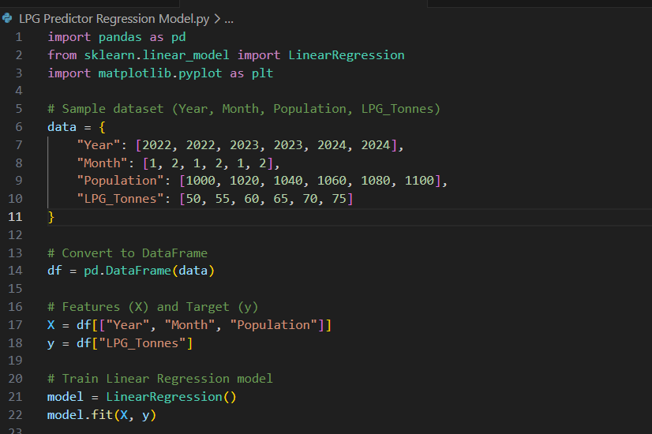
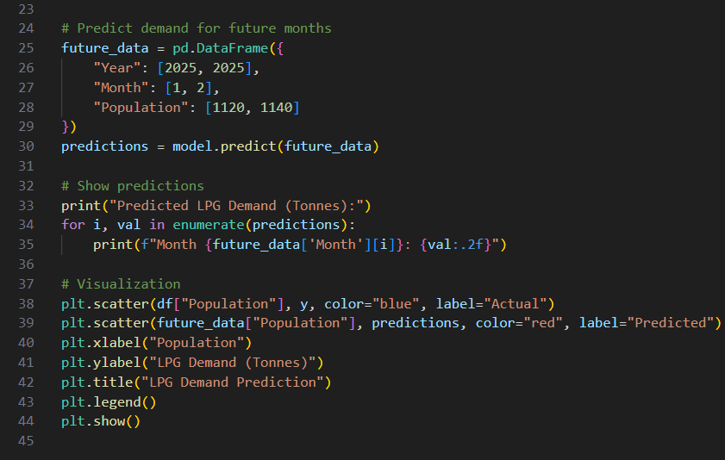
To run this script:
- - Install dependencies: pip install -r requirements.txt
- - Run the script in IDLE, Jupyter Notebook, or VS Code

