Atefe Rajabi 40230563

Functionality

1. DateProcessor
2. Recombination
3. Chromosome
4. NSGAII
5. Fast-NSGAII
6. PlotProcessor

Results

1. DS02
2. DS04
3. DS05
4. DS07
5. DS08
6. DS10

Overall Result

1. Effect of columns number expansion
2. Effect of samples number expansion
3. Effect of fast-non-dominated sorting parallelization
4. Effect of objective evaluation parallelization

Results:

Dataset: DS02:

Num-features: 56

Num-samples: 27

MAXFE: 300000

Evaluations: 100000, Hypervolume: 48.29629629629629

Evaluations: 200000, Hypervolume: 48.29629629629629

Evaluations: 300000, Hypervolume: 50.07407407407407

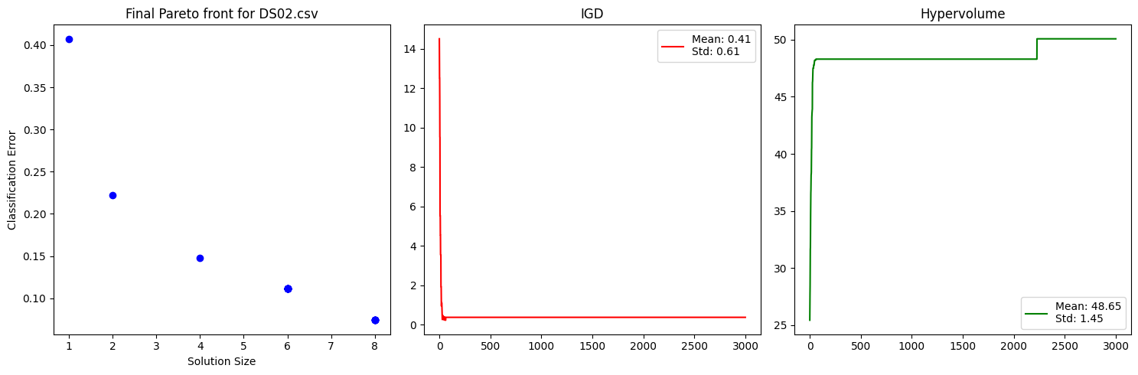

Dataset: DS04

Num-features: 64

Num-samples: 1000

MAXFE: 300000

number of features: 64

Evaluations: 100000, Hypervolume: 59.31214747681813

Evaluations: 200000, Hypervolume: 59.40911570252888

Evaluations: 300000, Hypervolume: 59.40911570252888

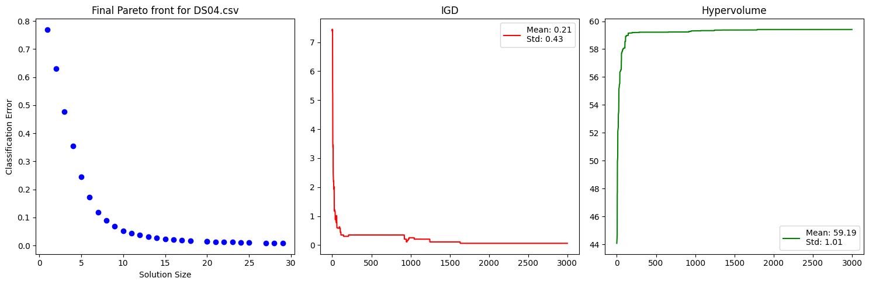

Dataset: DS05

Num-features: 500

Num-samples: 600

MAXFE: 300000

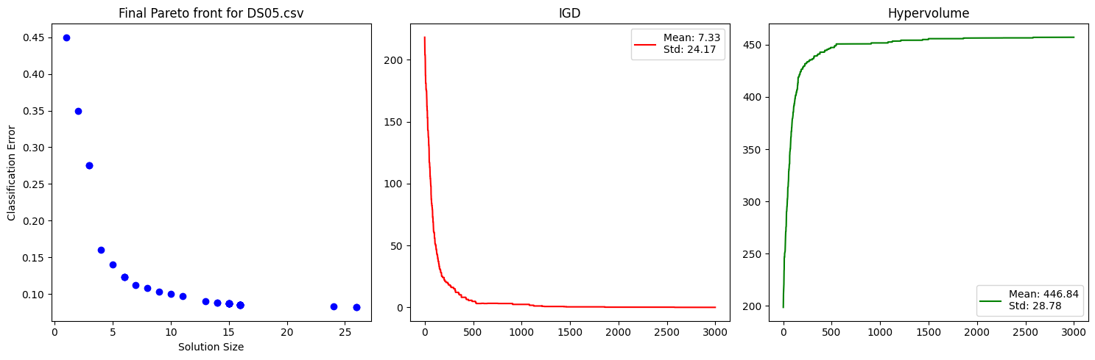

Dataset: DS07

Num-features: 561

Num-samples: 900

MAXFE: 300000

Evaluations: 100000, HV: 542.0255555555556, IGD: 2.4288419141085584

Evaluations: 200000, HV: 548.6122222222222, IGD: 0.18200412428615262

Evaluations: 300000, HV: 549.2444444444444, IGD: 0.17772037702437637

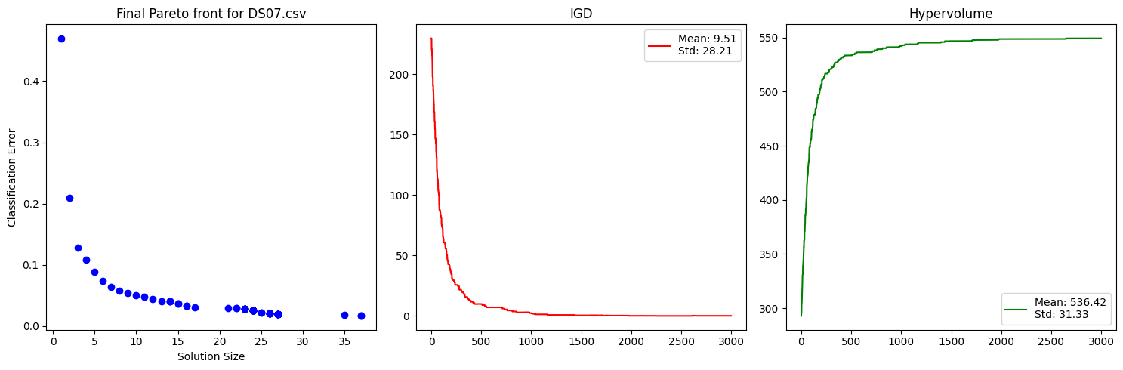

Dataset: DS08

Num-features: 561

Num-samples: 1200

MAXFE: 300000