

Homework 1

Simulated Annealing

Advanced Algorithm

Supervisor:

Dr. Ziarati

Atefe Rajabi

40230563

Spring 2024

**Index**

Abstract

Introduction

Bin Packing problem

Solution Feasibility

Simulated Annealing

Parameters

Objective Function

Neighborhood

Cooling Schedule

Equilibrium Condition

Stopping Condition

Libraries

Results

Discussion

**Abstract:**

The Application of Simulated Annealing in Bin Packing (1D-BPP), a classic NP-hard combinatorial optimization challenge, is explored. The primary focus is on minimizing the number of bins required while accommodating all given items without exceeding the capacity of any single bin. This problem has significant implications in industries like logistics, computing, and manufacturing, where efficient space utilization is crucial. Through a comprehensive examination of the algorithm's parameters, cooling schedules, and various tweaks or adjustments, the study aims to optimize the solution approach effectively. The document thoroughly evaluates the performance of the algorithm using different configurations and scenarios, providing insights into its efficiency and effectiveness in real-world applications.

**Introduction**:

The one-dimensional bin packing problem (1D-BPP) poses significant challenges in both theoretical and practical contexts due to its NP-hard nature, making it difficult to solve as the problem size increases. This document presents an in-depth analysis of the Simulated Annealing algorithm's application to this problem, highlighting its ability to find near-optimal solutions through a heuristic approach. The study delves into the algorithm’s initialization, iteration processes, and strategic modifications that adaptively adjust to the solution's landscape, thereby enhancing the overall solution quality. Key aspects such as the algorithm's cooling schedule, equilibrium condition, stopping criteria, and parameter impacts are explored in detail. Additionally, the document discusses the results obtained from multiple executions of the algorithm, illustrating its practical capabilities and limitations. This introduction sets the stage for a detailed discussion on optimizing the bin packing process using simulated annealing, aiming for an efficient algorithmic strategy that balances computational resources with solution quality.

**Bin Packing problem:**

The 1D bin packing problem (1D-BPP) is a classical combinatorial optimization problem that deals with efficiently packing a finite set of items into bins. Each item has a weight (or size), and each bin has a maximum capacity that cannot be exceeded. The goal is to minimize the number of bins required to pack all the items. This problem is an example of an NP-hard problem, meaning it is computationally challenging to find an exact solution, especially as the size of the problem grows.

Here are the key components of the 1D bin packing problem:

1. Items: Each item has a specific size or weight.

2. Bins: All bins have the same maximum capacity, and no bin can hold items exceeding this capacity.

3. Objective: The primary objective is to minimize the number of bins used to pack all the items.

This problem has practical applications in various industries, such as logistics for optimizing space in cargo containers, in computing for data storage optimization, and in manufacturing for minimizing material waste.

The challenge lies in how to arrange the items in the bins in such a way that the number of bins is minimized, considering the capacity limit of each bin. Various algorithms, especially heuristic and metaheuristic algorithms, are employed to find near-optimal solutions to this problem due to its complexity and the impracticality of solving it exactly for large instances.

**Solution Feasibility:**

If both checks are passed—no bins are overloaded and the total weight of items in the bins matches the total weight of all items—the function returns ‘true’, confirming that the solution is feasible. This means:

- All items are accounted for without duplication.

- No bin exceeds its capacity.

This feasibility check is crucial for ensuring that any proposed solution to the bin packing problem adheres to the fundamental constraints of the problem, thereby confirming that the solution is viable and correct.

**Simulated Annealing:**

Simulated annealing is a computational technique used for finding an approximate solution to optimization problems. The method is inspired by the physical process of annealing, where materials such as metals or glass are heated and then slowly cooled to remove defects and reduce energy states.

In the context of optimization, simulated annealing helps to find a good approximation of the global minimum of a function. Here's how the method generally works:

1. Initialization: Start with an initial solution, often chosen at random.

2. Iteration and Candidate Generation: For each step, generate a new candidate solution by making a small random change to the current solution.

3. Evaluation and Acceptance: Calculate the change in the cost function due to the new solution. If the new solution improves the cost function (e.g., lower cost in a minimization problem), it is accepted as the new current solution. If the new solution is worse, it may still be accepted with a probability that depends on the difference in cost between the current and new solutions and a global parameter called "temperature", which gradually decreases over time.

4. Cooling Schedule: The temperature parameter decreases slowly as the algorithm proceeds. This controls the probability of accepting worse solutions, making it high initially (to escape local minima) and lower towards the end (to refine towards a minimum).

5. Stopping Criteria: The process repeats until a stopping criterion is met, which could be a fixed number of iterations, a time limit, or when the solution quality no longer significantly improves.

The effectiveness of simulated annealing depends on the cooling schedule and the method of generating new candidate solutions. The technique is useful especially for large problems where traditional optimization methods become impractical due to the high computational cost or the presence of many local minima.

**Parameters:**

1. Type Definitions:

- ‘ScheduleType’: This enum defines different types of temperature schedules that the algorithm can follow:

- ‘linear’: Temperature decreases linearly over time.

- ‘logarithmic’: Temperature decreases logarithmically, which is slower than linear.

- ‘composite’: A combination of different scheduling types.

- ‘square_root’: Temperature decreases at a rate proportional to the square root of time.

- ‘StopType’: This enum determines under what conditions the algorithm should stop:

- ‘timeLimit’: Stops after a specific amount of time.

- ‘iteration’: Stops after a certain number of iterations.

- ‘convergence’: Stops when the solution quality converges or does not improve significantly.

- ‘z’: Z is a constant used to define the equilibrium of the filled bin.

- ‘max_iteration’: The a limit for maximum number of iterations the algorithm will perform.

- ‘schedule’: Refers to the ‘ScheduleType’.

- ‘no_improvement_threshold’: The number of iterations to allow without any improvement before considering a stop due to lack of progress for equilibrium condition.

- ‘acceptance_rate’: The desired rate of accepting worse solutions as the temperature decreases, facilitating exploration of the solution space.

- ‘stopType’: Refers to the ‘StopType’.

- ‘convergence_threshold’: A specific value that defines when the solution is considered to have converged.

- ‘no_overall_improvement_threshold’: for stopping condition

- ‘time_limit’: The maximum time (in seconds) the algorithm runs before stopping for the case stopping type is set to time limit.

**Parameters value:**

{

"z": 2,

"max_iteration": 10000,

"schedule": 2,

"no_improvement_threshold": 100,

"acceptance_rate": 0.90,

"stopType": 2,

"convergence_threshold": 5.0,

"time_limit": 10

}

**Objective Function:**

The objective function proposed in the paper[1] focuses on optimizing the placement of items in bins by considering not only the number of bins used but also the amount of unused space within these bins. Specifically, to avoid stagnation and encourage the algorithm towards finding optimal solutions, the objective function incorporates the amount of unused space alongside the count of bins.

Minimization Objective Function: This function aims to minimize the inverse of the sum of the filled capacity ratios of all bins. Mathematically, it is represented as minimizing

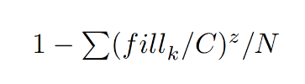

, where fill k is the filled capacity of bin k, C is the fixed bin capacity, z is a constant used to define the equilibrium of the filled bin, and N represents the number of bins in the solution.

These objective function prioritizes solutions that use fewer bins and minimize the unused space within those bins, aiming for efficient bin utilization. The inclusion of z, typically set to 2, helps balance the emphasis on bin count versus the filled capacity, guiding the optimization towards more desirable solutions.

The constant z in the objective functions of the optimization problem is a significant parameter that influences how the solution's quality is assessed in terms of both bin utilization and the number of bins used. Here’s a detailed explanation:

Role of z

The constant z plays a crucial role in balancing these two aspects. Specifically, it adjusts how much emphasis is placed on the filled capacity of the bins relative to their total capacity.

Mathematical Interpretation

The exponent z modifies the impact of the ratio 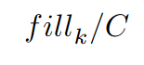on the objective function:

- When z > 1, the function places increasing emphasis on bins that are closer to being full. This means that as bins get filled closer to their capacity, they contribute more significantly to the objective function, encouraging solutions that efficiently utilize bin space.

- When z = 1, the function simplifies to a linear relationship with the fill ratio. In this case, each percentage point increase in bin utilization is valued equally, regardless of how full the bin is.

- When z < 1, the function would, hypothetically, place less emphasis on bins being fully utilized.

**Algorithm:**

Main Loop

The main loop continues until a stopping condition is met (‘stopped’ flag becomes true). Here are the steps performed in each iteration of the loop:

1. Temperature Calculation: The ‘calculate_temperatures’ function dynamically calculates the temperature based on the current iteration. This temperature influences the acceptance probability of a new solution.

2. Equilibrium Condition Loop: Inside the main loop, there's a nested loop that runs as long as the equilibrium condition is true. This inner loop is responsible for exploring the solution space until a thermal equilibrium is achieved at the current temperature.

- Objective Function Evaluation: Computes the objective value for the current packing configuration.

- Tweak Selection and Application: A tweak function is selected and applied to create a new bin packing arrangement. (based on a mechanism that will be explained.)

- Objective Comparison: The objective values of the current and new configurations are compared.

- Acceptance Decision: If the new configuration is better, it's always accepted. If it's worse, it may still be accepted based on a probabilistic condition influenced by the current temperature and the magnitude of the objective function degradation.

3. Update and Reheat: After the inner loop, tweaks are reassessed based on their performance (reward/penalty history), and probabilities are updated to favor more successful tweaks. This mechanism allows the algorithm to adaptively focus on more promising regions of the solution space and simultaneously explore new solutions.

4. Stopping Condition: Checks if the algorithm should stop. This is based on factors like runtime duration, number of iterations, and solution convergence.

Key Components

- Adaptive Probability Adjustment: The algorithm adaptively changes the probabilities of selecting each tweak based on their performance, encouraging exploration of more fruitful adjustments.

- Probabilistic Acceptance of Worse Solutions: By occasionally accepting worse solutions, the algorithm avoids local optima and explores the solution space more thoroughly.

- Convergence Tracking: Monitors improvements in the solution and adjusts the conditions for continued processing based on whether improvements are still being observed.

**Neighborhood:**

Tweak Functions

1. Single Item Move: This Tweak attempts to move an item from one bin to another that has sufficient capacity. The item and bin are selected randomly.

2. Swap: This Tweak attempts to swap two items between two different bins. The swap only occurs if both bins have sufficient capacity to accommodate the swapped items. This could help in optimizing space usage across bins.

3. Merge Bins: This function tries to merge the contents of one bin into another if there's enough capacity. This could reduce the total number of bins used, thereby optimizing the solution.

4. Split Bin: In this function, one bin's contents are distributed between two new bins. This can be useful if distributing its items could lead to more efficient packing when combined with other tweaks.

Adaptive Selection Mechanism[2]

The adaptive selection mechanism uses rewards and penalties to guide the selection of tweaks during the optimization process. The method is designed to prefer tweaks that have historically led to improvements and to avoid those that frequently result in worse solutions. Here’s how it works:

1. Initialization and Updating of Probabilities:

- Each tweak type is assigned a probability of being selected, which is initially set equally across all tweaks.

- After each application of a tweak, rewards and penalties are updated based on the tweak's effectiveness. Rewards are given for improvements in the solution, and penalties are given for non-improvements or worsening of the solution.

2. Reassign Probabilities:

- The probabilities of selecting each tweak are recalculated based on the recent history of rewards and penalties.

- This is done by computing a value for each tweak using the formula: 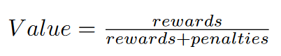 - These values are then normalized to ensure they sum to one, forming a new set of probabilities that guide the future selection of tweaks.

- If a probability is zero (indicating consistent failure of a tweak), it is adjusted to a small positive value to ensure that no tweak is ever completely excluded, allowing for exploration.

3. Selection of Tweak:

- When a tweak is to be selected, a random value is generated and used to select a tweak probabilistically based on the cumulative distribution of the tweak probabilities.

- This selection is inherently adaptive as it favors tweaks that have been more successful but still allows for exploration of less successful tweaks.

**Cooling Schedule:**

1. Initial Temperature Calculation

The initial temperature is a critical starting point in simulated annealing, as it sets the stage for how freely the algorithm can explore the solution space. The initial temperature is calculated with the following method:

- Maximum Energy (‘c_max’): This value represents the worst-case scenario of the objective function. For the bin packing problem, ‘c_max’ could be represented by placing each item in its own bin, which usually results in the highest cost or least optimal solution. (resulting in maximum energy when from the best solution (a solution with objective function equals to zero) we move to the worst one)

- Acceptance Rate: The acceptance rate (‘acceptance_rate’) is a predefined threshold that influences the initial probability of accepting worse solutions. Typically, a higher acceptance rate at the beginning allows the algorithm to escape local minima more easily.

- Formula: The formula used is ‘-c_max / log(acceptance_rate)’. This formula ensures that the initial temperature is proportionally high relative to the maximum possible degradation in solution quality (‘c_max’). The logarithmic function modifies the influence of the acceptance rate, ensuring that the temperature starts sufficiently high to allow significant exploration.

2. Cooling Functions

Cooling functions determine how the temperature decreases in each iteration of the algorithm. Different cooling strategies impact the balance between exploration and exploitation as the algorithm progresses:

- Linear Decrease: The temperature decreases linearly with respect to the number of iterations ‘k’. It's calculated as ‘initial_temp / (k + 1)’, meaning the temperature is inversely proportional to the iteration number. This straightforward approach ensures a steady decrease in temperature, reducing the likelihood of accepting worse solutions as the algorithm converges.

- Logarithmic Decrease: The temperature decreases logarithmically, calculated as ‘initial_temp / log(k + 1)’. This slower decrease allows the algorithm to maintain a higher temperature for a longer period compared to linear cooling, which can be beneficial for exploring complex solution spaces more thoroughly.

- Square Root Decrease: Here, the temperature is reduced based on the square root of the iteration number, ‘initial_temp / sqrt(k + 1)’. This method offers a balance between linear and logarithmic cooling, providing a moderate cooling rate that lessens the temperature gradually but not as slowly as logarithmic cooling.

‘adaptive_cooling(int k)’

- Adaptive Approach: This method adapts the cooling based on the algorithm's progress in finding better solutions. It involves dynamically resetting the temperature when no significant improvements are observed for a set number of iterations (‘no_overall_improvement_threshold’). The temperature resets based on the number of resets already performed (‘reheating_count’), and between resets, it decreases at a rate determined by a ‘cooling_factor’. This adaptive method helps to prevent premature convergence by reheating (increasing temperature) to encourage further exploration when necessary.

**Equilibrium Condition:**

This function uses specific conditions to assess whether the system has reached a state of equilibrium at the current temperature, implying that no further significant progress is being made and suggesting that it might be time to adjust the temperature.

1. No Improvement Count Check:

- This condition checks if the count of consecutive iterations without any improvement has reached or exceeded a pre-set threshold.

- When the count hits this threshold, it indicates that the algorithm is no longer making progress in improving the solution at the current temperature. This is a signal that the system might be in a temporary equilibrium or stuck in a local minimum.

2. Max Iteration Check:

- This checks whether the number of iterations has reached the predefined maximum iterations limit (‘max_iteration’).

- If this condition is true, it means the algorithm has exhausted the allowed iterations without finding a significantly better solution. This is typically used to prevent the algorithm from running indefinitely and to ensure computational resources are used efficiently.

- When the maximum iteration count is reached, the function returns ‘false’, indicating that no further processing should be done, essentially signaling that the algorithm should terminate.

**Stopping Condition:**

These stopping conditions provide mechanisms to control the termination of the Simulated Annealing process based on practical constraints like time and computational resources, or based on the algorithm's performance, such as convergence or exhaustion of allowed iterations. Each condition plays a crucial role in ensuring that the algorithm does not run indefinitely and that it stops when further computation is unlikely to yield significantly better results.

**Libraries:**

In the implementation of the Simulated Annealing algorithm for the bin packing problem, several external libraries have been utilized to enhance functionality and streamline various operations. Matplotlibcpp is employed for plotting and visualization, enabling a graphical representation of the algorithm's performance over different iterations and configurations. This visualization aids in understanding the optimization trends and the effectiveness of different parameter settings. The Json library is used to handle configuration files, allowing for flexible and easily adjustable parameters that can be modified without altering the core codebase. This capability is crucial for experimenting with different algorithm settings to determine optimal configurations. Lastly, Libxl is integrated for its capabilities in reading from and writing to Excel files, facilitating easy data manipulation and storage. This is particularly useful for documenting the results in a structured format that is suitable for analysis and presentation, thereby supporting extensive evaluation and reporting of the algorithm's outcomes. These libraries collectively contribute to a robust development environment that supports efficient data handling, result visualization, and configuration management, crucial for comprehensive optimization studies.

**Results:**

All the plots, visualization, outputs are available in the project folder.

These results are derived from 20 algorithm execution.

|  |  |  |  |
| --- | --- | --- | --- |
| file_name | Optimum solution | Best solution | Worst solution |
| Falkenauer_t120_04 | 40 | 41 | 41 |
| Waescher_TEST0097 | 12 | 12 | 12 |
| Waescher_TEST0030 | 27 | 28 | 28 |
| Hard28_BPP178 | 80 | 81 | 82 |
| Schwerin2_BPP78 | 22 | 22 | 22 |
| Falkenauer_t60_05 | 20 | 21 | 21 |
| BPP_50_100_0.2_0.8_4 | 30 | 30 | 30 |
| Falkenauer_t501_15 | 168 | 168 | 169 |
| Falkenauer_u250_04 | 101 | 101 | 102 |
| Schwerin2_BPP44 | 22 | 22 | 22 |
| Hard28_BPP781 | 71 | 72 | 73 |
| Falkenauer_u120_18 | 49 | 49 | 49 |
| Falkenauer_t120_16 | 40 | 41 | 41 |
| BPP_50_75_0.2_0.8_4 | 27 | 27 | 27 |
| Hard28_BPP40 | 59 | 60 | 61 |
| Hard28_BPP900 | 75 | 76 | 78 |
| Schwerin2_BPP2 | 22 | 22 | 22 |
| Waescher_TEST0075 | 13 | 13 | 14 |
| Falkenauer_t60_09 | 20 | 21 | 21 |
| Falkenauer_t501_05 | 168 | 168 | 169 |
| BPP_50_120_0.2_0.8_6 | 28 | 28 | 29 |
| *Falkenauer_u1000_15\** | ***402*** | ***404*** | ***405*** |
| Schwerin2_BPP25 | 22 | 22 | 22 |
| Falkenauer_t249_06 | 83 | 84 | 84 |
| Falkenauer_u500_15 | 201 | 201 | 202 |
| BPP_50_120_0.1_0.8_6 | 22 | 22 | 22 |
| Schwerin2_BPP75 | 22 | 22 | 22 |
| BPP_50_125_0.1_0.7_3 | 20 | 20 | 20 |
| Falkenauer_u120_01 | 49 | 49 | 49 |
| BPP_50_120_0.2_0.7_2 | 22 | 22 | 22 |

***Falkenauer_u1000_15***

Although increasing the number of iterations could reduce the number of bins required for this instance, this approach has not been applied in order to keep the overall running time low.

**Variance:**

Orange line: Optimum solution

Blue line: Solution with Simulated Annealing

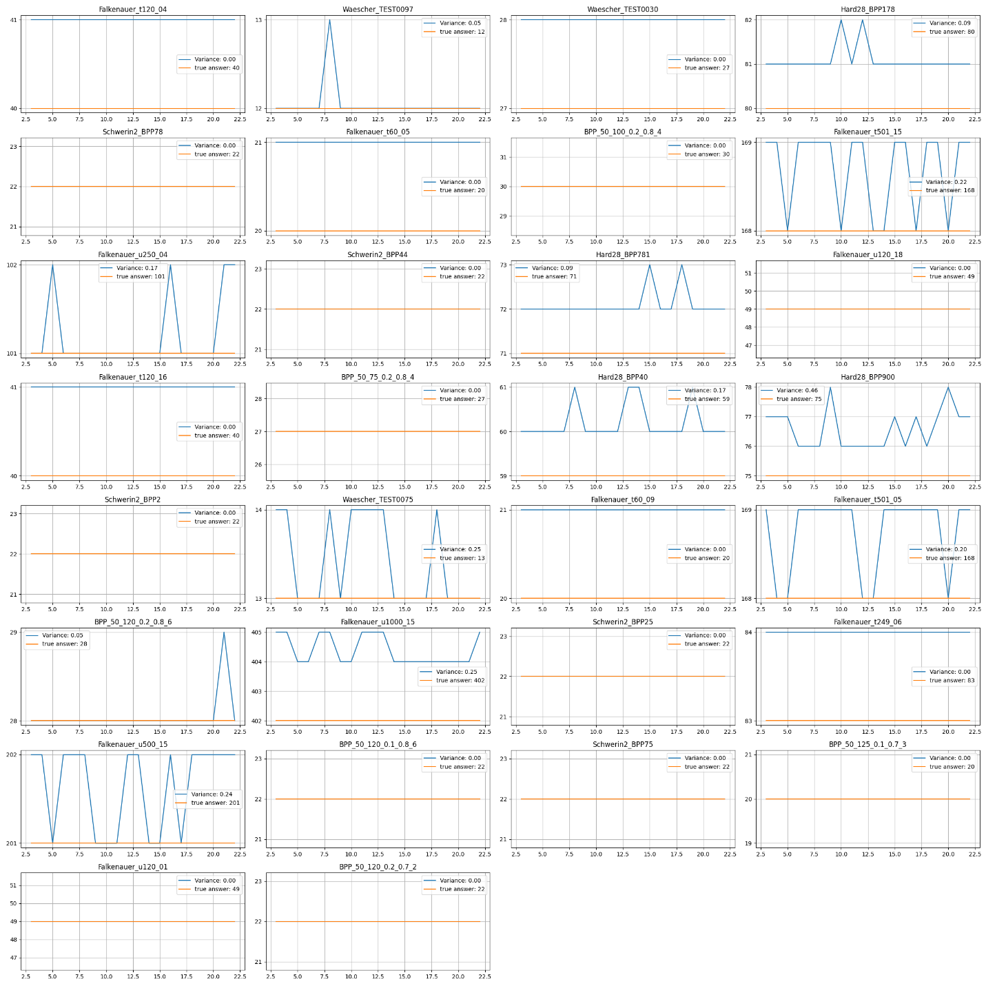

**Plots:**

\BPP_50_75_0.2_0.8_4

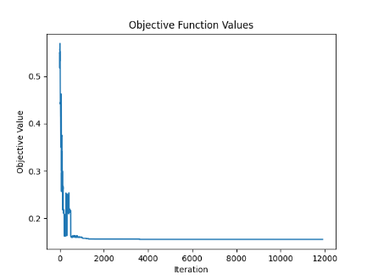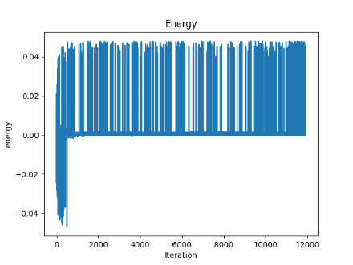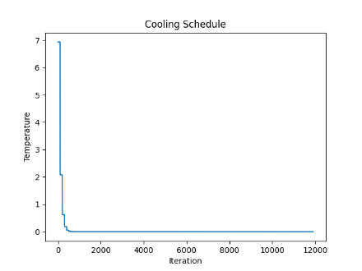

\BPP_50_100_0.2_0.8_4

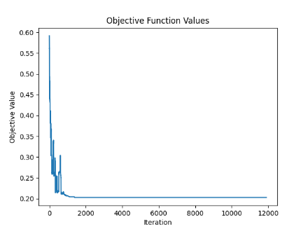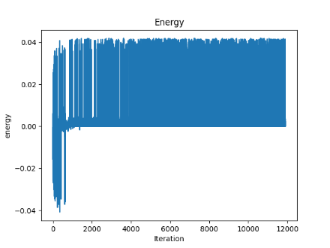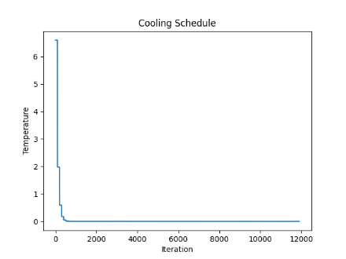

\BPP_50_120_0.1_0.8_6

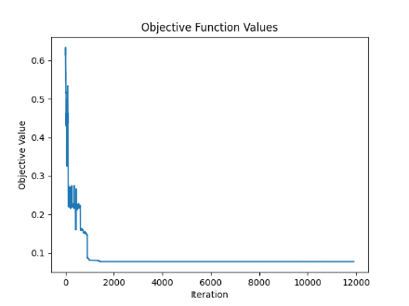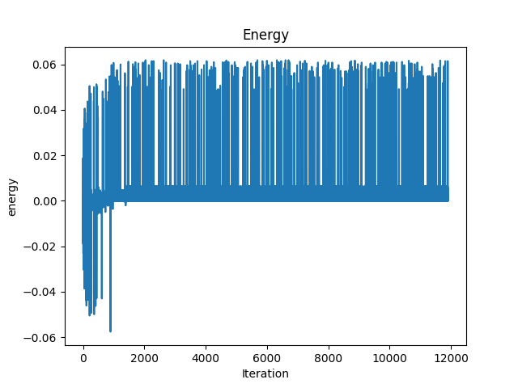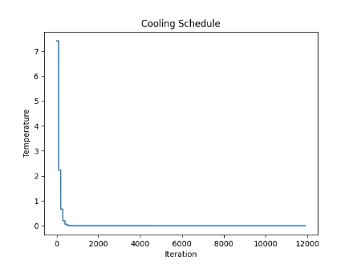

\BPP_50_120_0.2_0.7_2

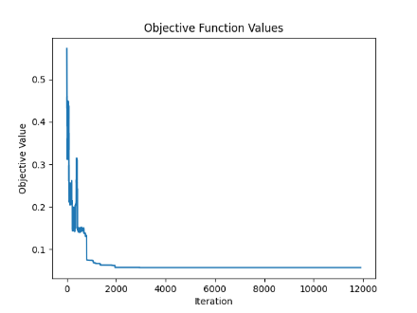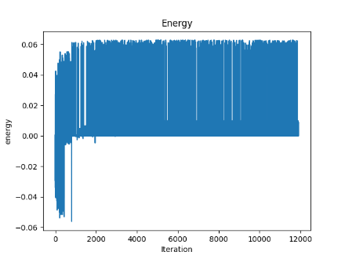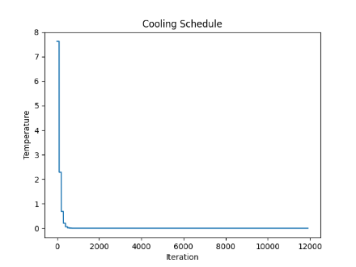

\BPP_50_120_0.2_0.8_6

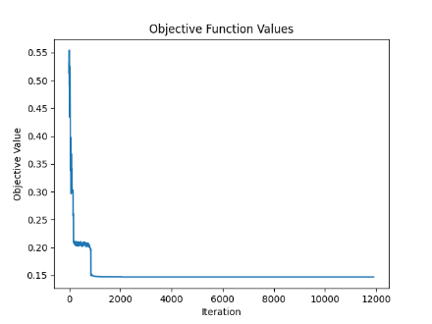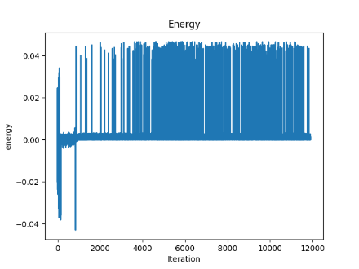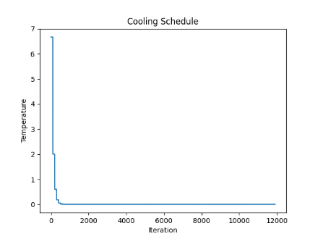

\BPP_50_125_0.1_0.7_3

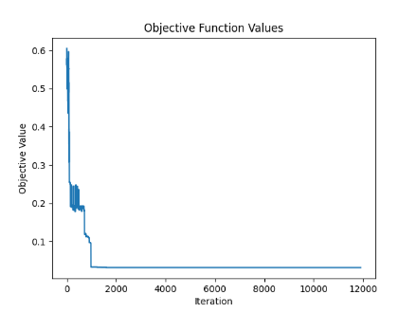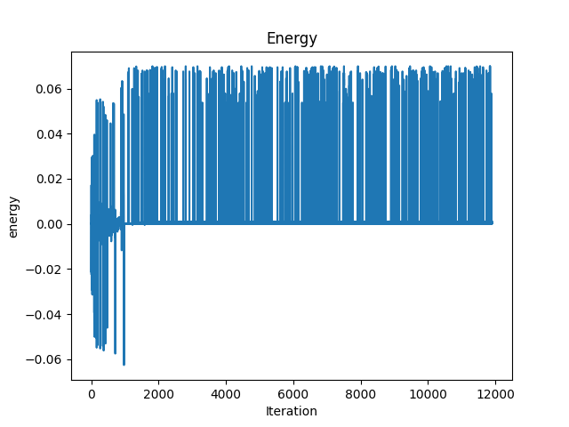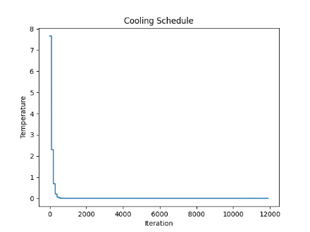

\Falkenauer_t60_05

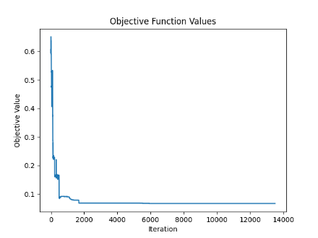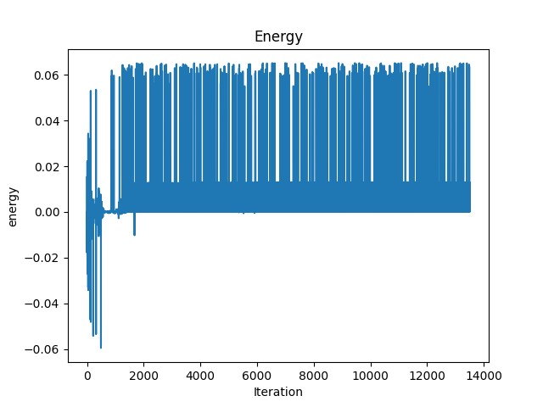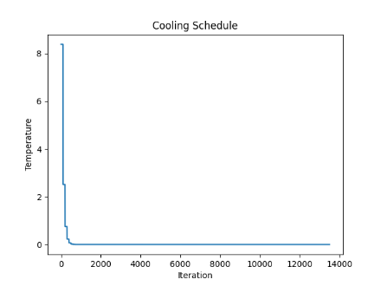

\Falkenauer_t60_09

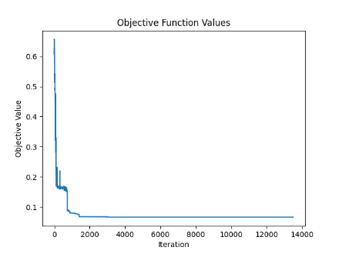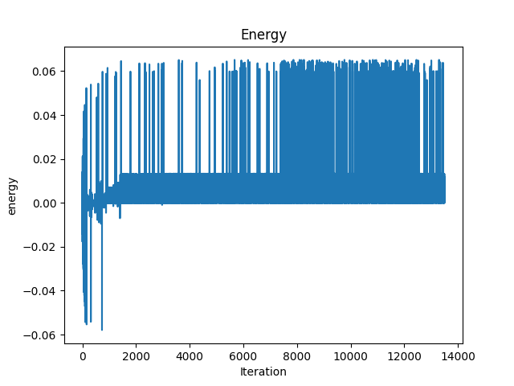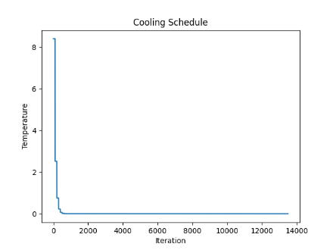

\Falkenauer_t120_04

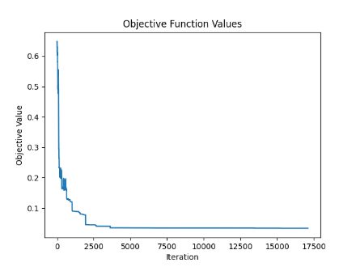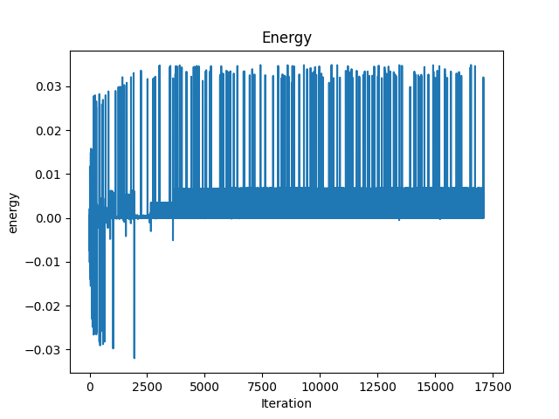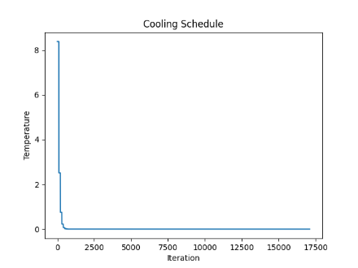

\Falkenauer_t120_16

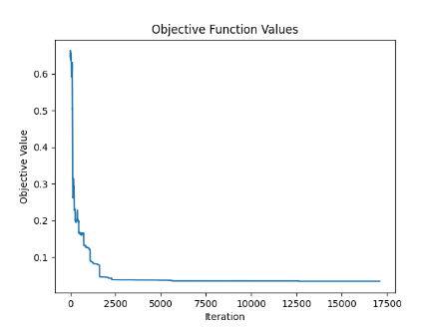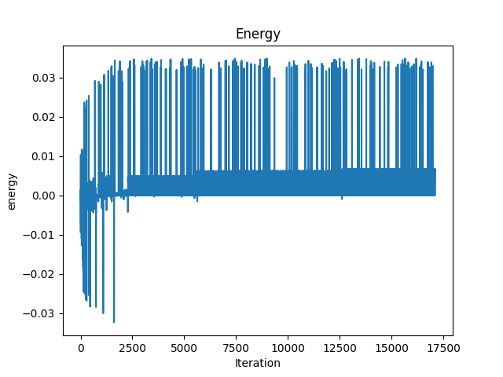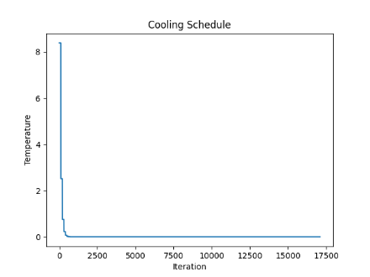

\Falkenauer_t249_06

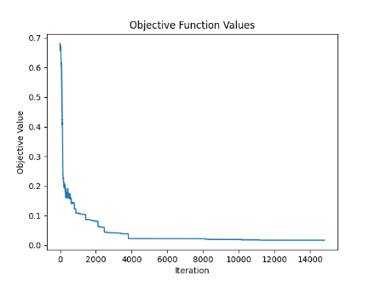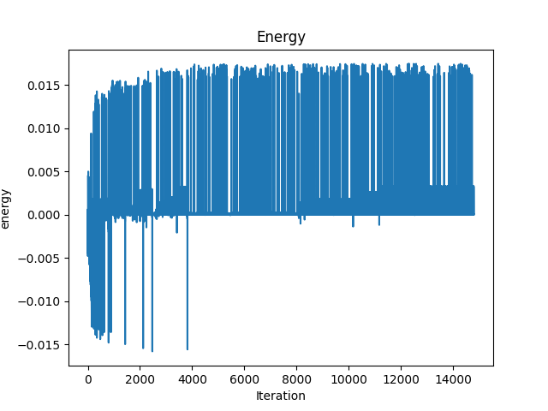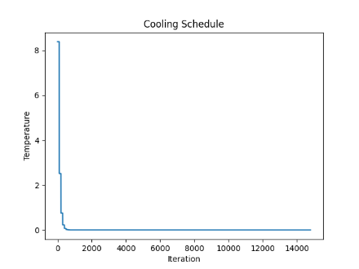

\Falkenauer_t501_05

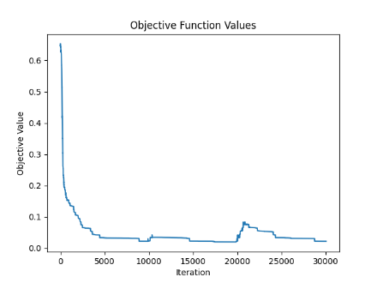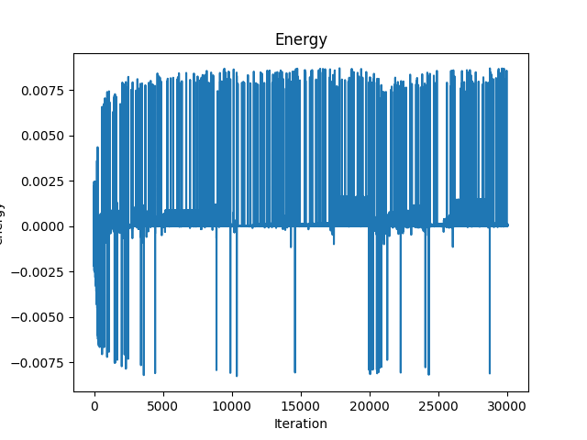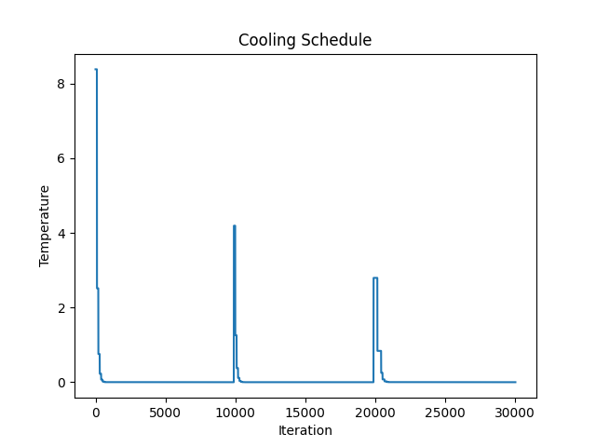

\Falkenauer_t501_15

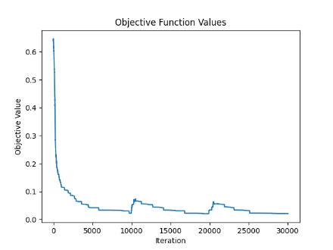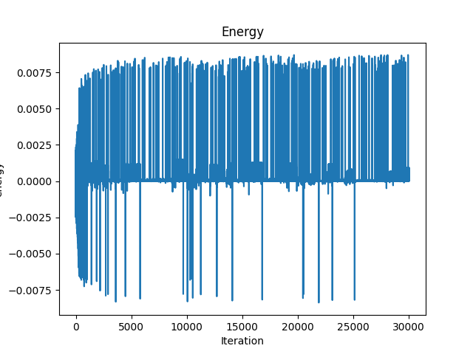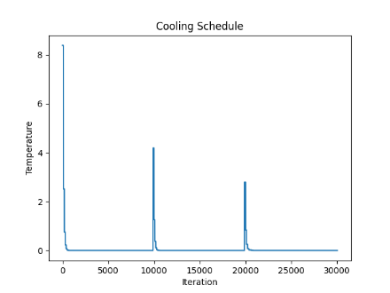

\Falkenauer_u120_01

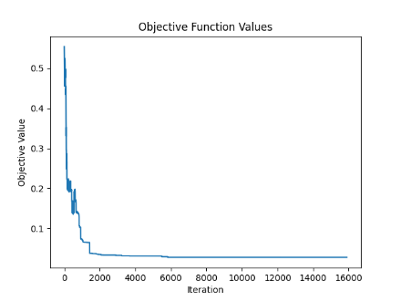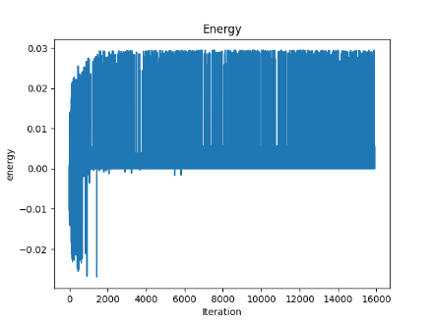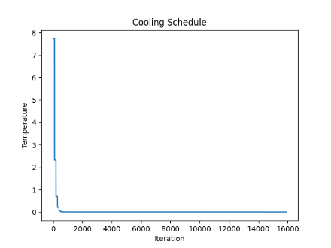

\Falkenauer_u120_18

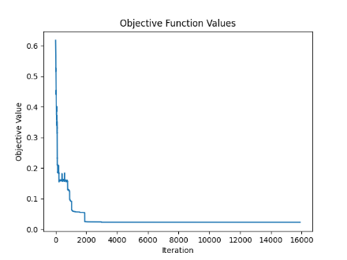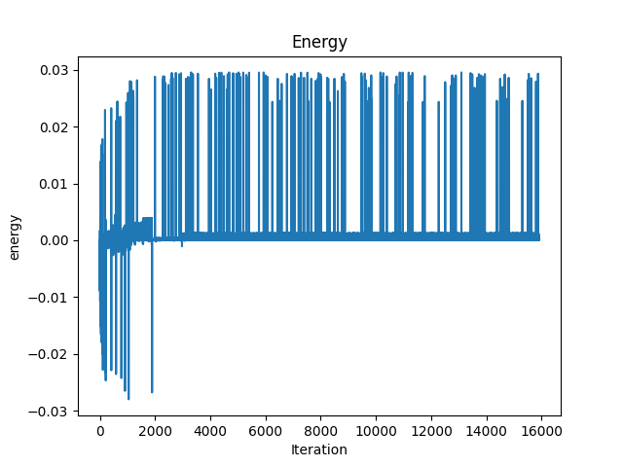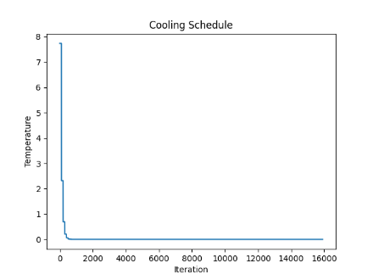

\Falkenauer_u250_04

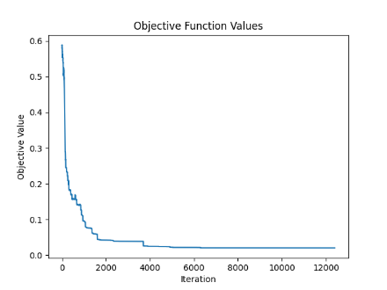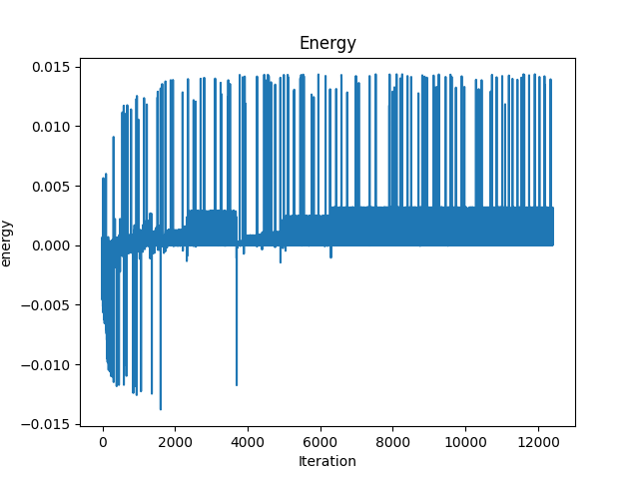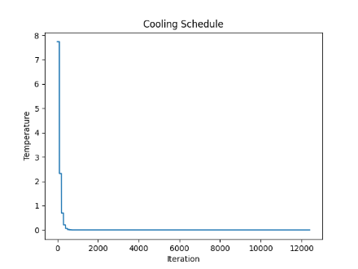

\Falkenauer_u500_15

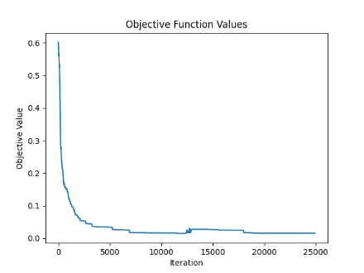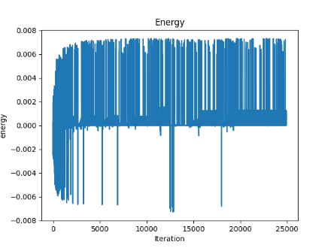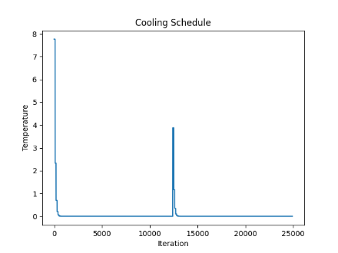

\Falkenauer_u1000_15

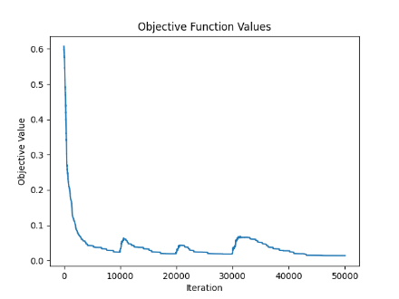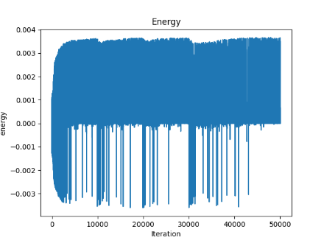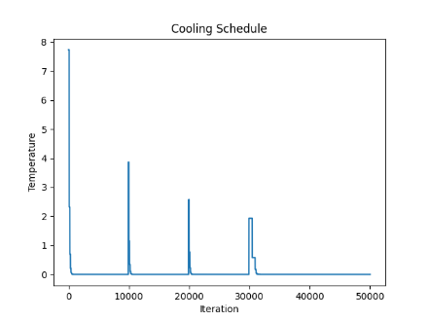

\Hard28_BPP40

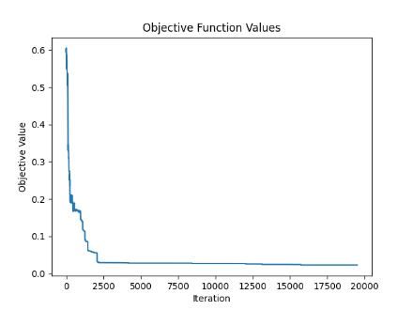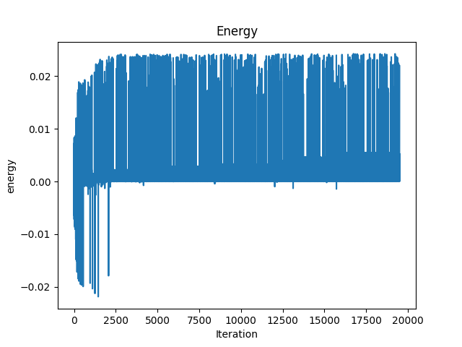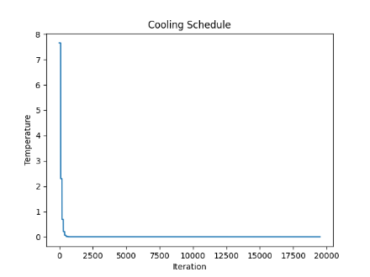

\Hard28_BPP178

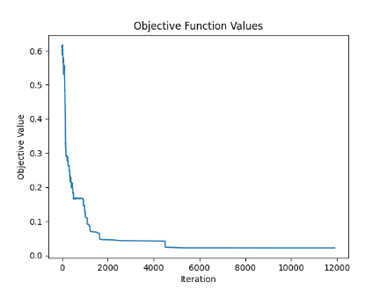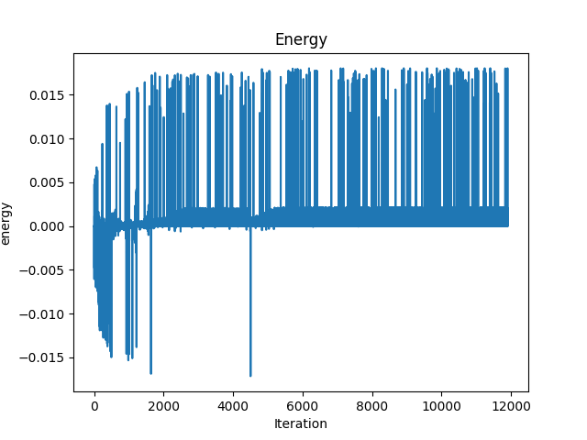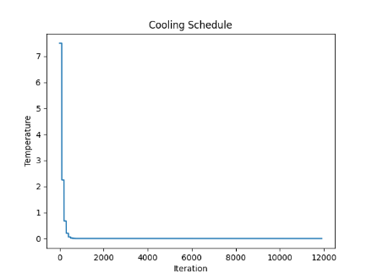

\Hard28_BPP781

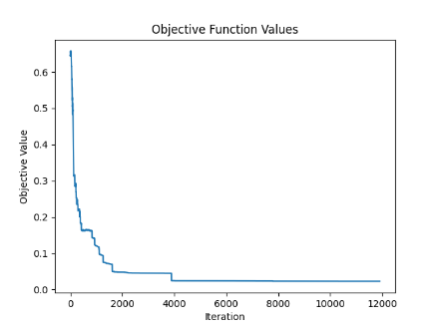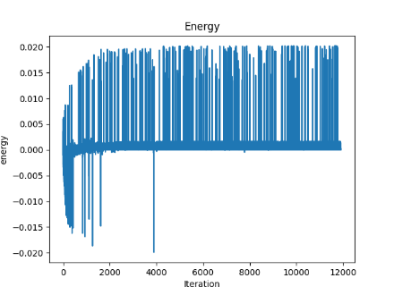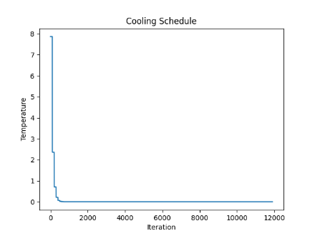

\Hard28_BPP900

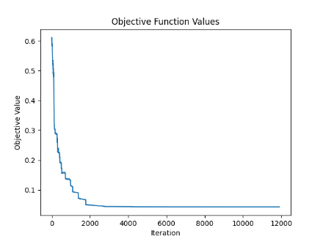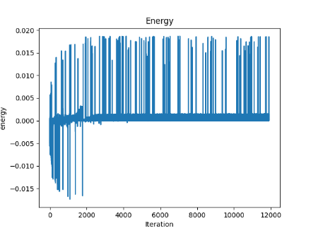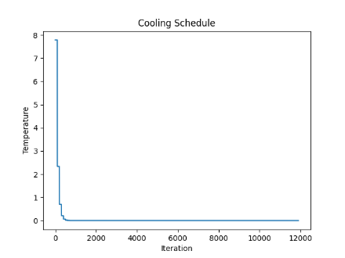

\Schwerin2_BPP2

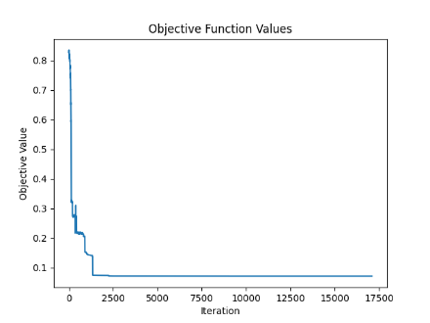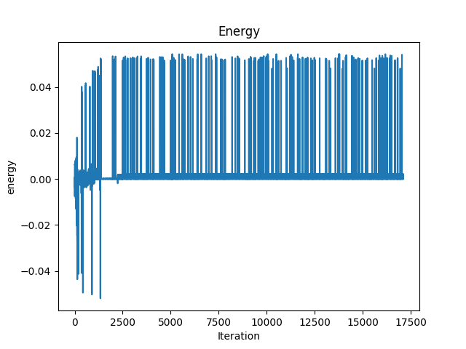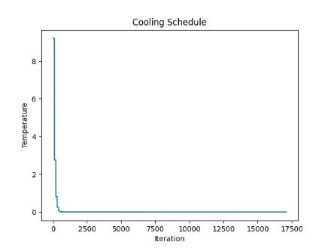

\Schwerin2_BPP25

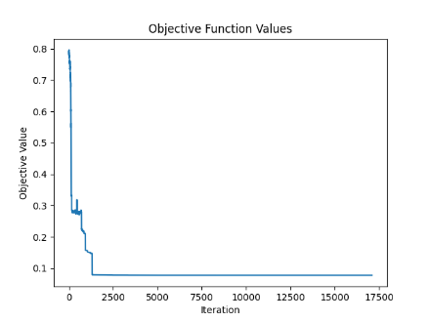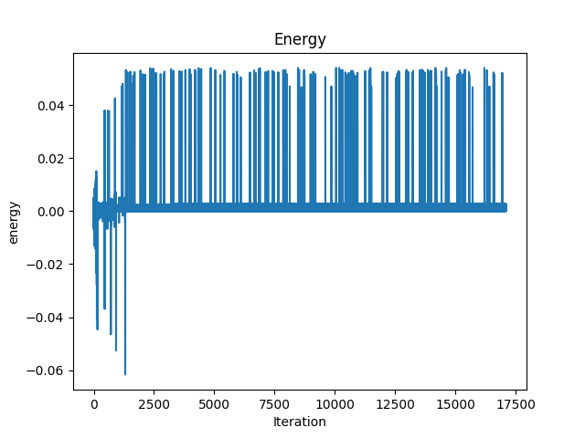

\Schwerin2_BPP44

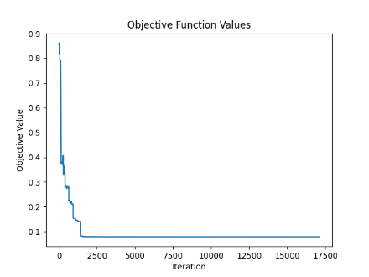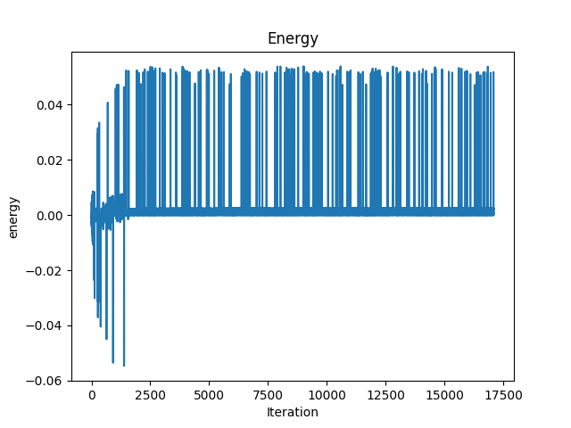

\Schwerin2_BPP75

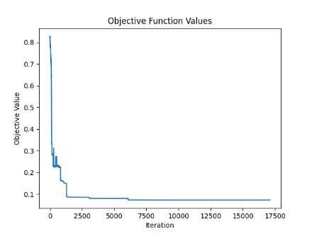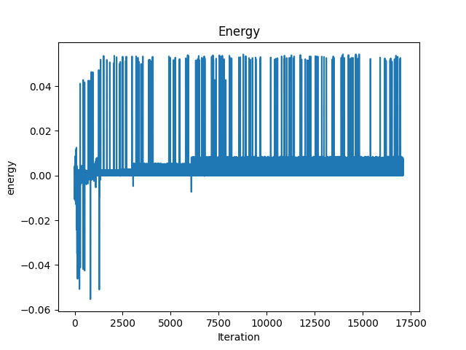

\Schwerin2_BPP78

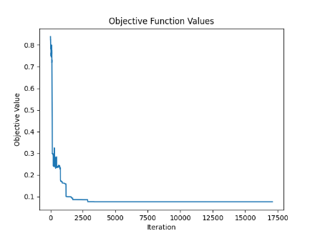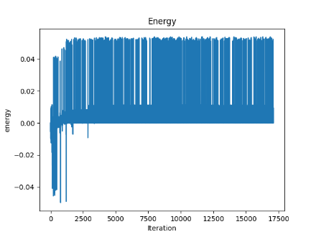

\Waescher_TEST0030

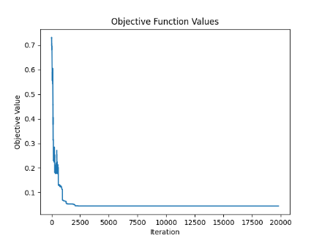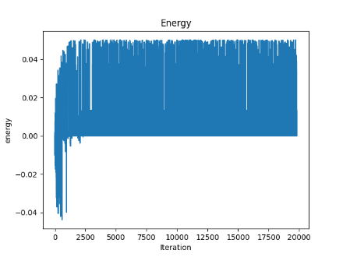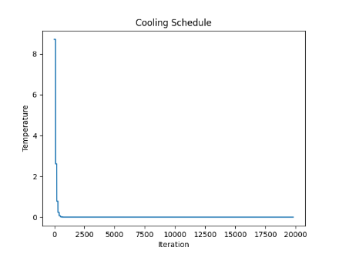

\Waescher_TEST0075

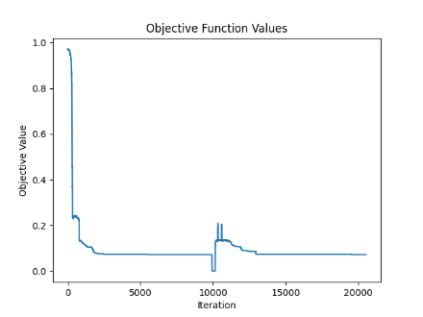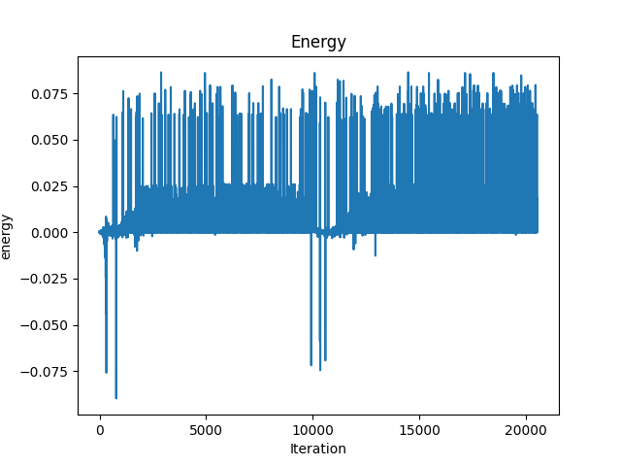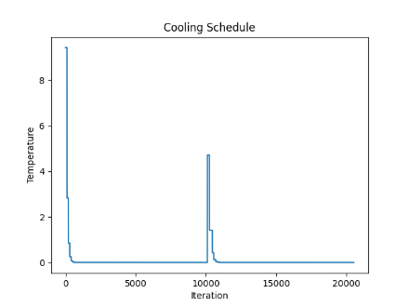

\Waescher_TEST0097

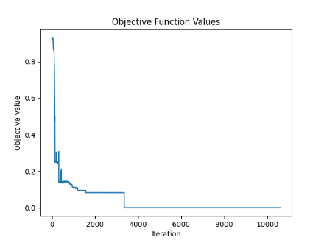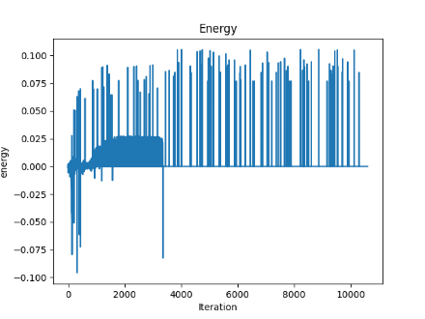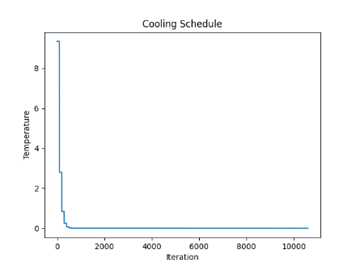

**Discussion:**

In the context of simulated annealing for solving optimization problems such as bin packing, several parameters play crucial roles in shaping the algorithm's behavior and effectiveness. These include various thresholds, the maximum number of iterations, and the acceptance rate. Each of these parameters affects how the algorithm explores and exploits the solution space, and they determine when and how the algorithm decides to halt. Let’s explore these parameters in detail:

1. No Improvement Thresholds

- No Improvement Threshold (‘no_improvement_threshold’): This threshold helps in avoiding unnecessary computations when the current path is not yielding better results, prompting a shift in strategy.

2. Max Iteration

- Maximum Iteration (‘max_iteration’): This parameter sets an lower limit on the maximum number of iterations the algorithm will perform, serving as a hard stop for the algorithm. This is crucial for ensuring that the algorithm does not run indefinitely, especially in cases where a satisfactory solution may not be easily attainable. It provides a control for computational expense, allowing users to balance between the desire for optimal solutions and the practical limitations of runtime and resource availability.

3. Acceptance Rate

- Acceptance Rate (‘acceptance_rate’): This parameter influences the initial probability of accepting a worse solution at the start of the simulated annealing process. A higher acceptance rate means the algorithm is more likely to accept suboptimal solutions initially, enhancing exploration by allowing the algorithm to traverse and escape local minima in the solution landscape. As the temperature decreases, the likelihood of accepting worse solutions naturally diminishes, focusing the algorithm more on exploitation of the best-found solutions.

Interplay and Impact:

- Exploration vs. Exploitation: The initial acceptance rate and the cooling schedule (influenced by thresholds and iteration counts) balance exploration and exploitation. Early on, high acceptance rates and higher temperatures encourage exploration; as the algorithm progresses, these parameters guide the shift toward exploitation.

- Algorithm Efficiency and Effectiveness: The no improvement thresholds ensure that the algorithm does not waste computational resources on unproductive paths, while the maximum iteration limit ensures a bound on the computational effort. Together, these parameters help maintain the efficiency of the algorithm.

4. Z

The choice of z directly impacts the algorithm's performance in finding an optimal or near-optimal solution to the bin-packing problem. By adjusting z, one can fine-tune the optimization process to prioritize either the number of bins used or the efficiency of space utilization within those bins. In the paper, z is often set to 2, which means the algorithm strongly favors solutions where bins are more fully utilized, effectively balancing the goal of using fewer bins with the goal of minimizing wasted space within those bins.

Cooling Schedule

Calculating the initial temperature and employing an adaptive cooling schedule are strategies within the simulated annealing process that can significantly influence the effectiveness and efficiency of finding an optimal or near-optimal solution.

Advantage of Calculating Initial Temperature

The method that have been used for calculating the initial temperature, ‘-c_max / log(acceptance_rate)’, offers several advantages:

1. High Initial Exploration Capability:

- By setting the initial temperature relative to the maximum possible degradation in solution quality (‘c_max’), the algorithm starts with a high enough temperature to allow significant exploration of the solution space. This high starting temperature enables the algorithm to accept worse solutions at the beginning, thereby avoiding premature convergence on local minima and exploring a broader range of possible solutions.

2. Control Over Exploration Intensity:

- The use of the logarithmic function in relation to the acceptance rate helps control how aggressively the algorithm explores initially. A higher acceptance rate leads to a higher initial temperature, thus promoting more exploration. This control allows the algorithm to be tuned according to the specific characteristics and challenges of the problem.

3. Balancing Exploration with Computational Efficiency:

- By calculating the initial temperature based on the problem's specific parameters (like ‘c_max’ which relies on worst case solution), the algorithm can be finely adjusted to balance thorough exploration with computational efficiency. This ensures that the algorithm does not waste time exploring unpromising areas too extensively and moves towards exploitation in a timely manner.

4. Avoiding wasting time with unnecessary high temperature

Advantage of Adaptive Cooling Schedule

Using an adaptive cooling schedule, as described in adaptive cooling method, brings its own set of advantages:

1. Responsiveness to Algorithm Performance:

- The adaptive cooling adjusts the temperature based on the performance of the algorithm, specifically through measures like ‘no_improvement_count’ and ‘no_overall_improvement_threshold’. This responsiveness ensures that the cooling rate is suitable for the algorithm's current state, either prolonging exploration by reheating when progress stalls or continuing to cool when improvements are being consistently found.

2. Avoidance of Stagnation:

- By potentially reheating (increasing the temperature) when there have been no significant improvements for a set period, the adaptive schedule helps the algorithm escape potential stagnation in local minima. This ability to escape and explore new areas can lead to finding better overall solutions that might not have been discovered with a static cooling schedule.

3. Optimal Utilization of Iterations:

- The adaptive approach can extend or shorten the exploration phases as needed, making better use of the available iterations. This tailored utilization of computational resources can lead to more effective convergence on optimal solutions without unnecessary computations.

4. Dynamic Balance Between Exploration and Exploitation:

- As the algorithm progresses, the adaptive cooling dynamically shifts the balance between exploration (trying out less optimal solutions) and exploitation (refining the best solutions found). This dynamic adjustment is crucial for maintaining efficiency, especially in complex solution spaces where the landscape of solutions can change as the search progresses.

Adaptive Tweak mechanism

The adaptive tweak mechanism in the context of simulated annealing for the bin packing problem plays a crucial role in enhancing the algorithm's performance by dynamically adjusting the selection probabilities of different "tweaks" or modifications based on their effectiveness. This adaptive approach helps in efficiently solving the problem by focusing computational efforts on more promising solution modifications while still allowing for exploration to avoid local minima. Here’s how this mechanism aids in solving the problem:

1. Enhanced Exploration and Exploitation Balance

- Adaptive Learning from Performance: As the simulated annealing progresses, each tweak’s effectiveness in improving the solution is tracked via rewards (for positive impacts) and penalties (for negative impacts). This feedback loop allows the algorithm to learn which tweaks tend to yield better results in the current solution landscape.

- Dynamic Adjustment of Probabilities: Based on the accumulated rewards and penalties, the probabilities of choosing each tweak are recalculated. Tweaks that frequently lead to better solutions are assigned higher probabilities, while less effective tweaks are less likely to be chosen. This dynamic adjustment helps the algorithm to exploit known effective strategies more frequently, enhancing the exploitation phase without entirely ceasing exploration.

2. Avoidance of Local Minima

- Maintaining Exploration Capabilities: By never completely zeroing out the probability of any tweak, the algorithm retains the ability to escape from local minima. Even tweaks that are less effective are still occasionally tried, which could lead to new and potentially unexplored areas of the solution space. This feature is particularly useful in complex optimization problems like bin packing, where the landscape can have many local optima.

3. Efficient Use of Computational Resources

- Focus on Promising Areas: By increasing the probabilities of more effective tweaks, the algorithm spends more computational resources on exploring areas of the solution space that have shown promise. This efficient allocation of computational effort can lead to faster convergence on high-quality solutions.

- Reduction in Wasted Efforts: Conversely, by decreasing the likelihood of selecting less effective tweaks, the algorithm reduces the time and resources spent on unfruitful directions. This not only speeds up the optimization process but also improves the overall efficiency of the search.

4. Enhancement of Solution Quality

- Continuous Improvement: The adaptive tweak mechanism allows for continuous improvement of the solution during the annealing process. As the environmental factors change (such as temperature and the solution itself evolving), the tweak effectiveness can also change. The ability to adaptively reassign probabilities ensures that the solution process remains optimal under varying conditions.

- Fine-tuning of Solutions: Towards the later stages of annealing, when finer adjustments are necessary to improve solution quality, the adaptive mechanism's focus on more effective tweaks can help fine-tune the solutions to achieve better packing configurations.

5. Flexibility and Robustness

- Responsiveness to Changes: The adaptive mechanism is inherently robust, as it responds well to changes in the solution landscape. If a tweak that was previously effective becomes less so due to changes in the problem configuration or as the solution approaches an optimum, its probability will decrease accordingly.

- Handling Diverse Problems: This flexibility makes the adaptive tweak mechanism well-suited for a variety of bin packing scenarios, including different item sizes, bin capacities, or constraints.

The use of adaptive tweaks in simulated annealing, particularly for complex optimization problems like bin packing, brings additional strategic depth through the varied nature of the tweaks themselves. Each tweak—whether it's splitting bins, merging them, or simply moving items between them—offers unique ways to explore and exploit the solution space.

1. Diverse Exploration Strategies

Each tweak type inherently manipulates the solution structure in a different way, providing varied methods of exploration:

- Example: Splitting Bins: A tweak like splitting a bin can temporarily worsen the current solution by increasing the number of bins used. However, this act creates new configurations by redistributing items across more bins, potentially uncovering new and better arrangements that were not possible in a fewer-bin setup. This can be particularly useful in scenarios where bins may be overfilled or where the distribution of item sizes makes single-bin solutions suboptimal.

2. Potential for Superior Long-Term Solutions

The initial degradation in solution quality can lead to superior solutions in the long term:

- Indirect Benefits: While the immediate effect of some tweaks might seem detrimental (e.g., increasing the number of bins), the rearrangement can facilitate further beneficial tweaks that were not previously feasible, leading to a better overall solution. For instance, splitting bins might allow subsequent tweaks to more efficiently pack items, reducing the total number of bins eventually needed.

- Simulated annealing has more up and down accepting solutions, so converging is a bit harder compared to Tabu Search.

1. Munien, C., & Ezugwu, A. E. (2021). Metaheuristic algorithms for one-dimensional bin-packing problems: A survey of recent advances and applications. *Journal of Intelligent Systems*, 30, 636-663. https://doi.org/10.1515/jisys-2020-0117
2. Inspired by “Xue, Y., Zhu, H., Liang, J., & Słowik, A. (2021). Adaptive crossover operator based multi-objective binary genetic algorithm for feature selection in classification. *Knowledge-Based Systems, 227*, 107218. https://doi.org/10.1016/j.knosys.2021.107218”