**MICROPROCESSOR AND COMPUTER ARCHITECTURE LABORATORY**

**UE19CS256**

**4th Semester, Academic Year 2020-21**

|  |  |  |
| --- | --- | --- |
| **Name:** Atul Anurag | **SRN:** PES2UG19CS075 | **Section:** B |

**Date: 27-03-2021**

Week#7

Program Number: 1

1. **A) Implement a Tinkercad simulation to turn on and off the Arduino’s on-board LED.**

Arduino Code:

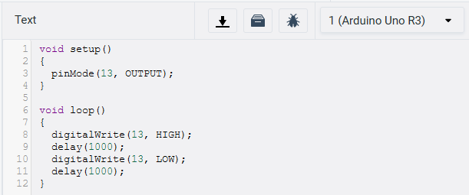

Output Screen Shot:

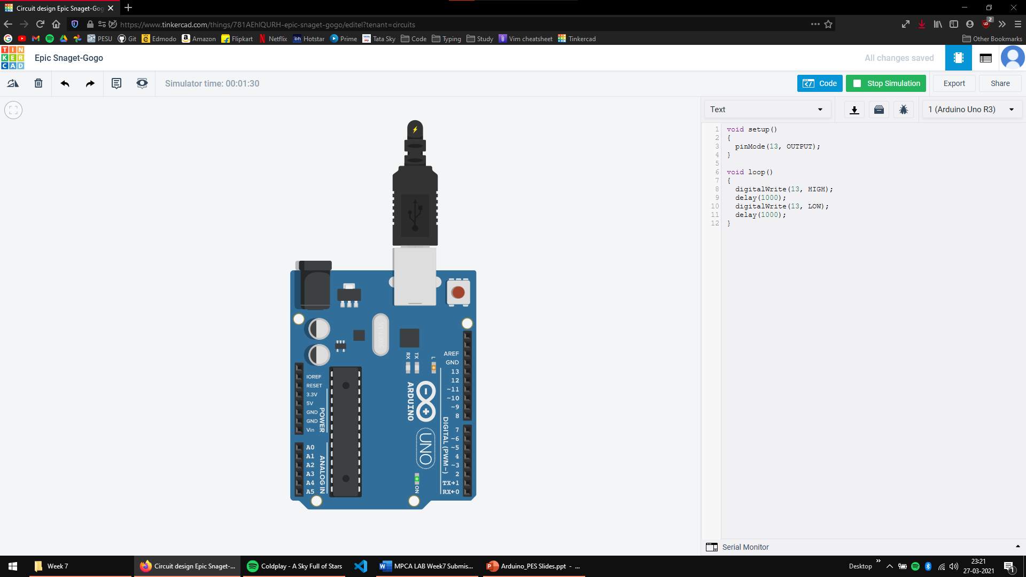

**B) Implement a Tinkercad simulation to turn on and off an external LED connected to the Arduino board**

Arduino Code:

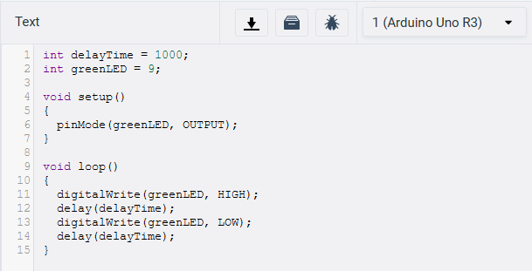

Output Screen Shot:

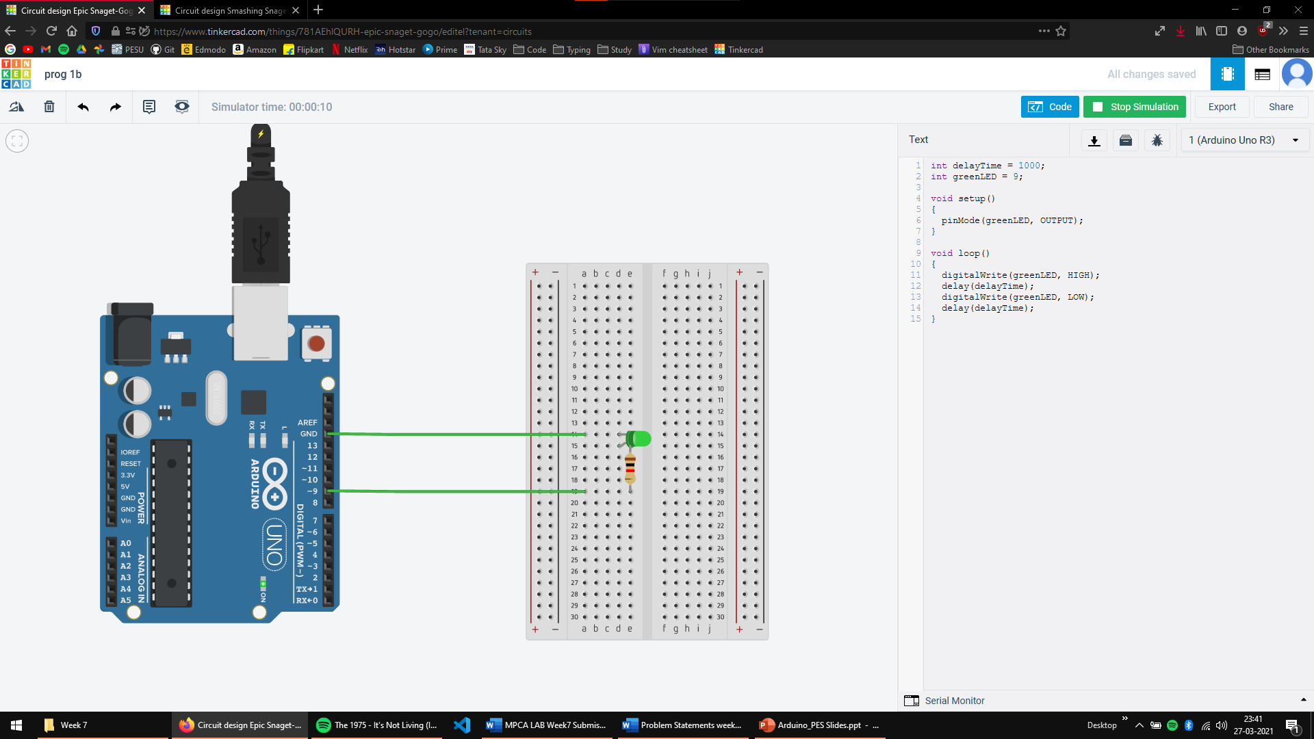

Program Number: 2

**Implement a Tinkercad simulation to alternately turn on and off two external LEDs connected to the Arduino board**

Arduino Code:

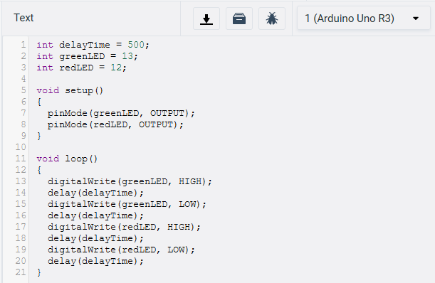

Output Screen Shot:

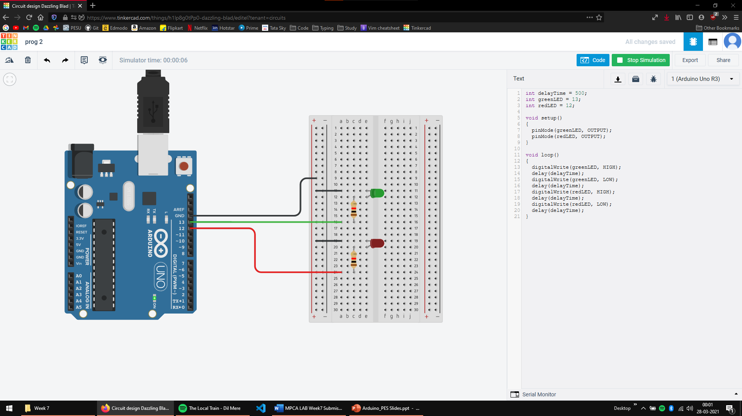

Program Number: 3

**Implement a Tinkercad simulation to use a pushbutton to control an LED.**

Arduino Code:

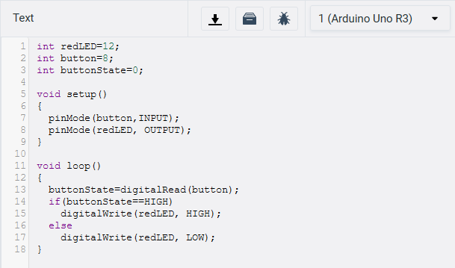

Output Screen Shot:

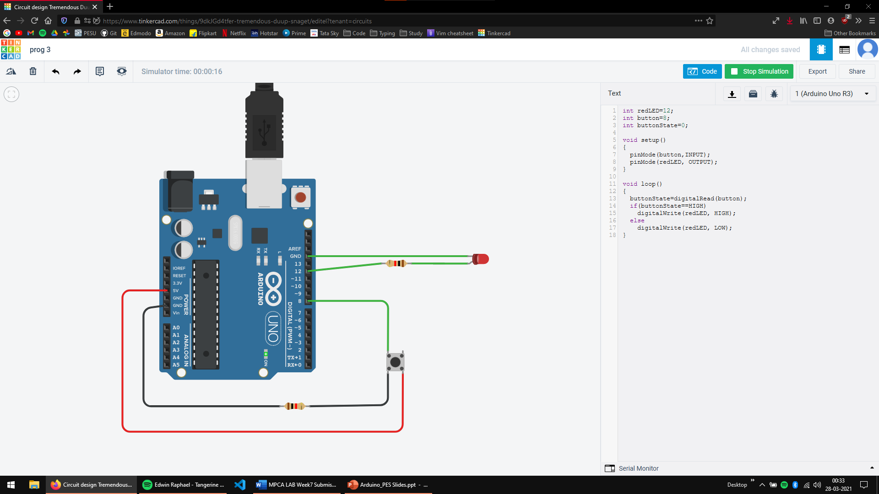

Program Number: 4

**Implement a Tinkercad simulation to demonstrate fading of an LED (zero to maximum brightness slowly)**

Arduino Code:

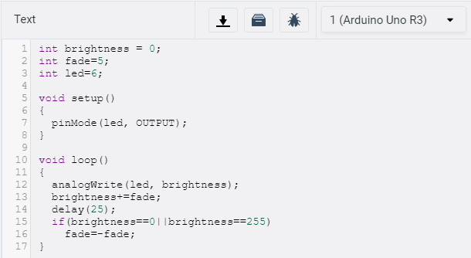

Output Screen Shot:

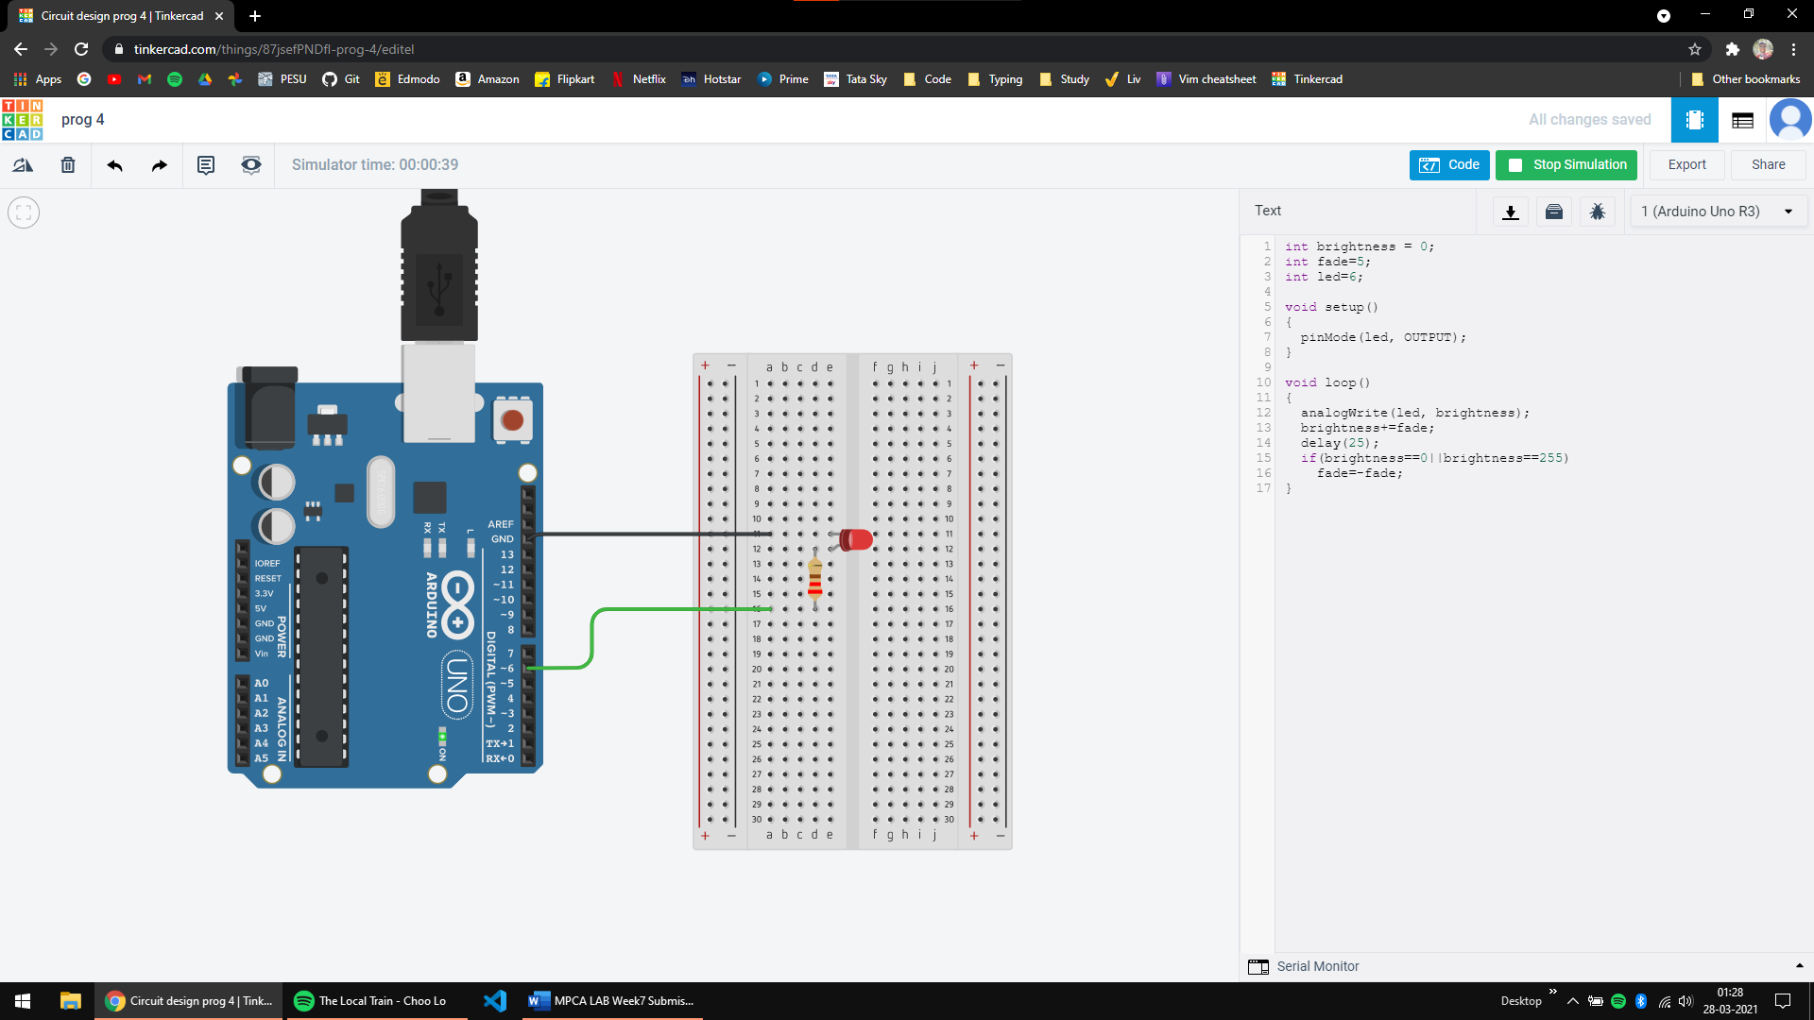

**Disclaimer:**

* The programs and output submitted is duly written, verified and executed by me.
* I have not copied from any of my peers nor from the external resource such as internet.
* If found plagiarized, I will abide with the disciplinary action of the University.

Signature: Atul Anurag

Name: Atul Anurag

SRN: PES2UG19CS075

Section: B

Date: 27-03-2021