DOCKER
GitHub Link :-https://github.com/itsaurabhh-dev/Docker_Saurabh

1.Frontend (Node.js with Express)
1. Create a frontend using Express and Node.js.
2 .Include a form similar to the one from the Flask Assignment 2.
3. Configure the form to send a request to the Flask backend.
—-------------------
Create a package.json
- > npm init → Start project initialization
- > npm install express → Install Express from npm
Create server.js -Basic js that create a server and serve html and css
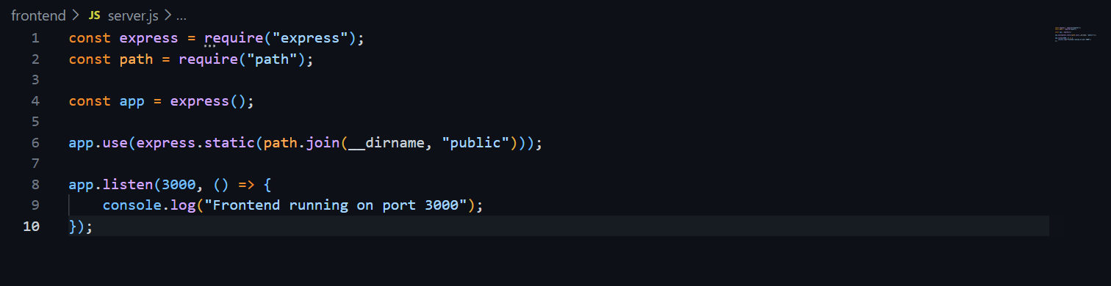
Create a folder named project and create a file named index.html inside it. With basic form where action send data to the Flask .Also create a basic css file with basic style .

2. Backend (Flask)
1.Use the Flask backend to handle the form submission and process the data.
—------------------
Create a “requirements.txt” file with all package in it (like Flask)
>pip install -r requirements.txt → install all the package
Create app.py -Basic Flask app that receives data from the form using request.form and /api display all the records
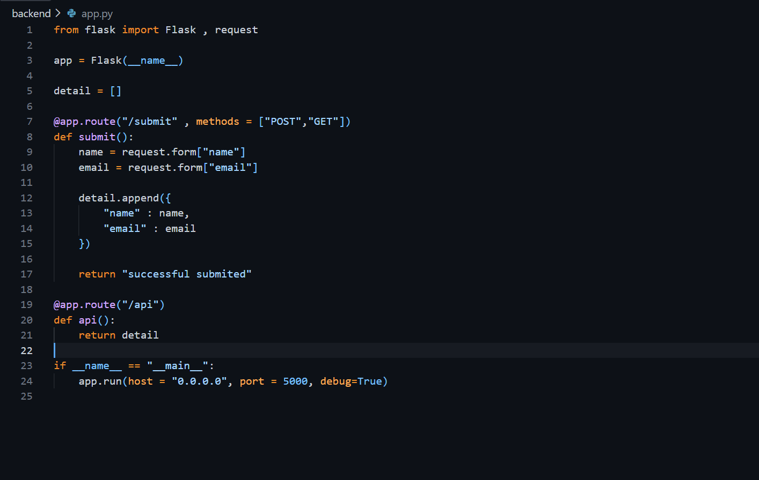

3. Folder Structure
1. Organize the project with separate folders for the frontend and backend.
—------------
Organize all the file in separate folder.
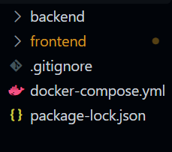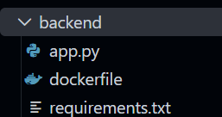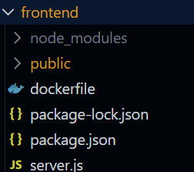

4. Docker Configuration
1. Create a Dockerfile for both the frontend and backend.
2. Write a .yaml file (Docker Compose) to connect both services in the same network.
3. Upload both images to Docker Hub, and push your whole code to GitHub. Add node_modules and other non-required files (e.g., .vscode) to .gitignore.
—-----------
Create Dockerfile in frontend folder
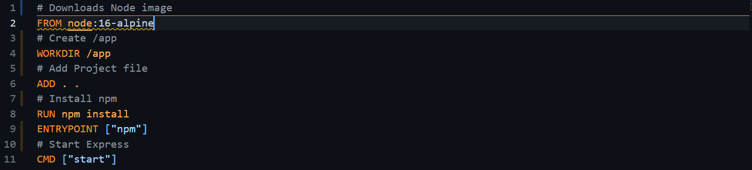
Create Dockerfile in backend folder
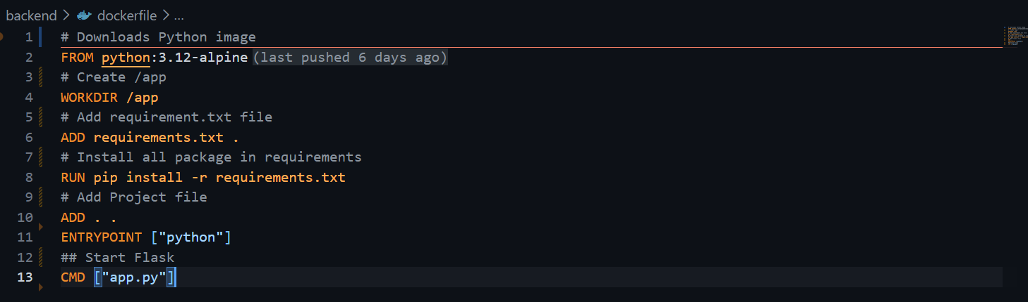

Open 2 terminal one for frontend and other for backend.
- T1>docker build -t frontend .
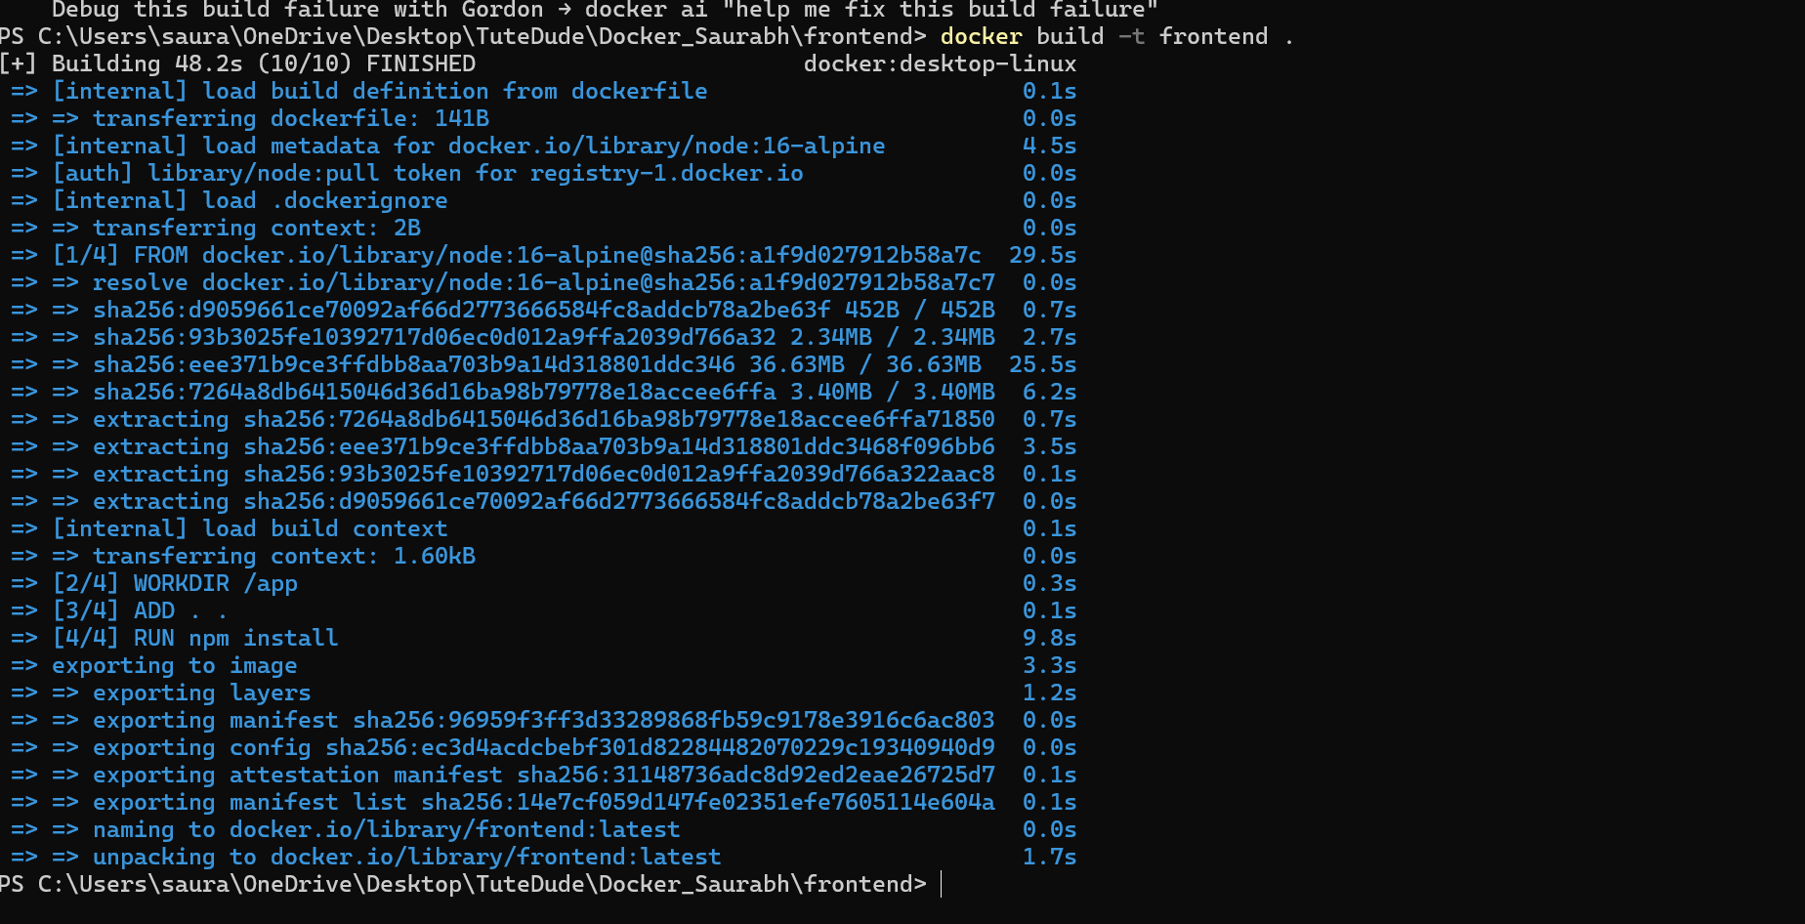
- T1> docker run -p 3000:3000 frontend
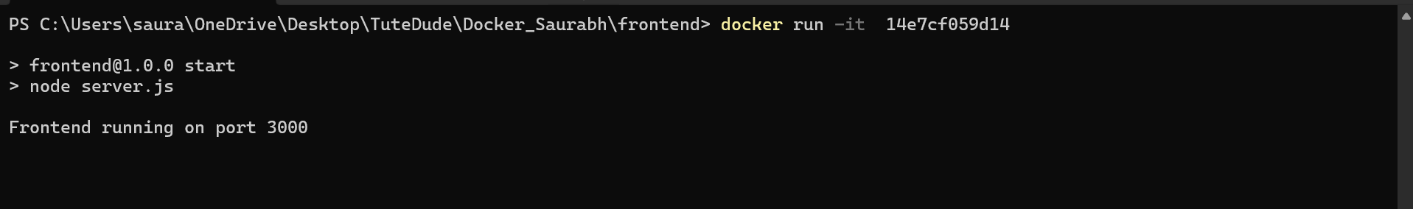

- T2>docker build -t backend .
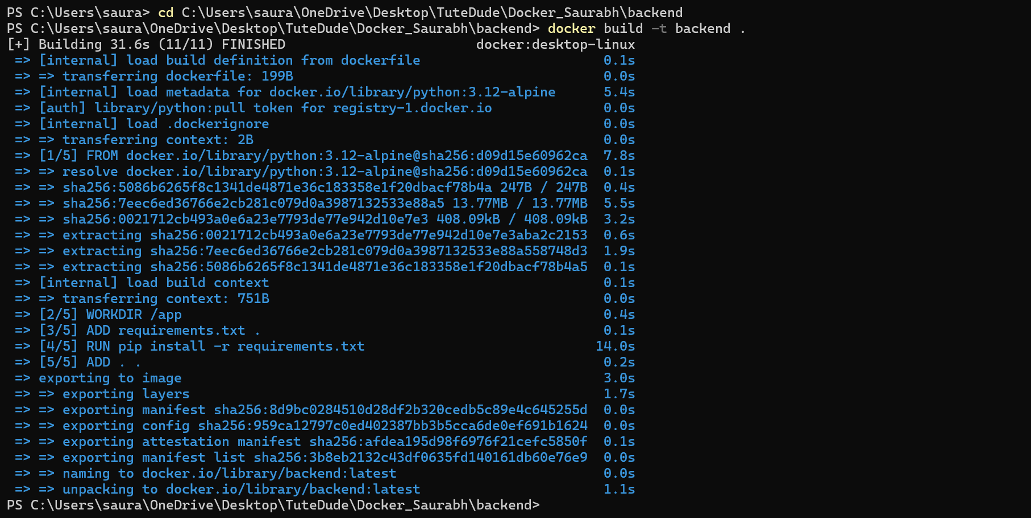
- T2> docker run -p 5000:5000 backend
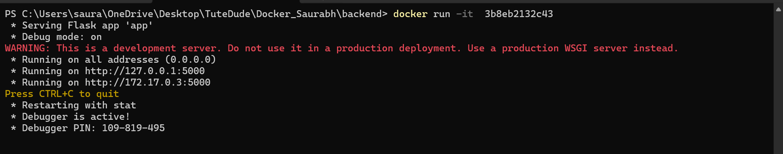

Create Docker Compose
- Create docker-compose.yml
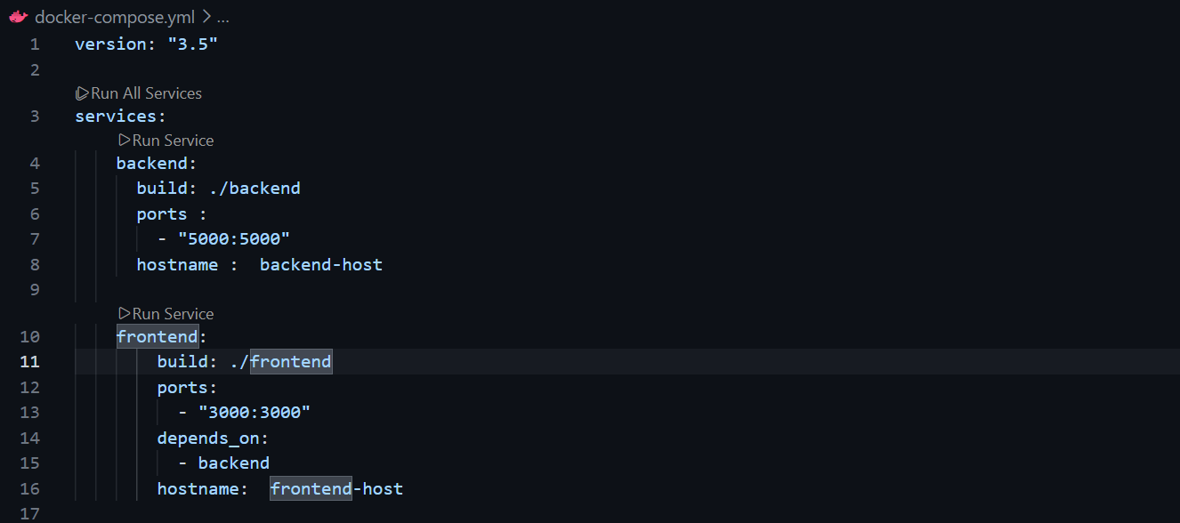

- To run
  - > docker-compose up --build
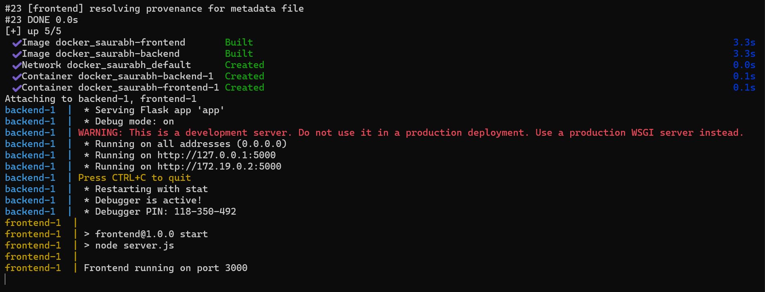
Backend will load first as ,frontend depends on the backend.

Create .gitignore and add all the unnecessary file from being uploaded to GitHub.

Then push it to GitHub
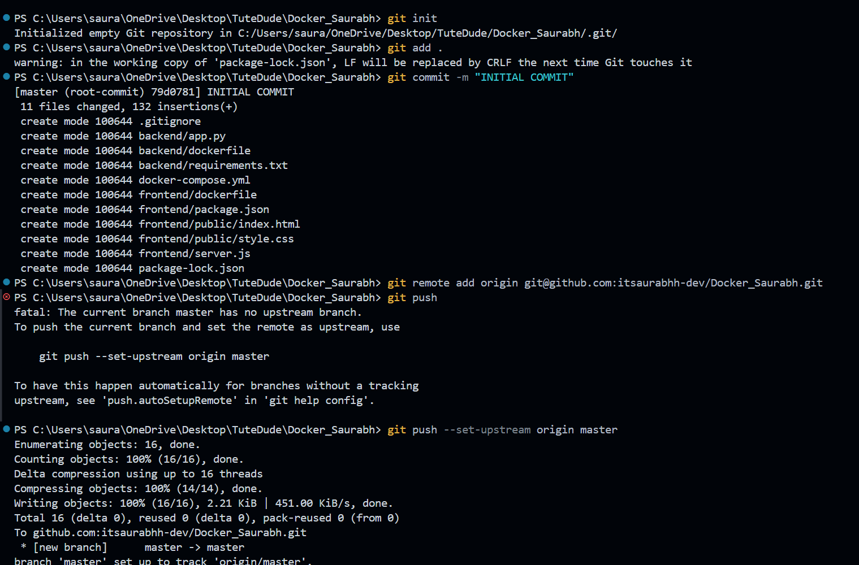

Upload IMAGES to Docker Hub

>Login in docker
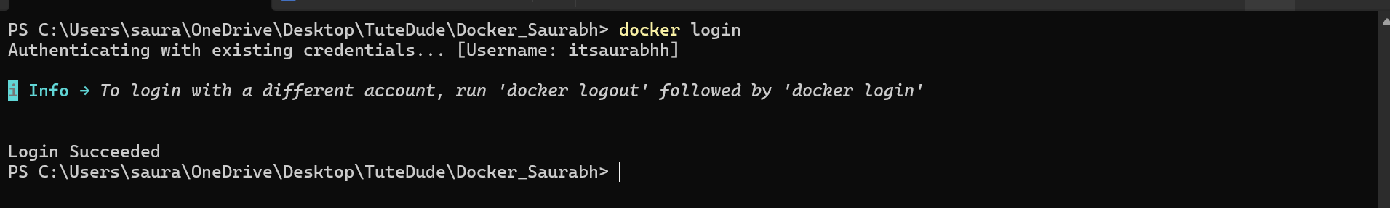

>Tag frontend Images and then push it.
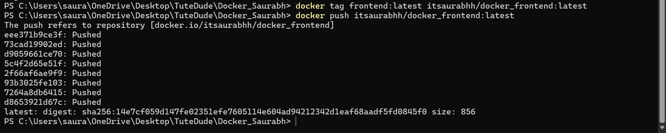

>Tag backend Images and then push it.
