

Chatak PG API Transactions Testing

Version 1.0

Notice of Proprietary Property
The information contained herein is the property of Girmiti Software Private Limited the possessor agrees to maintain this document in Confidence, not to reproduce, copy, reveal or publish it in whole or in part.
Version | Date | Description | Author
1.0 | 27-Aug-2015 | Initial Version | Girmiti Software
Table of Contents

1 Introduction 4
2 Overview 4
3 Pre-Requisites 4
4 OAuth Service Test and Get Access-Token 4
5 Transaction Services Test 6
6 PG Transaction APIs 9
6.1 Supported Card Types 14
6.2 Test Cards: 14
7 Assumptions and Limitations 14

Introduction

Chatak Payment Gateway provides APIs for payment transactions. This document helps to test the transactions through REST Client simulator and verify the transactions.

Overview

PG transaction REST APIs can be tested and verified with browser REST client.

Pre-Requisites

Required below to verify the REST APIs:
- Mozilla Firefox
- Install “RESTClient” Add-On (Extension) to the Firefox browser
- REST APIs to be deployed
- Chatak Admin should be provided below information
  - Service HTTP Basic Auth Username (izf8p5t73ffcshzq1lpa2adho0tgm6zt)
  - Service HTTP Basic Auth Password (C7511182M9FEFM4D5DM84A5M68B1188F6220)
  - Service Access Client Username (resgpcqlmg8lydip)
  - Service Access Client Password (9570AFBEMA36EM4130M9B72M44C9D3C9703C)
  - Merchant ID ()

OAuth Service Test and Get Access-Token
OAuth service is used to get the access token and will be used to send token in all transactional APIs. Below is the URL to be accessed in the RESTClient with GET method.
https://pay.rapidefund.com/chatak-pay/pg/oauth/token?grant_type=password&username=resgpcqlmg8lydip&password=9570AFBEMA36EM4130M9B72M44C9D3C9703C

- Enter above URL, select method as GET and click on SEND button as shown in the browser:
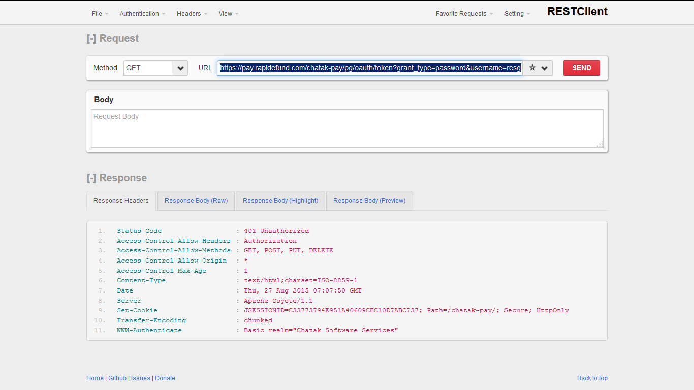

- When you click on SEND, browser will be prompted for Base Auth Username and Password as shown below:
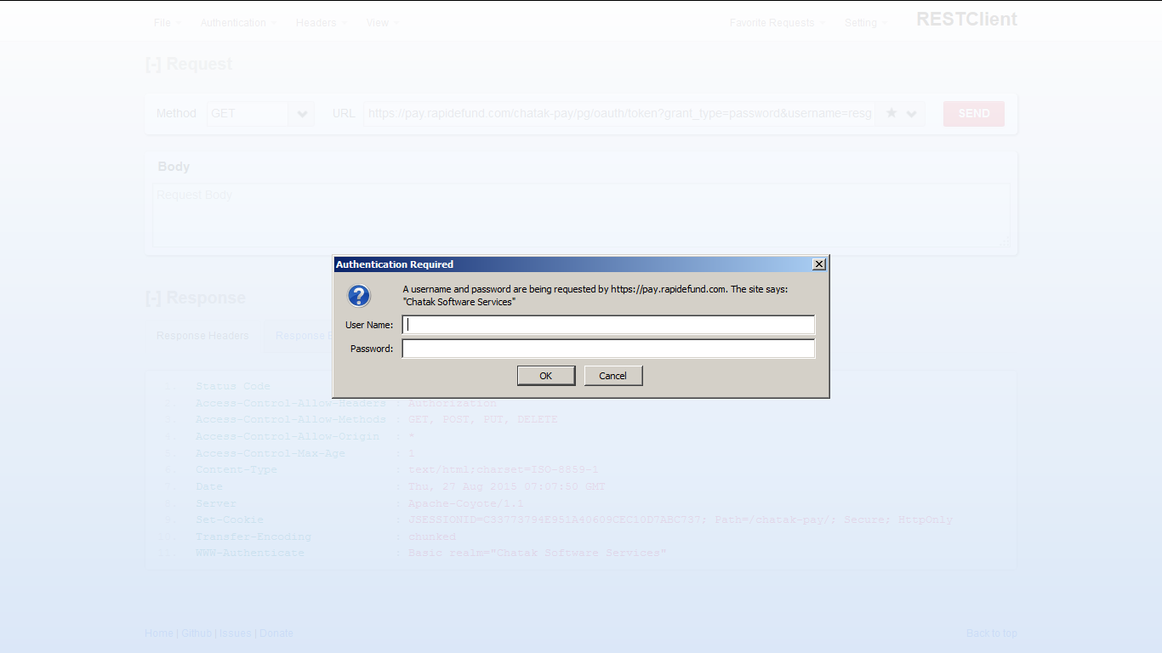
- Enter HTTP Basic Auth Username and HTTP Basic Auth Password and service will be called and return with success response and can be viewed under “Response Body (Highlight)” as below
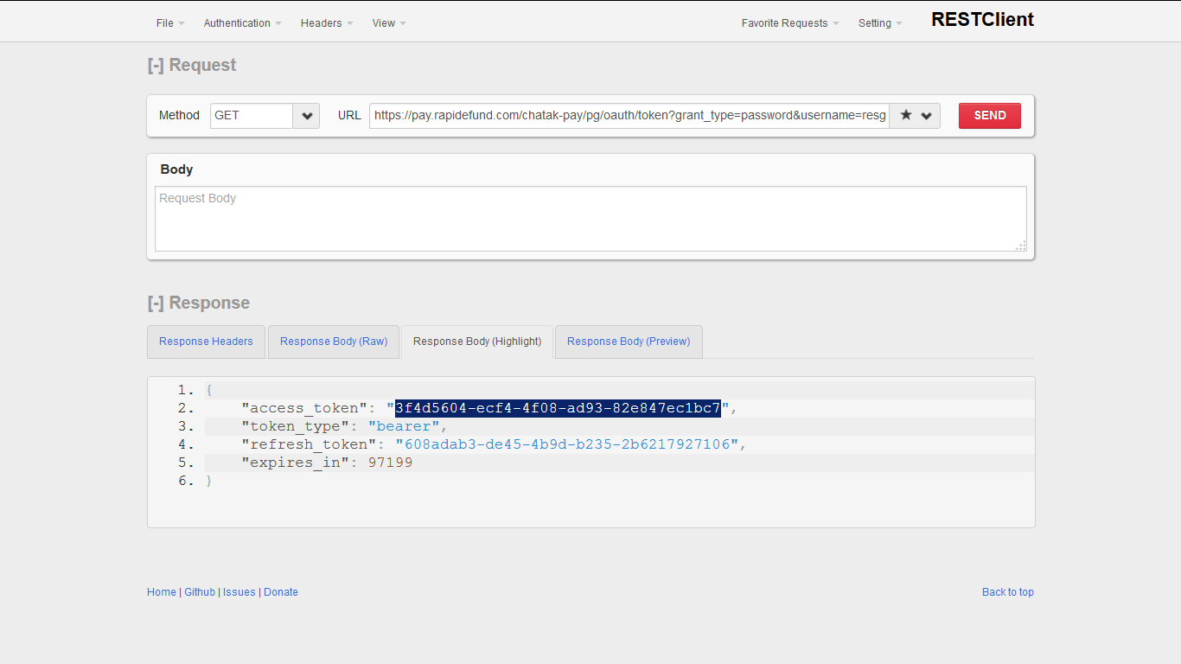
The highlighted access_token value will be used for transaction API will be called. Please copy the response.

Transaction Services Test

- To call PG Transacion API, copy https://pay.rapidefund.com/chatak-pay/pg/transaction/process url into RESTCLient URL field and change Method as POST as shown below:

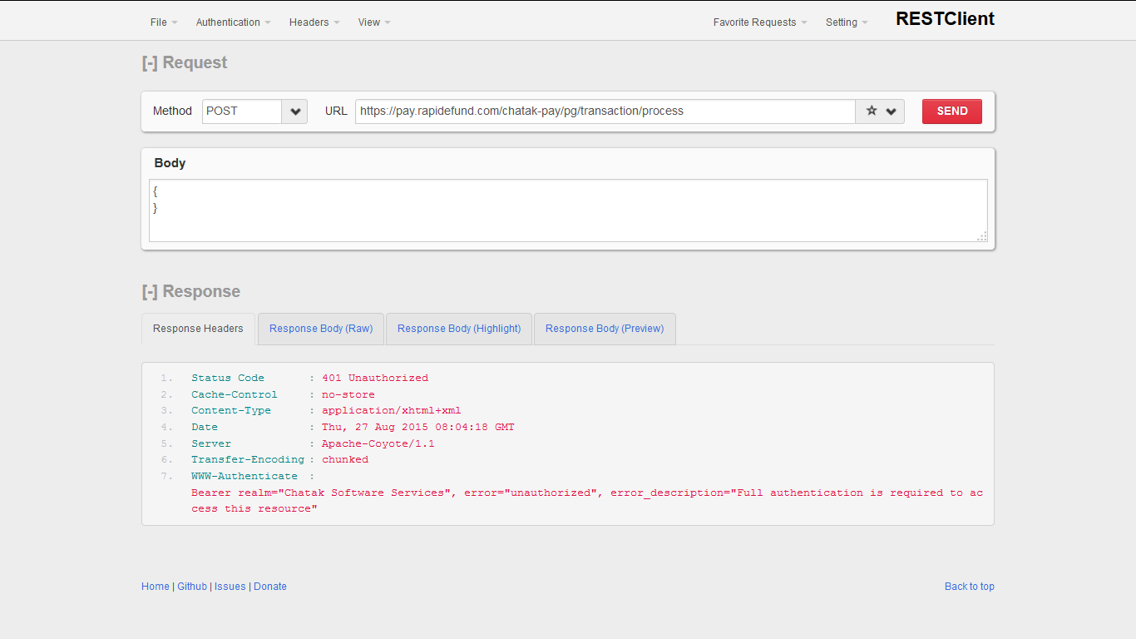

- We need to add HTTP HEADERs to access the Transaction APIs. Select “Headers” and “Custom Header” option as shown below:

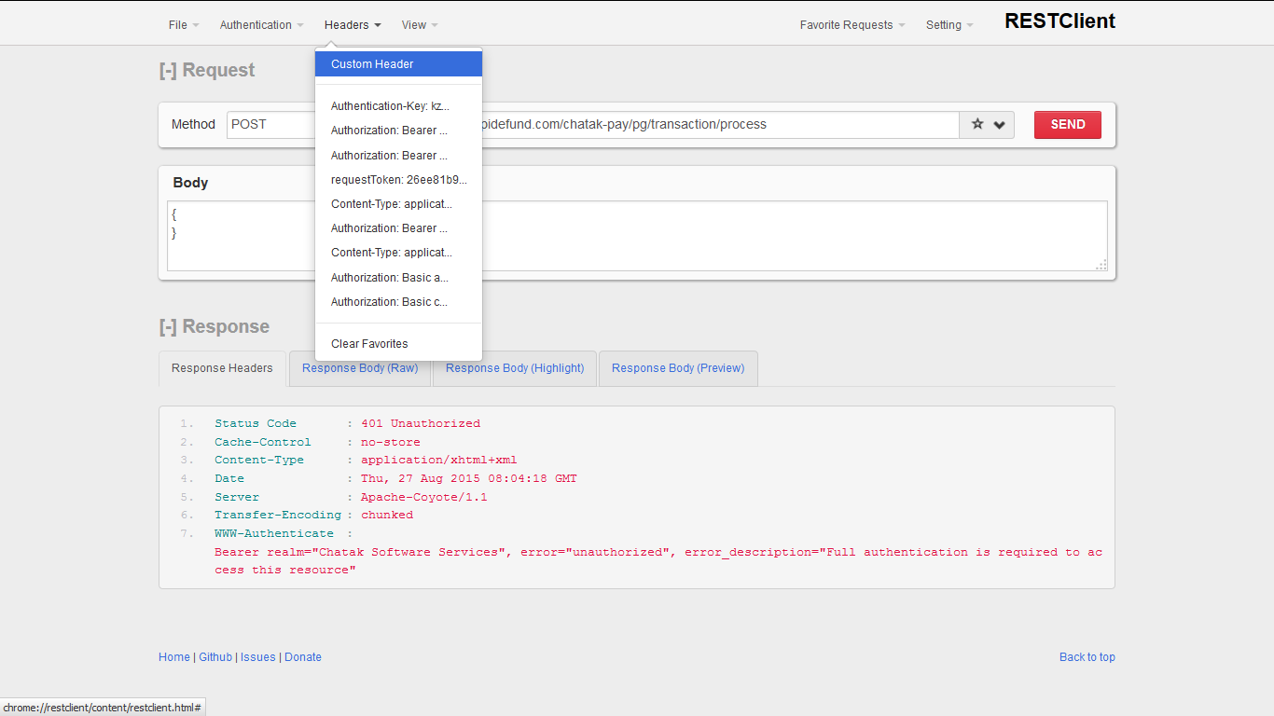

- Add Header name as “Authorization” and Value as “Bearer {access_token_value} and click save/OK as shown below:

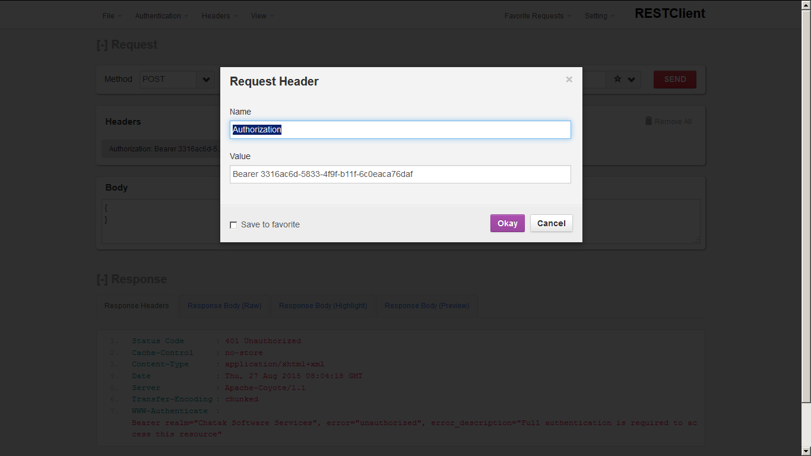

- Add Header name “Content-Type” and value as “application/json” and click save/OK as shown below
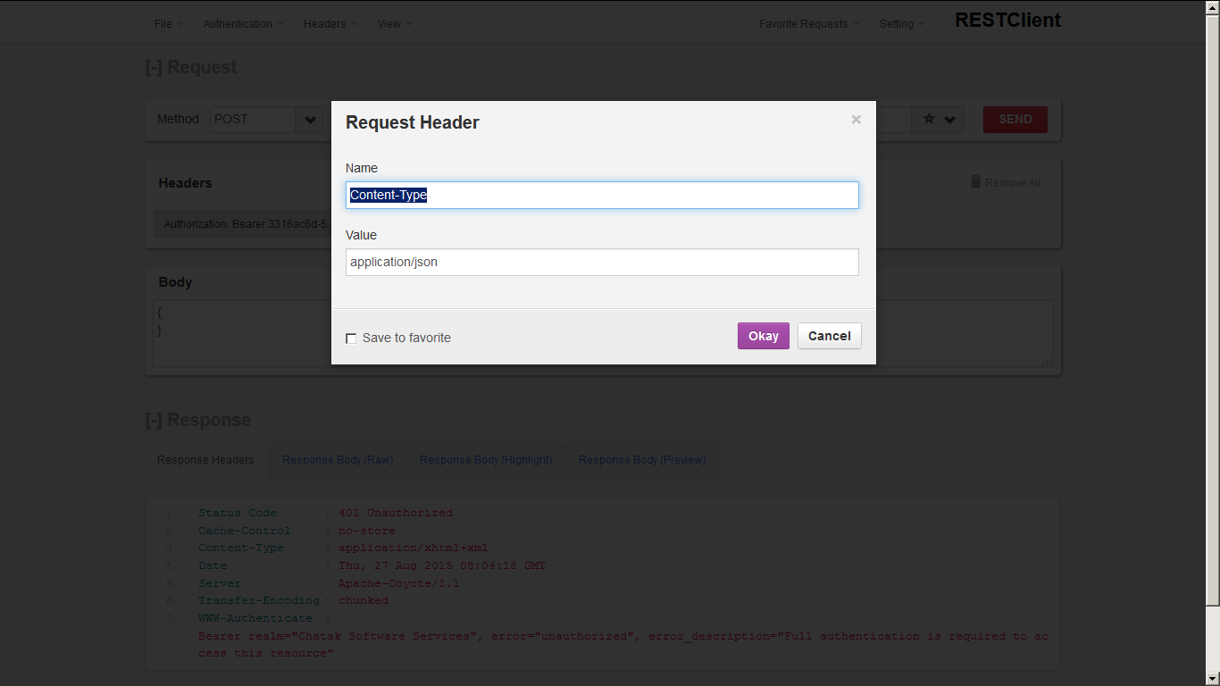

- Enter Transaction Request PayLoad in “Body” field and click on SEND as shown below and you will get response in the Response section as shown below.
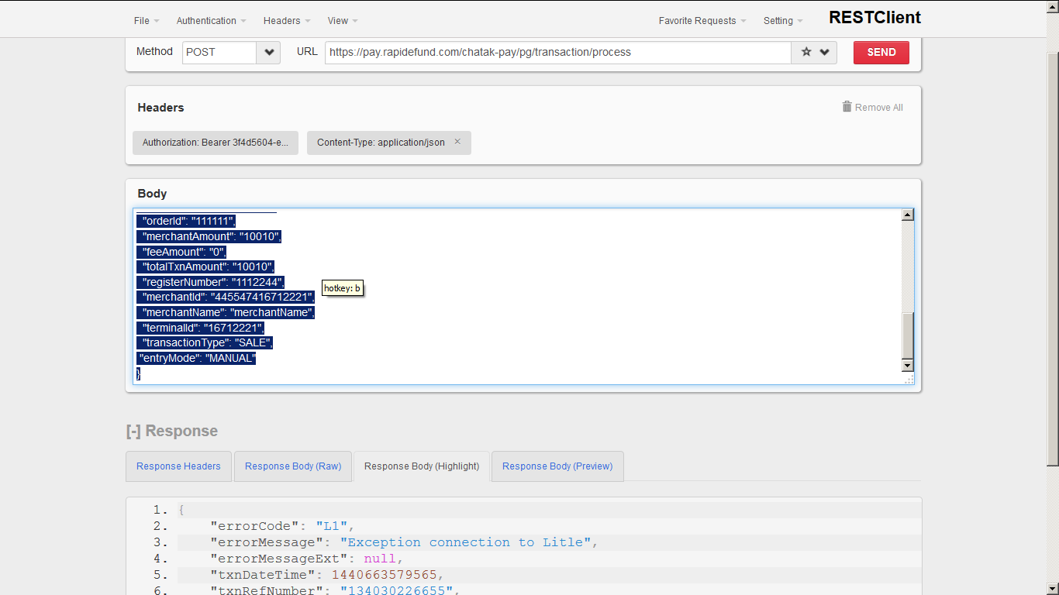

Follow the same for different transaction types of requests and verify. PayLoads and Test cases spreadsheet attached in the mail (ChatakPay_Test_Scenarios.xlsx).

PG Transaction APIs

Description: This API is used to perform online transactions.
URL: https://pay.rapidefund.com/chatak-pay/pg/transaction/process

Method: POST
Content Type: application/json
Payload:

Request header:
- Content-Type: application/json
- Authorization: Bearer [space] OAuth token received as part of login user response

SALE API Request Parameters:
M: Mandatory, O: Optional, NA: Not Applicable
Field length specified as max length.

API: SALE
SlNo | Parameter | Mandatory | Data Type (Length) | Description
1 | merchantId | M | String(15) | Merchant Id provided by Chatak Admin
2 | terminalId | M | String(8) | Terminal Id provided by Chatak Admin
3 | merchantAmount | M | Long(12) | Merchant Amount in cents- will be credited to Merchant/partners account – value > 1
4 | feeAmount | O | Long(12) | Fee Amount in cents - will be credited to Merchant fee account and Chatak Fee account
5 | totalTxnAmount | M | Long(12) | Total Transaction Amount in cents (Merchant Amount + Fee Amount) – value > 1
6 | merchantName | M | String(100) | Merchant Name
7 | invoiceNumber | M | String(20) | Invoice Number will be generated by Merchant
8 | registerNumber | M | String(20) | Register Number will be generated by Merchant
9 | orderId | M | String(20) | Unique Purchase/Sale Order Id
10 | transactionType | M | String(50) | Transaction Type Ex: SALE
11 | entryMode | O | String(50) | POS entryMode is optional, if this field is null or 'MANUAL' in the request, API will check for cardNumber, expDate.  If entryMode=MAGNETIC_STRIP, API will check for track2 field to get the Card Number and Exp Date.  Possible values: MANUAL, MAGNETIC_STRIP, ICC, OCR,PAN_AUTO_ENTRY_CONTACTLESS_M_CHIP
12 | cardData | M | Object | Holds Card Data details ( from parameters 12 to 16 below)
13 | cardData.track | C | String(50) | Track (Track1/Track2 or both) data of Card. Conditional. This field is mandatory when entryMode=MAGNETIC_STRIP. Value should be AES encrypted with a KEY shared by Chatak Admin team
14 | cardData.cardHolderName | C | String(50) | Card Holder Name is mandatory when entryMode=null or MANUAL
15 | cardData.cardNumber | C | String (19) | Card/PAN Number – length 16 to 19. It is mandatory when entryMode=null or MANUAL
16 | cardData.expDate | C | String(4) | Card Expiry Date(YYMM) It is mandatory when entryMode=null or MANUAL
17 | cardData.cardType | M | String(2) | Card Type (MC,VI,AX,DC,DI)
18 | cardData.cvv | C | String(4) | CVV of Card - can be 3 or 4. Conditional. For the MANUAL entry mode, this is mandatory
19 | description | O | String(500) | Description of transaction
20 | billingData | O | Object | Holds Biller Data details ( from parameters 19 to 25 below)
21 | billingData.address1 | M | String(100) | Biller Address line1
22 | billingData.address2 | O | String(100) | Biller Address line 2
23 | billingData.city | M | String(100) | Biller City
24 | billingData.state | M | String(100) | Biller State
25 | billingData.country | M | String(50) | Biller Country
26 | billingData.zipCode | M | String(15) | Biller Zip Code
27 | billingData.email | M | String(100) | Biller Email

Response Parameters:
Sl No | Parameter Name | Description
1 | errorCode | Response Error Code
2 | errorMessage | Response Error Message
3 | errorMessageExt | Response Extended Error Message
4 | txnDateTime | Transaction Date time in milliseconds
5 | txnRefNumber | Transaction Reference Number for Transaction tracking, refund and any queries
6 | authId | Transaction Authorization Id
7 | cgRefNumber | Chatak Gateway Reference Number for Transaction tracking and any queries

SALE Request Sample: Below is the payload sample for SALE API request and transactionType=SALE and cardData.entryMode=MANUAL
{
"billingData": {
"address1": "abc",
"address2": "Bangalore",
"city": "Bangalore",
"state": "KA",
"country": "India",
"zipCode": "123456",
"email": "email@email.com"
},
"cardData": {
"entryMode": "MANUAL",
"cvv": "232",
"cardHolderName": "abc",
"expDate": "1604",
"cardNumber": "4215729002869979",
"cardType":"VI"
},
"invoiceNumber": "12144124540",
"merchantAmount": "10",
"feeAmount": "1",
"totalTxnAmount": "11",
"registerNumber": "111224",
"orderId": "11121243545541",
"merchantId": "372605264715263",
"merchantName": "merchantName",
"terminalId": "13606818",
"transactionType": "SALE"
}

SALE Request Sample: Below is the payload sample for SALE API request and transactionType=SALE and cardData.entryMode=MAGNETIC_STRIP
Note: track2 data is encrypted with SDK.
{
"cardData": {
"entryMode":"MAGNETIC_STRIP",
"cvv": "232",
"track2":"1r2MJvS8mEschAqbTCi6wIRVODzivnZ9e6sOZMBAtBEZFGZwVheArsdyAts8TNbw",
"cardType":"VI"
},
"invoiceNumber": "121441245425101",
"merchantAmount": "10",
"feeAmount": "1",
"totalTxnAmount": "11",
"registerNumber": "1112234118",
"orderId": "111212435455118",
"merchantId": "455416286838425",
"merchantName": "merchantName",
"terminalId": "13606818",
"transactionType": "SALE"
}

SALE Response Sample:
{
"errorCode": "00",
"errorMessage": "Approved",
"errorMessageExt": null,
"txnDateTime": 1432147116895,
"txnRefNumber": "572958132823",
"authId": "622061",
"cgRefNumber": "554782199431805000"
}

VOID API Request Parameters:

API: VOID
SlNo | Parameter | Mandatory | Data Type (Length) | Description
1 | merchantId | M | String(15) | Merchant Id provided by Chatak Admin
2 | terminalId | M | String(8) | Terminal Id provided by Chatak Admin
3 | transactionType | M | String(50) | Transaction Type Ex: VOID
4 | txnRefNumber | M | String(12) | Sale transaction reference number which is from SALE API response
5 | cgRefNumber | M | String(50) | Sale transaction Chatak Gateway number which is from SALE API response
6 | description | O | String(500) | Description of transaction

VOID Request Sample: Below is the payload sample for VOID API request where transactionType=VOID
{
"merchantId": "719516713606818",
"terminalId": "13606818",
"transactionType": "VOID",
"txnRefNumber": "713561067601",
"cgRefNumber": "844021121273175000"
}

VOID Response Sample:
{
"errorCode": "00",
"errorMessage": "Approved",
"errorMessageExt": null,
"txnDateTime": 1431503034010,
"txnRefNumber": "751216522532
}

REFUND API Request Parameters:

API: REFUND
SlNo | Parameter | Mandatory | Data Type (Length) | Description
1 | merchantId | M | String(15) | Merchant Id provided by Chatak Admin
2 | terminalId | M | String(8) | Terminal Id provided by Chatak Admin
3 | transactionType | M | String(50) | Transaction Type Ex: REFUND
4 | txnRefNumber | M | String(12) | Sale transaction reference number (txnRefNumber ) which is from SALE API response
5 | cgRefNumber | M | String(50) | Sale transaction Chatak Gateway number (cgRefNumber) which is from SALE API response
6 | description | M | String(500) | Description of transaction

REFUND Request Sample: Below is the payload sample for VOID API request where transactionType=REFUND
{
"merchantId": "719516713606818",
"terminalId": "13606818",
"transactionType": "REFUND",
"txnRefNumber": "713561067601",
"cgRefNumber": "844021121273175000"
}

REFUND Response Sample:
{
"errorCode": "00",
"errorMessage": "Approved",
"errorMessageExt": null,
"txnDateTime": 1431503034010,
"txnRefNumber": "751216522532
}

Supported Card Types

- MASTER CARD (MC)
- VISA (VI)
- DISCOVER (DI)
- AMEX (AX)
- DINERS CLUB (DC)

Test Cards:

Below are the test cards and expire of card shown inside brackets

TBD

Assumptions and Limitations

- Currently only Sale and Void transactions are supported and the transaction set will be enhanced based on need in subsequent releases
- Currently only full void of a previous transaction amount is supported and the associated fee is also reversed when the void is raised.
- Chatak PG Acquirer for upstream authorization and processing is currently integrated to Litle & Co

