CS3081: Artificial Intelligence
Lab 1 Report: Maze Solver
Depth-First Search & Breadth-First Search

Effat University • Computer Science Department • Spring 2026
Instructor: Dr. Naila Marir

Exercise 1: Run and Observe (DFS)
The original maze.py uses StackFrontier (Depth-First Search). The program was run against all three provided maze files. Results are recorded below.

Maze | Dimensions | States Explored | Path Length
maze1.txt | 6 × 7 | 11 | 10 steps
maze2.txt | 16 × 29 | 194 | 22 steps
maze3.txt | 6 × 7 | 17 | 14 steps

maze1.txt — DFS Output
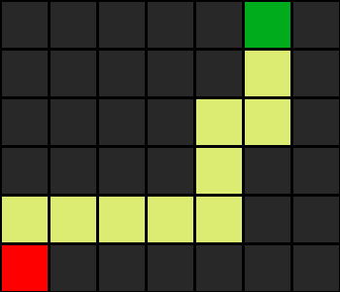
Figure 1: maze1.txt solved with DFS — 11 states explored, 10-step path

maze2.txt — DFS Output
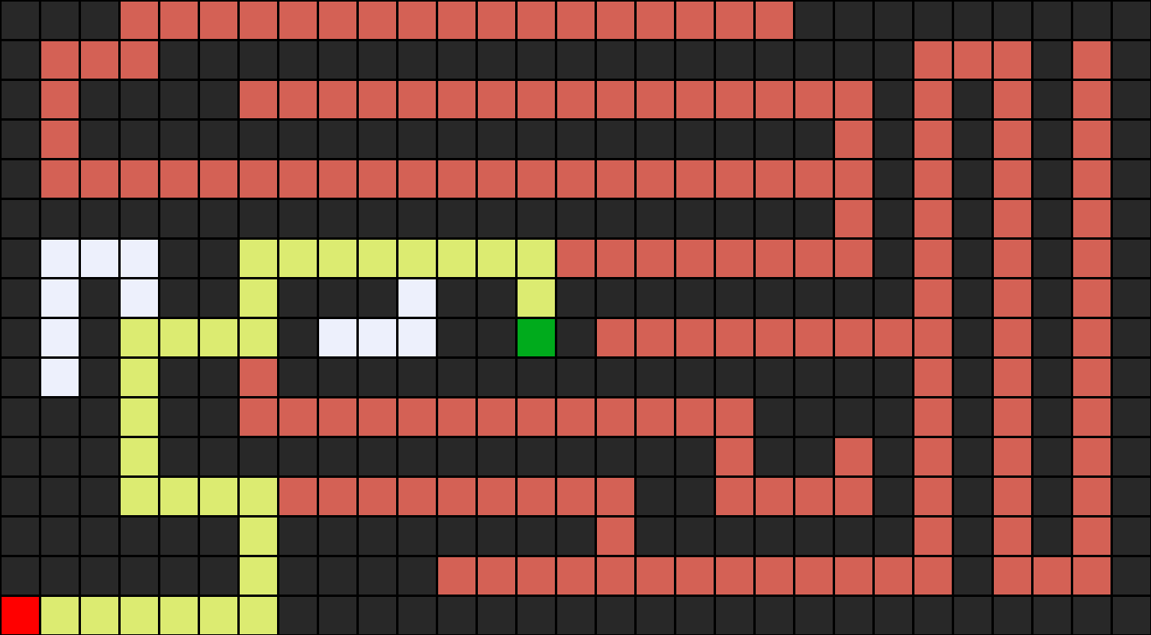
Figure 2: maze2.txt solved with DFS — 194 states explored, 22-step path

maze3.txt — DFS Output
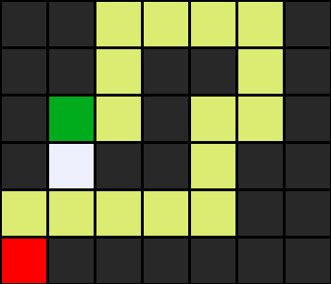
Figure 3: maze3.txt solved with DFS — 17 states explored, 14-step path

Exercise 2: Switch to BFS (maze_bfs.py)
The only change made was on line 127 of maze.py:

Before: frontier = StackFrontier() → After: frontier = QueueFrontier()

This converts the algorithm from DFS (Last-In-First-Out) to BFS (First-In-First-Out), exploring all cells at distance 1 before moving to distance 2, and so on.

Maze | DFS States | BFS States | DFS Path | BFS Path | Same Path?
maze1 | 11 | 11 | 10 steps | 10 steps | ✓ Yes
maze2 | 194 | 77 | 22 steps | 22 steps | ✓ Yes
maze3 | 17 | 6 | 14 steps | 6 steps | ✗ No

maze1.txt — BFS vs DFS

Figure 4: maze1.txt solved with BFS — 11 states explored, same path as DFS

maze2.txt — BFS vs DFS
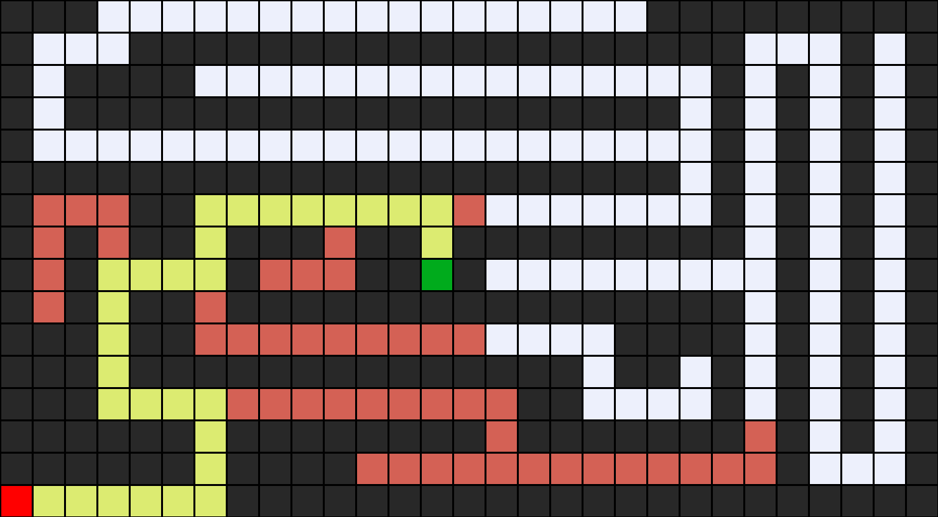
Figure 5: maze2.txt solved with BFS — 77 states explored (vs 194 for DFS), same path

maze3.txt — BFS vs DFS (Different Path!)
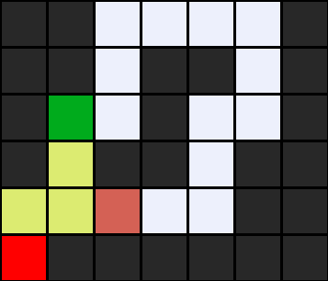
Figure 6: maze3.txt solved with BFS — only 6 states explored, shorter 6-step path (DFS took 14 steps)

Key Observations
- BFS explores significantly fewer states in larger mazes (77 vs 194 for maze2).
- BFS always finds the shortest path. In maze3, it found a 6-step path while DFS found a 14-step one.
- The exploration pattern differs: DFS dives deep along one branch; BFS fans outward level by level.
- For maze1, both found the same result because the maze has very little branching.

Exercise 3: Custom Maze (maze4.txt)
A custom maze was designed so that DFS and BFS find completely different paths. The key insight: the neighbor-checking order in maze.py tries 'up' before 'down'. By placing B below A with a short left-side route and a long right-side winding route, DFS (which prefers going up/right) takes the long path, while BFS finds the short direct one.

Maze layout (maze4.txt):
#######
#A #
# #
## ## #
# # #
# # # #
# # B #
# # #
# #
#######

Maze | Algorithm | States Explored | Path Taken
maze4 | DFS | 11 | Long (right side)
maze4 | BFS | 23 | Short (left side)

DFS path (right-side, longer)
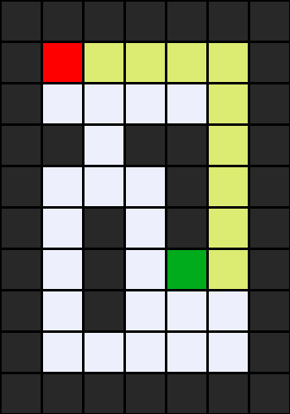
Figure 7: maze4.txt solved with DFS — 11 states explored, wraps around right side

BFS path (left-side, shorter)
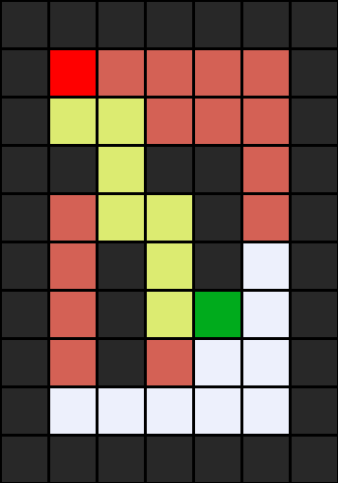
Figure 8: maze4.txt solved with BFS — 23 states explored, direct short path down left

Discussion Questions

Q1: Why does the current implementation use StackFrontier instead of QueueFrontier?
The lab uses StackFrontier to implement Depth-First Search (DFS). A stack operates on the Last-In-First-Out (LIFO) principle: the most recently added node is always explored next. This makes the algorithm go deep — it follows one path all the way until it hits a dead end, then backtracks and tries another branch. This behavior mirrors how one would physically explore a maze: always go forward until you hit a wall, then backtrack to the last junction and try a different direction.

Q2: What would happen if line 127 used QueueFrontier() instead?
Using QueueFrontier converts the algorithm to Breadth-First Search (BFS), which operates on a First-In-First-Out (FIFO) queue.
- Exploration pattern: Instead of diving deep, BFS fans out like ripples in water — it explores all cells at distance 1 from start, then all at distance 2, and so on.
- Path found: BFS guarantees the shortest path in terms of number of steps. DFS finds a valid path but not necessarily the shortest one.
- States explored: BFS explored 77 states in maze2 vs DFS's 194, and only 6 states in maze3 vs DFS's 17. However, BFS can explore more states than DFS if the goal is located deep in one branch (since BFS must first explore all shorter paths first).

Q3: Is DFS guaranteed to find the shortest path? Why or why not?
No. DFS is not guaranteed to find the shortest path. Because DFS commits to going deep along one branch before considering others, it may reach the goal via a very long, winding route when a much shorter path exists. The search order depends entirely on which neighbor is checked first (up, down, left, right in this implementation), not on which path is shorter.
Evidence from our lab: In maze3, DFS found a 14-step path while BFS found a 6-step path — the same start and goal, but DFS took more than twice as many steps. BFS, by contrast, always finds the shortest path because it explores nodes in order of increasing distance from the start.

Q4: How does the number of explored states differ between maze1.txt and maze2.txt?
DFS explored 11 states in maze1 but 194 states in maze2. BFS explored 11 states in maze1 but 77 states in maze2.
maze2 has far more explored states because it is much larger (16 x 29 versus 6 x 7) with many more branching corridors and dead ends. The search space grows significantly with maze size. DFS in particular is affected because it tends to follow dead-end branches deep before backtracking, and maze2 has many such dead ends. The difference between DFS and BFS is also more visible in maze2 (194 vs 77) than in maze1 (11 vs 11), because larger, more complex mazes expose the behavioral differences between the two algorithms more clearly.

Q5: What would happen if we removed the explored set check?
Without the explored set, the algorithm would be able to revisit cells it has already processed. In a maze that has any open areas or loop-like passages (which most mazes do), this creates an infinite loop — the algorithm bounces between the same pair of adjacent cells forever, never terminating.
The explored set ensures each cell is processed at most once. When a node is removed from the frontier and expanded, it is added to the explored set, and subsequent checks prevent it from being added to the frontier again. This is the key mechanism that guarantees the algorithm terminates — whether or not a solution exists — and runs in time proportional to the number of cells in the maze rather than infinitely.

