Lab Goal : This lab was designed to teach you more object oriented programming and how to write a larger game.
A+ Computer Science Golf – THE GAME Lab Value - 100

Lab Description : Write the complete game logic for Golf. At this point, Card, GolfCard, Deck, and Player should all work.

public class Golf
{
Files Needed ::
Card.java
GolfCard.java
Deck.java
AbstractPlayer.java
Player.java
Dealer.java
Golf.java
private Player player1;
private Player player2;
private Deck deck;

public Golf()
{
// instantiate all of your instance variables
}

public void playGame() {
//all game code goes in here
}

public static void main( String args[ ] ) {
Golf game = new Golf();
game.playGame();
}
}

How do you play the game of Golf?

shuffle the deck of cards
do{
1st – everyone gets 4 cards – 1 card at time

2nd – print out each player’s hand value & cards
loop 2 times for each player
if the player wants to swap a card, then swap it
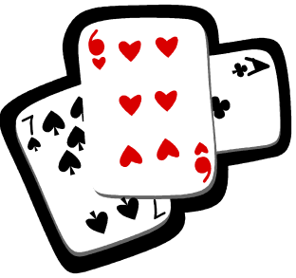
4th – determine which player won

5th – update the win total for the winner

6th – shuffle the deck of cards if needed

}while another game is to be played

Sample Output :

PLAYER
Hand Value :: 17
Hand Size :: 4

You can swap two cards if you want!
Cards in Hand :: hand = [EIGHT of CLUBS | value = 8
FOUR of DIAMONDS | value = 4
TWO of CLUBS | value = 2
THREE of HEARTS | value = 3] - 17

Do you want to swap cards? [ enter in card number 0-3 or -1 for NO ] 0
Cards in Hand :: hand = [KING of CLUBS | value = 13
FOUR of DIAMONDS | value = 4
TWO of CLUBS | value = 2
THREE of HEARTS | value = 3] - 22

Do you want to swap cards? [ enter in card number 0-3 or -1 for NO ] -1

player2
Hand Value :: 35
Hand Size :: 4
Cards in Hand :: hand = [JACK of SPADES | value = 11
TWO of HEARTS | value = 2
KING of DIAMONDS | value = 13
NINE of SPADES | value = 9] - 35

You can swap two cards if you want!

Do you want to swap cards? [ enter in card number 0-3 or -1 for NO ] 0

Do you want to swap cards? [ enter in card number 0-3 or -1 for NO ] 3

Player wins!
player2 Hand Value :: 27
Player Hand Value :: 22

player2 has won 0 times.
Player has won 1 times.

Do you want to play again? [Y,y,N,n] ::

