**Instructions**

* There are **2** questions in this assignment.
* Email/paper/other modes of submissions will not be accepted.
* Upload a word **version** of this document.
* Assignment submitted after due date will not be evaluated and a score of zero will be awarded.
* Plagiarism may lead to award of zero marks.

**Due Date: 12pm, 4th Sept. 2024**

**Submitting this Assignment**

You will submit (upload) this assignment in MS Teams. Name this document as GLA1_AJPODD2024_John_Doe.doc in case your name is John Doe, and this graded lab assignment is 1 of course whose acronym is AJP, and offered in ODD 2024. Paste your code after each question, paste the screenshot of output, save and upload the document.

**Grading Scheme:** This assignment has5 marks.

**Question 1:**

Create a web page for internal links; when the user clicks on different links on the web page it should go to the appropriate locations/sections in the same page.

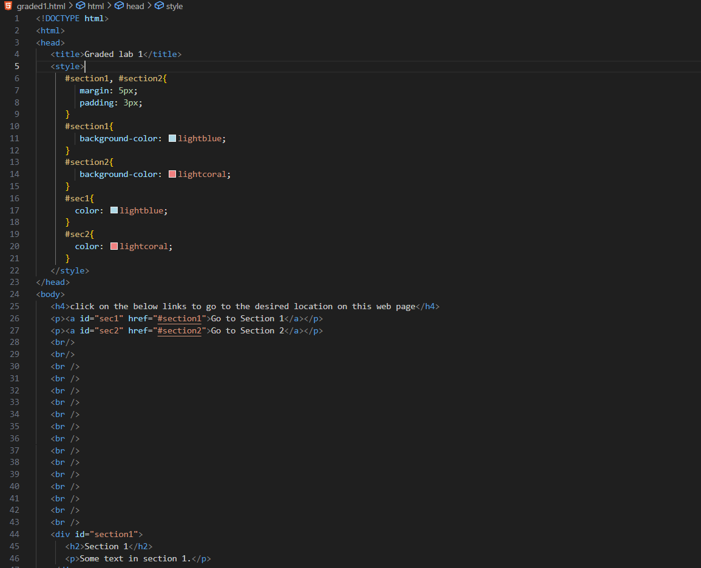

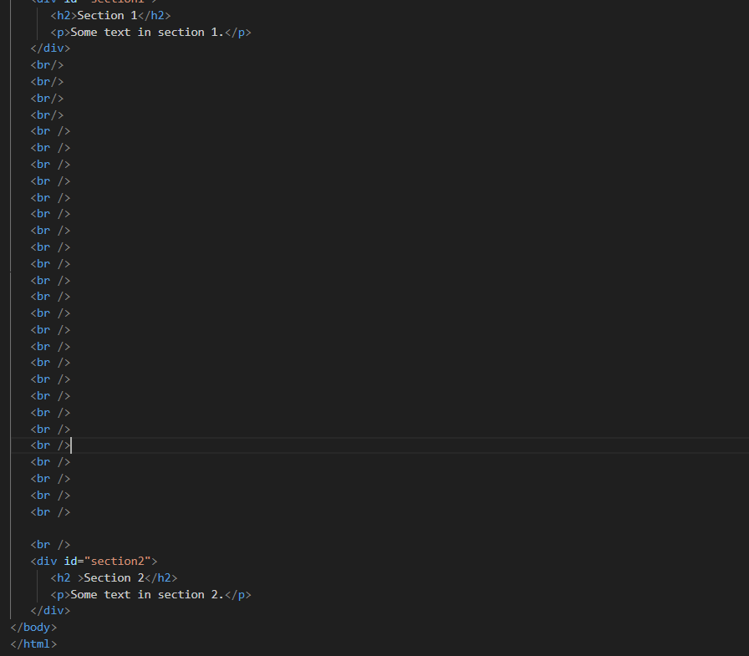

OUTPUT: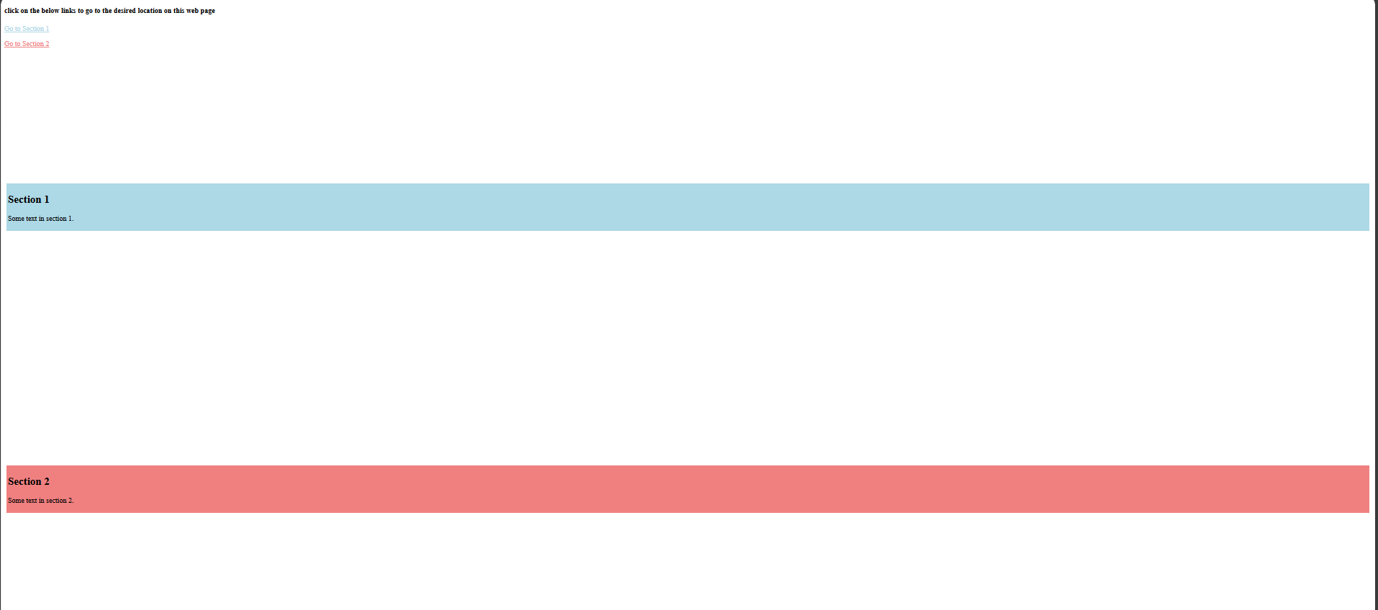

**Question 2:**

Create a web page, showing an ordered list of all semester courses enrolled.

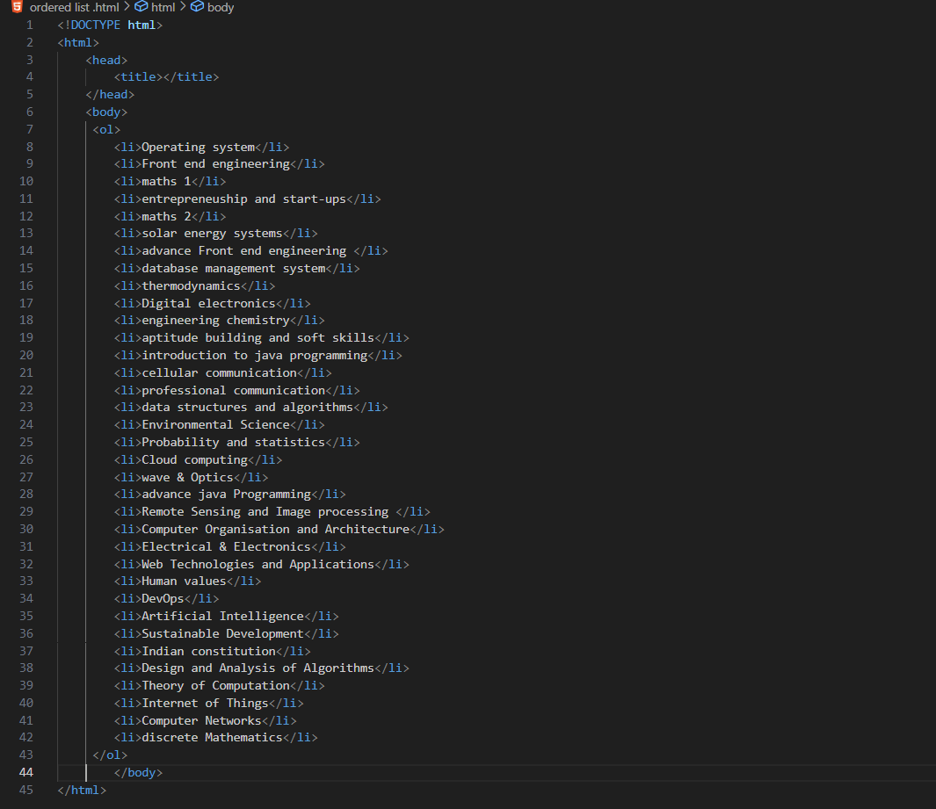

OUTPUT:

