QME Now
Comprehensive UI/UX Design Specification
Visual Redesign Brief for Claude Code
Prepared: Tue Jun 02 2026
All reference images are embedded below each section.

Document Purpose
This document is the authoritative design brief for the QME Now system redesign. Each section maps a screen or feature to its reference image (embedded directly below the description) and provides detailed specifications. Claude Code should treat this as the single source of truth.
Reference images are embedded inline so the system can see exactly what is being described. Color palette, typography, component style, and layout structure should all be derived from these images unless this document explicitly overrides them.

1. Global Design System

1.1 Color Palette — derived from Image 9
The primary brand palette for the entire QME Now system comes from Image 9 (NeoAI Landing Page) shown in Section 8.
- Primary Purple: #6B4EFF / #7B5FFF — CTAs, active states, brand highlight, primary buttons
- Deep Navy: #1A1A2E — page backgrounds, sidebar backgrounds
- Dark Surface: #16213E — card backgrounds, panel backgrounds
- Mid Surface: #0F3460 — secondary panels, table rows
- Accent Violet: #533483 — hover states, gradient midpoints
- Warm Yellow: #F5A623 — highlights, warnings, secondary accents
- White: #FFFFFF — primary text on dark backgrounds
- Light Grey: #CCCCCC / #E8E8E8 — secondary text, dividers, borders
- Success Green: #22C55E — confirmed states, completed statuses
- Error Red: #EF4444 — error states, destructive actions

1.2 Typography
- Font family: Inter or SF Pro (system font fallback)
- All dark-mode screens: white (#FFFFFF) primary text; #AAAAAA secondary
- Heading scale: H1 36px, H2 28px, H3 22px, Body 14–16px
- Stats and counters (queue numbers, timers, totals): font-weight 600–700
- Verification codes and IDs: monospace font (JetBrains Mono or Fira Code)

1.3 Component Rules
- Rounded corners: cards 12–16px, buttons 8–12px, pills 9999px
- Glassmorphism / frosted glass on modal overlays (backdrop-filter: blur)
- Cards: 1px border (rgba white 10–15%) on dark backgrounds
- Shadows: soft layered — no hard drop shadows
- Icons: outlined set (Lucide or Heroicons) — filled only for active/selected states
- Motion: 150–250ms ease-in-out transitions; no abrupt changes
- Spacing: 8px base grid (8, 16, 24, 32, 48, 64)

2. Lion's Stash Screen — Stylist / Service Provider View
📸 Reference: Image 1 — Donezo Dashboard
This is the screen the stylist or service provider sees while actively serving a client. The primary goal is real-time session awareness. Image 1 below is the direct layout reference.
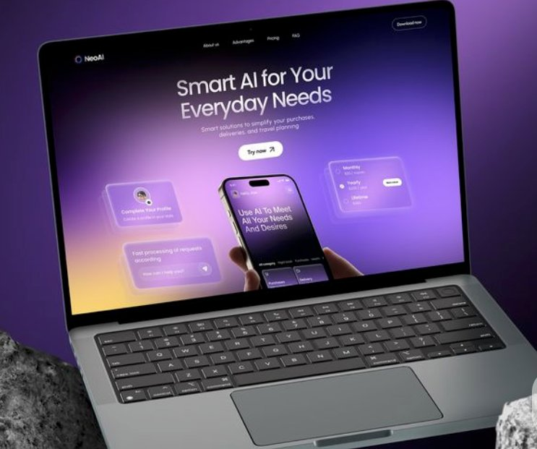
Image 1 — Donezo Dashboard (Lion's Stash / Session Timer Reference)

2.1 Layout Structure
- Left sidebar: navigation (Menu + General sections, same structure as Donezo in Image 1)
- Main area: row of 4 stat cards at top, then queue/analytics below
- Bottom-right: persistent session timer widget (see 2.3)

2.2 Stat Cards (Top Row)
- Four cards: Total in Queue, Served Today, Avg. Wait Time, Pending
- Primary card (Total in Queue): dark background with primary purple (#6B4EFF) instead of Donezo's green
- Each card has an arrow icon (top-right), large number, and trend indicator below

2.3 Session Timer — Critical Feature
Styled exactly like the Time Tracker widget in the bottom-right of Image 1. Always visible. Cannot be hidden.
- Dark card, large digital HH:MM:SS display, white digits, bold
- Pause button (outlined circle) + Stop button (filled red circle)
- Starts automatically when stylist scans the client QR code
- Stops automatically when moving to next client, or can be manually stopped
- Label above timer shows: current client name + ticket number
- Small refresh/reset icon in the corner of the card

2.4 Queue Panel
- Each row: client avatar/initials, name, ticket number, wait time, status pill (Next Up / Waiting / In Progress)
- '+ Add Walk-in' button replaces the '+ Add Member' button in Image 1
- Clicking a client row opens their details and allows the stylist to call them

2.5 Session Progress Widget
- Donut chart showing % of today's appointments completed
- Three segments: Completed, In Progress, Pending — same visual as Image 1's Project Progress

2.6 Next Appointment Reminder
- Shows next scheduled client: name, time slot, service type
- Green 'Start Session' CTA button — same style as the green 'Start Meeting' button in Image 1

3. Manager Dashboard
📸 Reference: Image 2 — Stavest Stock Dashboard
Dark-themed analytics and operations hub. Should feel like a financial command center. Image 2 is the direct layout reference.
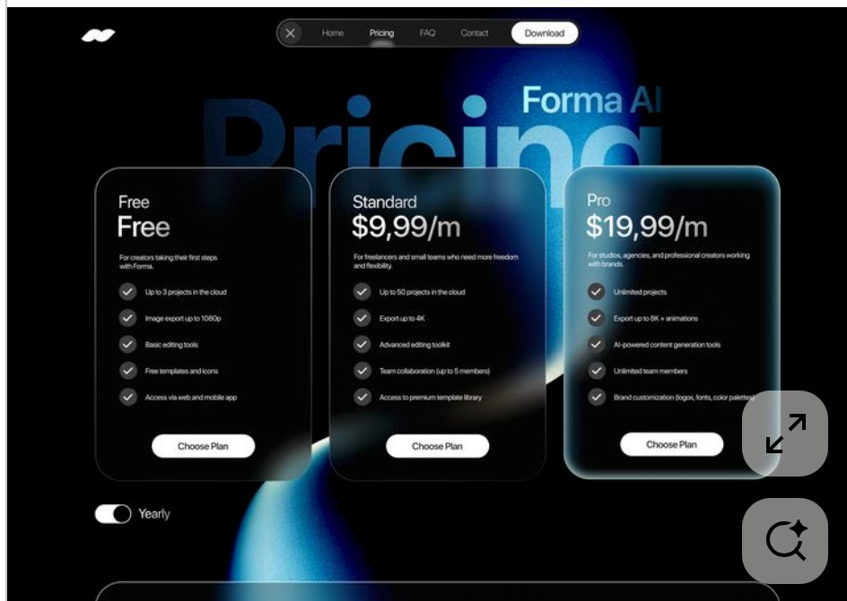
Image 2 — Stavest Stock Dashboard (Manager Dashboard Reference)

3.1 Layout
- Left sidebar with nav sections; active item uses a bright blue/purple pill highlight
- Top bar: welcome message, search, notification bell, settings, avatar
- Main area: full-width cards and charts

3.2 Total Queue Count (replaces Total Holding)
- Large number, prominent — today's total queue count
- Time period toggle: Today / Week / Month (same pill style as Image 2's 6M/1Y buttons)
- Trend indicator: green arrow + % vs last period

3.3 Active Stations (replaces Portfolio Cards)
- Horizontal scrollable row of cards — one per station/stylist
- Each card: stylist name, current client, session duration, status
- Active station card is highlighted — similar to selected stock card in Image 2

3.4 Queue Performance Chart (replaces Portfolio Performance)
- Full-width area chart, dark background, blue/purple gradient fill under the line
- X-axis: time of day; Y-axis: queue length or clients served
- Hoverable tooltip; time range buttons: 1D / 1W / 1M / 3M

3.5 Queue Overview Table (replaces Portfolio Overview)
- Columns: Client Name, Ticket #, Check-in Time, Wait Time, Station, Status
- Filter tabs: All / Active / Waiting / Completed

3.6 Alerts Panel (replaces Watchlist)
- Real-time alerts: long wait times, no-shows, idle stations
- Tabs: Most Urgent / Active / Resolved

4. Executive Dashboard
📸 Reference: Image 3 — DWISON eCommerce Dashboard
High-level business overview. Dark background with green accent highlights from Image 3 — use QME Now purple as the primary accent instead of green.
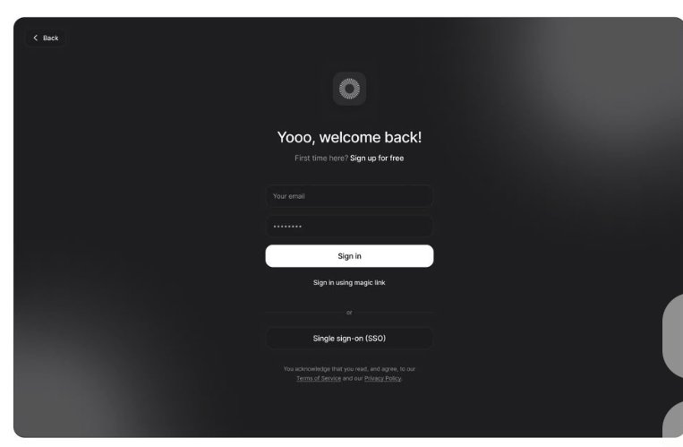
Image 3 — DWISON eCommerce Dashboard (Executive Dashboard Reference)

4.1 Layout
- Three-column: narrow left sidebar, wide main content, right panel (notifications + activity)

4.2 KPI Cards (Top Row)
- Four cards: Total Revenue, MRR, Occupancy Rate, Total Clients Served
- Quarterly goal card uses the radial/donut progress indicator from Image 3

4.3 Business Overview Widget
- Donut chart: service category breakdown
- Category list to the right: label + count/value
- Sparkline chart showing profit trend (top-right of the widget)

4.4 Client List Table
- Columns: Name/Email, Visits, Total Spend

4.5 Enterprise Upsell Card
- Retain the Premium Plans card style from Image 3; adapt for QME Now's enterprise tier
- Green 'Get Started' CTA

4.6 Right Panel (replicate exactly from Image 3)
- Notifications: new registrations, bookings, system alerts, unread messages
- Activities: recent changes, updates
- Contacts of managers: list with action menus (...)

5. Mobile App — General UI Feel
📸 Reference: Image 4 — Project Management App
Image 4 defines the overall visual language for QME Now's mobile app. Clean, minimal, bold typography, generous white space.
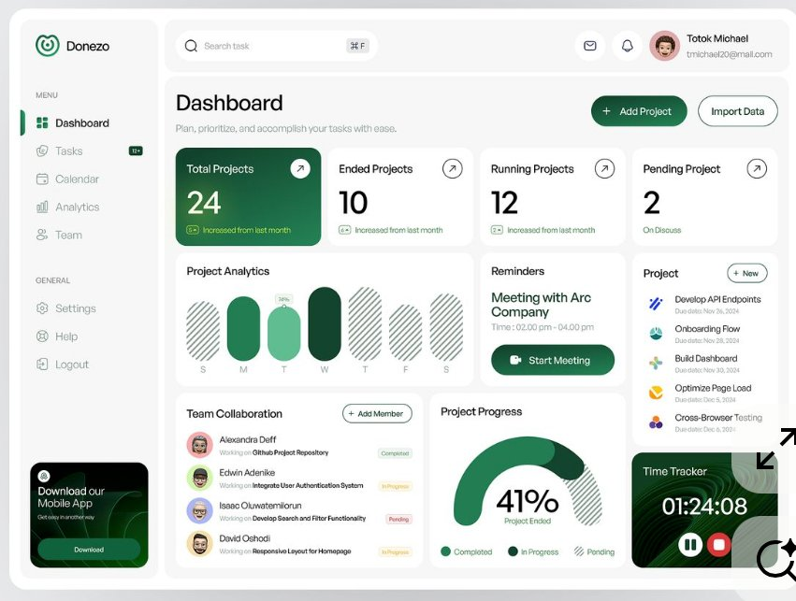
Image 4 — Project Management App (Mobile UI Reference)

5.1 Overall Mobile Aesthetic
- Main surfaces: near-white (#F8F8F8) or true white
- Primary cards: near-black (#1C1C1E) dark card with white text
- Secondary cards: light grey (#F0F0F0) surface
- Bold, large headings at the top of every screen
- User avatar in top-right corner
- 24px horizontal padding on all screens

5.2 Home Screen
- Top: bold greeting ('Hey [Name]! You're in line') + avatar
- Search bar below greeting
- Horizontal card scroll: dark card = primary/active, light card = secondary
- Task/quick actions list: checkbox rows with status dots
- Bottom tab bar: Home, Schedule, Notifications, Profile + centered '+' FAB

5.3 Today / Schedule Screen
- Date displayed prominently at top
- Horizontal week strip — selected date in dark pill
- Timeline view: vertical line with time-stamped event cards
- Active event: dark background, title, description, participant avatars, checkmark
- Inactive events: white background, title, description only

5.4 Client Queue Screen
- 'You are #12 in line' — position number, large, bold, centered
- Estimated wait time below
- Progress indicator showing queue position
- When called: full-screen transition to QR code screen (Section 7)

6. Additional Design Reference — Financial App Aesthetic
📸 Reference: Image 5 — Pinterest Financial App Designs
Secondary visual reference for card-based layouts, balance displays, and transaction list styling.
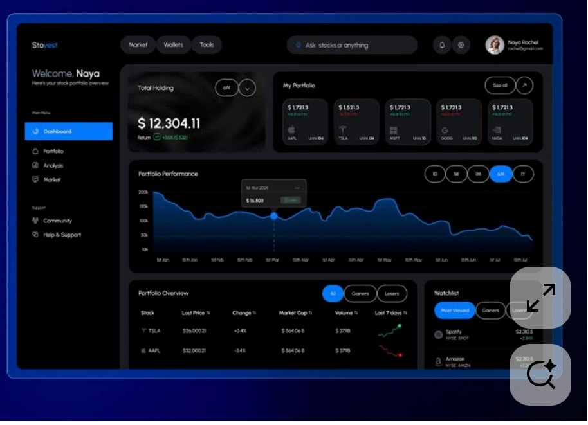
Image 5 — Pinterest Financial App Designs (Secondary Reference)
- Card with balance prominently displayed at top
- Dark mobile fintech aesthetic: deep blacks, high-contrast numbers
- Transaction lists: icon, merchant name, amount (green income / red expense)
- Informs the billing/invoicing screens and the client mobile home screen header card

7. Invoice / Billing Mobile Screens
📸 Reference: Image 6 — Invoice App
Informs the look of QME Now's payment, billing, and receipt flows on mobile.
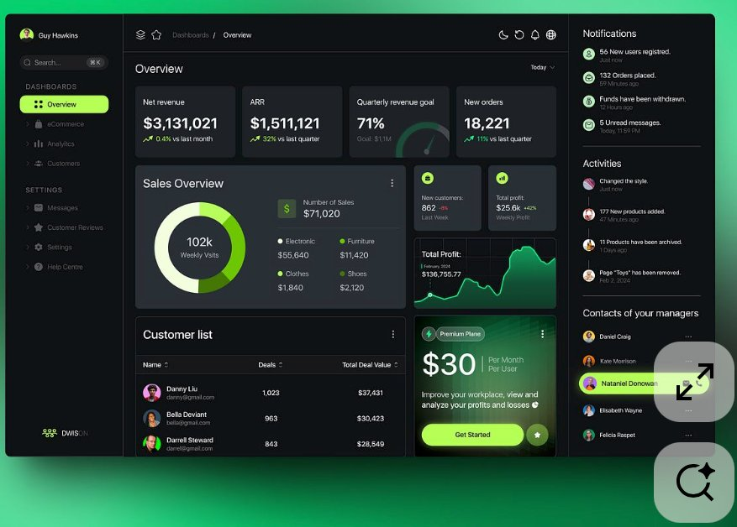
Image 6 — Invoice App (Billing & Payment Mobile Reference)

7.1 Invoice List Screen
- Dark background (#0D0D0D / #111111)
- Top: user greeting + wallet/balance summary card
- Filter tabs: All / Open / Paid (pill-style)
- Each invoice: icon, client name, amount, date, status dot (Paid = green, Open = yellow)
- Grouped by date: TODAY / THIS MONTH / EARLIER

7.2 New Invoice / Checkout Screen
- Step indicator at top ('Step 2 of 3')
- Line items: service name, qty x price
- '+ Add Item' button at bottom of items list
- Subtotal, Tax (%), Total breakdown
- Bright green 'Continue' CTA — full width, rounded

7.3 Receipt / Details Screen
- Invoice number at top
- Meta grid: invoice date, total, status
- 'Mark as Paid' — full-width green button
- 'Share' and 'Edit' secondary buttons side by side
- 'Download Receipt' link
- QR code displayed below

8. QR Code Client Verification Flow — New Feature
When a client reaches the top of the queue, the system shows them a QR code. The stylist scans it (or the client reads a 6-character code aloud) to verify identity before starting the session — similar to Uber's rider PIN verification.

8.1 Client Mobile — QR Code Screen
- Full-screen takeover when client is called to the top
- Animated banner at top: 'You're up! Head to the chair now'
- Center: large QR code (minimum 240×240px on screen)
- Below QR: 6-character alphanumeric code in large monospace font (fallback)
- Bottom: client name, ticket number, station/chair assignment
- QR auto-refreshes every 60 seconds for security
- Background: dark with animated gradient or pulse effect

8.2 Admin / Stylist — Verify Modal
- When stylist taps 'Call Next Client', a modal appears
- Shows next client name + ticket number
- Two options: Scan QR (activates camera) or Enter Code (6-char input field)
- On success: modal closes, session timer starts, Lion's Stash updates
- On failure: red error border, 'Code does not match — please try again'

8.3 Client State Machine
- Waiting → Called → Verifying → In Session → Completed
- Queue positions update in real-time for all waiting clients when one is called
- No-show threshold: if client doesn't appear within X minutes, system marks no-show and calls next

9. Marketing Website

9.1 Color Scheme — Image 9 (Primary Reference)
📸 Reference: Image 9 — NeoAI Landing Page (color scheme + landing page layout)
The marketing website takes its entire color identity from Image 9. Do not deviate from this palette.
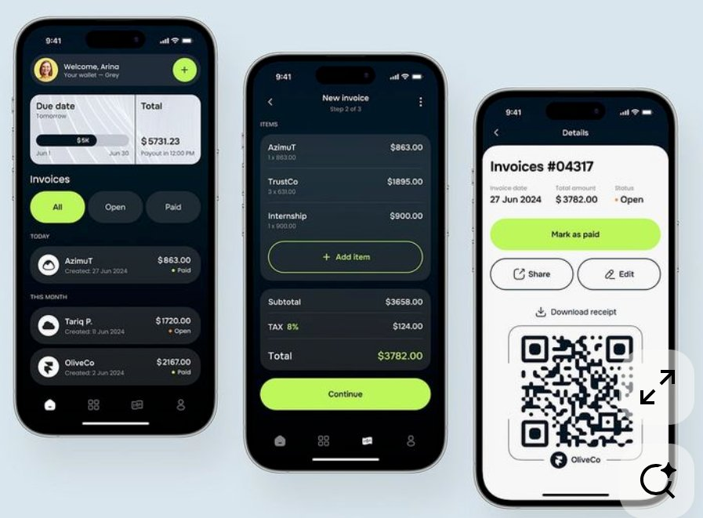
Image 9 — NeoAI Landing Page (Marketing Website & Color Scheme Reference)
- Page background: deep dark purple-to-indigo gradient (#0D0D1A → #1A0A2E)
- Primary CTA button: bright purple (#7B5FFF) with white text
- Secondary text: soft lavender (#C4B5FD or #A78BFA)
- Accent warm glow: bottom-left warm yellow-orange (as seen in Image 9)
- Headlines: white; body copy: soft purple-grey

9.2 Hero Section — pixel-for-pixel from Image 9
- Headline: 'Smart Queue Management for Your Business' (bold, large, white)
- Subheadline: 'Simplify appointments, reduce wait times, and delight your clients'
- Primary CTA: 'Download the App' — purple button
- Secondary CTA: 'Try for Free' or 'Book a Demo'
- Center: floating phone mockup showing the mobile app UI
- Surrounding the phone: floating feature highlight mini-cards (same as Image 9's layout)
- Mini-cards content: 'Complete Your Profile', 'Fast Queue Processing', 'Real-time Updates', pricing toggle

9.3 Pricing Section — Image 7 Reference
📸 Reference: Image 7 — Forma AI Pricing Page
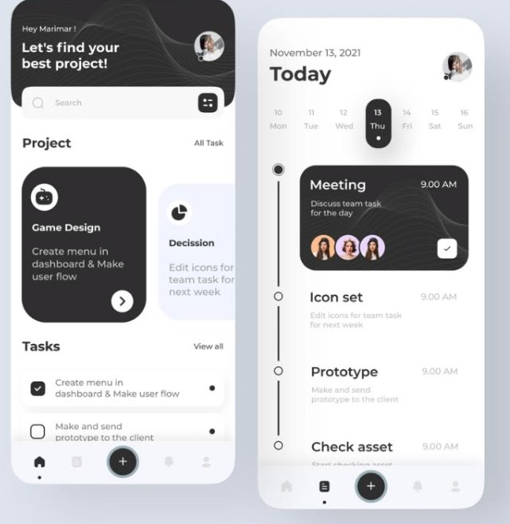
Image 7 — Forma AI Pricing Page (Pricing Section Reference)
- Dark background with blue/purple radial glow in center
- Large 'Pricing' text in background (oversized, transparent/blurred)
- Three glassmorphism pricing cards:
  - Free — for individual clients checking in
  - Standard: $9.99/m — for solo providers or small shops
  - Pro/Enterprise: $19.99/m — for studios/salons; includes desktop app license
- Each card: plan name, price, description, feature checklist, 'Choose Plan' button
- Pro card is slightly elevated/scaled and highlighted (as in Image 7)
- Monthly/Yearly billing toggle at the bottom

9.4 Navigation Bar
- Dark background, minimal; logo left, links center, 'Download' CTA pill right
- Nav links: Home, Pricing, FAQ, Contact — with rounded active state pill

9.5 Sign-In / Auth Page — Image 8 Reference
📸 Reference: Image 8 — Dark Sign-In Page
The sign-in page for the web portal and desktop app should match Image 8 in layout and feel.
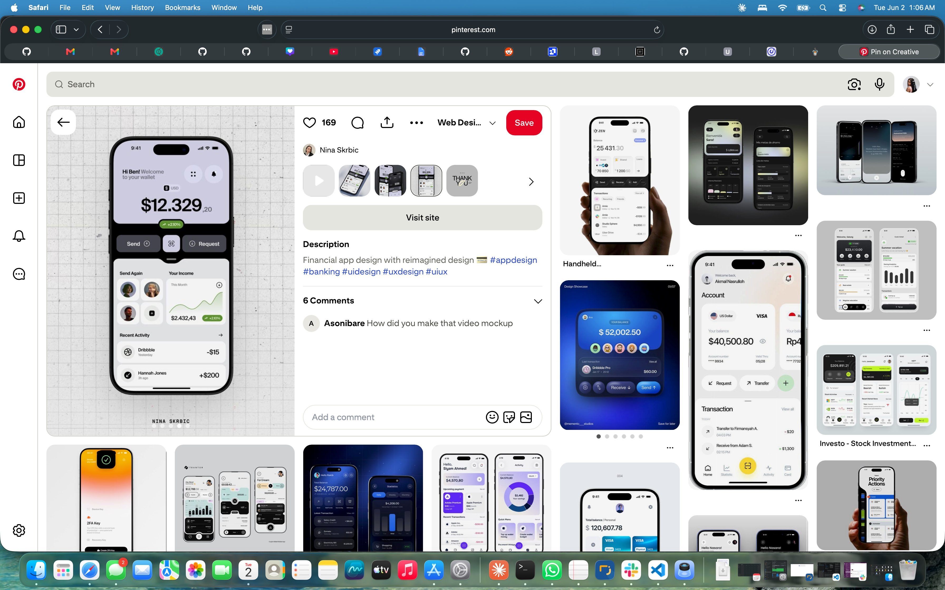
Image 8 — Dark Sign-In Page (Auth / Desktop App Reference)
- Full-page dark background, white/grey radial gradient spotlight from the right
- Center-aligned form (no visible card border — floats on the gradient)
- Small circular logo icon at top with geometric/spiral pattern
- Headline: casual and warm — 'Yooo, welcome back!' style
- Sub-line: 'First time here? Sign up for free' with clickable link
- Form: Email input, Password input — minimal, white-bordered on dark bg
- Primary button: white bg, dark text 'Sign in' — full width, high contrast
- 'Sign in using magic link' text link
- Divider: 'or'
- 'Single sign-on (SSO)' outlined dark button, full width
- Legal copy: Terms of Service + Privacy Policy links in muted blue underline

10. Desktop App (Windows / macOS)
The desktop app is the enterprise/licensed version for salon and shop owners. It blends the dark dashboard aesthetic from Images 2 and 3 with the focused, minimal sign-in feel from Image 8.

10.1 Application Chrome
- Native dark title bar (#0D0D0D); standard window controls per OS
- Persistent left sidebar: navigation, user profile, quick stats at bottom
- Top bar: search, notifications, settings gear, user avatar
- No browser chrome — feels like a native app

10.2 Dashboard Screens
- Loads to Manager Dashboard (Section 3) or Executive Dashboard (Section 4) based on user role
- All specs from Sections 3 and 4 apply; three-column layout fully expanded on desktop
- Right panel (notifications, activity) always visible — never collapsed on desktop

10.3 Desktop-Only Features
- QR Code scanner: webcam integration to scan client QR codes
- Multi-tab support within the app (multiple queue views, multiple stations)
- Keyboard shortcuts: call next, pause timer, mark as complete
- Persistent session timer visible in the title bar or taskbar area

11. Implementation Notes for Claude Code

11.1 Build Priority Order
- 1. Marketing Website — landing page, pricing, sign-in (Images 9, 7, 8)
- 2. Mobile App — home + schedule screens (Image 4)
- 3. QR Code Verification Flow (Section 8 — no image, described only)
- 4. Lion's Stash / Stylist Screen (Image 1)
- 5. Manager Dashboard (Image 2)
- 6. Executive Dashboard (Image 3)
- 7. Desktop App (Images 2, 3, 8)

11.2 Recommended Tech Stack
- Mobile: React Native (or Flutter)
- Web (marketing + portal): React + Tailwind CSS
- Desktop: Electron wrapping the React web app
- Charts: Recharts or Tremor — match exact chart style from Images 2 and 3
- Icons: Lucide React (outlined)
- Animation: Framer Motion for transitions and micro-interactions

11.3 Responsiveness
- Marketing website: fully responsive (desktop, tablet, mobile)
- Dashboard apps: desktop-first; tablet desirable; not mobile-responsive (mobile has its own app)
- Mobile app: 375–430px width (iOS and Android phones)
— End of QME Now Design Specification v1.1 —

