1. move is to increase or decrease the height or width in uneven proportion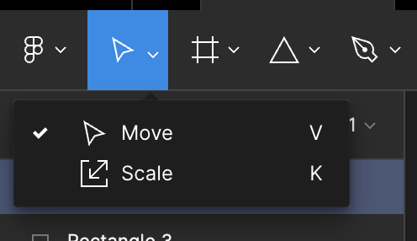
2. scale is to reshape the shape in even proportion
3. normal mode and vector mode🡺normal mode🡺click on shape then ur are in normal mode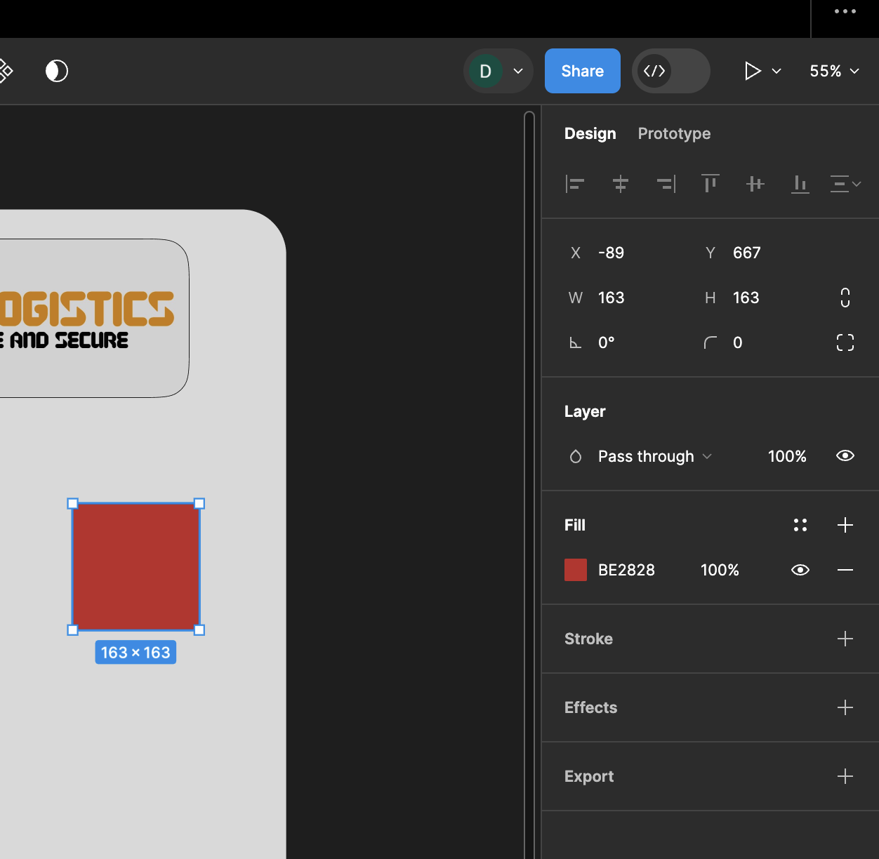

to go to vector mode🡺be on normal mode and click enter:

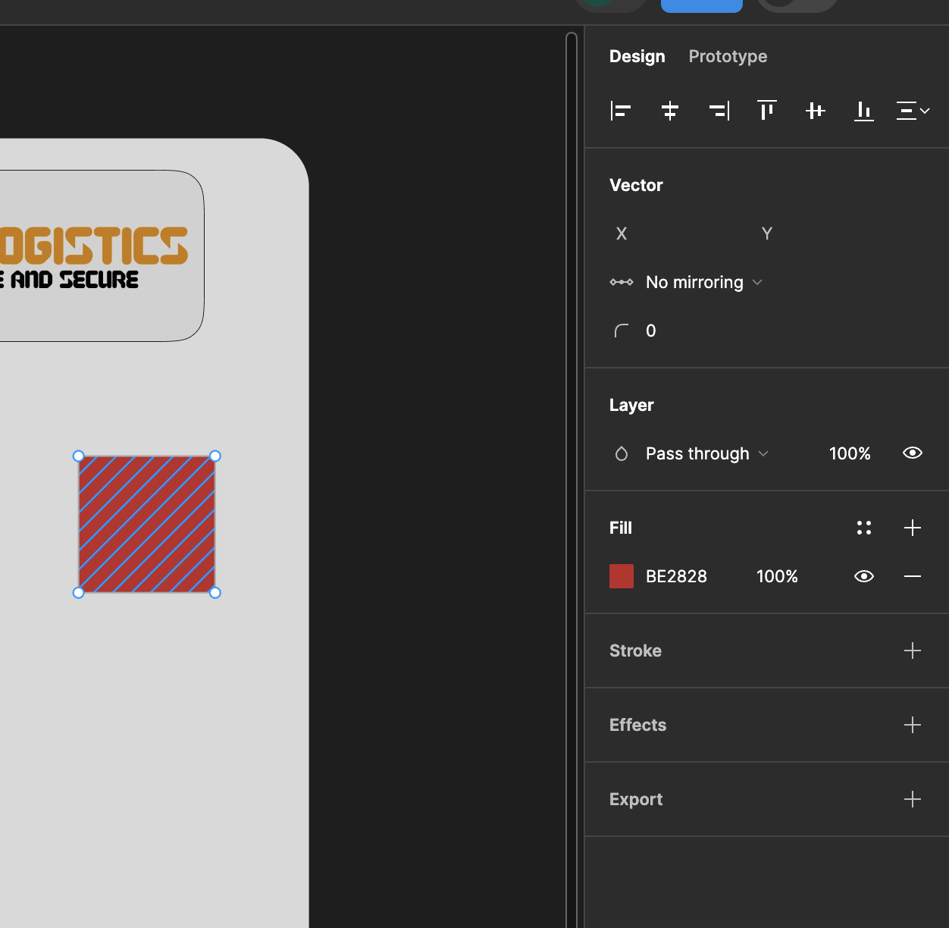

1. in vector mode we can get n number of edges by placing cursor in b/w two edges u will get one point and I u place the cursor again in b.w that mid point and other edge again u will get another mid point and soo on

got the following shape from rectangle by vector selection mode:

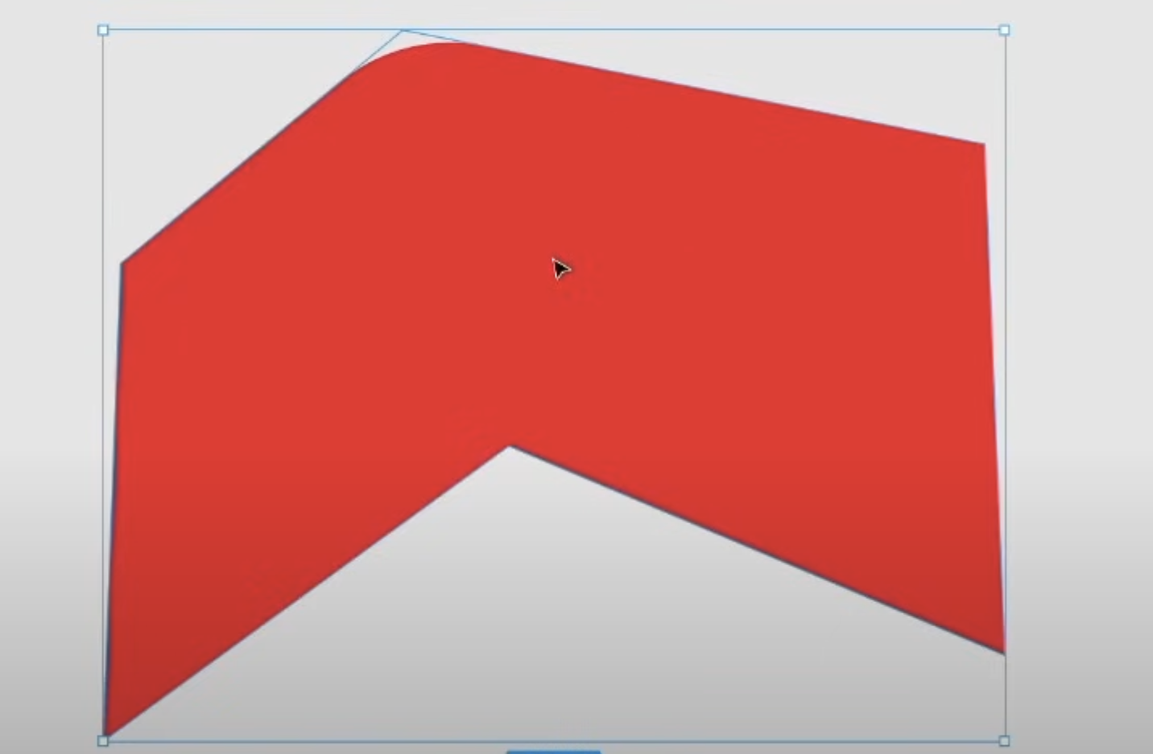

1. to create a custom vector point go to vector mode on any shape first then selct the pen option in tool bar then place the pen where u want to insert the vector point and then u will be having to place another point so to get rid of that click on esc

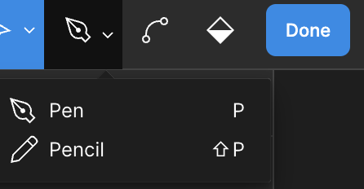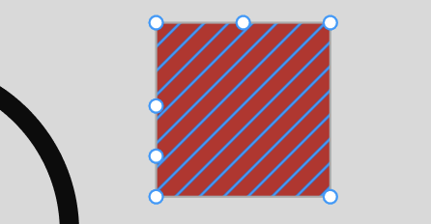

Extra vector point insatlled



1. in figma u can also icrease and decrease no of sides for some shapes like polygon and stars
2. For normal 5 count star if count ==8 it would be as below

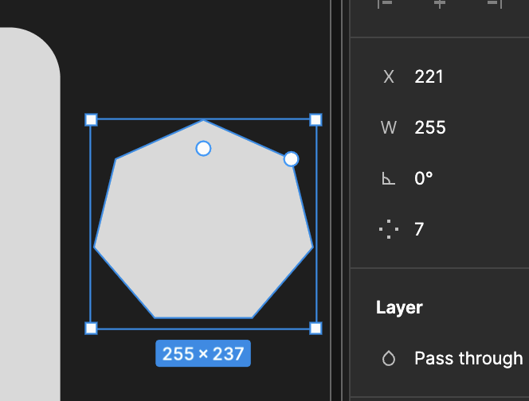

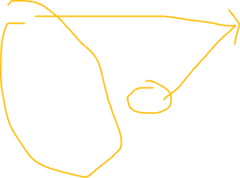

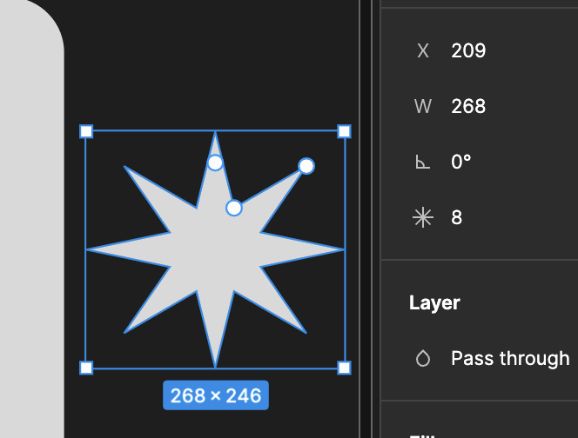

1. In figma we have three measurement

🡺pixel(44)  
🡺percentage(44%)

🡺degrees(44 °)

1. Design tree:

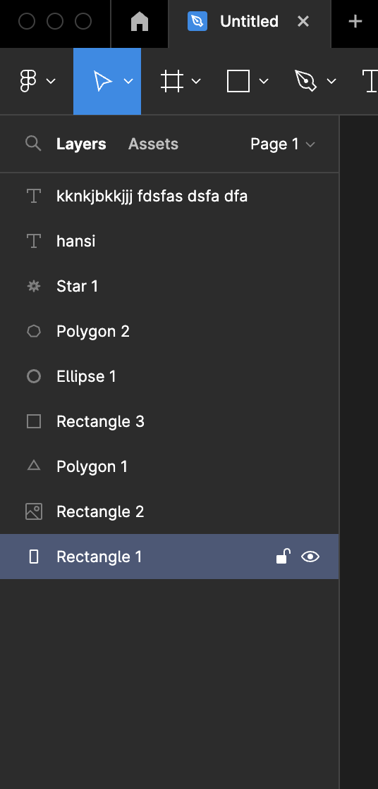`

Contains the objects created in figma canvas

