**Cordova Android App using Alchemy API and Cloudant**

(Can be extended to iOS and Windows)

-Deepak Rai

@itsdeepakrai

**Pre-requiste**

Install Node.js - <https://nodejs.org/en/>

Eclipse with ADT Plugin installed

Install Android SDK - <http://developer.android.com/sdk/index.html>

**Steps**

1. Create a Cordova App using the cmd promt

cordova create FeedbackApp com.dpk.feedback FeedbackAPP

1. Enter the FeedbackApp Directory

cd FeedbackAPP

1. Add the Platform Android to the existing project

cordova platform add android

1. Will be able to see the following folder structure inside the directory

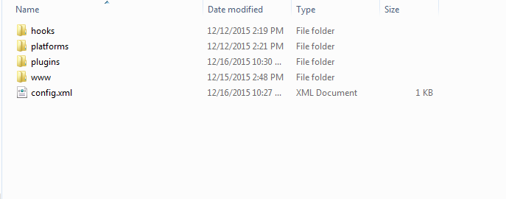

1. Copy the contents of www folder from <https://github.com/itsdeepakrai/Feedback-APP> and replace the contents from www folder locally
2. Import the project to Eclipse
3. Go to <https://console.ng.bluemix.net/>
4. Sign UP/Sign IN (IF loging for the first time, Create a space if it doesn’t exist)
5. Go to Catalog, Select Watson from left hand Menu

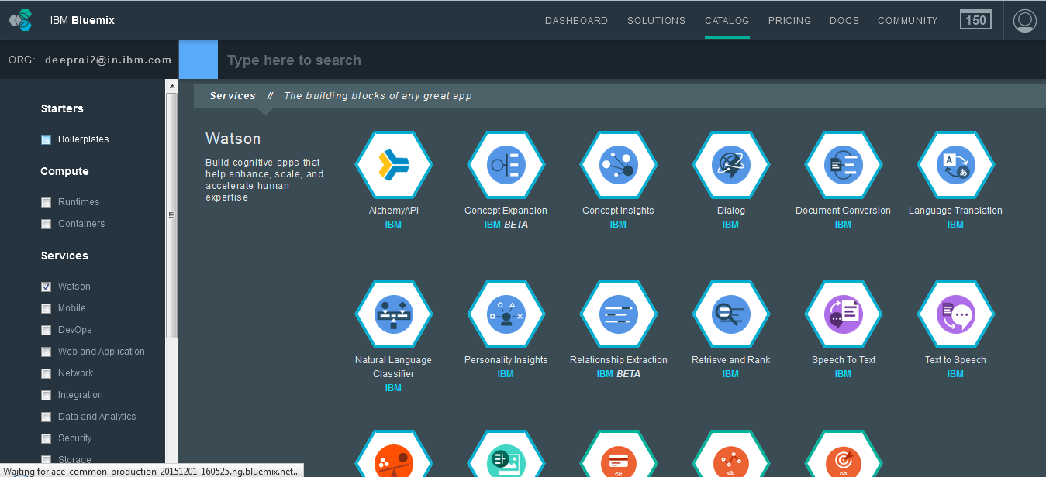

1. Go to AlchemyAPI

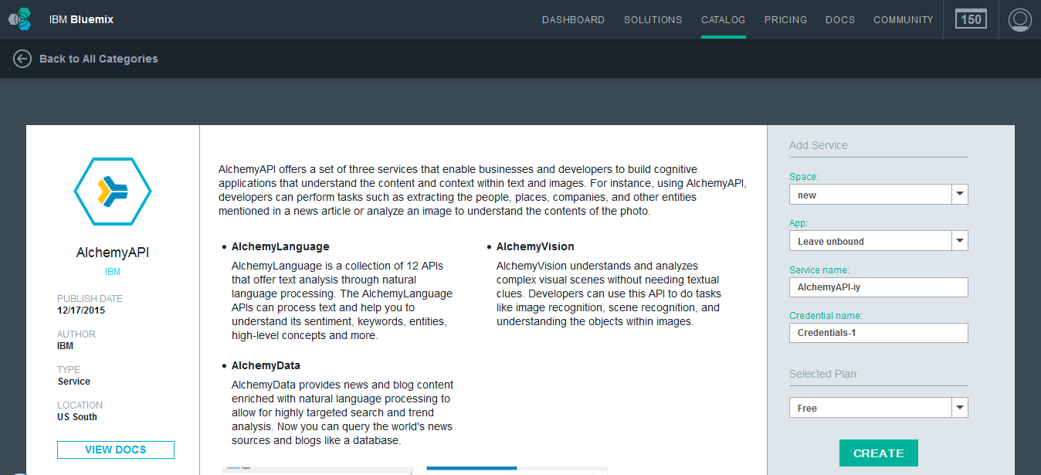

1. Will be able to see your apikey for alchemy api from service credentials

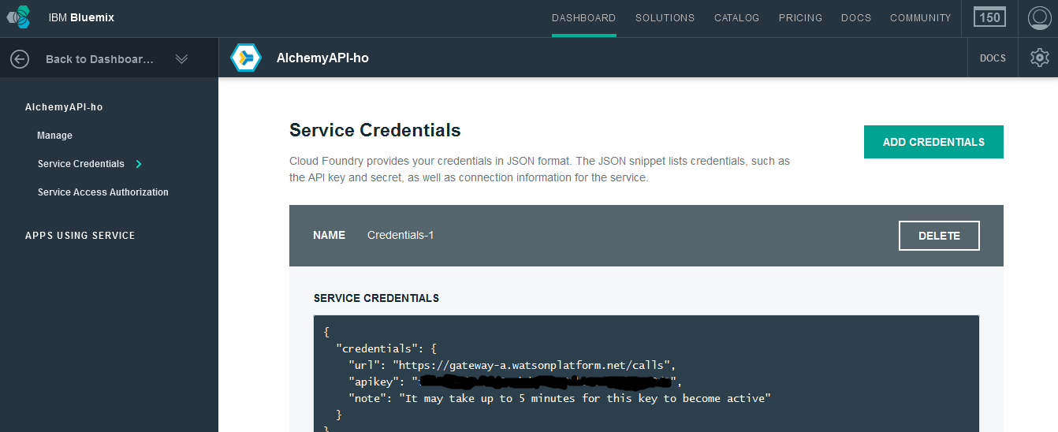

1. Copy the apikey to the senti.js file
2. Similarly create the cloudant Database in Bluemix.
3. Create a Databse in Cloudant and Create Views (Link will be updated)
4. Before the running the project , for any changes made in the code to reflect in the application we must run

Cordova Prepare android

Each time in the cmd prompt.

