+
-Add Ons for Better Coder –
JS Objects >
JS Object Structure with few examples of accessing individual property.
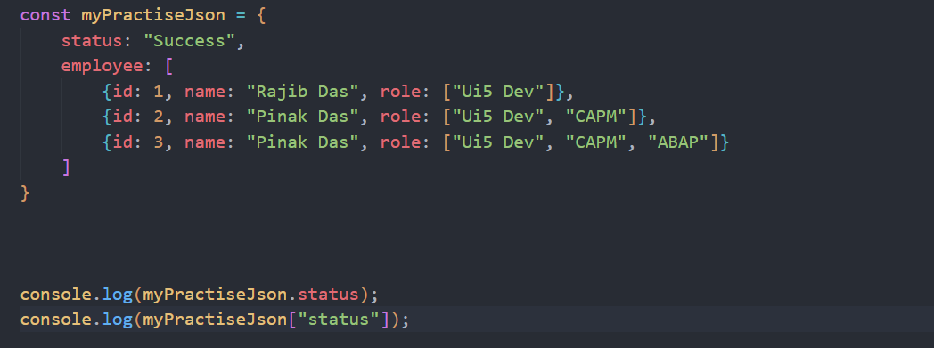
Remember for accessing JS object we can use objectName.Key or objectName[“Key”]
Also, we cannot treat a JSON as variable and access, we can only if we convert it to JS Object.
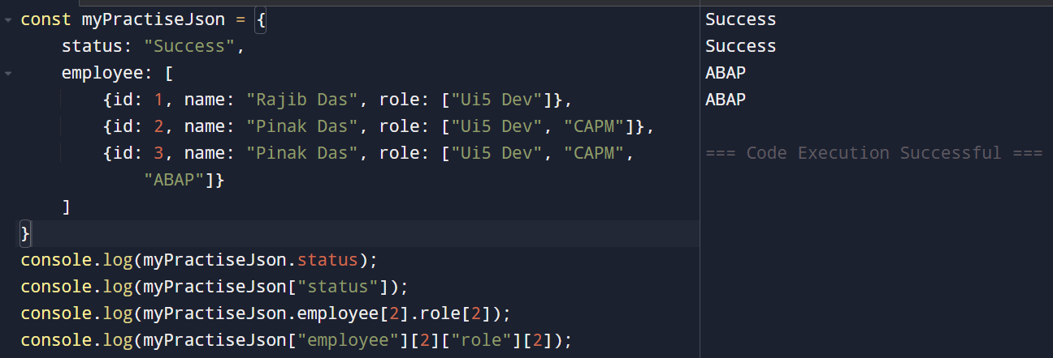
Another Example –
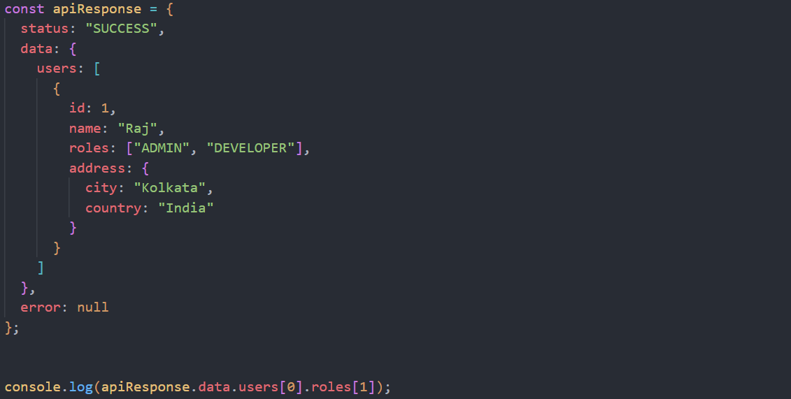
Answer is “Developer”
JSON >
It is a lightweight, text-based data format used to store and exchange data, especially between a frontend (browser / UI5 / JavaScript) and a backend (Java, Node.js, SAP, etc.).
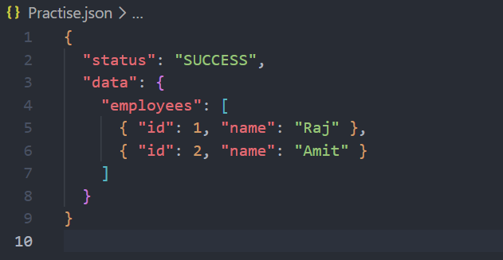
Remember JSON cannot be stored in a variable, we can need to convert to JS Object.
How to convert JS Object to JSON and JSON to JS Object >
For converting JS Object to JSON, we need to use JSON.stringify(variable) and converting JSON to JS Object we need to use JSON.parse(stringFormat)
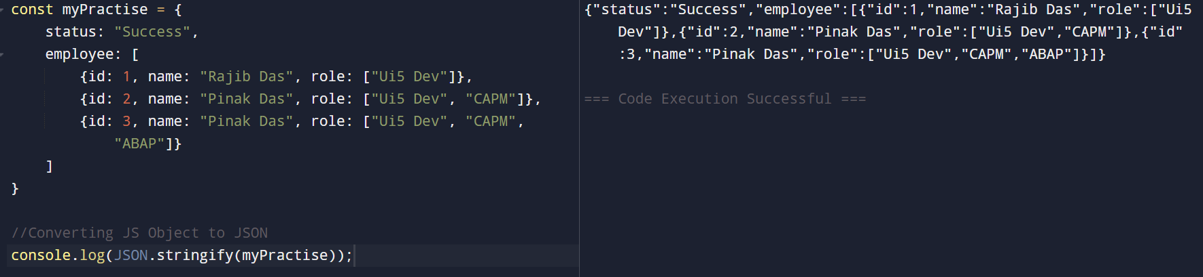
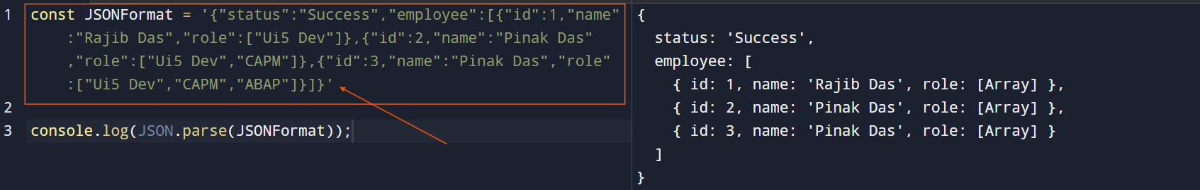
Parse needs String as input.
Functions are ignored while conversion
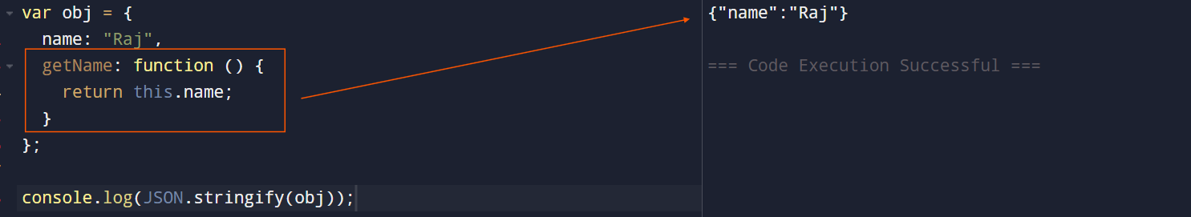
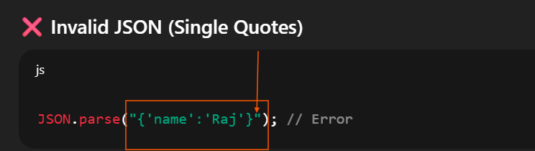
Remember for JSON to JS Object only ‘ ‘ is allowed
IMP >
JS Object can be written as below as well, never get confused (internally JS store it as JS Object) >> For JSON to be stored in a variable we need it in string format with single courts
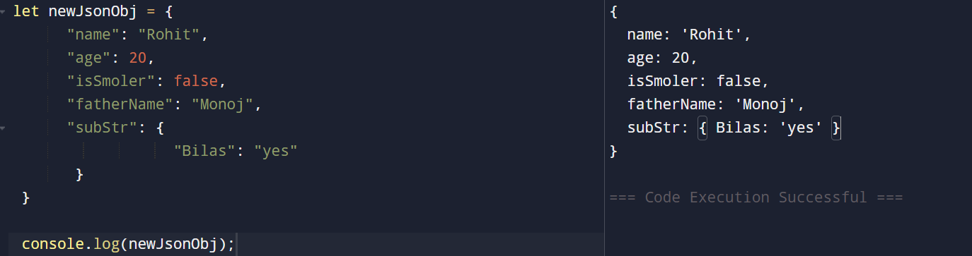
If we don’t assign in variable then it can be JSON, existing in .Json file.
Destructuring objects >
Object destructuring allows us to extract properties from an object into variables using a concise syntax.
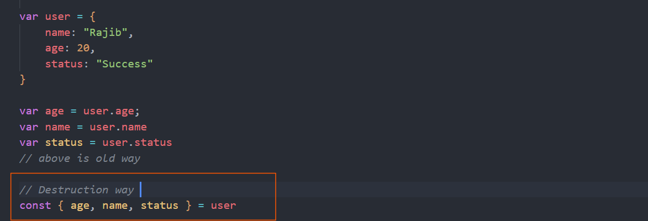
Remember VVI – Array destructuring or Object Destructuring gives the elements or values from array or object in a Variable
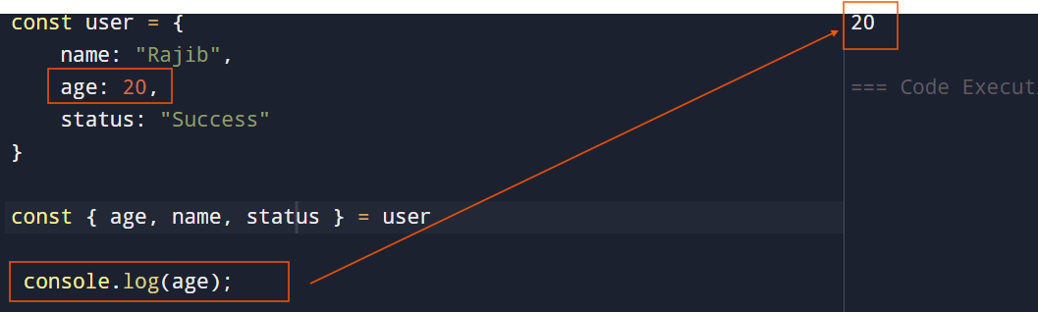
Renaming Variable
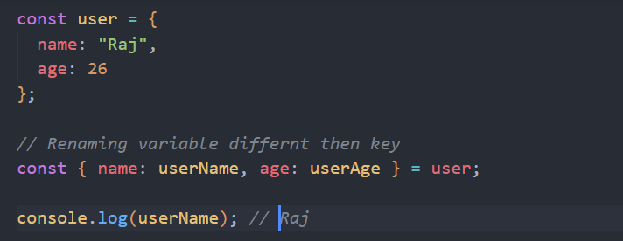
Default Values
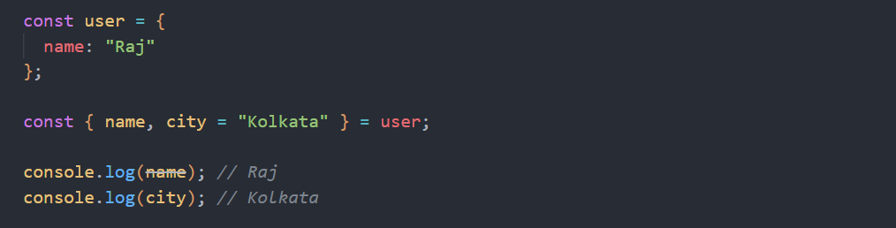
Destructuring Nested Objects
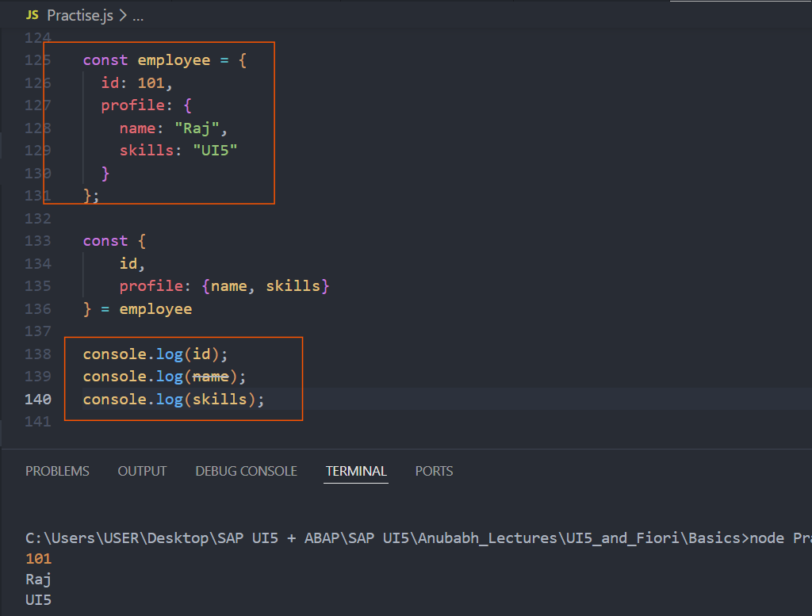
Destructuring Objects with Arrays Inside
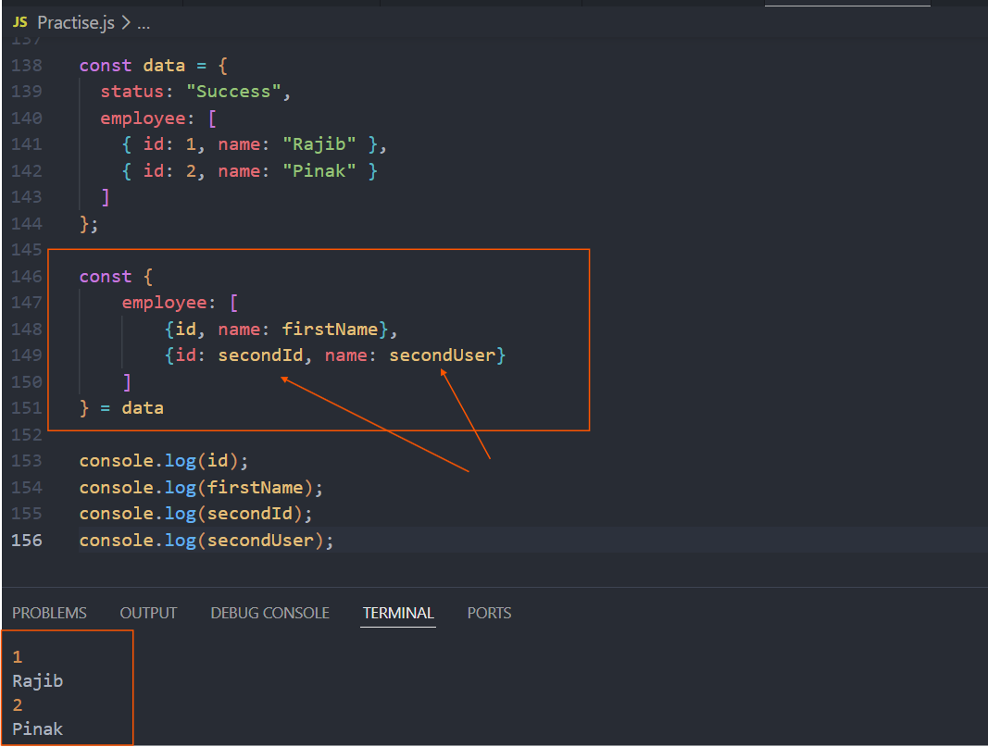
Destructuring in Function Parameters
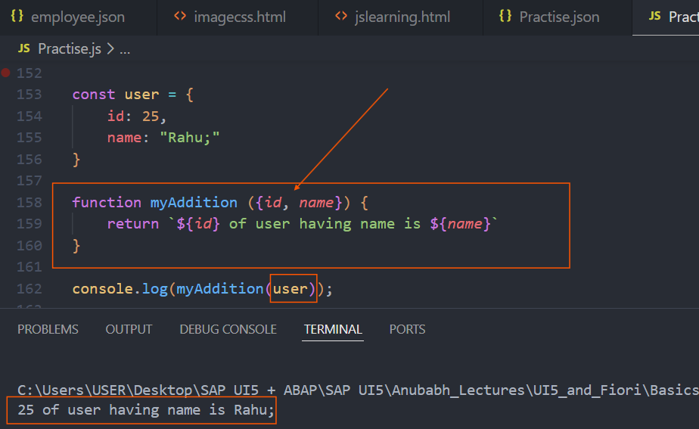
Array destructuring >
Simple example
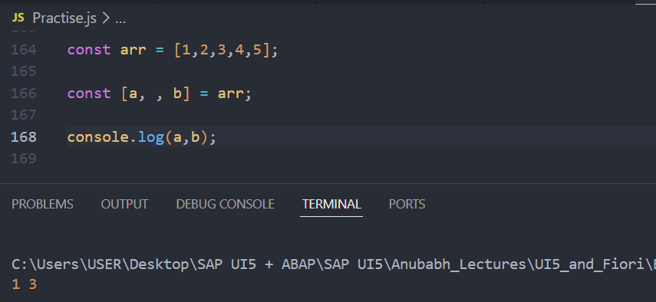
Example with function
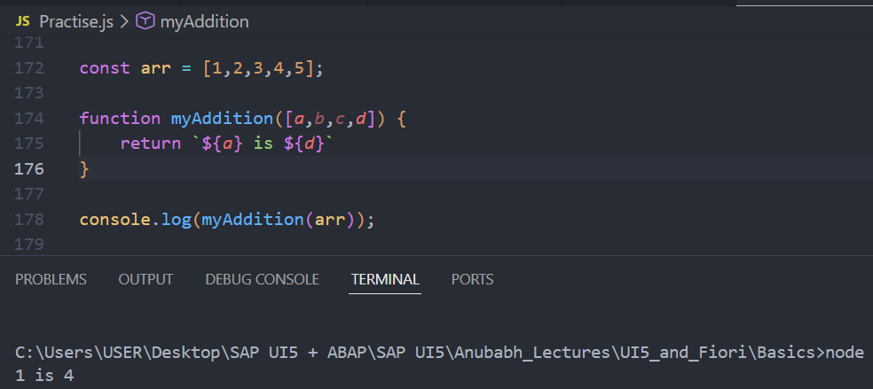
See in above example it is clear that we are getting a, b, c, d as variable or directly as parameter.
Rest and Spread Operator >
The rest operator collects multiple values and packs them into a single array or object depending on the data type. Remember for function arguments it collects array or object inside Array only.
Examples >
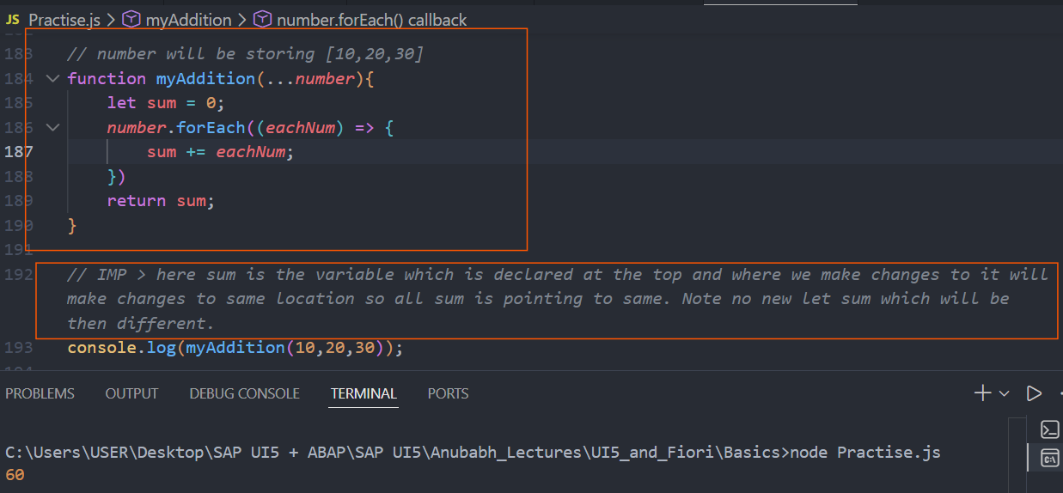
IMP > here sum is the variable which is declared at the top and where we make changes to it will make changes to same location so all sum is pointing to same. Note no new let sum which will be then different.
Simple when we try to assign some object or array, we can use Rest operator syntax …Rest.
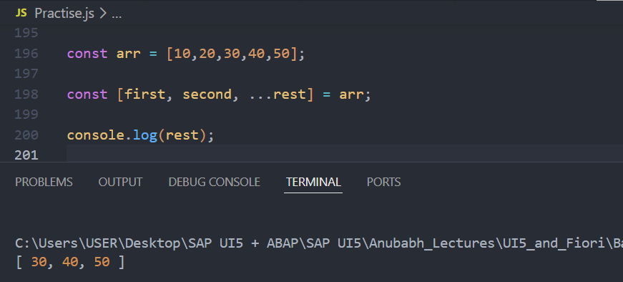
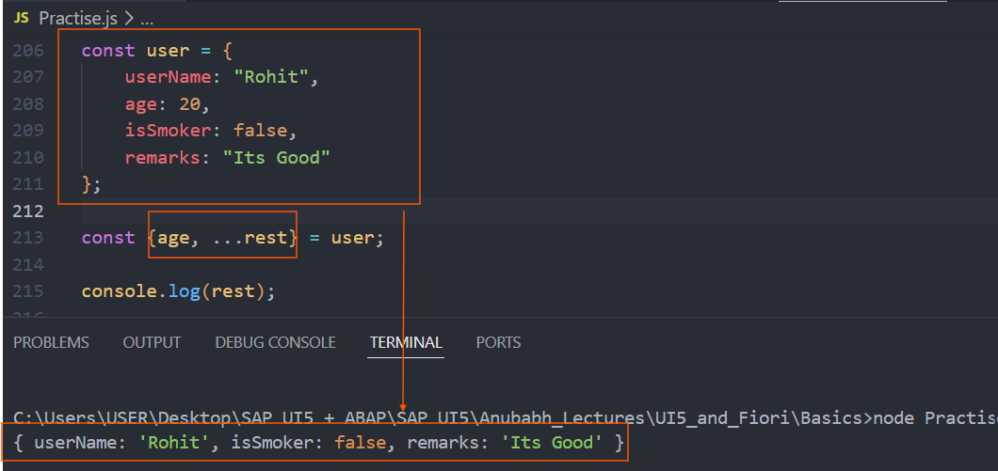
See above example, It is key name which matters we can keep key any place. Also Remember REST should be at last.
Spread > The spread operator expands an array or object into individual elements.
Basically, rest collects and put array or object depending on the data type. Whereas Spread opens array or object and make it open.
Examples
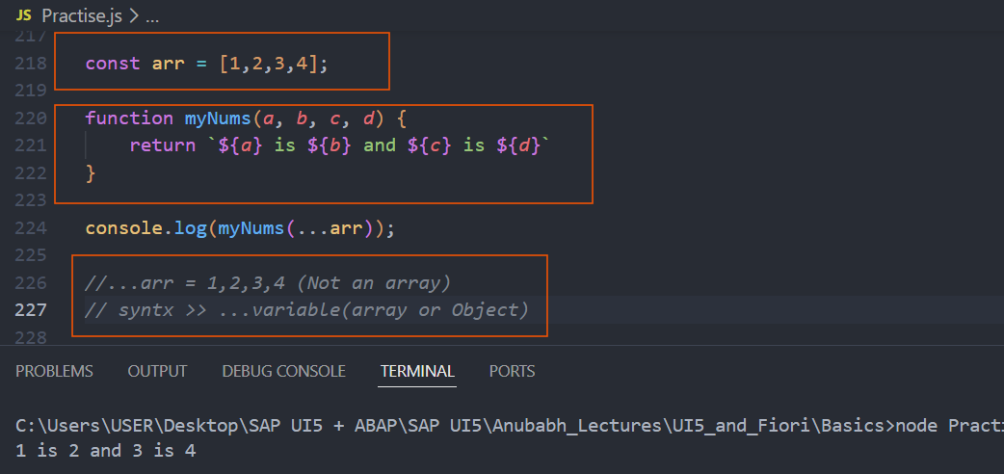
Merging two arrays and Object
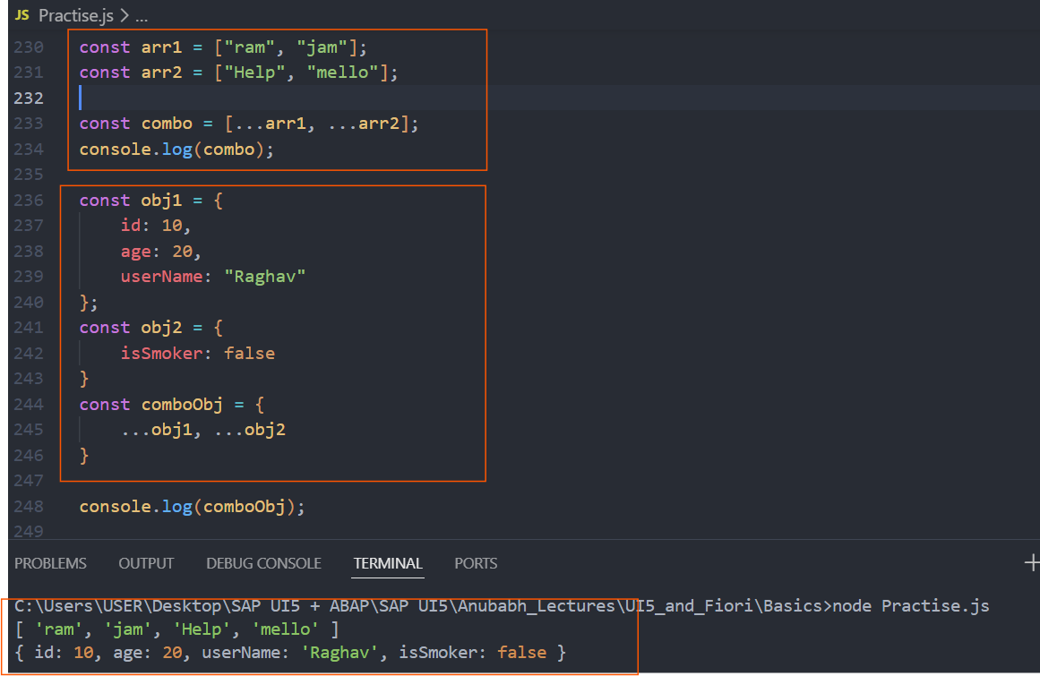
Cloning an array
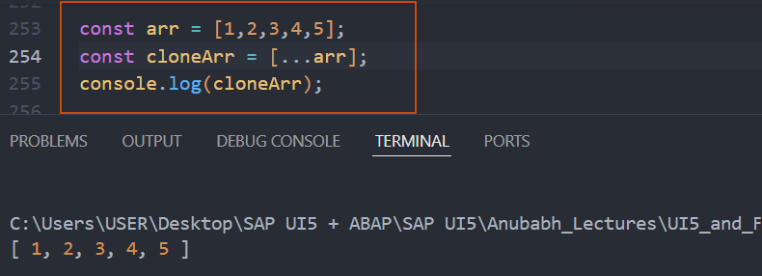
Rest and spread together – Rest with function behaves differently than destructuring IMP
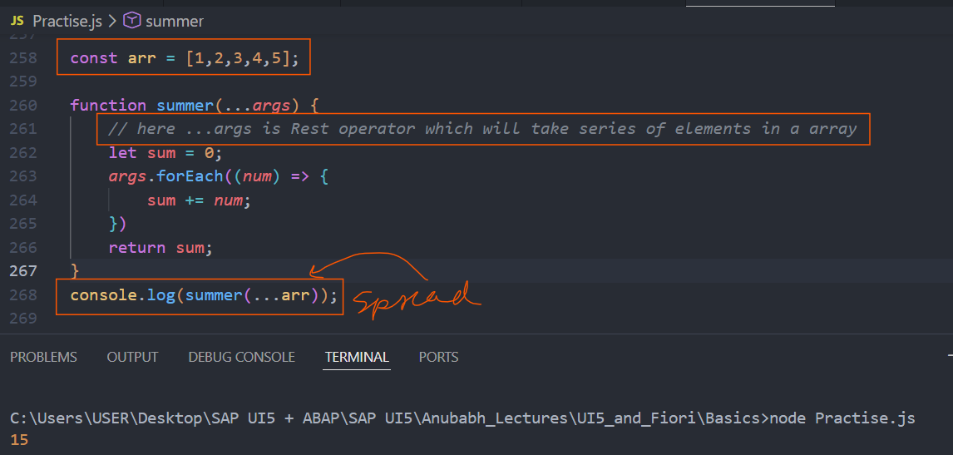
Changed Behaviour -- Rest
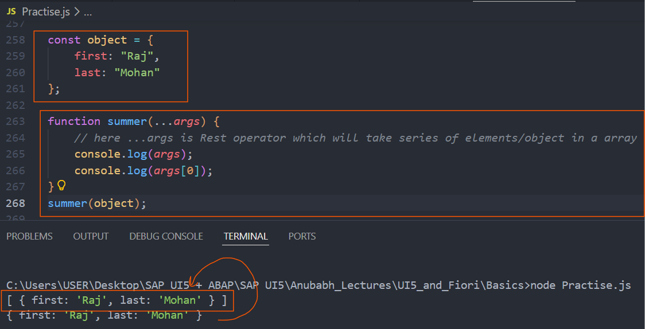
Prototypal Inheritance >
See below we are getting so many properties/methods for created arr variable
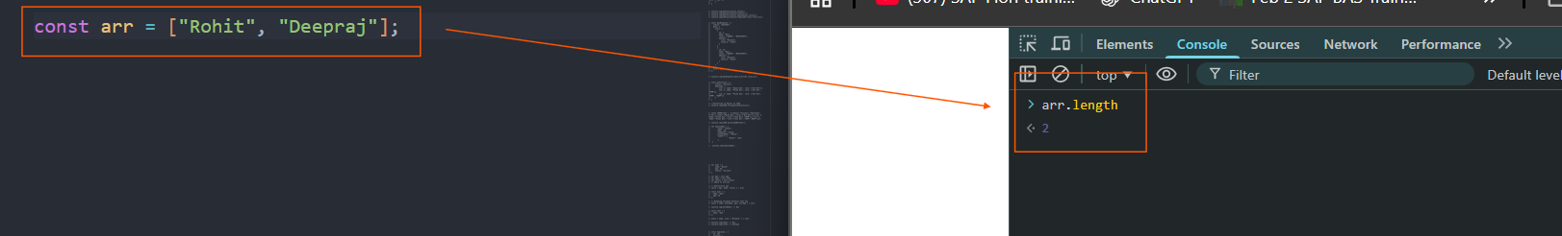
Basically, in JS, array, string, function all are objects only.

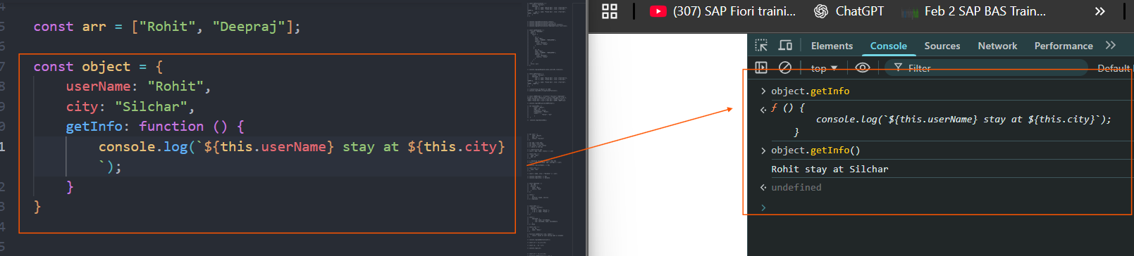
What is Prototype
A prototype is another object that provides shared properties and methods. This is an internal reference to another object.
object (I created) → Object.prototype → null
Object.prototype is the Prototype of object or linked to our object, it is where inheritance comes in objects.
How to check prototype of any object > use objectName.__proto__
Below is a example of arr that I created how it is linked with its prototype.
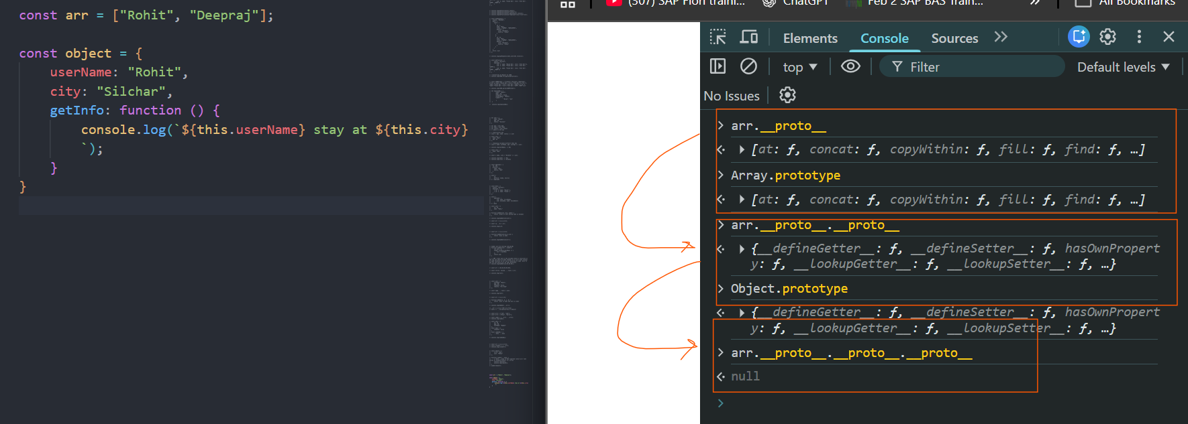
Same for function and normal object
arr (I created) → Array.prototype → Object.prototype → null (each and every property and methods of Array.prototype and Object.prototype can be used by arr)
fun (I created) → Function.prototype → Object.prototype → null
Creating Constructor and how Array.prototype came explained below –
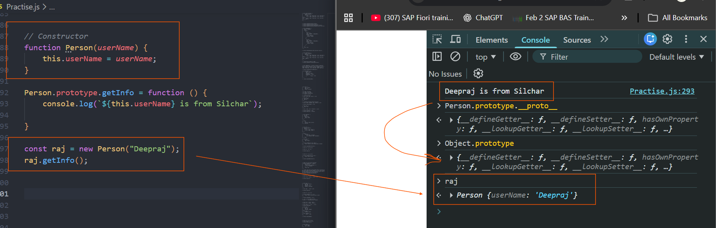
raj (I created) → Person.prototype → Object.prototype → null
Looping over Objects and Shallow copy and deep copy >
For…in with Objects and Arrays (it includes inherited properties also)
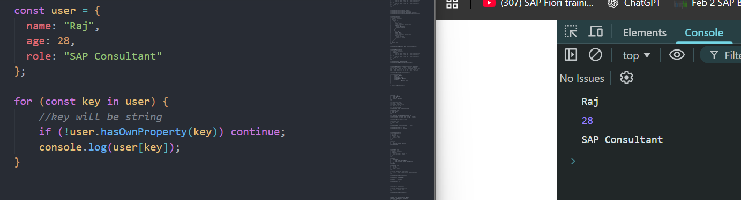
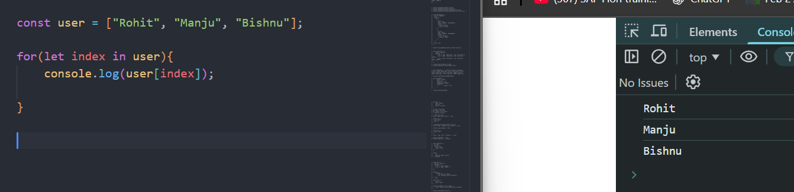
For for…in remember in Object we get keys and in Array we get index. Which is not a case for map, forEach etc.
For…of
See, for of, map, foreach all are best for array. For Objects we need to convert Object into array then only we will directly can access each element of array in an iteration.
We have Object.keys(ob), Object.values(object) and Object.entries(Object) which converts Objects to keys, values in an array.
Examples
Array example – for…of
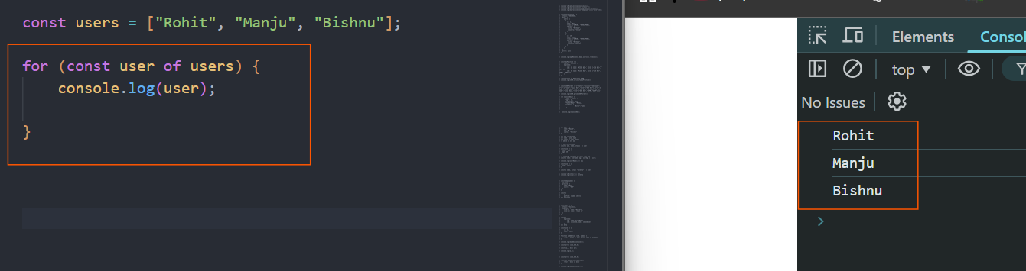

Object example with for…of
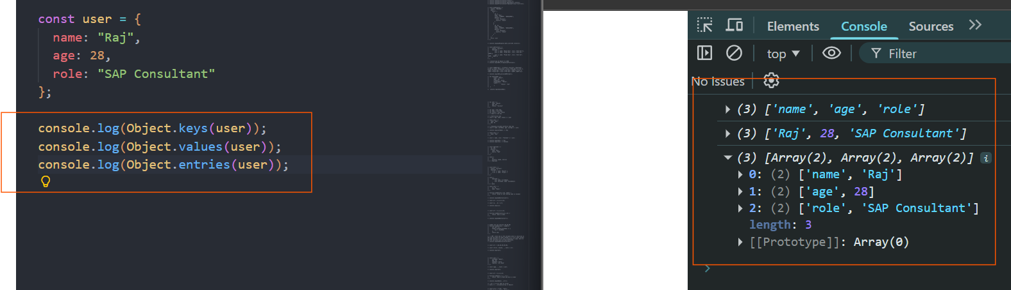
See above we first needs to convert Object to array then we can use map, for…of, reduce etc.
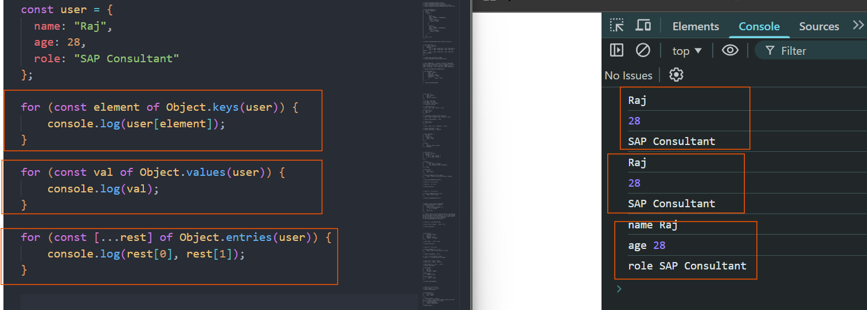
Using map
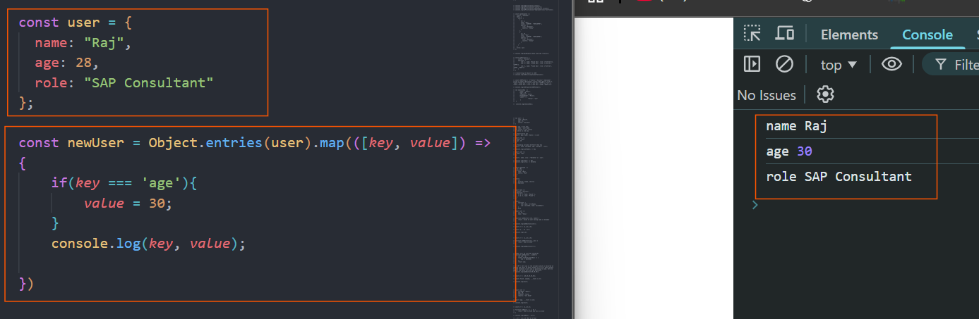
Below is one best example where we can see how to use Recursion.
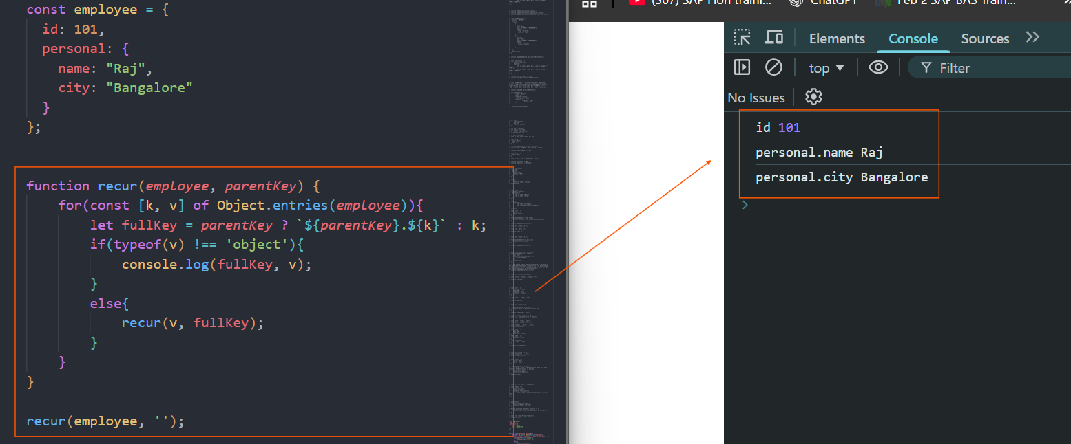
Shallow copy and Deep copy >
Always use spread operator for shallow copy. In shallow copy Copies only the first level
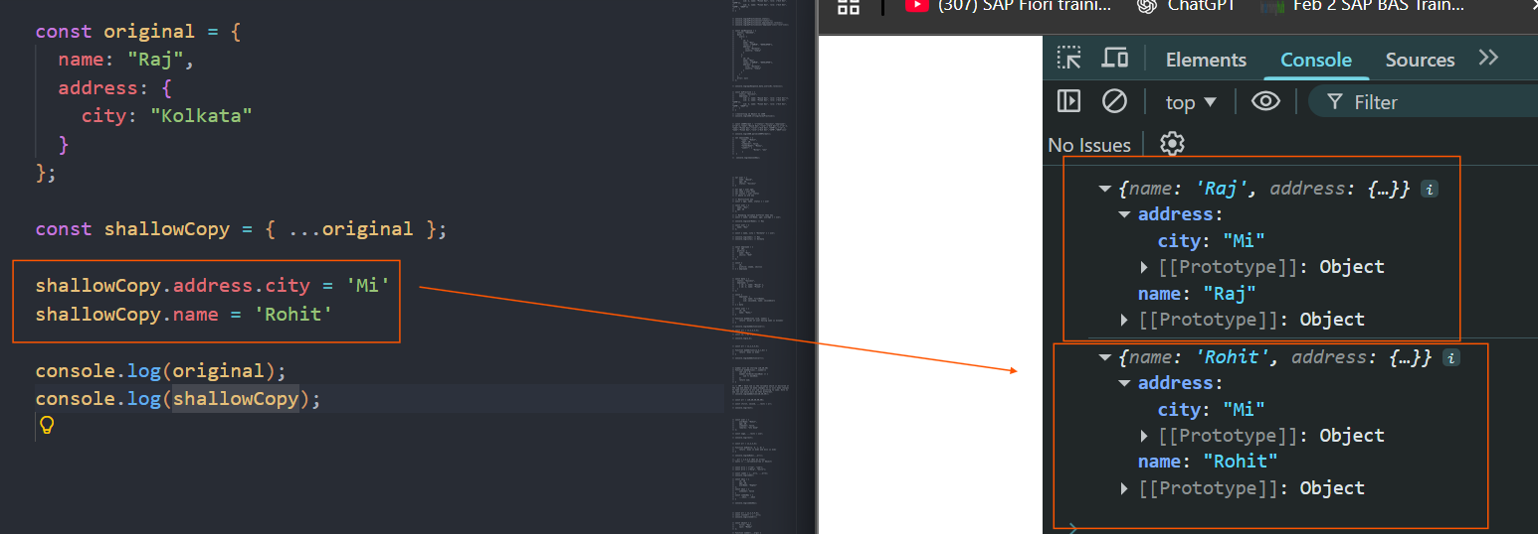
In case of shallow copy Nested objects share the same memory reference, so any changes on copied one will change original. Sol. Deep copy
Deep Copy – It will copy the entire object even the Nested object also, and also there will be no linkage with original one.
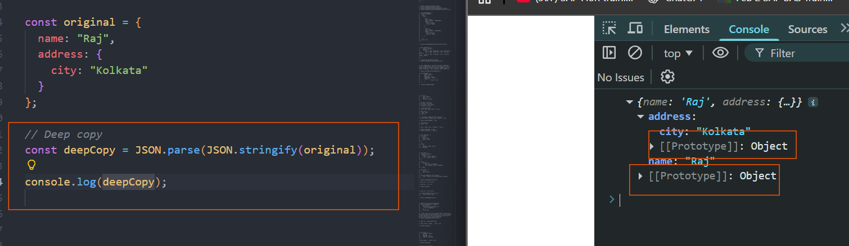
Remember each object has its prototype chain, even Nested Object also. Shallow cloning copies references for nested objects, whereas deep cloning recursively copies all levels, ensuring complete independence from the source object.
map, filter and reduce example –
Question 1: Total Salary by Department
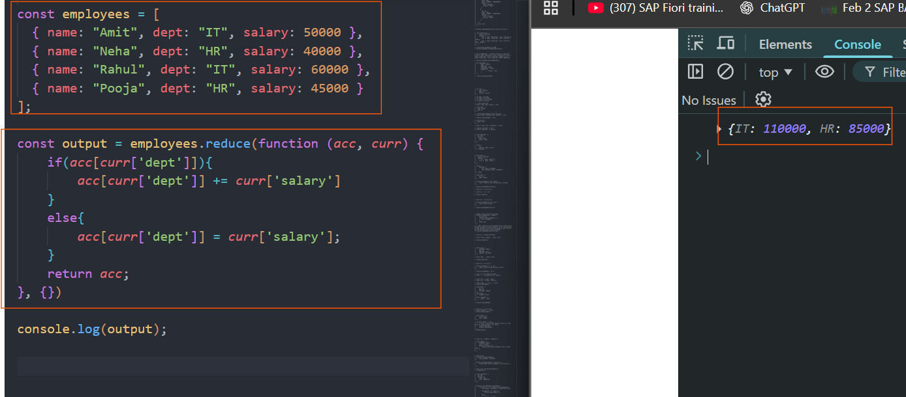
Question 2: Average Marks of Passed Students
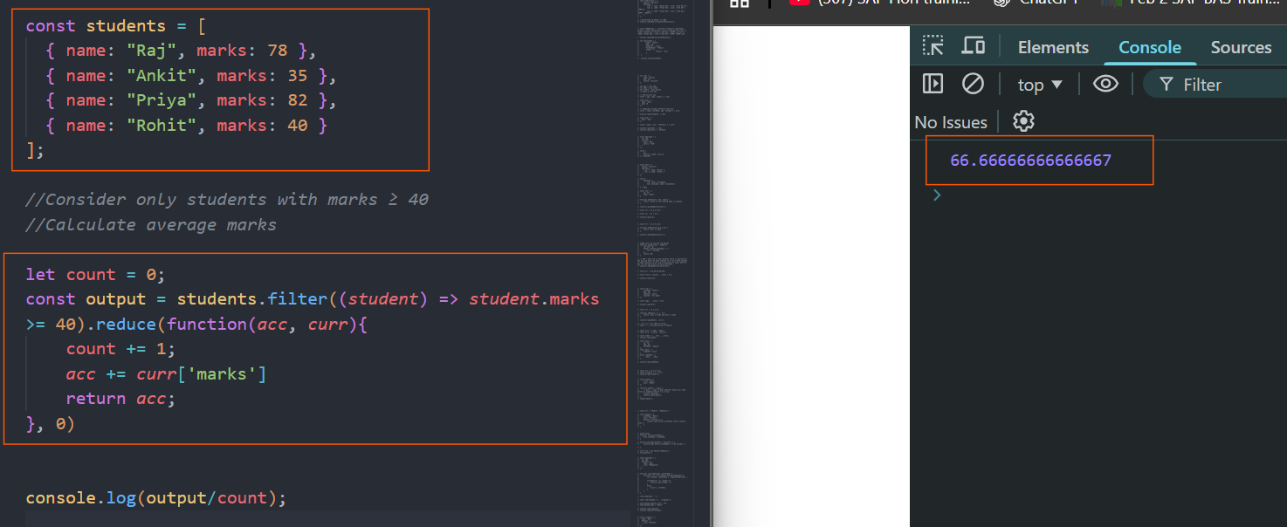
Question 3: User Role Mapping
Modern JS Syntax –
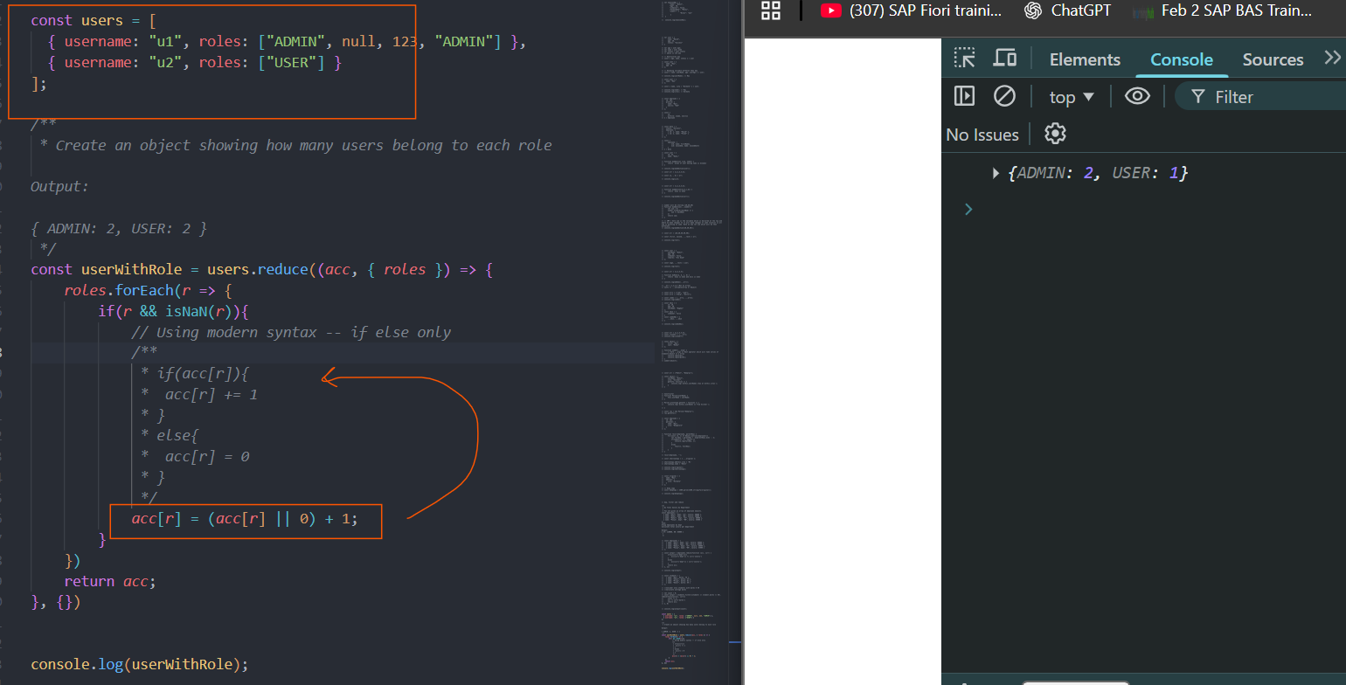
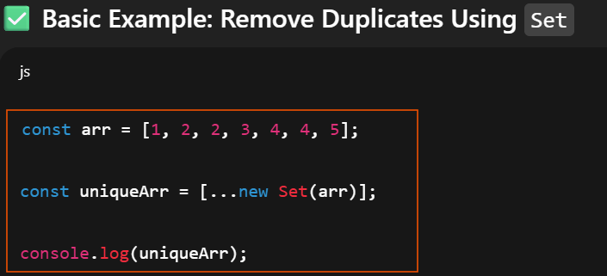
Question 5: Count Word Occurrences
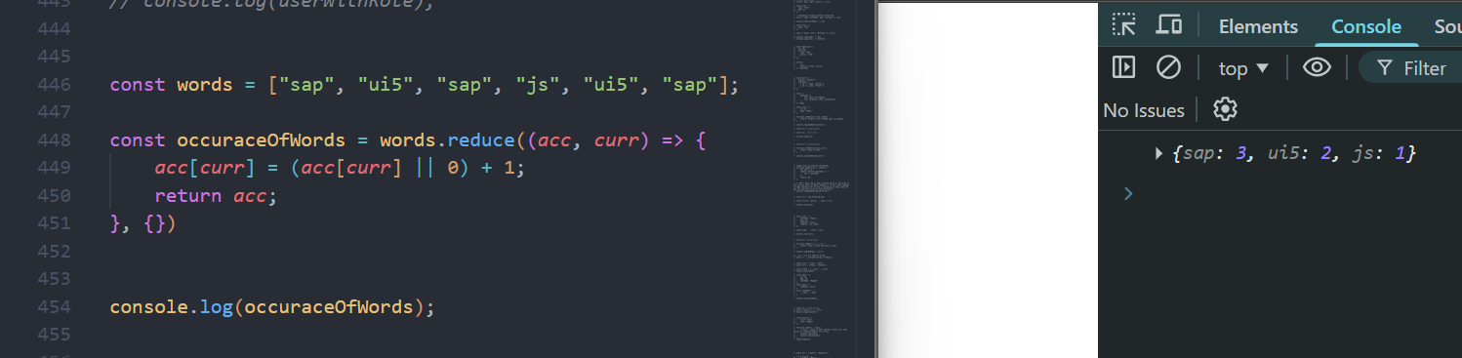
Question 7: Flatten and Sum Nested Scores
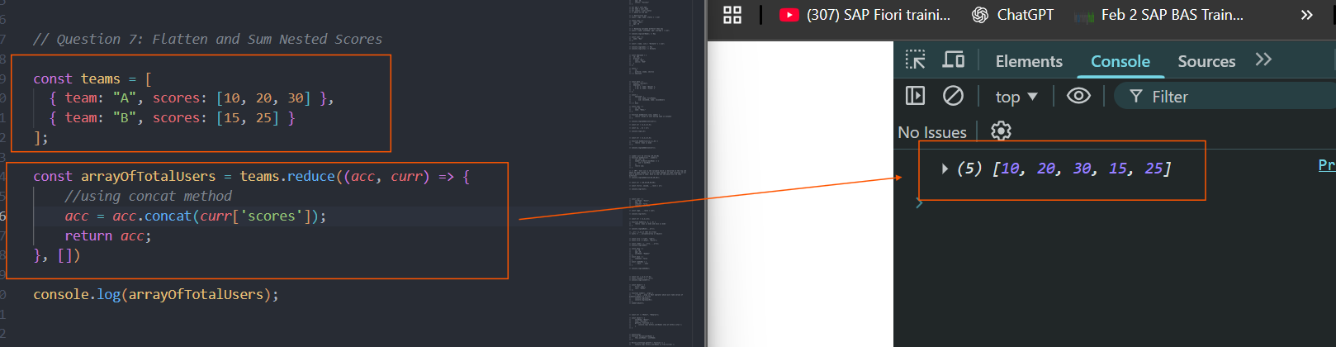
Question 10: Shopping Cart Summary
