Amitabh Notes – UI5, Fiori and OData
Table in HTML >
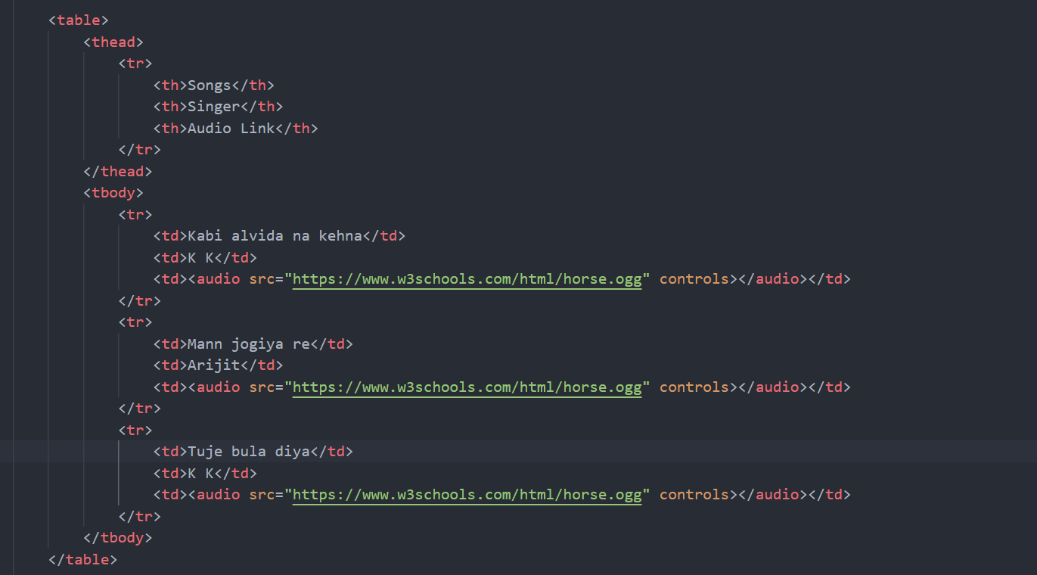
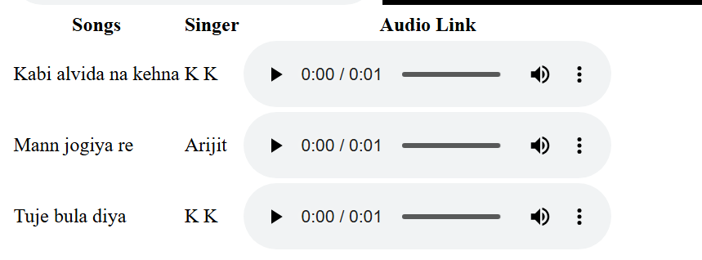

IFrame tag >
Used to integrate one DOM to another DOM.
<!-- code to integrate my DOM with youtube DOM - now youtube can be seen -->
<iframe width="1265" height="480" src="https://www.youtube.com/embed/ekf_3quj9Pw" title="New Meteor 350 Stellar Matt Grey Review | Motorxone" frameborder="0" allow="accelerometer; autoplay; clipboard-write; encrypted-media; gyroscope; picture-in-picture; web-share" referrerpolicy="strict-origin-when-cross-origin" allowfullscreen></iframe>

Responsive web pages >
Adding float ->
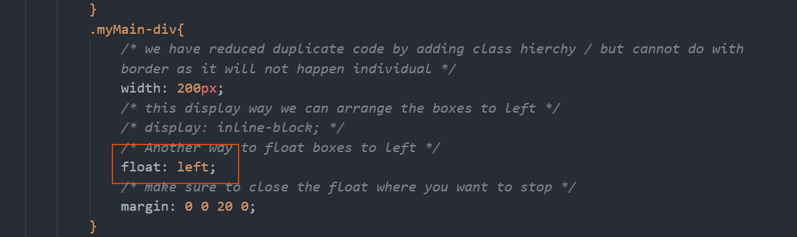
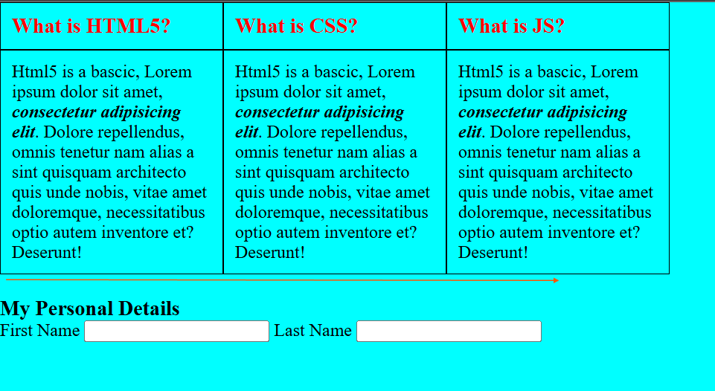
We need to stop float: left property after starting
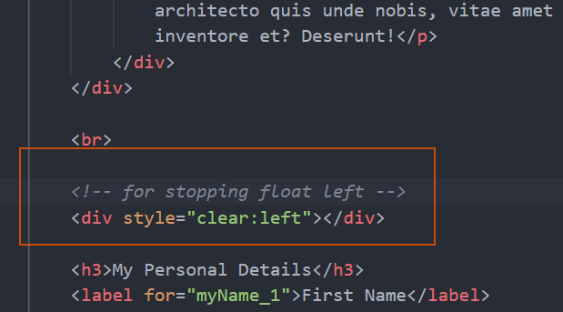

Changing Height width of Image >
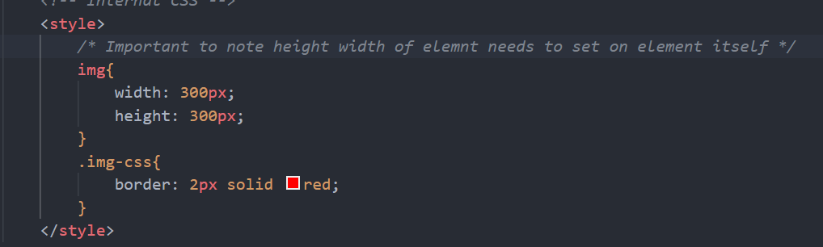
We need to set height width directly on IMG element then only it will change as it is inline-block element, if we change on div it will change div’s only not the child one.
Aligning text to centre >
For aligning text to centre we need to use text-align: centre;
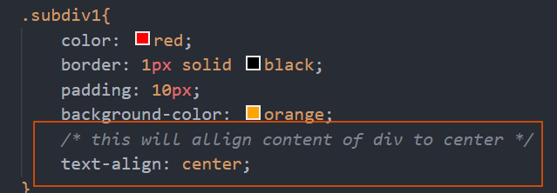
Subdiv1 is the div with h3 inside.
How to align Label and input properly >
The basic way is to do with Flex and style accordingly, another way we can do is by keeping label and input in a table but without header.
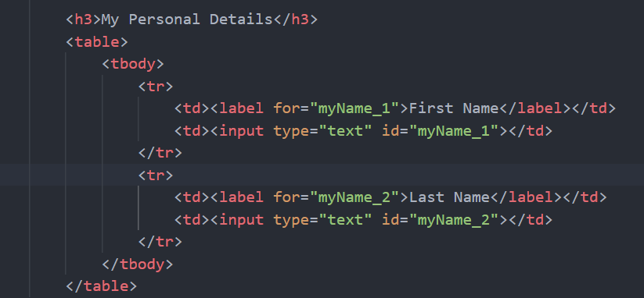
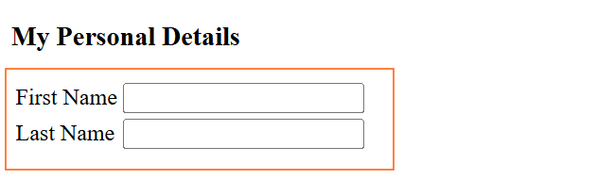
How to create a Navigation bar >
Mostly for creating Navigation bar we use display: flex and style accordingly, another way to do the same by using float: left property.
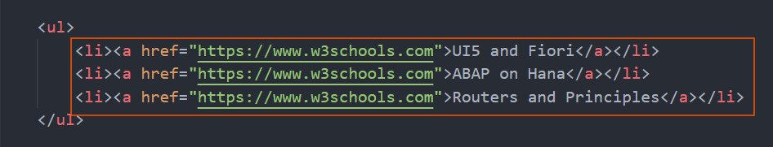
Text-decoration: none helps to remove underline and link of a tag.
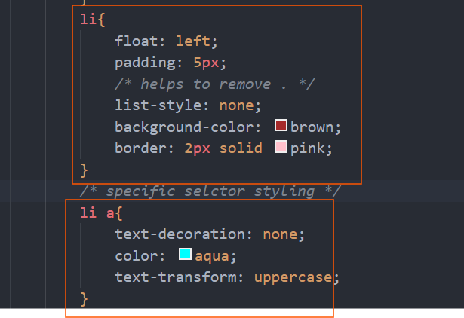
How to style a Table >
For styling table, we need to use border by taking th and td, also to make border collapsed we need to use border-collapse: collapse property. Also to colour the rows alternately we need to use pseudo class nth-child(even/odd) by considering
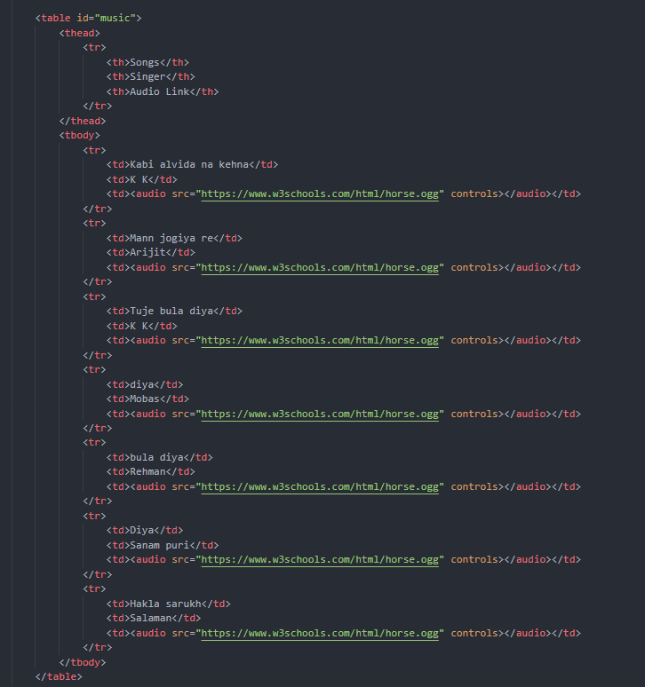
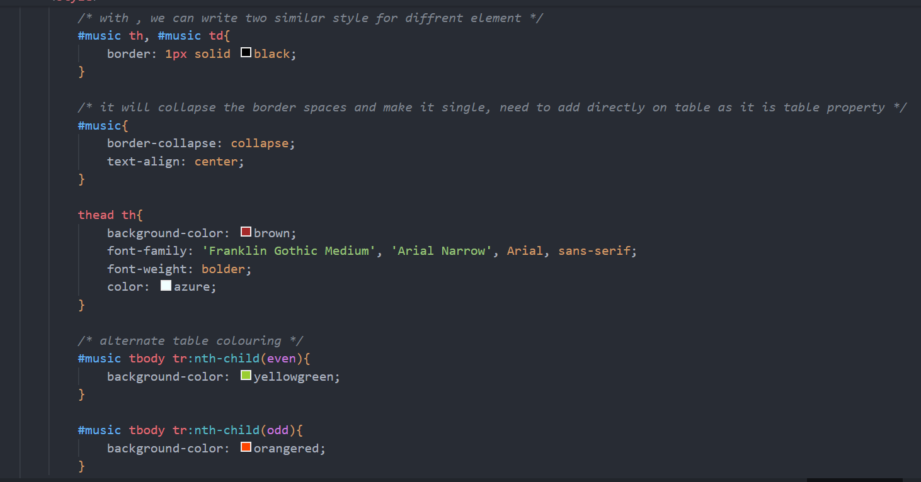

JS Object VS JSON >
🧠 1. Definition
Concept | Description
JavaScript Object | A data structure used in JS to store key-value pairs.
JSON (JavaScript Object Notation) | A text format for data exchange — used to store or send data (like between frontend & backend).

🧱 2. Syntax Example
✅ JavaScript Object
const person = {
name: "Raj",
age: 25,
isActive: true,
greet: function() {
console.log("Hello!");
}
};
✔ Can contain:
- Functions
- Variables
- Symbols
- Single quotes
- Trailing commas

✅ JSON
{
"name": "Raj",
"age": 25,
"isActive": true
}
❌ Cannot contain functions
❌ Keys must be in double quotes
❌ No trailing commas
✔ Only strings, numbers, booleans, arrays, objects, null
Codes of JS >
1. let z = 10;
2. console.log(z)
3. 10
4. typeof(z)
5. 'number'
6. let y = '20'
7. z+y
8. '1020'
9. //parseInt() used to convert string to number
1. parseInt(y)
2. 20
1. //Array
1. const arr = [
2. "Bsn",
3. "Potato",
4. "Apple",
5. "jada ho raha h"
6. ]
7.
8. arr
9. (4) ['Bsn', 'Potato', 'Apple', 'jada ho raha h']
1. arr[1]
2. 'Potato'
1. arr.length
2. 4
1. arr.push("ya ali") //add value at end
2. 5
3.
1. arr
2. ['Bsn', 'Potato', 'Apple', 'jada ho raha h', 'ya ali']
3. arr.pop() //removes array’s elements from end
4. 'ya ali'
5. arr
6. ['Bsn', 'Potato', 'Apple', 'jada ho raha h']
7.

1. //Splice of array – can add and remove elements from org array
2. arr //print
3. (4) ['Bsn', 'Potato', 'Apple', 'jada ho raha h']
4. arr.splice(1,0,"hello") // adding “hello” at index 1 ( 0 means no delete )
5. [] //outcome
6. arr //print
7. (5) ['Bsn', 'hello', 'Potato', 'Apple', 'jada ho raha h']
8.
1. 1. // deleting items using splice
2. arr
3. (5) ['Bsn', 'hello', 'Potato', 'Apple', 'jada ho raha h']
4. arr.splice(2,1) // at 2nd index deleting 1 element i,e Potato
5. ['Potato']
6. arr
7. (4) ['Bsn', 'hello', 'Apple', 'jada ho raha h']
8.
1. 1. 1. //Looping through array
2. 2. for (let i = 0; i < arr.length; i++) {
3. 3. console.log(arr[i])
4. 4.}
5. 5. Bsn
6. 6. hello
7. 7. Apple
8. 8. jada ho raha h
9. 9.
10. //forEach – use for side effects only it never returns array (nor changes original) so map is better
11. arr.forEach(ele => {
12. console.log(ele)
13.})
14. Bsn
15. hello
16. Apple
17. jada ho raha h
18.
1. //Technique to add element in JS object
2. let hula = {
3.
4.
5.}
6. undefined
7. hula.name = "raj"
8. 'raj'
9. hula
10. {name: 'raj'}
11.
1. // Map is very powerful as it returns new array from map method so we can use it further
1. const newArr2 = arr.map(ele => {
2. console.log(ele)
3. return ele;
4.})
5. Bsn
6. hello
7. Apple
8. jada ho raha h
9.
10. newArr2
11. (4) ['Bsn', 'hello', 'Apple', 'jada ho raha h']
12.
//JS Object and JSON
//JS Object
1. let newObject = { name: "Badshah", age: 22, }
2.
3. newObject //print
4. {name: 'Badshah', age: 22}
5. newObject.Address = ["home", "Berlin", "MG Road"]
6. (3) ['home', 'Berlin', 'MG Road']
7. newObject
8. {name: 'Badshah', age: 22, Address: Array(3)}
9. Address: (3) ['home', 'Berlin', 'MG Road']
12.
13. newObject.help = { location: "footpath", factory: "roso" }
14. {location: 'footpath', factory: 'roso'}
15. newObject
16. {name: 'Badshah', age: 22, Address: Array(3), help: {…}}
17. Address: (3) ['home', 'Berlin', 'MG Road']
22.
//JSON
1. let newJsonObj = {
2. "name": "Rohit",
3. "age": 20,
4. "isSmoler": false,
5. "fatherName": "Monoj",
6. "subStr": {
7. "Bilas": "yes"
8. }
9.}
10.
11. newObject //print
12. {name: 'Badshah', age: 22, Address: Array(3), help: {…}}
13.
//convert to JSON -
1. newJsonObj.Address = ["hola", "mata"]
2. (2) ['hola', 'mata']
3. newJsonObj
4. {name: 'Rohit', age: 20, isSmoler: false, fatherName: 'Monoj', subStr: {…}, …}Address: (2) ['hola', 'mata']age: 20fatherName: "Monoj"isSmoler: falsename: "Rohit"subStr: {Bilas: 'yes'}}
5. JSON.stringify(newJsonObj) //This is how we convert JS object to JSON
6. '{"name":"Rohit","age":20,"isSmoler":false,"fatherName":"Monoj","subStr":{"Bilas":"yes"},"Address":["hola","mata"]}'
7.
//Convert JSON to JS object
1. let myJson = JSON.stringify(newJsonObj)
3. myJson
4. '{"name":"Rohit","age":20,"isSmoler":false,"fatherName":"Monoj","subStr":{"Bilas":"yes"},"Address":["hola","mata"]}'
5. let myJS = JSON.parse(myJson)
6.
7. myJS //converted to JS object
8. {name: 'Rohit', age: 20, isSmoler: false, fatherName: 'Monoj', subStr: {…}, …}
9.
//Traversing JSON or JS each element
1. for (let comp in myJS) {
2. console.log (comp + "has" + myJS[comp])
3.}
4. namehasRohit
5. agehas20
6. isSmolerhasfalse
7. fatherNamehasMonoj
8. subStrhas[object Object] //it has not worked because it is type object and not string
9. Addresshashola,mata
10.
//we can conditionally convert to string the object then it will print
1. for (let comp in myJS){
2. if (comp === "subStr"){
3. console.log (comp + "has" + JSON.stringify(myJS[comp]))
4. } else {
5. console.log (comp + "has" + myJS[comp])
6. }
7.
8.}
9. VM5777:5 namehasRohit
10. VM5777:5 agehas20
11. VM5777:5 isSmolerhasfalse
12. VM5777:5 fatherNamehasMonoj
13. VM5777:3 subStrhas{"Bilas":"yes"}
14. VM5777:5 Addresshashola,mata
15.

1. let myName = "Deepraj Deb roy"
2.
3. myName.split(" ") //convert string to Array , Join converts array to string
4. (3) ['Deepraj', 'Deb', 'roy']
5.
//To find substring in string
1. myName.indexOf("hello")
2. -1
3. myName.indexOf("roy")
4. 12
5.

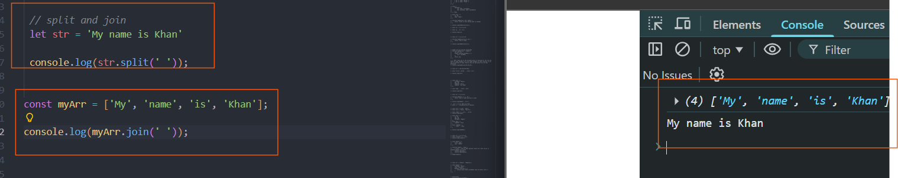
JS output >
There are 4 types of output functions in JS
- alert
- console.log
- document.write
- oHTML.innerText

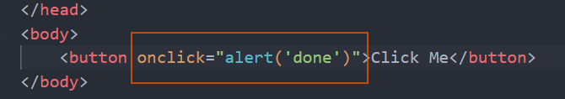
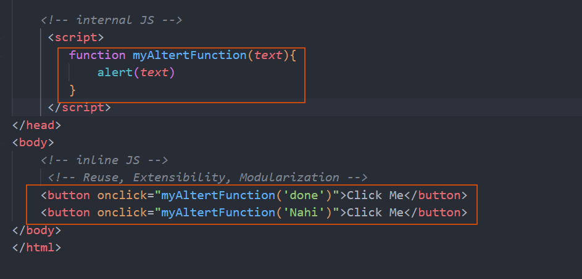
DOM Manipulation learn from ChatGPT >
Element.getElementById(), Element.getElementByClassName(), Element.getElementByTagName(), querySelector () Gives the first matching element (class name or tag), querySelectorAll () Gives all the element, classList contains list of class for an element has toggle (), add (), remove () methods.
Remember in QuerySelector () we write #, . for id and class. Not required otherwise. Also, Html object means, pure DOM element.
jQuery >
for jQuery use the documentation - https://api.jquery.com/
1. Basic syntax - $('.myMain-div').fadeIn(3000);
Ajax – asynchronous JavaScript and xml –
1. $.ajax("https://api.rootnet.in/covid19-in/stats/latest", {
2. success: (data) => {
3. let aData = data.data.regional;
4. updateDOM(aData);
5. }
6. })
7.

UI5 Project creation bare minimum >
Steps –
- Create a Project Folder mkdir UI5project
- npm init to create package.json and initialize a node project
- Create a webapp folder under main project folder.
- then do ui5 init to initialize as ui5 project ( make sure ui5 tooling’s modules are added )
- add manifest.json file in webapp and add “sap.app” and mention id and type.
- After all this create a index.html inside webapp folder and do bootstrapping.
Very Imp Findings >
To run use JSview we should create view object like below and then place it at DOM, JS view file should be separate.
Codes -> /ui5learning_1/
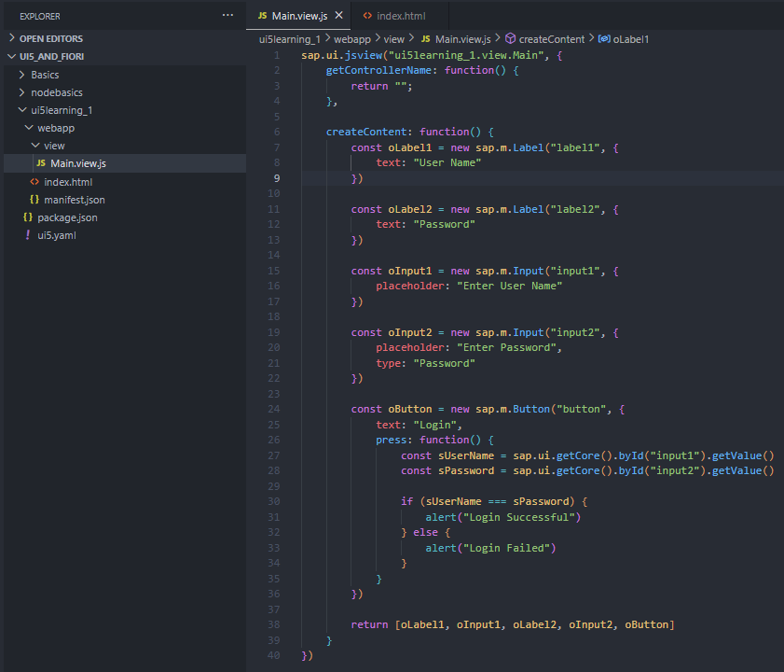
Here sap.ui.view() is a function just like sap.ui.jsview()
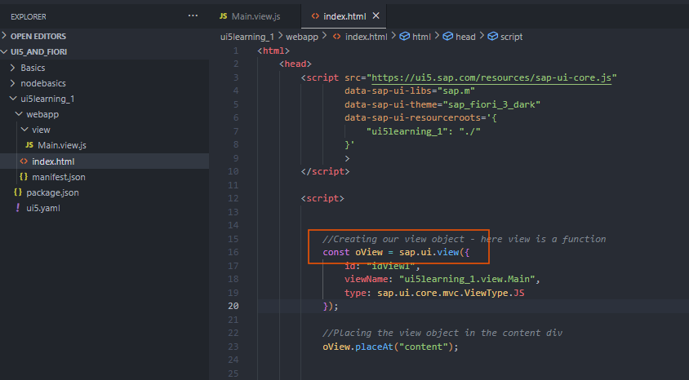
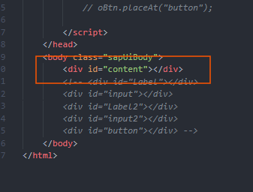
Controller –
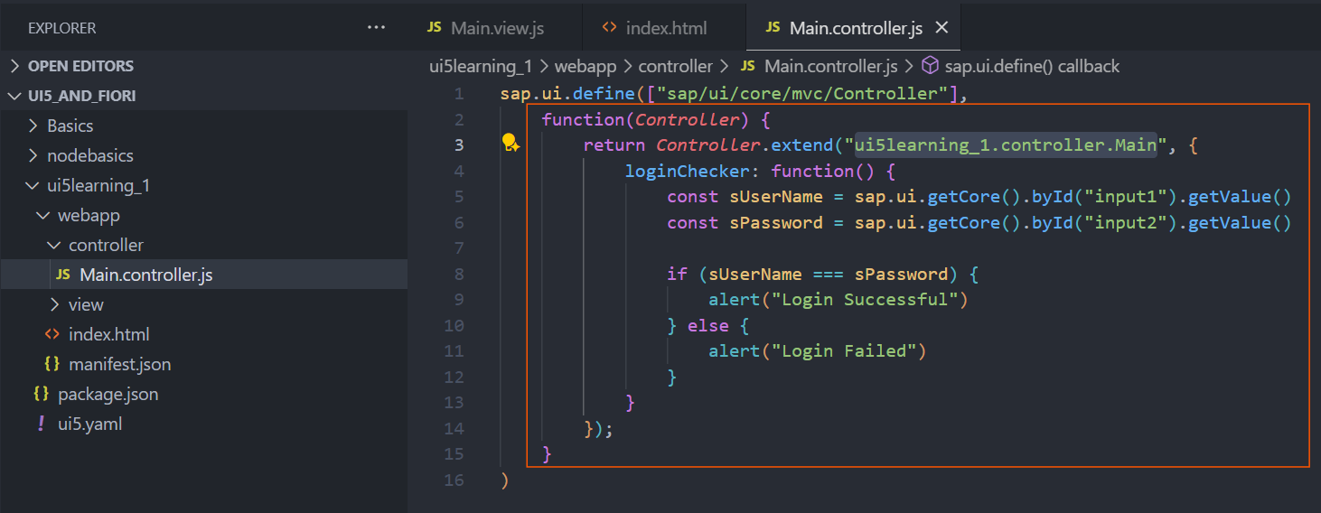
SimpleForm > /ui5learning_1/
The editable property in a SimpleForm helps to align the Label with input
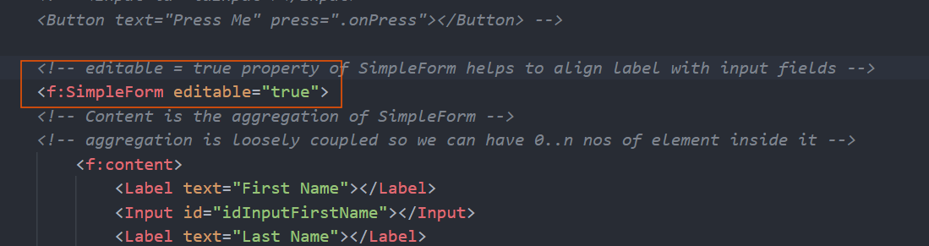
View/Controller Life cycle >
onBeforeRendering – This lifecycle function will be called MULTIPLE times just before the view is displayed to the user. We can write any pre-processing code in this function. It like PBO of a dialog program in ABAP. E.g. we can write code to do some checks and change the value of a field/control.
onAfterRendering - This lifecycle function will be called MULTIPLE times just after the view is displayed to the user. We can write any post-processing code in this function. E.g. we can write code to do some effects display to the user once the view is displayed.
For example, if we navigate from view A to view B, then first onBef and onAft of B will be called and again if we navigate back then onBef and onAft of A will be called as it will be again render in DOM and displayed to user.

SAP UI5 is build on jQuery so we can use jQuery easily.
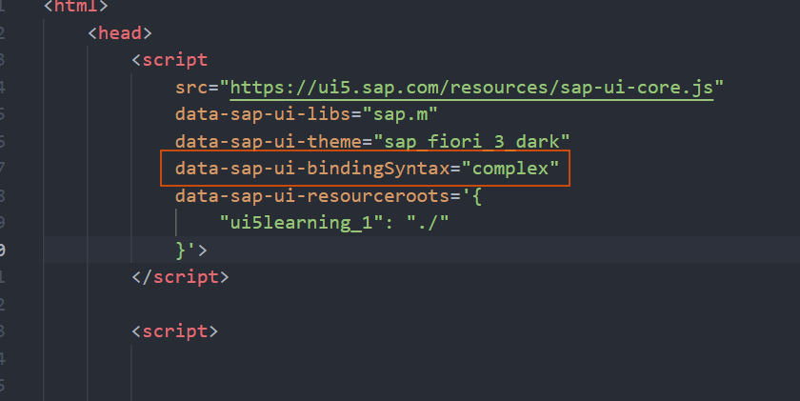
The above is used to load complex binding like {path: ‘address of json’}
Loading Json data from external file in Project >
If we have json data and if we want to modularize then we can create a Folder and add json file (earlier we used to entry in manifest.json in model section) and use oModel.loadData(“provide the location of your data”). Here we don’t use adding dependency like adding in array, as it works only with JS files not with JSON file.
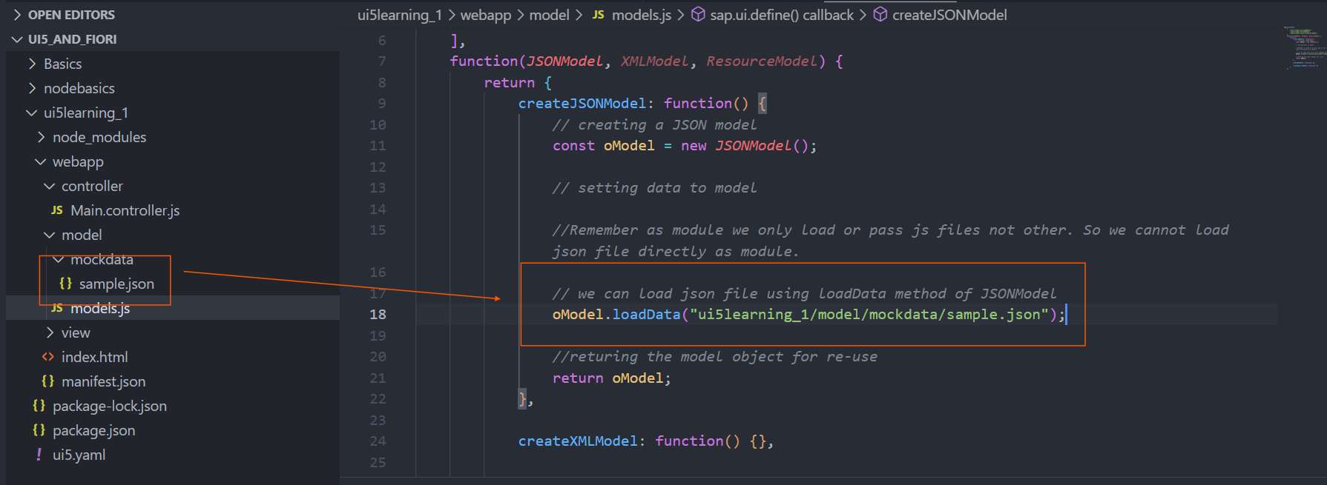
Important observation below about loadData –
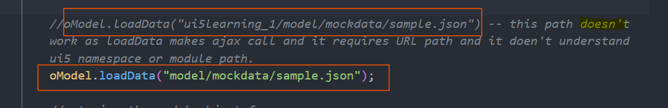
Best technique to create any JSONModel >
Here we can pass the path of json file dynamically while calling from controllers so we can create n numbers of json model with same code. Best reusable technique.
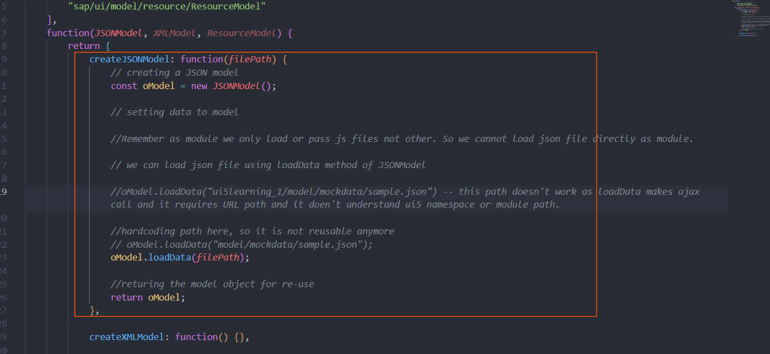
Passing filePath while calling the method.
Information about Model >
2 default Model cannot exist in same app, basically if we try to have, the one called lately will replace the first one.
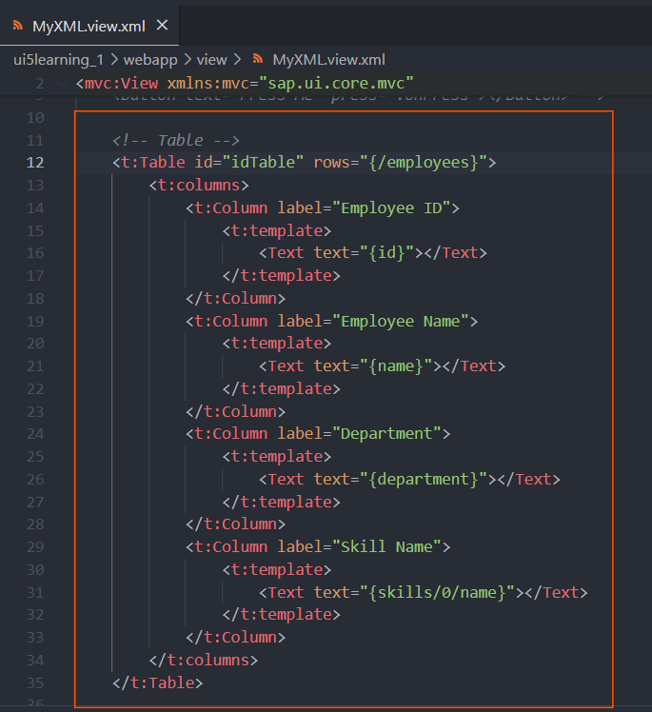
sap.ui.table.Table control, it has columns aggregation and columns aggregation has Column control with label and template as aggregation. Label can be used as property in Column as well as an aggregation, however template is solely used as aggregation and inside that we can provide our table rows relative path. Also, table has another important aggregation is rows (which can be used only through binding).
Concept of Event Object > (also given in PPT)
We can use event object whenever we have event listener and its event handler, whenever a event occurs in UI5 application, ui5 passes an event object that has many information from where the event has originated.
We can use -> getSource(), getParameters() -> will given object and in that object, we can have all the parameter who has been involved in generating the event. getParameter(sParameterName) -> sParameterName can be found from getParameters() object value and can refer sdk for details like which one we can use.
Very important concept, we should use event concept to get control not by ID as much as possible.
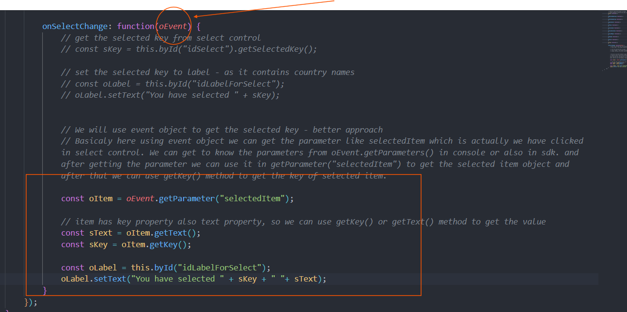
Resource Model >
Often when we create application, we need to translate our application labels in different languages, so we use the resource model. i18n – internationalization
- As a developer, we need to create a i18n.properties file where we maintain all the labels in most commonly used language for our app (English).
- Then we create resource model and bind all the labels with text/label kind of or Hard coded text element created in i18n file
- Then we translate the i18n file to i18n_ISOLANGCODE (e.g. – i18n_hi) file and keep labels in different language
- Finally, we test using? sap-ui-language=CODE
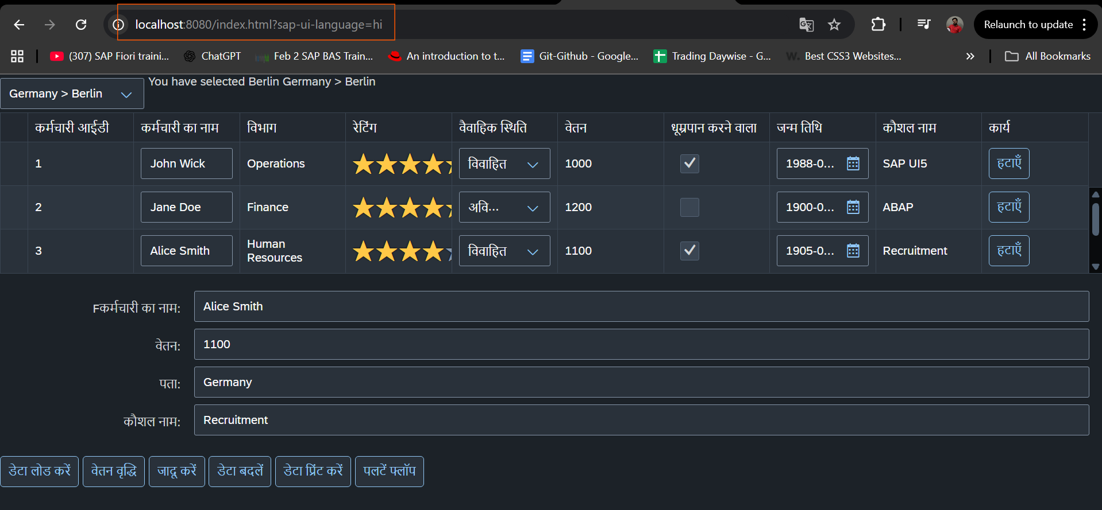

Very Important Concept > BaseController Reusability
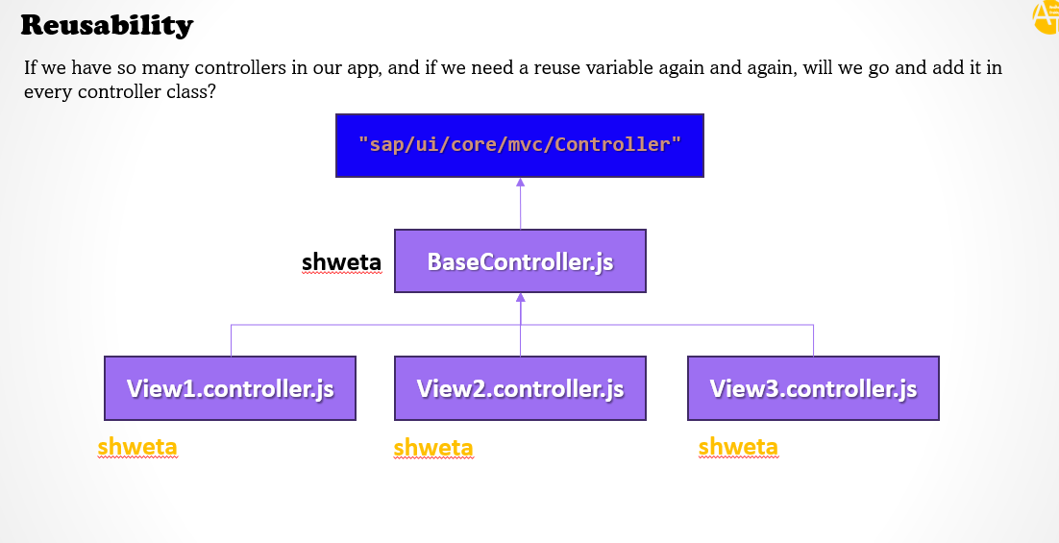
The above image shows how we can optimize our application by creating BaseController class, basically we will create BaseController as a pure controller class and then we will extend that class only in View Controllers, by that way we will reduce creating duplicate variable like formatter variable in multiple view controller class. Basically, we are using inheritance.
SAP Fiori Guideline >
Basically, Ui5 is the toolkit (framework) and Fiori is the Guideline like how our app look and feel and also includes best practices.
Follow PPT and you can check - https://www.sap.com/design-system/fiori-design-web/?external#
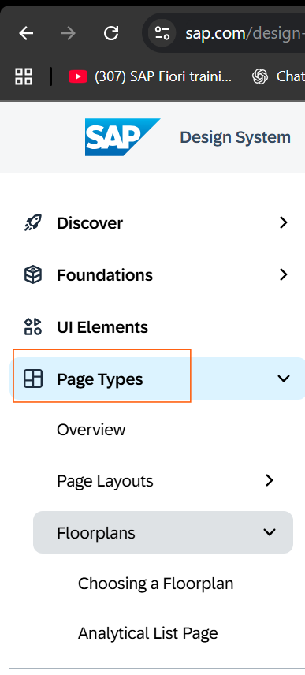
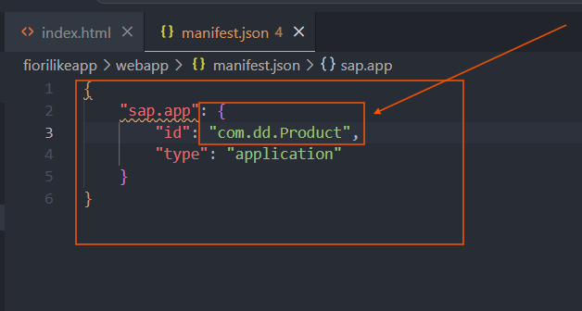
For manifest.json the ID should be very unique, basically – companyName.functionalArea.project
ComponentContainer >
By using ComponentContainer in index.html helps UI5 to detect the Component.js file which is the entry point of the Fiori application. And it helps to instantiate the file.
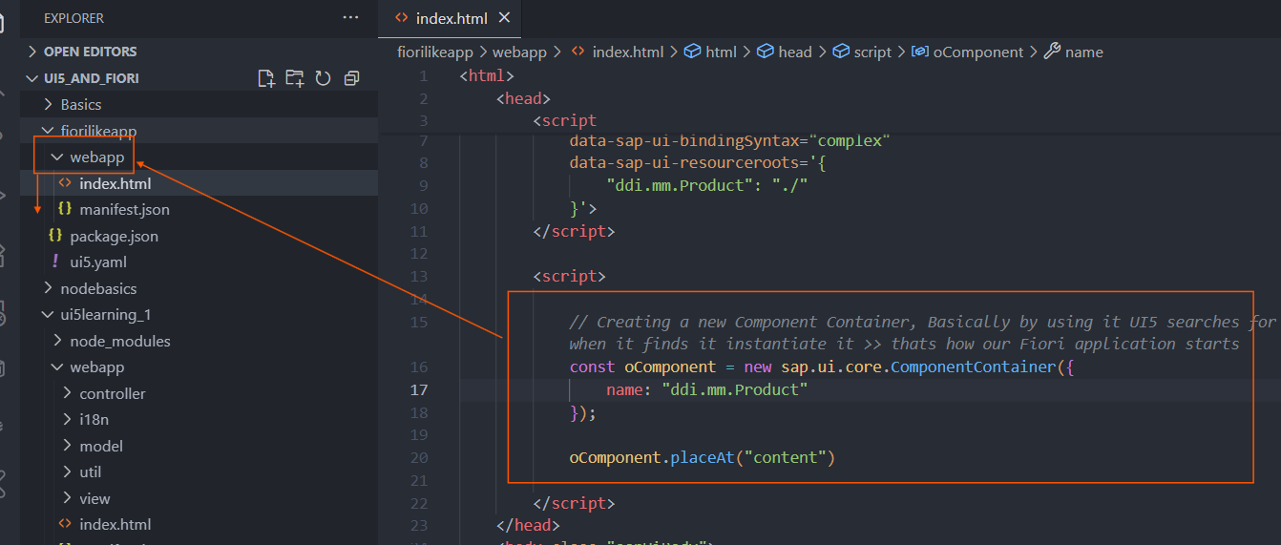
ComponentContainer is a SAP UI5 control used to load and display a Component (like Component.js) inside the HTML page.
It acts as a wrapper that initializes the component, manages its lifecycle, and renders its main view in the browser.
Manifest.json >
Manifest.json is the app descriptor file, in manifest we have our all the app related information for documentation purpose and also some properties used for functionality of the application. Basically, it has 3 section –
- sap.app
- sap.ui
- sap.ui5
LIST >
Remember list/control created in view1 is not accessible in view2
List Items > From VS Code > fiorilikeapp
<items>
<!-- DisplayListItem -> It is used to display data to Business user, basically on left and right corner -->
<DisplayListItem label="Apple" value="It is the most loved Fruit in the world!"></DisplayListItem>

<!-- StandardListItem has icon property and shows data up and down -->
<StandardListItem icon="sap-icon://customer" description="SAP is world largest ERP company" title="SAP"></StandardListItem>

<!-- CustomListItem , when none of the ListItem fulfilled our requirements then we go for CustomListItem -->
<CustomListItem >
<content>
<HBox justifyContent="Start" alignItems="Center">
<Text text="This is from Custom List Item" class="sapUiSmallMarginEnd sapUiSmallMarginBegin"></Text>
<Switch ></Switch>
</HBox>
</content>
</CustomListItem>

<!-- InputListItem , when our intension is to take input from user -->
<InputListItem>
<content>
<HBox justifyContent="SpaceBetween" alignItems="Center">
<Text text="Which fruit you love the Most"></Text>
<Input ></Input>
</HBox>
</content>
</InputListItem>

<!-- ObjectListItem is mostly used it is used to show Business Entity -->
<ObjectListItem title="3000145" intro="This is Object List Item for IBM" icon="sap-icon://home" number="30,000" numberUnit="USD" numberState="Success"></ObjectListItem>

<!-- FeedListItem -> Mostly used to create social media application, it comes like Feed -->
<FeedListItem icon="sap-icon://customer" text="Hello Bhaiyo and Behno" timestamp="27/10/2025" sender="Modi"></FeedListItem>

<!-- ActionListItem , Provides clickable action button -->
<ActionListItem text="Order Now" press="onOrder"></ActionListItem>

</items>

Filtering >
Filtering also done and included in Notion and Vscode.
List Modes >
We have mode property for List which includes,
- SingleSelectLeft – not user friendly
- SingleSelect – it is better than above but still not a good UX
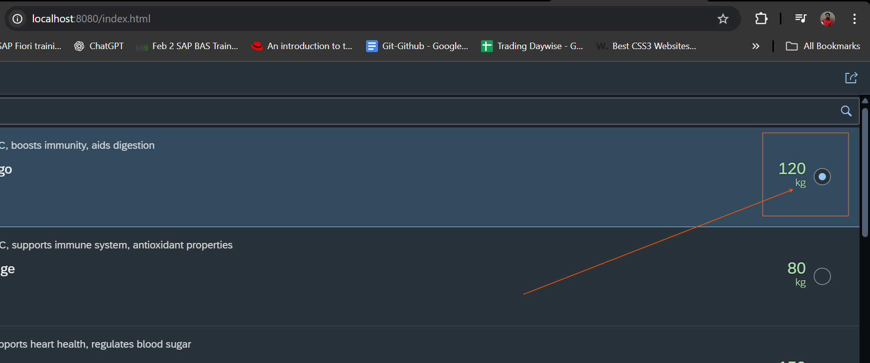
- SingleSelectMaster – Better, as it helps to select list item by clicking anywhere.
- MultiSelect – Provide multiple select option.
- Delete – Provide delete icon.
In case of Delete mode SAP Provides an eventlistner called delete by using it we can temporarily delete the item. We have removeItem method to remove item from List.
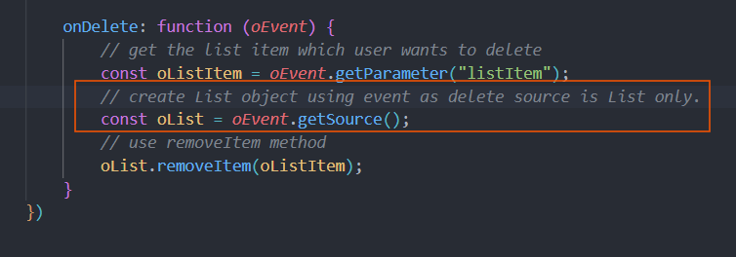
***For delete event the source is List so we can use it.
Remember >
List has method of getSelectedItems, and getSelectedItem these are very helpful.
ItemPress Event in List >
When we set type ‘Navigation’ or ‘Active’ property for ObjectListItem/ColumnListItem (Table) List gets activated and a navigation icon starts showing. Along with this we get another event that is ItemPress event in List level and it is very helpful.
Worklist Fiori App >
Worklist Fiori app is an app where we have a Search, many buttons, List showing data and drill down to next page we have detailed of the List. (Here container is App container)
ObjectHeader Control >
It is given by SAP to show single business Object data to the user in Details, we can connect Icon Tab bar/filter along with it to create floor plan (like Master Detail app)
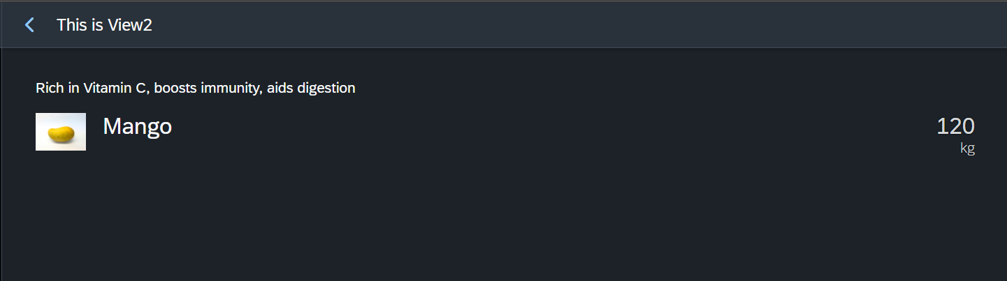
Changing type=Navigation and corresponding itemPress >
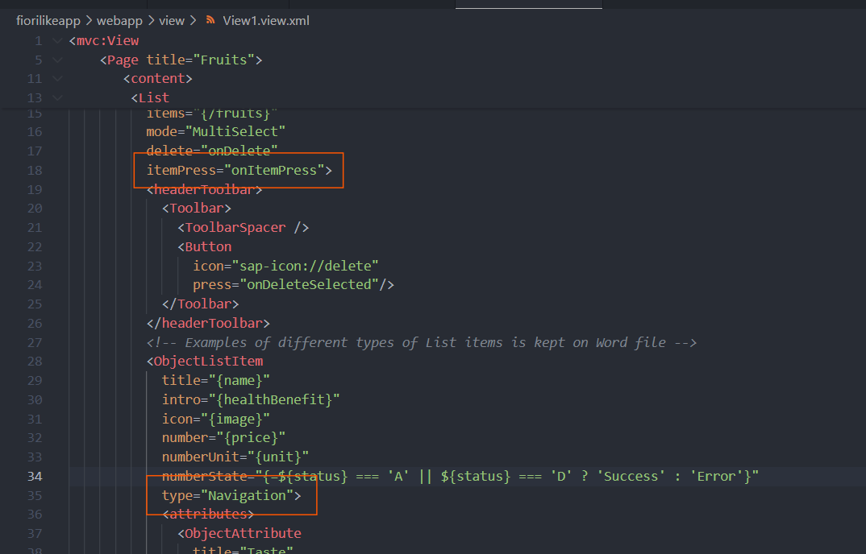
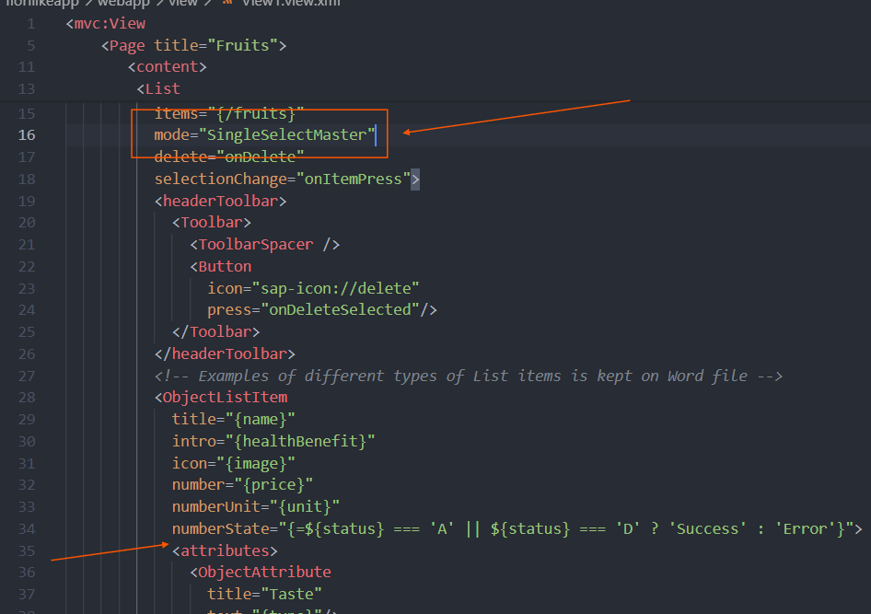
IconTabBar Control >
It provides section in Object Header like control.
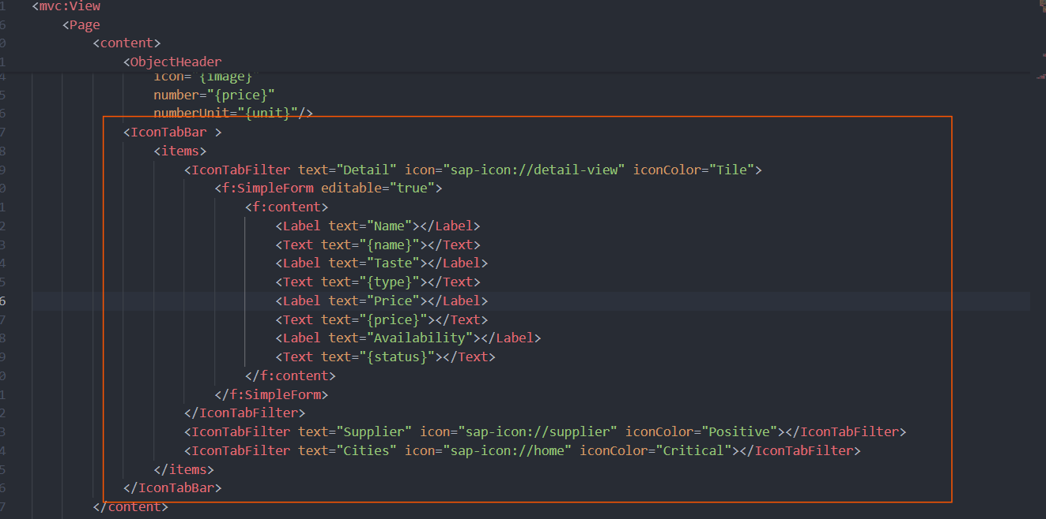
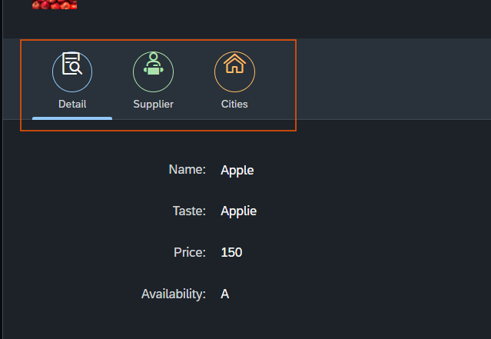
First Status in ObjectListItem >
ObjectlistItem has aggregation of attributes and firstStatus and this aggregation helps to add ObjectStatus with color and integrating with Formatter.
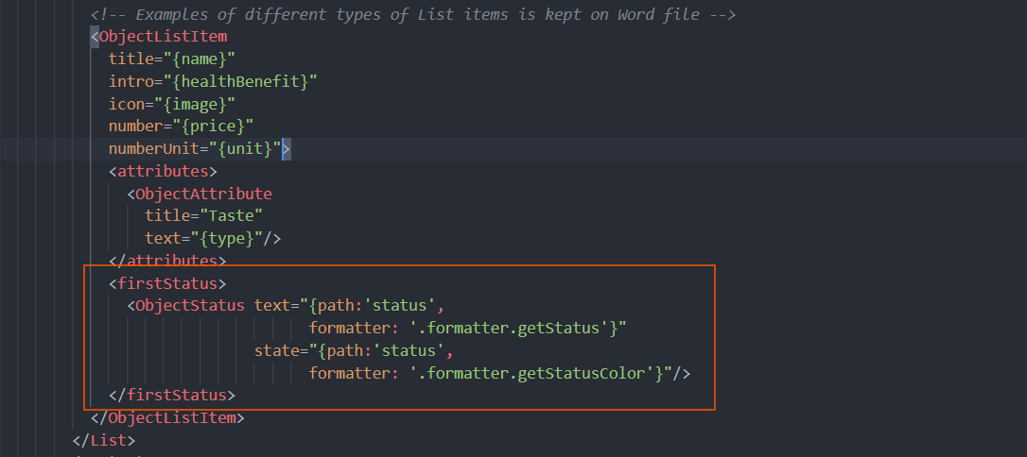
Different types of Drop-Down in Fiori UI5 >
- Select - Select control -> it allows one item, first item is already selected and doesn’t allow custom data.
- Combo-Box - Combo Box -> This helps to type custom Data means it has both Drop-down + Input functionality.
- Multi Combo-Box - MultiComboBox - This helps to type custom Data means it has both Drop-down + Input functionality also allows choosing multiple data

Routing >
Routing is one of the important concepts in application development using UI5, as it handles the view and controller pair creation and also navigation between our views.
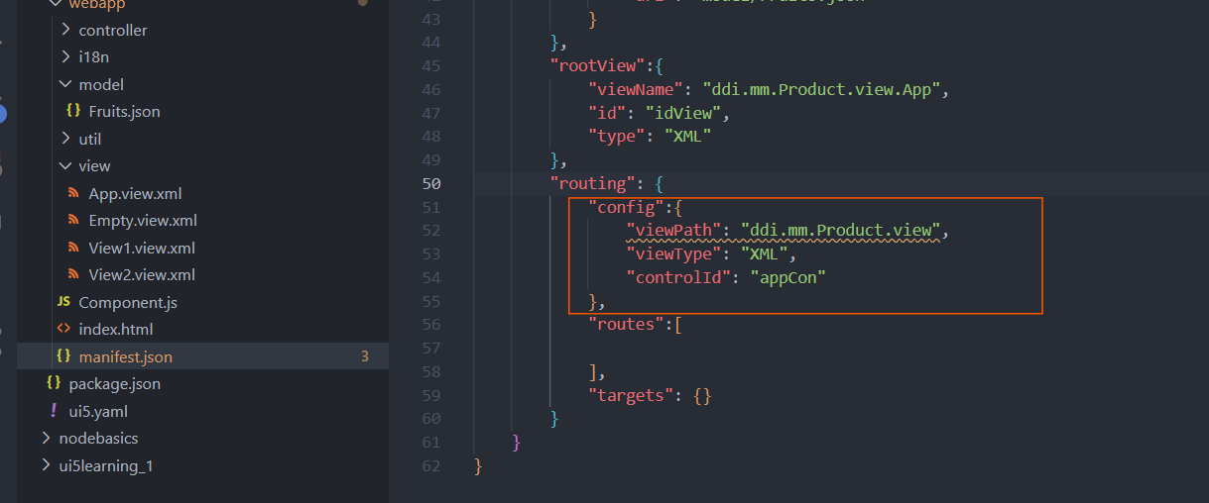
Very important routing config, here we maintain veiwPath, viewType basically we help router with info that our view’s are in view folder and type XML (whenever we initialize router its search for routing config).
Fragment >
There are 2 types of Fragments a> Static Fragment b> Dynamic Fragment
Static Fragment example –
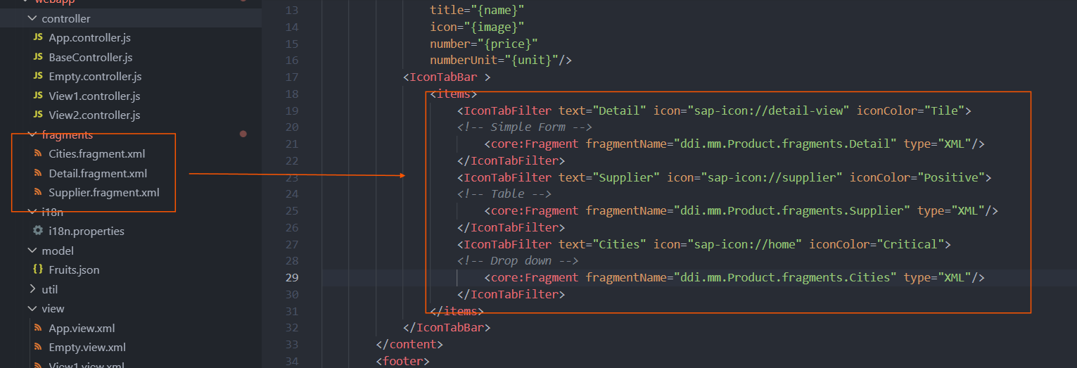
We need to first create a Fragment using XML syntax then add the Fragment in View.
Popup Control >
Dialog and SelectDialog > Dialog is a simple popup where we can create a Form inside and fill on runtime, and SelectDialog comes with Search and we can have multiple things inside it also it comes with a Button called close.
Dynamic Binding inside Fragment handling >
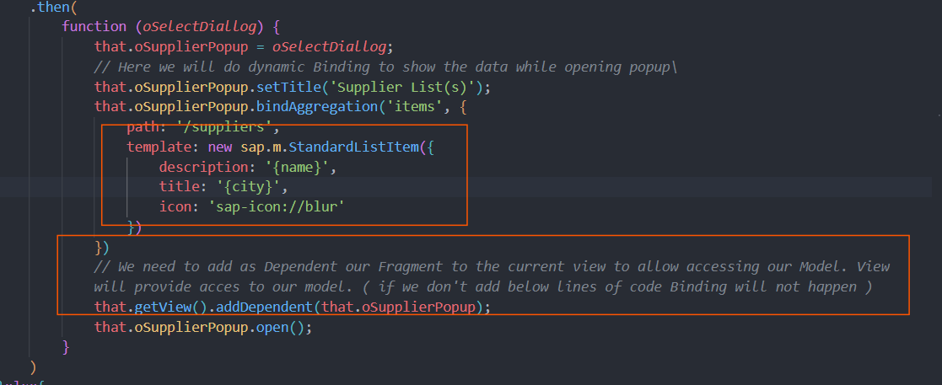
How to handle, like update the clicked value of F4 popup to the input >
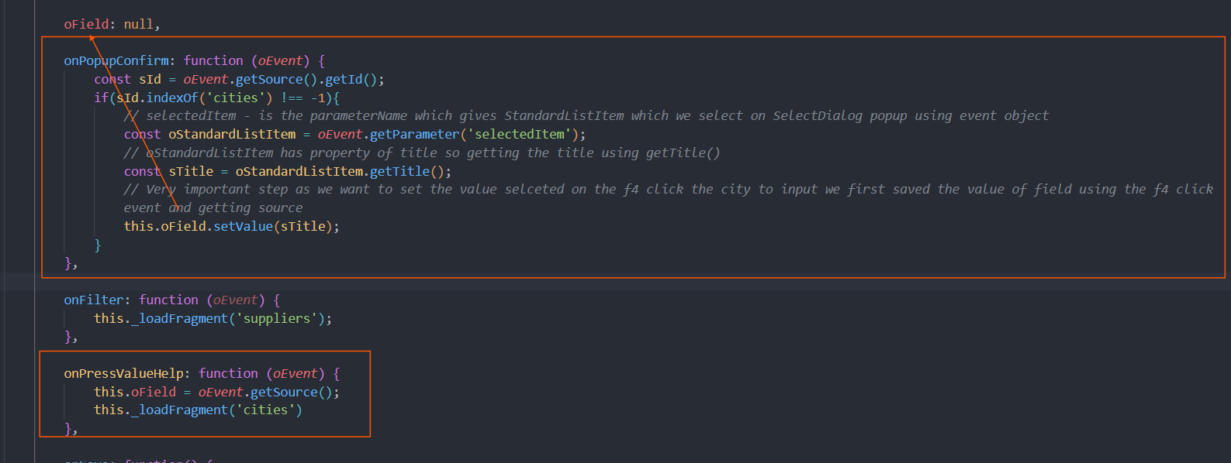
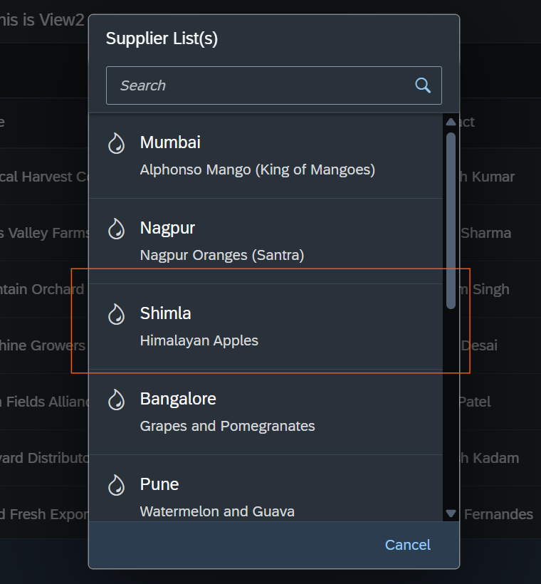
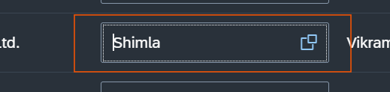
Remember as we are re-using one XML Fragment and creating multiple objects from it, we need to handle all the edge cases manually
***Why below code works and what’s the reason?
this.oRouter.getRoute("routeSecond").attachMatched(this._selectItemHandler, this)
Here this._selectItemHandler passed and not this._selectItemHandler() because if we call like method then attachMatched will be getting return from the handler method immediately as we are call it immediately and return value is undefined. So, we must use as variable which will be pointing to entire method body and event listener will call the handler when ever event occurs (takes some time).
Another example of what actually works shown below –
Basically, we are getting value in return so working.
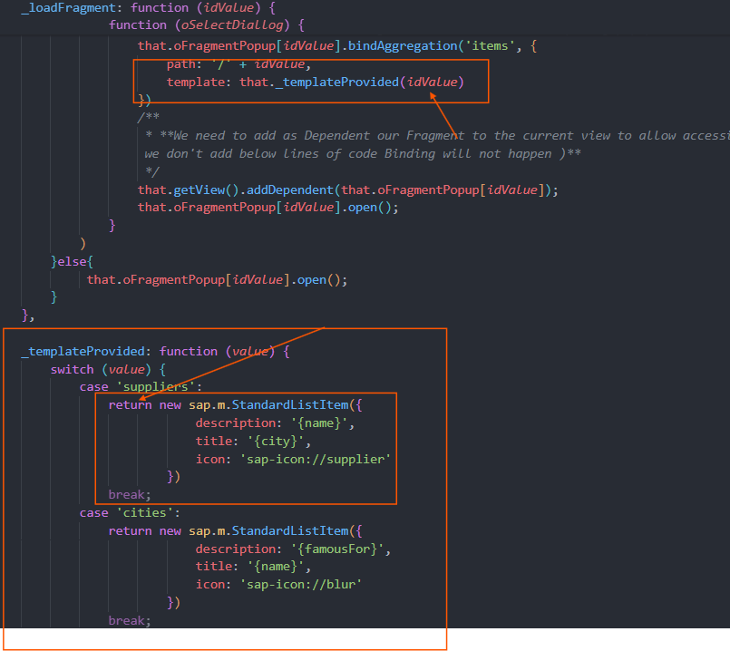
Dynamic i18nBinding >
For dynamic binding basically means to use JS code and do binding, for that we first get i18n Property using getText(propertyName, [value1, value2...]) also we need to maintain the index of array in {} in i18n file.
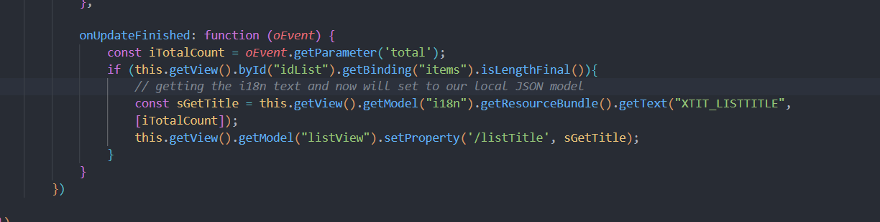
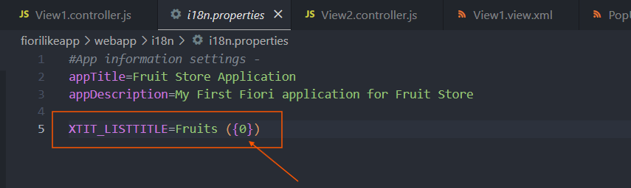
What is Service Document, EntitySet and EntityType
Service document – Describes the overall structure of OData service, which contains collection of entity sets. Each entityset represent one DB table in the background. We can perform CURDQ (Create, Update, Read, Delete and Query) –
EntitySet is the one which provides array of data that we bind, EntityType is simply the collection of Property or structure which each row of entitySet consists (An entity type is like a structure of our data e.g. empId, empName, salary, currency, gender, smoker…etc).
https://services.odata.org/V3/Northwind/Northwind.svc/
Remember for predicate we should start with ? first then with each predicate we have $ and second predicate we write with & as separator
https://services.odata.org/V3/Northwind/Northwind.svc/Customers?$pre1=value&$pre2=value2
How to get data of multi-entity in a single http call > $expand
First let’s learn how navigation property works in OData, lets for example in Northwind we have Customers entitySet and also Orders entitySet. But now we need to find say Customer A has how many orders in his name.
For finding these we have navigationProperty we can see that in metadata document.
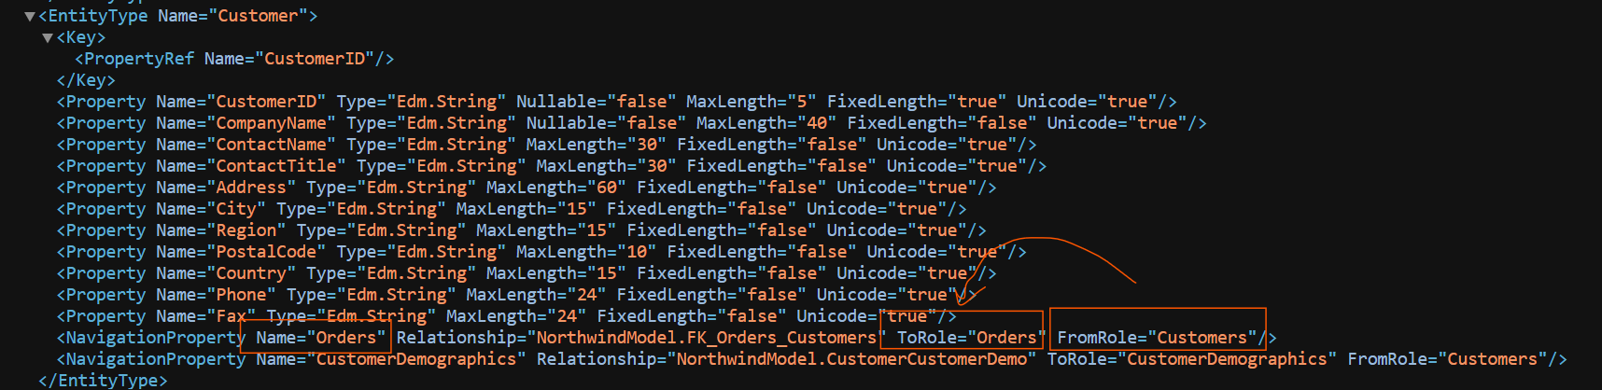
From customers to Orders navigation we have navigationProperty as Orders so using it, we can find the orders details.
https://services.odata.org/V2/Northwind/Northwind.svc/Customers('ALFKI')/Orders?$format=json
Now this will give only Orders for that customer, we have to query Customer again in a sperate call. So, to rectify it we have $expand which fetches Customer and its corresponding order in a single call (provided they needs to have association – means join in them).
https://services.odata.org/V2/Northwind/Northwind.svc/Customers('ALFKI')?$format=json&$expand=Orders
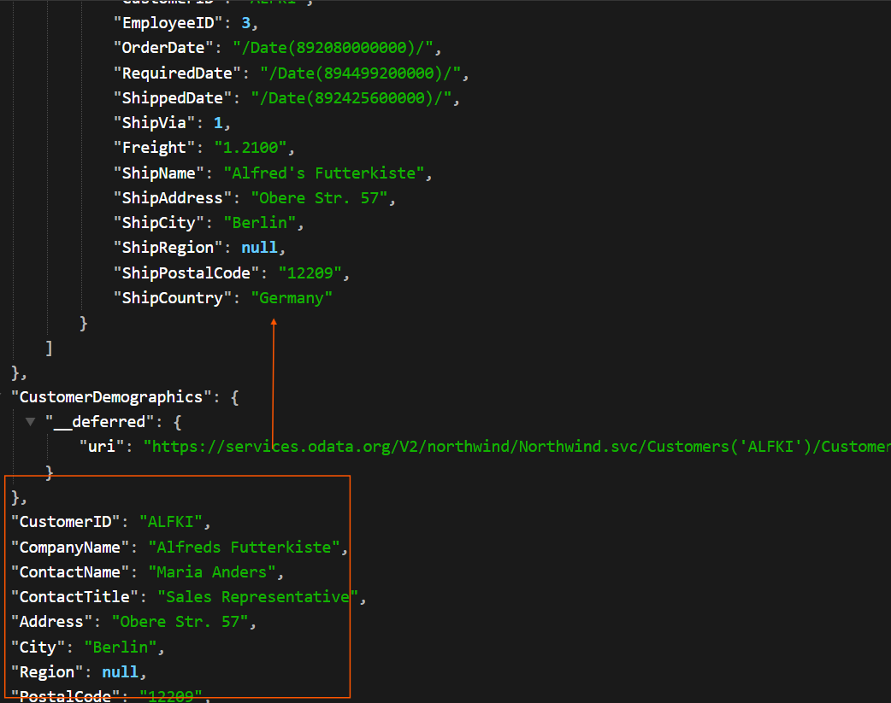
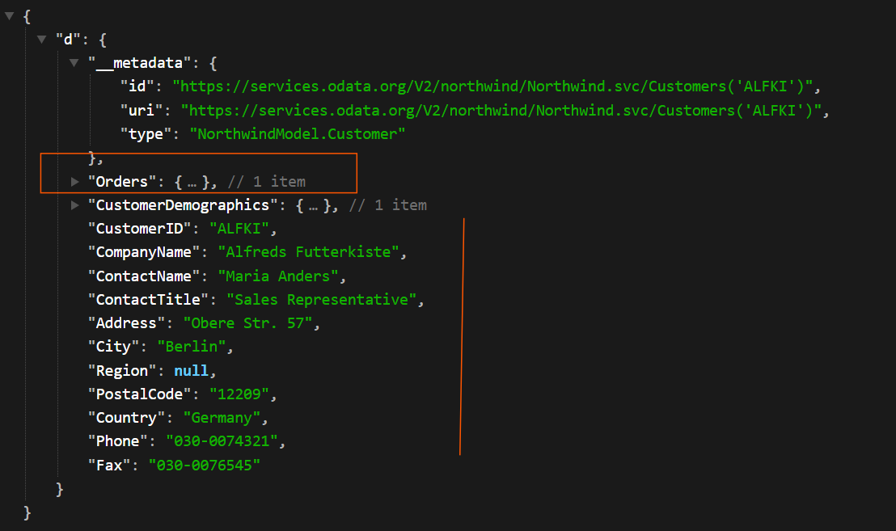
VVI: ‘this’ in formatter points to and how to leverage it
Remember this in formatter JS file inside object of AMD points to controller file only from where the call comes and we can use this to modularize our code, like for example shown below –
