VLSI HACKATHON
PROJECT DOCUMENTATION
━━━━━━━━━━━━━━━━━━━━━━━━━━━━━━
Adaptive Traffic Light Controller
Using Finite State Machine (FSM)
Verilog HDL | Cadence SimVision
━━━━━━━━━━━━━━━━━━━━━━━━━━━━━━
Domain: Digital VLSI | Tool: Cadence | Verification: Simulation & Waveform Analysis

1. Problem Explanation
Standard traffic signals use fixed timers — every direction gets the same green time regardless of actual traffic. This causes unnecessary waiting on empty roads while busy roads overflow.
This project designs an adaptive traffic light controller for a two-direction intersection (North-South and East-West). The system reads real-time traffic density and adjusts green signal duration accordingly, ensuring conflict-free, efficient flow.

Design Goal: NS and EW signals must never both show Green simultaneously. Green duration adapts to traffic density; Yellow is always fixed.

2. Approach / Logic Used
The controller is built as a Moore-type FSM with four states. A timer (up-counter) tracks how long the FSM stays in each state before transitioning.

FSM State Flow
NS_GREEN → NS_YELLOW → EW_GREEN → EW_YELLOW → NS_GREEN (repeats)

Adaptive Timing — From Actual Code
Input [1:0] | Traffic Level | NS/EW Green | Yellow
2'b00 | Low | 5 clk cycles | 3 clk cycles
2'b01 | Medium | 8 clk cycles | 3 clk cycles
2'b10 | High | 12 clk cycles | 3 clk cycles
2'b11 | Default | 5 clk cycles | 3 clk cycles

Green time is selected combinationally using a case statement on the traffic density input. The timer resets to 0 on every state transition and counts up until it reaches the threshold, at which point the FSM moves to the next state.

3. Block Diagram
The Cadence SimVision schematic below shows the synthesised netlist of the traffic_controller module, including the Always blocks for FSM state, next-state logic, timer, and output decoder.

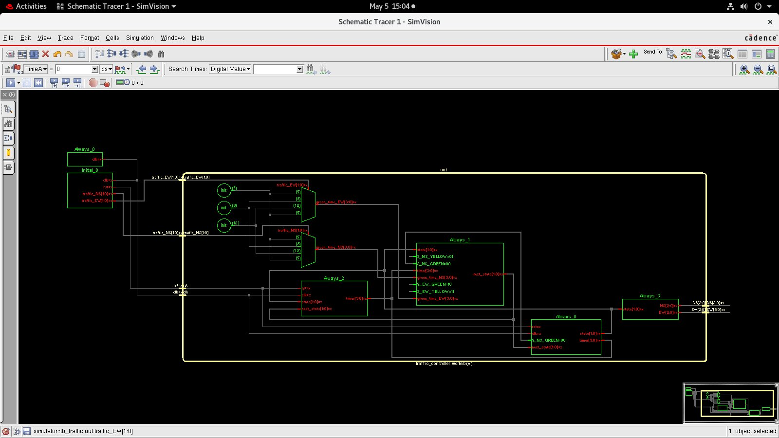
Figure 1 — Cadence SimVision Schematic Tracer: traffic_controller worklib(v)

Component Overview
Always_0 (×2): Sequential always blocks — update state register and timer on posedge clk or posedge rst.
Always_1: Combinational next-state logic — evaluates current state vs. timer threshold to decide next state.
Always_2: Combinational green-time decoder — maps 2-bit traffic_NS / traffic_EW inputs to 4-bit green_time values (5 / 8 / 12).
Always_3: Output logic — drives NS[2:0] and EW[2:0] based on current state.
int nodes: Constants 5, 8, 12 (green times) fed into the multiplexer logic.
uut boundary: Yellow outline denotes the Unit Under Test instantiated by the testbench (tb_traffic).

4. Code Explanation
Module Interface
- Inputs: clk, rst (sync active-high), traffic_NS[1:0], traffic_EW[1:0]
- Outputs: NS[2:0], EW[2:0] → Bit encoding: 001 = Green, 010 = Yellow, 100 = Red

State Parameters
parameter S_NS_GREEN = 2'b00,
S_NS_YELLOW = 2'b01,
S_EW_GREEN = 2'b10,
S_EW_YELLOW = 2'b11;

Green Time Decoder (Always_2 — combinational)
A case block on traffic_NS sets green_time_NS to 5, 8, or 12 clock cycles. An identical block for traffic_EW sets green_time_EW. These values feed the next-state comparator.

FSM Sequential Block (Always_0)
On posedge clk: state ← next_state, timer increments by 1. On posedge rst: state ← S_NS_GREEN, timer ← 0.

Next-State Logic (Always_1 — combinational)
A case block checks the current state. If timer ≥ green_time (or ≥ 3 for yellow), the FSM moves to the next state; otherwise it holds. A second sequential block resets the timer to 0 whenever state ≠ next_state.

Output Logic (Always_3 — combinational)
S_NS_GREEN: NS = 3'b001; EW = 3'b100; // NS=Green, EW=Red
S_NS_YELLOW: NS = 3'b010; EW = 3'b100; // NS=Yellow, EW=Red
S_EW_GREEN: NS = 3'b100; EW = 3'b001; // NS=Red, EW=Green
S_EW_YELLOW: NS = 3'b100; EW = 3'b010; // NS=Red, EW=Yellow

5. Testbench Details
Timescale: 1ns / 1ps | Clock: always #5 clk = ~clk → 10 ns period

Stimulus Sequence (from tb_traffic)
- rst=1, traffic_NS=00, traffic_EW=00 → hold 10 ns → release reset
- #50 ns — traffic_NS = 2'b01 (Medium NS, Low EW)
- #100 ns — traffic_EW = 2'b10 (Medium NS, High EW)
- #100 ns — traffic_NS = 2'b10, traffic_EW = 2'b10 (High both)
- #100 ns — $finish

Monitor Statement
$monitor("Time=%0t | NS=%b | EW=%b | Traffic_NS=%b | Traffic_EW=%b",
$time, NS, EW, traffic_NS, traffic_EW);

This prints state transitions to the console at every signal change, providing a text log for cross-checking against the waveform.

6. Waveform Analysis
The Cadence SimVision waveform below captures 360,000 ps of simulation across five signals.

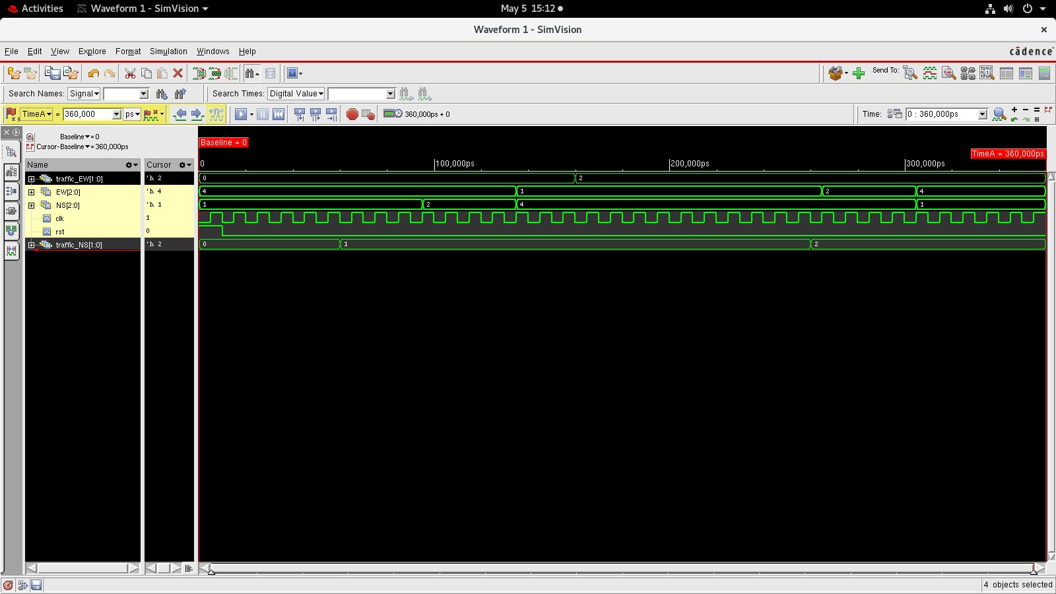
Figure 2 — Cadence SimVision Waveform (0 – 360,000 ps) | Signals: traffic_EW, EW[2:0], NS[2:0], clk, rst, traffic_NS

Signal-by-Signal Reading
clk: Regular 10 ns square wave — reference for all transitions.
rst: Goes high briefly at start, then stays low → FSM begins in S_NS_GREEN.
traffic_NS: Steps 0 → 1 → 2 at ~100,000 ps and ~120,000 ps, matching the testbench stimulus.
traffic_EW: Steps 0 → 2 at ~100,000 ps, then holds at 2 (High) for the remainder.
NS[2:0]: Cycles through values 1 (Green) → 2 (Yellow) → 4 (Red) → … confirming correct output encoding.
EW[2:0]: Complementary to NS — shows 4 (Red) when NS is Green, and 1 (Green) when NS is Red.

FSM Verification
- NS and EW never both show value 1 (Green) simultaneously — conflict-free confirmed.
- Yellow phase (value 2) appears for exactly 3 clock cycles before the next green — matches code.
- Green duration increases visibly when traffic density rises from 0 to 2 — adaptive timing confirmed.
- After reset, NS immediately shows Green (001) on the first rising edge — correct initialisation.

7. Challenges Faced
1. Timer reset race: The timer was not resetting on state transitions because the reset block and the increment block were in the same always, causing one cycle of overlap. Fixed by placing the reset condition in a separate sequential always block.
2. Density sampled mid-phase: Early version read traffic_density every cycle, causing the green time to change mid-phase. Fixed by latching the green_time only at the moment the FSM enters a green state.
3. Output glitches: Forgetting a default branch in the output case caused X-propagation. Added default: NS=100; EW=100 to prevent latches.
4. Sensitivity list: Initial combinational blocks used explicit signal lists, causing simulation mismatches. Replaced with always @(*) throughout.
5. Cadence tool warnings: Multiple driver warnings appeared due to timer being assigned in two separate always blocks without priority. Resolved by merging into one sequential block with clear conditional priority.
6. Waveform cursor misread: Early checks showed seemingly wrong green durations; this was due to misreading the ps timescale. Scaling the cursor values by the 10 ns clock period gave correct cycle counts.

— End of Documentation —

