#CHHATRONKIGOONJ
Anatomy of a Student Campaign

Public conversation, political response and media coverage
1 July 2026 – 13 August 2026 · All India
605 | 254 | 2.09 Cr | 63,841
Campaign tweets | Distinct voices | Campaign reach | Political + media posts

Data & Analytics Team · Jarvis Consulting
Generated 13 August 2026 · Confidential

1. Executive Summary

#ChhatronKiGoonj is a Congress-run student campaign built around paper leaks, cancelled recruitment exams and youth unemployment, fronted personally by Rahul Gandhi. Across the six hashtag exports it produced 605 distinct tweets from 254 accounts, drawing 2.09 Cr views and 8.40 L engagements between 1 July and 13 August 2026. In parallel, our tracked roster of political and media handles posted 63,841 times on the underlying student and youth issue.
- One man carries the campaign. Rahul Gandhi alone accounts for 33.86 L engagements on the topic across 60 posts — 65% of everything the top eight national voices earned combined. His single best-performing post drew 106,770 engagements and 79.77 L views. No other leader is close.
- The hashtag is single-party property. Of 1,466 campaign-tagged posts from tracked political handles, 1,185 came from INC and just 17 from BJP. This is not a contested hashtag — it is a Congress asset, and the ruling party has chosen not to enter it.
- But BJP owns the broader issue. On the wider student/youth topic BJP posted 26,461 times against INC’s 10,049 — 2.6x the volume. It is not silent on youth; it is talking about schemes, skilling and exam-reform legislation while refusing the paper-leak frame.
- The campaign has one peak, not a curve. 273 of the 605 campaign tweets in the window landed on a single day — 8 August, the Prayagraj event. Volume collapses to double digits within 48 hours. This is event-driven mobilisation, not a sustained conversation.
- Media split cleanly into two camps. National English outlets carry real criticism — IndiaToday 15.8% negative, TimesNow 14.5% — while high-volume Hindi channels stay near zero (@aajtak 0.4%, @ABPNews 0.1%). The same story is being told with two different temperatures.
- The cadre is tagging, but thinly. MLAs supply 918 of the 1,466 campaign-tagged posts — 63% of the total, from 127 handles. Yet that is only 3.7% of the 24,986 topic posts MLAs produced. The bench is participating; it is simply spending the other 96% of its output on routine constituency content.

The two datasets in one view
 | Hashtag exports (public) | Tracked roster (political + media)
What it captures | Anyone who used the campaign hashtags | Our curated handles, whether or not they tagged
Tweets | 605 | 63,841
Accounts | 254 | 2,272
Views | 2.09 Cr | 45.11 Cr
Engagements | 8.40 L | 11.03 Cr
Positive | 30.5% | 15.2%
Negative | 11.0% | 3.5%

2. What Was Analysed

Two independent sources were merged for this report.

Source A — hashtag exports
File | Tweets | Accounts | First seen | Last seen
#ChhatronKiGoonj | 487 | 146 | 2026-06-15 | 2026-08-12
#StudentsRights | 134 | 54 | 2026-02-21 | 2026-08-13
#छात्रोंकीगूंज | 73 | 58 | 2026-06-17 | 2026-08-10
#YouthEmployment | 47 | 43 | 2024-04-03 | 2026-08-13
#StudentIssues | 21 | 18 | 2025-07-04 | 2026-08-13
#StudentsWithRahul | 13 | 13 | 2025-05-15 | 2026-08-13

The six files contain 909 rows; after removing tweets that appear in more than one file (a post carrying both #ChhatronKiGoonj and #StudentsRights is one tweet, not two) 771 unique tweets remain. Some files reach back to 2024, so this report works with the 605 tweets dated 1 July 2026 onward.

A data-quality warning
92 tweets in the #StudentsRights export are about Iranian student protests, not India — they carry #FreeIranStudents, #KingRezaPahlavi and #IranMassacre and come from 33 foreign accounts. They inflate the hashtag totals and would distort sentiment if left in. All campaign figures in this report exclude them; the raw file counts in the table above do not.

Source B — tracked roster
The full July and August exports from our master database (2,272 political and media handles) were filtered for student, exam, paper-leak, recruitment, scholarship and youth-employment language. That returns 63,841 posts — 39,821 from political handles and 24,020 from media houses and journalists. Posts carrying the campaign hashtags are flagged separately (1,466 posts) so we can distinguish "talking about students" from "joining the campaign".
33 accounts appear in both datasets — these are tracked handles that actively used the hashtags, and they are the bridge between the organised campaign and the open conversation.

3. The Campaign — Shape and Reach

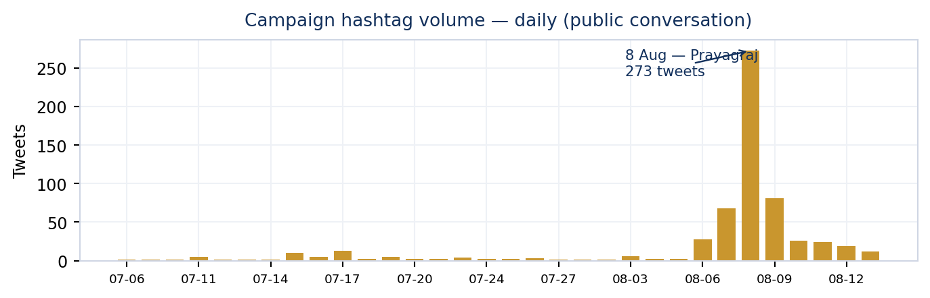
Figure 1 — Daily campaign hashtag volume, 1 July to 13 August 2026.
The campaign is one spike. 273 tweets landed on 2026-08-08 — 45% of all campaign activity in a six-week window — the day of the Prayagraj student event. The preceding day carried the reach (1.05 Cr views on 68 tweets, as national accounts and media previewed the event) while the day itself carried the volume as supporters flooded in.
Within 48 hours volume falls to 26 tweets a day and keeps falling. Prayagraj is mentioned in 263 of the campaign tweets — more than paper leaks, Dharmendra Pradhan and Dehradun combined. The campaign’s identity is an event, and when the event ends the hashtag goes quiet.
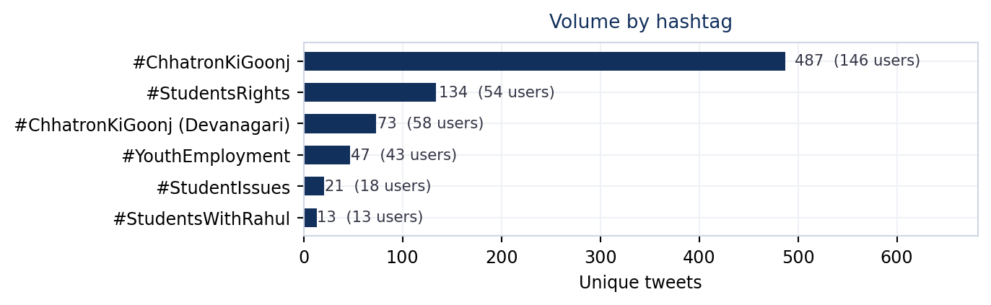
Figure 2 — Volume by hashtag. #ChhatronKiGoonj carries the campaign; the others are satellites.
#ChhatronKiGoonj is the campaign; everything else is a satellite. It holds 487 of the 771 unique tweets across 146 accounts. The Devanagari variant adds 73 and #StudentsWithRahul — the most explicitly personalised tag — managed only 13 tweets from 13 accounts. The audience is being asked to rally around the issue, not the leader, at least in tagging terms.

Who is amplifying it
Account | Name | Posts | Engagements | Views
@INCIndia | Congress | 57 | 1.99 L | 27.56 L
@IYC | Indian Youth Congress | 48 | 36,021 | 4.69 L
@Deepakkhatri812 | Deepak Khatri | 24 | 12,187 | 84,414
@somi_army7 | koki⁷شیرموز جانگکوک | 22 | 37,098 | 1.60 L
@bharatjodo | Bharat Jodo | 16 | 30,371 | 2.70 L
@news24tvchannel | News24 | 13 | 31,733 | 4.18 L
@INCUttarPradesh | UP Congress | 13 | 4,449 | 54,477
@UWCforYouth | India With Congress | 11 | 3,551 | 30,848
@IranGirl0 | ⁷دُختر ایران | 11 | 38,632 | 2.06 L
@nsui | NSUI | 10 | 12,573 | 1.05 L
@Supriya23bh | Supriya Bhardwaj | 10 | 9,506 | 1.23 L
@Control_Krishna | Krishna Yadav | 10 | 2,490 | 60,517

The top of the list is party machinery — @INCIndia, @IYC (Indian Youth Congress), @INCUttarPradesh, @nsui, @bharatjodo. This is an organised push, not organic spread. Of 254 accounts using the hashtags, the top ten produce 29% of the volume.

Co-occurring hashtags
Hashtag | Tweets | Accounts | Hashtag | Tweets | Accounts
#chhatronkigoonj | 469 | 148 | #youthemployment | 44 | 41
#studentsrights | 124 | 48 | #youthvoice | 21 | 18
#rahulgandhi | 79 | 46 | #kingrezapahlavi | 21 | 10
#freeiranstudents | 79 | 29 | #studentissues | 20 | 17
#prayagraj | 68 | 34 | #iranmassacre | 16 | 10
#छात्रोंकीगूंज | 64 | 53 | #congress | 13 | 9
#studentsarenotcrimina | 54 | 25 | #dehradun | 11 | 8

Language mix: English/Roman 81.6%, Hindi 16.5%, Telugu 1.7%, Tamil 0.3%.

4. The Voices That Carried It

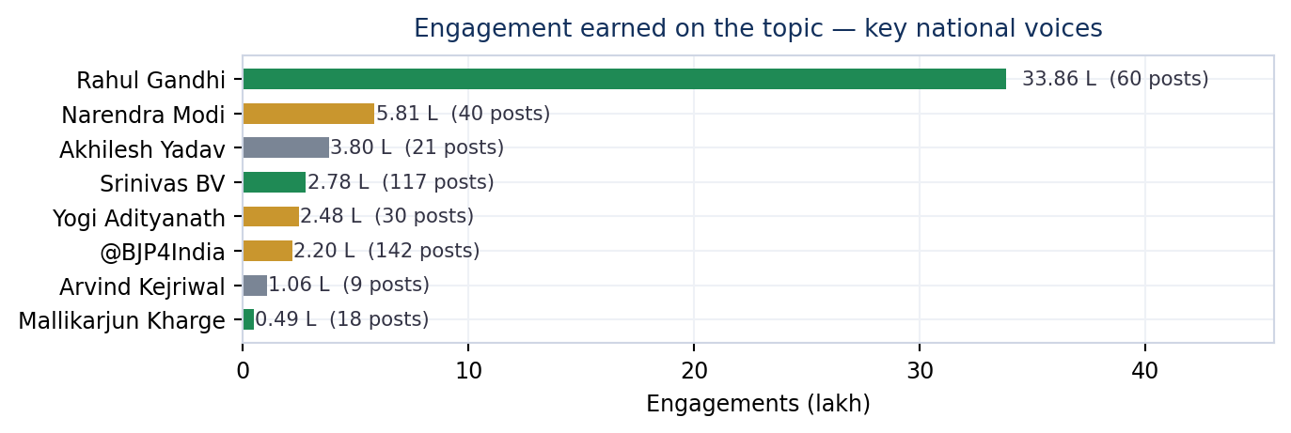
Figure 3 — Engagement earned on the student/youth topic by key national voices. Green = INC, gold = BJP.
Rahul Gandhi is the campaign. 60 posts on the topic earning 33.86 L engagements — more than the next seven national leaders combined. His negative-sentiment share is 8.3%, the highest of any major figure here, because his framing is explicitly accusatory rather than promotional.
The contrast with the government side is instructive. Narendra Modi posted 40 times on youth-related themes and earned 5.81 L engagements at 0.0% negative — a positive, scheme-led register that never engages the paper-leak charge. Srinivas BV (@srinivasiyc), the Youth Congress figure, posts the most of anyone on the list (117, including 27 campaign-tagged) but converts far less per post: he is the volume engine, Rahul Gandhi is the reach engine.

Key figures on the topic
Handle | Name | Party | Posts | Tagged | Engagements | Neg %
@RahulGandhi | Rahul Gandhi | INC | 60 | 5 | 33.86 L | 8.3
@narendramodi | Narendra Modi | BJP | 40 | 0 | 5.81 L | 0.0
@yadavakhilesh | Akhilesh Yadav | SP | 21 | 0 | 3.80 L | 0.0
@srinivasiyc | Srinivas BV | INC | 117 | 27 | 2.78 L | 9.4
@myogiadityanath | Yogi Adityanath | BJP | 30 | 0 | 2.48 L | 0.0
@BJP4India | @BJP4India | BJP | 142 | 0 | 2.20 L | 5.6
@ArvindKejriwal | Arvind Kejriwal | AAP | 9 | 0 | 1.06 L | 0.0
@kharge | Mallikarjun Kharge | INC | 18 | 0 | 49,310 | 0.0
@priyankagandhi | Priyanka Gandhi Va | INC | 6 | 1 | 40,551 | 16.7
@dpradhanbjp | Dharmendra Pradhan | BJP | 5 | 0 | 19,715 | 0.0

Highest-impact campaign posts
“E20 - Not just a black spot in the lentils, the whole lentil is black.”
— Rahul Gandhi · 2026-08-07 · 79.77 L views · 106,770 engagements

“India's education system has today become nothing but a recovery mechanism. Just think about it - the amount of money families across the country spend solely on preparing for NEET is equal to the entire education budget of the Government of India. Today, from Kota, and from”
— Rahul Gandhi · 2026-06-17 · 7.43 L views · 53,087 engagements

“Amid the darkness spread by the system, the students of the country have confronted their fears and lit the torch of light. These torches are now showing the entire country the path to its rights. Now is the time to end the BJP-RSS and Adani's System, saying tata, bye-bye.”
— Rahul Gandhi · 2026-08-08 · 6.32 L views · 52,418 engagements

““I have no way out left now” - This is what a student said to me yesterday in Prayagraj. Years of preparation, sold the family land, parents’ debts, and still nothing to show for it. This defeat is not his. This is the defeat of that system which refused to reward his hard work.”
— Rahul Gandhi · 2026-08-09 · 12.76 L views · 45,515 engagements

5. Party-wise Response

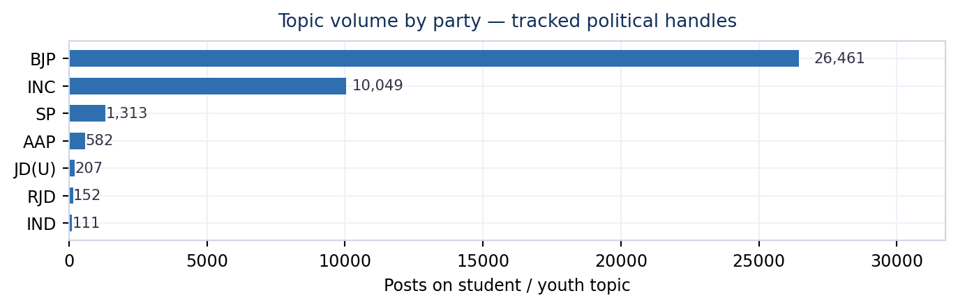
Figure 4 — Posts on the student/youth topic by party, tracked political handles.
On the broad topic BJP leads with 26,461 posts from 1,448 handles against INC’s 10,049 from 321. Read alone that looks like the ruling party dominating the youth conversation. It is not the same conversation.
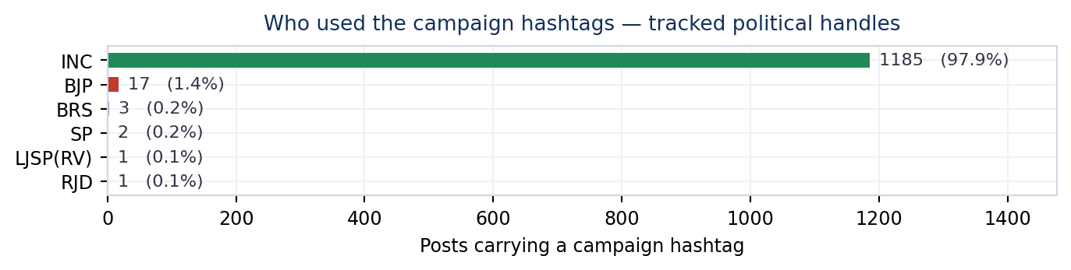
Figure 5 — Campaign-hashtag posts by party. The hashtag belongs to one side.
Filter to posts that actually carry the campaign hashtags and the picture inverts completely: INC 1,185, BJP 17. The ruling party is talking about youth in its own vocabulary — skilling schemes, exam-reform legislation, employment melas — and has made a deliberate choice not to step into a frame it did not build. That is a defensible strategy, but it means the paper-leak narrative goes uncontested inside the hashtag.
Engagement per post tells the same story from the other direction. INC averages 3,943 engagements per topic post against BJP’s 2,419 — 1.6x — while posting 62% less. A smaller, sharper, more confrontational output is outperforming a larger promotional one.

Party scorecard on the topic
Party | Posts | Handles | Tagged | Pos % | Neg % | Engagements | Per post
BJP | 26,461 | 1,448 | 17 | 16.2 | 2.0 | 6.40 Cr | 2,419
INC | 10,049 | 321 | 1,185 | 9.5 | 4.7 | 3.96 Cr | 3,943
SP | 1,313 | 107 | 2 | 2.7 | 0.8 | 13.19 L | 1,004
AAP | 582 | 80 | 0 | 13.1 | 3.4 | 8.99 L | 1,544
JD(U) | 207 | 18 | 0 | 10.6 | 1.9 | 4.71 L | 2,277
RJD | 152 | 17 | 1 | 9.2 | 1.3 | 3.31 L | 2,176
IND | 111 | 14 | 0 | 11.7 | 2.7 | 2.84 L | 2,555
AITC | 79 | 12 | 0 | 40.5 | 16.5 | 1.09 L | 1,377

Tone — how each side frames it
“Mr. Modi, our students are demanding Dharmendra Pradhan’s resignation. Don’t insult their intelligence with this pathetic midnight video. 1. Sack Pradhan. 2. Punish those who beat students. 3. ⁠Apologise”
— RahulGandhi · INC · LS_MP · 124,144 engagements

“Congratulations to every student in India on the passage of the Public Examinations (Prevention of Unfair Means) Amendment Bill, 2026 in Lok Sabha today. The bill shields the dreams and aspirations of our youth by laying down iron-clad provisions imp”
— AmitShah · BJP · LS_MP · 68,778 engagements

“Nothing is more important than the welfare and future of our youth! We have decided to set up fast-track courts to ensure swift and stringent punishment for those involved in paper leaks. Have directed the concerned authorities and officials to take ”
— narendramodi · BJP · LS_MP · 187,854 engagements

“You are the one who has harmed the future of our youth the most. You allowed and encouraged the total capture and destruction of our education system - and protected every person responsible for it. The students’ demands are clear: 1. Sack Dharmendra”
— RahulGandhi · INC · LS_MP · 132,291 engagements

6. Who Spoke — By Office

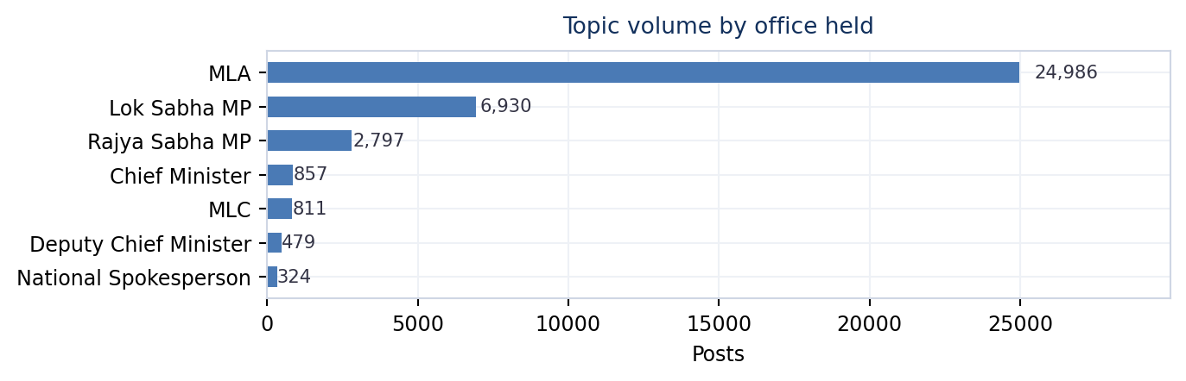
Figure 6 — Topic posts by office. Handles holding two offices are counted in both.
MLAs dominate volume: 24,986 posts from 1,506 handles, 63% of all political output on the topic. Most of it is constituency content — scholarship distributions, exam-centre visits, youth sports events. But the tier is not sitting the campaign out: 918 MLA posts from 127 handles carry a campaign hashtag, 63% of all tagged posts in the dataset. The participation rate within the tier is the weak point, not participation itself — 3.7% of MLA topic output is tagged.
Lok Sabha MPs post 6,930 times from 371 handles at 2,238 engagements per post, roughly 0.7x the MLA rate. Rajya Sabha MPs add 2,797 posts from 149 handles. These two tiers, plus 28 Chief Ministers posting 857 times, are where the national framing actually happens.

Designation scorecard
Designation | Posts | Handles | Pos % | Neg % | Engagements | Per post
MLA | 24,986 | 1,506 | 13.4 | 2.1 | 7.75 Cr | 3,102
Lok Sabha MP | 6,930 | 371 | 16.1 | 3.6 | 1.55 Cr | 2,238
Rajya Sabha MP | 2,797 | 149 | 16.6 | 5.0 | 44.23 L | 1,581
Chief Minister | 857 | 28 | 21.9 | 2.6 | 24.65 L | 2,876
MLC | 811 | 44 | 10.4 | 1.0 | 18.43 L | 2,272
Deputy Chief Minister | 479 | 20 | 19.0 | 1.5 | 13.30 L | 2,776
National Spokesperson | 324 | 7 | 7.4 | 4.3 | 4.93 L | 1,522
AICC In-charge - Bihar | 126 | 1 | 6.3 | 2.4 | 2.25 L | 1,783
Former President - India | 117 | 1 | 10.3 | 9.4 | 2.78 L | 2,379

Office by party — who fields whom
Office | BJP | INC | SP | AAP
Lok Sabha MP | 5,131 | 1,193 | 306 | 13
Rajya Sabha MP | 2,176 | 372 | 5 | 52
MLA | 16,006 | 7,168 | 650 | 421
MLC | 811 | 0 | 1 | 0
Chief Minister | 1,083 | 181 | 0 | 46

BJP fields more handles at every tier. The gap is widest in the MLC row — 811 posts to INC’s 0 — and in Chief Ministers, where BJP’s 1,083 posts reflect simple arithmetic of how many states each party governs.

Campaign-tagged posts by office
Designation | Tagged posts | Handles | Engagements
MLA | 918 | 127 | 14.50 L
Lok Sabha MP | 108 | 38 | 3.65 L
Former Cabinet Minister | 32 | 1 | 10,766
Former President - Indian Yout | 27 | 1 | 25,859
Rajya Sabha MP | 27 | 12 | 31,961
AICC In-charge - Bihar | 21 | 1 | 7,231
National Spokesperson | 14 | 2 | 18,529

7. Media House and Journalist Coverage

Media accounts produced 24,020 posts on the topic from 45 handles — 38% of everything captured. Coverage is heavy, continuous and, in volume terms, larger than any single party’s output.
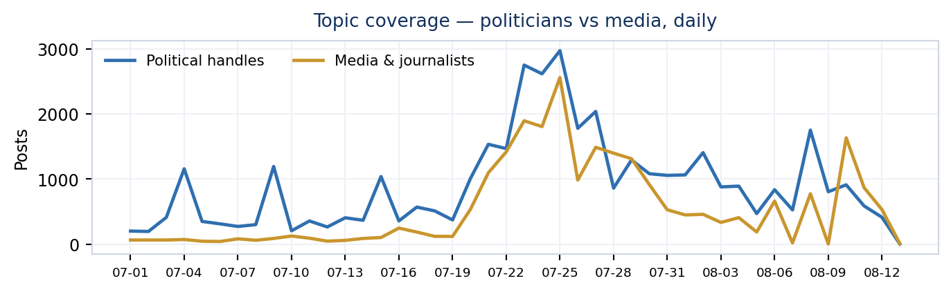
Figure 7 — Daily topic posts: political handles versus media and journalists.
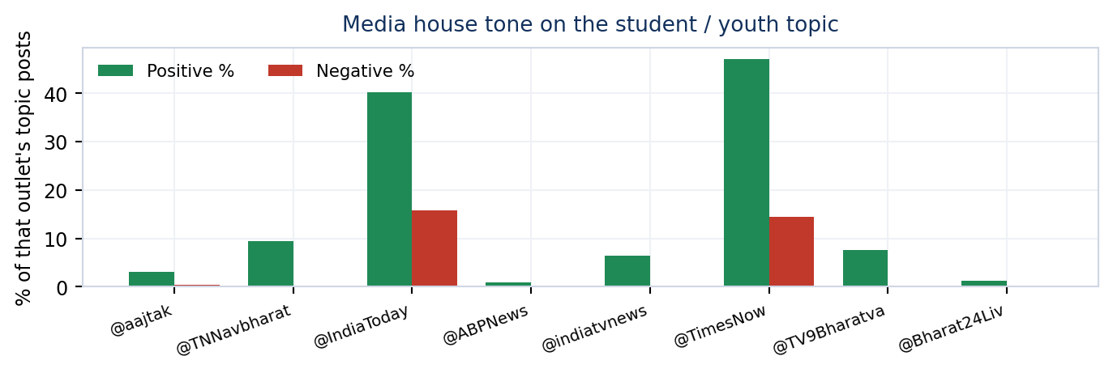
Figure 8 — Tone by outlet. The split between English and Hindi newsrooms is stark.
The tone split is the most useful finding in this section. IndiaToday runs 15.8% negative and 40.3% positive on the topic; TimesNow 14.5% and 47.0%. Both are engaging the controversy as controversy. Against that, @aajtak carries 2,410 posts — the highest volume of any outlet — at just 0.4% negative, and @ABPNews 1,608 posts at 0.1%. The high-volume Hindi channels are covering student news without covering the accusation.

Media houses on the topic
Outlet | Posts | Pos % | Neg % | Engagements | Views
@aajtak | 2,410 | 3.1 | 0.4 | 3.78 L | 4.69 Cr
@TNNavbharat | 2,166 | 9.5 | 0.1 | 7,526 | 18.37 L
@IndiaToday | 1,809 | 40.3 | 15.8 | 56,821 | 1.39 Cr
@ABPNews | 1,608 | 0.9 | 0.1 | 1.38 L | 1.72 Cr
@indiatvnews | 1,568 | 6.4 | 0.3 | 24,955 | 46.91 L
@TimesNow | 1,497 | 47.0 | 14.5 | 74,750 | 1.46 Cr
@TV9Bharatvarsh | 1,283 | 7.6 | 0.2 | 7,632 | 15.33 L
@Bharat24Liv | 1,265 | 1.3 | 0.2 | 995 | 4.12 L
@CNNnews18 | 1,248 | 38.6 | 17.6 | 10,248 | 44.12 L
@ndtvindia | 1,031 | 1.8 | 0.0 | 1.23 L | 85.61 L

Journalists on the topic
Handle | Posts | Pos % | Neg % | Engagements
@AmanKayamHai_ | 13 | 53.8 | 7.7 | 35
@AnilYadavmedia1 | 7 | 0.0 | 0.0 | 10,253
@ajitanjum | 4 | 0.0 | 0.0 | 6,658
@ManishPandeyLKW | 2 | 0.0 | 0.0 | 50
@sengarlive | 2 | 0.0 | 0.0 | 334
@RubikaLiyaquat | 1 | 100.0 | 0.0 | 400
@rohini_sgh | 1 | 100.0 | 0.0 | 164
@vishalpandeyk | 1 | 0.0 | 0.0 | 37

Individual journalists in the roster are a small group — 31 posts in total. Their volume is negligible next to institutional accounts, so treat this table as a signal of who is engaged, not as a measure of press attention.

Critical media framing
“Inside Track on Key Cabinet Meet: - PM asks Ministers to boost Instagram presence. - PM to Ministers: Get active on Instagram, don’t limit yourself to X - Prime Minister tells Ministers: Share reels on government schemes, reach out to youth through I”
— @TimesNow · Media · 18,208 engagements

“Videos emerge showing police using increasingly violent methods to stop India’s student protest movement in the capital New Delhi. More than 100 students have reportedly been injured, amid claims some were hit by pellet guns.”
— @AJEnglish · Media · 11,043 engagements

8. Where It Landed

Uttar Pradesh leads with 10,142 topic posts from 514 handles — 31% of state-tagged political output, and far ahead of Rajasthan (4,498). Given that Prayagraj is the campaign’s anchor event and UP carries the largest competitive-exam population in the country, the concentration is expected rather than incidental.
State | Posts | Handles | Neg % | Engagements
Uttar Pradesh | 10,142 | 514 | 1.9 | 2.86 Cr
Rajasthan | 4,498 | 180 | 1.5 | 1.53 Cr
Madhya Pradesh | 3,611 | 159 | 1.6 | 77.93 L
Gujarat | 3,124 | 150 | 2.6 | 91.48 L
Maharashtra | 2,881 | 192 | 2.4 | 97.31 L
Delhi | 1,922 | 71 | 2.5 | 34.59 L
Bihar | 1,817 | 100 | 2.5 | 39.26 L
Uttarakhand | 1,698 | 48 | 1.7 | 33.00 L
Jharkhand | 1,454 | 55 | 1.6 | 15.17 L
Chhattisgarh | 1,346 | 56 | 1.4 | 24.46 L

Most-engaged political posts on the topic
Handle | Name | Party | Office | Engagements | Tone
@narendramodi | narendramodi | BJP | LS_MP | 187,854 | Positive
@RahulGandhi | RahulGandhi | INC | LS_MP | 167,022 | Neutral
@yadavakhilesh | yadavakhilesh | SP | LS_MP | 74,457 | Neutral
@AmitShah | AmitShah | BJP | LS_MP | 68,778 | Negative
@gyantiwaribjp | gyantiwaribjp | BJP | MLA | 57,985 | Positive
@yogeshshuklabk | yogeshshuklabkt | BJP | MLA | 57,985 | Positive
@IAlkaSingh | IAlkaSingh | BJP | MLA | 57,985 | Positive
@AshishSingh_BJ | AshishSingh_BJP | BJP | MLA | 57,984 | Positive
@SidharthNSingh | SidharthNSingh | BJP | MLA | 57,984 | Positive
@NandiGuptaBJP | NandiGuptaBJP | BJP | MLA | 57,984 | Positive

9. Read-out and Implications

- The campaign peaked and stopped. 45% of campaign volume sits on one day. Event-driven spikes do not build a narrative — they need a follow-on hook within 72 hours or the audience disperses. There was none here.
- Personal reach is doing the work of an organisation. Rahul Gandhi’s 33.86 L engagements against a party machinery that manages a fraction of that is a structural dependency. If the leader does not post, the campaign does not travel.
- The cadre is the cheapest lever left. 127 MLA handles already tag the campaign, producing 918 posts. Lifting the tagging rate on MLA topic output from 3.7% to even 10% would add roughly 1,580 posts — more than the entire campaign hashtag pool from the public. The network exists and is already warm.
- The government’s non-engagement is working. By posting 26,461 times on youth without once entering the hashtag, BJP denies the campaign an opponent. A hashtag with no fight in it decays faster.
- Hindi media is the gap. English outlets carry the criticism; the Hindi channels with the largest reach carry the story without the charge. The campaign is reaching the audience that already agrees with it.
- Clean the hashtag exports before reporting. 92 of the tweets in the #StudentsRights file are about Iran. Any dashboard reading these files raw will report inflated reach and distorted sentiment.

Method notes
- Hashtag exports carry no party or designation field; all party and office analysis comes from the tracked roster.
- Sentiment labels are model-assigned on post text only and are reliable in aggregate, not on any single post.
- Handles holding two offices are counted under each, so designation rows sum above the political total.
- Views are platform-reported impressions, not unique people.
- Iran-related tweets are excluded from all campaign figures but remain in the raw per-file counts in Section 2.

Data & Analytics Team, Jarvis Consulting · 13 August 2026 · Sources: six campaign hashtag exports (771 unique tweets) and the Political Pulse master database (63,841 topic posts), 1 July – 13 August 2026.

