| SOCIAL MEDIA INTELLIGENCE NEWSLETTER | 13 August 2026

#ChhatronKiGoonj — The Student Uprising That Cost a Minister His Job
How Rahul Gandhi turned a paper-leak grievance into a national campaign — and what India actually said about it
Campaign deep-dive · Social Media Data Team · 1 July – 13 August 2026

35,062 | 605 | 35.1 L | 4,245 | Minister resigned
Posts on the controversy | Campaign hashtag tweets | Rahul Gandhi engagements | Peak day (25 July) | Outcome

1. The story in five lines

It began as an exam grievance and ended with a Union Cabinet minister resigning in 38 days.
- Congress launched #ChhatronKiGoonj in mid-June as a city-to-city student dialogue series — Kota, Dehradun, Ranchi, Prayagraj — with Rahul Gandhi personally in the room, no teleprompter, taking questions from students directly.
- The number that gave it teeth: 152 papers leaked in 10 years, one every month, 7.5 crore students affected, nobody punished. Priyanka Gandhi Vadra put that line into circulation on 17 July and it became the campaign's spine.
- On 18 July Sonam Wangchuk was forcibly removed from his hunger strike at Jantar Mantar. On 20 July the "Chalo Sansad" march met lathicharge and tear gas. The grievance became a confrontation.
- On 23 July the Prime Minister announced fast-track courts for paper-leak crimes — the single most-engaged post of the entire episode. Two days later Education Minister Dharmendra Pradhan resigned.
- On 7–8 August Rahul Gandhi took the campaign to Prayagraj, India's largest competitive-exam city. It produced the biggest single-day hashtag spike of the period and a direct BJP counter-attack.
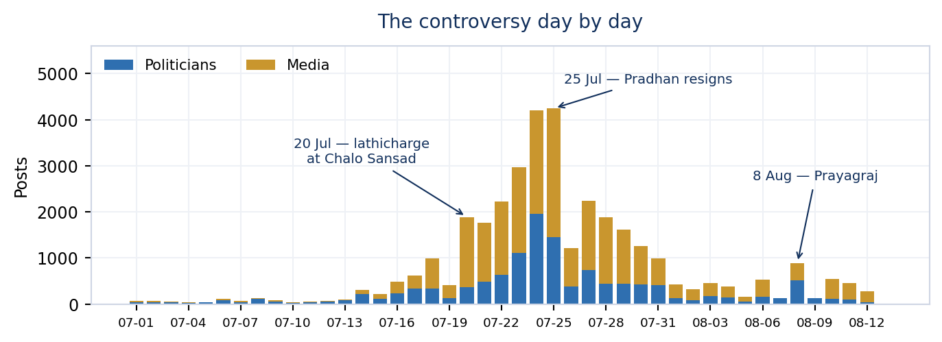
Every day of the controversy. The 25 July resignation is the peak — not the Prayagraj event.

2. How it unfolded

A campaign that ran on a schedule, then got overtaken by events.
Date | What happened | What it produced
16–17 Jun | #ChhatronKiGoonj launched at the Kota mega rally — Rahul Gandhi in open dialogue with students | "No teleprompter, no pre-rehearsed questions" becomes the campaign's signature
14–17 Jul | Sonam Wangchuk's hunger strike gathers support; Dehradun leg of the campaign | Priyanka Gandhi: "152 papers leaked, 7.5 crore students harmed, not one person punished"
18 Jul | Wangchuk forcibly removed from Jantar Mantar | Akhilesh Yadav, Dimple Yadav, Rahul Gandhi all react within hours
19 Jul | Ranchi torch procession (मशाल जुलूस) | "Ranchi has shown it: the students are now awake"
20 Jul | "Chalo Sansad" march — lathicharge and tear gas in Delhi | Al Jazeera reports thousands demanding the PM's and minister's resignation
21 Jul | March to the PM's residence; metro stations, roads and internet restricted | Rahul: "Metro band karo. Raste band karo. Internet band karo."
23 Jul | PM Modi announces fast-track courts for paper-leak crimes | 1,87,854 engagements — the largest single post of the episode
25 Jul | Dharmendra Pradhan resigns as Education Minister | 4,245 posts in one day; @Cockroachisback: "DEMOCRACY WINS"
26–28 Jul | Pradhan welcomed at Bhubaneswar airport and in Parliament; BJP counter-attacks CJP | Narrative splits into "students won" vs "campaign was sponsored"
3 Aug | Siwan (Bihar) police action on students; BJP contrasts Jharkhand's "genuine" movement | Amit Malviya: "temple langar, not Junaid's biryani"
7–8 Aug | Prayagraj — the campaign's largest event | 273 hashtag tweets in one day; BJP pushes #RaGaFlopShow

3. How Rahul Gandhi led it

This was not a campaign Rahul Gandhi endorsed. It was one he ran in person, and the data shows a leader operating on three tracks at once.
Track 1 — He went to the students, city by city
The campaign was built as a travelling dialogue, not a rally circuit: Kota in June, Dehradun on 17 July, Ranchi's torch procession, then Prayagraj on 7–8 August. The format was deliberately unpolished — no teleprompter, unscripted questions, students speaking first. Congress MP Deependra Singh Hooda described the Kota launch as "a direct heart-to-heart conversation with the country's Gen Z". Prayagraj alone is named in 263 of the campaign tweets, more than paper leaks, Dharmendra Pradhan and Dehradun put together.
Track 2 — He carried the students' own words back
A | Rahul Gandhi 17 July · Dehradun  ““I have no way out left now” — this is what a student said to me yesterday in Prayagraj. Years of preparation, and then the paper leaks.”  45,515 engagements · 12.76 L views  Why it landed: He is not making the argument himself — he is quoting a student. This is the single most repeated technique across his 65 posts on the topic, and the one that travels furthest.

Track 3 — He escalated it to the top, by name
B | Rahul Gandhi 20 July  “प्रधानमंत्री मोदी भारत के इतिहास के सबसे युवा-विरोधी प्रधानमंत्री हैं — इतने युवा विरोधी कि एक नाकाम शिक्षा मंत्री धर्मेंद्र प्रधान का इस्तीफा भी नहीं ले सकते। 152 पेपर लीक। 7.5 करोड़ छात्र पीड़ित।”  1,67,022 engagements · 26.34 L views  Why it landed: His highest-performing post of the entire episode. It fuses a personal charge against the PM with a hard, checkable statistic — and it names the demand (Pradhan's resignation) five days before it was met.

C | Rahul Gandhi 24 July  “Mr. Modi, our students are demanding Dharmendra Pradhan’s resignation. Don’t insult their intelligence with this pathetic midnight video. 1. Sack Pradhan.”  1,24,144 engagements · 57.64 L views · retweeted by MLAs and MPs across 6 states  Why it landed: A one-line, one-demand post. Every Congress handle from Siddaramaiah down retweeted this exact text — it became the party's script for the day.

D | Rahul Gandhi 25 July · the day Pradhan resigned  “धर्मेंद्र प्रधान का इस्तीफा हमारे education system को फिर से संवारने की दिशा में बहुत बड़ा कदम है। शाबाश देश भर के छात्रों, आप सभी पर गर्व है।”  1,07,097 engagements · 19.32 L views  Why it landed: The victory post gives the credit away — to the students, not the party. That framing is what let the campaign continue after the demand was met.

Across 60 posts on the issue he earned 33.86 L engagements — more than the next seven national leaders on this topic combined. His negative-sentiment share is 8.3%, the highest of any major figure, because unlike everyone else he is making accusations rather than announcements.
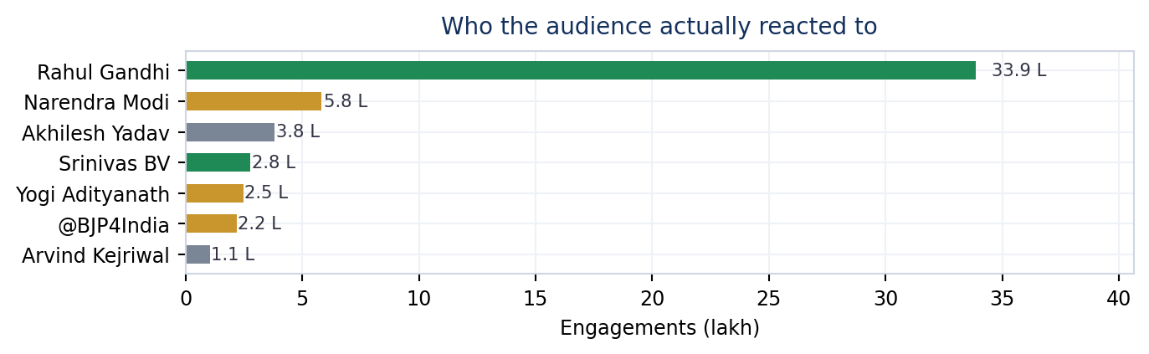
Engagement earned on the controversy. Green = Congress, gold = BJP.
4. What the public actually said

Setting aside party handles and news accounts, 457 tweets came from ordinary users, student groups and independent voices — 264 accounts drawing 56.60 L views. Their tone is markedly sharper than the politicians': 27.8% positive and 10.7% negative, against a near-flat political feed.
The four things people kept saying
- "The students are awake" — The most repeated formulation in the public feed. Ranchi, Kota and Prayagraj are each described as proof that a previously passive group has mobilised. It is a statement about the movement, not about any party.
- "Chowkidar hi chor nikla" — The older anti-corruption slogan gets recycled onto the paper-leak issue — the accusation is not incompetence but complicity.
- "The throne will shake" — Recurring across Hindi posts. The register is confrontational and future-tense: this is framed as the beginning of something, not a completed protest.
- The crowd as the argument — After Prayagraj, the most common public post is not a slogan but a claim about turnout — that the size of the crowd itself refutes the #RaGaFlopShow line.
Top public tweets
1 | Neha 7 August · general public  “With this very ink, we will write revolution. The students of Jharkhand are still fighting together for writing a better tomorrow. How would those who never even tried to know about it understand?”  30,969 engagements · 9.19 L views  Why it landed: The highest-performing non-political post of the campaign. It claims the movement for the students themselves and pointedly excludes outsiders — no party, no leader, no hashtag politics.

2 | Deepak Khatri 9 August · general public  “In reality, Yogi and the Modi government, who called it #RaGaFlopShow, are stunned by the massive crowd at Rahul Gandhi ji's event in Prayagraj! The students' echo has shattered all their claims.”  7,566 engagements · 51,036 views  Why it landed: A direct rebuttal of the government's counter-hashtag. When the opposition's own supporters start answering #RaGaFlopShow, the counter-narrative has done its job of setting the terms of debate.

3 | Cockroach Janta Party 9 August · protest group  “Defence Minister Rajnath Singh must resign.”  8,672 engagements · 1.25 L views  Why it landed: CJP — the Gen Z protest outfit at the centre of the Jantar Mantar agitation — moves from the education minister to the next target. Evidence that the movement is looking for a second act rather than closing.

4 | Jharkhand Youth Congress 19 July · party youth wing  “Ranchi has shown that the students are now awake! The massive crowd that gathered in the torch procession bears witness to the strength of this movement.”  7,188 engagements · 1.35 L views  Why it landed: The torch procession image — मशाल जुलूस — is the campaign's most reproduced visual motif, and this is the post that set it.

5. How the media covered it

Media accounts produced 22,509 of the 35,062 posts on this controversy — nearly two-thirds of everything published. That is unusually heavy: on most issues our roster's political handles out-post the press.
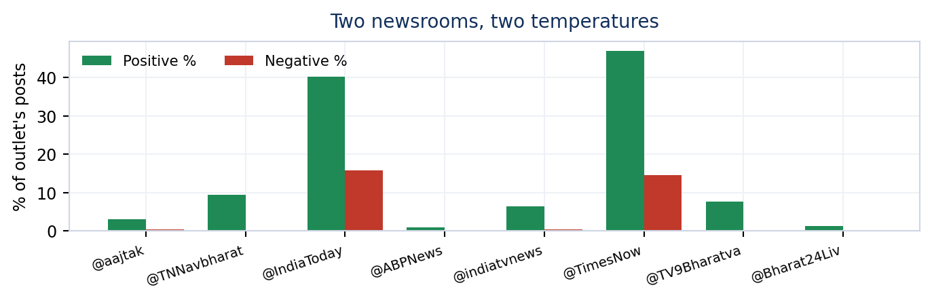
The same story at two different temperatures.
The split runs along language lines. IndiaToday carried the story at 15.8% negative and TimesNow at 14.5% — they treated it as a controversy with an accused. The highest-volume Hindi channels covered it as news without the charge: @aajtak posted 2,410 times at 0.4% negative, @ABPNews 1,608 times at 0.1%. A viewer following Hindi television saw a student protest; a viewer following English saw a government under pressure.
The media posts that mattered
1 | Al Jazeera English 20 July · international  “Thousands of protesters are gathering in the Indian capital, demanding the resignation of Prime Minister Narendra Modi and his education minister. It follows back-to-back paper leaks.”  36,608 engagements  Why it landed: The moment the story went international. An exam grievance reframed as a demand for the Prime Minister's resignation — this is the post that made the protest a national-reputation issue.

2 | News24 20 July · Hindi national  “"हमारे MP थाने में बिठाए हुए हैं और बाहर बच्चों की पिटाई की जा रही है" — सपा प्रमुख अखिलेश यादव”  16,607 engagements · #संसद_मार्च #CJPProtest  Why it landed: Hindi television's framing of 20 July: not policy, but children being beaten while MPs are detained. Emotional, immediate, and the version that reached the largest audience.

3 | The Lallantop 18 July · digital  “CJP के फाउंडर अभिजीत दिपके ने अनशन का ऐलान किया है। उन्होंने कहा कि 20 जुलाई को 'चलो संसद' मार्च तय कार्यक्रम के मुताबिक होगा।”  7,916 engagements  Why it landed: Digital-native outlets covered the organisers directly. This is where the Cockroach Janta Party stopped being a curiosity and became a named actor in the story.

4 | Times Now 28 July · after the resignation  “WATCH | Odisha: A large crowd welcomed former Union Education Minister and BJP MP Dharmendra Pradhan at Bhubaneswar Airport.”  6,241 engagements · labelled Positive  Why it landed: The counter-image. Within 72 hours of resigning, Pradhan is shown being welcomed home — a resignation reframed as a dignified exit rather than a defeat.

6. How the government answered

The BJP response ran on two tracks that never touched the campaign hashtag: act on the substance, and attack the organisers.
Track 1 — Concede the issue, own the fix
1 | Narendra Modi 23 July · Prime Minister  “Nothing is more important than the welfare and future of our youth! We have decided to set up fast-track courts to ensure swift and stringent punishment for paper leaks.”  1,87,854 engagements — the largest single post of the entire controversy  Why it landed: The most effective post of the episode by any actor. It accepts the grievance as real, offers a concrete instrument, and never mentions the protest, the opposition or the minister. It converts an attack into an announcement.

The cadre did the rest. Modi's follow-up — "More strict actions against paper leaks to come in tomorrow's Cabinet!" — was retweeted verbatim by MLAs and MPs across BJP, AGP, JSP, JD(U) and independents, each carrying roughly 58,000 engagements. Across the whole controversy 54% of political posts are retweets rather than original text: both sides run on amplification, not authorship.
2 | Amit Shah 25 July · announcing the resignation  “भाजपा के कार्यकर्ताओं के लिए पद से कहीं अधिक महत्वपूर्ण देश, हमारी युवा पीढ़ी और विद्यार्थी हैं। आज केंद्रीय शिक्षा मंत्री श्री धर्मेंद्र प्रधान जी ने...”  46,999 engagements  Why it landed: The resignation is presented as a party value, not a concession — "for our workers, the post matters less than the country". It denies the opposition the word "forced".

Track 2 — Attack the organisers, not the students
3 | @BJP4India 25 July · party handle  “कथित 'छात्र आंदोलन' के नाम पर CJP का असली एजेंडा बेनकाब…! एक तरफ यूपी सरकार को खुली धमकियां, दूसरी तरफ पंजाब के पेपर लीक पर पूरी चुप्पी।”  14,929 engagements  Why it landed: The counter-frame in one post: the students are genuine, the organisers are not. Pointing at Punjab — where Congress and AAP govern — turns a national grievance into a selective one.

4 | Amit Malviya 3 August · BJP IT cell head  “झारखंड के छात्र आंदोलन और राजनीतिक रूप से प्रायोजित अभियानों का अंतर देखिए। यहाँ जुनैद की बिरयानी नहीं, मंदिर का लंगर है। यहाँ फाइव-स्टार टेंट नहीं…”  20,340 engagements  Why it landed: Splits the movement in two — an authentic protest versus a sponsored one — using cultural markers rather than argument. The most-shared BJP post that engages the campaign directly.

5 | Kiren Rijiju 8 August · Union Minister  “Rahul Gandhi ji should have gone to Ranchi instead of Prayagraj.”  13,333 engagements · 11.69 L views  Why it landed: One line, posted on the day of the Prayagraj event, and the highest-reach government response to it. It concedes the issue and disputes only the venue — the tactic of choice all through August.

7. The rest of the opposition

Congress did not have the field to itself. The Wangchuk removal on 18 July pulled in every non-NDA party, and the resignation on 25 July produced a queue of claimants.
1 | Akhilesh Yadav · Samajwadi Party 18 July  “श्री सोनम वांगचुक जी को 'बल-प्रयोग' करके, ज़बरदस्ती उनके आमरण अनशन स्थल से उठाकर ले जाना अत्यंत निंदनीय है।”  34,538 engagements  Why it landed: SP's highest-engagement post of the episode. Not about exams at all — about the right to protest.

2 | Kapil Sibal · Independent (RS) 25 July  “Congratulations. Dharmendra Pradhan resigns. At what cost? Peaceful protesters: lathicharged, suffered injuries, pellets embedded…”  35,992 engagements  Why it landed: The sharpest reading of the outcome: the win is real, the price was paid by the students, not the party.

3 | Arvind Kejriwal · AAP 27 July  “देश के युवाओं ने एक होकर आवाज़ उठाई तो धर्मेंद्र प्रधान को इस्तीफ़ा देना पड़ा। E20 पर भी हमें एक होकर आवाज़ उठानी पड़ेगी।”  22,377 engagements  Why it landed: Credits "the country's youth" rather than Congress, then immediately transfers the energy to AAP's own campaign. The clearest example of a rival trying to inherit the movement.

4 | Sachin Pilot · Congress 20 July  “दिल्ली में छात्रों पर लाठीचार्ज करना और आँसू गैस के गोले दागना पूरी तरह ग़लत है। मैं इसकी कड़े शब्दों में निंदा करता हूँ।”  11,608 engagements  Why it landed: The strongest original Congress post that is not Rahul Gandhi's. Note the gap: 11,608 against his 1,67,022.

Party-wise mentions by position · 20 July – 13 August
Party | CM | DCM | LS MP | RS MP | MLA | MLC | Total | Retweets | Likes | Tone | Loudest voice
BJP | 68 | 99 | 989 | 542 | 3,855 | 216 | 6,182 | 3.53 Cr | 7.99 L | Positive | @narendramodi
INC | 38 | 6 | 363 | 94 | 2,359 | 0 | 3,201 | 81.60 L | 12.13 L | Positive | @RahulGandhi
SP | 0 | 0 | 106 | 5 | 258 | 0 | 535 | 3.91 L | 1.40 L | Positive | @yadavakhilesh
AAP | 50 | 0 | 8 | 33 | 251 | 0 | 379 | 6.31 L | 1.65 L | Positive | @JarnailSinghA
JD(U) | 0 | 0 | 0 | 8 | 54 | 0 | 62 | 2.75 L | 201 | Positive | @ranarandhirbj
RJD | 0 | 4 | 8 | 7 | 19 | 0 | 38 | 2.12 L | 3,019 | Positive | @VinodNarayanJ
BSP | 0 | 0 | 0 | 3 | 14 | 0 | 34 | 78,037 | 3,417 | Positive | @babbuvinod4bj
IND | 0 | 0 | 0 | 9 | 13 | 0 | 22 | 1.32 L | 87,050 | Positive | @mlacbsaakya
TOTAL | 156 | 109 | 1,474 | 705 | 6,838 | 216 | 10,644 | 4.54 Cr | 25.84 L | — | —

The office columns show where each party put its weight. BJP fielded 3,855 MLA posts, 989 Lok Sabha MP posts and 68 from Chief Ministers — a full-spectrum response using the whole organisation. INC fielded 2,359 MLA and 363 LS MP posts, roughly half the volume, but converted 12.13 L likes against 7.99 L. More retweets for one side, more likes for the other: BJP is being forwarded by its own network, INC is being agreed with by the audience.
Note the MLC row: 216 posts from BJP, zero from INC. And the Deputy CM row — 99 to 6. These are structural, not strategic: they reflect which party holds those offices.
And on the campaign hashtag itself
BJP posted 26,461 times on students and youth over the full window and used the campaign hashtag 17 times. Congress posted 10,049 times and used it 1,185. The ruling party engaged the subject heavily while refusing the frame — and on this evidence, that worked.
8. Public overview — log is topic par kya keh rahe hain

Party handles and news accounts set aside, this is the open conversation: 372 tweets from 203 ordinary accounts between 20 July and 13 August, drawing 36.80 L views.
372 | 203 | 36.80 L | 27.7% | 11.3% | Supportive
Public tweets | Distinct accounts | Views | Positive | Negative | Overall mood

Overall mood: Zyadatar samarthan / support (27.7% positive, 11.3% negative, 61.0% neutral)
Public sentiment on this issue runs 2.5x more positive than negative — but "positive" here means approval of the protest, not of the government. The model is reading encouragement, solidarity and celebration of the resignation. Negativity at 11.3% is more than triple the political-handle rate: ordinary accounts are saying things elected representatives will not.
Sabse zyada dohrayi ja rahi baatein · most repeated phrases
rahul gandhi 82 | prayagraj chhatronkigoonj 36 | chhatronkigoonj prayagraj 33 | echo students 25 | rahulgandhi chhatronkigoonj 21
chhatronkigoonj rahulgandhi 18 | shri rahulgandhi 18 | leader opposition 17 | राहुल गांधी 17 | rahulgandhi prayagraj 16

Narrative words · keyword ke saath chal rahe shabd
chhatronkigoonj 255 | prayagraj 179 | students 132 | rahulgandhi 116 | rahul 92 | gandhi 85
youth 84 | छात्रों 46 | echo 45 | today 39 | system 35 | voice 34

Samarthan me · support
“With this very ink, we will write revolution. The students of Jharkhand are still fighting together for writing a better tomorrow. How would those who never even tried to know about students' issues understand?”
— Neha · general public · 7 Aug · 30,969 engagements · 9.19 L views

“Leekh Pradhan has reluctantly given up the chair, but the Modi government is not abandoning its shamelessness and arrogance. The new Education Minister is saying the previous one did a great job.”
— Kanhaiya Kumar · 26 Jul · 9,959 engagements · 1.49 L views

“Ranchi has shown that the students are now awake! The sparks of change across the country are already smouldering.”
— Jeetu Burdak · general public · 20 Jul · 4,901 engagements

Aalochna me · criticism
“Unable to stop Rahul Gandhi or silence the students, the BJP has now released sewage water into the venue in Prayagraj where the Chhatron Ki Goonj programme is scheduled to be held later today.”
— Gaurav Pandhi · 8 Aug · 6,095 engagements · 1.02 L views

““I work 10 hours at Blinkit… then I study… and still the paper gets leaked.” In Prayagraj, Rahul Gandhi ji shared a young man's soundbite. The youth will work hard, the system will leak.”
— Adv. Vijay Singh · general public · 8 Aug · 3,050 engagements

“In the market of hate, once again, the shop of love.”
— Pawan Khera · 8 Aug · 5,529 engagements

Neutral / khabar
“Rahul Gandhi ji should have gone to Ranchi instead of Prayagraj.”
— Kiren Rijiju · Union Minister · 8 Aug · 13,333 engagements · 11.69 L views

“In reality, Yogi and the Modi government, who called it #RaGaFlopShow, are stunned by the massive crowd at Rahul Gandhi ji's event in Prayagraj. The students' echo has shattered all illusions.”
— Deepak Khatri · general public · 9 Aug · 7,566 engagements

Sawal aur maang jo uthaye gaye · questions and demands
86 of the 372 public tweets carry a direct question or demand — roughly one in four. The three that recur:
- "Paper leak ka zimmedar kaun?" — Accountability, not policy. The demand is for a named person to be punished, and the resignation on 25 July is treated as proof the demand works.
- "Ab agla kaun?" — After Pradhan, the question shifts targets — CJP publicly named Rajnath Singh on 9 August. The movement is searching for a second demand.
- "Itni mehnat ka kya fayda?" — The most personal register, and the most repeated: students describing years of preparation destroyed by a leak. This is what gives the campaign its emotional charge.
“Listen — Gen Z's hot favourite Modi ji talked about hanging whom? #DharmendraPradhanResign”
— Jignesh Mevani · 25 Jul · 2,516 engagements

9. Read-out

- The campaign got its scalp — and lost its story. The demand was Pradhan's resignation. It was met on 25 July. Everything after that is a movement looking for a second target, which is why CJP moved to Rajnath Singh and Kejriwal moved to E20. A campaign that wins its stated demand needs the next one ready before it wins.
- It is one man's reach, not a network's. Rahul Gandhi earned 33.86 L on this issue. The best-performing Congress voice who is not him managed 11,608. Remove him and the campaign does not travel.
- Conceding fast beat arguing back. The single most-engaged post of the whole episode is the government announcing fast-track courts — not any attack on the government. Acting on the substance while ignoring the hashtag drained the confrontation.
- The hashtag never became contested. 1,185 campaign-tagged posts from Congress handles against 17 from BJP. A hashtag only one side uses reaches only the people already inside it.
- Hindi television was the ceiling. The channels with the largest audience carried the story at near-zero negative sentiment. The criticism lived in English media and on X — the campaign never crossed into the largest room in the house.
- The public was angrier than the politicians. Ordinary accounts ran 10.7% negative against 2.7% for political handles. The sentiment on this issue is coming from below, and it is running ahead of what any party is willing to say.

Social Media Data Team · Jarvis Consulting · 13 August 2026

