POLITICAL PULSE
Social Media Intelligence Report

All India · X (Twitter) Landscape Analysis
1 July 2026 – 11 August 2026
670,777 | 2,956 | 312.49 Cr | 33.90 Cr
Tweets analysed | Handles tracked | Total views | Total engagements

Prepared by the Data & Analytics Team · Jarvis Consulting
Generated 13 August 2026 · Confidential — internal circulation

1. Executive Summary

Between 1 July and 11 August 2026 we captured 670,777 tweets from 2,956 tracked handles across India — 449,589 posts from political handles and 221,188 from media houses and journalists. Together these posts drew 312.49 Cr views and 33.90 Cr engagements (likes, retweets and replies combined).

What the numbers say
- Announcement, not argument. 80% of all posts are neutral in tone. Political handles are overwhelmingly in broadcast mode — event photos, greetings, scheme announcements — rather than debate. Only 1.5% of political posts carry negative sentiment.
- Media carries the sharper edge. Media and journalist accounts are 4.1x more negative than politicians (6.2% vs 1.5%) and also more positive (22.4% vs 14.1%). Newsrooms polarise the feed; politicians flatten it.
- One party owns the volume. BJP accounts for 357,710 posts — 81% of all party-tagged political output, from 1,664 handles. The nearest challenger, INC, posts 39,288.
- Opposition trades volume for reach. INC averages 1,472 engagements per post against BJP's 683 — roughly 2.2x more traction per tweet despite posting 89% less.
- Seniority sets the tone. Chief Ministers post the most positive feed of any tier (22.6% positive) and command the highest engagement per post (1,084). MLAs supply the bulk of volume (311,463 posts) at 12.0% positive.
- Students are the live wire. 66,384 posts (9.9% of everything) touch students, exams, paper leaks, recruitment or youth employment. It is the single largest issue-based cluster in the period and the one place where opposition negativity spikes (INC at 5.2% negative).

Headline metrics
Metric | All | Political handles | Media & journalists
Tweets | 670,777 | 449,589 | 221,188
Unique handles | 2,956 | 2,901 | 55
Positive | 16.8% | 14.1% | 22.4%
Negative | 3.0% | 1.5% | 6.2%
Neutral | 80.1% | 84.4% | 71.4%
Views | 312.49 Cr | — | —
Likes | 3.96 Cr | — | —
Retweets | 29.70 Cr | — | —
Replies | 23.64 L | — | —

2. Scope and Method

Source. Tweets are collected continuously from a curated roster of 2,956 Indian political, media and journalist handles and stored in a single master database keyed on Tweet ID, so the same post can never be counted twice. Every handle is mapped against a reference table carrying state, constituency, designation, party and category — the raw capture supplies only the post and its metrics.
Window. 1 July 2026 to 11 August 2026 — 42 days of continuous capture. All timestamps are converted to IST before bucketing, so a "day" here is an Indian calendar day.
Sentiment. Each post carries a model-assigned label (Positive / Negative / Neutral) and a signed score. Labels are applied to the post text only; images, video and quoted content are not read. Read the neutral share as "no clear emotional charge in the words", not as "no opinion".
Segmentation. Handles tagged Media House or Journalist are reported separately throughout and are excluded from all party and designation tables — mixing a newsroom's 15,000 posts into a party total would distort every ratio on the page. Handles holding more than one office are counted under each office, so designation rows sum to more than the political total by design.

What this report does not claim
- Reach figures are platform-reported view counts, not unique people.
- Absence of a handle from the roster means absence from this report, not absence from the platform.
- Sentiment is directional at scale and unreliable on any single post — treat the percentages, not the individual labels.
- Engagement is counted at time of capture; older posts have had longer to accumulate it.

3. Volume and Activity

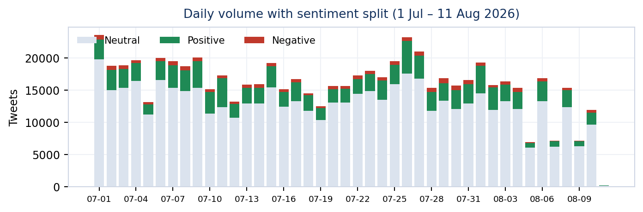
Figure 1 — Daily tweet volume, split by sentiment. Neutral shown in grey, positive in green, negative in red.
Output averages 15,970 posts a day across the roster. The busiest day was 2026-07-01 with 23,550 posts (47% above average); the quietest was 2026-08-11 at 172. Weekday-to-weekend variation is modest — this is a professionalised feed with scheduled output, not an organic crowd.

Ten busiest days
Date | Tweets | vs daily average
2026-07-01 | 23,550 | +47%
2026-07-26 | 23,181 | +45%
2026-07-27 | 20,951 | +31%
2026-07-09 | 20,053 | +26%
2026-07-06 | 19,959 | +25%
2026-07-04 | 19,637 | +23%
2026-07-07 | 19,479 | +22%
2026-07-25 | 19,476 | +22%
2026-08-01 | 19,264 | +21%
2026-07-15 | 19,172 | +20%

4. Sentiment Landscape

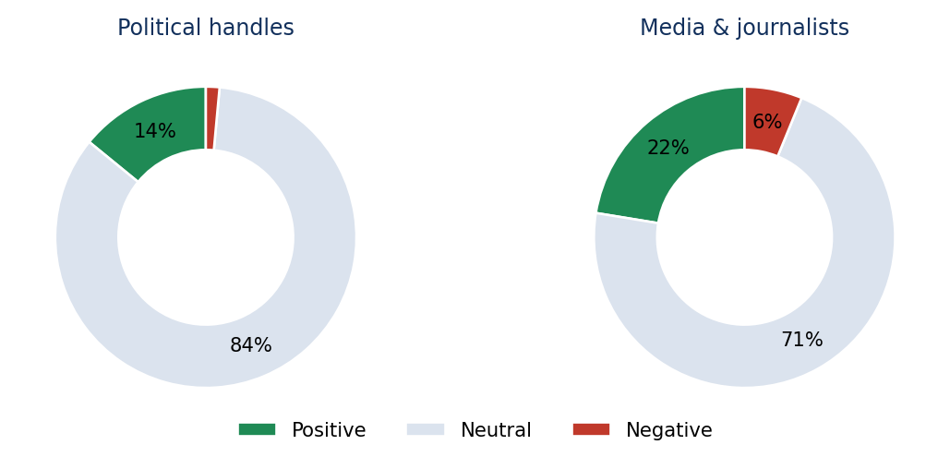
Figure 2 — Sentiment mix: political handles versus media and journalists.
The defining feature of the period is how little emotional charge sits in political output. 84.4% of political posts read neutral. Politicians are using X as a noticeboard — inaugurations, condolences, birthday wishes, scheme launches — and the sentiment model correctly reads most of that as flat.
Media accounts behave differently. They run 22.4% positive and 6.2% negative, meaning roughly 29% of newsroom output carries a clear charge against 16% for politicians. When a citizen scrolls a mixed feed, the emotional colour they encounter is overwhelmingly supplied by media, not by politicians.

Sentiment by segment
Segment | Tweets | Positive | Negative | Neutral
Political handles | 449,589 | 14.1% | 1.5% | 84.4%
Media houses | 220,986 | 22.4% | 6.2% | 71.4%
Journalists | 202 | 18.3% | 5.4% | 76.2%
All captured | 670,777 | 16.8% | 3.0% | 80.1%

5. Party-wise Analysis

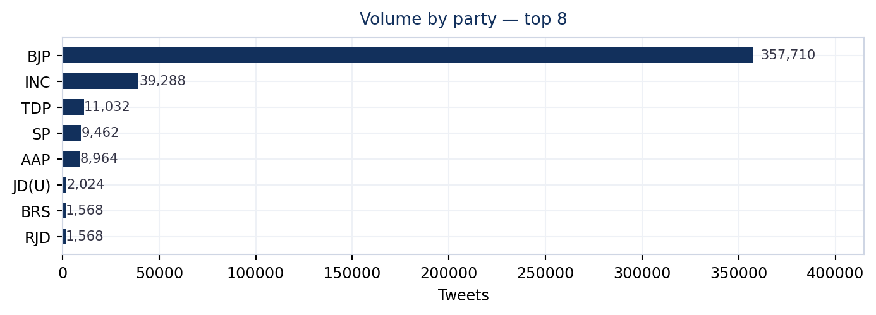
Figure 3 — Tweet volume by party, top eight.
BJP dominates raw output with 357,710 posts from 1,664 handles — 81% of party-tagged political volume. But volume and impact diverge sharply. INC posts 39,288 tweets, 11% of BJP's total, yet averages 1,472 engagements per post against 683 — 2.2 times the traction per tweet.
That gap is the story of the period: one side runs a distribution network, the other runs a message. A larger cadre posting routine local content produces enormous volume with modest per-post pickup; a smaller set of high-follower accounts posting confrontational content produces the opposite.
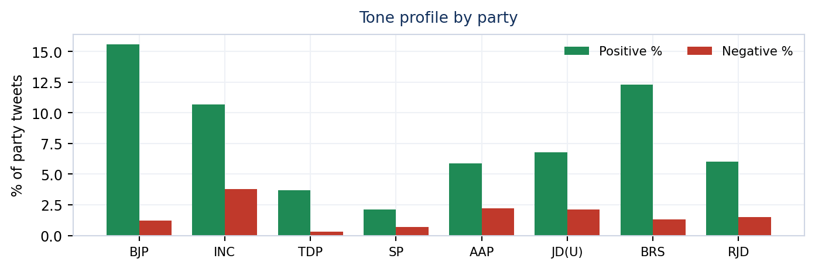
Figure 4 — Positive and negative share of each party's own output.
INC also carries the highest negative share among major parties at 3.8%, roughly 3.2x BJP's 1.2%. Its feed is built to contest; the governing party's feed is built to announce, which is why BJP runs 15.6% positive.

Party scorecard
Party | Tweets | Handles | Pos % | Neg % | Engagements | Per post
BJP | 357,710 | 1,664 | 15.6 | 1.2 | 24.43 Cr | 683
INC | 39,288 | 397 | 10.7 | 3.8 | 5.78 Cr | 1,472
TDP | 11,032 | 117 | 3.7 | 0.3 | 8.96 L | 81
SP | 9,462 | 131 | 2.1 | 0.7 | 95.01 L | 1,004
AAP | 8,964 | 92 | 5.9 | 2.2 | 51.34 L | 573
JD(U) | 2,024 | 24 | 6.8 | 2.1 | 11.60 L | 573
BRS | 1,568 | 25 | 12.3 | 1.3 | 4.71 L | 300
RJD | 1,568 | 22 | 6.0 | 1.5 | 9.47 L | 604
IND | 1,451 | 22 | 10.6 | 1.1 | 6.91 L | 476
NCP(AP) | 1,315 | 22 | 1.7 | 0.2 | 23,103 | 18

6. Who Is Speaking — Designation Analysis

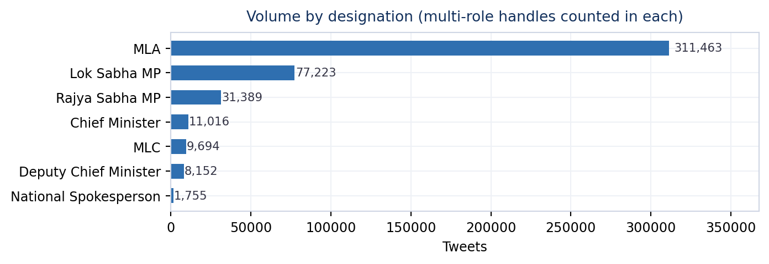
Figure 5 — Volume by office held. Handles holding two offices are counted in both.
MLAs are the engine room: 2,087 handles producing 311,463 posts, 69% of all political output. Their feed is hyperlocal — road inaugurations, local grievance redressal, constituency events — which is why it is the flattest in tone at just 12.0% positive and 1.2% negative.
Parliamentarians speak less but land harder. Lok Sabha MPs post 77,223 times from 456 handles at 21.1% positive — nearly double the MLA rate — and pull 882 engagements per post. Rajya Sabha MPs, 31,389 posts from 194 handles, run a similar profile at 20.4% positive with the highest negative share of the elected tiers (2.4%), reflecting a bench weighted toward national spokespersons and debate rather than constituency work.
Chief Ministers are the sharpest signal in the dataset. Just 32 handles produce 11,016 posts — but at 22.6% positive and 1,084 engagements per post, the highest of any tier. A CM tweet is worth roughly 1.5 MLA tweets in reach terms. This tier is the most tightly managed and the most consistently on-message.

Designation scorecard
Designation | Tweets | Handles | Pos % | Neg % | Neu % | Per post
MLA | 311,463 | 2,087 | 12.0 | 1.2 | 86.7 | 718
Lok Sabha MP | 77,223 | 456 | 21.1 | 1.9 | 77.0 | 882
Rajya Sabha MP | 31,389 | 194 | 20.4 | 2.4 | 77.2 | 648
Chief Minister | 11,016 | 32 | 22.6 | 2.1 | 75.3 | 1,084
MLC | 9,694 | 55 | 7.2 | 0.5 | 92.2 | 522
Deputy Chief Minister | 8,152 | 20 | 14.4 | 0.7 | 84.8 | 633
National Spokesperson | 1,755 | 7 | 7.1 | 3.0 | 90.0 | 981
National Secretary and Spo | 1,037 | 1 | 1.9 | 0.9 | 97.2 | 349
National Secretary | 977 | 7 | 22.4 | 1.7 | 75.8 | 804

Note: a handle holding two offices (for example an MP who is also an MLA) is counted under both rows, so the column does not sum to the political total.

7. Geography

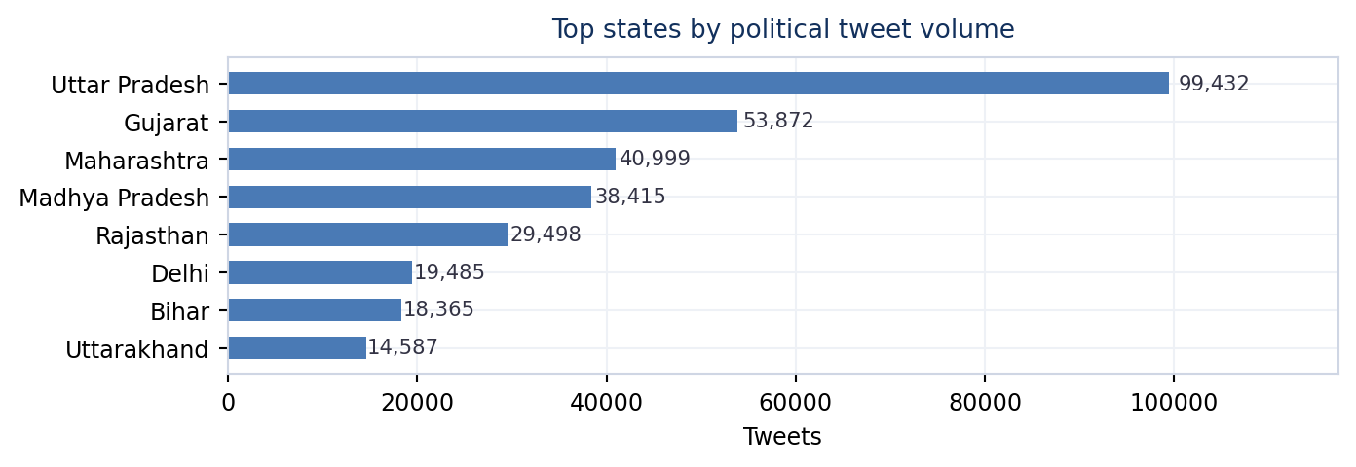
Figure 6 — Top states by political tweet volume.
Uttar Pradesh leads with 99,432 posts from 598 handles — 27% of state-tagged political output and comfortably ahead of Gujarat (53,872). The concentration tracks roster size and assembly strength rather than population, so read it as "where our coverage is densest" as much as "where the noise is loudest".
State | Tweets | Handles | Pos % | Neg % | Engagements
Uttar Pradesh | 99,432 | 598 | 8.0 | 0.8 | 8.03 Cr
Gujarat | 53,872 | 176 | 19.2 | 1.2 | 4.01 Cr
Maharashtra | 40,999 | 235 | 13.3 | 1.5 | 3.03 Cr
Madhya Pradesh | 38,415 | 185 | 10.1 | 0.8 | 2.61 Cr
Rajasthan | 29,498 | 196 | 9.3 | 0.7 | 2.65 Cr
Delhi | 19,485 | 72 | 15.3 | 1.9 | 1.59 Cr
Bihar | 18,365 | 119 | 12.2 | 1.3 | 1.41 Cr
Uttarakhand | 14,587 | 52 | 17.6 | 1.0 | 1.33 Cr
Andhra Pradesh | 14,572 | 164 | 6.5 | 0.5 | 35.43 L
Karnataka | 14,062 | 126 | 20.8 | 2.8 | 99.72 L

8. Media House and Journalist Coverage

Media accounts are a third of everything captured. 37 media house handles posted 220,986 times (151.53 Cr views) and 18 journalist handles posted 202 times. Volume sits almost entirely with institutional newsroom accounts; individual journalists in this roster are a small, high-signal group rather than a volume driver.
Tone is the important difference. Media houses run 22.4% positive and 6.2% negative; journalists run 18.3% positive and 5.4% negative. Institutional accounts amplify announcements; individual reporters carry a materially higher share of critical framing.

Top media houses by volume
Handle | Posts | Engagements | Views
@TNNavbharat | 14,691 | 46,763 | 1.22 Cr
@aajtak | 13,890 | 11.11 L | 22.63 Cr
@Bharat24Liv | 13,426 | 8,478 | 47.22 L
@IndiaToday | 12,821 | 2.54 L | 7.55 Cr
@TimesNow | 11,845 | 3.28 L | 7.89 Cr
@CNNnews18 | 11,399 | 57,683 | 3.18 Cr
@ndtv | 11,227 | 4.91 L | 14.69 Cr
@indiatvnews | 10,660 | 96,507 | 2.63 Cr
@WIONews | 8,833 | 34,985 | 2.43 Cr
@ZeeNews | 8,269 | 4.33 L | 5.12 Cr

Most active journalists
Handle | Posts | Engagements | Views
@AmanKayamHai_ | 51 | 134 | 12,467
@AnilYadavmedia1 | 32 | 25,710 | 4.19 L
@nistula | 26 | 1,326 | 46,383
@Aamitabh2 | 19 | 441 | 59,596
@upadhyayabhii | 11 | 3,775 | 2.20 L
@vishalpandeyk | 10 | 733 | 13,996
@sengarlive | 8 | 1,005 | 62,979
@rohini_sgh | 8 | 3,956 | 68,338

Highest-impact media posts
“Thousands of protesters are gathering in the Indian capital, demanding the resignation of Prime Minister Narendra Modi and his education minister. It follows back-to-back scandals related to examination paper leaks and cancelled tests. Journalist Neha Poonia r”
— @AJEnglish · Media · 36,608 engagements

“RT @narendramodi: Nothing is more important than the welfare and future of our youth! We have decided to set up fast-track courts to ensur…”
— @DDNewslive · Media · 31,481 engagements

“RT @narendramodi: More strict actions against paper leaks to come in tomorrow’s Cabinet!”
— @sansad_tv · Media · 19,791 engagements

9. Hashtag Reach

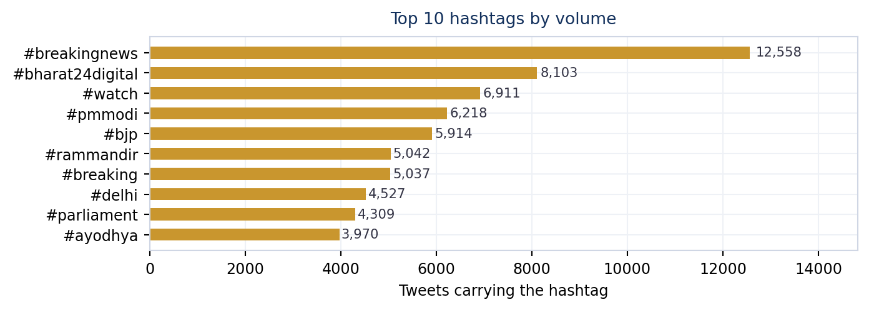
Figure 7 — Top ten hashtags by number of tweets carrying them.
56,662 distinct hashtags appear in the period. The leaderboard is dominated by newsroom furniture rather than campaigns — #breakingnews (12,558 posts, 57 handles) and #watch are wire-service tags, not political mobilisation. Read them as evidence of how much of the hashtag layer belongs to media.
Two signals are worth separating from that noise. Single-handle tags such as #bharat24digital (8,103 posts from 1 handle) are one outlet's branding, not reach — a high count with a handle count of one is a publishing habit. By contrast #bjp appears across 437 handles and #pmmodi across 200: those are genuinely distributed, coordinated tags where many accounts push the same marker.
Hashtag | Tweets | Handles | Engagements | Spread
#breakingnews | 12,558 | 57 | 1.84 L | Distributed
#bharat24digital | 8,103 | 1 | 5,667 | Single source
#watch | 6,911 | 264 | 2.44 L | Distributed
#pmmodi | 6,218 | 200 | 1.17 L | Distributed
#bjp | 5,914 | 437 | 1.15 L | Distributed
#rammandir | 5,042 | 67 | 1.57 L | Distributed
#breaking | 5,037 | 41 | 5.81 L | Distributed
#delhi | 4,527 | 101 | 2.46 L | Distributed
#parliament | 4,309 | 95 | 2.38 L | Distributed
#ayodhya | 3,970 | 55 | 1.07 L | Distributed
#rahulgandhi | 3,863 | 104 | 4.20 L | Distributed
#congress | 3,821 | 111 | 1.87 L | Distributed
#abpnews | 3,774 | 2 | 2.26 L | Single source
#uttarpradesh | 3,749 | 101 | 61,750 | Distributed
#cwg2026 | 3,731 | 620 | 16.47 L | Distributed

10. What the Conversation Is Actually About

Reading the post text rather than the metadata, the period breaks into three recognisable registers.

Recurring phrases across all captured text
Phrase | Occurrences | Phrase | Occurrences
bjp india | 24,256 | जन्मदिन हार्दिक | 9,105
हार्दिक बधाई | 16,752 | नेतृत्व में | 8,679
बधाई एवं | 16,179 | bharat digital | 8,133
प्रधानमंत्री श्री | 15,911 | भारतीय जनता | 7,204
श्री narendramodi | 13,286 | जनता पार्टी | 7,086
उत्तर प्रदेश | 12,961 | विधानसभा क्षेत्र | 7,042
उत्तम स्वास्थ्य | 9,641 | मुख्यमंत्री श्री | 6,990
में आयोजित | 9,574 | prime minister | 6,899
पेपर लीक | 9,554 | रहा है। | 6,781

Register 1 — Courtesy and ceremony
The single largest block of language is congratulatory: "हार्दिक बधाई" (16,752), "बधाई एवं" (16,179), "जन्मदिन हार्दिक" (9,105), "उत्तम स्वास्थ्य" (9,641). Birthday wishes, festival greetings and good-health blessings account for tens of thousands of posts. This is relationship maintenance, and it is the main reason the neutral share sits above 80%.

Register 2 — Attribution upward
"प्रधानमंत्री श्री" (15,911) and "श्री narendramodi" (13,286) show how much state and local output is framed as delivery of a national leadership agenda. Credit flows upward in the language even when the event is a district-level function.

Register 3 — The one live grievance
"पेपर लीक" appears 9,554 times — the only genuinely contested phrase in the top of the list, and the entry point to the largest issue cluster in the period. Section 11 takes it apart.

11. Spotlight — Students, Exams and Youth Employment

Filtering the full corpus for student, exam, paper-leak, recruitment and youth-employment language returns 66,384 posts from 2,323 handles — 9.9% of everything captured, and the largest single-issue cluster in the window. 42,695 of those come from political handles and 23,689 from media.
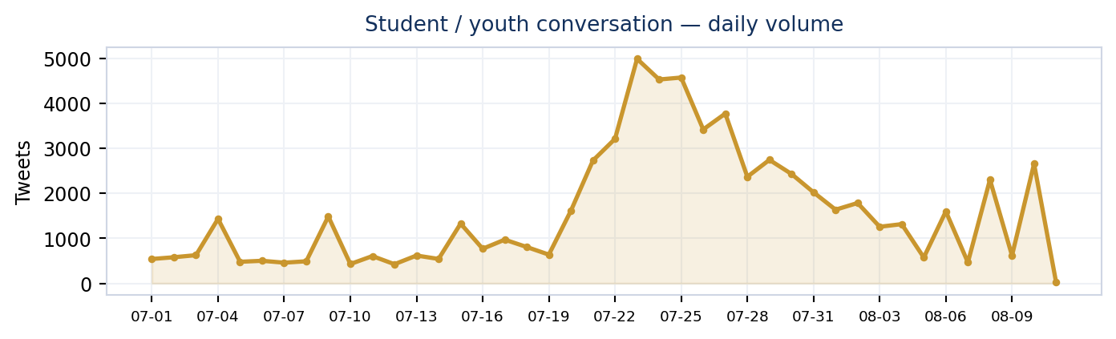
Figure 8 — Daily volume of student and youth-related conversation.
Tone on this cluster runs 16.7% positive, 4.0% negative, 79.3% neutral. The negative share is 2.7x the political baseline — modest in absolute terms, but this is where the disagreement in the dataset is concentrated.

Who is talking about it
Party | Posts | Handles | Pos % | Neg % | Engagements
BJP | 29,667 | 1,467 | 17.9 | 2.5 | 8.49 Cr
INC | 9,418 | 327 | 10.4 | 5.2 | 3.53 Cr
SP | 1,367 | 108 | 2.4 | 0.8 | 14.32 L
AAP | 654 | 86 | 10.2 | 3.4 | 7.77 L
JD(U) | 240 | 18 | 10.0 | 2.9 | 5.91 L
RJD | 178 | 17 | 12.9 | 2.8 | 3.67 L
IND | 101 | 15 | 11.9 | 3.0 | 3.07 L

The split is instructive. BJP posts 29,667 times on the topic at 2.5% negative — it is talking about youth in the language of schemes, skilling and opportunity. INC posts 9,418 times at 5.2% negative, more than double the rate: it is talking about the same audience in the language of grievance, exams and accountability. Both are addressing young voters; only one is doing it adversarially.

By office
Designation | Posts | Handles | Engagements
MLA | 28,367 | 1,603 | 9.33 Cr
Lok Sabha MP | 7,700 | 379 | 1.99 Cr
Rajya Sabha MP | 3,039 | 152 | 63.67 L
Chief Minister | 996 | 26 | 27.65 L
MLC | 861 | 45 | 24.01 L
Deputy Chief Minister | 525 | 20 | 17.12 L

Hashtags inside the cluster
Hashtag | Tweets | Hashtag | Tweets
#studentprotest | 2,966 | #jantarmantar | 1,340
#paperleak | 2,067 | #pmmodi | 1,296
#rahulgandhi | 1,568 | #jharkhand | 1,276
#breakingnews | 1,564 | #neetpaperleak | 1,246
#parliament | 1,426 | #dharmendrapradhan | 1,165
#neet | 1,408 | #cjp | 1,062

12. Highest-Impact Voices

The posts below are the single best-performing tweet from each of the top handles by engagement, politician accounts only, one per handle.
Handle | Name | Party | Office | Engagements | Tone
@narendramodi | narendramodi | BJP | LS_MP | 187,854 | Positive
@RahulGandhi | RahulGandhi | INC | LS_MP | Senior l | 167,022 | Neutral
@yadavakhilesh | yadavakhilesh | SP | LS_MP | 85,785 | Neutral
@AmitShah | AmitShah | BJP | LS_MP | 68,778 | Negative
@asadowaisi | asadowaisi | AIMIM | LS_MP | 65,541 | Negative
@yogeshshuklabkt | yogeshshuklabkt | BJP | MLA | 57,985 | Positive
@gyantiwaribjp | gyantiwaribjp | BJP | MLA | 57,985 | Positive
@IAlkaSingh | IAlkaSingh | BJP | MLA | 57,985 | Positive

Positive register — what support sounds like
“Nothing is more important than the welfare and future of our youth! We have decided to set up fast-track courts to ensure swift and stringent punishment for those involved in paper leaks. Have directed the concerned authorities and official”
— Narendra Modi · BJP · 187,854 engagements

“You are the one who has harmed the future of our youth the most. You allowed and encouraged the total capture and destruction of our education system - and protected every person responsible for it. The students’ demands are clear: 1. Sack”
— Rahul Gandhi · INC · 132,291 engagements

“RT @narendramodi: More strict actions against paper leaks to come in tomorrow’s Cabinet!”
— Yogesh Shukla · BJP · 57,985 engagements

Critical register — what opposition sounds like
“Mr. Modi, our students are demanding Dharmendra Pradhan’s resignation. Don’t insult their intelligence with this pathetic midnight video. 1. Sack Pradhan. 2. Punish those who beat students. 3. ⁠Apologise”
— Rahul Gandhi · INC · 124,144 engagements

“Congratulations to every student in India on the passage of the Public Examinations (Prevention of Unfair Means) Amendment Bill, 2026 in Lok Sabha today. The bill shields the dreams and aspirations of our youth by laying down iron-clad prov”
— Amit Shah · BJP · 68,778 engagements

“RT @xIsraelExposedx: It took a little longer than expected, but we have created a website for people to view the footage collected from Gaz…”
— Asaduddin Owaisi · AIMIM · 65,541 engagements

13. Observations and Implications

- The neutral wall is a vulnerability, not a strength. With 84.4% of political output emotionally flat, the accounts producing it are almost invisible in an algorithmic feed that rewards reaction. Volume is being spent without buying attention.
- Engagement efficiency is the metric that matters. INC produces 89% less content than BJP but 2.2x the engagement per post. Tracking posts-per-day flatters the larger network and hides the gap.
- The MLA tier is under-leveraged. 2,087 handles generating 311,463 posts at 718 engagements each is the largest untapped asset in the network. A 10% shift from ceremonial to issue content in this tier would move more volume than any change at the top.
- Media sets the emotional weather. Newsroom accounts supply most of the charged content in the feed. Any sentiment reading that mixes media and political handles will mistake press tone for public tone — they must stay separated.
- Students are the contested ground. 66,384 posts, 9.9% of the corpus, and the only cluster where negative sentiment meaningfully rises. Whoever frames exams, recruitment and paper leaks over the next quarter sets the youth narrative.
- Hashtag counts need a handle-count check. Tags like #bharat24digital look large and are one account. Always read tweet count alongside handle count before calling something a trend.

Prepared by the Data & Analytics Team, Jarvis Consulting · 13 August 2026 · Source: Political Pulse master database, 670,777 tweets, 2,956 handles, 1 Jul – 11 Aug 2026.

