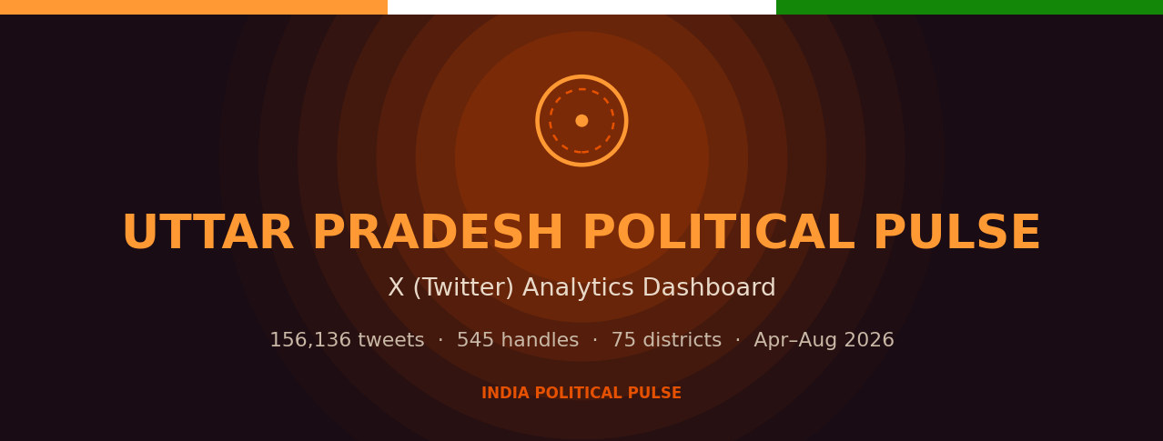

Uttar Pradesh Political Pulse — Dashboard Overview
Uttar Pradesh Political Pulse is an interactive analytics dashboard that tracks the political conversation on X (Twitter) across Uttar Pradesh. It ingests every tweet from tracked political handles — MPs, MLAs, MLCs, the Chief Minister and Deputy CMs — and turns them into live, filterable intelligence: who is saying what, how much reach and engagement it earns, the sentiment behind it, and how the picture shifts by party, district, and date.
The dashboard runs in two modes — a fully self‑contained offline HTML file (nothing to install, just double‑click) and a live MongoDB‑backed server for always‑fresh data. Every number, label, and filter is driven by the underlying data — nothing is hardcoded.

At a Glance
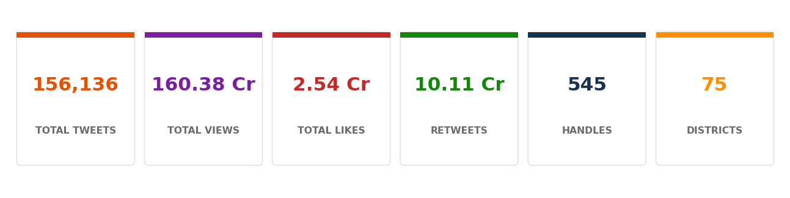
The current dataset covers 1 April – 1 August 2026 (123 days) for Uttar Pradesh:
Metric | Value
Total tweets (UP) | 1,56,136
Total views | 160.38 Cr
Total likes | 2.54 Cr
Retweets | 10.11 Cr
Tracked handles | 545
Districts covered | 75 (all of UP)
Parties tracked | BJP, SP, INC, SBSP, IND (top 5 by volume)
Date range | 1 Apr 2026 → 1 Aug 2026

What’s Inside
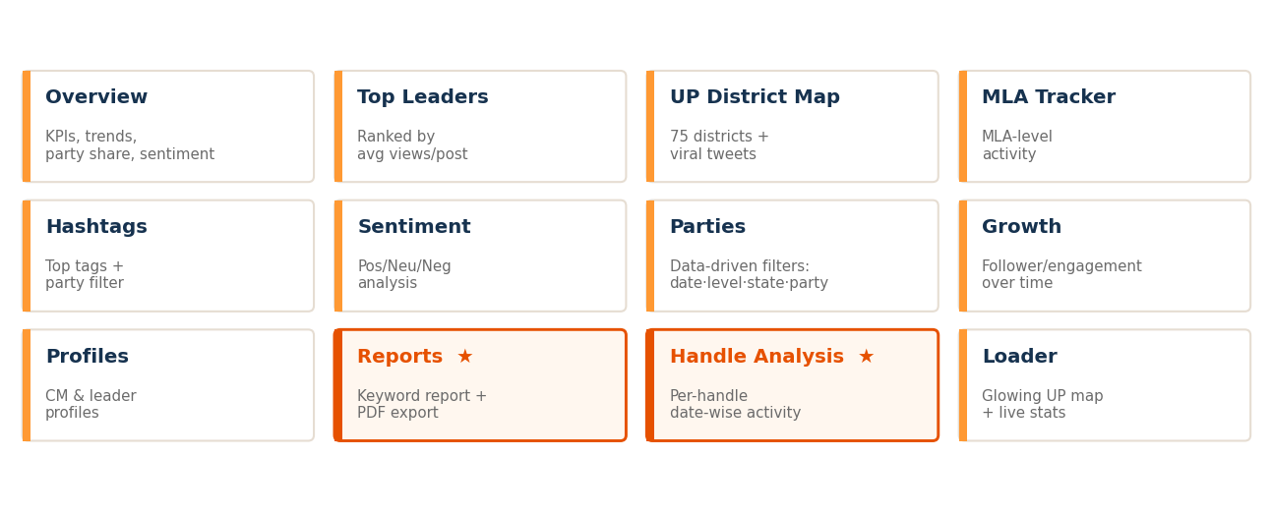
The dashboard is organised into focused tabs. The two items marked ★ are the newest additions — a keyword Reports generator and a Handle Analysis tool.

Feature Deep‑Dive

1. Overview (Dashboard)
The landing view. Headline KPI cards (tweets, views, likes, retweets, avg views/tweet, avg likes/tweet), each with a live sparkline. Below: Daily Activity (tweets & average views/post over time), Tweet Share by Party (donut, top‑5 UP parties), Sentiment Mix, Engagement — Likes vs Retweets trend, Top Performers (avg views/post) and Most Active (by tweet count). A clean, at‑a‑glance snapshot for any date range.

2. Top Leaders
A leaderboard of handles ranked by average views per post, with level filters (LS MP, RS MP, MLA, MLC, CM, Dy CM) and party filters — quickly surface who is breaking through.

3. UP District Map + Viral Tweets
An interactive map of all 75 UP districts, colour‑coded by activity, plus the Top Viral Tweets table. Each row shows the handle (clickable → opens the X profile), a View Post button (opens the exact tweet), party, date, sentiment and engagement.

4. MLA Tracker
MLA‑level activity tracking across the state — drill into assembly‑constituency representatives.

5. Hashtags
The most‑used hashtags ranked by views, with a party filter to see which narratives each party is pushing.

6. Sentiment
Positive / Neutral / Negative breakdown of the conversation, over time and by segment.

7. Parties
Party‑overview cards (top‑5 by tweet volume) with tweets, views, likes, retweets, handle counts and a sentiment breakdown per party. Fully dependent filters — Date (All / Last 7 / Last 3 days), Level, State and Party — every one of them re‑filters the cards and charts live from the data.

8. Growth
Follower and engagement growth over time — how each handle/party is building its audience.

9. Profiles
Individual profile pages for the Chief Minister, Deputy CMs and key leaders.

10. Reports ★ (new)
A keyword report generator. Type a topic and keywords (e.g. “Ram Mandir, Ayodhya, ghotala”) and the dashboard scans the tweet text and instantly builds a formatted report:
- Topic / Hashtags‑Keywords / Tracking Window header
- Overall Volume Summary — Total Tweets, Retweets, Likes, Unique Handles, Total Views, Overall Sentiment
- Party‑wise Mentions by Position — CM / Dy CM / MP / MLA counts, totals, RT, likes, sentiment and the top tweet per party
- Key Insights — auto‑generated observations
The report previews on screen and downloads as a full‑colour PDF styled to match the dashboard. The date range of the data is always shown.

11. Handle Analysis ★ (new)
Pick any handle and a custom date range and see that handle’s day‑by‑day activity — which dates they tweeted (✔ with count) and which they didn’t (✖), plus views, likes and retweets per day, and a summary like “tweeted on 72 of 123 days.” Answers, precisely, “did this person tweet on this date or not?”

12. Loader
A branded splash screen — a glowing map of Uttar Pradesh (all 75 districts) with pulsing city markers, the Ashoka‑chakra motif, tricolour strip and live headline stats — while the dashboard loads.

Data & Coverage
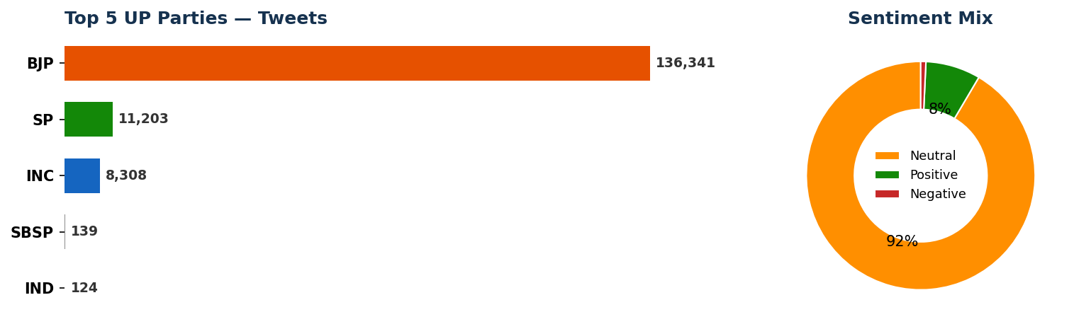
Party landscape. BJP dominates volume (~1.36 lakh tweets), followed by SP, INC and the smaller SBSP and IND. The mix is deliberately UP‑only — the dashboard filters to State = Uttar Pradesh, so national/other‑state parties are excluded and only the parties active in UP appear.
Sentiment. The conversation is overwhelmingly neutral/informational (~92%), with a positive tilt and a small negative share — typical of official political messaging.

How the Data Flows
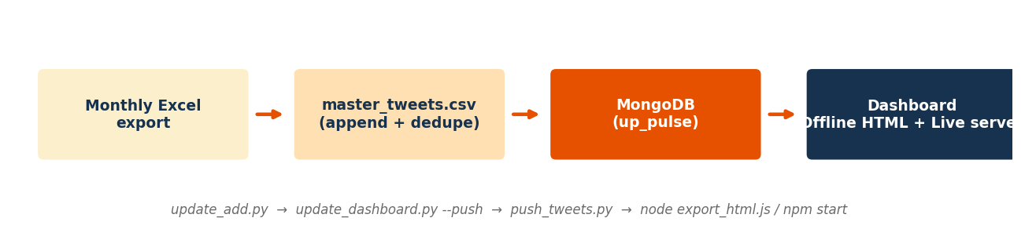
Each month a fresh Excel export is dropped into the project folder. A short pipeline turns it into a live dashboard:
- update_add.py — appends the new data to the master, de‑duplicating by Tweet URL (old data is never lost).
- update_dashboard.py --push — recomputes every metric (KPIs, party breakdowns, districts, dates, sentiment, growth) and writes them to MongoDB.
- push_tweets.py — loads the raw tweets into MongoDB for the Reports / Handle Analysis search.
- node export_html.js (offline) or npm start (live) — renders the dashboard.

Two Ways to Run
Mode | How | Best for
Offline HTML | Double‑click the generated .html file | Sharing, presenting, viewing anywhere — no server, no internet. All features (including Reports & Handle Analysis) work client‑side.
Live server | npm start → http://localhost:3001 | Always‑fresh data straight from MongoDB; lighter pages.

Data‑Driven by Design
A core principle: nothing is baked in. When new data is added and the pipeline is run, everything updates automatically —
- Date range & “Today” reflect the actual last date in the data (e.g. add data to 17 Aug → dropdowns and filters move to 17 Aug on their own).
- District count comes from the UP district set (75).
- Parties shown are the real top‑5 by volume in the data.
- All filters (date, level, state, party, handle) recompute live from the dataset.
This keeps the dashboard honest and effort‑free to maintain — update the data, run the pipeline, and every screen, label and report is current.

