Tuition Agency Website

# Concept

This is a tuition agency website, basically it help users to find tutors/students.

# Sitemap

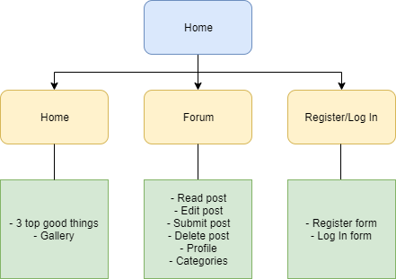

# Userflow Mock Ups

1. User wants to Log In
2. User wants to create post
3. User wants to see the gallery

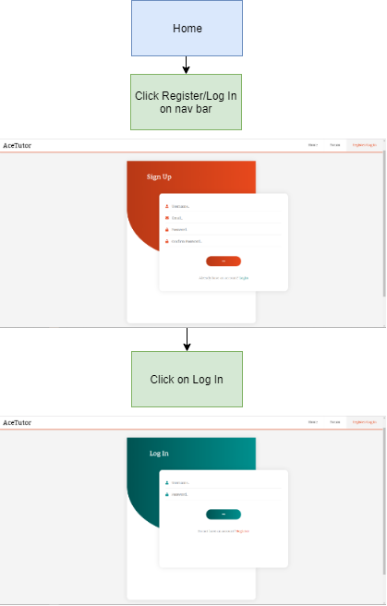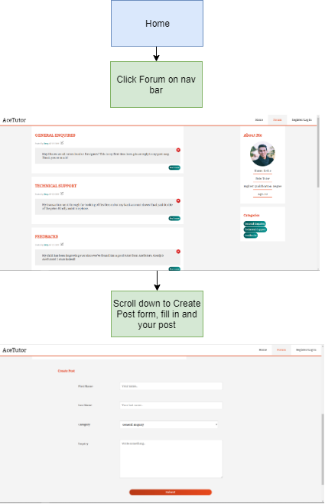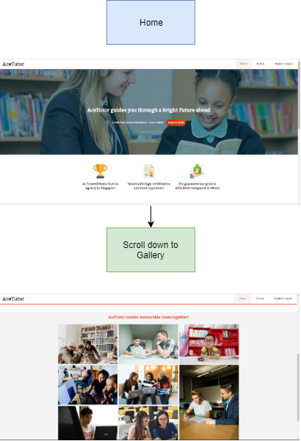

# Responsive Techniques ( Layout )

* Mostly fluid ( Percentage, REM , EM are mostly used for better responsive )
* Layout shifter ( Media quaries )
* Tiny tweaks ( Adjusting font size, image, etc )
* Using of flex

# Responsive Techniques ( Menus )

* Layout shifter
* Mostly fluid

# Reflection and lessons learned

* I find out that hard code the responsive based only on HTML/CSS only is tough without bootstrap help.
* I realise that it is better to use percentage, rem and em throughout the assignment process.
* It takes more time than I expected as there are many things to solve for each element.

# Unlisted Video Link

<https://www.youtube.com/watch?v=crpiojTM0qM>