German: Issue 0: Reinigungskraft, Issue 1: Dieser Reinigungskraft zugewiesen, Issue2: Anderer Reinigungskraft zugewiesen, Issue 3: Zusatzaufgaben der Reinigungskraft zuweisen

Italian: Issue 1: Assegnato a questo housekeeper, Issue2: Asseganto ad un’ altro housekeeper, Issue 4: Camere prenotate

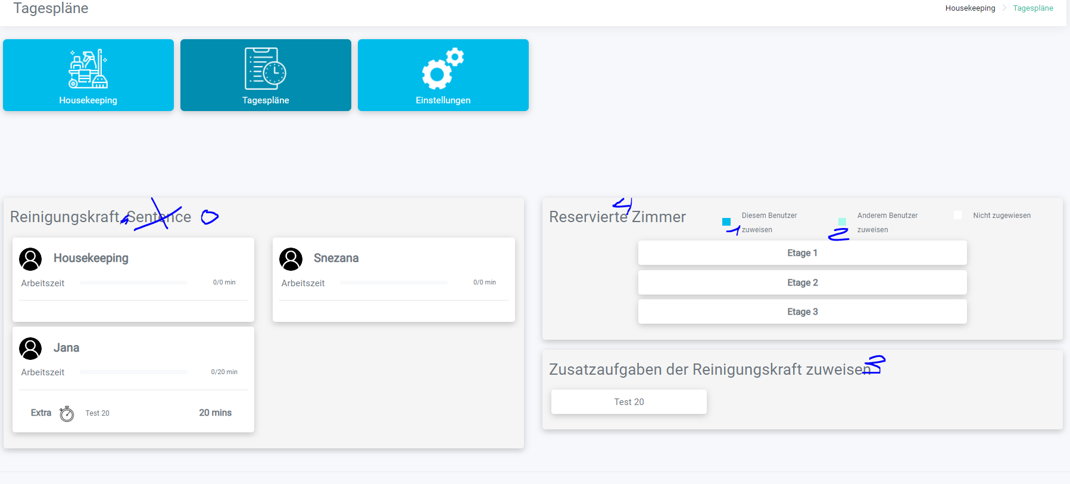   
  
Italian: Issue 5: Housekeeping, Issue: Agg. categorie di camere  
  
Housekeeping Button is not working

