METHOD

- Objectives
The objectives of this activity are to:
- ..
- ..
- ..
- Preparation
Preparation is done by providing tools and materials that will be used for data retrieval as in Table 3.1
Table 3.1 Tools and materials
No | Tools | Materials
1 | Core sampler | Etiquette
2 | GPS receiver | Plastic string
3 | Bamboo stick | Aluminum foil
4 | DBH tape | Plastic (1 Kg and 5 Kg)
5 | Clothes meter | Alcohol 70%
6 | Densitometer | Papers
7 | Soil Tester
8 | Scales
9 | Compass Brunton
10 | Crucifixion plate
11 | Ground oven
12 | Oven furnace
13 | Sasak plants
14 | Identification books

- Data Collection Method
  - Determination of Observation Locations
Preparation of the location of data collection is done by direct and indirect survey. A survey conducted a direct survey to the field with to take coordinate points. An indirect survey by classifying land cover using the Google Earth base map done in ArcMap 10.4.1. Cikapundung River was digitised onscreen using a polyline shapefile, then buffered as far as 100 m left in the river and segmented along 403 m so as to produce 99 segments on the left and right side of the river (Figure 3.1). Classification is based on SNI 1: 250.000 standard using eight classes of the settlement, industrial building, forest, bush and shrub, rice field, moor, grassland, and water body. In each segment will be data collection plants and soil on the right side of the river so that the total point of observation is 198.
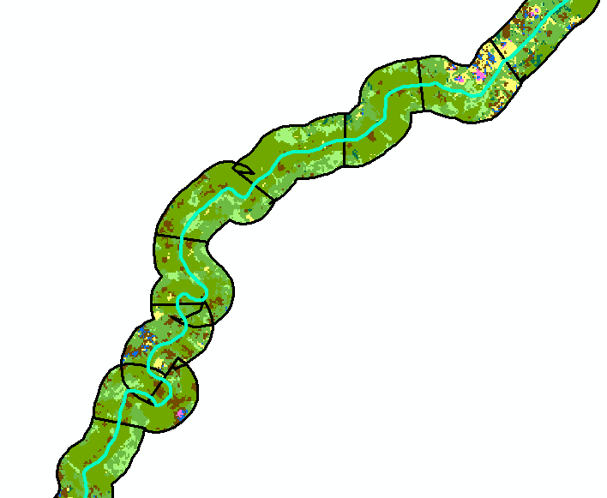
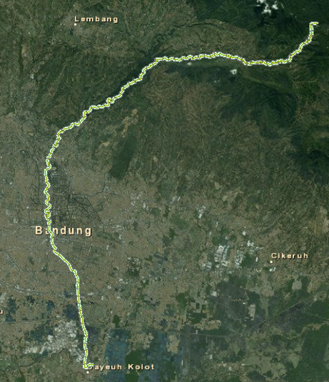
Figure 3.1 Segmentation of Cikapundung River

  - Preparation of Vegetation Observation and Observation Plots
The research was done by using belt transect method. The plot is made with a size of 20 m x 5 m which are placed parallel to the length of the river. In the plot 20 m x 5 m there are four subplots measuring 5 m x 5 m (Figure 3.2). The area in 1 vegetation observation plot is 100 m ^ 2, so in this study, the total area of the observation plot is 1.98 ha.
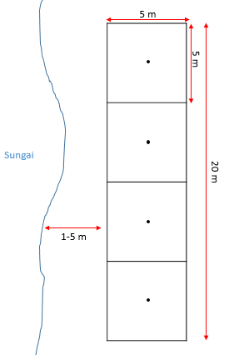
Figure 3.2 Plot observation of plants
Plot size 20 m x 5 m for analysis of trees with diameters ≥ 10 cm, 5x5 meters for tree analysis <10 cm, shrubs and herbs. In this study, the analysis and measurement of trees are done based on life stages include trees, poles, stakes and seedlings. The characteristics of each of these steps are that the seedlings have a height of ≤ 1.5 m, Sapling height> 1.5 m and DBH ≤ 10 cm, the pole has DBH 10cm <DBH ≤ 20 cm and Tree (sawlog) DBH> 20 cm.
Data were taken for tree diameter ≥ 10 cm is DBH (diameter at breast height), as well as the number of individuals, trees <10 cm is the percentage of boards and number of individuals. As for the shrubs and herbs of data taken is the percentage of hoards. Plants not identified in the field were duplicated for the herbarium and further identified at the Terrestrial Ecosystem Analysis Laboratory SITH ITB.
The measurement of DBH is the diameter of the rods approximately at the height of 1.3 meters above the ground. DBH is used to determine the basal area of ​​the tree (LAB) which is one of the important values ​​index parameters. The area of ​​the basal area is the surface area covered by the tree trunk. In the field conditions are often found a few exceptions due to the form of a variety of tree trunks. DBH measurement method on various tree shapes in Figure 3.3.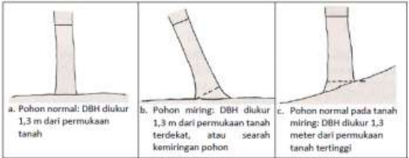
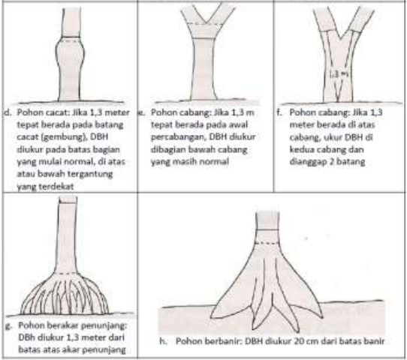
Figure 3.3 DBH measurement method
Individual hoards of saplings (saplings and seedlings), shrubs and herbs were determined using the Daubenmire closure class (Daubenmire, 1959) (Table 3.2).

Table 3.2 The closing scale of Daubenmire (Daubenmire, 1959)
Closing class | Closing range | The middle-grade value
6 | 95-100 | 97.5
5 | 75-95 | 85
4 | 50-75 | 62.5
3 | 25-50 | 37.5
2 | 5-25 | 15
1 | 0-5 | 2.5
*for data analysis used middle-class value

  - Measurement of the Edaphic Factor
Edaphic factors measured were pH, organic content, mineral content and bulk density. Soil pH measurements were performed directly in the middle of the subplot of size 5m x 5m, so there were five repetitions in 1 plot. Soil tester is used to measure pH and soil moisture. The way to use it is by plugging the whole sensor (probe) soil tester into the soil and pH can be read directly. After the used, cleaned the sensors and traces.
Measurements of organic content, minerals and soil bulk density were carried out by sampling soil samples on each plot using auger and core sampler and then analysed further in Territorial Ecosystem Analysis Laboratory SITH ITB. Calculation of organic content and soil minerals is done by using an auger to take the soil layer on horizon A with 10 cm deep. Taken approximately 10 grammes of soil and put in a sealed container known to its weight. Using the scales, weighed to form a fresh weight. In the laboratory, soil samples are fed into an oven of 105°C to a constant weight. After that, cool for a while and weigh the dry weight of the soil. Taken extracts of dry soil 5 grammes of dry soil and then put into a dry porcelain that has been known to weigh. The spraying process can be done with a high-temperature furnace or furnace (450^{O}C) for 4 hours. After that, the sample was cooled in the desiccator and weighed the soil weight of the soil.
How to sample the soil to determine the value of the weight of the contents using the core sampler (rings). The ground surface is cleaned first from grass and litter. Core sampler placed on the ground. Made a circle with the same centre with the core sampler and his fingers twice the radius of the core sampler. In the circle is made a hole around the core sampler as deep as 10 cm, so that when the core sampler is inserted easily pressed into the ground. The core sampler is pressed carefully and remains in a vertical position. When the ground is hard enough, the core sampler is hit slowly. If the core sampler has entered all the ground, the ground beneath the core sampler is cut with a shovel or knife. The ground is levelled at the mouth of the core sampler with a thin blade or nylon thread. This intact piece of soil kept in a box is maintained so that it is not destroyed for further processing in the laboratory. Soil trailing was immediately weighed with fresh analytical scales (accuracy of 0.01 g). The trailer was dried in the oven at 105OC for 24 hours and weighed a constant dry weight.

- Data Analysis
- Important Value Index (IVI)
Important value indices show the relative dominance of species to other species within a community. Each species has a relative contribution to its community as a whole. The Important Value Index (IVI) is one of the analyses used to measure the relative contribution (Barbour et al., 1999). IVI is obtained from a combination of relative density values, relative hemp and relative frequency. The density indicates the number of individuals in a given area, the sheath is the percentage of the area controlled by the plant in a plot regardless of the closure of the other species, and the frequency is the encounter rate of a plant species during the observation.
Relative frequency (Frr) = $$\frac{Type of frequency}{ Total frecuency}$$ x 100%
Relative density (Krr) = $$\frac{type of density}{ Total density}$$ x 100%
Relatif heap (Kbr) = $$\frac{Type of heap}{ Total heap}$$ x 100%
IVI (Important Index Value) = Frr + Krr + Kbr
IVI calculations such as the above formula can not be performed for all plant habitus (Table 3.3). For the third tree, the parameters include frequency, density and heaviness can be included in INP calculations while for shrubs and herbs only of two parameters ie frequency and shade.

Table 3.3 IVI Calculation Parameters
 | Relative Density | Relative Heap | Relative Frequency
Seedling | ✓ | ✓ | ✓
Stakes | ✓ | ✓ | ✓
Poles | ✓ | ✓ (LAB) | ✓
Trees | ✓ | ✓ (LAB) | ✓
Shrubs |  | ✓ | ✓
Herbs |  | ✓ | ✓

- Species Richness, Diversity Index and Dominance
Species richness (Species Richness) is the total number of species found in a research area. The calculation of species diversity uses the Shannon-Wiener (H ') diversity index. Calculation of dominance is done using the index of a dominant position (J). The index value of diversity and dominance is derived from the equation:
$$H^{'}= \sum_{i=1}^{s}{}pi ln pi$$J = $$\sum_{i=1}^{s}{}{pi}^{2}$$
Description:
S : Total types
Pi : The proportion of the number of a species to the total number of species

- Mineral content, Soil Organics and Bulk Density
Calculation of mineral content, organic soil and bulk density as follows.
Organic soil content (%) = $$\frac{soil dry weigh-ash weigh }{soil dry weigh}100\%$$
Soil mineral content (%) = $$\frac{ash weigh }{soil dry weigh}100\%$$
Bulk density (g/cm³) = $$\frac{soil dry weigh }{volume core sampler}$$

