CHAPTER III MATERIALS AND METHODS

  - Preliminary Study
The preparatory phase is done by creating an onboard Cikapundung polyline vector which is digitised on screen in the Google Earth base map with ArcMap 10.4.1. The rough estimation of land cover in the Cikapundung River riparian zone is carried out by providing buffer zones as far as 100 m, 300 m, and 500 m from the river body from upstream to downstream (figures 3.2, 3.3, and 3.4). Data for classification downloaded from Google Earth recorded on November 15, 2016. The classification of land cover is divided into nine classes: forests, shrubs and bushes, fields, fields, grasslands, constructed land, industrial buildings, and water bodies in Figure 3.1. Furthermore, to know the proportion of land cover class in an area, the 36 km buffer is divided into ten segments, each segment has a length of 3.6 km. The percentage of land cover is presented in the form of a graph, from upstream to downstream with a limit of 430 meters represented by segments 1, 2, 3 and so on in figures 3.2, 3.3, and 3.4.
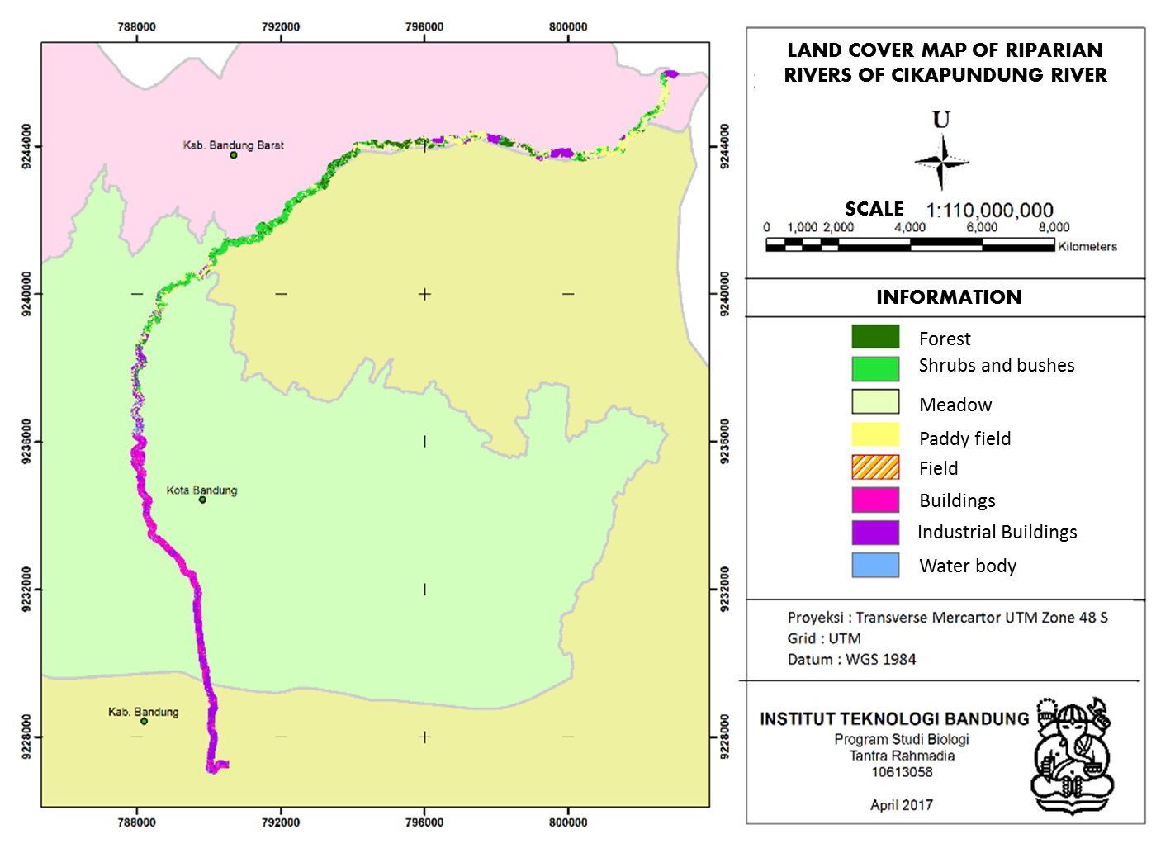
Figure 3.1 Cikapundung River Classification from Basemap Google Earth 2016
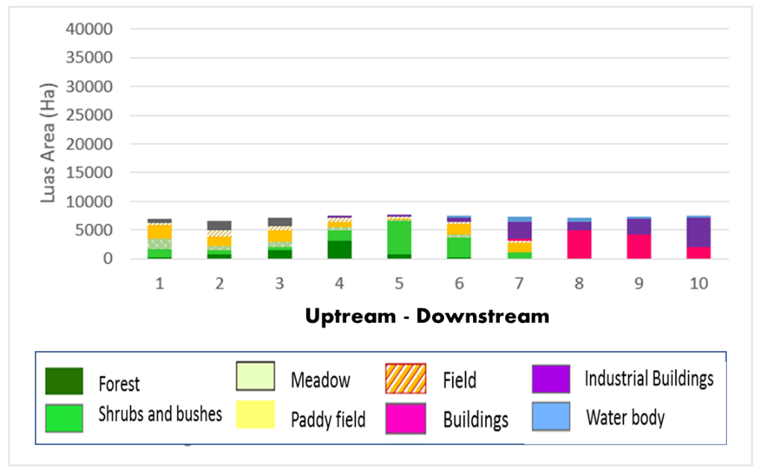
Figure 3.2 Segmentation of Cikapundung River per 3.6 km within buffer zone 100 m

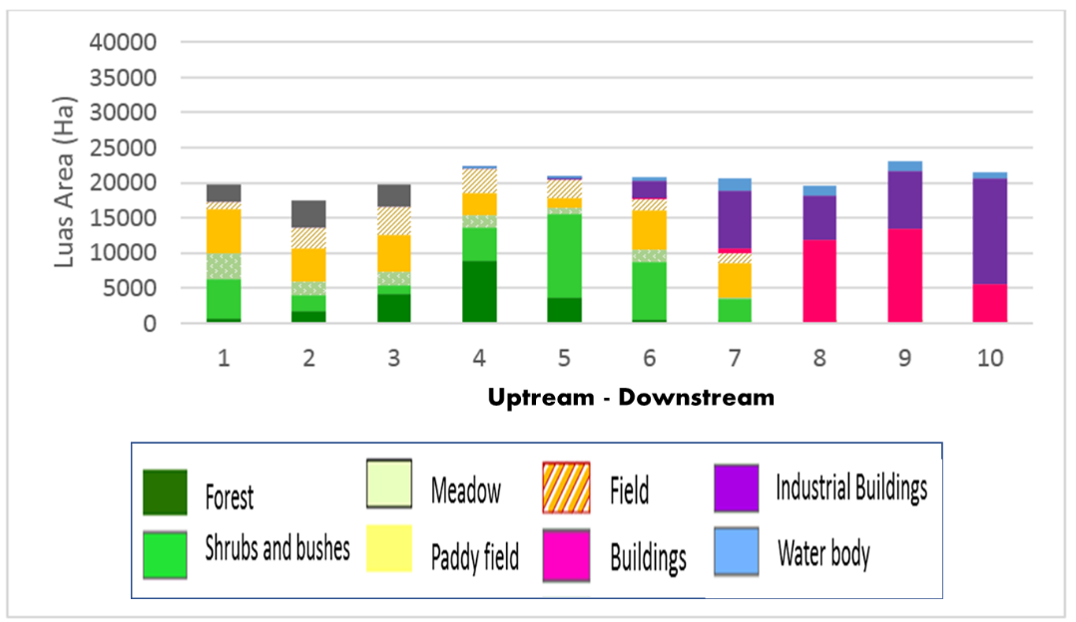
Figure 3.3 Segmentation of Cikapundung River per 3.6 km within buffer zone 300 m
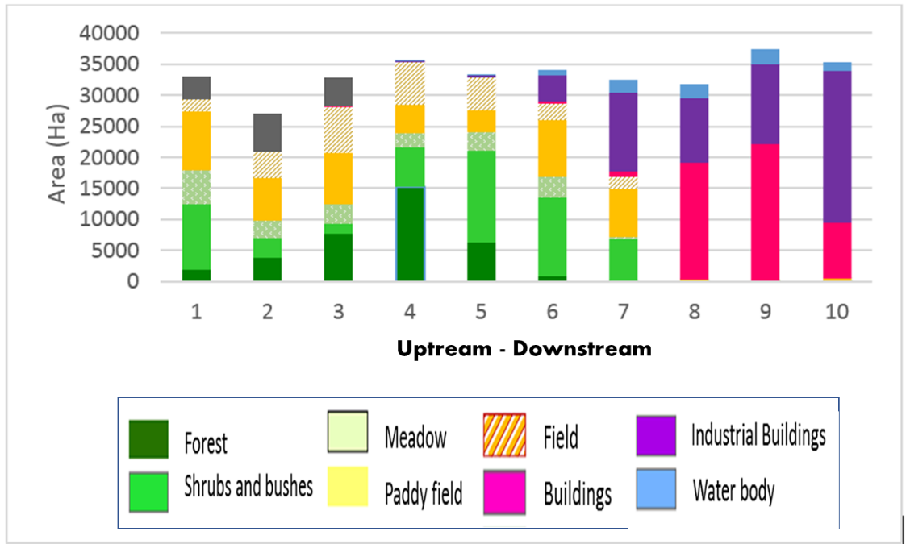
Figure 3.4 Cikapundung River Segmentation per 3.6 km within buffer zone 500 m

  - Collecting Data
The main data in this research is SPOT 5 image data product which has a monochromatic spatial resolution as far as 5 m and panchromatic as far as 2.5 m. The data is used because it is classified high-resolution image data that can provide visual sightings are quite detailed for the Cikapundung River. Based on the survey in the field, the width of the Cikapundung River in the upstream area is less than 5 m, while downstream reaches 15 - 26 m. Satellite image recording will be captured in July 2005, 2010, and 2015 as it is in the dry season, rainfall in the minimum conditions, thus minimising the external disturbance occurring in the atmosphere during recording. The supporting data that will be used are in the form of vector division of the administrative area of Regency / City of Bandung, vector of river area division based on hydrodynamic character, and vector of regency/municipality administration division.

  - Work Stages
This research uses the help of ENVI 5.3 software, ArcMap 10.4.1, and for processing satellite image data. Image pre-processing that includes ortho-rectifying, radiometric correction, and cloud masking or cloud cover removal are processed in ENVI 5.3. Further geoprocessing and image processing are done in ArcMap 10.4.1. To ensure that there is no difference in cover class on the thematic map results with the land cover in the field, an accuracy analysis using the Kappa equation is used. The result of the thematic map then calculated the landscape change at the difference of 5 years by using software FRAGSTAT 4.2. The following figure is a flow chart of the work stages.

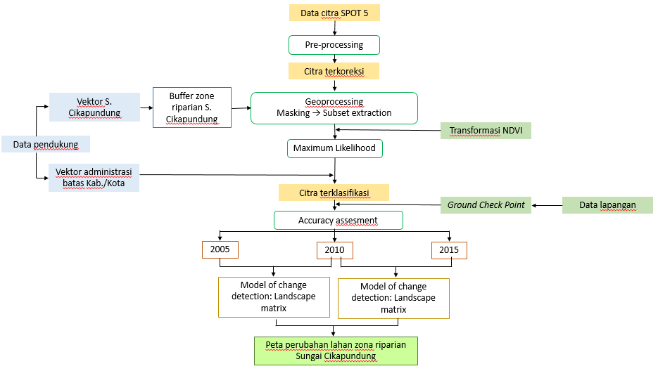
Figure 3.5 Work stages

  - Data Analysis

    - NDVI

NDVI calculation is the transformation of vegetation index to Near-Infrared and Visible Red band ratio. NDVI formula is as follows:
$$NDVI= \frac{Near Infrared-Visible Red}{Near Infrared+Visible Red}$$
The result of the NDVI calculation will produce a band with a range of values from -1 to +1. Very little green vegetation will produce a value very close to zero (0). Conversely, the presence of tightly green vegetation will result in a value close to +1 (Norman et al., 2014).

    - Calculation of Kappa Accuracy Value

Accuracy value calculation is necessary to compare the accuracy of digital classification results with the fact of land cover in the field. Cohen's Kappa or so-called Kappa is used in the calculation of precision values in this study because it uses the same formula for both observers (digital classification and ground check in the field) but may have different distributions for the same rating category (Kirilenko & Stepchenkova, 2016). The error matrix model, as in Table 3.1, is used to derive preliminary data from the predictive value of accuracy. From the matrix, in addition to Kappa value, accuracy, sensitivity, specificity, and true skill statistic (TSS) values can be seen in Table 3.2.

Table 3.1 Error Matrix
 |  | Existing Data on Field
 |  | Available | None
Data Classification Model | Available | a | b
 | None | c | d

Sensitivity is the value of the proportion of two data in the "exist" category, whereas the specificity is the proportion of two data that gives the number in the "none" category. Both sensitivity and specificity are independent of each other (Allouche, et al., 2006). The sensitivity and specificity values can be used for True Skill Statistic (TSS) calculations. TSS value has positive (+) value range for sensitivity and negative (-) for specificity. The +1 value indicates the perfect match value between observed data and the expected data, whereas 0 to ¬-1 indicates both data have a very high random value (Ruete & Leynaud, 2015).

Table 3.3 Kappa Calculation Formula and Prediction Accuracy
Calculation | Formula
Observed agreement (π_{o}) | $$\frac{a+d}{n}$$
Expected agreement (π_{e}) | $$\frac{(a+b)(a+c)+(c+d)(b+d)}{n^{2}}$$
Sensitives | $$\frac{a}{a+c}$$
Specifies | $$\frac{d}{b+d}$$
Kappa (κ) | $$\frac{π_{o}- π_{e}}{1- π_{e}}$$
TSS | $$sensivitas+specificity-1$$
$$n=a+b+c+d$$
The calculation of Kappa's statistical value can be categorised in a qualitatively grouped value range called a benchmark scale or benchmark (Gwet, 2012). In this research, we use the Landis & Koch's benchmark scale interpretation because it has a relatively high accuracy range compared to Fleiss and Altman's as shown in Table 3.2 below. Tabel 3.2 Interpretasi Nilai Kappa Statistik
- Landis & Koch’s Benchmark Scale (1977)
Poor | Slight | Fair | Moderate | Substantial | Almost perfect
Kappa
0.0 | 0.20 | 0.40 | 0.60 | 0.80 | 1.0

Kappa | Agreement
<0 | Less than chance agreement
0.01 – 0.20 | Slight agreement
0.21 – 0.40 | Fair agreement
0.41 – 0.60 | Moderate agreement
0.61 – 0.80 | Substantial agreement
0.81 – 0.99 | Almost perfect agreement

- Fleiss’ Benchmark Scale (1981)
 |  | Poor | Intermediate to good | Excellent
Kappa
0.0 |  | 0.40 |  | 0.75 | 1.0

Kappa | Agreement
<0.40 | Poor
0.40 – 0.75 | Intermediate to good
>0.75 | Excellent

- Altman’s Benchmark Scale (1991)
 | Poor | Fair | Moderate | Good | Very good
Kappa
0.0 | 0.20 | 0.40 | 0.60 | 0.80 | 1.0

Kappa | Agreement
<0.20 | Poor
0.21 – 0.40 | Fair
0.41 – 0.60 | Moderate
0.61 – 0.80 | Good
0.81 – 1.00 | Very good

    - Landscape Metrics

Land cover change is a dynamic environmental phenomenon that can trigger fragmentation. Fragmentation events have an effect on conservation, one of which can reduce biological diversity (Remteng, et al., 2015). Landscape analysis of fragmentation in this research using FRAGSTAT 4.2 software. Classified land cover maps are a source of data for land cover indicators and landscape metrics (Giordano & Marini, 2008). Land cover indicators include an extensively categorised land cover evaluation. Landscape metrics will measure the spatial structure associated with landscape composition and configuration using the formulas below (McGarigal, et al., 2012).
Types of Landscape Metrics | Formula | Description
Number of Patches (NP) | $$NP=n_{i}$$  Ni = bnumber of patch | Many patches on a landscape with patch type i
Patch Density (PD) | $$PD=\frac{n_{i}}{A}(10000)(100)$$  Ni = number of patch on keys i  A = landscape Total area (m2) | The number of patch I on an area landscape
Total (Class Area) (CA) | $$CA=\sum_{j=1}^{n}{}a_{ij}(\frac{1}{10000})$$  Aij = area (m2) on patch in | Total class area (m2) on ij patches converted to acres (divided by 1000)
Percentage of Landscape (PLAND) | $$PLAND=P_{i}=\frac{\sum_{j=1}^{n}{}a_{ij}}{A}(100)$$  Pi = proportion  Aij = area (m2)on patch ij  A = landscape total area ( (m2) | The proportion (%) of the patch type i in the patch area ij per total area of a landscape.
Largest Patch Index (LPI) | $$LPI=\frac{{max (a_{ij}) }_{j=1}^{n}}{A}(100)$$  Aij = area (m2) on patch ij  A = landscape total area ( (m2) | Calculation of patches with the largest extents in the overall landscape area in percent
Mean Area (AREA_MN) | $$MN=\frac{\sum_{i=1}^{m}{}\sum_{j=1}^{n}{}x_{ij}}{N}$$  x_{ij} = dot on patch ij  N = number of patch | Total patch area divided by the number of patches
Shannon’s Diversity Index (SHDI) | $$SHDI=-\sum_{i=1}^{m}{}(P^{*}lnP_{i})$$  Pi = proportion on landscape in class patch i | Proportion of abundance on each patch on a landscape

