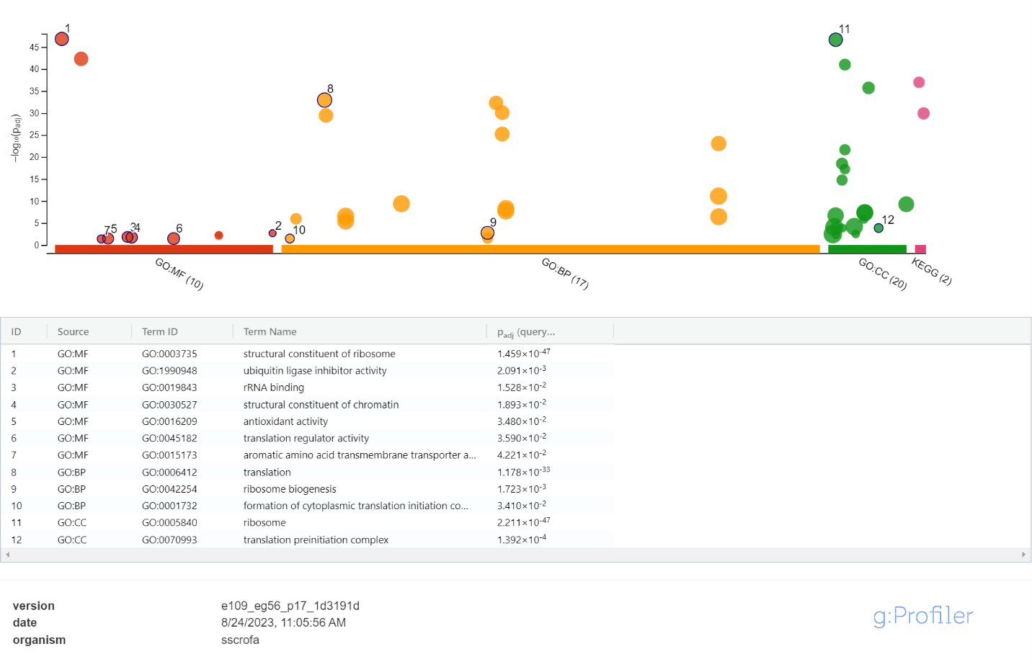
Figure S1. Piglet birth weight pathway analysis of differentially expressed genes. Control low birth weight vs. Control average birth weight pigs (along x-axis depicts various Gene Ontology databases: GO:MF = molecular function, GO:BP = biological process, GO:CC = cellular component)

